THE SECOND WORLD WAR: AN ANALYTICAL LOOK AT THE CONFLICT
THROUGH THE PRIZME OF THE DOCUMENTARY FILMS
OF THE ERA

By

Tigran Poghosyan

Presented to the Department of English and Communications

Under the Supervision of:

Dr. Melissa Beattie

American University of Armenia

Yerevan, Armenia

Table of Contents:
Introduction 3-4

Literature Review 4-10

Analysis 10-13

Research Question 13

Methodology 13-15

Analysis on the Propagandistic and Aesthetic aspects 15-32

Conclusion 33

Bibliography 34

Introduction:
This paper is going to analyze the key specific occurrences and the philosophical meaning of the Second World War. A representation of key battles and events during the time period from 1939 to 1945 is going to be presented within the paper dwelling into their philosophical importance and their overall meaning as a potential side effect on today’s modern societies. I am also going to talk about the two main participants of the war and their decision making during the span of the conflict. For the sake of keeping the paper concise enough and for better clarity the aforementioned choice was made to highlight that the war in its revelations was quite an intricate chain of events that led to unforeseen circumstances that decided the fate of millions of people and their future generations.
For the longest time people’s fascination with history has kept the world in a position where opinions and attitudes towards war have come to a point where no one is capable of deciphering the minute machinations behind such events and their outcomes. The main subject of those ponderings is the second world war in particular that has left its influence upon how academics need to understand and analyze history moving forward. The magnitude of the conflict was immense enough for it to influence every aspect of life from geopolitical systems and structures to something, in comparison, as insignificant as greetings. Understanding the changes, it introduced to today’s societies is crucial in the process of learning history and applying the newly acquired knowledge in the best ways possible. In order not to dwell into the whole set of details that the war consists of, I am going to highlight some specific occurrences and touch upon specific themes that make the history of the conflict more fathomable. Those events that are going to be mentioned are considered by many historians and analysists to be the most crucial events within the entire span of the second world war, and their importance does not always prove to be strategically based, but rather shows philosophical and moral decisions that influenced that specific event. I am also going to be talking about two parties that were the most heavily involved within the war, Nazi Germany and the Soviet Union. This kind of a representation will allow enough flexibility when dissecting all the small details that had connections with the decisions of both parties and how said views changed the course of the war multiple times. I will however leave the main question open for interpretation, and it is “How does the view of the second world war help with today’s problems.” I will be nonetheless trying to answer said question by analyzing the material I have gathered to show the best possible solutions for answering it. By showing the conflict from various side points and viewpoints, like focusing more on the aspect of the propaganda elements of the waring parties, which I will do with the help of the analyses of two most prominent documentary films of the era, I will hopefully achieve a certain amount of clarity in terms of verifying why the conflict should remain in public consciousness.
Literature Review:
“The only thing we have to fear, is fear itself,” This quote by Franklin D. Roosevelt summarizes what it was like living in the times of war. A person’s value was determined based on his or her ability to contribute to the “Cause” and that would be any cause for that matter. In the 1930s no one was even close to thinking about another war erupting in just little over 10 years after the end of the First World War. And although the great depression has certainly had its toll on the majority of countries in those years, for one particular party in Germany it proved to be the call, the call to rise and spread its influence on the impressionable minds of the population. The catalyst for the events to transpire into a war was meticulously, but unconsciously crafted by the leading superpowers of the world. Blinded by greed those countries decided to invest into a new ideology, a new “beacon” that in their eyes would illuminate Europe and put an end to the economic crash. Those actions as history shows proved to be the most devastating decisions that would scar the face of the earth with atrocities that no sane mind could think of. The acts committed and the orders executed on behalf of the Nazi regime are unspeakable and they show the inhumane side of the world that every state to this day tries to hide in their attempts to present the world.
For the better understanding of the second world war, I have chosen to present the argument that its significance lies in the strategic decisions, underlying themes of propaganda management and the specificity of decision making by the higher commanding bodies of the nations at the time. I am also going to present the notion that the combination of said components and the mindset of the masses in those days differs very drastically from the perception of world altering changes we have today. I will start by introducing the concept of realizing the accuracy of historical events and how they may have been construed involuntarily by historians to make better sense of the conflict as a whole. The most notable source of the mindset of the aforementioned “Mistake” in historical analyses comes from the work of Viktor Suvorov titled “The Chief Culprit: Stalin's Grand Design to Start World War II.” In his work Viktor Suvorov puts quite an interesting spin on historical research as he debunks the main culprit behind the start of WW2. By his criteria which are based on years of documented evidence compiled by many historians and himself regarding the strategic advances of both the Soviet Union and Nazi Germany, The Soviet state was responsible for starting the second world war as they, and most prominently Stalin Himself were concerned that the communist idea has not spread far enough and has not enveloped the entirety of the world as he and his predecessor would have imagined. Simply put the second world war was needed to put a decisive statement into the world where a heroic regime is saving the world from the aggressor meanwhile all parties involved could not be called in any way righteous. This work acts as a linchpin when addressing the true intent of the Soviet Union, or rather the desire of the dictator in command. The strategic executive plans that the Soviet Union wanted to implement during the war were, in many cases mirroring the plans of their adversary Nazi Germany.
The notion of even the most minor geopolitical occurrences having staggering effects on the conflict as a whole is a display of the ambiguity of the world at the time with its economic crashes, poverty and unemployment. Take the Reichstag fire of 27th of February, 1933 for example. That specific occurrence while in and of itself holding no significance, as it was supposedly a fire breaking out in the building at first glance, played upon the nationalistic and socio-cultural fabric of the German society and ultimately became one of the constitutional factors of the Nazis being put in power. Most post-war accounts of the Reichstag fire repeat the legend that by destroying the Reichstag the incendiary or incendiaries intended to destroy the visible ‘symbol’ of German democracy – not only Parliament but parliamentary government as well (Tobias, 1964). Said event effected the group mentality of the Germans as well as fired up their collective ego into making a decision which was the start of the chaos that was about to ensue. That was not however the only way the National Socialist party used the propaganda to its advantage as it was very vigorously trying to deploy the idea of every single opposing party or concept, which dared to rival theirs was not only to become problematic but was directly threatening the lives of the German citizen and all of it needs to be dealt with, with the most extreme measures. Such opposing group or rather the central group of people that was unequivocally connected to all of the hardships the Aryan race faced during its lifespan was the Jewish race, and by the criteria that were added later, their existence was unacceptable.
As the understanding of today shows, the only way the civilized German population would believe such nonsensical conceptualizations was through two specific mechanisms, the feeling of hatred and contempt and the feeling of superiority. By combining the psychological effects of narcissism and guilt reversal the Nazi propaganda machine achieved more than they would hope to accomplish, and although there were a certain few that clearly apposed them, no one, in those days and even many historians today, would disagree that the methods used proved rather effective. The work by Roger B. Nelson titled “Hitlers Propaganda Machine” goes into meticulous detail of how all of the minor achievements of the Nazi party were made by carefully crafted and strategically positioned occurrences playing into each other whilst the portrait of the “Righteous Fuhrer” and the heroic parades imprisoned the German mind and perception into that extraordinary cage. The same apparatus, albeit with various other moving “Cogs” was used in the Soviet Union as well, however there the racist rhetoric was not ever implemented as a mechanism for devotion, as it would rival the main working system, that of communism. And despite being a utopian mindset, communism by its principles, still strives to achieve far more sensible goals than Nazism.
When it comes to the strategic advancements of both major parties involved in the war, history proves that no two instances in history show the same amount of evidence for careful planning than the Stalingrad battle and the Leningrad blockade. The work by Anthony Beevor titled “Stalingrad” shows the sheer magnitude of horror of the war. It also serves as the representation of the comparison between all facets of military might between the Soviet Union and Nazi Germany. Known by multiple accounts as possibly the most vicious battle ever fought on planet Earth the battle of Stalingrad is also the intricately presented guide within history for understanding that particular time period of 4 months during the war. Anthony Beevor paints the battle in meticulous detail with its absolutely inhumane atrocities described within the book. Every aspect starting from preparation and execution of maneuvers to the eventual aftermath of the battle are once again painted in excruciatingly accurate details. this work illustrates the philosophical role of the battles fought during the war. Many historians and analysists believe that each battle and especially the battle of Stalingrad had importance in the factors of establishing the true link between the nature of the state, in one case the Nazi regime dictating their questionable values onto the people, whilst they, transforming into hungry masses rather than a collective of individuals, emotionally cling to the puppetry. And in the other case the Soviet regime throwing countless people into battle without giving them the specific orders that need be followed, and using them as meat shields to protect the larger part of the country. The battle serves as the example of the human tenacity overcoming obstacles and difficulties and continuing to fight in the face of defeat and death. The historical importance of the battle cannot be overlooked as well, as it just so happens to be the first major loss of the Nazi regime after countless victories. In those years most of the people were sure that the Nazi invasion is impossible to stop and that their military might could not be rivaled especially by the much worse prepared soviet army. However, as with any historical battle the climate played its role in deciding the eventual victor, as although the red army were at a disadvantage regarding their weapons and ammunition, they were fighting on their own soil and knew all the surprises nature had in store for them, and the same could not be said about their adversary.
The Stalingrad battle was definitely the decisive one from the perspective of the Soviet side. However there existed only one battle in the end which mattered the most, the Battle for Berlin. Cornelius Ryan in his book titled “The Last Battle: The Classic History of the Battle for Berlin” does a thorough analysis of every major and minor occurrences that constituted the end of the Third Reich. The fear and suffering of civilians, and the disregard for them by the political leaders is captured and displayed with no words spared for the most minute of details. The battle for Berlin, the last offensive against Hitlers Third Reich, began at precisely 4 A.M., Monday, April 16, 1945- or A-Day as it was called by the western allies. At that moment, less than thirty-eight miles east of the capital, red flares burst in the night skies above the swollen river Oder, triggering a stupefying artillery barrage and the opening of the Russian assault on the city. As that attack began, Berliners waited in the bombed rubble of their city, numb and terrified, clinging to the only politics that now mattered- the politics of survival. To eat had become more important than to love, to borrow more dignified than to fight, to endure more militarily correct than to win (Ryan, 1966). The understanding of this battle allows for better realization regarding the culmination of Third Reich. This battles importance lies primarily, in a morale victory over the great evil. However, upon closer inspection the actual truth of the matter becomes clear. Thousands of soldiers that never participated in battles and countless civilians who had no fault in sins of the Nazis were sacrificed for the “Greater Good” because their opinions did not matter in the grand scheme of things.
However, the view of the citizens and soldiers that were unwillingly intertwined with the whole scenario of battles and survival is also a point of notice for this assignment.
Take for example the work by Paul Fussell titled “Wartime: Understanding and Behavior in the Second World War” where the author dwells into, as the title suggests, the understanding and behavior of civilians and soldiers during the war. Paul Fussell carefully analyses the psychological, social and behavioral aspects that were displayed by the “insignificant” participants of the war. It is important to note that the people and their decisions is what ultimately decided the outcome of the war, with some being misled and misrepresented and with others having no say at all. Using this kind of a representation will allow for further analyses of the realization of people about the war and its potential consequences. A certain type of morale guide was needed to be created for people to follow to not sway from the right path during their individual decision-making processes and build a concrete staple for humans to follow and not to become victim of the enemy’s opinionated rhetoric. The book by Ian Mclaine titled “Ministry of Morale”, first published in 1979, is an analysis of the wartime Ministry of Information, responsible for the maintenance of public morale. How was it that British morale remained high, yet the department responsible was so bad? This book examines the domestic work of the Ministry and offers an unprecedented insight into the mind of both government and people during the war. It answers key questions: How did a government department assess and set about maintaining morale? How did it handle the social and political questions associated with morale – post-war social reform, press freedom and censorship, the nature of the Soviet regime? How sound in fact was civilian morale, on the basis of the secret Wartime Intelligence reports then available? One of the most fascinating aspects of this book is the Ministry’s constant internal debate on how its responsibilities should best be carried out. It is a key work of research on the political, psychological and mass communications problems facing a society at war (Mclaine,1979). The use of this work will allow a look into not only the British morale building system, but also all countries attempt to achieve the same effect through carefully controlled information distribution, since all countries at the time used the” News” machine to achieve a certain type of effect on the respective populations. When looking upon communication channels that for the most part convey some sort of information, it is important to note that nothings is much more striking than a documentary film. Of course, for the sake of the continuation of the narrative of the essay thus far, I am going to touch upon two films that in my opinion can be considered both polar opposites and mirroring representations depending on the criteria that is going to be placed when analyzing them. Those two films are “Triumph of the Will” by Leni Riefenstahl and “Triumph over Violence” or “Ordinary Fascism” by Mikhail Romm. In the further explanations and analyses, the dichotomy and subsequently the concurrence of both films is going to be discussed with the addition of the component of their aesthetic and propagandistic components.
Analysis:
When it comes to the connection between the documentaries and the actual occurrences of the war, the films depict some parts of the entire picture but never go in depth in realizing all the aspects that were detrimental to the conflict as an event. The visuals of the Riefenstahl film depict a utopia where everyone is happy and satisfied and that was presumably its original aim. The minor details regarding in depth technicality of the films is hard to explain, due to them being quite old and also due to their narrative structures. Key events leading up to the war are not highlighted, which makes the experience lacking in the department of actual historical research value. In the Romm film, the historical events, although shown, do not give off actual components for analysis and rather depend on the emotional response of the audience, which is once again a result originally intended. But, in defense of both films, from the perspective of their historical value, both of them are integral in understanding the aforementioned workings of the respective propagandas. Propaganda is hardly less true than any traditional art which seeks to achieve certain specific emotional effects, to manifest a vision of the world compellingly. Its poor reputation rests largely on the fact that it succeeds so seldom or partially. Such failure is virtually a condition of the fiction propaganda film, where the world presented is not necessarily the real one, where the work is ostensibly imagined, and though emotion may be stirred, it is not stirred by the facts of life. Since propaganda is concerned with influencing attitudes toward life in a given time and place, and indeed in terms of specific events and people, its ideal must always be to present this life, these events, these people. When this is done in the context of a story, with actors playing realities, the limitations mentioned above still obtain, fiction is most obtrusively strange when it works with specific fragments of “truth”. The semi-documentary approach, sticking as close to fact as possible, using history rather than story, minimizing the role of actors (particularly actors of famous personages) so there is no sense of the creation of the illusion of Lenin or Kerenski; this re-enactment of event is Eisenstein’s way, and Goebbels so admired the power of Potemkin that he made it an ideal of German propagandists in the thirties (Kelman, 2003). With such an artful approach to propaganda, the Riefenstahl film achieved something that was crucial in the understanding of the inner state of mind of a German, in those times. In the film it is used as a virtue, rather than deliberate contraption, which makes sense, in the context of the level of realization of history for the majority of the people living during the times of war. The Romm film, completely embraces the idea of propaganda used for the sake of pointing a finger at someone supposedly inferior. But the approach to the film was quite different in the beginning. In its conception the film was not supposed to be a propagandistic in any way. The film Ordinary Fascism was conceived in response to the power of images. in 1963 the critics Maia Turovskaia and Yuri Khaniutin watched thousands of yards of film footage from Weimar and Nazi Germany, much of it captured by red army forces from German archives. “We were amazed,” they later wrote, “at how much the face of Germany had changed. life became completely standardized. The whole country was a faceless mass, raising its hand and hysterically shouting ‘heil!’” They originally intended to show that transformation in a blend of documentary footage, which would convey the passage of time, and clips from German fiction films of the 1920s. Following the sociologist Siegfried Krakauer, they believed that these films demonstrated the psychological vulnerability of the German petit bourgeoisie, which created a hospitable environment for Nazism. From its inception, then, Ordinary Fascism was meant to be neither a documentary chronicle of the second world war nor a visual account of what was only beginning—and not yet in the Soviet Union—to be called the holocaust. Turovskaia and Khaniutin wanted to explore the metamorphosis of an entire society, and the historically factual images of conventional documentary, albeit essential, could not in themselves do the job. They therefore took their project to Mosfilm, the soviet union’s premier feature film studio, and to Mikhail Romm, one of its premier directors. (Woll, 2010).
The films portray the real world in very different ways. Firstly, there is the notion of fantasizing. The Nazi regime were famous for tying their suggested viewpoints with various German folklore and most importantly with famous German figures, some of whom did in reality express much of the same ideals that the Nazi party later adopted as their own. Such a figure in history was the famous composer, Richard Wagner, whose antisemitism rivaled his musical talent and genius as a composer. The almost messianic fervor with which Hitler planned the extermination of European Jewry was inspired by Richard Wagner's antisemitism. Ignored by many critics but often cited by Hitler, Wagner's ‘Prose Works’ specifically develop the idea that Judeo‐Christian morality and Jewish commerce must be eliminated so that humanity can regain oneness with Nature and true pagan love. Wagner cast himself as the savior of the German people through art. Hitler translated Wagner's crusade into politics (Brearley, 2010). Another important person that Hitler greatly admired, while simultaneously putting into complete disregard the actual nature of his writing, was Friedrich Nietzsche. Hitler saw him as the main procurer of the idea of the German superman, the Uber mensch and later put him on the pedestal amongst the greatest Germans to have ever lived. It may not be at all surprising that the post-war de-Nazification of Nietzsche occurred above all in France and the USA, where, given not only the brilliance but the remarkable elasticity of Nietzsche’s oeuvre, he could be harnessed to new cultural and political agendas. In Germany, of course, loosening him from these moorings was a different matter. In the land where Nazism had arisen and flourished and where Nietzsche had become so identified with the regime, it should perhaps not surprise us that, for upholders of the new liberal-democratic regime, resistance to his renewed influence was perhaps the greatest (Golomb, 1997)
Research Question:
The main point I am going to be addressing is how the understanding of the second world war is going to further help establish a pathway towards figuring out solutions to the problems of today. Basically, the question is going to be “how the war, as an occurrence with an abundance of examples of every area of life involving events that it has, is still not thoroughly understood by today’s society, and how that brings about problems that have already been solved in the past.” I think by sticking to these two fields of research I can potentially come close to the reader’s and my personal understanding of how the acceptance and the continuous learning of the facts of the past will allow for a subconscious mechanism of moral building to occur.
Methodology:
For the realization of my goal, I will need to go about the process step by step. First and foremost, I will start with an introduction that will help the reader get accustomed to the theme of the research and get acquainted with the topic of it, for better clarity of the proceeding in-depth analyses. For the analysis I am going to use the sources that I have gathered to help me with the intricate explanation of every concept that I am about to present, and it will also aid me in filling the potential gaps that I might have in my narrative. I have also chosen two documentary films which I will analyze that will help me illustrate all the points carefully and not dwell into details that may be too obvious or redundant. One of the documentaries I am going to use is the “Triumph of the Will” or “Triumphs des Willens” originally from German. This documentary will allow me to dissect the information regarding the ritualistic aspects of Nazi Germany and it also serves as many historians reason for believing that people were drawn into the whole scheme, because of said grandiose representations. The Second documentary I am going to use is called “Ordinary Fascism” or originally in Russian “Обыкновенный фашизм.” It was made in 1965 in the Soviet Union and it is the gateway of understanding for the Soviet population at the time of what the war meant and how its end serves as an example for the world today. This film if filled with propaganda from the side of the Soviet government however it is still a great representation of the war through the eyes of the soviet citizen.
What data will I be analyzing to help me answer the research question:
The data I am going to be using is going to come through various sources that are academically credible. I will use journals and various research through books that will allow me to present my arguments without significantly open spaces for speculation. That is, I am going to answer every question that I present, and try to reach a conclusive answer with each of them. When it comes to the sources, as mentioned above, credibility and authenticity is key in their positive usage so I will therefore try not to sway from the focal points presented within them and I will be sure to address both the factual evidence in them and the controversial opinions that they might present in the long run. Other than that, I find the usage of other sort of data gathering mechanism redundant as it might also, become problematic when addressing solely factual evidence.
How will the data be collected?
The data will be collected based on three crucial criteria. Firstly, it needs to be closely connected with the subject, so analytical and/or argumentative research that might be present within the work will not be used for the most part. Secondly, it needs be applicable in a sense of it being added to the narrative. If it cannot be put within the text without it being too eye-catching, as it might get the reader off of the main point of the narrative, its going to be modified and/or its specific part that does present such an effect will be ignored. And finally, the data needs to have a thoroughly evidentially based background and an in-depth analytical approach of using said information within the source should also be present for it to be used.
How will the data be analyzed?
By using all of the gathered information the analysis of the data will be done based on two functions. Firstly, the analysis will be done based on the actual materials connection with the narrative. How much of it can be connected to the narrative and how much of it is supporting evidence. Secondly the information needs to have references to actual historic events and occurrences, and a fair amount of analysis needs to be done on those events as well. The utilization of both of those functions will allow for a representation that will incorporate all the fields that this kind of research has to offer. It will also allow for an examination of every detail of the specific historical event that will in turn transform the narrative into an informational guide as well.
Analysis on the Propagandistic and Aesthetic aspects
At first glance it might seem like the “Triumph of the Will” directed by Leni Riefenstahl and the “Triumph over Violence” directed by Mikhail Romm are two films which are directly standing in opposition to one another, with one presenting a propagandistic portrayal of the third Reich with all of its “Glory” and “Excellence” whilst the other showing the disasters that were brought upon by said regime and the utter ridiculousness of the thoughts of the people who were in control. And such a mindset is certainly acceptable, in a sense that a soviet propaganda machine of the 1960s is much more tolerable than that of Nazi Germany. But, as presented in the context above, the notion of nationalistic agendas being pushed forth in pursuit of gaining influence over impressionable masses of people is certainly one area that cannot be overlooked. Both the Nazi high command and the Soviet ruling bodies in their respective documentaries were leaning towards establishing control and instilling an idea which would seem like common sense to the viewer once presented with the right circumstantial evidence. In that sense both documentaries do present their fair share of truthfulness when looked upon at a certain angle. An example to that would be that, the Nazi regime did in fact build a mighty army that did prove itself to be quite effective in execution of commands and was consequentially feared by most in those days. Adding to that, the theatricality that the Nazi leaders decided to implement as a mechanism for devotion of the populace, in those days, did really feel very grandiose and eye catching.
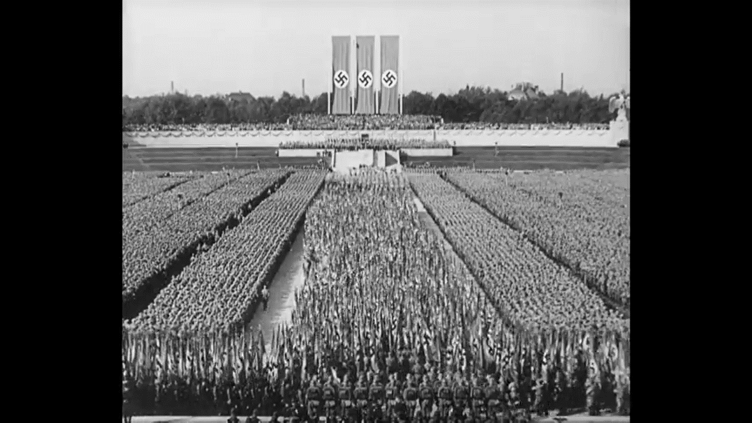
Figure 1. A Nazi Rally (Source: Riefenstahl, 1935)
In this scene for example, taken from the Riefenstahl film, we can see that the amassment of various divisions and cores are gathered to hear the speech of Hitler. We can see clear representations of such concepts as “Flagging” the nation. There are several banners, posters and flags depicting both the swastika and the SS lightning symbol, which is a clear instance of trying to solidify this imagery as mandatory for the nationalistic understanding overall.
The same sort of tactics of filmmaking can also be viewed in the Soviet documentary as well, although the choice of the narrative is skewed towards bashing the enemy rather than praising oneself. In the “Triumph over Violence” the Nazi barbarities are shown and condemned at full force, as they rightfully should be and the representation of the concept’s mentioned prior is also mocked and used as examples of intellectual inferiority. Those kinds of choices in documentary filmmaking do however show that both films are not devoid of rhetoric that clearly creates suggestive opinions. When looking retrospectively on both of the films, the true nature behind their meticulous structure seems clear and almost boring, as there is nothing that is obscure for the viewer who has the necessary information to realize the end goal behind their conception. However, for people living during the times of their making, the films represent something intrinsically tied to the collective mentality. For a German citizen who is loyal to the Nazi ideals and who is watching the “Triumph of the Will” in 1934, the film does invoke the feelings of pride and gratitude towards the National Socialists Party for regaining the lost honor of Germany and the deceptive points within the scenes would be overlooked for its value as a “Film showing the Greatness of Germans.” For those very reasons the film mostly relies on imagery rather than monologues to drive the point across.
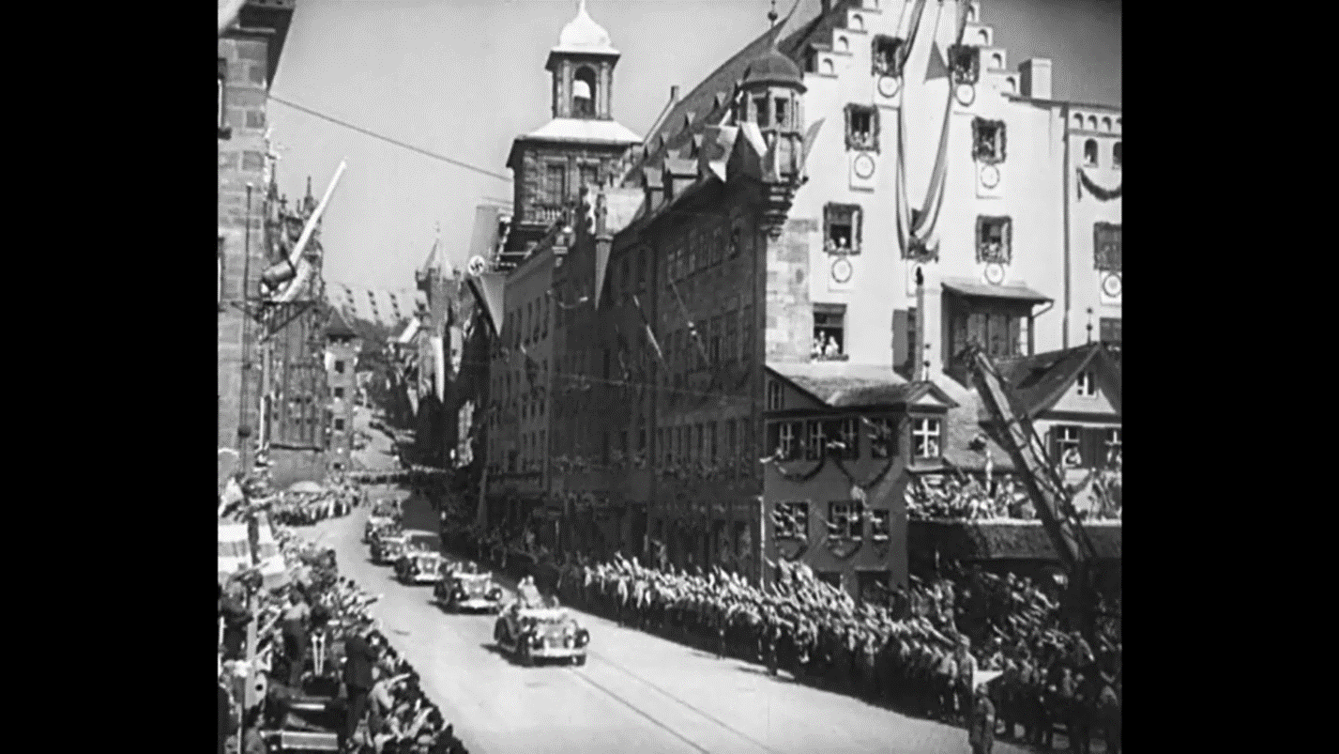
Figure 2. Hitler riding through Nuremberg (Source: Riefenstahl, 1935)
In this particular scene, it is noticeable that several people are looking out the window at the Fuhrer, driving over through the city. The reaction of people was captured, and regardless of the fact of whether or not that display of devotion was mainly a fearful response or not, the showing of devotion in the country was not an unnatural thing to see. There is also the component of the bystanders doing the Nazi salute, which means at the very list that their reaction is for the most part not forced.
The rare instances when words are used to convey something they are always simple in nature and provide no deeper understanding of the film as a whole. The same cannot be said about the Soviet side as in their case the choices of words are quite intricately placed within the film with the corresponding scenes to show the viewer that the Soviet Union is in fact superior in areas of filmmaking and as a ruling power overall. As films which are intertwined with the desires of the people which commanded their creation and ordered showing them to the masses, those pieces of cinematography are linchpins that make understanding of the two superpowers at the time much more accessible. As mentioned above, when taking a look in the past and realizing the importance of the films as propaganda mechanisms, one thing remains odd about one of them. The “Triumph Over Violence” does certainly have propaganda elements within it but, the way it depicts the actual horrors of the war and its consequences on millions of people certainly resonates with today’s mentality as well. The film is presenting the fact that animosity and inhumane acts are no way towards the creation of an ideal world. The scenes that foreshadow that thought are present in the beginning and the end of the film. And while the ending of the film does have its fair share of deceptive imagery, the core philosophy of it remains the same, which is that violence cannot bring salvation.
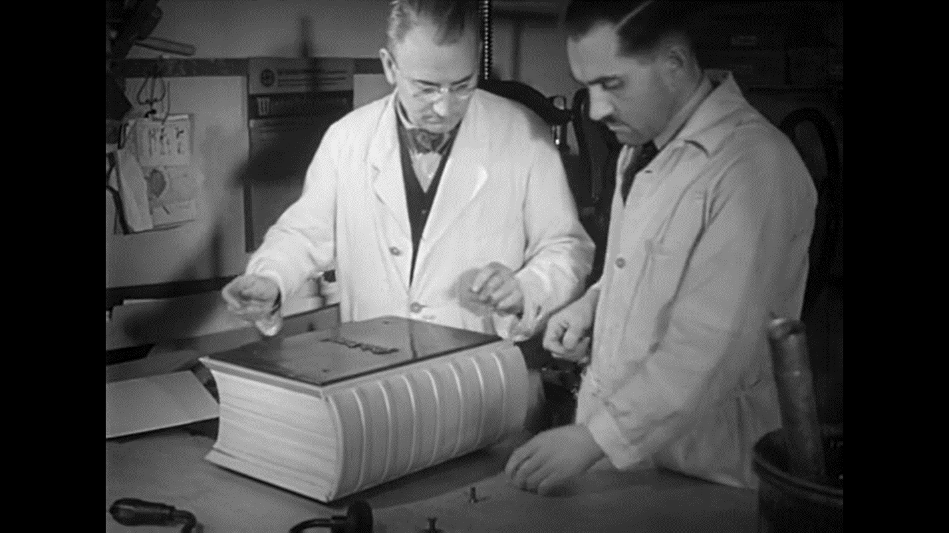
Figure 3. Making of the thousand-year version of Mein Kampf (Source: Romm, 1965)
Arguably the most important scene within the Romm film, it depicts the creation of the thousand-year Mein Kampf edition that is going to outlive even the Third Reich. This scene points at the culmination of both the propaganda and the ritualistic behaviors that accompanied the Nazis throughout their lives. Before Hitler, Germany was the philosophical center of the world, producing far more literature and commanding more influence than any country in the world. Since Hitler, the quantity of production has remained impressive, but the quality has dropped catastrophically. Almost no significant books have appeared and the most important movements have been driven out or smothered. Marxist writers and others influenced by Marxism and even intellectuals committed to trade unions or to liberal reforms were persecuted and silenced. The ban was extended further. Even philosophical schools aloof from politics were scattered. Thus, logical positivism or logical empiricism, as it is now called, fled from berlin in 1933, from Vienna in 1938, from Prague in 1939, and from Warsaw in 1938-9 (McGill, 1940). This goes to show that the Nazis were indifferent to maintaining a standard that was going to somewhat adhere to the expectations of the worldwide community. The theatrical arrangements were much more important in a sense that, they presumed that the world would be forced to listen to them anyway. Those very notions are explained within “Triumph Over Violence” through the use of exploring the sheer absurdity of their nature and their complete disconnect with, at that time, the modern worldview.
The Riefenstahl film on the other hand is simply a booklet or a brochure in moving picture form. It certainly paints the elements that need to be elevated, in a favorable light and it does not present the actual negativity present within the mindset behind the theatrical “play.” That is where the two films differ greatly from each other and how their narrative’s part ways when it comes to forcing influence. The “Triumph Over Violence” does not need to show and mock the utter absurdity of the Nazi regime in order for people to favor the Soviet Union over it. But showing the massacres of millions of people to illustrate the lack of empathy of the Nazi command, was in fact a move by the director not to push forth the view of superiority mentioned prior, but to show respect and mourning towards the people who perished. The choice of words within the film shows that side of the coin quite well and it does not let the viewer think otherwise of the representation.
The suggestive and propagandistic elements of the two documentaries lies in the monologues of the narrators and the careful positioning of the scenes within the films. It is very easy to pinpoint those areas as they are clearly playing into the desire of the respective directors. The tumultuous imagery present in the Riefenstahl film is in fact very carefully crafted and presented so that no one can doubt that every human expression in the film is forced and not authentic. The use of Swastikas in every changing shot is a heavy indication that despite the films primary effect on the conscious viewing, the subconscious influence is something which was definitely not overlooked. The scenes of the workers and the Nazi high command praising their own work and the glory of Germany, and of course the excellence of their “Righteous” Fuhrer is very eye catching in that they do not shy away of proudly displaying dictatorship presenting it as true freedom.
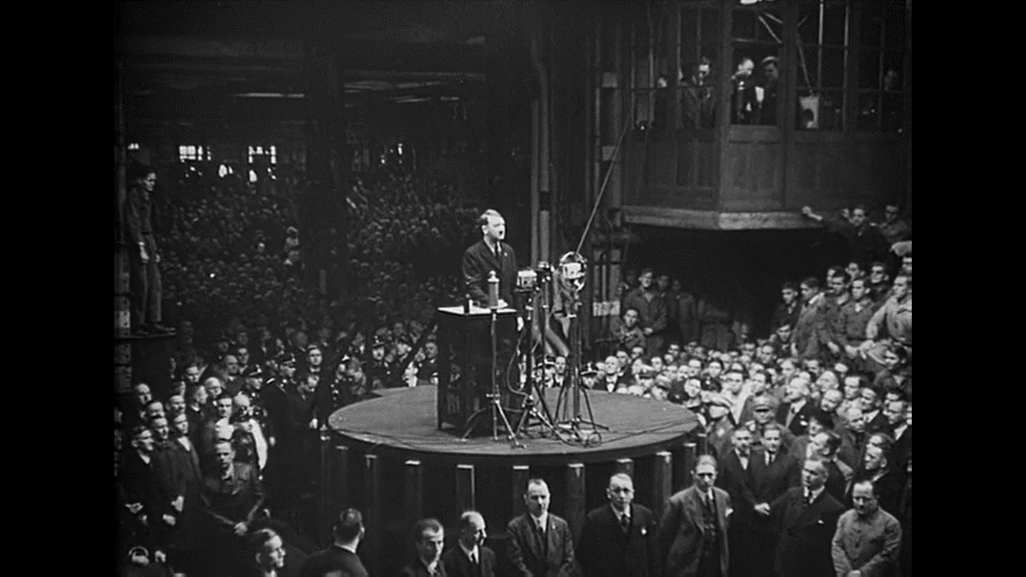
Figure 4. Hitler speaking at a factory (Source: Romm, 1965)
In this scene from the Romm film, Hitler is presumably speaking at a factory, since in the film it is not clearly stated where the meeting takes place. Judging from the majority of the people present and their attire, it can be understood that this is one of the first notable speeches of Hitler, judging also from the way he is dressed. This scene echoes to the humble beginnings of the National Socialist Party and also Hitler as initially its primary speaker. The way the scene is depicted in the film is with the notion that Hitler was carefully crafting his target audience, and it was he who was choosing people to give speeches to rather than, people choosing to listen to him.
In the Romm film the propaganda elements are very apparent but the execution of their implementation is much more subtle. Take for instance, the ending of the film where the narration heavily implies that the looming threat of another global conflict would lie on the shoulders of the American political and military machines. This particular part, although true in the sense that the American political program was navigating towards further confrontation with Soviet Union, is still propagandistic in nature as it makes the viewer stand in favor of a global system which seemingly presents freedom and peace instead of war. The ideological fallacies that are present in both films, become that more apparent when the viewer is acquainted with minute details of the ideas of both states, that the films are either describing or alluding to. Those very ideological standpoints are what the films are pointing towards when establishing a link between the narration and the perception of the audience. To suggest that both films are devoid of propaganda, since they were filmed at times when the majorities of the respective viewing populaces were convinced of the film’s authenticity, could be brought up, however that does not mean that the films were meant strictly for concentrated regional viewing. Both films are available today for any person to watch and make up their own perspective on them. And even today the reaction and analysis of the films can vary with regards to the audience, but the fact of them being quite generously littered with propaganda would most certainly not be debated. In the Romm film the sense of the narration pointing towards the erudition of the audience choosing to view that particular picture and leading towards the apparent “Realization” that the western culture and society can become just as deluded, cruel and barbaric as the highly sophisticated German culture has, is already propaganda in and of itself. Those very thoughts are imbued in the fabric of propagandistic filmmaking and if we were to scale propaganda as a benign technique, Romm’s films does an excellent job of masking it and showing once again, circumstantial evidence to back up the claims made.
When it comes to the aesthetics of a documentary film, three aspects of filmmaking need to be observed. The subject of the film is by far the most important as it puts all the other elements into perspective and it allows the audience to really focus on the most important concepts. The purpose of the film is another crucial point, as it gives the subject meaning in a bigger context of the conscious and subconscious analysis of the film. And finally, we have the actual filmmaking techniques that are used in film in order to elevate the two aforementioned categories and show the influence of their symbiotic nature. Now, as much as the subject and the purpose of the film are central in explaining the way they come across to convey meaning, focusing on the technicality is what gives the results. Now in the films of Riefenstahl and Romm the balance of scenic and explanatory scenes is mismatched as both documentaries strive to achieve meaning through suggestive imagery. In case of the Riefenstahl film wide shots of cities, landscapes and marches are used very often, in order to show the glorified theatricality that the Nazi high command wanted to be seen all around the globe.
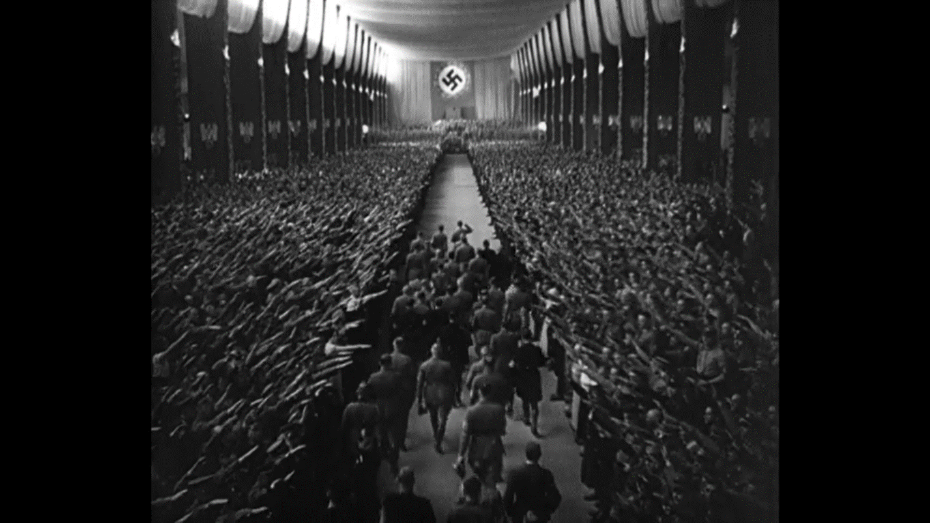
Figure 5. Hitler and Party members walk towards the Nazi flag (Source: Riefenstahl, 1935)

The above scene, happens at the end of the Riefenstahl film and it obviously plays into the aesthetic pleasing aspect of cinematography. A wide shot is chosen to show the entire crowd present. A giant Nazi flag is present in the middle towards which walks Hitler and the other members of the party. And of course, the lighting is distributed generously throughout the hall to. Once again highlight the size of the crowd and capture their movements before, during and after the speech.
When it comes to Romms film we can see that when scenes are used to display something, in most cases they are backed up by the narration that speaks about the shot either in a primary way or using a slightly skewed rhetoric of sarcasm and irony. Within both films however, one thing is certainly overlooked. That is the actual and most crucially, accurate historic information. In the Riefenstahl film, it is fairly obvious why this or that scene was favored more compared to the other, whilst in Romms film we can understand, primarily from the narration, that the viewing is for an already enlightened audience, whose goal is not the understanding of historic events, but rather the realization of the emotional aftereffect and the moral judgements that can be made moving forward. So, the horrifying scenes depicting the holocaust do not serve an educational purpose. They do however show the harsh reality by which they become the focal points of the narration and of its absence. Needless to say, that both films are quite heavy in terms of imagery, rhetoric and as mentioned prior, propaganda, even though in Romms film it is much less noticeable. Aesthetically the more “Pleasing” out of the two documentaries would have to be the Riefenstahl film, as its every aspect was done with careful preparation and meticulousness. The music chosen for it excellently implies that the themes ahead, are going to be connected with heroism and valiance. The scenes in the beginning showing the city of Nuremberg are truly remarkable for that era of filmmaking and blind devotion of people captured on film, in some strange and disturbing way does reflect the reality and the feelings of the majority of people in those times.
The seminal ideas in both films are counterintuitive in a sense that they want to achieve a certain response from the audience that would feel much more grandiose than what is shown. Both of the films visuals and meticulously crafted scenes lead people to believe that, in one case, although Germany was a force to be reckoned with, it was also a fanatically organized state that put measures that were going up the scale in terms of their extremality. And in the other example we have a portrayal of war, that for some reason does not allow us to make a logical stance on the war, and rather brings forth propaganda about the Soviet State, with the added component of trying to solidify the rightful existence of only that one power. It seems that this kind of dogmatic attempts at pushing forth the idea of absolute superiority is what ultimately decided the fate of both states. Of course, there were many instances in history that contributed to the collapse of the Soviet Union and the downfall of the third Reich, no one can deny that their suggested worldviews are integral in their eventual demise. There is also the factor of national agenda and trust at play, which factually did not correspond with the propaganda that meant to elicit a certain response. Although Nazi propaganda has only recently come to receive the attention of historians commensurate with its importance, the degree of consensus about its effectiveness is quite revealing. Historians of widely different political persuasions and approaches have testified to the crucial role it played in mobilizing support for the Nazis. Z. A. B. Zeman asserted that the growth of the NSDAP from ‘insignificant beginnings’ to a truly mass movement ‘was due to the skillful exploitation of propaganda techniques (Welch, 1993). Historians today, believe that the majority of the citizens of Germany at the time were not aware of the barbarities committed by their governing state as the foreign policy, although racist and war mongering, did not point at treating people as animals and killing them by millions. This effect was achieved through various mediums ranging from the establishment of the Hitler youth to the incorporation of eugenics and scientism.

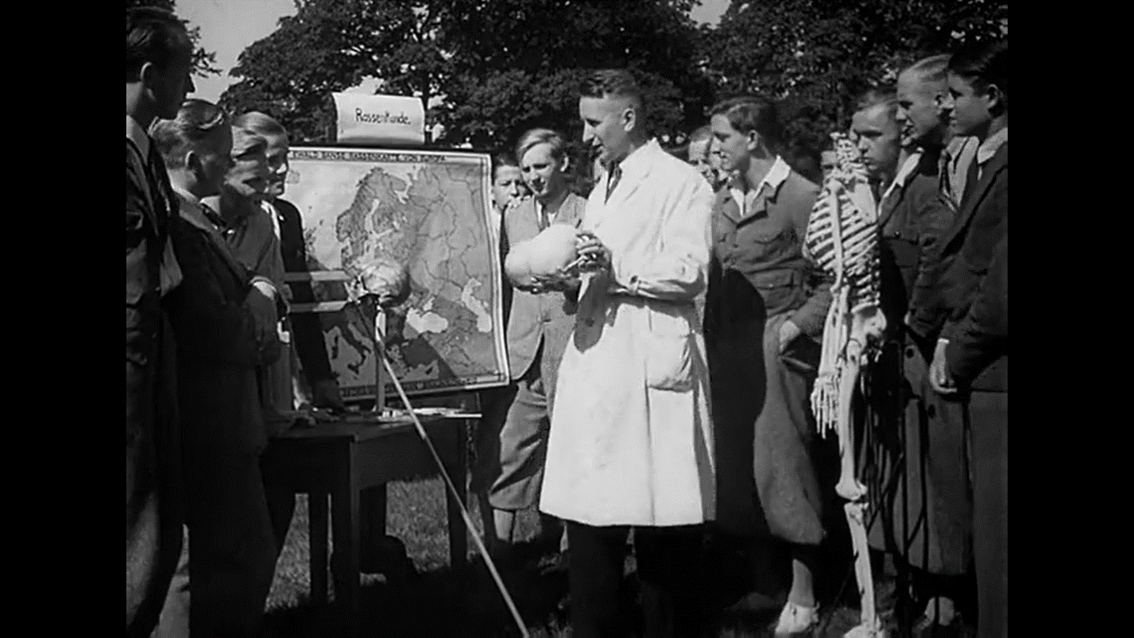
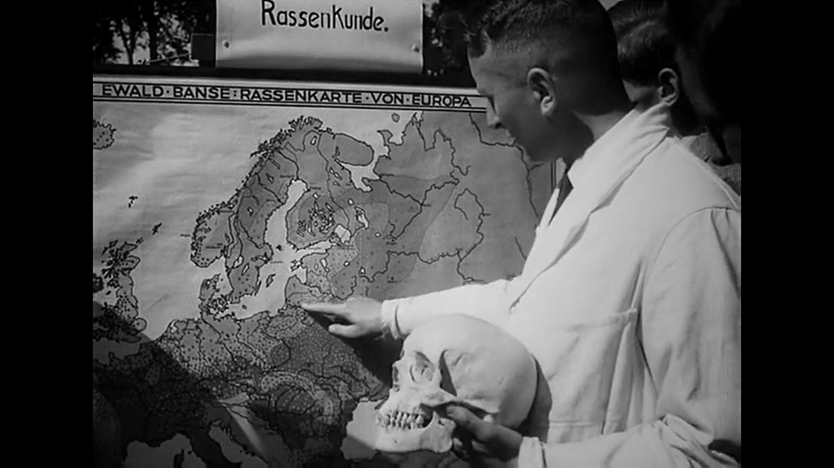
Figure 6. A pseudo-scientist explaining the difference between skulls (Source: Romm, 1965)
Figure 7. A pseudo-scientist explaining the origin of the Nordic skull (Source: Romm, 1965)

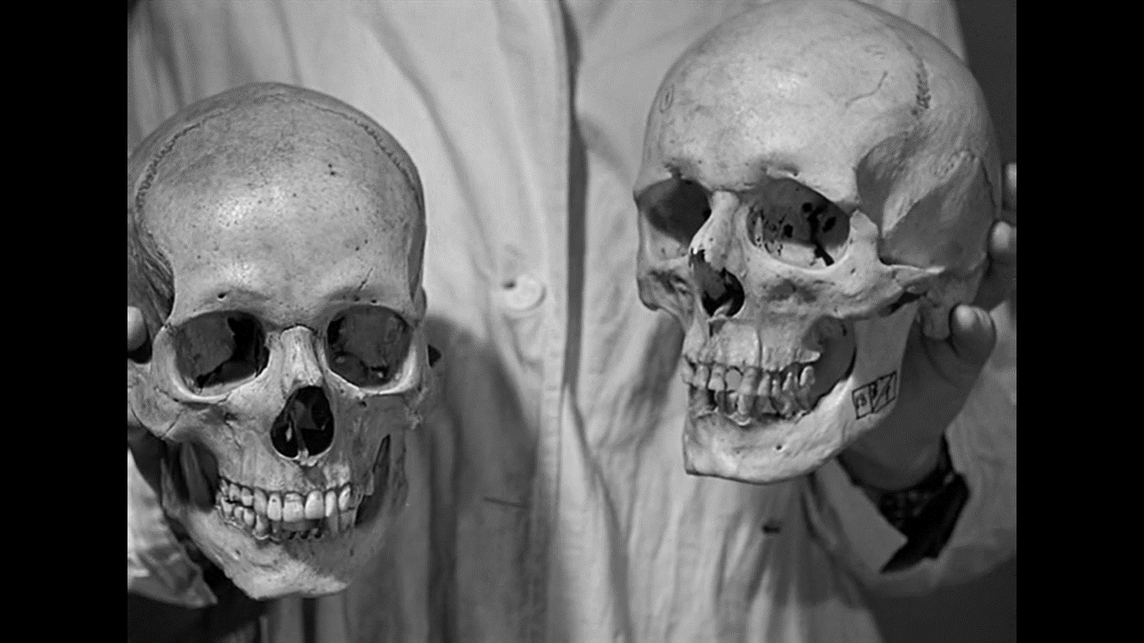
Figure 8. A pseudo-scientist holding up two skulls of different origins (Source: Romm, 1965)

In these three scenes from the Romm film depicted above, the narrator talks about how the Nazi pseudo-science organizations and supposed specialists are differentiating and teaching about the variation between Aryan skull shapes and subhuman skulls. Such opinionated viewpoints were popular amongst the German populace at the time, as they were all based on the Nazi racial superiority profiling schemes. Hitler tried to legitimize his anti-Semitism by medicalizing it, and wrapping it in the more palatable pseudoscientific facade of eugenics. Hitler was able to recruit more followers among reasonable Germans by claiming that science was on his side. While Hitler's race hatred sprung from his own mind, the intellectual outlines of the eugenics Hitler adopted in 1924 were made in America (Black, 2003).
The seeds were planted very carefully and did not leave room for further questions and pondering. The notion that history could also be read by youths or anyone else for that matter as a form of relaxation was rejected, as was also the notion that popular history should be dry and dull instructions. It served ideological orientation, nothing else (Koch, 1975). There are a handful of scenes depicting the Hitler youth in the camps playing sports and having fun. Most of the adolescent individuals in those camps, where not aware what kind of inhumane actions will be conducted on their supposed behalf and while many of them did understand what a war was, they could not have predicted how it would affect them in the future. In the Romm film those very ideas are explored, sometimes even mocked, but the underlying themes of suggestion through propaganda are still explored quite deeply. And yet nonetheless in the film, they are treated as naïve children who were forced to give up their lives and their outlook on the world in pursuit of something that was not connected with them. Those representations mentioned above point at the incongruous nature of German citizens worldviews and what they were led to believe. The Minister of Propaganda, Joseph Goebbels, whose speeches were primarily aimed at sparking hatred and disgust of the supposed enemies of the Third Reich, was also in charge of making sure the public morale and motivation for all the things suggested to them was always going in the correct direction. Compared to him Hitlers later speeches seemed foggier in meaning, although both of them had the oratory capabilities to carry on any kind of demagogy. Those strictly representative speeches that carried little to no meaning are crucial in understanding the way the propaganda actually reached the hearts of the German people.
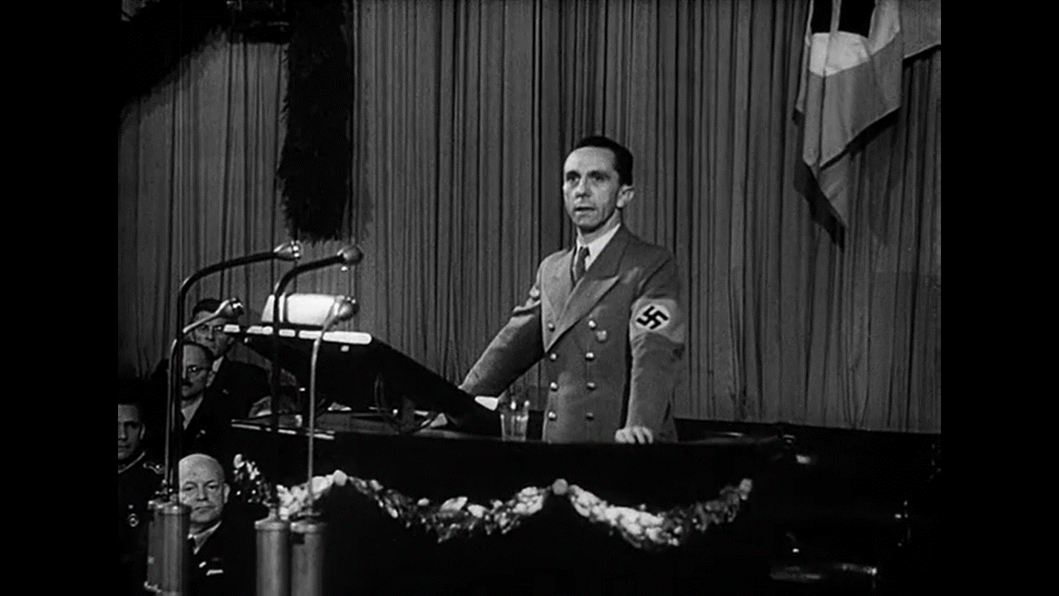
Figure 9. Goebbels speaking with the scientific community (Source: Romm, 1965)
In this scene from the Romm film Joseph Goebbels is talking to the scientific community of the Third Reich, which by the standards of those days was regarded as one of the best in the world. Ironically, the scene precedes the part where eugenic concepts are discussed and taught, which paints a really representative picture of the scientific community as well as of Goebbels as the Minister of Information.
After the loss in the First World War, Germany was in shambles, trying to live through any way it could. That invoked a certain response in the form of mockery, where Germans were ridiculed for their actions and were treated quite badly. That points at the lining of how the hatred started to develop as German people grew more and more impatient with the remarks thrown their way. Hitler specifically chose the Jewish community to despise not primarily because the communist uprising was going on in Germany, and not for the fact that Marx and Lenin were Jews. He chose to do so because Jewish people were actually hard-working wealthy people in Germany, which eventually worked as a catalyst against them. We must not forget that all wars are in most cases are economically and financially driven conflicts that result from new dictatorial regimes not being able to carry on ruling because of economic instability. So, the mass murder of Jews was not only based upon supposed racial superiority it was also for the financial “Wellbeing” of the German society. The amount of jewelry, furniture, gold and other valuable belongings that were snatched from the Jewish population proved to keep the Reich afloat for a certain while, enough actually to have the Olympic games hosted.
And so, the war was needed to continue the practice of stealing people’s valuables to ensure that the state prospers. That was in fact the initial philosophy of the German state which was hidden under the curtain of “Liberation.” That concept of giving people freedom was the reason some groups, like the Bandera faction, were created. The film explicitly shows this depiction in the scene where after Hitler speaks, the soldiers yell praise for him, for Germany and for National Socialism. In the Romm film that exact scene is mocked pointing at its theatricality and the supposed circus like contraption of the entire setup.
Another important component that needs to be closely inspected is the cult like nature of the Nazi state. When closely inspecting the scenes in the Riefenstahl film, we can see that a lot of attention is given to the specific rituals which would commence under the orders of superiors and the authority in general. The carrying of the swastika, the various greetings and the answers to them, the insignias present on army uniforms. The most infamous of the marks, except for of course the swastika, would have to be the skulls present on the SS uniform.
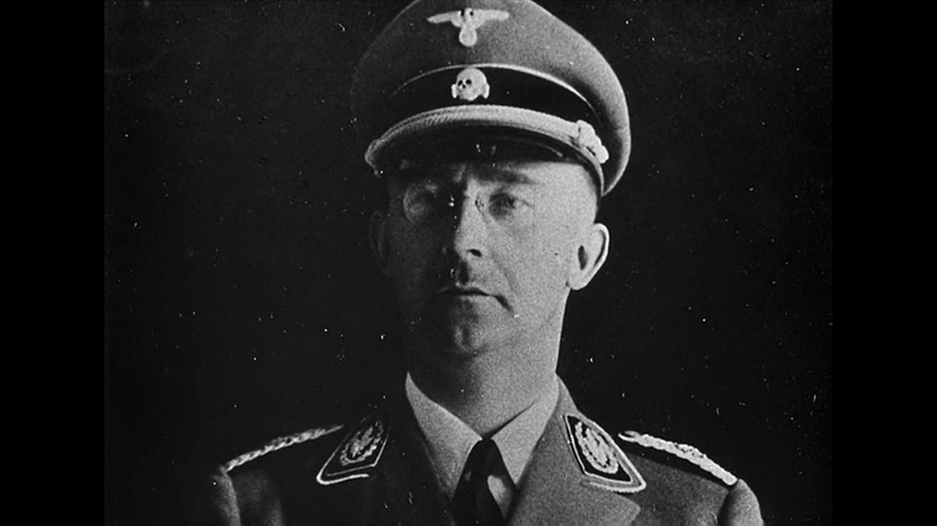
Figure 10. A photograph of Heinrich Himmler (Source: Romm, 1965)

Above is the picture of Heinrich Himmler, the leader of the SS and the creator of the concentration camps. Known as by far the most ruthless amongst the Nazi high command, he proudly wore the Totenkopf, or the “Skull of Adam” as it is more popularly known. It is considered by many historical analysists to be a departure from the heroic and valiant representation that the propaganda wanted to show. The Totenkopf represented both death and defiance in the face of death, which suits a man like Himmler a lot. The head of many eugenics’ programs and the overseer of many of the concentration camps, Himmler was truly unaffected by the suffering of others and carried out the sentences and torture of thousands of people in order to ensure that his ideals were kept high.
In December 1935, Heinrich Himmler established an SS agency designated as Lebensborn, or the “Well of Life” society, ordering it to perform a twofold task: to administer welfare assistance to SS families having a large number of racially valuable children; and to extend maternity and child-care facilities to expectant mothers, whether they were married or not, if they could prove the biological excellence of their expected children. Even with the emphasis placed on racial value as a criterion for Lebensborn involvement, the agency might appear to have been a curious blend of an SS “fringe benefit” combined with a charitable SS gesture toward unwed mothers. In reality, Lebensborn functioned as one unit within a comprehensive eugenics policy begun earlier in 1931 when the Reichsführer issued his famous “marriage decree” to the SS (Thompson, 2008).
There is also the way many things were branded, with fiery remarks and intriguing sounding names. Compared to the Nazi regime, the Soviet Union did not even come close to realizing such a deep cultural background, albeit completely fabricated. The only true “Sign” the Soviets had was the red star and the name the red army. Other than that, the Soviet army had a regular composition that was akin to other militaries present at that time in the war. Most of those “Props” that the Nazis had and used quite effectively, were borrowed from Italy and specifically from Mussolini. Even the Nazi salute is derivative of the ancient roman greeting which the Mussolini army adopted for their own purposes. And all of this goes to show that superiority was decided upon initial military might in those days, as no one garnered as much attention in the 1930s as the Nazis. Most of the popularity that the Nazis procured, has to be accredited to Radio broadcasting both within Germany and outside. During the democratic period, when the Weimar government introduced progovernment political news, the growth of Nazi popularity slowed down in areas with access to radio. This effect was reversed during the campaign for the last competitive election as a result of the pro-Nazi radio broadcast following Hitler’s appointment as chancellor. During the consolidation of dictatorship, radio propaganda helped the Nazis enroll new party members. After the Nazis established their rule, radio propaganda incited anti-Semitic acts and denunciations of Jews to authorities by ordinary citizens. The effect of anti-Semitic propaganda varied depending on the listeners’ predispositions toward the message. Nazi radio was most effective in places where anti-Semitism was historically high and had a negative effect in places with historically low anti-Semitism (Adena, 2015).
Back to the topic of Italy. The other interesting difference between Italy and Germany was the fact that Germany was a treasure land full of natural resources, such as an abundance of coal. The film explicitly does not demonstrate that very obvious advantage of Germany over other countries, as if to indicate that the actions of the German Reich speak for themselves. The Romm film does not mention this fact either, which indicates another possible layer of propaganda, which is meant to elicit the notion that the soviet state did not concede in any way to the Germans. The film does however, have time to laugh at and mock Mussolini, which was not uncommon as everyone in those days thought that his overall character was hilarious at best.
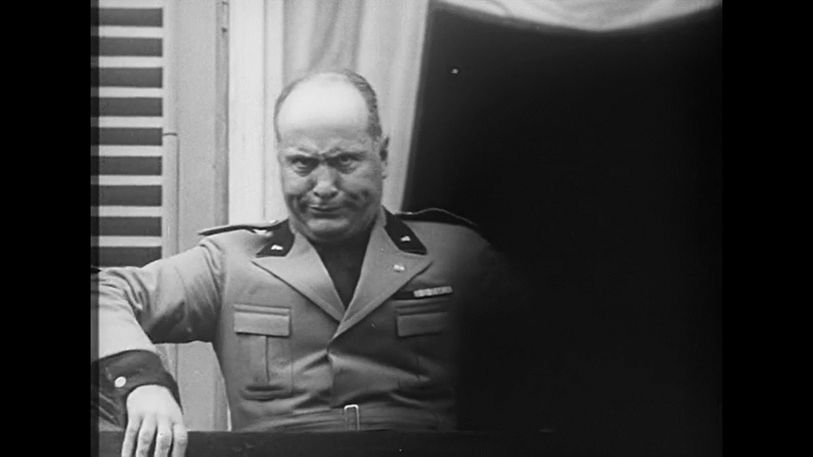
Figure 11. A shot of Mussolini on the balcony (Romm, 1965)
In the above scene, taken from the Romm film, Mussolini is mocked and made fun of, for his antics, when speaking to the crowd. The film also mentions an important historical factor, which relates to half of the scene, having been blackened out. The man standing on that side of the balcony, who is not visible, is Victor Emmanuel the third, the then monarch, king of Italy. Mussolini presumably hated him for many things, such for example his height. Historically the king was forced to give Mussolini power due to him amassing more and more followers and becoming very prominent amongst the Italian populace.
Conclusion:
When looking back at the conflict with all of the details regarding its conception, its duration and the eventual outcome, one thing becomes clear. Both the Nazi regime and the Soviet Union were states that demanded allegiance to their ideals and most importantly to one figurehead, that was placed in charge. The similarities between those ruling parties are so striking in fact, that to this day many political-historical analysists cannot give a conclusive answer regarding the nature of the Nazis. Where the Soviet Union kept clyster clear to its ideology the, National Socialist party has remained ambiguous as to its allegiance either to the political left or right. That question may never be answered to completion, but one thing remains certain. The states were mirroring each other throughout the entire course of their existences.
Regarding the paper and the analysis which I have done within it, I believe that by looking upon the documentary films that I have chosen the socio-political, psychological and ideological elements of the Nazi state in particular becomes easier to understand overall. The Nazis did not really want to hide anything from the world, and have made their actions fathomable for every person who lived in those times. That and of course the scale of the conflict, are the reasons the vast majority of people know the word Nazi and the name Hitler. History and fate have collided and put the second world war, as the crossroad not only for humans in those times to choose which direction they would prefer to go, but also for people today to realize why those events need to always remain unforgotten. The war and its outcome are why we live today in the world we know, and why people have to realize the importance of “Today.”

References:
McLaine, I. (1979). Ministry of Morale: Home Front Morale and the Ministry of Information in World War II (1st ed.). Routledge. https://doi.org/10.4324/9781003190646
Suleiman, S. R. (1970, January 1). Susan Rubin Suleiman, crises of memory and the Second World War. PhilPapers. Retrieved November 19, 2021, from https://philpapers.org/rec/SULCOM.
Fussell, P. (1990). In Wartime understanding and behavior in the Second World War. essay, Oxford University Press.
Suleiman, S. R. (2012). Crises of memory and the Second World War. Harvard University Press.
Rees, L. (2021). In Hitler and Stalin: The tyrants and the Second World War. essay, Public Affairs, Hachette Book Group.
Rees, L. (2021). In Hitler and Stalin: The tyrants and the Second World War. essay, Public Affairs, Hachette Book Group.
Mann, Y. (2013). The Leningrad Blockade, 1941–1944: A new documentary history from the Soviet Archivesby Bidlack, Richard and Lomagin, nikita. The Journal of Slavic Military Studies, 26(4), 723–725. https://doi.org/10.1080/13518046.2013.844564
Keneally, T. (2019). In Schindler's ark. essay, Sceptre.
BEEVOR, A. N. T. O. N. Y. (2021). In Stalingrad. essay, LITERA MEDIA GROUP.
Aleksievich, S., Pevear, R., & Volokhonsky, L. (2018). In The unwomanly face of war. essay, Penguin Books.
Tobias, F., Pomerans, A. J., & Tobias, F. (1964). In The reichstag fire. essay, Putnam.
Ryan, C. (1994). The last battle: The classic history of the battle for Berlin. Simon and Schuster.
Propaganda as vision: Triumph of the will - logos. (n.d.). Retrieved May 11, 2022, from http://logosjournal.com/kelman.pdf
Kivelson, V. A., & Neuberger, J. (2010). Picturing Russia: Explorations in visual culture. Yale University Press.
Brearley, M. (1988). Hitler and Wagner: The leader, the master and the Jews. Patterns of Prejudice, 22(2), 3–22. https://doi.org/10.1080/0031322x.1998.9969950
Golomb, J. (1997). Nietzsche and Jewish culture. Routledge.
Guilford Press. (1989). Science & Society: General index volumes 26-50 (1962-1986/87).
Welch, D. (2006). The Third reich: Politics and propaganda. Routledge.
Black, E. (n.d.). The horrifying American roots of Nazi eugenics. History News Network. Retrieved May 11, 2022, from https://historynewsnetwork.org/article/1796
Thompson, L. V. (1989). Lebensborn and the eugenics policy of the reichsführer- SS. The „Final Solution“, 601–624. https://doi.org/10.1515/9783110970470-014
Adena, M. (2013). Radio and the rise of the Nazis in prewar Germany. Centre for Economic Policy Research.
Triumph of the will. (1934).
Triumph over violence. (1965).

