THE TECHNIQUES THAT RESTAURANTS USE TO ENGAGE NEW CUSTOMERS THROUGH SOCIAL MEDIA MARKETING

by

Yana Baghdasaryan

Presented to the Department of English & Communications in Partial Fulfillment of the Requirements for the Degree of Bachelor of Art

American University of Armenia
Yerevan, Armenia
May 21, 2021
OUTLINE
Introduction 3-6
Literature Review 7-10
Research Question 11
Methodology 12-23
Research Findings & Analysis 24-31
Limitations and Avenues for Future Research 32-34
Appendices 35-37
Bibliography 38-39

Introduction
“In social media, every customer is a reporter”, - Jay Baer. Nowadays social media has become a very strong weapon for different businesses, in one second the business may be maligned as well as praised. Most of the time customers leave feedbacks on social media platforms and those feedbacks may influence the service of the business. Some leave those feedback, others enter social media platforms to check on the reviews, before visiting. That is the reason that Jay Baer mentions that every customer is a reporter. In the 21st century, people have noticed vast improvements in technology and innovation in the field of the internet. The main source for people became social media. Social media helps consumers to get information about the different services as well as products. Nowadays, every single individual uses social media to make their lives easier. Last but not least, the restaurant sphere is very developed on social media platforms, as people reserve tables, order food, and give feedback using social media platforms. This paper aims to concentrate on techniques that restaurants use to engage new customers through social media.
So, as it is known social media marketing represents an intelligent strategy to engage customers, moreover to build influence. Nowadays, developing a website is essential for every kind of business. If the business is not active in social media it risks missing out on great opportunities. There are a huge number of advantages that social media marketing can bring to the business, such as factual relationships. Effectively communicating with your clients in online networks and groups, and by actively utilizing hashtags on social media websites such as Facebook, Instagram, and Twitter brands raise awareness and become widely available for the public.
I think that this topic is worth research as, nowadays because of the COVID19, people (customers) feel more connected with social media. They have plenty of time, which they waste on social platforms, such as Facebook, Instagram, Twitter, Youtube, and Telegram. On the other hand, restaurants are using their social media platforms to make themselves more popular. They even post pictures about their best seller dishes; to make those dishes known.
To take advantage of the situation that I visited the USA, I decided to compare two countries' social media marketing techniques. Below is my paper, I am going to state the techniques that use the restaurants in Armenia, as well as a restaurant in Palm Springs. The restaurant, which I chose from Armenia, is the restaurant of Baklachoff collection “Chaihona”. I was thinking about different Armenian restaurants and was trying to find the best one for this kind of research. So, to understand which restaurant will fit into the topic, I started to examine social media platforms of the known restaurants in Armenia, such as “Malocco”, “Pesto”, “Coza Nostra” and a lot other successful restaurants chains. As well as I examined the social media pages of the “Baklachoff” collection that has two restaurants for now “Chaihona” and “Patricks”. I noticed that this restaurant chain is very successful, meanwhile very active on social media. So, it became interesting for me to analyze whether social media has so much effect on the restaurants’ success. To go into details, why this restaurant has been selected is that it’s very known, mostly for tourists and youth. It has a great location, which is in the heart of the center, more concrete it is situated in the northern avenue, which is nowadays a tourist visiting place. The restaurant is rich by its cuisines, as it has almost a single dish from various cultures, so it gives its customer’s a chance to try different culture’s kitchens. Customers mostly like the fact of sitting in Armenia, feeling like in Georgia or Italy. About the social media platform, I would like to mention Instagram on which “Chaihona” has 14 K followers, which is a great amount for business platforms. The restaurant which I chose from the U.S.A. is in Palm Springs, the name of which is “Farm”. As I researched the Armenian restaurant, I did the same for the restaurant in the U.S.A., at first I was thinking about choosing “Catch LA” restaurant, which is the most famous one in Los Angeles. When I searched for the restaurant, I got amazed as I couldn’t find them on any of the platforms. This was a surprising fact as I never thought that a restaurant like that may not have a social media page. So, I eliminated “Catch LA” from the list and started to examine the page of “Farm”, which as I mentioned is situated in Palm Springs. As I had a chance to visit them and I saw the number of customers they have every single morning, I got interested in their way of managing their social media platforms. The reason for choosing especially this restaurant is that it’s well known luxurious restaurant known for its tastiest breakfasts. As it is known, Palm Springs is a desert resort city in California; people living in Los Angeles frequently visit Palm Spring as a vacation and resort city. So, the “Farm” is situated in the center of the city, where again most of the tourists visit, comparing with “Chaihona”, “Farm” has more, not eye-catching entrance, so in order to find “Farm” one has to know the place. On its Instagram page, they have 5K followers, which to be frank is a small amount for that kind of known restaurant. So I have two restaurants that appear to be very different, and after analyzing their social media pages I got more interested in studying their techniques. Both are very popular in their regions but are very different at the same time. So, it will be an interesting topic to discuss and cover. There are number of reasons why this topic is an interesting one, first, it is interesting to understand whether the numbers of followers on those two pages have a real influence on their customer engaging progress. Second, it is quite interesting to find out if the social media platforms have an overall role and influence on the customers, and finally, we look to understand how differently do restaurant social media platforms work and plan everyday posts. I planned a few techniques, which I will use for my research, of course, I am going to discuss the resources which I used, below in the literature review section, in the methodology section I am going to discuss how I interviewed both of the social media marketers of the restaurant, as well as I will state about the survey, which I did with the customers of both of the restaurants.

Literature Review
The study by Tuten and Ashley called “Creative Strategies in Social Media Marketing: An Exploratory Study of Branded Social Content and Consumer Engagement” is a content analysis of the social media content’s creative strategies that top brands utilize. The method of content analysis that has been used for the study aimed at gaining content information about the branding efforts on social media (Tuten & Ashley, 2014, 20). The authors of the study had a disciplinary, global perspective. Authors took a sample of 100 brands that the Interbrand’s Best Global Brands valuation study listed, then filtered out those brands with a social media excellence according to the report Engagementdb or Forester Groundswell Awards (Tuten & Ashley, 2014, 20).
The study emphasizes how branded social campaigns add value to consumer relationship management in the company. That is, it highlights the idea that the sole knowledge of social media usage is not enough to maintain interconnection between the brand and its customers. The study evaluated which social media channels those top brands utilize to be recognized, appeal with their message to the society, and which strategies and tools they integrate into their social media channels to attract customers.
This study crucially addresses my research question. It discusses the influence of branded social campaigns and creative strategies that brands can utilize to attract customers and maintain a loyal customer base. The literature gives me ideas and perspectives on how brand-specific campaigns and creative strategies can be used in the restaurant industry to attract new customers.

The study by Tafesse called “An Experimental Model of Consumer Engagement in Social Media” is a content analysis of the experimental model of consumer engagement centralized on social media pages of brands on Facebook. The method of content analysis that has been used for the study aimed at synthesizing the Facebook brand pages’ affordances of experiential nature in line with epistemic, perceptual, embodied, social qualifications, and focused on testing what impact these Facebook brand pages have on consumer engagement (Tafesse, 2016, 424). The author of the study had a disciplinary, local (UK) perspective. The author took a sample of three industries, including Top 50 Cosmetics Brands 2013, Top 50 Auto Brands 2013, and Top 50 Spirit Brands 2013, that Brand Finance brand consultancy firm listed. The author then used those brands for external brand ranking in order to complete the research of social media and derive analysis (Tafesse, 2016, 428).
The study points out that brand-generated content are the widely-used one that leads brands to successful customer relationship management through social media. That is, through brand-generated content, brands interact with customers through likes and comments, which creates the connection between the brand and the consumer. The experimental model of consumer engagement that brands use provides brands with the opportunity to connect with customers, as well as attract new customers through technical capabilities of social media, hedonistic motivation, voluntary engagement with brands’ social media pages.
This study crucially addresses my research question. It discusses how brand-generated content and the experimental model of consumer engagement helps brands attract new customers and maintain strong customer relationship management.

The study by Bennett called “Marketing Strategies: How Small Restaurant Businesses Use Social Media” is a multicase analysis of top marketing strategies that small restaurant businesses use in Western North Carolina (WNC). The qualitative research method was used for the multicase study that integrated interviews, documentation, and observation aimed at understanding perspectives, experiences, and thoughts of people to analyze how these five most successful small restaurants’ social media strategies were interconnected with the customers (Bennett, 2017, 42). The author of the study had a disciplinary, local (WNC) perspective. The author took five small restaurant businesses established in Western North Carolina. Then the author used those small restaurants to analyze how successful social media strategies added value to the business growth, customer relationship management, and increase of employment (Bennett, 2017, 40).
The study provides an analysis of small restaurant businesses’ social media strategies through the 5-step analysis plan of Yin. Social media platforms, including Facebook and Instagram, are the focus of the study as widely used social media platforms. The study brings up the problem of small restaurant businesses being afraid of getting into the social media marketing world. However, in line with that, the study lists and analyzes the strategies that small restaurant businesses use in social media marketing. As a result, the study introduces three significant themes within the five small restaurant businesses’ social media strategies that aid the success in customer relationship management, including the widely used social media platforms, word-of-mouth, and challenges to ignore for successful implementation of social media.
This study crucially addresses my research question as it discusses how small restaurant businesses attract new customers and maintain strong customer relationship management through effective social media strategies. The information that the study gives is useful for my research paper as I can analyze which social media platforms are the most suitable for local restaurant businesses, how word-of-mouth may affect the customer engagement process, as well as how it is possible to ignore the challenges that may arise during the implementation of social media in the restaurant industry.
The study by Baldus called “Leveraging Online Communities to Support the Brand and Develop the Community” is a longitudinal study of the degree to which brand and community outcomes are affected by marketers and marketing activities along with online communities that have community member motivations. The method of a longitudinal study that has been used for the research aimed at finding out whether a wide range of online communities affects the brand and community outcomes positively or negatively (Baldus, 2018). The author of the study had a disciplinary, local perspective. The author took a sample of 256 members from 3 different industries that represented nine different marketing research online communities. The author then used those marketing research online communities to analyze how they affect the brand assessment, community-supportive behaviors as well as brand-supportive behaviors (Baldus, 2018).
The study emphasizes the importance of giving customers activities that satisfy their wants and needs. That is, it highlights that the consumers of a particular brand should be the focus of the brand. In that way, the brand gets the opportunity to research the target market, understand their motivations to be with the brand, and give them things that will definitely either meet or exceed their expectations.
This study marginally addresses my research question. It discusses how important it is for the brands to take into account what motivators their customers have and what the wants and needs of those customers are.
Research Question
My primary research question is “How do the techniques of engaging new customers through social media marketing in the restaurant industry differ from country to country?” As I mentioned above there is going to be a comparison between an Armenian restaurant and a restaurant in Palm Springs. I would like to find out what are the main differences of the techniques that the restaurants use.
My secondary research question is “How did the social media platforms influence the customers? From a restaurant's point of view”. What I mean by this is that a lot of customers pay a lot of attention to the reviews of the restaurants. I would like to understand how they work and how do they smoothly make the customer write a review. A lot of people may like the restaurants a lot but the customers always forget about writing down about their feelings.

Methodology
The type of research I did
This chapter of the paper shall discuss the research methods that were available for the study. This part discusses the ways which have been used to gather more information on the field. The methodology section will discuss the types of the research, the design and visuals used for that research, the way the data has been collected, the way the data has been analyzed, the tools and materials used for the research, as well as the rationale for choosing specifically those research methods.
Besides the bibliography part, it was very interesting to do real life experiments and methods to find more about the restaurants' usage of social media to engage new customers. As the paper discusses and compares two restaurant’s social media usage from different countries, the research had to be the same for both of the restaurants.
First of all, as a research method, it has been decided to make a survey for both of the restaurants. If there was a chance, it would be great to visit both of the restaurants and ask the manager to give the survey, so customers throughout the day may give feedback on social media usage.
Why surveys?
At first, it was decided to make face-to-face interviews with the customers. In order to find out their opinion on the usage of social media of their favorite restaurants. On the other hand, a lot of people may be shy to give interviews and feedback sitting in restaurants, while the waiters may hear of the going conversation. In that case, many customers could give positive answers in order to seem loyal. So, anonymous surveys became the best choice for this kind of research.
As the second part of the research, it has been decided to make interviews with both of the social media managers of the restaurants. The interviews planned to consists of a few questions to which the managers will answer about the organization of the social media platforms.
Why interview?
A face-to-face interview is the most important for research as whenever a person is sitting in front of you and you ask him/her a question, he/she does not have enough time to think of a correct answer, whether that correct answer is lying. So consequently, the person is answering your questions with the most honesty. As well as a lot of other personal qualities are being noticed during the interviews such as communication skills, confidence level, and social behavior.
How was the materials constructed? (Questions)
As it is mentioned above, two methods have been used for the methodology part. It is important to have at least one method for both of the sides: customers and specialists. In order to learn about two different points of views two different methods have been used. The first one is an interview with social media specialist and the second one is the survey with customer which has been done in two ways. The two ways are going to be analyzed below in the second section. This section is going to analyze more thorough the methods including the selection of the question which had been asked.
To start with the interview, that was planned to do with both of the social media marketing specialists of the restaurants. There were five questions to which the specialists answered. To go more thorough into the question and why were those questions created I would rather speak about the questions one by one.
The first question is “Which social media platform do they use?”
As there are number of social media platforms such as “Facebook”, “Instagram”, “Twitter”, “Youtube”, “Tik Tok” and a lot other, it’s interesting to understand why those platforms are more important than other ones. This question is one of the most important ones, as it is important to realize which social media platforms do specialists find more effective. Moreover, which platforms do they find to be customer engaging. Throughout the time the platform’s activities are changing and different platforms are becoming trendy from time to time. Every individual has its own understanding of those trends, so this was another part to see what they think about nowadays trendy platforms. that will help to invest the money on social media promotions in a right way, be it influencer marketing or online advertisement. Moreover, as every post requires unique approach based on the platform, it will give a better idea on how the content should be planned and executed.
The second question is “Why do they prefer especially those platforms?”
This question was developed having the expectation that specialists may have the chance to speak more about their selected platforms and give reasons why do they prefer especially those. As it is known every single social media platform has its own style. For instance “youtube” is created for short videos, blogs and films. “Twitter” has the style of writing tweets, which are texts containing different kind of information. It may include the users thoughts, ideas, announcements, as well as people can retweet each other, which means sharing. “Instagram” has the style of creating a beautiful and eye-catching feed, which means having a good home page, where pictures correlated with each other. Another popular platform is “Tik Tok”, where people post short funny videos from 15-60 seconds. So, the main purpose of this question is to understand what kind of information has to be posted on social media platforms and whether specialists prefer videos, pictures, humor or beautiful home pages.
The third question is “How do they find their target audience?”
As the data shows, every single social media platforms have different percentages of the age range of people. As it is mentioned “Tik Tok” has the youngest age range of users from 11-20 years. Majority of the users are teenagers and children, minority are adults and old people. “Instagram” is in the middle as it has both 50% of teenagers and 50% of adults. In the third place stands “Facebook” as it has more adult users than teenagers. So, this question has been planned to ask, as it is interesting to determine which age range customers the specialists see in their restaurants. As well as it is interesting to find out whether specialists do take into consideration the age range customers who use the platforms, or they work on all people of all age range. On the other hand this question has the expectation to find out whether do the specialists find their customers themselves or the vice versa. For example, if the restaurant is having special healthy food offerings, what do they do in that case? There are four different steps they can use. The first one is posting a picture or video where they include the whole information about that specific dish or offer and just wait for their followers to react. The second step is that they can post the information online, meanwhile work on the oral spreading of the information which is known as a marketing tool “word of mouth.” In this case, one person is enough to speak up about the special offer, and the message will get spread from one person to another in continuous manner. The third step is that specialists may activate a paid advertisement, where they have a chance to select specific target audience of gender, age range, lifestyle and food preferences (fast food, healthy food). The final step which they can use to engage new customers is the most time consuming, as specialists may send specific informative texts to their target audience, and wait for their responses.

The forth question is “What kind of posts do they prefer to make?”
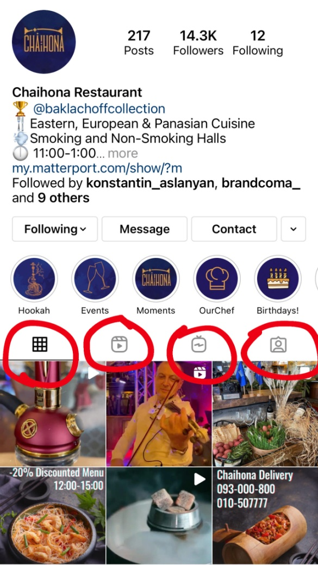
Based on my research, it has been found out that from ten different restaurant pages, every single prefers specific posts which they assume to be effective. For this part of the paper, I would like to present the categories of the posts and stories that social media marketers use to engage new customers. To start with the post category of the posts, there are photos, videos and reels, and IGTV videos.
Here you can see four sections in the red circle, the post section, the reels section, the IGTV video section and the last one which is reposting section. Whenever anyone mentions the restaurant’s page those picture are being added to that section.

The pictures of the restaurant pages most of the time are pictures of the food and a beverage which is a long-lasting photoshoot, as it’s important to get the right lighting for the dishes. It’s believed that those pictures can make people hungry. After taking pictures, the professionals have to edit the pictures, during which, they add effects and the majority add texts such as best offers, special day’s event or just a quote.
As for the part of the picture, it is often noticed that the restaurant pages post pictures of their restaurant atmosphere and design. The reason for that kind of post is sending vibes to their customers and to those who look at their social media pages. The atmosphere is an essential factor for a lot of people, as people want to listen to relaxing music, sit in comfortable chairs and sofas.
As well as, a lot of people want to be surrounded by many people, they want to see new people and be seen. So, posting pictures of the atmosphere of the restaurant is another way to engage customers.
To state about videos, there are three types of videos which are mentioned above, videos which are limited and the limit is 1 minute, videos which are called reels and have a limit of 30 seconds and the final one is IGTV videos, which completely do not have any limit. Every single of three has specific sections on Instagram so it’s easier for the viewers to find the video types. The first type of the videos are limited to 1 minute, this kind of videos are used to create, atmospheric videos, advertisement videos, processing videos. For the atmospheric ones, there is nothing to add. For the advertisement videos, it’s again a long process to make this kind of video. This may be a girl entering the restaurant ordering one of the best seller dishes, seeing there her friends, and having an amazing time. These kinds of video is being posted not very often, mostly are posted from season to season.
As for the processing ones, it’s become a new trend, to post how a specific dish or cocktail is being prepared by the waiter or a bartender. The processing videos mostly are the reels, as the videos are short and posted with music. The reels videos are either processing ones or atmospheric ones. To speak about IGTV video, they are long and may include anything. From the restaurant pages, I noticed that there are interviews with the customers, feedback videos, and advertisement videos that are longer than 1 minute.
For the story part, it’s a photo or a video that disappears in 24 hours. Although for the story, there are a lot of other functions which restaurants use to increase activity. The first thing to mention is the location function. While posting a photo or a video as a story both customers and social media marketers have the option to mention their location which is the name of the restaurant. So, it’s a good way to make the viewers see the name of the restaurant very frequently. Psychologically, the viewers get used to the name and start to feel some kind of connection. As well as the customers mention their location and make their personal followers see the name of the restaurant. The second function is the hashtag, which SMM specialist use in order to select specific categories for food and beverages. So, whenever they post a dessert picture with ice cream they put the hashtag and write ice cream so those who are interested in ice cream can find them easier through the hashtag. The third function is the music function which allows the users to select any kind of music and add music to the videos and photos this is again another way to catch the eye of the viewer through the music. The fourth function is the poll, where they have a chance to put yes or no questions or just a question with two option answers so the viewers may select one of them this again raises the activity of the page. The fifth one is the “ask me a question” function which gives the chance to the viewers to ask them questions so the specialists write a question and leave a space for them to ask questions. The sixth function is the countdown which is mostly used for events so whenever the restaurants have upcoming events they post the countdown for that specific date so the customers will become interested in what is going to be on that date. The last function for the “story” is the reposting function. This is done whenever someone mentions you on their pages; the restaurant's page has the opportunity to repost that story. This function is the most time-consuming.

The fifth question is “How frequently do they post?”
Having followed a lot of restaurant pages, it has been noticed that a lot of specialists working for restaurants sometime exceed the limit of posting, sharing and stories which is having negative effect. On the hand there are restaurants who do not even hire a specialist for online platform development and they post pictures very rarely and not professionally, which again have negative impact on their customers. It’s believed that there is an ideal frequency for posting for each platform that specialists take into consideration. As well as it depends on the restaurants style and every specialist has to find his/her own frequency limit which is believed to be ideal. So, this question aims to understand whether the specialists tried specific techniques about the frequency of the posts. Moreover, to find more about what their experience taught them, as it is important to keep followers engaged and informative. Another interesting point to discuss is the scheduling of the posts, more thorough during the day which time is the most influential. Thinking logically, all of the people are free after 6PM, which is the end of the working time, and at that time majority of people tend to use social media platforms for different purposes and they show more activity in the evening hours. So, it’s interesting to determine whether this point is important for the specialists, do they schedule their posting for an evening time or their do not have that kind of limits.

How was the materials constructed? (Questions) survey
I decided that the survey will be more concentrated on the customer feedback, so the survey had to be given to the customers to get their ideas and comments on both restaurants. I decided to create an online survey for both of the restaurants and as I have 1600 followers on Instagram I decided that I will share both of the surveys online on my page. I shared both of the surveys as a story, also included the link to the survey in my bio section. Besides that, I also sent the survey to my friends from the USA as well as from Armenia and asked them to complete the survey. I wanted to visit both of the restaurants and give them printed copies of the surveys so the waiters can give those online surveys to the customers with the check so they can fill the form up so we can have client feedback. Unfortunately, I couldn’t visit the USA so I decided to create an online survey for the visitors of "Farm" and an online survey for the "Chaihona" visitors as well as I took the chance to visit "Chaihona" and give them the printed version of the survey so they can give those surveys to the customers with the check.
Overall I included six questions in the online survey and I didn’t defer the questions I had six same questions for both of the restaurants to draw clean parallels between the restaurants,
so the first question which is included in the survey is “What is your gender” this question is essential as we will see how much percentage of female and male mostly visit the restaurant
The second question which is included in the survey is "What age range do you fall into." This question is planned to be asked as it interesting to understand what age category visits which restaurant. As well as to understand which age category is more interested in social media accounts of the restaurants. As answers, I included from 16 to 26, the second option was from 27 to 45, and the third option was 46 and high. The third question which is included in the survey is "Are you following any social media of "Chaihona" or "Farm" restaurant for this question there are yes or no options. This question is just for getting an idea of how many people are active on social media and how many people are aware that "Chaihona" or "Farm" restaurants have social media pages. The fourth question is "Why did you start following the social media page of "Chaihona" or "Farm."' I left a blank part for the users to have a place to write a text so I didn’t limit them with options. This question is planned to ask as it’s interesting to identify why are people following "Chaihona" or "Farm" restaurant pages and what they think is engaging about those pages. The fifth question is "How often do you use their social media pages" and included options every day, from time to time and rarely. This question is asked to understand how the social media page engages the users how often do the social media marketers engage their customers and overall how active the page is. The last question for the survey is "What kind of posts do they like or save." This question opens a lot of minds as the answers are planning to be transferred to the SMM specialists as this can be good feedback for them to understand what kind of post do the followers and users like what kind of posts they save and what is beautiful and eye-catching for the users.

How I designed the materials.
For this part of the methodology part, I would like to discuss how I designed and arranged the materials by saying the materials I mean the interviews and the surveys.
So to start with the interviews I had plans to travel to the USA and I hoped to get a real face-to-face interview with the social media marketer of the restaurant “Farm”. I ask the manager, who’s name is Lulu Lindsey whether I can record our talk so I can take notes afterward and she was not against it. The overall arrangement of the interview with form was like that.
To speak about the interview with the “Baklachoff” collection, I contacted the SMM specialist who is one of my peers, her name is Bella Unusyan, and she is a graduate AUA student, So I appointed a meeting in order to ask her the questions which I planned to ask. So I took notes while speaking with the social media marketer of the “Baklachoff” collection so I will not miss a part. The SMM specialist of collection said that it’s not the first time of them having talks with students and lots of students are using the restaurant chain for their projects, on the other hand, she was very happy to answer my questions and she got really excited that I am comparing their restaurant chain with an American restaurant.
So for the survey part, I conducted two surveys from which one was an online survey and the other one was a printed survey.
To start with an online one I would like to mention that I used Google forms in order to create the survey, so it’s a comfortable platform where I put all of the questions that I had for the survey. Afterward, I used my social media account of Instagram, where I put the survey and all of my friends and family members had an access to take part in the survey. During the process of them submitting the surveys, I had a chance to control the questions and to regulate the number of participants. For the online survey they were, there were two surveys the first one was special for "Baklachoff" collection, and the second one for "Farm", the questions were the same but the restaurant's names were different. As the majority of my friends are from Armenia I sent the "Farm" restaurant's survey to especially those friends who are living in the USA. Overall I got the result which I need thanks to all of my friends and relatives.
For the second type of survey which I did which was a printed one, I use some interesting techniques which I would like to represent. So as the background color I used orange color as it is known to catch the eye of people. On the top of the survey, I had written SURVEY with bold white letters. After that, I had a part where I wrote "your participation is very important for us" the part I have in the red as again red catches the eye of the viewer and I have this part with little letters so the participants will give importance to the red small letters. They will think that it's something very important. Afterward I have the main question in white letters. Then I have the answer either the choices or the part where the participants may write short texts. At the bottom of the surveys, I had the logo of the restaurant for the participants to keep in mind about which restaurant the questions are.

Findings
As I presented the functions of Instagram in the top, now I would like to present the seven day short research that I did on the usage of overall functions not only the story ones and this is what I got. Every single day the page of “Chaihona” posted multiple stories. The music function has been used in every second story as it is mentioned above music function keeps a mood for everyone. The poll function was used twice in the stories. The function of the hashtag was used four times in the stories throughout those seven days. The countdown was used only once, it tries to make the followers remember the date of their brand new hookah’s arrival. For the posts, it has been noticed that the page posts twice a week and it tries to have both video and a photo for a week. In this case of research, they posted one picture of their brand new hookah on Monday and the second one on Thursday, which was a video about the hookah; it was a video of an advertisement. For both of the posts, they had a caption of “EXCLUSIVE AT CHAIHONA, PREMIUM HOOKAH BRAND: LIMITED EDITION” as well as they included hashtags for the post to get spread more easily.
The research has been done with the “Farm” page as well, in order to draw parallels in their everyday activity. Throughout those seven days, the page of the ”Farm” did single stories for every day. The majority of those were reposting ones, and only two stories were about food and beverages. From the aspect of posts, they posted only one picture which is the stairs of the entrance, the picture has a caption “When you know you've arrived”. So we can call it an atmospheric post. A lot of specialists always include the phone number and an address on the post, or under the post in the description section, as for a new customer to get more information at once, as well as to direct and motivate customer to make any move, such as calling and reserving a table or just visiting. As from their experience, this question aims to find out which ways of posts do the specialists find more effective and more eye-catching and customer engaging.
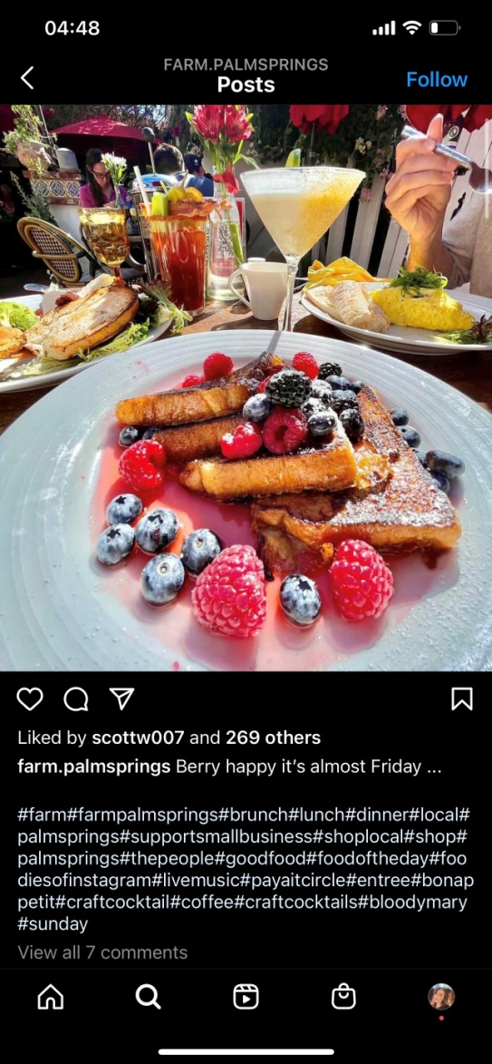
So as represented the research which I did for seven days on both of the pages, now I would like to discuss the likes and the comments both of the pages have on their posts. And overall what kind of techniques do they use on daily basis to have more likes on their posts. Of course, they are able to control the likes of the posts but they are not able to control the comments so let’s start from the restaurant “Farm” so their last post which is an French toast with berries has 270 likes and seven comments. it’s a very colorful picture with appropriate lighting as for the caption they have “ very happy it’s almost Friday” please can be some whole motivational statement like a quote, which reminds the viewers that it’s Friday, after the caption, they have about 25 hashtags which they use in order to increase the visibility of their posts. They have hashtags such as Palm Springs, brunch, breakfast, tasty food, and a lot more. as for the comments they have seven of their clients who are writing about how tasty the omelet is that the omelet is the only reason they visit “Farm”.

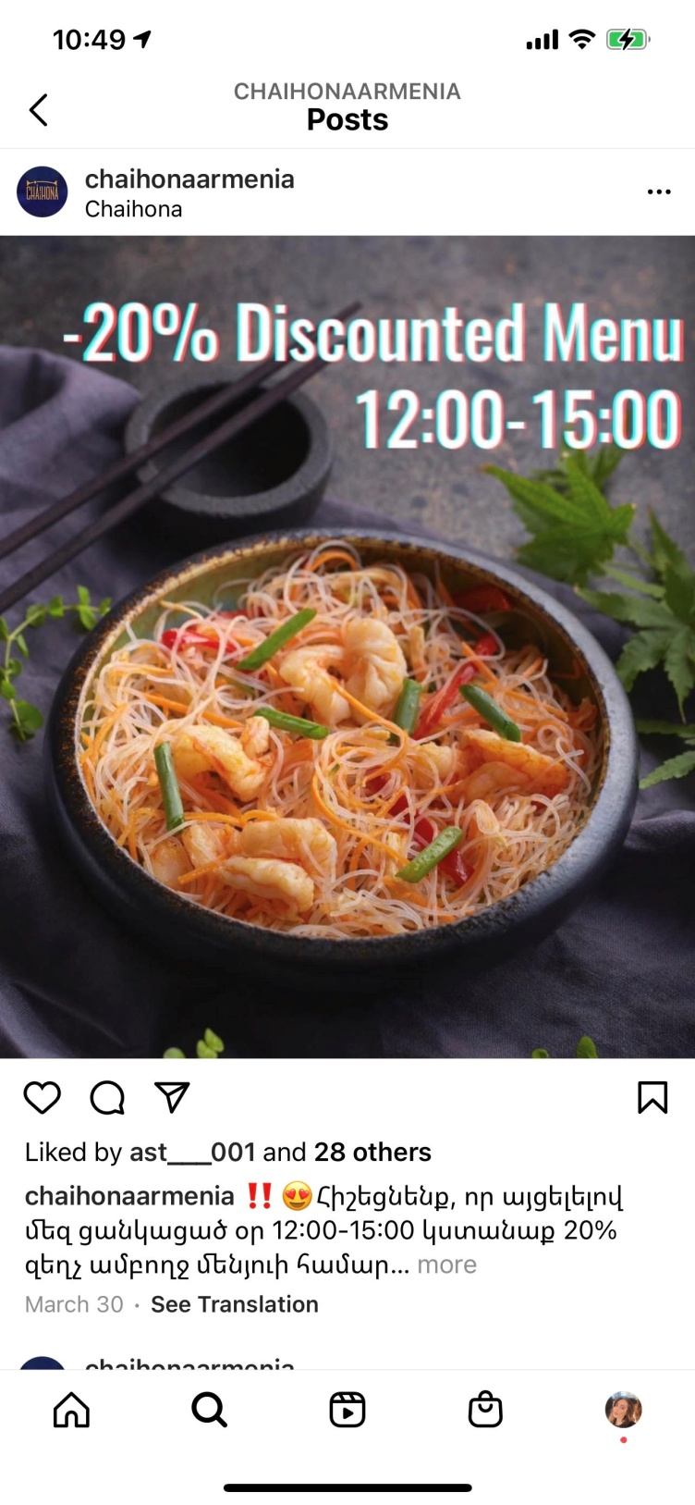
As well as it is very important to take a look at the latest post of the “Baklachoff” collection, keeping eye on the likes and comments. So the post which they have is the post of the dish which has been discounted. so it’s a picture of seafood funchoza, on the pictures they have a text which says “-20% discounted menu” as well as the time for the lunch. so the viewers will take into consideration that the discount is for the only lunchtime. As for the caption they have the same text and they are dates that they are awaiting their customers every day to try the discounted menu dishes. As well they have about 10 hashtags which are: Chinese food, lunch, “Baklachoff collection” and a few others. There are only 29 likes which are surprising comparing to their follower’s number, and there is no comment below the post. So researching this post made me think because the first sight of the page gives you a feeling that the page is very developed it’s very famous and it’s well organized but whenever you are taking look at the likes and comments you see that there is no enough activity compared to the number of followers.

This research gave me ideas to think as from the first sight I thought that the page of “Farm” is not enough developed and worked on compared to the page of “Baklachoff” collection on the other hand after researching the likes and comments that the posts have I realized that the first sight reaction can be wrong.
After analyzing the likes and comments of both of the pages in this chapter of the paper I would like to analyze the survey which has been done in an online way. To go more thoroughly into the organization of the survey I would like to present the questions which have been included in the survey and the survey was mostly for customers of the restaurants. The survey has been created in Google form app which gives a chance for the participants to select the correct answer or to have short text answers which will be submitted and the owner of the survey will have the chance to take a look at it. It has been decided to create two different surveys with the same questions meanwhile with different restaurant names, so the first one was created for the restaurant "Farm" and all of the questions were addressed to the "Farm" restaurant, meanwhile, the second survey which has all of the same questions included in the end the name of the “Baklachoff collection”. So not to go too far the questions that were included in the survey were about their gender and age range. So, all of the survey questions are mentioned above I don’t want to go far in detailing the questions and why I choose specifically those questions but I would like to put concentration on the findings.
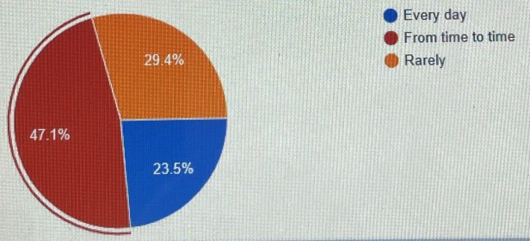
To start with the findings of the "Farm" restaurant for the survey there were 42 responses from which 45% were male 50% were female and only 5% preferred not to mention their gender. About the age range which the participant fell into there are 35% people who are from 27-45 years old. Then we have 55% from 16-26 years old, and finally, 5% which are 46 and above. This shows us that the majority of the participants and restaurant visitors are teenagers and adults. As the reason for them starting following the social media page of the "Farm" there were different and interesting answers some of them want to be updated on the offerings as they post whenever they are having interesting offers for dinner. Some of the other participants answer that they are following the page as they like their atmosphere, their yard, their design of the outside sitting. As well as there is a group of people who mentioned here that they like their breakfast dishes and interesting offers of eggs and they follow them in order to get daily morning breakfast dishes from their page and most of them sometimes use those pictures as theirs. About the usage of their social media page, there were 47% of people who use their social media page from time to time, 30% who use rarely, and 23% of people who use their social media page every single day. As we see here majority of users visit their page from time to time this may be connected to the passive Instagram page leading about which we will find out later in the paper. And to the last question about what kind of post do they mostly like or save most of them answered about the fancy breakfast posts. The other group of people mentioned about their drink posts and about morning cocktails which are being very delicious in the pictures. So most of the answers were about morning aesthetic pictures as well as there was a participant who answered “I would really advise them to be more active on the posts and stories."
To go further I would like to present the survey on “Baklachoff collection”. For this restaurant, there are 60% of male visitors and 40% female which is surprising. There are 60% from 16 to 26 years old and 35% from 17 to 45, and only 5% for 46 and above. To the question of whether they’re following the social media page of "Baklachoff collection", 65% voted as yes and 35% voted as no. As the reason, the following the collection restaurant people said that they want to keep updated with them as they are opening a new restaurant from time to time that they are waiting to know the opening days. They like how their page is organized that they have great food pictures did they are getting daily does each of the restaurants they like their creativity as well as to catch information about their new menu dishes. About the usage of social media page, we have the data of 63% of people who use from time to time, 25% that use every day, and 12% who use rarely. To the last question about which kind of post to say mostly like most of the answers were about the processing videos. Another group of people answered that they like their event posts and pre-event ones. As well as they mostly save the food pictures in order to try them later.
Now it’s time to speak about the interviews which have been conducted with the social media marketing of “Baklachoff collection” and the manager of the “farm”. As all of the questions are mentioned above I will represent the findings and I will start with the restaurant “Farm”. I contacted the manager of the "Farm" through phone and asked her whether I can record our conversation in order to somehow take notes and be able to represent the findings. To the question of which social media platforms do they use the manager answered that they mostly use Instagram and Facebook and they post the same things on Facebook and Instagram pages. Why especially Facebook and Instagram, because those two platforms are the most known for them and most of their visitors and clients are checking on them through those two specific platforms. About the questions of their target audience how to say find them she answered that they are not trying to find their target audience meanwhile they have their target audience and the work that they do on social media is done as they want to make them updated about the restaurant and the new stuff which is going on in there. And finally, when asked who is their target audience is their target audience, she answered that their target audience is middle-aged people, not teenagers and not older people but especially the middle-aged ones. Then I asked what kind of post do they prefer to make. To this question, she responded that mostly they post cocktail and breakfast dish pictures but they mostly like to repost from their customers. She mentioned that every single morning they are having from 30 to 45 tables and from that number half are posting and mentioning them on Instagram page, so they are choosing the best ones from correct lighting from the correct angle and they are posting those pictures into their account either posts or stories. About using the IGTV or reels, she answered that they are not using reels, meanwhile, they use IGTV once or twice in the month. And to the last question about how frequently do they post she answered that there is no specific schedule for posting they are taking pictures whenever they are having new offerings of breakfast or cocktails and as I mentioned 70% of posts and stories are connected to their customers so whenever their customers will post anything they will repost it.
I interviewed the social media marketing manager of the "Baklachof collection" and to the question about their preference of social media platforms she answered that they mostly use Facebook and Instagram as those two platforms are the ones which people use on a daily basis. She added that Twitter or YouTube or not do you platforms that people use them daily basis, and in order to be in touch with their customer is the preferred Facebook and Instagram. To the question of how they find their target audience, she answered that most of the time she is using hashtags which raises the visibility of the post. Moreover, they are using is a paid version of an advertisement of paying three dollars for a day, through this way the post is being advertised and this is another way to raise the visibility of their posts. Also, she mentioned that whenever they are having to offer healthy food or an offering of a fitness dish for the customers they should be in the most visible place. So again with the paid advertisement, with the hashtags, and with visible captions they have to be available for everyone. About their preference of the posts which they make on their accounts, she mentioned that now the processing videos have become a trend. It doesn’t matter whether it’s food or a cocktail people like the processing videos. Another interesting point which she mentioned is that nowadays people feel more comfortable whenever the menus include pictures of the dishes and the same with the social media accounts people who are entering the social media account of the restaurant they want to see the food pictures. To the question about the frequency of their posting, she thinks that it's vital to post every single day as customers need to get a dose from the restaurant. So it’s very important to post stories every single day moreover they are trying to make several stories throughout the day. About the posts, they are posting three times a week in order not to get the customer feel bored and not to make the customer feel too much integrated with the restaurant.

Limitations and Avenues for Future Research
In this section of the paper, I would like to present the limitations which I had during my research process as well as what kind of future research I see in this field of social media marketing and how to engage new customers through it.
I would like to start with the limitations and state that I felt that there are limits during my interview part of the research. As I mentioned above the restaurant which I choose the “farm” is situated in the USA. When I started to interview the social media marketer of “Baklachof collection” it was very easy and comfortable for me to contact and meet face to face and communicate with the specialist. On the other hand, I felt that there are limits whenever I had to interview the social media marketer of the “farm”. First of all, I wrote a message to their Instagram account, I never got a message back then I wrote them into their Facebook page and again got the same. So I had to call one of my cousins and ask her to call them directly in order to be in touch with them. Finally, my cousin gave them what’s app number and they wrote me a message. I called them and asked for an interview with their social media marketing specialist unfortunately the manager told me that the specialist is always busy and she doesn’t have enough time to answer my questions. So she was the one who I search for all of my questions as she is aware of every work that is going on in the restaurant. Of course, this was a limitation for me as I could visit them and sit face-to-face with them and speak directly with the specialist. Overall, I could go over the limit and get the answers to all of the needed questions. Another limitation for me was the survey part as I had not enough American friends who could participate in the survey of the “farm”. At one point I had about 45 responses from the “Baklachoff collection” on the other hand, there were about 19 responses for the “farm”. That was kind of a limit for me as there was no one else whom I can send the survey and ask to participate. After all, I decided to ask my American friends to send the survey to more people in order to get more responses. Finally, I could make the responses equal.
To speak a little bit about the future research which is available for people who have an interest in doing more research into this field, I would like to mention that this field is so broad and some so many different specialists use different techniques to engage customers that it may last forever to find out the right way of working. I believe there is no right way there are just signatures of different specialties that we see on the social media platform pages. The kind of research that I did was all short-termed, such as two-day research or seven-day research and there is a possibility to research the pages for more periods. Researching a specific social media platform page for a month will bring more thorough details and information about the leading. As well as, there are number of interesting questions that can be asked to the specialists and get incredible and eye-opening answers. Another interesting point which I would like to make is that the surveys and interviews may go viral on the website and be visible to all of the people. This may be done in order for the customers to take a look into the answers of the specialists and somehow understand their mentality. The interview answers may be also very useful for those who want to enter the field as a professional. The survey answers may interest the specialists and the business owners as sometimes they include a paper of review with the check but the “+” and “-“maybe not enough for them to get visual feedback from their customers. In the survey answers, there were some negative answers which may either shock the specialist or be beneficial and useful for them. And not to forget the positive ones which may give the specialists motivation and more strength to work harder.

Appendances/Interview Transcripts
Interview with the manager of “Farm”- Lulu
Y Which social media platform do you use?
L We mostly use Facebook and Instagram platforms and we share the same posts on both of the platforms.
Y Ok, interesting Why do they prefer especially those platforms
L Most of our clients use especially those two platforms, and those two are the most popular and used ones for 21st century.
Y How do you find your target audience?
L Tto be frank, we never searched for a target audience. All work that you see on our pages is done just in order to keep our clients updated and informed. We know for sure, that our target audience are middle-aged people, on the other hand we never used social media to get to them.
Y What kind of posts do you usually make?
L When you look at our page, you will see three specific cocktails, breakfasts and atmospheric pictures and videos. Those are our essential, that are being posted as “posts”, as for the “story” part, we are not wasting a lot of time as our beloved clients are doing it by themselves. Every single morning we are having from 35-40 tables for breakfasts and they are taking amazing shots and placing them into platforms. Mentioning us gives us a chance to repost the pictures to our page. Talking about new functions of Instagram we are using IGTV video section about twice a week, and unfortunately we never used reels function but will do in future
Y Thanks, and my last question is “How frequently do you post?”
L You know, there is no fixed schedule for posting. We are posting whenever we are having new offering, if we have three new dishes coming up, we will post those three one by one each day. And, as I mentioned earlier we do not control story section that is all done by the customers, they will post we will post.
Y Thank you Lulu, for interesting interview!

Interview with social media specialist of “Baklachof collection”- Bella
Y Which social media platform do you use?
B We mostly use Facebook and Instagram on daily basis.
Y Why do you prefer especially those platforms?
B There are other interesting platforms such as Youtube, Twitter and other, but we decided to concentrate our attention on those two, as we think those two are the platforms that people enter every single day.
Y How do you find your target audience?
B Oh, this is an interesting question. For catching and finding our target audience we are using various techniques such as hashtag use and paid advertisement. Whenever we post anything, we use caption section for the hashtags, through which people find what they need easier. Hashtag is a way to raise awareness of a product which we want to sell, As well as, there is the paid advertisement function which is another way to make our posts visible for more people.
Y What kind of posts do you usually make?
B We post everything. Nowadays the processing videos have become a trend. It doesn’t matter whether it’s food or a cocktail people like the processing videos. Another interesting point which is worth mentioning is that nowadays people feel more comfortable whenever the menus include pictures of the dishes and the same with the social media accounts people who are entering the social media account of the restaurant they want to see the food pictures. That’s why we post food pictures, processing videos as reels, interesting IGTV videos and finally interesting stories about what is going on the restaurant for that day.
Y My last question is “How frequently do you post?”
B Posting every single day is very important as customers need to get a dose from the restaurant. It is vital to make several stories throughout the day. About the posts, we are posting three times a week in order not to get the customer feel bored and not to make the customer feel too much integrated with the restaurant.
Y Bella thanks a lot for impressive answers!

Bibliography

Ashley, C., & Tuten, T. (2015). Creative strategies in social media marketing: An exploratory study of branded social content and consumer engagement. Psychology & Marketing, 32(1), 15-27.

Tafesse, W. (2016). An experiential model of consumer engagement in social media. Journal of Product & Brand Management.

Kwok, L., & Yu, B. (2013). Spreading social media messages on Facebook: An analysis of restaurant business-to-consumer communications. Cornell Hospitality Quarterly, 54(1), 84-94.

Bennett, T. (2017). Marketing strategies: How small restaurant businesses use social media.

Kim, S., Koh, Y., Cha, J., & Lee, S. (2015). Effects of social media on firm value for US restaurant companies. International Journal of Hospitality Management, 49, 40-46.

Baldus, B. J. (2018). Leveraging online communities to support the brand and develop the community. Journal of Internet Commerce, 17(2), 115-144.

Assimakopoulos, C., Antoniadis, I., Kayas, O. G., & Dvizac, D. (2017). Effective social media marketing strategy: Facebook as an opportunity for universities. International Journal of Retail & Distribution Management.

Evans, D., Bratton, S., & McKee, J. (2021). Social media marketing. AG Printing & Publishing.

Bashar, A., Ahmad, I., & Wasiq, M. (2012). Effectiveness of social media as a marketing tool: An empirical study. International Journal of Marketing, Financial Services & Management Research, 1(11), 88-99.

Lepkowska-White, E. (2017). Exploring the challenges of incorporating social media marketing strategies in the restaurant business. Journal of Internet Commerce, 16(3), 323-342.

Grizane, T., & Jurgelane, I. (2017). Social media impact on business evaluation. Procedia Computer Science, 104, 190-196.

