The Integration to Society of Spontaneous Arrivals from Nagorno-Karabakh in the Republic of Armenia

by

SERGEY KHACHATRYAN

Presented to the Department of English & Communications
in Partial Fulfillment of the Requirements
for the Degree of Bachelor of Arts

American University of Armenia
Yerevan, Armenia

May 18, 2021

ABSTRACT

The territorial dispute between Armenia and Azerbaijan over the Nagorno- Karabakh area has lasted for decades, but violence in the area has worsened last year, when on September 27, 2020 a war broke out between Azerbaijan and Armenia. Clashes between Armenian and Azerbaijani forces have displaced half the population of the Nagorno- Karabakh region. The vast majority of the population of Nagorno- Karabakh, which is located within Azerbaijan, is ethnic Armenians and the religion of the majority of the inhabitants is Apostolic Christian Orthodox. According to a report released by ACAPS, ¨More than 90,600 displaced people from Nagorno- Karabakh have been registered in all of Armenia’s provinces. 39% of these were registered in Yerevan province, 18% in neighboring Kotayk province, and 9% in Syunik province, which borders Nagorno- Karabakh.¨ Spontaneous Arrivals taking refuge in Armenia have since had to deal not only with leaving their homeland, but also adapting to a new country, language, culture, and surroundings.

Key Words: Nagorno- Karabakh Conflict, Spontaneous Arrivals, Azerbaijan/Armenia War, Territorial Dispute,

INTRODUCTION
This report seeks to understand the problems preventing the integration of Spontaneous Arrivals into the Armenian society. It will analyze and identify the problems faced by those seeking refuge in the Republic of Armenia, hereinafter: Armenia. It will also discuss personal and social issues displaced peoples face, including linguistic and cultural differences and problems with housing, as these issues also complicate full integration. The paper will also offer recommendations for future aid, in order to maximize the benefits for the individuals in order to integrate successfully in everyday life. Due to the limitations of the paper, it will not study the vast array of issues and possibilities of Spontaneous Arrivals from Nagorno- Karabakh in the Republic of Armenia, but will give a comprehensive overview of the dispute and recommendations on how to ameliorate their integration in society.
The escalation in hostilities between Armenia and Azerbaijan, over the past months, evidenced, from the beginning, that the outbreak of a new open phase of conflict would occur in a matter of time. Both countries, historically faced by the control of the Nagorno- Karabakh region, have lived the last 26 years in a tense atmosphere, dominated by failed negotiations, lack of political predisposition and specific armed confrontations. Before the resumption of the conflict, said enclave, despite being located entirely within Azerbaijani territory, is it was populated by 99.7% Armenians, who lived under direct control of the self-proclaimed Republic of Artsakh.
The beginning of this new armed confrontation brought with it chaos and uncertainty about the future of the region and generated a direct impact on international society. The OSCE through the co-chairmanship of the Minsk Group has promoted a series of meetings in order to establish different humanitarian truces. This fact, positioned Russia and the United States as the main mediators assets of the confrontation. Other actors with great influence at the regional level such as Turkey, Iran or Israel have also been deeply involved in the event. The military superiority of Azerbaijan, together with the support received by different allies directly on the battlefield, has led to the signing of a Russian-sponsored peace declaration, from which Armenia has notably emerged disadvantaged. According to Hetq Investigative Journalists ¨This year, Armenia’s Ministry of Defense spent US$640 million. Azerbaijani defense and security expenditures topped US$2 billion.¨ Additionally, Azeri troops do not have a spiritual motivation because they never inhabited that region, while the Armenian soldier defends his land.
The Nagorno- Karabakh (Upper Karabakh or Artsakh in Armenian) conflict must be framed and understood in a broad historical, geographical and strategic framework to be understood in its origins, development and future perspectives. Indeed, the conflict arises in a complex geography that has its roots in the millennial struggle of the Armenian people to preserve their unity and identity and which is the result of the rivalries of the great regional powers in their quest to expand their areas of influence and even ancestral fears of the disintegration of their national states for ethnic claims.

Karabagh: Geopolitics and Self-Determination
Despite its conformation as an ethnic and cultural Armenian region, Stalin -virtually in Moscow power- established in 1923 that Karabagh and Najichevan would be autonomous regions administratively dependent on the capital of Azerbaijan, Baku, to despite strong opposition from the indigenous population. The dismemberment of the USSR in 1991 put national disputes on the table, ethnic and religious that the tight political and military control of Moscow maintained in their state larval. In August September 1991 the Republics of Azerbaijan and Armenia declared again its full independence from Moscow and on September 3, the Parliament of Nagorno Karabagh declared the independence of the autonomous enclave. This was not accepted for Baku, who started the repression. For three years, open warfare was fought between the Azeri troops, who managed to invade the region and were repulsed by the forces of Karabakh self-defense. This undeclared war caused thousands of deaths and injuries on both sides, it destroyed almost all urban centers and communication routes in the region. After these horrible events, a period of truce continued, marked by the aim for peace talks, where Armenia, Azerbaijan, Moscow, the United Nations Security Council and an official representative of the Karabakhtsis took part. Since 1995, the members of The OSCE Minsk Group and The Organization for Security and Co-operation in Europe (OSCE), have sought to mediate the talks between Armenia and Azerbaijan in search of a final solution to the conflict. However, there has been great dispute over the groups’ participation, especially the Minsk Group. According to Shamkhal Abilov´s journal, OSCE Minsk Group: Proposals and Failure, the View from Azerbaijan: ¨…despite its ¨great efforts,¨ parties to the conflict have not come to an agreement and are still insisting on their position of ´territorial integrity´ and right of ´self-determination’ therefore there has been no progress in the settlement of the conflict.¨
Despite these efforts, since 2008 the Armed Forces of Azerbaijan began a process of strong rearmament, deteriorating the delicate situation. It is known to have bought arms from Israel for an amount in excess of 1.6 billion dollars, and even had placed an order from Russia in 2013 for delivering ¨tanks, artillery cannons and rocket launchers worth $1 billion to Azerbaijan.¨ According to Reuters:
A source at the Russian Defense Ministry said the order had been on hold for some time to avoid upsetting the military balance in the South Caucasus, where Russia has a military base in Armenia and an agreement to defend the country if it comes under attack. But the deal had been pushed through at the behest of Russia’s powerful arms industry, he said.
Parallel to the purchases, shootings increased along the border line. The most significant violation of the ceasefire occurred on March 5, 2008, causing the death of 16 soldiers. Similar events occurred again during 2010 on July and August 2014, tensions in the conflict zone escalated, due to constant violations of the cessation of hostilities, both in Nagorno- Karabakh and in the border regions of Armenia. Also, the President of Azerbaijan, Aliyev, threatened the Armenians with restarting hostilities, stating that the war there had not yet finished. After the Four Day War that occurred in 2016, the atmosphere between the two sides remained relatively stable until mid-July of 2020, there was an armed confrontation on the Armenian-Azerbaijani border causing the death of at least 16 military personnel and one civilian.

Armenia- Azerbaijan War 2020
On September 27, 2020, an armed conflict commenced between Armenia and Azerbaijan for sovereignty over Nagorno- Karabakh. The six week war generated military and civilian casualties and violated three humanitarian ceasefires. According to the Armenian authorities, the hostilities began at 7:00 in the morning when the Armed Forces of Azerbaijan attacked Stepanakert by means of an air raid and subsequently with the launch of missiles and artillery conventional warfare that wounded various civilians.
The aforementioned peace agreement entered into force on November 10, 2020, gives Russia a central role in the region, an elemental role which was last held during the USSR era three decades ago. Carnegie Europe states that: ¨As a result of the agreement, a Russian peacekeeping mission of 1,960 men was deployed to both Karabakh and the Lachin corridor between Karabakh and Armenia for an initial five years, with the possibility of renewal.¨ However, this a peace agreement has not been received lightly by Spontaneous Arrivals from Karabakh, nor by the Armenian community. As a matter of fact, the community has declared its disbelief and anger, feeling betrayed by the Armenian government and the international community as a whole.
According to a report by USAID published on February 5, 2021, 90,640 individuals from Nagorno- Karabakh sought asylum in the Republic of Armenia. Today, according to The Human Rights Ombudsman of the Republic of Artsakh ¨Survivors and families in the affected areas have been forced to flee their homes fearing for their lives.¨ The Armenian Foreign Minister Zohrab Mnatsakanyan, detailed that ¨Nearly 90,000 people have been displaced, losing their homes and property," causing the displacement of 90% of the citizens of Artsakh, both to Armenia and to other safer areas of the zone, according to the figures also depicted by Artsakh ombudsman Artak Beglaryan. Due to the fact that Nagrono- Karabakh residents traditionally hold Armenian Passports, they are not considered refugees, but ¨Spontaneous Arrivals.¨
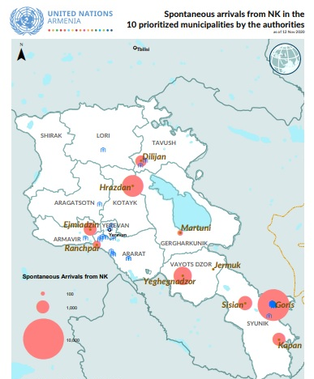
A report by World Vision Armenia, disclaims that most displaced peoples move to the capital of Armenia, Yerevan, in addition to the regional cities of Goris, Sisian, and Syunik region close to Nagorno- Karabakh. These arrivals are from the cities from Stepanakert, Hadrut, Martakert, Martuni, Askeran, Shushi/Shusha, and Kashatagh. The majority are women and children, who still do not know when and under what conditions they will be able to return to their place of origin. Repatriates face many difficulties when settling in; economic hardships, health insurance, housing, education, are just a few of the factors these individuals have to learn to reassemble.
“Armenia: Spontaneous Arrivals from Nagorno-Karabakh.” UNHCR Operational Data Portal (ODP), 12 Nov. 2020, data2.unhcr.org/en/documents/details/83339.

Integration of Spontaneous Arrivals is essential to the development of a nation. The Armenian government offers assistance to those needing humanitarian aid, and aims to assist these individuals by any possible means. The social inclusion and citizens’ active participation in the social and economic life are basic indicators of inclusion. An individual’s inclusion within their community, shows the integration experienced by citizens and non-citizens of the country. This report aims to study, assess, and analyze the incorporation of peoples in refugee-like situations in Armenia.

LITERATURE REVIEW
To understand the effects of social displacement fully, it is essential to analyze a vast array of resources. As general scholarship on social displacement of refugees and their integration into society, it is essential to analyze what has been written in the past decade about the Syrian refugee situation, for example one of the most important documents used in this paper is Elen Manukyan´s 2016 report: ¨ Market Analysis and Needs Assessment on the Provision of Business and Legal Services Among Newly Naturalized Persons, Asylum Seekers and Refugees in Armenia.¨ A very descriptive and resourceful document, depicting market analysis and social analysis of the Syrian refugee situation in the Republic of Armenia. Additionally, ¨Armenia: Syrian refugees find a home away from home¨ an article written by the organization SOS Children´s Villages, which discusses the integration of Syrians of Armenian origin in the Republic of Armenia. Moreover, a report conducted by the EU Regional Trust Fund ¨EU Regional Trust Fund in Response to the Syrian Crisis, the 'Madad Fund' Action Document,¨ in response to the Syrian- Armenian refugee situation will also be applicable in this scholarly document.
This reports research finds the United Nations High Commissioner for Refugees (UNHCR) Armenia Fact Sheet of July 2020 to be extremely significant in the expansion of the data. Additionally USAID´s, Fact Sheet #1 Fiscal Year (FY) 2021: Nagorno- Karabakh – Complex Emergency, published on February 5, 2021 is also a vital document due to its updated information. Additionally, digital documents provided by World Vision Armenia, Assessment Capacities Project (ACAPS), The Human Rights Ombudsman of the Republic of Artsakh, and The UN Refugee Agency (UNHCR), among others; are also vital to the construction of this report.
Thomas Felke, the author of ¨It's been twenty years: The case of ethnic Armenian refugees from Nagorno- Karabakh and Azerbaijan,¨ states that the government of the Republic of Armenia has undertaken measures to protect and to facilitate integration of Spontaneous Arrivals, as it has ¨offered [Spontaneous Arrivals] an opportunity for local integration through a facilitated naturalization process.¨ Amidst the three month war, there was an evident absence of the major humanitarian organizations, hence the Armenian government and civilians stepped up to help. In an interview with The New Humanitarian, Grigor Yeritsyan, president of the Armenian Progressive Youth NGO, stated that ¨he receives regular lists of family sizes and needs from the Yerevan municipality, and assembles packages of food, clothes, and medicine items to deliver to the displaced.¨
World Vision Armenia reported that on October 22, 2020, they quickly mobilized an emergency response team in order to distribute resources to those seeking shelter in Armenia from Nagorno- Karabakh. World Vision raised funds to provide necessary items such as: hygiene kits, blankets and food to those in need. Additionally, the organization continues to focus on the needs and protection of children from Nagorno- Karabakh, in addition to the integration into the community.
However, there is still great concern regarding this humanitarian issue: ¨winters are very cold in this region, and the taxes for heating are very high for the average citizen,” Yeritsyan explicated. “If you have 10 or 15 people who are guests in your house, I don’t know how this will work out, with the municipal budgets and state budgets mainly directed to public health and the military.” As Spontaneous Arrivals continue to flow into Armenia, shelters are reaching full capacity, as is stated by the NGO Save The Children, women and children are living in very crowded conditions. In a statement given by H.E. Mr. Artak Apitonian, Deputy Minister of Foreign Affairs of the Republic of Armenia at the 71st session of the Executive Committee of the High Commissioner’s Programme Geneva, on October 5th, 2020, Apitonian states that ¨ Thousands of displaced families face shortage of food, water and access to medical care¨
Historically, these events have shown that displaced populations in Armenia are extremely vulnerable and underprivileged. This is due to the fact that most displaced persons face major barriers to integration, including limited state resources, unemployment and low salaries, language barriers and a lack of centralized information and communication between actors. Many displaced peoples suffer displacement-related vulnerabilities and face specific displacement-related needs.
Spontaneous Arrivals face many health issues, especially in the rise of the COVID-19 pandemic, and due to the war, hospitals are overwhelmed with patients and lack the infrastructure necessary to provide good health service to those Spontaneous Arrivals. Additionally, according to the Deputy Minister of Labor and Social Affairs of Armenia, Mesrop Araqelyan, the Ministry of Education is granting children whom arrive from the disputed region to attend school in Armenia. Yet, there are not many children enrolled in the program as most of the arrivals are still suffering from post war trauma, lack of financial stability to be able to buy school items, and have language barriers as Armenian dialect is not the same in Nagorno- Karabkh, as it is in Armenia.
In an article published on azatutyun.am, Armenian officials have determined that Spontaneous Arrivals of the Nagorno- Karabakh conflict will each receive a compensation of 68,000 drams ($135) from the Armenian government. This will be of assistance to Spontaneous Arrivals to start building a life in Armenia. A small assistance, as they find ways to make an income of their own. Nevertheless it is essential to analyze, an evaluation conducted by Mission East, reported by ACAPS, stating that Spontaneous Arrivals believe they will not be able to cover food costs beyond November 2020. Although the government has displayed extreme concern in regards to the wellbeing of Spontaneous Arrivals, granting them this pension, ¨arrivals face unemployment and informal workers may not have access to benefits. Economic and agricultural activities have also been disrupted in border regions with conflict-affected areas.¨
On November 10, 2020, Armenia and Azerbaijan coincided in signing a nine point agreement, under the mediation of the Republic of Russian, to officially end the war in Nagorno- Karabakh; after more than forty days of fighting that left hundreds of civilian and military dead. The agreement also details that internally displaced persons and Spontaneous Arrivals, will be able to return to the separatist enclave and the surrounding regions under the control of the UN High Commissioner for Refugees. However the biggest issue today is those Spontaneous Arrivals that decide to stay in Armenia, this is becoming a huge humanitarian issue. The goal of this study is to conduct a comprehensive analysis and assessment of how Spontaneous Arrivals navigate the social environment in the Armenia. This involves the extensive analysis of the hardships lived by displaced individuals and their integration into society. In conclusion, the existing literature is very coherent and detailed, and is extremely important in the development of the essay.

RESEARCH QUESTIONS
This report seeks to answer several questions in regards to the integration of Spontaneous Arrivals. The main question of this project is:
Do Spontaneous Arrivals face integration problems when seeking asylum in the Republic of Armenia?

Due to the fact that this question is broad when it comes to conducting research, I have divided this main question into two sub-questions. Many refugee seekers come from regions where language and customs differ, hence the first sub-question of this report is: What personal and social issues, including linguistic and cultural differences, do Spontaneous Arrivals face when arriving in the Republic of Armenia? This question will be analyzed by targeting the results of future survey respondents about their incorporation into the Armenian community and understanding the challenges to their integration.

METHODOLOGY
This report consisted of a market analysis and needs assessment on provisions of Spontaneous Arrivals from Nagorno- Karabakh after the conflict experienced in the region which was started by Azerbaijan and Turkey, against Armenians living in Nagorno- Karabakh. The main objective of this research report is to find out the hardships Spontaneous Arrivals experience when it comes to their integration and to provide recommendations to help them play a greater role within the Armenian society. In order to attain a complete view of the matter, the research consisted of surveys, assessments, and interviews with professionals and Spontaneous Arrivals from Nagorno- Karabakh.
The surveys used an integrated approach to provide detailed information on the hardships experienced by Spontaneous Arrivals in the Republic of Armenia, it consisted of only multiple-choice questions in order to simplify its completion. The survey were provided online, to facilitate access for those individuals whom will not be available to complete the survey in person, as Spontaneous Arrivals are mostly displaced in the regions of Stepanakert, Hadrut, Martakert, Martuni, Askeran, Shushi/Shusha, and Kashatagh. The surveys were conducted by selecting all Spontaneous Arrivals from Nagorno- Karabkh, the selection will be based on the data and databases provided by different organizations that work with the selected population. The reason for this is that, in order to attain a holistic view of the matter, the report will not contain reliable and accurate information if it is solely provided to a certain age-group, sex group, or any other specific group of individuals; for this report it is essential to attain variant information. The overall survey assessed the main obstacles experienced by incoming arrivals, these issues included, language barriers, cultural barriers, economic issues, and process towards integration experienced by these individuals.
The survey questionnaires took no more than 30 minutes and the assessment, due to its specific questions open-ended questions, in most instances it took no longer than 45 minutes. The first part of the survey, covered demographic information on the target population, such as: name, gender, age, residence in Nagorno- Karabakh, educational level, occupation in Nagorno- Karabakh, and professional skills. Subsequently, the second part of the questionnaire was directed towards issues of integration, perception of danger in Armenia, issues such as livelihood, medical assistance, education, and children´s integration. This information is important as it provides general information that will later be important to create a correlation between the data and research.
In addition to the methods stated above, this report consisted of depth interviews with NGOs and organizations that deal with Spontaneous Arrivals from Nagorno- Karabakh, these include: World Vision Armenia, UNICEF Armenia, the UN Refugee Agency (UNHCR), Elen Manukyan, from the Armenia Bar Association, and representatives of the Ministry of Foreign Affairs of the Republic of Armenia. The one-on-one interviews will take approximately 60 minutes. The interview will consisted of 10 open-ended question and final opinions on the matter. The encounters will be semi-structured discussing a set of issues to guide the interview. A depth interview is particularly important in regards to this topic because, the study involves and in depth investigation on a complex matter. The explication of the decision making process of these large organizations, is essential to the wellbeing of Spontaneous Arrivals from Nagorno- Karabakh. The interviewees, will have to provide detailed and analytical information on this major issue.
The survey and interview questions were all designed to provide the necessary information in regards to Spontaneous Arrivals from Nagorno- Karabakh, these were conducted from May 12- May 16. The analysis of the studies are based on the responses of those surveyed. The methodologies aims to provide a realistic picture of the realities Spontaneous Arrivals face when choosing to leave their land.
The limitations confronted during the realization of the survey mainly relates to the sampling procedure and the focus on Spontaneous Arrivals. Due to the fact that many refugees refused to complete the survey or even communicate through other means, only 23 completed surveys were received. Additionally, to the fact that only the interview were conducted and answered by professionals, the survey may depict biased ideals and/or may be missing information. This correlates with the importance of holding in depth interviews with professionals in their area. Despite these limitations, the methodology chosen to conduct this report offered information not found in any other report available today.

NAGORNO- KARABAKH CONFLICT & SPONTANEOUS ARRIVALS
Since the declaration of independence, Nagorno- Karabakh, renamed the Republic of Artsakh in 2017, is one of those few countries that no one recognizes, except for other countries not recognized by the United Nations, such as Abkhazia, Transnistria and South Ossetia. Despite the cease-fire (intermittently) in 1994, Armenia and Azerbaijan have not been able to sign a peace agreement, nor with the mediation of the Minsk Group, created by the OSCE for this purpose that same year. The national pride of both has outweighed peace.
During an interview conducted with Nagorno- Karabakh war veterans, they all agreed on something; Azerbaijan would have what it wanted: peace or war. And they also agreed on this: "We will tell you the same as the Turks [Azeris] but in reverse." I was grateful that they did not try to impose their version on me, that they even relativized it, because each one defends his own and has his own conditions that the other is not willing to accept. The war veterans wished to remain anonymous for this project.

Syrian- Armenian Refugees in The Republic of Armenia
It is not the first time Armenia has opened its borders for refugees. As of 2018, Armenia hosts around 22,000 displaced Syrian-Armenians, a part of which are in a state of location change. Repatriates face enormous challenges in integrating to Armenia’s economic environment. Most are in Armenia for the first time in their life, and there are significant cultural, language and business differences between their former homes in Syria and their new environment. Its history dates back to the genocide perpetrated by the government of the Young Turks in the Ottoman Empire, starting in 1915, albeit with previous massacres, against Armenians, Greeks and Assyrians. A genocide still denied by Turkey and not recognized by countries like Spain. Syria was one of the countries that hosted Armenian refugees just a century ago, so there is a large Armenian community in Syria that is descended from those: ¨ During the First World War, Armenians had to seek shelter in present Syria. This resulted into an estimated 100,000 Syrians with Armenian ancestors predominantly living in Damascus, Aleppo and Latakia before the crises emerged.¨ When the world began to turn its back on Syrian refugees, Armenia opened its doors to them
Recent studies have shown that, most displaced Syrians seeking refuge in Armenia are typically more vulnerable and underprivileged than those who chose to leave Syria at earlier stages of the conflict. Act Alliance, an NGO that works on humanitarian relief and development, found that “while some persons displaced from Syria [to Armenia] managed to bring significant resources and are self-reliant, others have exhausted their resources.” Most displaced Syrian-Armenians face major barriers to integration, including limited state resources, unemployment and low salaries, language barriers (Syrian-Armenians speak Arabic and Western Armenian, which is distinct from the Eastern Armenian spoken in Armenia) and a lack of centralized information and communication between actors.¨Many displaced Syrian-Armenians suffer from displacement-related vulnerabilities or face specific displacement-related needs.¨
However, “The presence of Syrian refugees in Armenia's mono-ethnic society has been celebrated.” Given their displacement-specific needs and vulnerabilities, the government considers those displaced due to the conflict in Syria to be people of concern regardless of their current legal status under Armenian law. Syrian-Armenian refugees faced many challenges when arriving in the Republic of Armenia, some of these challenges included language barriers and cultural differences. However, according to Elen Manukyan from ABA ROLI ¨The Government of Armenia, despite limited resources, [has offered] some assistance in meeting the humanitarian and integration needs of displaced populations in Armenia.¨
Ashot Kocharyan, the National Director of SOS Armenia, stated that “Syrian-Armenians enrich our culture, I am really happy we can welcome these people here in Armenia and that SOS Children's Villages can support the families and children.¨ Syrian-Armenian refugees have been a very valuable cultural addition to the Republic of Armenia, by opening new businesses, for example. Additionally, they have brought in a new cultural change in the country, for example bringing in their fashion styles, ideals, and values. In addition, just as the war in Syria resulted in many displaced Syrian-Armenians, as a consequence of the intensification of the Nagorno- Karabakh conflict between Armenia and Azerbaijan in 2020, some new displacement occurred in Armenia.

RESEARCH FINDINGS AND ANALYSIS
For this research, market analysis was used to identify problems faced by the respondents of the survey. This included the weaknesses in the Armenian economy, in addition to personal issues such as linguistic and cultural barriers. The overall survey conducted assessed the main obstacles of Spontaneous Arrivals from Nagorno- Karabakh when arriving to the Republic of Armenia, these include: integration issues after settling in the country, language barriers, cultural barriers, economic barriers, government assistance and employment search, among many other obstacles analyzed. The Government of Armenia has made efforts to welcome and integrate the displaced people by simplifying citizenship acquisition, fast-tracking asylum proceedings, and privileging their residence permit applications.
To supplement the survey conducted for this research, it was also essential to review the situation of receptivity towards Syrian-Armenians, refugees, and persons in a refugee-like situation. This is highly important as it reviews ¨ the legal framework, refugee status determination procedures, and reception conditions for asylum-seekers, livelihoods, and progress towards integration, health care and social protection services, community mobilization, and access to free legal aid.¨ The format of this research included a survey of Spontaneous Arrivals from Nagorno- Karabakh.
As a result of the 44 day war, which began on September 27th, 2020, a significant number of people have been displaced from their homelands making the decision to move to the Republic of Armenia. Consequently, several efforts have been made by the Armenian community in addition to the international community in order to identify, the needs of the displaced population and their location. According to the Displacement Tracking Matrix (DTM):
The latest update on registration data on Spontaneous Arrivals from the Migration Service or Armenia as of 9 December 2020 indicate that 90,640 Spontaneous Arrivals are scattered across 593 settlements and communities. Currently, 74 per cent of Spontaneous Arrivals are hosted in urban settlements, while 26 per cent are hosted in rural settlements. 39 per cent of the displaced population have been registered in Yerevan, 18 per cent in Kotayk, and 9 per cent in Syunik.

While these numbers may be subject to change due to the high inflow and outflow of Spontaneous Arrivals. Furthermore, DTM has closely followed the flow of Spontaneous Arrivals since that war first started on September 27th. According to the research,

¨a total of 90,640 individuals were registered in 27,501 families in 593 communities. This represent an increase of 2 per cent compared to the 89,149 individuals registered in Round 2 [published on Dec 03 2020 ] and an increase of 11 per cent compared to the 81,408 individuals registered in Round 3 [published on Dec 14 2020 ].¨
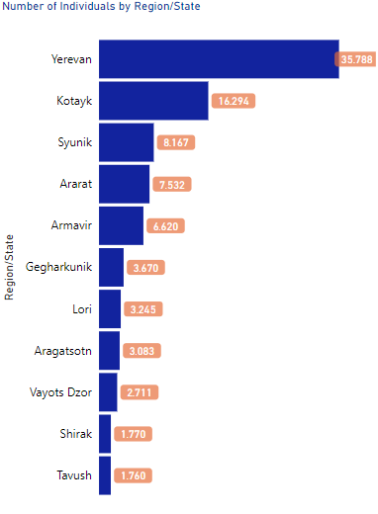
There is an absolute increase in terms of where individuals decided to reside, varying from Round 3[published on Dec 14 2020] and Round 1 [published on Nov 23 2020]. This increase is observed in the regions of Yerevan (+4, 238) and Ararat (+1,131), according to DTM, additionally an increase was seen in the region of Tavush (+22%) and Ararat (+18%). Moreover, it is determined that ¨ three quarters (66%) of all individuals are mapped in the region of Yerevan (39%), Kotayk (18%) and Syunik (9%).¨ Research has also determined that the distribution of families, much like individuals, were mainly distributed in the Yerevan region by 38% followed by Kotayk and Syunik with 18% and 10%.
Terminasyan, Ilona. The Displacement Tracking Matrix (DTM), 2020, pp. 1–5, Armenia — Displacement Report — December 2020— Round 3.
According to the research provided by Ilona Terminasyan, from The Displacement Tracking Matrix (DTM) and the Migration Service of the Ministry of Territorial Administration and Infrastructure of the Republic of Armenia, ¨about 74 per cent of all individuals is reported to be registered in urban communities and settlements, while the remaining 26 per cent is registered in rural communities.¨ As a matter of comparison, those whom decided to settle in the Yerevan region are registered in a more city urban community, whilst the latter have settled in rural communities, in regions such as Ararat (71%), Aragatsotn (59%) and Armavir (57%).
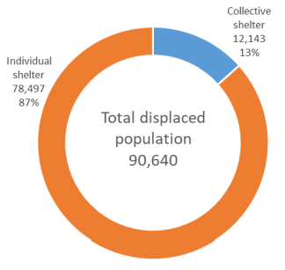
These Spontaneous Arrivals are reported to be living in private accommodations, such as rented living spaces, staying at loved one´s place, among other options, whilst 13% of Spontaneous Arrivals are said to be accommodated in local community shelters. According to the survey, the highest population of Spontaneous Arrivals in community shelters is seen in the regions of Aragatsotn (37%), Lori (24%), Syunik (20%).
Terminasyan, Ilona. The Displacement Tracking Matrix (DTM), 2020, pp. 1–5, Armenia — Displacement Report — December 2020— Round 3.
Giving the detailed settlement data provided by the Statistical Committee of the Republic of Armenia ¨the share of individuals in collective shelters is higher than the average in the regions of Aragatsotn (37%), Lori (24%), Syunik (20%).¨ This same data shows that most Spontaneous Arrivals stay at volunteer hotels providing shelter for those displaced from their homelands, in addition to sanatoriums, these reported accommodations fill 51% of collective shelters. The other reported accommodations re administrative structures 32%, children's centers 5%, and other support centers 4%.
An interesting analysis is that from the 88% of Spontaneous Arrivals are Women and Children, and hence most of the registered Spontaneous Arrivals to Armenia are female at a rough 67% of the total with only 33% being males. According to a detailed analysis conducted by DTM in correlation to data provided by the Migration Service of the Ministry of Territorial Administration and Infrastructure of the Republic of Armenia:
The disproportion between female and male population is particularly visible in the adult age brackets: 52 per cent of the female population is between 18 and 59 years of age, while only 19 per cent of the registered males is between 18 and 59 years of age.

This comparison is portrayed in the following image, where a correlation between female and male Spontaneous Arrivals can be seen:
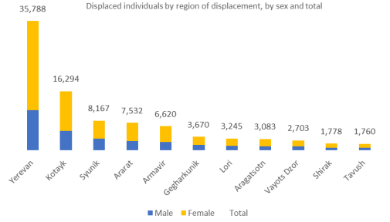

Terminasyan, Ilona. The Displacement Tracking Matrix (DTM), 2020, pp. 1–5, Armenia — Displacement Report — December 2020— Round 3.

Furthermore, children from ages zero to seventeen escalate at a flabbergasting 37,095 of which 19, 366 are males and 18, 539 are females. In regards to the place of origin of these Spontaneous Arrivals, it is reported that the majority comes from Stepanakert with 35%, Martuni 15%, Martaker 13%, Hadrut and Askeran with 10% each.

Survey Findings
The survey conducted by this research covered individuals in a refugee-like situation whom arrived from Nagorno- Karabakh after the outbreak of the conflict between Armenia and Azerbaijan. Due to the fact that most activities of the target population are located in Yerevan, most of the respondent were in this area. Nonetheless, the geographic coverage of survey also expanded a bit to the outskirts of the capital city. Due to time limitations and limited sources, there were only 23 respondents to the survey, this is due to the unavailability of the majority of arrivals in Armenia; many did not wish to respond to the survey nor get in other form of contact with me. Due to this, this section is based on survey findings in addition to data from databases sourced by different organizations, such as The Displacement Tracking Matrix (DTM).
- Respondent Profile
The surveys received during the completion of this research, covered a random, selection of people in refugee-like situations from Nagorno- Karabakh. These respondents were chosen from a small database provided by the Migration Service of the Ministry of Territorial Administration and Infrastructure of the Republic of Armenia. It is important to highlight that the results are not fully representative of the entire displaced community, given that the surveyed population resided mostly in Yerevan and its outskirts, limiting the diversity of information provided. These limitations were unavoidable, given the difficulty and denial of the target population to want to participate in such research. The survey had 10% male respondents and 90% female.
- Results of Survey in Regards to Integration Issues
In regards to respondent answers, most found no issue in integrating to society stating that ¨ [They] have not had any problems with integration.¨ 85% reported not having problems in adapting to Armenia, whilst 15% did experience problems due to communication, lack of work, integration of their children in schools, and other. It is important to highlight that 100% of all survey respondents stated that they felt safe taking shelter and living in the Republic of Armenia.
Those that answered not having any problems with integration reported that language barriers were not evident as their main language is Armenian, and are fully fluent in the language. Additionally they stated not experiencing cultural barriers arguing that ¨ [they did] not have cultural problems, as Artsakh and Armenia have the same culture¨
In Annex 1, Question 5 individuals were asked whether they had experienced any form of distress due to this situation all respondents said yes. Some of the responses included that their emotional distress had be a caused of witnessing the military actions in Nagorno- Karabakh and the losses they had as a result of military actions, this includes the death of a loved one, leaving their homeland, burning their home, humanitarian violations, among other. Additionally, those that feel they are not adapting to living in Armenia, state that one of their distresses is the big differences between living in Nagorno- Karabakh and Armenia.
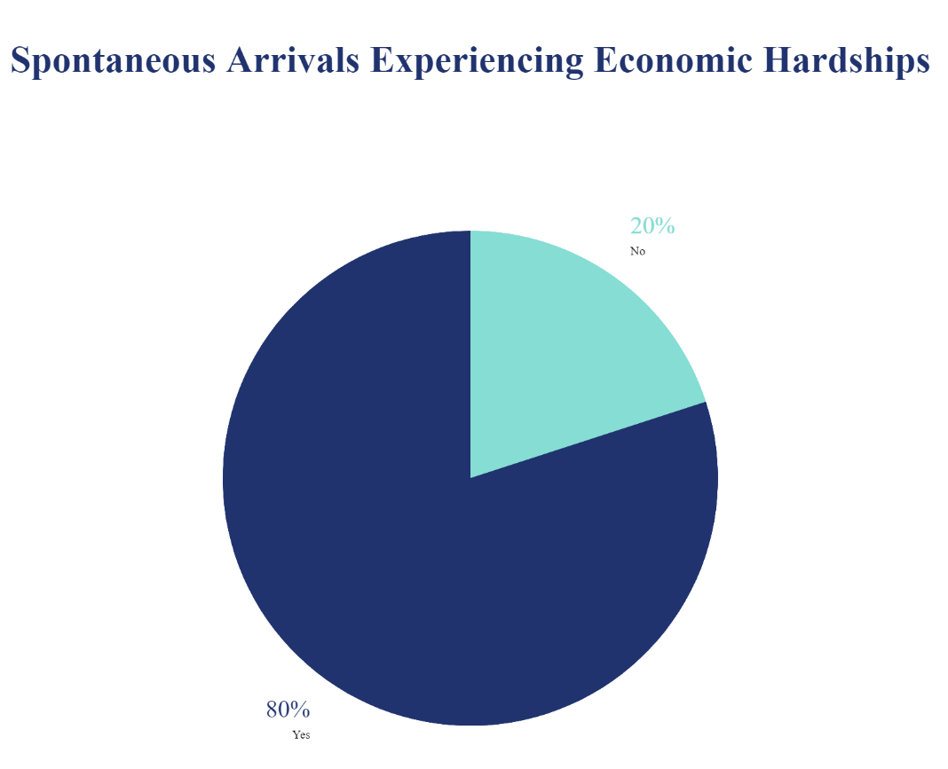
However, both samples, those whom did not experience language and cultural barriers and those whom did, did experience economic hardships. Most of the answers to the question: Did you experience any ECONOMIC barriers after settling in the Republic of Armenia? of the survey were answered in a similar way: ¨There were cases [of economic hardships] that were resolved quickly and ¨There were problems, some of which were solved, some of which were not.¨ Additionally, 95% of respondents stated that they are still unemployed but wish to find a job soon in order to be able to economically maintain themselves, while 5% stated they had already found a job that paid them. Additional aid has been received by NGOs and banks, UNHCR states that ¨Armenian Red Cross Society (ARCS) with ICRC support has started disbursement of cash support to host families in Tavush and Syunik marzes, in alignment with…Social Security Service and banks.¨ Moreover, when asked if Spontaneous Arrivals had received a pension or some form of benefit, most had received both a pension and allowance, while a small number did not receive any form of financial aid.
In the surveys, several questions were devoted to the aid received by Spontaneous Arrivals from government entities and locals. When asked the question: Did the local Government reach out to you in time of crisis? 90% of respondents answered Yes, whilst only 10% answered No; stating they have not completed paperwork necessary to receive such aid, but that they have received aid from NGOs ( such as donations). Regarding presence of problems, respondents were asked to clarify what institution they turned to when needing assistance. Responses included: the state, the Ministry of Social Affairs, and Social workers. Meaning the majority asked for help from the government before anything else. In parallel, most Spontaneous Arrivals, found tremendous help from their relatives and neighbors.
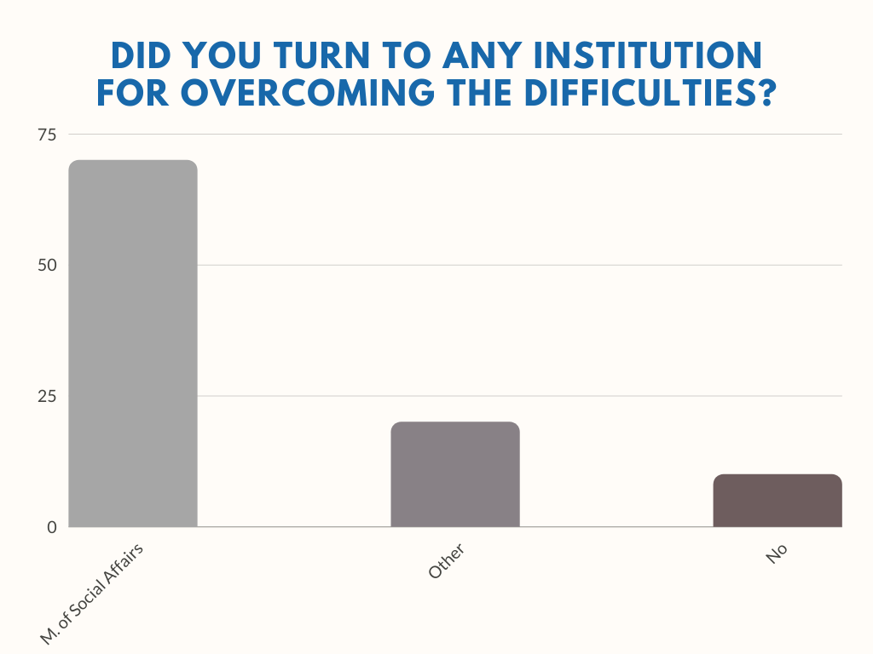
In Annex 3, Question 4, individuals were asked whether they turned to any institution for overcoming the difficulties. Answers varied, 70% of respondents answered that they turned to the Ministry of Social Affairs, 20% stated other, and 10% stated they did not turn to any local institution for help. Those whom answered they turned to the Ministry of Social Affairs stated they ¨… applied to the local government bodies, the Ministry of Social Affairs and received some support.¨ whilst others argued that, ¨Some issues have been resolved with the support of the Ministry of Social Affairs.
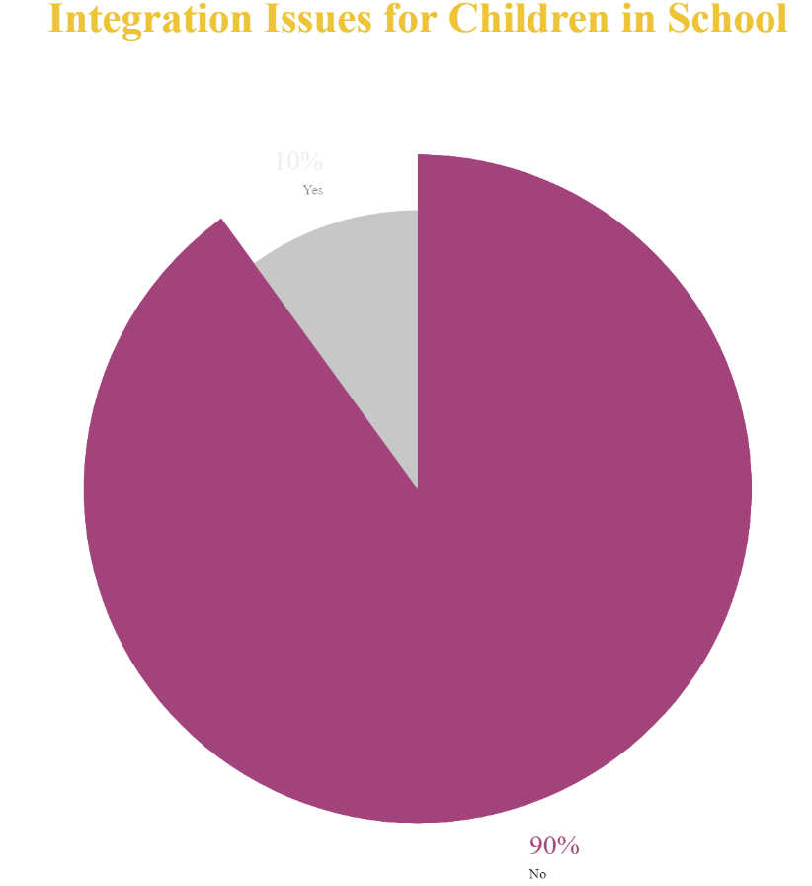
Additionally, Annex 3, where respondents were asked if there were any problems connected with the education of the children, 10 % of respondents reported having such issues. These concerns were due to cost of tuition fees and lack of income in addition to difficulty in adaption at the new school, such as change of classmates and isolation. 90% of respondents stated they did not experience any issues with their child´s education, with 65% stating their children adapted to their school perfectly and did not experience any form of integrational issue. The remaining 25% stated their children were already past the scholarly age of 3-18 year olds, and having already graduated university. The data depicted on the pie chart above, depicts the percentage of children whom suffered integration distress and those whom didn’t. Additional information provided by UNHCR states that ¨ Aleppo NGO provided scholarships to 40 students living in a refugee-like situation to support their studies at Armenian universities.¨
Survey respondents were also asked whether they had received medical aid. The majority of respondents stated that they did receive aid. Spontaneous Arrivals have the same right to receive free medical care and services guaranteed by the State for the citizens, as long as they meet the legal requirements. Spontaneous Arrivals, the majority, hold Armenian passports and hence receive free medical care. Inpatient and outpatient medical assistance for Spontaneous Arrivals is funded by the state. Moreover, when asked if they were satisfied with the quality of medical aid, most said no, but this may be due to the COVID-19 pandemic and the disasters it has caused. Therefore, the portion of information is not liable to use as precise information. Furthermore, it is essential to take into consideration that medical aid has also been provided by NGOs:
In order to respond to the need for free medication and supplies at primary healthcare level, WHO has donated 59 standardized drug modules (set packages to respond to non-communicable diseases) to the MoH to help provide free non-communicable disease medication to up to 66,000 individuals.

Furthermore, the United States has dedicated 1.1 million USD in support for essential health care and water, sanitation, and hygiene (WASH) interventions in Armenia. Additionally, the distribution of ¨hygiene kits to displaced individuals living with host communities or sheltering in communal facilities, helping mitigate the transmission of communicable diseases in Armenia, including COVID-19.¨ has also been successful thanks to the collaboration of such organizations and the Armenian government

CONCLUSION AND RECOMMENDATIONS
The six week war over Nagorno- Karabakh, generated military and civilian casualties and violated three humanitarian ceasefires. Additionally, it caused the displacement of 90% of the citizens of Artsakh, both to Armenia and to other safer areas of the zone, according to the figures also depicted by Artsakh ombudsman Artak Beglaryan. The Armenian Foreign Minister Zohrab Mnatsakanyan, detailed that ¨Nearly 90,000 people have been displaced, losing their homes and property." This report sought to answer several questions in regards to the integration of Spontaneous Arrivals. The main question of this project tried to answer was whether Spontaneous Arrivals faced integration problems when seeking asylum in the Republic of Armenia. Throughout the research conducted, several sub questions were answered, one of these was: What personal and social issues, including linguistic and cultural differences, do Spontaneous Arrivals face when arriving in the Republic of Armenia?
The answer to this question, and analyzing the surveys and the graphs conducted during this research, one can safely say that the majority of Spontaneous Arrivals have a shared language, ethnicity, and cultural similarities. The major obstacles faced by Spontaneous Arrivals, were mainly in regards to their economic situation and financial aid. The next most noted need for Spontaneous Arrivals was the need to have an institution backing for overcoming the difficulties, as 90% of the respondents stated they felt the need to ask for help during these times from higher institutions. It is noted that these two obstacles are related as without an income, Spontaneous Arrivals seek help from the government.
During the past years, a shared ancestry and traditional cultural identity has impeded changes in the two societies. This resulted in the easy integration of Spontaneous Arrivals into the Armenian community of the Republic of Armenia. Additionally, since the beginning of the war, many local and international organization have assisted Spontaneous Arrivals facilitating their adaptation to their new lives in Armenia. For example on January 22, 2021, ¨the UN launched the 2021 Interagency Response Plan for Armenia, calling for $62.6 million to support populations affected by recent fighting between Armenia and Azerbaijan.¨ A recommendation that may aid their integration, may be incorporating individuals in refugee-like situations into the working market. By providing new jobs, individuals will be able to maintain their lifestyle and start building their new life in the Republic of Armenia.
This research project portrays the progress that has already been made in regards to the integration of Spontaneous Arrivals from Nagorno- Karabakh. The Republic of Armenia, alongside many other organizations, have succeeded in maintaining sustained assistance for new arrivals, be the Syrian-Armenian community and other displaced communities. The aid provided by the national government in addition to other organizations and NGOs, such as the Red Cross, The World Health Organization, Armenian Red Cross Society (ARCS) with ICRC, Mission East, among many others. This aid helps ensure the success of integration and assistance to vulnerable groups, such as Spontaneous Arrivals, improving the overall social and economic integration and positive long-term outlooks for displaced communities. If these services and aids be taken away from these communities, this progress may decline greatly. It is essential to continue aiding and supporting Spontaneous Arrivals in accessing the existing free health care and the educational system. Additionally, it is essential for the Armenian government to assist and educate individuals in refugee like situations on the rights provided by the law, including benefits, pensions, health care and other services.
The Republic of Armenia has opened its borders for Spontaneous Arrivals who´s homes and property have been destroyed. As a result of the atrocious conflict which began on September 27th, individuals sought refuge in their mother-land, where not only did the government do everything to aid them but also the most common civilian aided in their form. As a final analysis of this research paper, it is evident to say that Spontaneous Arrivals, no matter their sex, age, or their economic situation, are more than grateful to their motherland for everything they have given them, and for the two most important things to them: health and tranquility. Karabakhtsis may have lost it all, but their Armenian ancestry keeps burning inside of them, and they will not stop until Nagorno- Karabakh is recognized as Armenian land.
“I should like to see any power of the world destroy this race, this small tribe of unimportant people, whose wars have all been fought and lost, whose structures have crumbled, literature is unread, music is unheard, and prayers are no more answered. Go ahead, destroy Armenia . See if you can do it. Send them into the desert without bread or water. Burn their homes and churches. Then see if they will not laugh, sing and pray again. For when two of them meet anywhere in the world, see if they will not create a New Armenia.”
― WILLIAM SAROYAN
BIBLIOGRAPHY

20:12:00, Vahe Sarukhanyan2020-10-24. “Armenia vs. Azerbaijan: Military Expenditures.” Hetq.am, 24 Oct. 2020, hetq.am/en/article/123482

“ՀՀ ՍփյուռքիՆախարարություն - ՍիրիահայերիԱնկյուն - ՊետականՔաղաքականություն.” RA Ministry of Diaspora - Dear Armenians around the World, 2018, www.mindiaspora.am/am/petakan_qaxaqakanutyun

ABILOV, SHAMKHAL. “OSCE Minsk Group: Proposals and Failure, the View from Azerbaijan.” Insight Turkey, vol. 20, no. 1, 2018, pp. 143–164. JSTOR, www.jstor.org/stable/26301072 Accessed 30 Apr. 2021.

“AD HOC REPORT: On the Children Rights Affected by the Azerbaijani Attacks Against the Republic of Artsakh ( Nagorno- Karabakh).” The Human Rights Ombudsman of the Republic of Artsakh, 9 Nov. 2020.
“Armenia.” ACAPS, 17 Dec. 2020, www.acaps.org/country/armenia/crisis/nagorno- karabakh-conflict-in-armenia.
Armenia Inter-Agency Operational Update, 1- 31 March 2021 - Armenia. ReliefWeb. (n.d.). https://reliefweb.int/report/armenia/armenia-inter-agency-operational- update-1-31-march-2021 .
“Armenia Foreign Minister: Over 90,000 Displaced in Karabakh.” PanARMENIAN.Net, 24 Oct. 2020, www.panarmenian.net/eng/news/287004/Armenia_Foreign_Minister_Over_900 00_displaced_in_Karabakh
“Armenian, Karabakh Leaders Discuss Post-War Reconstruction.” "Ազատ Եվրոպա/Ազատություն" Ռադիոկայան, Ազատություն ռ/կ, 22 Nov. 2020, www.azatutyun.am/a/30963129.html

Apitonian, Artak. “Armenia Statement.” The UN Refugee Agency (UNHCR), 7 Oct. 2020.
“Azerbaijan Makes Massive Israeli Weapons Purchase -- But Not Because of Iran.” Eurasianet, eurasianet.org/azerbaijan-makes-massive-israeli-weapons-purchase- but-not-because-of-iran.

“Azerbaijan Launches Wide Scale Offensive.” EVN Report, www.evnreport.com/spotlight-karabakh/azerbaijan-launches-wide-scale- offensive.

“Azerbaijan and Armenia: Conflict in Nagorno-Karabakh.” Assessment Capacities Project (ACAPS), 20 Nov. 2020.

Connelly, Andrew. “The Humanitarian Fallout of the Nagorno-Karabakh Conflict.” The New Humanitarian, 5 Nov. 2020, www.thenewhumanitarian.org/news- feature/2020/11/5/nagorno-karabakh-armenia-azerbaijan-conflict-humanitarian- impact

EU Regional Trust. (2018). EU Regional Trust Fund in Response to the Syrian Crisis, the 'Madad Fund'. Action Document.

Felke, Thomas. (2010). It's been twenty years: The case of ethnic Armenian refugees from Nagorno-Karabakh and Azerbaijan. Dissertations Collection for University of Connecticut.

Geographic reference Armenia Admin 1, source HDX Settlement, source https://ace.aua.am/vector-database-armenia-file-overview/.

Ierwirth, C. (2015, July 30). Interview with UNHCR Representative [Interview]. Retrieved July 12, 2018, from http://www.un.am/en/news/303

Kucera, Joshua. “Armenians Flee Fighting in Karabakh.” Eurasianet, 4 Nov. 2020, eurasianet.org/armenians-flee-fighting-in-karabakh.

Manukyan, E. (2016). MARKET ANALYSIS AND NEEDS ASSESSMENT ON THE PROVISION OF BUSINESS AND LEGAL SERVICES AMONG NEWLY NATURALIZED PERSONS, ASYLUM SEEKERS, AND REFUGEES IN ARMENIA.

“Response to the Refugee Crisis in Armenia – ARM161.” Act Alliance, 19 July 2016, Retrieved from http://actalliance.org/wp- content/uploads/2016/07/Appeals_07_2016_Refugee-Crisis-in- Armenia_ARM161.pdf

“Nagorno-Karabakh Conflict-Sitrep November 2, 2020.” World Vision Armenia, 2 Nov. 2020

The RA law on Refugees and Asylum, article 23.

Reuters Staff. “Russia Starts Delivering $1 Billion Arms Package to Azerbaijan.” Reuters, Thomson Reuters, 18 June 2013, www.reuters.com/article/us-russia- azerbaijan-arms-idUSBRE95H0KM20130618

“Response to the Refugee Crisis in Armenia – ARM161.” Act Alliance, 19 July 2016, Retrieved from http://actalliance.org/wp- content/uploads/2016/07/Appeals_07_2016_Refugee-Crisis-in- Armenia_ARM161.pdf

Save the Children International. “Nagorno-Karabakh Fighting Leaves Children Who Fled the Conflict in Distress.” Save the Children International, 23 Oct. 2020, www.savethechildren.net/news/nagorno-karabakh-fighting-leaves-children-who- fled-conflict-distress

SOS Children's Villages. (2017, January 1). Armenia: Syrian refugees find a home away from home. SOS. https://www.sos-childrensvillages.org/sources/syrian-refugees- in-armenia.

Terminasyan, Ilona. The Displacement Tracking Matrix (DTM), 2020, pp. 1–5, Armenia — Displacement Report — December 2020— Round 3, displacement.iom.int/system/tdf/reports/ARMENIA%20DTM%20Round%203 %20Narrative_v4.pdf?file=1&type=node&id=10330

USAID. “Nagorno-Karabakh – Complex Emergency.” USAID, 5 Feb. 2021.

Varshalomidze, Tamila. “'Syrian Refugees Improve Armenia's Social Fabric'.” Israeli– PalestinianConflict | Al Jazeera, Al Jazeera, 17 Dec. 2017, www.aljazeera.com/indepth/features/2017/12/refugees-improve-armenia-social- fabric-171214061224398.html.

Waal, Thomas de. “Unfinished Business in the Armenia-Azerbaijan Conflict.” Carnegie Europe, 11 Feb. 2021, carnegieeurope.eu/2021/02/11/unfinished-business-in- armenia-azerbaijan-conflict-pub-83844

(www.dw.com), Deutsche Welle. “Half of Nagorno-Karabakh's Population Displaced by Fighting: DW: 07.10.2020.” DW.COM, 7 Oct. 2020, www.dw.com/en/half- of-nagorno-karabakhs-population-displaced-by-fighting/a-55183758

“Armenia.” ACAPS, 17 Dec. 2020, www.acaps.org/country/armenia/crisis/nagorno-karabakh-conflict-in-armenia.
20:12:00, Vahe Sarukhanyan2020-10-24. “Armenia vs. Azerbaijan: Military Expenditures.” Hetq.am, 24 Oct. 2020, hetq.am/en/article/123482
ABILOV, SHAMKHAL. “OSCE Minsk Group: Proposals and Failure, the View from Azerbaijan.” Insight Turkey, vol. 20, no. 1, 2018, pp. 143–164. JSTOR, www.jstor.org/stable/26301072 Accessed 30 Apr. 2021.
“Azerbaijan Makes Massive Israeli Weapons Purchase -- But Not Because of Iran.” Eurasianet, eurasianet.org/azerbaijan-makes-massive-israeli-weapons-purchase-but-not-because-of-iran.
Reuters Staff. “Russia Starts Delivering $1 Billion Arms Package to Azerbaijan.” Reuters, Thomson Reuters, 18 June 2013, www.reuters.com/article/us-russia-azerbaijan-arms-idUSBRE95H0KM20130618 .
Reuters Staff. “Russia Starts Delivering $1 Billion Arms Package to Azerbaijan.” Reuters, Thomson Reuters, 18 June 2013, www.reuters.com/article/us-russia-azerbaijan-arms-idUSBRE95H0KM20130618 .
“Azerbaijan Launches Wide Scale Offensive.” EVN Report, www.evnreport.com/spotlight-karabakh/azerbaijan-launches-wide-scale-offensive.
Waal, Thomas de. “Unfinished Business in the Armenia-Azerbaijan Conflict.” Carnegie Europe, 11 Feb. 2021, carnegieeurope.eu/2021/02/11/unfinished-business-in-armenia-azerbaijan-conflict-pub-83844.
Waal, Thomas de.
USAID. “Nagorno-Karabakh – Complex Emergency.” USAID, 5 Feb. 2021.
“AD HOC REPORT: On the Children Rights Affected by the Azerbaijani Attacks Against the Republic of Artsakh ( Nagorno- Karabakh).” The Human Rights Ombudsman of the Republic of Artsakh, 9 Nov. 2020.
“Armenia Foreign Minister: Over 90,000 Displaced in Karabakh.” PanARMENIAN.Net, 24 Oct. 2020, www.panarmenian.net/eng/news/287004/Armenia_Foreign_Minister_Over_90000_displaced_in_Karabakh
(www.dw.com), Deutsche Welle. “Half of Nagorno-Karabakh's Population Displaced by Fighting: DW: 07.10.2020.” DW.COM, 7 Oct. 2020, www.dw.com/en/half-of-nagorno-karabakhs-population-displaced-by-fighting/a-55183758
“Nagorno-Karabakh Conflict-Sitrep November 2, 2020.” World Vision Armenia, 2 Nov. 2020
“Azerbaijan and Armenia: Conflict in Nagorno-Karabakh.” Assessment Capacities Project (ACAPS), 20 Nov. 2020.
Felke, Thomas. (2010). It's been twenty years: The case of ethnic Armenian refugees from Nagorno-Karabakh and Azerbaijan. Dissertations Collection for University of Connecticut.
Connelly, Andrew. “The Humanitarian Fallout of the Nagorno-Karabakh Conflict.” The New Humanitarian, 5 Nov. 2020, www.thenewhumanitarian.org/news-feature/2020/11/5/nagorno-karabakh-armenia-azerbaijan-conflict-humanitarian-impact
“Nagorno-Karabakh Conflict-Sitrep November 2, 2020.” World Vision Armenia, 2 Nov. 2020.
“Nagorno-Karabakh Conflict-Sitrep November 2, 2020.” World Vision Armenia, 2 Nov. 2020
“Nagorno-Karabakh Conflict-Sitrep November 2, 2020.” World Vision Armenia, 2 Nov. 2020.
Connelly, Andrew. “The Humanitarian Fallout of the Nagorno-Karabakh Conflict.” The New Humanitarian, 5 Nov. 2020, www.thenewhumanitarian.org/news-feature/2020/11/5/nagorno-karabakh-armenia-azerbaijan-conflict-humanitarian-impact
Save the Children International. “Nagorno-Karabakh Fighting Leaves Children Who Fled the Conflict in Distress.” Save the Children International, 23 Oct. 2020, www.savethechildren.net/news/nagorno-karabakh-fighting-leaves-children-who-fled-conflict-distress
Apitonian, Artak. “Armenia Statement.” The UN Refugee Agency (UNHCR), 7 Oct. 2020.
Kucera, Joshua. “Armenians Flee Fighting in Karabakh.” Eurasianet, 4 Nov. 2020, eurasianet.org/armenians-flee-fighting-in-karabakh.
“Armenian, Karabakh Leaders Discuss Post-War Reconstruction.” "Ազատ Եվրոպա/Ազատություն" Ռադիոկայան, Ազատություն ռ/կ, 22 Nov. 2020, www.azatutyun.am/a/30963129.html
“Azerbaijan and Armenia: Conflict in Nagorno-Karabakh.” Assessment Capacities Project (ACAPS), 20 Nov. 2020.
“Azerbaijan and Armenia: Conflict in Nagorno-Karabakh.” Assessment Capacities Project (ACAPS), 20 Nov. 2020.
“ՀՀ ՍփյուռքիՆախարարություն - ՍիրիահայերիԱնկյուն - ՊետականՔաղաքականություն.” RA Ministry of Diaspora - Dear Armenians around the World, 2018, www.mindiaspora.am/am/petakan_qaxaqakanutyun
EU Regional Trust. (2018). EU Regional Trust Fund in Response to the Syrian Crisis, the 'Madad Fund'. Action Document.
“Response to the Refugee Crisis in Armenia – ARM161.” Act Alliance, 19 July 2016, Retrieved from http://actalliance.org/wp-content/uploads/2016/07/Appeals_07_2016_Refugee-Crisis-in-Armenia_ARM161.pdf
Manukyan, E. (2016). MARKET ANALYSIS AND NEEDS ASSESSMENT ON THE PROVISION OF BUSINESS AND LEGAL SERVICES AMONG NEWLY NATURALIZED PERSONS, ASYLUM SEEKERS, AND REFUGEES IN ARMENIA.
“Response to the Refugee Crisis in Armenia – ARM161.” Act Alliance, 19 July 2016, Retrieved fromhttp://actalliance.org/wp-content/uploads/2016/07/Appeals_07_2016_Refugee-Crisis-in-Armenia_ARM161.pdf
Manukyan, E. (2016).
Varshalomidze, Tamila. “'Syrian Refugees Improve Armenia's Social Fabric'.” Israeli–PalestinianConflict | Al Jazeera, Al Jazeera, 17 Dec. 2017, www.aljazeera.com/indepth/features/2017/12/refugees-improve-armenia-social-fabric-171214061224398.html.
Manukyan, E. (2016).
Manukyan, E. (2016).
SOS Children's Villages. (2017, January 1). Armenia: Syrian refugees find a home away from home. SOS. https://www.sos-childrensvillages.org/sources/syrian-refugees-in-armenia.
Ierwirth, C. (2015, July 30). Interview with UNHCR Representative [Interview]. Retrieved July 12, 2018, from http://www.un.am/en/news/303
Terminasyan, Ilona. The Displacement Tracking Matrix (DTM), 2020, pp. 1–5, Armenia — Displacement Report — December 2020— Round 3, displacement.iom.int/system/tdf/reports/ARMENIA%20DTM%20Round%203%20Narrative_v4.pdf?file=1&type=node&id=10330 .
Terminasyan, Ilona.
Terminasyan, Ilona. The Displacement Tracking Matrix (DTM), 2020, pp. 1–5, Armenia — Displacement Report — December 2020— Round 3, displacement.iom.int/system/tdf/reports/ARMENIA%20DTM%20Round%203%20Narrative_v4.pdf?file=1&type=node&id=10330.
Terminasyan, Ilona.
Terminasyan, Ilona.
Terminasyan, Ilona.
Terminasyan, Ilona.
Terminasyan, Ilona.
Terminasyan, Ilona
Terminasyan, Ilona
Geographic reference Armenia Admin 1, source HDX Settlement, source https://ace.aua.am/vector-database-armenia-file-overview/.
Terminasyan, Ilona
Terminasyan, Ilona
USAID. “Nagorno-Karabakh – Complex Emergency.” USAID, 5 Feb. 2021.
Terminasyan, Ilona
Terminasyan, Ilona.
Terminasyan, Ilona.
Armenia Inter-Agency Operational Update, 1- 31 March 2021 - Armenia. ReliefWeb. (n.d.). https://reliefweb.int/report/armenia/armenia-inter-agency-operational-update-1-31-march-2021 .
Armenia Inter-Agency Operational Update, 1- 31 March 2021 - Armenia. ReliefWeb. (n.d.). https://reliefweb.int/report/armenia/armenia-inter-agency-operational-update-1-31-march-2021 .
The RA law on Refugees and Asylum, article 23.
Armenia Inter-Agency Operational Update, 1- 31 March 2021 - Armenia. ReliefWeb. (n.d.). https://reliefweb.int/report/armenia/armenia-inter-agency-operational-update-1-31-march-2021 .
USAID. “Nagorno-Karabakh – Complex Emergency.” USAID, 5 Feb. 2021.
(www.dw.com), Deutsche Welle. “Half of Nagorno-Karabakh's Population Displaced by Fighting: DW: 07.10.2020.” DW.COM, 7 Oct. 2020, www.dw.com/en/half-of-nagorno-karabakhs-population-displaced-by-fighting/a-55183758
“Armenia Foreign Minister: Over 90,000 Displaced in Karabakh.” PanARMENIAN.Net, 24 Oct. 2020, www.panarmenian.net/eng/news/287004/Armenia_Foreign_Minister_Over_90000_displaced_in_Karabakh
USAID. “Nagorno-Karabakh – Complex Emergency.” USAID, 5 Feb. 2021.

