INSTAGRAM’S INFLUENCE ON LUXURY CONSUMPTION ON ARMENIAN VS LEBANESE PEOPLE

by

Natali Darchinyan

Presented to the
Department of English & Communications
in Partial Fulfillment of the
Requirements for the Degree of Bachelor of Arts

American University of Armenia
Yerevan, Armenia

May 17, 2021
Table of Contents

- Introduction…………………………………………………………..………………… 3

- Literature Review……………………………….……………………………………....6

- Research Questions.………………………………………………....………...………14

- Methodology……………...…………………………………………………………… 14

- Research Findings and Analysis…...………………………………………………… 20

- Conclusions ……..………………………………………………….......……………… 43

- Limitations and Avenues for Future Research ...……………….......…………….… 44

- Works Cited ……….………………………………………………....………...……… 45

- Introduction
Emergence of innovation after another happened throughout the 21st century. The most prominent one of those innovations was Steve Jobs’ creation of the very first iPhone, which was the start of a whole new era. Applications and fast growing Internet sources were even more accessible to people as the smartphone was like a mini computer that would be with them all the time and much easier to access than it is for computers. At first, these technological innovations were all presented as beneficial tools for their “users''. In fact, only two industries refer to their buyers as “users'', which are the social media industry and the drug industry, both of which have proven to have addictive effects on the people who use them. It is undeniable that social media had and continues to have positive effects on people, including the ease of connecting to family and friends that live abroad, the abundance of sources ready to research about literally any topic in the world, the ability to start a revolution at times of political unrest such as the Twitter Revolution in Iran, the means to raise awareness for important issues such as the MeToo Movement that was against sexual assault, the ability to organize fundraisers for those in need, etc. These quick, simple and completely free of charge social platforms have also become an intermediary for online shopping and luxury consumption, which has proven to have different effects on different people.
Historical, political, and cultural differences all affect people on the various choices they make, including their shopping choices. For instance, Armenians and Lebanese have differing viewpoints on almost any aspect in life. Historically, the Armenian population that are currently living in Armenia have been through a lot. They are living in a post-Soviet country for 30 years now, and a big part of the population is still under the Soviet mentality that is passed to them from their parents. The new generation is still developing, but it’s really hard to change a whole population in just 30 years, especially when there are political issues and ongoing threats of wars. Not to mention that Armenia’s GDP isn’t that high, $13.67 Billion in 2019 (Armenia GDP, 2019), because of years of corruption. Lebanon has also been under foreign supervision, however, it was by the French Government. The civil war that was from 1975-1990 has left generations traumatized, not to mention the recent economic crisis of 2019 that is getting worse each and every year. The Lebanese government is nonexistent and is so inconsiderate that it has left almost 3000 tons of Nitrate Ammonium in the Beirut Port, which ended up exploding back in 2020, taking hundreds of lives and leaving 300.000 people homeless.
These two countries have faced quite similar political and economic changes, yet culturally they have always remained different. Armenians have a different approach when it comes to looks and fashion. For instance, when attending university, students, especially the girls, dress formally. They give a lot of importance to their looks and makeup, to the point where it is so uncommon to see a girl without makeup in the streets. However, the girls in Lebanon go to university wearing leggings and sweats, almost nobody does a full face of makeup while going to university, even in the streets the norm is to see people wearing comfortable clothes with a bare face. Another example of the cultural differences seen in both societies is the habit of staring. Armenians, male or female, have a tendency to stare at other people, at their outfits, at their shopping carts, etc. In Lebanon, everybody minds their own business, and starring way too long at someone is considered offensive and an invasion of privacy. In Lebanon, even when people wear brands, they don’t make it look like a big deal and they don’t showcase as much as in Armenia where people constantly display their outfits and their outings, especially on Instagram (IG).
IG is considered to be the top social application that allows digital marketers to target their desired audience. Its vast popularity and the wide range of diverse users has made IG very beneficial for luxury brand companies to promote their products online. Therefore it is interesting to research and find out if IG has an influence on people, specifically those in Armenia and Lebanon, to shop luxury brands. There is more to the question since it is not just about understanding the reason behind luxury consumption, but also about the way that our every single move is monitored and analyzed by IG. It is about the way that there is no privacy whatsoever, since conversations between users are read and heard by IG in order to find out everything that users like and dislike, making targeting audiences way more easier and effective. It is more of a question of ethics. IG is constantly showing us products to consume and is making us believe that luxury consumption is what we not only want, but also need.
There is plenty of research conducted over IG and what it does to its users, but there is no research about the comparison of how IG influences luxury consumption on Armenians VS Lebanese people. Thus, through my research, I will be able to find out and compare how IG influences Armenians VS Lebanese on their luxury consumption choices.

- Literature Review
There are numerous changes that occur rapidly in the advancing age of social media. Nowadays some social platforms, especially IG, are viewed as a shopping center rather than a platform where people share their own pictures and interact with each other. It has become a vital tool for the marketing field since many companies use it to target their present and potential customers. Personally I am fond of digital marketing and am constantly exposed to the diverse marketing strategies that are showcased via IG. Investigating the unseen strategies that companies use via IG to promote their products, more specifically luxury brands such as Gucci, Chanel, Dior, YSL, etc., is essential in order to understand the modern day digital trends and marketing strategies and just how we are exposed to such strategies that make us unconsciously act in ways that companies want us to act. Thus, this literature review will showcase how IG psychologically controls its users by using influencers promoting unrealistic luxury lifestyles and psychologically targeting women to be influenced by popularity and socially constructed perceptions and ideals of perfection and luxury status.
Through this literature review, various themes will be discussed such as: the role of influencers and self-branding, the influence of other social networks on IG, the importance of two-way communication and data mining, and social psychology of dress.

Influencers

Influencers are one of the core elements that IG uses to influence luxury consumption on women. In the new economy, creative work status of being an influencer is highly recommended as it sets grounds for flexible, modern, and independent workers. Influencers are usually young and active IG users with an outstanding amount of social media followers, who use their platform to aestheticize and therefore monetize their lifestyles through posting sponsored advertisements and partnering with luxury brands, in order to constantly promote awareness and consumption of those brands to their followers (Perthuis and Findlay, 2019). Duffy and Hund (2015) note that mainstream media portrays influencers as a self-enterprising class of digital cultural producers. Additionally, a recent Wired (UK) feature by Sophia Epstein stated: “rarely are fashion bloggers just hobbyists these days—increasingly they are entrepreneurs with business plans and revenue”. Thus, influencers “creatively document a life lived well” (Salisbury and Pooley, 2017, 12) with the commercialized glamour of curated content and have turned into intermediaries between luxury designers and their target market. As much as there are similarities in the way that Influencers work, there are differences that make them authentic and therefore more influential.
● Self-branding
There are certain codes, rules and regulations, practices, and logics that encourage creative influencers to engage in self-branding and self-governance (Hearn, 2008). Lewis (2014) and Marwick (2013) investigate the growth of influencers in the context of web 2.0. Social entrepreneurialism is set through attention-seeking and status-enhancing habits and can be understood by “heteronormative femininity with discourses and practices of masculine entrepreneurialism” (Lewis, 2014; Marwick, 2013). There are certain similarities when it comes to the strategies of content sharing, however there are also differences in the way each influencer formulates their content. In order to better understand the way these influencers self-brand themselves there has been a number of studies.
- A qualitative analysis of the top 38 fashion blogs in the US conducted by Duffy and Hund in order to find what are typical and common self-representation strategies that influencers use. The studied bloggers aged 18-35 were influenced by Western beauty standards, like young, thin, and light-skinned. Furthermore, by taking posts from the IG accounts linked to those blogs and analyzing them thoroughly, the findings were that each post was coded in common patterns. Patterns included passion autonomy, the American Dream, the self as brand, experience, personality, travel, commercial affiliations, etc.
- Another qualitative research (Duffy and Hund, 2015), which was about interviewing eight professional fashion influencers, having two of them from their previous textual analysis. An hour long interviews were conducted and as a result it was made clear how different bloggers had differences in their line of work. Joy, one of the fashion bloggers, explained the reason why she had to hire an intern. “Building up our own numbers” was what Joy described her main objective to be. Whereas Eadie, another interviewee, mentioned that “so many lovely readers and supporters who make it all worth it…” referring to her own self-discipline and self-motivation. She does it all on her own and has a different style of self-branding strategies that she uses to curate her content to her audience.
Therefore, influencers use different methods to promote unrealistic perceptions of luxury, stress-free lifestyles through their self-branding methods and perfectly curated content which makes IG users, especially their followers, buy luxury brands in order to resemble them. That being said, it is proven how prominent influencers and their self-branding strategies are in helping IG influence women into buying luxury designer brands.

Influence of other social networks on IG

Influencers influence audiences in making purchase decisions, while other social networks influence the visibility of luxury brands on IG. There is an ongoing correlation between different social media platforms and plenty of strategies are applied to discover more about this correlation. Thus, social platforms hand in hand collect all the necessary data through two-way communication and data mining to try to understand what is appealing to which user so that luxury brands will easily target their audiences and influence their consumption decisions.
● Two-way communication
Due to the ongoing online opportunity, luxury brands are able to openly communicate with their customers, answer their questions, provide them with further information about their brand, etc. Thus, there is ongoing two-way communication without any restrictions in place, time, and medium (Kim & Co, 2012). This two-way communication results in cross-sharing of photos and videos between IG, Twitter, Facebook and Pinterest (Ramao et al., 2019). There can be the same carefully curated content on different social media platforms. IG is the medium that facilitates luxury brands’ online presence, as it has visual aesthetic characteristics that are appreciated by luxury designer teams (Dahlhoff, 2016).
● Data mining
Effectively extracting and internalizing user generated content is what data mining is all about as it helps in making valid predictions and improves marketing decisions (Silva, Moro, Rita & Cortez, 2018). Social media data comes mainly in the form of written content such as comments in reviews, status updates, and conversations with other social media users. Social media data can also come in the form of likes, dislikes, hashtags, shares, tags, emojis, and personal information (e.g. number of friends/followers, age, gender, etc.) (Kennedy, 2016). There are also annual reports on how IG algorithms work on an IG marketing platform called Later. Through platforms like these it can be seen how IG curates specific content for each user.
A study using data has been conducted to facilitate decision making processes concerning shared content on social media to go further with one particular luxury brand’s digital strategy. Josefina is the luxury brand whose social media data has been collected, specifically all its posts on Facebook, IG, Twitter, Google+ and Pinterest from September 1, 2015 till October 31, 2016. A total of 588 promotional posts made by Josefina on all its social media accounts have been collected, taking into consideration that different content has been uploaded on different social media platforms. The analysis of the data revealed that out of the 588 promotional posts, 365 were present on both Facebook and IG pages, 170 posts on Twitter, 116 Pinterest posts, and just 13 on Google+. From these promotional posts, it was made clear which features would enable relevant hints for “IG likes”. And from these features, there is one that can be modeled making the features named either “source” or “computed”. The term “source” refers to features that stay exactly as they were collected, while “computed” refers to the features that were the ones based on the “transformed” ones (Duffy and Hund, 2015). The result of this study was that out of the 588 promotional posts and sixty-seven originally collected features, only fifteen were considered to be ready to feed the modeling procedure.
Therefore, besides IG, other social media collect data by two-way communication and data mining to know exactly what appeals to which user and from that data help make luxury brands on IG more visible to their target audience. By this, other social media have a very important role in helping IG influence women in their luxury consumption decisions.

Social Psychology of Dress

The way people make decisions about what they buy, wear, and look like are all psychological. Self-image and self-worth are all factors that are linked to luxury consumption and can further explain why consumers exposed to luxury brands on social media purchase them without hesitation. Luxury brands have symbolic meanings that prime self-perceptions, and those self-perceptions influence consumption decisions. Therefore, IG controls its users by these factors of social psychology of dress in order to influence women on their luxury consumption decisions.
● Luxury brands affect the wearers
It is proven that the way a person dresses affects the behavior of that person as well as the behavior of others towards that person (Johnson & Lennon, 2014).
Gino et al. (2010) conducted a study of the effect of wearing designer sunglasses on one’s own behavior and also perceptions of others. Some of the glasses were described as counterfeit, while others were described as authentic Chloe sunglasses. Although counterfeits showcase status, the wearers feel that they are pretending to be something that they are not. Surprisingly, the participants who thought they were wearing fake Chloe sunglasses were the ones who cheated on experimental tasks, whereas the participants who thought they were wearing the original Chloe sunglasses did not cheat at all. In another experiment, the research showed that the participants who thought they were wearing the counterfeit sunglasses perceived their opponents as being dishonest and unethical. Finally, the researchers of this study linked the effect for wearing fake sunglasses on one’s own behavior to the symbolism of fraud attributed to the sunglasses. Therefore, it is proven how dresses and especially authentic and branded dresses and accessories affect wearers because of the symbolic meaning of those dresses or accessories and the direct physical experience of wearing branded items.
● Clothes prime self-perceptions
Hannover and Kuhnen (2002) uncovered the truth about why clothes could impact thought about one’s own self. Findings from social cognition helped them explain that clothing styles can prime certain mental categories about one’s self. Therefore, if clothing impacts self-knowledge, it will subsequently impact self-perception. For instance, a person wearing fancy and luxurious clothes would describe her or himself as a “glamorous” or “trendy” person.
During a study, the researchers placed the participants in front of mirrors and found how participants wearing casual clothing styles agreed to the “casual” traits and adjectives as more valid descriptions to themselves than formal traits. On the other hand, participants wearing luxurious clothes agreed to the “chic” and “elegant” traits as more correct descriptions to themselves than casual adjectives. It was concluded how clothing primed certain categories of self-perception (Hannover and Kuhnen, 2002).
● Self-perceptions influence consumption decisions
Sirgy (2015) came up with the self-image product-image congruity theory in order to describe the process of the way people purchase items in relation to their ideas of self. Through branding and marketing, products and services gain associated status and perception. The hypothesis is that products that consumers buy are images and ideas that are compatible with how they view themselves or with how they want to be viewed. During a recent experiment conducted, the main reason their participants were not pleased by their offered maternity clothes was because those clothes did not fit with their personalities. Therefore, it is inevitably true that self-perceptions and self-images impact clothing purchase decisions.
By referring to the facts that luxury brands have symbolic meanings that influence self-perceptions and that self-perceptions on their turn influence consumption decisions, IG targets its users more easily as it constantly exposes them to ideals of perfect looks. Plus, IG makes women compare themselves to those ideals of perfection, makes them feel the need to have the same exact looks and strive to their full potential of self-perception. These psychological factors that IG uses make women subconsciously believe that by having those luxury brands their self-worth will increase. Thus, these social psychological factors of dress help IG to control and influence women into buying luxury designer brands.
Overall, this literature has contributed a lot for finding out the different strategies that IG uses to influence luxury consumption. The overview of the different influencer styles and the way they self-brand, the correlation between other social media platforms and IG and the way social media data is collected to understand what makes users hit the “like” button and purchase products that they like, and also the social psychology of dress and the way luxury brands influence one’s behavior, self-description and self-perception are all crucial literature to help complete my research. The overall strength is that there are thoroughly explained theories from lots of different sources backed up with a lot of conducted experiments. The weaknesses can be that there is not much literature about how IG uses its users' self-perceptions in its digital marketing. The missing thing may be the fact that this literature is applied to social media users in the United States and not to IG users in Armenia and in Lebanon. The next steps for research is to find more sources about how IG uses its users’ self-perceptions in its digital marketing.

III. Research Questions
This research was conducted to find the answers to a number of questions. The main research question, which was answered throughout this research was:
How does IG influence luxury consumption on Armenians VS Lebanese people?
This central research question was further divided into other questions. Since IG cannot do all the work itself, it uses influencers with huge amounts of followers to target their desired audience easily and more effectively. Research has shown that besides influencers and their strategies of self-branding, other social media applications, Facebook in particular, are linked to IG’s control over its users. Thus, this research further answered the question: What role does IG’s influencers and other social media have on influencing the luxury consumption choices of Armenians VS Lebanese?
Additionally, since my research paper also refers to the sociocultural reasons that influence people’s consumption decisions, my research answered the following question as well: What role does society and culture play on influencing the luxury consumption choices of Armenians VS Lebanese?

IV. Methodology

Survey methodology
This capstone’s research questions will best be answered by surveys and focus groups that will be conducted among Armenian and Lebanese audiences as the main objective of this research is to analyze and compare how these two groups are influenced by IG on their luxury consumption choices. The survey that was conducted among young Armenian and Lebanese adults was the first research method used in this project to find out the target audience’s perceptions about IG’s influence on their own luxury consumption decisions. The type of surveys that was conducted was online surveys, since through an online format the questionnaires would reach out to more people in a quick and effective way, and it would also include participants that are living in different cities in both Armenia and Lebanon. The survey consisted of 15 different types of questions, such as demographic questions, yes or no questions, multiple choice questions, and Likert scale questions.
The first 5 questions were demographic questions to identify their age range, gender, city of residence, their marital status and employment status. All of the answers to these questions provided the research with the necessary information of the participants so that it will be easier to determine which subgroups are influenced by IG on their luxury consumption decisions and why. The age range is necessary to see if IG influences older generations differently than younger generations. Perhaps older generations may not be that interested in influencers, may not even know most influencers, making them less likely to get influenced by them. The gender of the participants was asked to see if girls would be influenced differently than boys or vice versa. The demographic question about the city of residence is the basis of the survey, since the answers to this question will showcase the perceptions of Armenians and Lebanese which will help with the comparison of the results. The last demographic questions are in a way linked. Being in a relationship or married or having a job are different sources of income. This will help in understanding if being financially secure paves the way for IG to further make people consume luxury brands.
After the demographic section, the participants answered where they usually go to look up and/or decide what items to buy for themselves. This question will be a ranking question, with the choices being shopping malls, local stores, IG, and all of the above mentioned choices. Through this question, it will be known if IG is transforming to a shopping center or not. If participants chose IG as their preferred source of luxury consumption, the ranking question will be followed by an open-ended question about why exactly participants prefer IG as their primary source of shopping over the other options. This will provide information about what exactly IG uses to facilitate the shopping experience of the participants that preferred it as their main source of luxury consumption. This question’s answers include the ease of shopping through IG, the fact that they can look for stuff anytime and anywhere (accessibility), the acquisition of promotional codes, the fact that it is trendy to shop via IG, and all of the above mentioned options.
Participants were then asked a yes/no question about influencers which is whether they follow any influencers on IG or not. The respondents who answered with “yes” had a follow up question that was about the type of influencers they follow with answers ranging from beauty and makeup to fashion and skincare, to celebrities and others. The next question was in order to find out why they follow the above mentioned influencers; either to resemble them, to be inspired by them, to get information, to get entertained by them or all of the above.
Then, the respondents had to specifically choose between a list of brand names that they might be following on IG. Brands such as Gucci, Louis Vuitton, Chanel, Dior and many other brands are options that the respondents had to choose from.
The last set of questions are psychological ones which determined the respondents’ feelings about certain aspects seen throughout IG. The first psychological question was a Likert scale question about what the respondents felt after buying a luxury brand item that they had seen on IG. With answers ranging from “very satisfied” to “satisfied” to “neutral” to “unsatisfied”.
The follow up question was: “How many times have you talked about a luxury item and that brand's ad has appeared on your IG feed?” The options of this Likert scale question about the frequency of these occurrences ranged from “always” to “often” to “sometimes” to “rarely” to “never”. The purpose of this question is to find the frequency of the occurrence of coming across the exact same luxury designer items on IG that participants have beforehand searched or talked about with other users via phone or text. By this it will be even more evident if IG listens to private conversations between its users or not, in order to use that information to target its intended audience with personalized content.
The next question was once again a Likert scale question about how often participants notice the same designer brands throughout different social media. The options of this question ranged from “always” to “often” to “sometimes” to “rarely” to “never”. By this question it would be easier to pinpoint how different social media all collectively analyze their users’ data and constantly target them. Through this question it will be easier to see if there is actually a correlation between apps, and if those apps also have an influence on luxury brand consumption. And the last question is about how other people showcasing luxury brands on IG make the respondents feel. “Annoyed”, “neutral”, “inspired,” and “jealous” are the options the respondents had to choose from or even provide an alternative answer describing their feelings, which will set the tone for knowing if IG actually influences people to consume luxury brands or not.
Thus, by analyzing and comparing the survey results, it will be much easier to draw conclusions and answer the sub-questions of the research. Consequently, finding out causation and correlation between the analyzed data, will help answer the main research question.

Focus group methodology
The second research method used in this study was the focus group. Two different focus groups were held; one for the Armenian audience and one for the Lebanese. However, the questions asked during these two focus groups were the exact same questions. Once again let us go through the questions and explain why they were asked to the focus groups’ participants, after which I will thoroughly analyze and compare them in order to see if there are any similarities or differences in the way IG influences Armenians and Lebanese in their luxury shopping choices.
The first question asked was about where the participants usually shop, either shopping malls or via IG, in order to know their preferred shopping source.
Next question was about whether they feel that IG has turned into a shopping center in its recent updates or not and explain their answers in order to find out IG’s role in its users' minds.
Then, the focus group participants were asked about IG’s influencers, if they had preferred influencers and whether they see them as real or fake. This question’s purpose was in order to find out about the audience’s overall perceptions of the influencers.
The focus group participants had to answer whether they happened to have unfollowed any influencer before, and whether or not they felt relieved afterwards. The answers to this question will make it even more obvious if the influencers are affecting IG users or not.
The next question in the focus group was about the specific luxury brands that they see the most on IG, whether it is through ads, or on people, mostly celebrities or influencers. This question will help us see what are the most prominent luxury brands, which will be beneficial in determining whether or not participants are overwhelmed by brands at all or not.
After this question, the participants were asked if they look up a brand’s page after they see that brand’s ad or someone on IG wearing them. By this, we will see how many participants are determined enough to go and look up the items that they see, which will help us see how much these luxury brands affect the participants.
Next question asked in the focus group was about whether or not the participants feel that they have privacy on IG. Through this question, we can see if the two audiences have similar experiences with privacy issues on IG, which will further prove if IG tracks its users or not. Following this question, there was the question about whether or not it would have been the same if there was no IG. The answers to this question will show how the participants really feel about IG and the role it plays in their lives.
Next question is going to be whether or not the participants would have wanted to become an influencer or not. They are going to explain their answer and also state if they would showcase luxury styles on their accounts as influencers or if they would do something differently. The answers will provide insights on the perceptions the focus group participants have about influencers. If they answer that if there is the chance they would do something differently, it means that they have negative perceptions on influencers, which will help us see a certain pattern.
And lastly, the focus group participants are going to be asked if buying expensive luxury items is even worthy at all. They will have to give additional feedback on what exactly makes them worth buying, specifically if it is the quality of the items or the brand. This question is one of the most important questions asked during these focus groups, because it will be seen if the participants are influenced by IG or in general, to buy luxury or they aren’t influenced at all.

V. Research Findings and Analysis
Survey Findings & Analysis
94.1% of the respondents were aged 18-25 with a huge difference in the percentage of gender with 81.4% of the respondents being females and only 18.6% of the respondents being males. 70.6% of the respondents were not in a relationship, whereas the rest, 29.4%, were either in a relationship, engaged or married. Most of the participants (63.7%) were not working at that time, whereas the other 36.3% had a job.
Moving on from the demographic questions, the respondents had to answer the question that was about where they usually shop. The majority of the Armenian respondents, 38,4% of them responded with malls being their primary source of shopping, whereas the majority of the Lebanese respondents, 62,5 %, responded with all of the above options, meaning they usually shop at the local stores, malls, and IG. 12,6% of the Armenian respondents chose local stores as their primary source of shopping. Only 14,4% of the Armenian respondents go to IG to shop and the remaining 34,6% use all the mentioned places to shop. Whereas 16,7% of the Lebanese audience chose local stores as their primary source of shopping, 12,5% chose malls to shop, and apparently only 8,3% use IG to shop. This shows that IG does not have a competitive advantage when it comes to the shopping industry, since both the Armenian and Lebanese audiences still use traditional ways to shop.
The next question was a follow up question for respondents who chose IG to clarify the reason behind their choice. The vast majority of the Armenian respondents, that made up 38,6% of the total number of Armenian respondents, chose IG because they could look for items anytime and anywhere, while most of the Lebanese respondents, 43,4% chose IG for all of the mentioned choices. 32,9% of the Armenian respondents chose IG because it is easier to find items they are looking for. 12,5% of them chose IG as their primary source of shopping because of the possibility of getting promo codes and only 4,5% of them chose IG because it is the new and trendy way to shop. And the remaining 11,5% who chose IG for shopping chose all of the above options. On the other hand, 30,5% of the Lebanese respondents who chose IG as their primary source of shopping, chose it for its easiness in finding items, 13% of the Lebanese respondents chose IG because they could look for anything anywhere, 8,7% of them chose IG because they could get promo codes, and only 4,4% of them chose IG as their source of shopping because it is the trendy way to shop. There is a certain similarity in this question’s results, as most of the respondents of both the Armenian and Lebanese audiences that chose IG chose it because of its ease and accessibility. Thus, IG’s facilitation of shopping is what attracts its users, no matter where the users are from.
Next there was the yes or no question about whether the respondents follow influencers on IG or not.
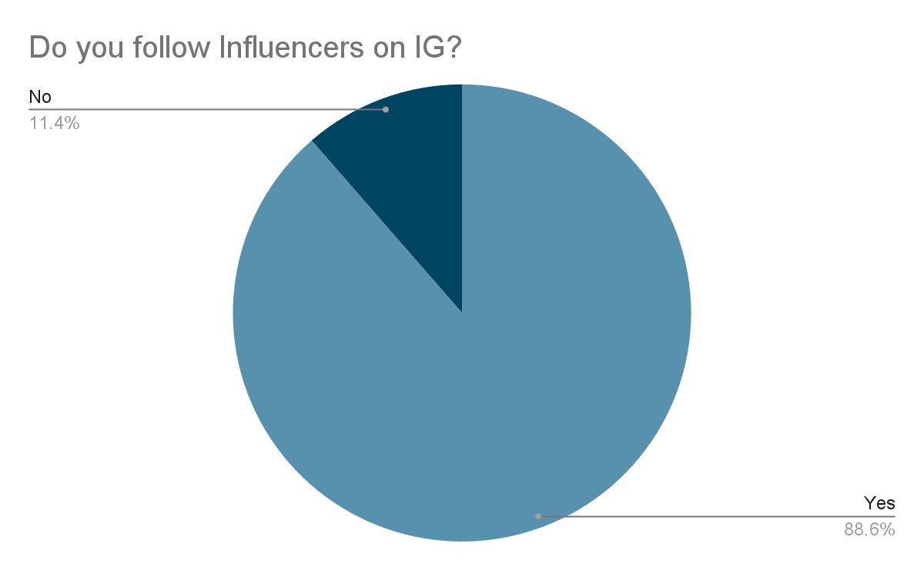
(Figure 1)
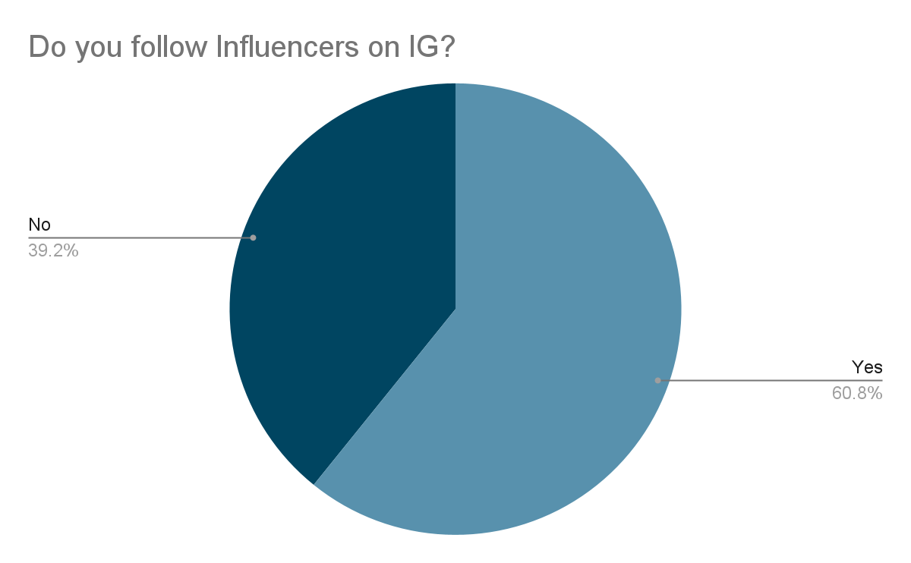
(Figure 2)

88.6% of the Armenian respondents said that they follow influencers and 11,4% do not follow influencers on IG (See Figure 1). Quite similarly, 60,8% of the Lebanese audience follow influencers and the remaining 39,2% do not follow influencers on IG (See Figure 2). The results of this question are quite similar because most of the respondents do follow influencers, but the % of Armenian following influencers is still more than that of the Lebanese. This showcases how Armenians are more interested in influencers on IG, which is the result of the cultural background that the Armenian population has; staring at others and living up to other people.
Then, there was a follow up question for those participants who answered that they followed influencers, so that they would specify which type of influencer they follow on IG. The majority of the Armenian audience, which was 28,8%, chose influencers that belong to the Fashion industry. Next 23,5% of the Armenian respondents chose Beauty and Makeup as the category of influencers that they follow. Similar percentages of the Armenian respondents,16,5% and 16,3%, choose the categories of Dieting and Healthy Lifestyle and Celebrities respectfully. And only 14,9% of them follow influencers that talk about skincare on their IG. For the Lebanese respondents, the percentages of respondents who chose Beauty and Makeup, Fashion, and Dieting and Healthy Lifestyle were all equal to 24,3%. Celebrities were the choice of 14,9% of the Lebanese respondents, and only 12,2% of them followed influencers for skincare purposes. The results of this question were very similar, with Fashion, Beauty and Makeup, and Dieting and Healthy Lifestyle being the top 3 choices of both Armenian and Lebanese respondents. Celebrities coming at number 4 as the most chosen answer about the type of influencers followed on IG. Whereas skincare being the least chosen option for both Armenian and Lebanese respondents. This question’s results show how both audiences value aesthetics and looks, whether it is through makeup or clothes or physical well-being.
The next question’s purpose is in order to find out the reason why the respondents follow these types of influencers.

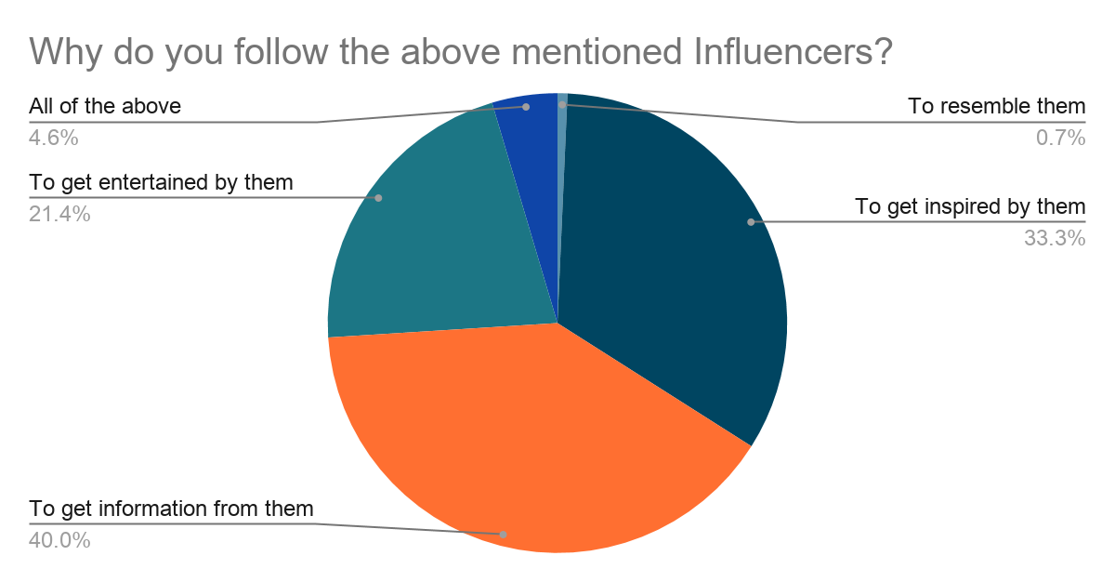
(Figure 3)
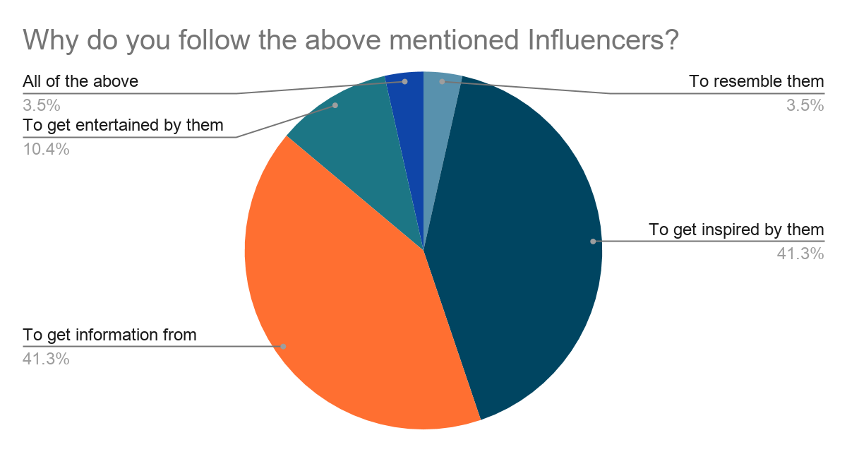
(Figure 4)

The majority of the Armenian respondents (see Figure 3), 40%, follow influencers to get information from them. The next biggest percentage of the Armenian population, that is 33,3%, follow influencers to get inspiration from them. Similarly, 41,3% of the Lebanese respondents, (see Figure 4), follow influencers to get information and exactly the same percentage, 41,3%, follow influencers to get inspired by them. The third most chosen option for this question is the fact that the respondents follow influencers to get entertained by them, with 21,4% of the Armenians having answered that and 10,4% of the Lebanese respondents having answered that. Now for the last two options, the Lebanese respondents have chosen with the exact same percentage yet again, with 3,5% of them following influencers in order to resemble them and the other 3,5% of them for all of the above mentioned options. Whereas only 0,7% of the Armenian respondents chose to follow influencers to resemble them and the remaining 4,6% follow influencers for all of the above mentioned reasons. This question’s results show that both Armenians and Lebanese follow influencers mainly to get information or inspiration from them. Resembling those influencers is their least chosen option, especially with the Armenian respondents. However, the majority of the respondents want to resemble them since most of them answered by getting inspired by them. They subconsciously want to resemble them, but they may have not wanted to admit that, that is why most of them chose the “to get inspired by them” option, rather than the resembling one. This again shows the effect influencers have on IG users, where even on anonymous surveys people do not admit their desires, but deep down they want to be just like those influencers that they follow on IG.
The next question that the respondents have to answer is about the specific luxury brands that they follow on IG. This question’s options vary from Gucci, Louis Vuitton, Chanel, Dior, Burberry, Giorgio Armani, Dolce & Gabbana, Ralph Lauren, Michael Kors, and None.
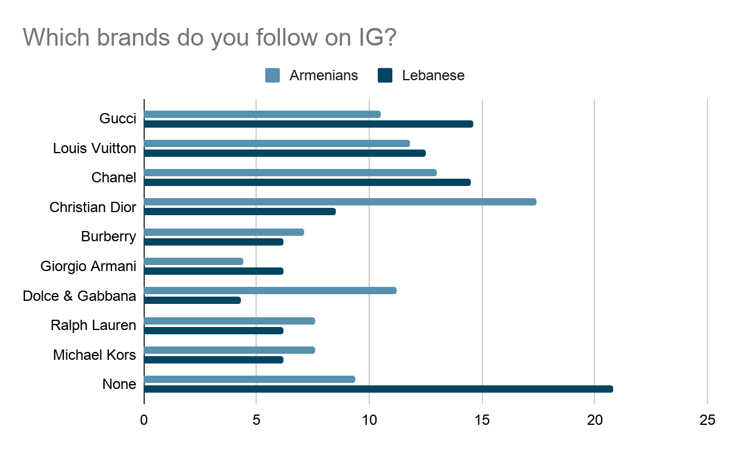
(Figure 5)
The biggest percentage of the Armenian respondents, (see Figure 5), 17,4%, follow Dior on IG. Interestingly, the biggest percentage of the Lebanese respondents, that is 20,8%, do not follow any luxury brand on IG. The second biggest percentage of the Armenian respondents, 13%, follow Chanel, 11,8% follow Louis Vuitton, 11,2% follow Dolce & Gabbana. Next 10,5% follow Gucci, which is actually the most followed brand by the Lebanese respondents. 9,4% of the Armenian respondents do not follow any designer brands at all. Ralph Lauren and Michael Kors are both followed by 7,6% each by the Armenians. 7,1% of them chose Burberry and the remaining 4,4% followed Giorgio Armani. Whereas from the Lebanese respondents, 14,6% follow Gucci, 14,5% follow Chanel, and 12,5% follow Louis Vuitton. The next 8,5% of the Lebanese respondents follow Dior on IG. Interestingly, Burberry, Giorgio Armani, Ralph Lauren and Michael Kors are all followed by 6,2% each of the Lebanese respondents. And the smallest percentage of the Lebanese respondents, 4,3%, follow Dolce & Gabbana on IG. It is seen how the first 4 brands; Gucci, Louis Vuitton, Chanel, and Dior are the most followed ones by both respondents, however there is a huge difference in the percentages of the respondents who don’t follow any brands; 9,4% Armenians are exactly half of the 20,8% Lebanese who don’t follow any brands. These results make it even more obvious that the Lebanese respondents don’t care about designer brands as much as Armenians do.
The next set of questions are the psychological ones with the one about how the respondents felt after buying a luxury brand off IG being the first question.
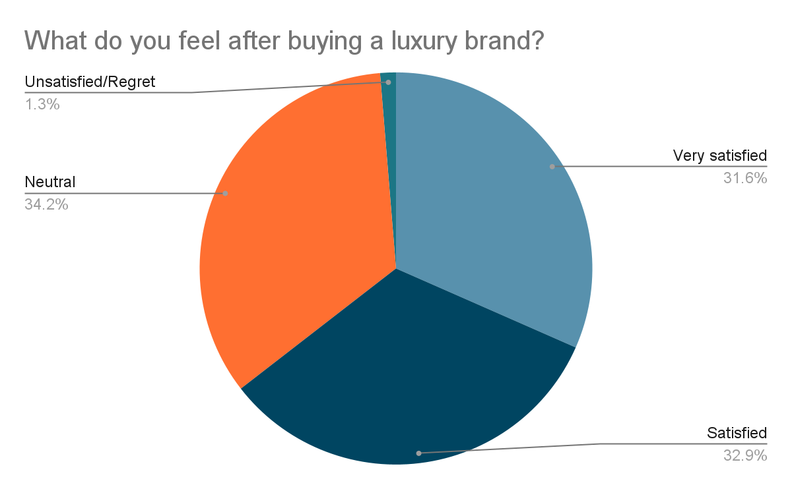
(Figure 6)
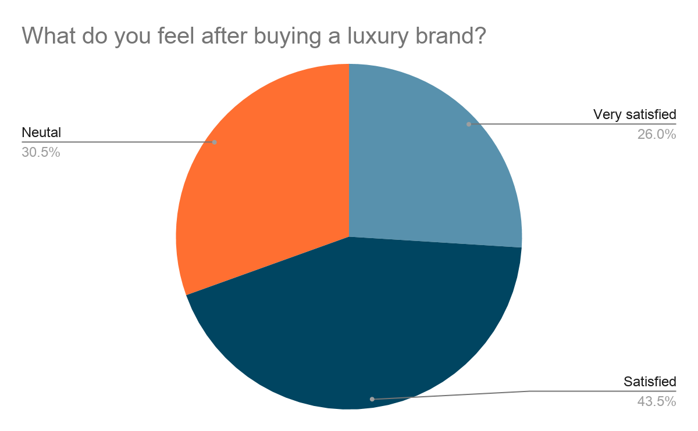
(Figure 7)
The biggest percentage of the Armenians, (see Figure 6), 34,2%, responded with feeling neutral about it. Whereas the biggest percentage of the Lebanese respondents, (see Figure 7), 43,5%, said they felt satisfied after buying luxury. 32.9% of the Armenians felt satisfied, 31,6% of them felt very satisfied, and only 1,3% of them felt unsatisfied and regretted buying the luxury items. 30,5% of the Lebanese felt neutral after buying luxury, 26% of them felt very satisfied, and nobody from the Lebanese respondents felt regret. Interestingly enough, there was a similarity between both audiences, as there was almost no one who felt unsatisfied with the brands, proving that they didn’t have any bad experiences after purchasing brands on IG, which further proves how well IG does its digital marketing to influence its users to buy luxury brands.
The next question asked in the surveys was: “How many times have you talked about a luxury item and that brand's ad has appeared on your IG feed?” The biggest percentage of the Armenian respondents, that was 37,5%, chose the “Often” option, and the majority of the Lebanese respondents, 26%, chose the “Sometimes” option. Moving on with the other percentages, 28,7% of the Armenians experienced this situation “Sometimes,” 15% experienced it “Always,” 13,7% “Never” experienced it, and only 5% of them “Rarely” experienced it. Interestingly, both “Always,” and “Rarely” were answered by each 21,7% of the Lebanese respondents. 17,6% of the Lebanese picked the option “Often,” and only 13% have “Never” experienced this occurrence before. These results are once again similar, since the majority of the respondents have experienced this occurrence once in their lives. From this it is further proven how IG tracks its users, no matter where they come from, or what cultural background they have.
Following this question, there is the one about other social media, which was: “How many times have you come across the same ad about a luxury brand on different social media?” 44,5% of the Armenian respondents chose “Often,” whereas the Lebanese chose “Often” and ‘Sometimes” each 33,3%. 21,5% of the Armenians chose “Sometimes,” but “Always” and “Rarely” both equally constituted 16,5%. Only 1,2% of the Armenians “Never” felt this occurrence. 28,7% of the Lebanese chose the option “Rarely,” 4,7% of them chose “Never,” and no one from the Lebanese respondents chose the option “Always.” It is interesting to once again see quite similar results, with the majorities of both Armenians and Lebanese having experienced this occurrence “Often” or “Sometimes.” This is clearly proving how other social media are also tracking their users, and curating specific content for specific users in order to target them and influence them to consume luxury.
And the last question of the survey was: “How does others showcasing luxury brands on IG make you feel?”

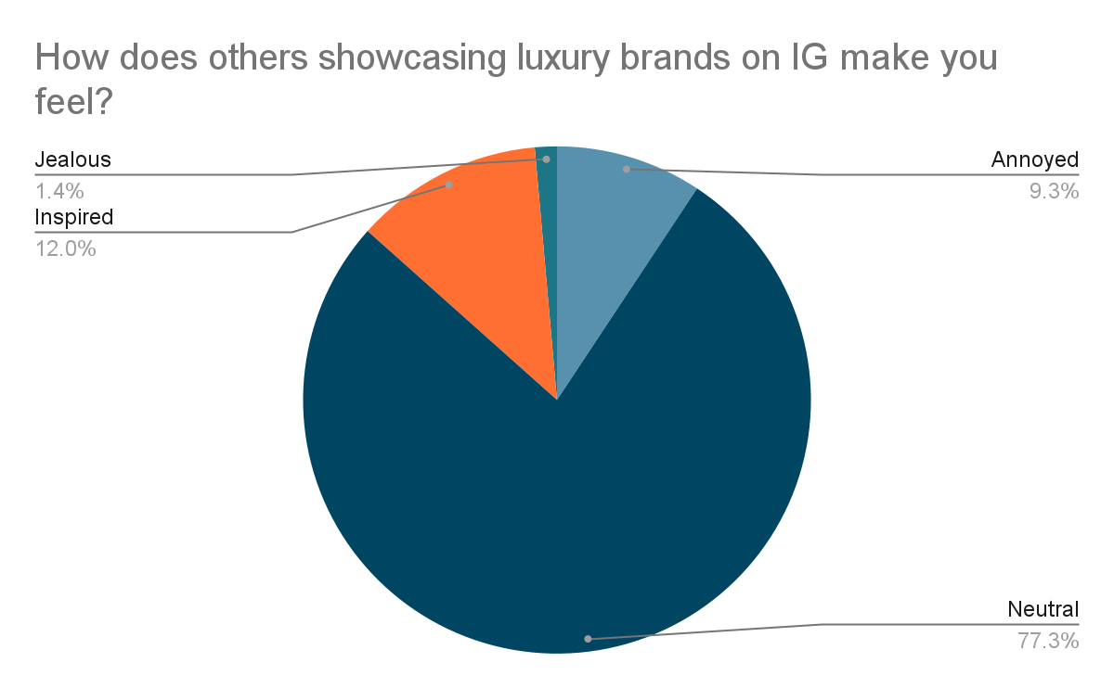
(Figure 8)

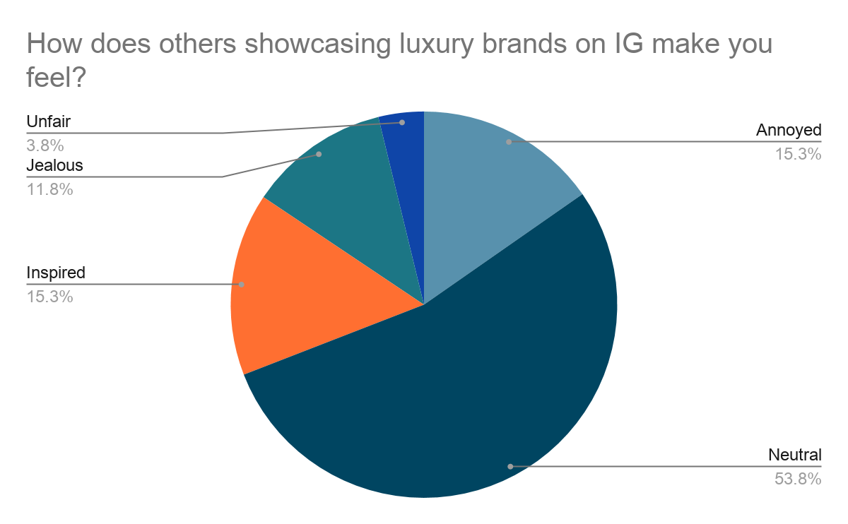
(Figure 9)
Both majorities of the Armenian and Lebanese audiences, (see Figures 8 & 9), 77,3% and 53,8% respectfully, chose the option “Neutral.” 12% of the Armenians felt “Inspired,” 9,3% felt “Annoyed,” and only 1,4% felt “Jealous.” The options “Annoyed” and “Inspired” both equally constituted 15,3% of the Lebanese respondents. 11,8% of them felt “Jealous,” and 3,8% added their own answer which was “Unfair.” Again, there was a similarity with both majorities choosing the safe option “Neutral,” but the option “Jealous” had more respondents choosing it from the Lebanese audience than the Armenian one. It is noticeable how there were more people choosing “Annoyed” than the “Jealous” one, which may be because of the fact that not everyone will be 100% honest in the surveys, since being annoyed may be a sign of jealousy.

Focus Group Findings & Analysis

Moving on to the focus group analysis, let us first put out the two groups’ respondents’ answers in order to compare them and find conclusions. The first question was about whether the participants usually shop from malls, stores, or IG. The Armenian participants answered that they shop from both stores and IG, but most of them said that they “go to malls.” One of the Lebanese respondents answered to this question saying that it is not common for her to shop via IG, but she does take inspiration from it. Another respondent added that it’s not like she purposely goes and searches for something on IG, she just happens to see an item and she checks it out to see if she can get that item from the mall. Overall, this question's answers are pretty similar, since both the Armenian and Lebanese audiences’ primary source of shopping are shopping malls, but IG is a source of inspiration to decide what to shop.
The second question of the focus group was about whether or not the participants feel that IG has turned into a shopping center recently and why they feel that. One Armenian participant said “Yeah, absolutely” and after I asked her if she likes IG’s recent change she answered: “No, I don’t like it, because it has become uninteresting.” Another person said that she doesn’t think it has turned into a shopping center, because we can still see people posting great content. A third participant also looks at IG as more of a social media than a shopping center. Now the Lebanese participants’ viewpoints were completely different, because the participants answered saying that IG has shifted from being a social platform to a shopping center especially after the recent update where at the bottom section where we used to press to post pictures is now a place to purchase items. One of them added saying: “It’s so annoying, it was a social platform before but now it has become a place to shop.” Another respondent then added that just because IG is adding all these features, it doesn’t mean that it’s improving itself as an app, because now there is too much info in one it, which is becoming confusing. The Lebanese all felt the shift IG had in terms of becoming a shopping place, however the Armenian audience still doesn’t see the big shift IG made.
The next question asked in both of the focus groups was about IG influencers. The respondents were asked if they have preferred influencers they follow and whether they think of them as real or fake on IG. Starting off with the Armenian focus group, the first participant mentioned that she follows Ed Mylett and Dan Lok, who are business influencers. She thought that they are pretty real, because “they are sharing their own experiences.” She added that she follows influencers that motivate her, and not celebrities, because she’s not into stuff like makeup and luxury; “I can do that myself but like I follow people who will transform me spiritually and educate me. I want to invest in myself.” Other participants from the Armenian focus group mentioned that they follow celebrities like Irina Shayk, Kendall Jenner and Bella Hadid, mostly because of their popularity and sense of style. Another participant added: “Personally, I don’t follow a lot of influencers, but I know other people who blindly listen to the influencers they follow and go and buy the things they advertise.” On the other hand, the Lebanese respondents answered that they follow influencers mostly to get inspired by them. Someone else added that she follows influencers to get promotion codes from them, not to mention the games and contests that those influencers organize for their followers. This question’s answers were diverse in both of the groups, but it was seen that there was a similar pattern in both of the groups, which was getting inspiration from influencers.
Then, I asked both focus group participants if they ever unfollowed certain influencers and felt relieved afterwards. One Armenian respondent said that she follows a lot of influencers and she doesn’t want to remove them, because she wants to see more content from them. Another respondent said that she follows celebrities to stay updated on the trends and wouldn’t want to unfollow them. Now the Lebanese respondents' answers were: “I follow people that know what to post about, people who advocate for normalizing body image, or telling people that nothing is perfect and there are always flaws and that we need to get used to it.” That same respondent then added that she tries to stay away from toxic influencers that only post about how “perfect” they are and if she ever stumbled upon these types of influencers that she happened to be following, she would unfollow them immediately. Another person added that even though we all knew how fake social media was, it is only recently that we discover more “fake stuff” that is on IG, like “the editing, the Photoshop, the lighting.” She then added that all of these influencers have an entire team behind them and that “a lot of work goes into one picture.” Apparently, she too used to follow fake influencers. She said “they're not fake people but they are fake influencers, because they don’t show their real lives,” “they don’t influence me for the better, they influence me for the worst”. She then continued telling that once she started following “real influencers” and started seeing content such as real skin and acne, she felt better because she knew that there are people like her, people that she could relate to, unlike the fake influencers living fantasy lifestyles. The answers, and the style of communication was once again very diverse. The Armenian respondents want to stay trendy and choose to do that by following celebrities and influencers, whereas the Lebanese don’t want to see edited and curated content all the time, they want to see real skin, they want to see normal body image, and influencers that look like normal people so that they can relate to them.
The next question in the focus groups is if the participants come across luxury brands’ ads on IG, or see people wearing them and which brands do they come across the most. Both focus group participants came across designer brands on IG, whether in the form of ads or on other people. For the question demanding to specify which brands they see the most, the Armenian participants answered brands like Zara, H&M, Givenchy, Gucci, and Giorgio Armani. One of them added how she has been recently seeing Armenian designer brands on her feed as well. The Lebanese focus group had a different approach while answering this question. Firstly, one participant said how her whole feed is designer bags and clothes that are obviously worn by influencers and celebrities, since “normal people cannot afford that.” Another person added that in the current economic situation, it is really hard to afford basic things. The exchange rate in Lebanon is so bad that they have to pay triple or four times the price, and the things that they used to buy that came from abroad are even more expensive. They cannot buy them anymore. She then added that even the ads that they see on IG are all sold in US dollars so they just skip the ads since they can’t afford them anymore so they just look at the local shops in Lebanon to see if they can find something from there or else they’re not going to buy. Additionally, another respondent added that they often forget that the influencers aren't even the ones who buy those luxury brands, most of their stuff are free gifts, so it is obvious that we are gonna see them wearing a lot of designer items. What was interesting to notice was that none of the participants mentioned any brand at all. A clear differentiation can be seen in both of the audiences, with the Armenians being all in on the luxury brands and the Lebanese not even mentioning brand names and instead, talking about their current economic crisis. By this comparison, it is clear how different people coming from different cultures have different priorities in their shopping choices.
Then we have the question that is concerned about whether or not the participants look up a certain brand’s page after they come across an ad or someone wearing them. One Armenian respondent answered: “Yes, I mostly check the pages to check the prices.” Another respondent answered that she doesn’t check the clothes, but she checks the accessories of designer brands, mostly their perfumes. Then, the same question was asked to the Lebanese respondents and one of them answered that she doesn’t go and search for a specific item, but if she sees an ad and she likes it she just goes and checks it out. But she added that she won’t specifically go and check for the brand on IG. Another person added that she knows how influencers put high expectations on normal people since they are always receiving designer gifts. So she tries as much as she can not to follow these types of “show-off influencers'' and to follow more beneficial influencers, like people who “really influence me”, and “not just for the looks and for the luxury brands.” She always keeps in her mind that they are always going to receive gifts and that she will never get that much luxury clothes in her closet, so she stays realistic and doesn’t follow these influencers. She then added that she might be inspired by the look, but she won’t go and buy it “I won’t go and kill myself to buy 1 luxury item” It is plainly evident how different these two audiences handle the luxury brands’ marketing on IG, even the way they answer the focus group questions were different. The Armenian respondents are interested in brands and in their prices, but Lebanese people don’t put that much effort into searching for a luxury item, instead they keep in their minds how fake IG is and that all those expositions of luxury that celebrities and influencers do are all gifts that they receive for being famous.
Next, I asked the respondents if they feel they have privacy on IG. Armenians started with: “Never.” Another person added: “Yesterday my mom said that a new perfume just came out and I saw that perfume’s ad on my feed. But that’s not only on IG that happens on FB on Google… I guess all our phones are being heard.” Another participant jumped in on the discussion by saying: “Yes I agree. For example I searched something from Kenzo on Google, and I saw Kenzo’s ads on FB and IG.” The Lebanese participants had similar viewpoints concerning this topic, as someone answered: “Yes, anything you see on FB you see it on IG, and even if you have a fake account and you look up something and then go to your main account, you see those same items’ ads. Everything is linked. Even when you look for something on YouTube, you see the same items’ ads on IG.” And the last comment was: “Even when I had an offline conversation and my phone was just next to me I was talking with my friend about clothes from a store that I never bought from before or I never wanted to buy even and then I opened my phone and I saw all the ads about it on my feed.” The similar answers of the two focus groups prove how common this feeling of not having any privacy on IG is. Even when they come from different countries, all of them felt this before, whether they were on or off the app.
The next question was about whether or not it would be the same if there was no IG, more specifically if the participants would go and buy luxury without IG. The Armenian participants thought that without IG things would have been much more different, since it is a place to advertise. One participant from the Lebanese focus group answered that people don’t realize how much IG affects us on all levels, emotionally, physically, fashion-wise, etc. “A lot of people are being dragged behind trends on IG without even realizing it”. “Especially since there is a global pandemic” she added, “if there was no IG, a lot of trends wouldn't have been happening.” A lot of people started cooking and showing off their recipes on IG, others started showcasing their secret talents. Then a lot of people started feeling useless during the lockdown, because they did not have secret talents she said. “If we didn’t have IG, we would have more positive thoughts about ourselves.” She then added that of course there are a lot of positive accounts that benefit us, but there are so many negative and toxic accounts that need to be regulated. She suggested that it would be better if there were alerts for users to tell them what content is fake and what content is real. Another respondent added that it had been 1 month since she deactivated her IG, and her mental health has been so much better than when she had IG. She said that it’s not just the influencers that affect us negatively, there are normal people as well that always show off what they wear or what they buy on IG and “it keeps influencing you in bad ways.” When I asked her if it was hard for her to deactivate her account, she admitted that at first it was hard to deactivate it, because our minds are conditioned to scroll through IG every day, and watch our friends’ stories, which are all part of our routine. But then she added that: “you get used to it, since you talk to the people you want to talk to on other platforms that are not toxic as much.” “All that time has passed. I don’t miss it, I really don’t miss it” she concluded. Another person agreed with the previous comments of the other participants and said that there’s no such thing as influencing positive vibes on IG. Apparently, she follows influencers that are really giving us positive vibes, after which she ended her comment with: “You know that you can’t always be happy.” This question’s answers prove that both audiences agree that it wouldn’t be the same without IG, however, the explanations to why without IG it wouldn’t have been the same are very different. The Armenians concentrated on the positive side of IG, and explained how much IG is needed for marketing purposes, whereas the Lebanese audience concentrated on the negative side of IG, and pointed out how much better their lives and self-perceptions would be if there was no IG. Again, we see the difference in the area of focus these two audiences have.
Next question the focus group audiences had to answer was if they would want to be an influencer or not, and whether or not they would showcase their luxury or if they would do something differently? Armenian respondents’ answers were such as: “I would show off on my account, because it will bring money and fame.” Another answer was: “Maybe me too, it will help me make money, just like the Armenian community, the Armenian celebrities and influencers are all making money out of IG.” Another respondent stated that she wouldn’t change anything in the influencers’ style, because she thinks that those influences’ feeds are what helps them be influencers and that's what keeps their ratings high. She added that if someone changes something or doesn’t showcase designer brands, their audience will decrease, since followers love people that always strive for wearing stylish clothes and they look up to them so that they can resemble them. She continued explaining that if you wear basic clothes, your rating will drop, because they do contests with those branded items and if they were basic items it would be less likely that someone would participate in a contest to win that prize. She then brought an example of this situation: “For instance, there was a time when Khloe Kardashian was organizing a contest for Louis Vuitton bags, where her followers had to follow other accounts and tag their friends under her post in order to win those bags, if it was basic Armenian local stores’ bags, that contest wouldn't have been made in the first place. Or if it was an ordinary brand like Zara, people wouldn’t have gone to those extents to try to win those bags.” Another participant from the focus group commented on this statement saying: “Because Zara cannot be compared to other brands, okay I like Zara, it has some pretty items once in a while, but Zara doesn’t have quality at all. You can buy Zara for your day to day outfits but if I wanna buy something decent I’ll go buy other brands, because I want more.” She then went on saying that even though there are people who don't like those designer brands, she goes crazy for them, because she knows that when she buys those items she can use them for a very long time. She concludes with: “And after buying them you feel so good because you are able to spend that much on yourself.” The discussion continued with another participant saying how influencers simply can’t advertise something like Zara on their page. She concluded her comment by saying: “Wearing designer brands is a way to differentiate yourself.”
Moving on to the Lebanese focus group, one participant answered that they would want to become an influencer, because it would be nice to change someone’s point of view about certain topics. “You can save someone from a platform that you’re using. IG doesn’t become useless when you use it the right way, for example when you change someone’s life by raising awareness about certain issues.” Another respondent added: “Me too, I would use it to raise awareness on certain topics and not just strictly fashion, I would use my voice and my followers, which a lot of influencers don’t use, even though they would raise so much awareness if they did. “And lastly, a participant agreed to the previous participant’s comments and said: “Yes I totally agree, you can do so many things when you are an influencer, you can raise funds, raise awareness, etc. If I had the chance to have a realistic IG account and raise awareness about important topics I would because who wouldn't? It's an amazing opportunity actually…” Additionally, I opened a discussion during the Lebanese focus group, which was about American influencers, selective activism and how in the Middle East, people talk more about social issues, because politically there are more issues in the Middle East than in America. Someone answered: “In Lebanon there are a lot of show-off people who are like “I’m rich come see” but there are a lot of accounts that talk about social issues as well, I guess it all comes from the background that you have, if you are well educated, cultured, etc.” Another person added that Lebanese people’s culture, values, and beliefs are different from Americans’ that is why there is a huge difference in the content that Lebanese and American people post. Another participant added: “I follow a few American influencers and I don't identify with them, I feel like they live in another world. They don't have any problems in their lives, they're just wearing nice clothes and having a good time, all day every day.” She continued explaining how she prefers to follow Lebanese influencers or people in her region, because she knows that what they show on their page is more similar to her life and she will identify with it. She ended her comment by saying: “We forget that they don't post the bad stuff, we tend to think that they are living their best lives and we’re suffering, but it's not true because we don't see all sides of their lives.” Then someone else added that those Lebanese influencers aren’t even living in Lebanon, most of them are in more developed Arab countries like Dubai or they’re touring in Europe, so they don’t even experience what their people are going through.
This question’s answers show how different priorities these two groups have, and how differently they would use their IG accounts if they were influencers. The Armenians don’t see any necessary change in the way influencers are portraying their lives through IG, and they view it as a means to make money. On the other hand, the Lebanese respondents talked about how they will use their voice to raise awareness about topics that matter to them, and not just showcase their styles and show off their outfits. It is obvious how affected the Lebanese people are from everything that Lebanon went through, and how they realize how in life there is more than just showcasing luxury on IG, but the Armenians didn’t mention social issues at all and they just concentrated on the importance of making money and looking glamorous on IG.
The last question asked in the focus groups was whether or not the participants think that luxury brands are worth buying. The Armenian focus group’s answers were all for buying luxury. One respondent started off by saying: “Yes, yes, yes, because when you touch it you feel the quality, for example I have had a Givenchy bag for 3 years now, and you cannot imagine how resilient that bag is. You can even throw it on the ground and nothing will happen to it, their high quality is on another level.” There was one participant who answered with “No” at the same time as the first respondent, but then added “maybe yeah their quality is better, but I think if those stores didn’t have the recognition that they have right now throughout the world, they wouldn’t have been that expensive with that quality. You can find good quality products elsewhere, without that brand’s name, they’re just doing branding.” Another answer was: “Yeah, it is, let me explain why, it’s an asset, so you give money, and you get another asset. It adds to your life, because you’re not wasting your money instead you are obtaining an asset, since you can always go and sell it.” The last comment was from someone that claimed to not only love brands but also wearing luxury brands on a daily basis; “I am so for designer brands selling their items with those prices, because you know that in the street not everyone can wear what you are wearing. For me the quality and the look are irreplaceable.” This question was answered by the Lebanese participants again by the tragic economic situation that Lebanon is currently facing. “We have more important priorities… I can't afford to buy luxury when I have to pay triple my tuition than what I used to pay before, I have to pay for my rent, I have to pay for my food, everything is becoming so expensive.” Then she added: “We don't really care about the luxury brands.'' The participant claimed that people aren’t even buying new clothes anymore because they aren’t even going out of the house since the lockdown. “Even if beforehand we thought that buying luxury was important, right now it's not the case because we have different priorities.” This comment was followed by other similar comments, which were: “No bag is worth $3000” She said that people are mostly buying the name of the brand, since you can get the same product without a brand or a brand that's not designer ‘with much lesser price and better quality.’” However, someone else admitted that brands give you a certain pleasure. “Once in a while, for example, on my birthday or when I'm graduating I might pamper myself and buy designer brands, other than that I don’t think they’re worthy.” She continued with: “It would be nice, I would feel good, of course everyone loves wearing brands, but I wouldn't buy them to wear for my day to day life.” Another comment was that it is generational, because in this generation people will buy designer brands just to show off. Two other people agreed to this comment and one of them added: “I'm not attracted by luxury, personally I don't have this love towards any luxury brands.” Additionally, someone else added that age is a big factor as well. In our age we have the maturity to understand what is going on IG, but younger generations don’t. She stated: “For example, my sister is 14 and whenever she sees some designer brand on IG she wants them no matter what, and her friends are also like her.” Another participant of the Lebanese focus group once again mentioned the current economic situation in Lebanon, saying that it was an “eye opener,” since there are so many things people could do instead of buying useless brands. She stated: “Why would you spend $3000 on a bag when you could do so much more with that money.” And went on by saying: “Sometimes the things that they put aren't even that good looking, they spend so much money on them and they're not even nice.” Then someone else commented: “There are some people who don't have food on their table and then there is this inequality where people spend thousands and thousands of dollars on items which are not even necessary for surviving.” And lastly, someone mentioned that she thinks people don’t even buy it for the quality of the product, yet they buy it just to show it off. She concluded how this whole thing is all psychological; “It doesn’t give you anything in your life, it doesn’t add quality to your life, it’s just psychological pleasure.”
Obviously, this past question’s comments made clear that Armenians in general care a lot about luxury and looks, and they feel that in order to feel unique and differentiate themselves from others, they have to wear luxury. They absolutely love showing off and have no doubts on the quality of those brands. The Lebanese, however, do not care that much about luxury. In my own personal opinion, in the Armenian society there is a habit of staring at other people and what they are wearing, etc. But in the Lebanese culture, there is no such thing. Lebanese people don’t feel that they have to wear designer clothes in order to differentiate from others, instead, they care more about social and political issues and give value to what someone has to offer from the inside and not to what brands he/she wears.
VI. Conclusions
Through this research it was made clear that IG has more influence on the Armenian people than the Lebanese people. The comparison and analysis of the survey and focus group responses made it obvious how much different these two groups of people are in their shopping choices. Armenians in general follow more luxury brands and influencers than Lebanese people do. The percentage of the Lebanese respondents that felt jealous of others showcasing luxury on IG was more than the percentage of Armenians, which again proved how Armenians don’t see any negative traits of showcasing luxury brands. Even when it came to influencers, the Armenians admitted to following them to stay trendy, whereas the Lebanese in general don’t like the curated content that IG influencers post. Even when asked about the luxury brands that are seen on IG, the Armenians were quick to mention a lot of brand names, but the Lebanese audience didn’t even mention one brand name and instead they talked about the economic crisis of their country. Armenians check brands and their prices through IG, whereas the Lebanese respondents don’t even search for the brands. Even when asked if it would have been the same if there was no IG, the Armenians felt that marketing wise it would be far worse if there was no IG, but the Lebanese stated how much better their lives would have been if there was no IG. The Armenians simply care more about luxury and glam life, since they wouldn’t change a thing if they were influencers, but the Lebanese give more importance to social and political issues, since if they had the opportunity to be an influencer they would do it a lot differently than the Armenians would have. All in all, the Armenians see luxury brands as a means to differentiate themselves from others, but the Lebanese differentiate themselves from others using different ways. To conclude, IG uses a lot of tools to influence its users, but it has more influence on the Armenians than it has on the Lebanese when it comes to luxury shopping.

VII. Limitations and Avenues for Future Research

The limitations of this research were that there was not enough data collected overall, making it difficult to find out the viewpoints of both Armenian and Lebanese people as a whole. Additional limitations may have been fears of judgment that people may have while giving out their personal opinions in surveys and focus groups. For instance, in the last question in the surveys about what the participants usually feel when they see others showcasing luxury brands on IG, some people may have not been completely honest with their answers out of fear of not looking jealous. And lastly, another limitation was the current global pandemic that made it difficult to conduct focus groups easily, since they were held via Zoom. The participants would have felt much closer to one another and would have discussed their opinions even more if they were physically close to each other.
An avenue for future research might be the influence of TikTok on Armenians, Lebanese, or Armenians VS Lebanese, on their luxury consumption choices. Having in mind that TikTok is taking over the Internet and surpassing IG, perhaps it would have a similar or even completely different influence on people regarding their consumption choices.

VIII. Works Cited

Duffy B. and Hund E., (2015) “Having it All” on Social Media: Entrepreneurial Femininity and
Self-Branding Among Fashion Bloggers, Social Media + Society, pp. 1-11.

Gino F, Norton MI, Ariely D. The counterfeit self: the deceptive costs of faking it,
Psychological Science, 2010 May; 21(5):712-20.

Hannover and Kuhnen, (2002), The Clothing Makes the Self via Knowledge Activation1,
Journal of Applied Social Psychology, 32(12): 2513-2525.

Hearn A., (2008), Meat, Mask, Burden`:
Probing the contours of the branded` self, 8(2):197-217.

Johnson et al., (2014), Fashion and Textiles, Dress, body and self:
Research in the social psychology of dress, 1:20.

Kennedy, (2016), Known or knowing publics?
Social media data mining and the question of public agency, 2(2).

Marwick, A. (2013). Status Update: Celebrity, Publicity, and Branding in the Social Media Age.
New Haven; London: Yale University Press, 163-204.

Ogle et al., (2013), The role of maternity dress consumption in shaping the self and identity
during the liminal transition of pregnancy, Journal of Consumer Culture, 13(2): 119-139.

Perthuis K. and Findlay R., (2019), How Fashion Travels: The Fashionable Ideal in the Age of
Instagram, Fashion Theory, 23:2, 219-242.

Ramao et al., (2019), Leveraging a luxury fashion brand through social media,
European Research on Management and Business Economics 25, 15-22.

Salisbury M. and Pooley J., (2017), The #nofilter Self: The Contest for Authenticity among
Social Networking Sites, Social Sciences, 2002-2016.

Sirgy M.J. (2015) Self-Image/Product-Image Congruity and Advertising Strategy. In: Kothari,
Proceedings of the 1982 Academy of Marketing Science (AMS) Annual Conference, Volume 09, eds., pp. 556-561.

