CRISIS COMMUNICATION ON TWITTER: A CASE STUDY OF
A 2018 H&M CONTROVERSY
by

Nancy Nersisyan
Presented to the Department of English & Communications
in Partial Fulfillment of the
Requirements for the Degree of Bachelor of Arts

American University of Armenia
Yerevan, Armenia

May 17, 2021

Table of Contents
Abstract 3
Introduction 4
Literature Review 12
Research Questions and Methodology 19
Analysis and Findings 21
Limitations and Avenues for Future Research 34
Bibliography 38
Appendices 42

Abstract
This research is a case study about the 2018 H&M Coolest Monkey in the Jungle PR controversy. It aims to understand the brand's crisis communication plan during the controversy and what they did to repair the situation. Besides this, it studies the reputation of H&M on Twitter by analyzing the language used by consumers in 3000+ tweets within the categories of #boycotthm and #hmracist. During the analysis of the tweets, the geolocations of some tweets were taken and mapped to see the usage of the hashtags mentioned above across the world.
Keywords: PR, brand reputation, Twitter controversy, H&M, crisis communication

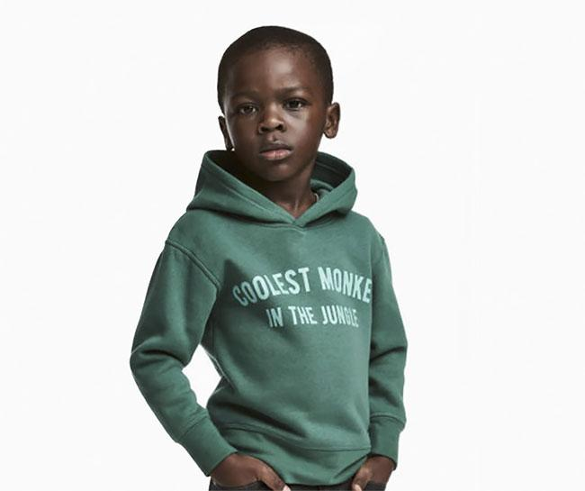
Figure 1: H&M's controversial 2018 ad
Introduction
X brand makes a Y number of Twitter users angry because of a controversial statement, which equals a controversy that may ruin the corporation's sales along with the public considering them “canceled.” Does this formula sound familiar? It might, as it usually seems like a recipe for disaster for a corporation to be in the eye of any kind of social media storm. This capstone project will focus on the global Twitter response to the 2018 H&M "Coolest Monkey in the Jungle" PR controversy. It will first discuss why the sweatshirt's choice and the image taken were such a big wake-up call for the H&M brand. The second part of the research will then analyze the words used by Twitter users and map their geolocations to understand who was angered by this controversy the most. The final portion will observe how H&M has changed its strategies after this controversy.
Based in Sweden, Hennes & Mauritz AB Group has 5,000 stores in 74 markets across the globe. It is the parent company of the following companies: H&M, COS, Monki, Weekday, & Other Stories, Cheap Monday, H&M Home, and ARKET. These companies are marketed as" a family of brands, driven by our desire to make great design available to everyone in a sustainable way." (H&M Group, n.d.)
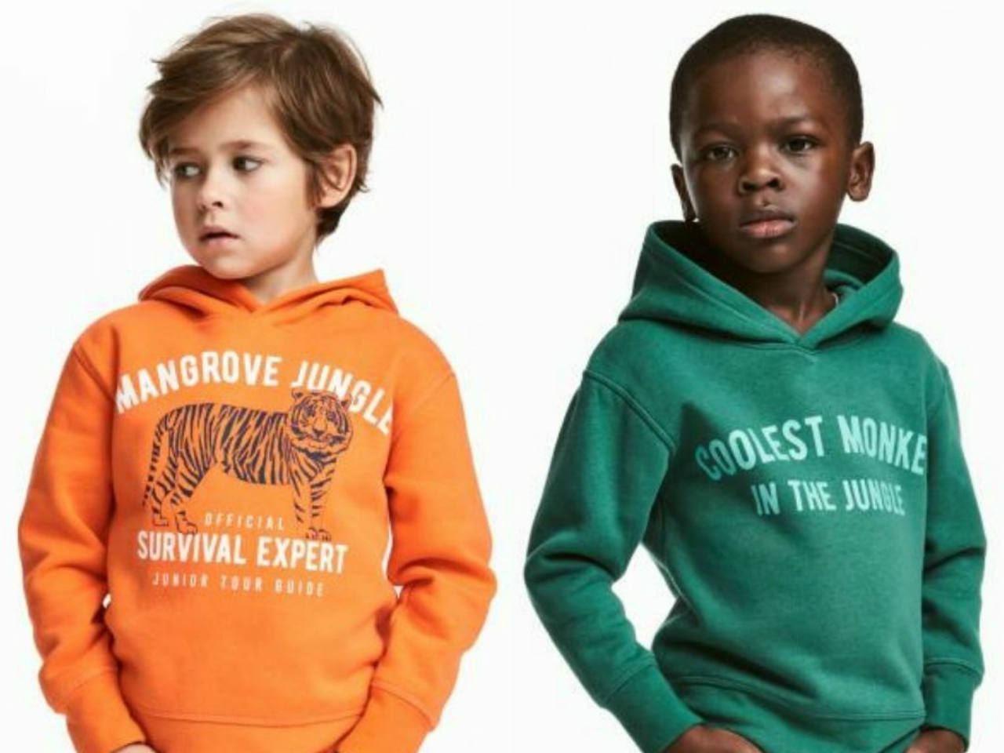
In 2018 Liam Mango, a five-year-old Black male, modeled a green sweatshirt with the words "Coolest Monkey in the Jungle." This sweatshirt was advertised on the H&M U.K. website, in the same listing alongside another white male, who modeled an orange sweatshirt
Figure 2: Comparison of Two Sweatshirt Options Offered on the H&M Website
with the words "Survival Expert." This difference was not received well by the public due to the

the long-lasting trope of African Americans being described as "apes." It is considered one of the oldest and most profoundly racist slanders in American history. This depiction — promoted by slave traders, historians, and practitioners of "scientific" racism — was used to justify slavery. This process of dehumanization often leads Americans to view African American men as larger and more fearsome than they are. (Staples, 2018)
Users on Twitter noticed the hoodie up on the U.K. site and started to spread the image across the platform. It is difficult to trace who tweeted about it first due to the high volume of tweets under the hashtag. This response prompted many celebrities such as Diddy, LeBron James, G-Eazy, and The Weeknd to post on social media about their disappointment towards the brand. The Weeknd, a Canadian pop singer, tweeted a statement that was exceptionally hard-hitting for H&M. He had previously collaborated with H&M in 2017 and had very successful campaigns of clothing collaborations. (Gonzalez, 2017.)
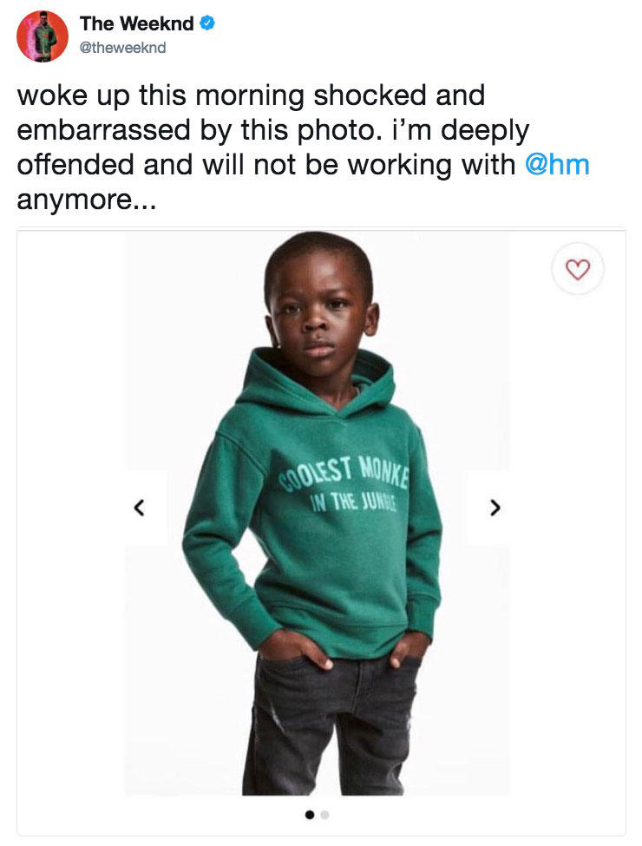
Figure 3: The Weeknd's Tweet About the Controversial Ad on January 8, 2018

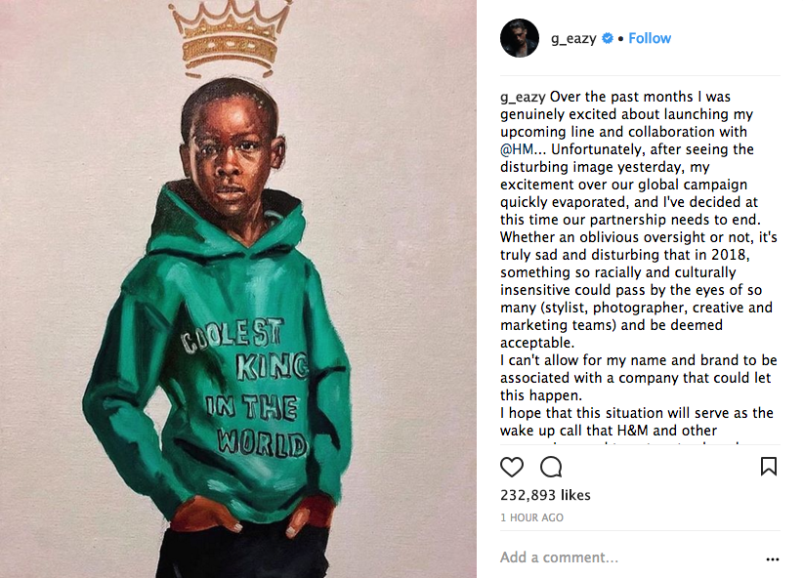
Figure 4: G-Eazy's Instagram Post About the Controversial Ad on January 8, 2018
G-Eazy, an American pop singer, also had an upcoming clothing collaboration with the brand, which he promptly withdrew from because of the controversy.
Liam Mango's mother, Terry Mango, also received backlash from the Black community when she mentioned that the response was an overreaction. “This is one of the hundreds of outfits my son has modeled…stop crying wolf all the time, unnecessary issue here…get over it,” she wrote on her Facebook. The harassment toward Liam's family got so bad that Terry had to ask H&M for assistance in dealing with the numerous reporters showing up at their front door. "I would not see such a connection to anything other than my son modeling a shirt.... but it is not an overreaction when it comes to racism. I have had racist remarks directed toward me before, even with the name monkey." Terry said during a 2018 This Morning interview.
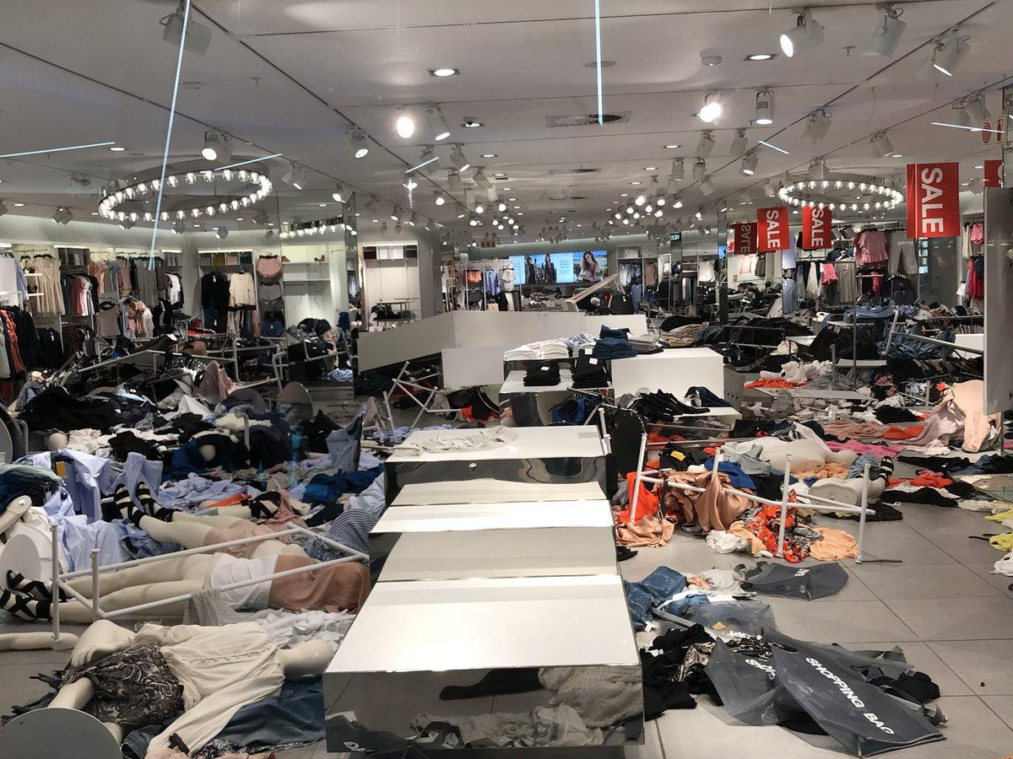
In turn, the ad angered many South Africans in particular. Demonstrators representing South Africa's second-largest opposition party, Economic Freedom Fighters, gathered at H&M locations across the country. (Fortin, 2018) The protests outside H&M locations in Johannesburg and Cape Town escalated with large crowds marching into the locations and trashing
Figure 5: H&M Store in South Africa After Protesters Entered on January 13, 2018
the stores. This prompted H&M to offer a statement that they would temporarily shut down all locations in South Africa and had a specific apology directed to protestors in South Africa.
Figure 6: H&M Tweet About Stores Being Trashed on January 13, 2018
On the first day of the controversy, the brand had a quick and very generic response to the outcry about the hoodie, which they offered to the Washington Post: "We understand that many people are upset about the image. We, who work at H&M, can only agree. We are deeply sorry that the picture was taken, and we also regret the actual print. Therefore, we have not only removed the image from our channels, but also the garment from our product offering globally. It is obvious that our routines have not been followed properly. This is without any doubt. We will thoroughly investigate why this happened to prevent this type of mistake from happening again." (H&M Group, 2018)
Besides this statement issued to the media, the official H&M Instagram account posted a comment replying to a user enraged by the controversy. “We sincerely apologize for offending people with an image of a printed hooded top. The image has been removed from all online channels. We believe in diversity and inclusion in all that we do and will be reviewing our internal policies accordingly.” (H&M Group, 2018). It was deemed the “most tone-deaf apology ever” by a popular African American news blogging site, Ice Cream Conversations. Xaviera, the blogger who wrote the post, stated that the company was “apologizing for the printed hoodie top…not for the putting said hoodie on a Black child.”
As mentioned, the brand's informal apology was not accepted and made consumers even angrier for refusing to address the actual issue on all H&M channels formally. They continued to stress that the hoodie should not have been manufactured in the first place. They considered the production of the hoodie the cause of the controversy and only stated that they have always believed in diversity.
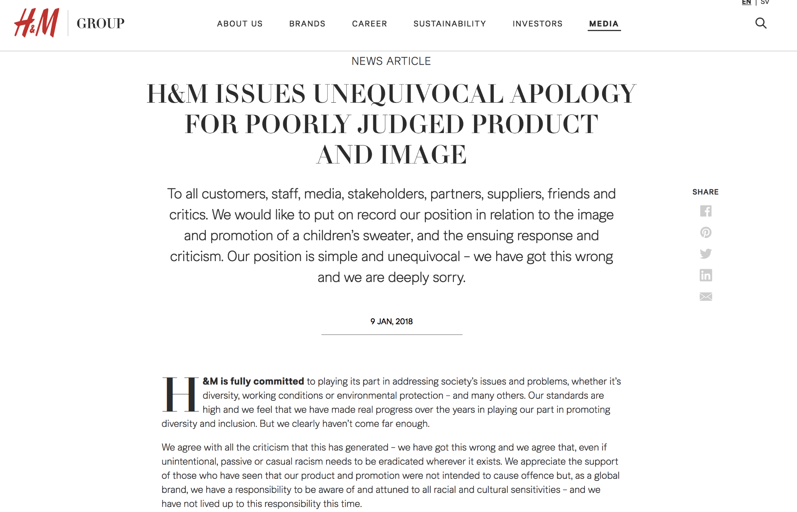
Figure 7: H&M's Apology Issued on January 9, 2018
After their first time striking out on their apology, H&M issued a second “official” apology through all their media channels: a press release, social media posts, and website posts. This apology was still very vague and focused more on how the company "feels that they have made real progress over the years in playing our part in promoting diversity and inclusion." But continued with, "But clearly we haven't come far enough." The caption of the apology reads, "H&M issues unequivocal apology for poorly judged product and image." "Poorly judged" can be interpreted as a passive construction that seems to push the blame off the brand. Was the product poorly judged by the audience or poorly judged by the brand? This phrase does not make it clear who is in the wrong in this situation, so the brand does not take the mistake upon itself completely. They mentioned that they “appreciate the support of those who have seen that our product and promotion were not intended to cause offence.” This portion is a subtle nod to the few people defending the company and pushing the narrative that the company was innocent.
After the apology, H&M hired Annie Wu, the new Global Leader for Diversity and Inclusiveness, as one of their steps to make sure such a mishap would not happen again. There was an interview with Annie Wu published on the H&M website in March 2018, where she stated that her role was to "bring both awareness of the topic of inclusiveness and diversity and help disrupt ourselves in this area. To make sure we make the changes internally in order to be at the forefront of the conversation. It involves looking at all processes and policies we have in place in the area and upgrading those where necessary."
As part of practices to prove to the public that they were sincerely ready to do their part for the Black community, H&M went through with the following steps:
- Hired a Nigerian American as the North America head of inclusion and diversity
- Created a seven-step processing system for all new clothing before they are for sale
- Created a system where at least 12 people in the studio will see a photo after it is uploaded
- Created a system to flag clothing at every stage and make notes about sensitivities
- Increased from one to five the number of people doing final-round quality checks
- Pledged that by 2025, 100 percent of employees would feel they have the same opportunity as anyone else and see visible diversity in leadership positions.
(The Arthur W. Page Center, n.d.)
Almost two years later, during the June 2020 Black Lives Matter protests, H&M published a press release addressing the racial issues happening in the U.S. "We also acknowledge our past mistakes, and they have made us acutely aware of how much we still need to learn. As a company, we are growing, but we can and must do better. We re-commit to taking tangible steps to challenge racism and support our colleagues, customers, and communities." (H&M Group, 2020). They pledged to "donate 500,000 USD to the NAACP Legal Defense and Education Fund, Color of Change, and the ACLU." These organizations work on fighting for justice, economic rights and empowerment of the Black community. The company also mentioned that they would constantly "provide our colleagues additional resources to educate them further around implicit bias." This statement is a nod to their 2018 controversy. The fact that the company acknowledges its wrongdoings and does not try to tiptoe around the issue signifies enormous growth.
Literature Review
To understand what it takes to address this PR controversy, one must have background knowledge on what a crisis is and what paths can be taken to manage a bad reputation. In Risk and Crisis Communication: Navigating the Tensions Between Organizations and the Public by Robert Littlefield and Timothy L. Sellnow, seven case studies of significant PR controversies are mentioned and how each of them left a considerable mark on the company. The book begins with defining a crisis: “a major occurrence with a potentially negative outcome affecting the organization, company, or industry, as well as its publics, products, services, or good name.” Each chapter discusses a different method and lesson learned from the controversies: timeliness, openness, certainty, organizational interest, taking responsibility, controlling the narrative, and emotional connection. If one does not have a balance of these seven traits, one cannot have an effective crisis communication plan on any channel. Since H&M had such a hasty and generic response to the crisis on their social media channels, these seven lessons have not been engraved into their crisis communication strategy.
“The Effectiveness of Corporate Communicative Responses to Accusations of Unethical Behavior” by Jeffrey L. Bradford and Dennis E. Garrett is a journal article that tests the effectiveness of a company's response through a model of potential corporate reactions. This source is the most effective for providing a graph of what a crisis response could potentially look like: excuses, justifications, concessions, or denials. When is each of these responses appropriate to use during crisis communication? Here is the list that the authors provided:
- Denials: when an accused actor can provide evidence that he/she did not commit an allegedly unethical action
- Excuses: when an accused actor can provide evidence that he/she did not have control over the occurrence and/or impact of a Corporate Responses to Unethical Behavior allegedly unethical action
- Justification: when an accused actor can provide evidence that inappropriate standards are being used to evaluate this allegedly unethical action
- Concession: when an accused actor concludes that the allegations raised are valid
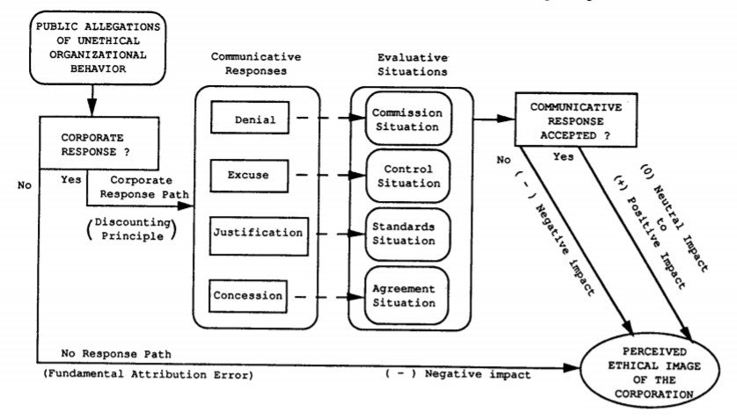
Figure 8: Bradford and Garrett’s Model on Corporate Crisis Communication Response
After measuring the effects of each crisis response, the authors concluded that concessions might be an especially effective response option. H&M took the excuses communicative response. Some excuses that they mentioned are that they had been working on moving forward in terms of diversity; they genuinely did not mean to convey a racist message; the product was the issue.
After understanding the above crisis responses, it would only be fair to focus on the perception of apology as a crisis management method. The journal article “The Power of Remorse and Apology” by Hershey H. Friedman gives a better understanding of what it means to be "sorry." Friedman brings an example of what steps should be taken as told by a 2004 O’Hara article: Identification of the wrongful act; Expression of remorse and regret for having committed the act; Promise to forbear from committing the wrongful act in the future; and Offer of repair. This source goes into detail about the importance of apologies in all sectors related to people: PR, law, politics, management. For PR specifically, "if the apology is not effective, the company will be seen as part of the problem, not the solution." (Friedman, 2006) This situation is precisely what happened to H&M. Their apology split people into groups: those who believed the controversy was an honest mistake that was completely innocent vs. those who did not. A genuine and empathetic apology is essential in the field of PR, which is why companies should aim to understand the weight of what it means to be genuinely "sorry."
“Denial outperforms apology in repairing organizational trust despite strong evidence of guilt” by Matteo Fuolia, Joost van de Weijer, and Carita Paradis challenges the view that apologizing is the first thing a company should do. This source sparks some debate in the reader's mind and questions whether the "traditional" approach of apologizing is the right thing to do. It explains the meaning of trust between organizations and their stakeholders. The source is because it offers a controversial opinion that most companies do not follow. Unlike an apology, a denial ignores the needs of the victims and signals no compassion for them (Coombs, 1999). For these reasons, the denial strategy is only prescribed for responding to rumors and unfair challenges (Coombs, 2007). This is the strategy that H&M took, denying all accusations of racism. What could have happened in the short term and long term if H&M had offered a different approach, one radically different than the one they gave?
With apologies defined, “Apology as Crisis Communication Strategy: Importance of Cultural Context” by Želimir Kešetović, Ivan Toth, and Nedžad Korajlić mentions that the cultural context of an apology is much more important than the apology itself. "Using a form of apology which is not in accordance with the cultural patterns of those to whom it has been addressed, the apology may jeopardize reconciliation, strengthen the resentment, prolong hostilities and additionally complicate resolving of the crisis." (Kešetović et al., 2014) For example, South Africans did not accept the type of apology that H&M put out, which resulted in the population further protesting the stores. Several H&M stores in Johannesburg remained closed. This source explains the importance of the five languages of apologies: expressing regret, accepting responsibility, making restitution, genuine repenting, and requesting forgiveness. If a company is mapping out its crisis communication plan to be distributed through any channel, it is vital that they understand the cultural context of each type of apology offered. The company must ask itself: which of these apologies is the best choice when directed towards a particular culture?
“ Culture is prescriptive because it consists of a series of instructions on how to behave in certain situations. It also defines the behavior in crisis situations as situations in which the basic values are threatened and the very survival brought into question, so that what is normal and acceptable in one society, can be completely out of place or at least unusual in another society and culture.” (Kešetović et al., 2014) This means that in order for a communication response to be effective, it must be looked at from different cultural contexts. This also means that the employees at any company must be from different backgrounds in order to have as many different points of view as possible. Every culture has a different set of eyes. It is even more important for a company present in 74 markets to have as many perspectives as possible on the apology or relevant crisis communication plan.
Two relevant dissertations were found discussing the same topic of H&M's controversy. Mette Kirk Kjærsgaard wrote the first dissertation, A Case Study of H&M's Online Crisis Communication. Her dissertation examined the theoretical frameworks of crisis communication, the importance of Corporate Social Responsibility and then had a coding analysis of 1360 Instagram comments under H&M’s post about the crisis. This dissertation aimed to take the perceptions of the public about H&M through the comments. It was found that 15% of these comments were positive towards H&M, and 26% were negative. It also splits the comments into 12 themes:
- Overreacting
- Racism/Race/Racial slur
- Offensive act
- Apology/Responsibility
- Perspective
- Mistake (Innocent vs. Intentional)
- Ignorance
- Forgiveness
- White supremacy
- Black culture
- Boycott
- Subliminal messaging
The second dissertation, Coolest Monkey in the Jungle, was written by Morten Christian Bjerre. His dissertation aimed to understand the long-term effects the controversy had on Americans, specifically through survey questions he had asked them.
Some questions included:
- Have your consumption patterns changed after the situation?
- To what extent do you agree with the following statement on a scale from 1-5: "H&M is a racist company."
- To what extent do you agree with the following statement: "My perception of H&M has been negatively influenced by this situation."
- “To what extent do you think the situation would impact your friends and family if
- they were customers of H&M prior to this situation?”
- “To what extent do you think the situation would impact your friends and family if
- they were customers of H&M prior to this situation?”
- To what extent do you think the situation would impact your friends and family if they were customers of H&M prior to this situation?
While Bjerre’s dissertation was very thought out and answered many questions about the public's stance on H&M, it was a small-scale survey. It had 128 respondents in total, with 22 unusable responses. This survey was far too narrow to be able to generalize the American public's general perception of H&M's brand and whether they would shop there after the controversy. The gap in this project is that there is no mention of where there was the most controversy about the communication plan that H&M implemented. To understand how the brand handled the crisis, there must be a clear map of which regions were angered by it the most.
While Kjærsgaard’s dissertation has many theoretical sources about whether or not H&M’s crisis communication plan was effective, her own analysis is lacking and has many causes for manual error. The gap in this project is that a human does the analysis of the comments. This may make way for a particular bias—maybe some words have a negative or positive connotation that is subjective to the human. It is impossible to have a reliable dataset that asks for personal opinions when sorting comments. For example, this Instagram comment written by a user was categorized by Kjærsgaard as “overreacting:”
“OKAY PEOPLE the sweater is fine, it’s only seen as a problem because you’re applying racial slurs towards it .... Don’t do that, just look at it for what it is...A KIDS SWEATER”
For me, this tweet could go into “perspective” instead of “overreacting” since the user state that people see what they want to see and apply racial slurs from their perspective.
In this case, this capstone project aims to address the consumer responses and language used to describe the crisis communication steps on Twitter specifically. This is because the platform is usually the most active for consumers to have discussions with each other. It also maps the places where people tweeted about the controversy to see who was angered by it the most. Each of the analysis portions are generated by a program or code to decrease human error through manual counting or subjectivity.
In conclusion, the existing literature contributes to this field by giving a general overview of the different crisis communications plans that can be formulated. The strength of the literature is the abundance of case studies in PR and how organizations have handled them -- it is good to look at past mistakes not to make them again. The weakness of the literature is the lack of a more extensive scaled survey to back up the claims that are being made about H&M's long-term reputation. However, nowadays, it is easier than ever to measure the spread of controversy and the public's thoughts on a brand through the help of digital tools that track trends.

Research Questions and Methodology
The first research question this project aims to answer is: how did H&M react to this controversy, and how did it revise its communication strategies after January 2018? The secondary research question is: how does Twitter language used by both a brand and its consumers play a role in portraying reputation?
The first part of the research was done through Google Trends, an online tool provided by Google to look at terms related to H&M that were searched in the past five years worldwide.
The data was collected by doing a Google Trends search of keywords such as:
- H&M controversy
- H&M apology
- H&M racist
- Coolest monkey in the jungle
The second part of the research was done using the R programming language, Twitter API developer platform, and Python programming language. Firstly, Twitter API is needed to extract tweets to analyze-- it is the developer portal for those who would like to use Twitter data to do research. The applications were open for academic or independent researchers. After a short inquiry about Twitter data usage, Twitter will respond in 24 to 48 hours about acceptance or denial. This portion of the research was achieved with the help of Computer Science student Ashot Janibekyan and Data Science Student Awadis Shikoyan.
After the Twitter API account is approved, a consumer key, secret consumer key, access token, and access secret token are needed to extract tweets. From there, it is only a simple Python or R code away from obtaining the list of required tweets in a CSV file. The Python code was used to scrape the tweets, make a CSV out of them, and find coordinates of those tweeting. The R code was also used to create CSV files out of the tweet database. This raw data was cleaned up in Google Sheets to prepare it for content analysis and mapping.
The third portion of the research was the content analysis of the 3000+ tweets that were scraped. To visualize the language of the tweets, Voyant Tools, an open-source analysis environment for digital texts, was chosen. A long list of English, Spanish, French, and German stop words was added to the program, which are filtered out before or after processing natural language data. (prepositions, links, pronouns, random letters) This tool helped visualize a word chart to see what sort of language--adjectives and nouns in particular-- was associated with the tweets mentioning #hmracist and #boycotthm.
The second to last section of the research was the mapping of the geolocation of the tweets. The mapping was achieved by taking the locations marked from the tweets in the extracted CSV file and converting them to latitude and longitude coordinates through a Google Sheets extension called Geocode. This tool helps you get latitudes & longitudes from addresses. A world map shapefile was put into QGIS, a geographic information software used to map the world correctly. These coordinates were then put into QGIS and adjusted based on the hashtag used in each geolocation, either #boycotthm or #hmracist. The third and fourth portion of the research was achieved with the help of professor Sedrak Mkrtchyan, a professor at AUA who teaches an introductory course on data visualization.
The last segment of the research was the content analysis of the yearly H&M Investor Reports from 1999 to 2020, available on the H&M Investor website. The investor reports display all the core values and focus of that year for the company. A simple word search was done in these pdf reports with Ctrl + F for "divers" to find all mentions of either diverse or diversity. This was done to see how much H&M has mentioned diversity as part of their brand's identity over 21 years. Each year's count was put into a sheet and then visualized as a line graph in Flourish Studio.

Analysis and Findings
Part 1: Google Trends Data
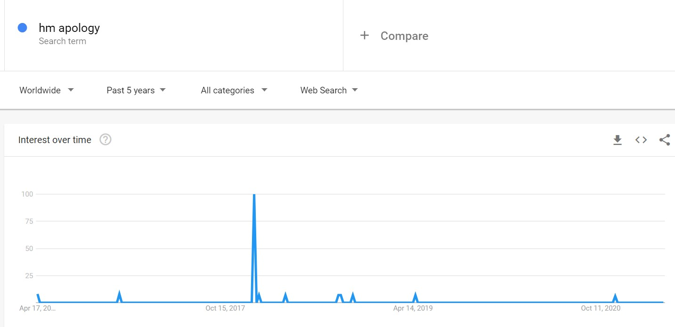
Figure 9: Search Trends for “hm apology”
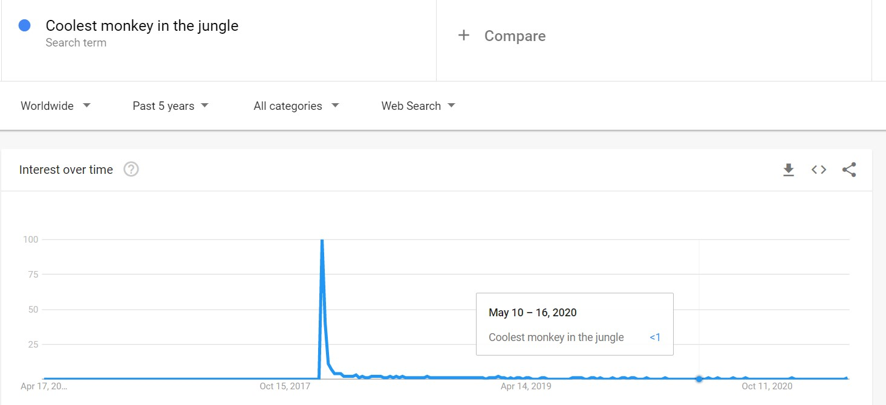
Figure 10: Search Trends for “coolest monkey in the jungle”
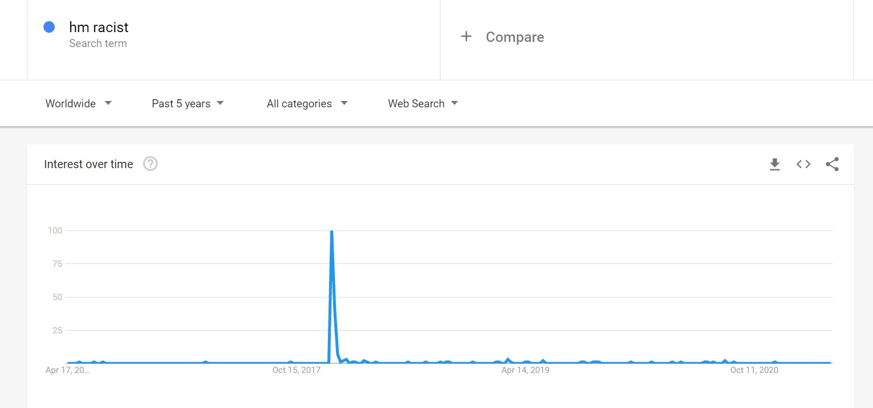
Figure 11: Search Trends for “hm racist”

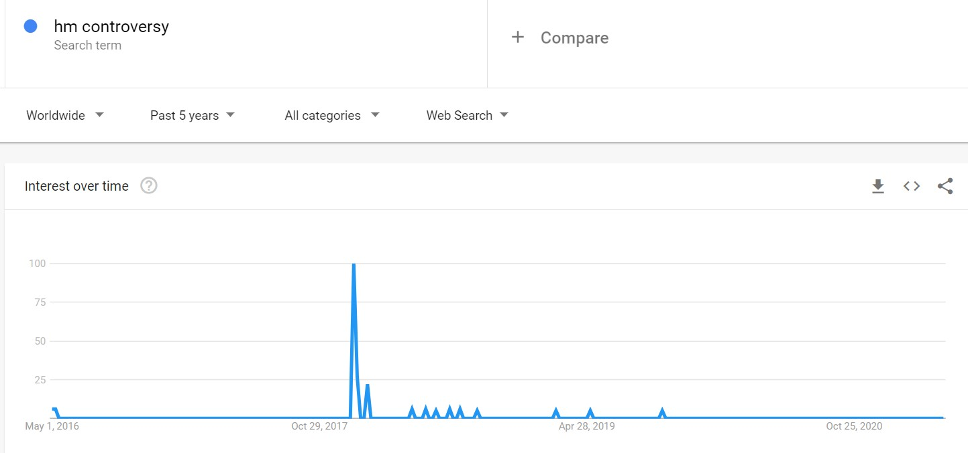
Figure 12: Search Trends for “hm controversy”
During the keyword search on Google Trends, it was found that there was a massive peak in January 2018, and not many people searched for the terms after the controversy blew up. This search was filtered with a worldwide search, over the past five years, and general web searches. Google searches are one of the most popular ways to understand how specific topics are related to each other. This could be seen when there was "hm racist" suggested as the most relevant term after "hm controversy" in the suggested section.
Through the Google Trends data, it seemed the controversy was short-lived and that it did not damage the brand's reputation. It seemed like one of those "Twitter explosions" of angry users attacking a brand or person that died down just as quickly as it flared up. But as proven later, these "Twitter explosions" change more about the users and company behavior than Google Trends would suggest. What was interesting were the results of “hm racist,” because there was only one big peak and some very small ones. When looking at other fast-fashion brands, it seems H&M has had the least amount of people searching for “racist” in association with their brand. Some other brands, like Zara, Gap, or Urban Outfitters had many peaks on how often the term was searched.
Since the controversy mainly was brewing on Twitter and somewhat on Instagram, it is only fair to evaluate the effect there and not only on Google Trends. However, Google Trends provides a foundation for understanding when the public was prompted to find more information on the controversy and H&M’s action plan afterward.
Part 2: Twitter Data Collection
The Twitter data collection was the most challenging part of the research, as it meant having to email Twitter back and forth about the application for data usage. After two denials, the research application was accepted through a vigorous explanation of what my project would entail. The Twitter developer platform had many resources for beginner and advanced coders, which is how we found the Python library called Tweepy. This library allowed us to access the users' locations that were tweeting with these hashtags to understand where the Twitter outrage was coming from. There was also another R library called twittR that was compatible with the Twitter API. This library allowed us to find, scrape, and create a CSV file of tweets about the controversy. The raw data was extracted, but it was challenging to find tweets with the hashtags #boycotthm, and #hmracist recently tweeted. The Twitter API only automatically retrieved hashtags that were popular recently and had many occurrences. We had to go way back to 2018, filter out tweets manually, and input URLS of tweets that were retweeted or liked a lot of times.

Part 3: Voyant Tools Analysis
When the Twitter data was obtained, it was time to clean up the CSV file and put it through Voyant Tools. The CSV file contained lots of info we did not need, such as random links and the number of favorites on the tweets. Once put through the Voyant Tools analysis, the program immediately showed the most frequent words. A long list of stop words was added to the program to understand which descriptors were used to describe the controversy.
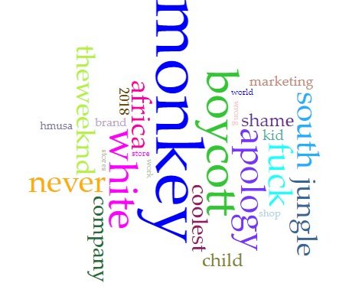
Figure 13: Result when Narrowed Down to 25 Words According to Frequency
This figure shows that the words associated with the two hashtags mentioned were shame, white, south africa, marketing, theweeknd, fuck, and wrong. It seems many were affected by The Weeknd’s tweet and were replying to the tweet mentioned in Figure 3. These tweets also mentioned “marketing” in the context of accusing the H&M marketing team of posting the image on purpose. There was also a high occurrence of the word “fuck” in the context of “fuck hm.”
“White” was written by users in the context of “white supremacy.”
Through the word analysis of the 3000 tweets, it seems that the controversy gained its highest momentum when it was tweeted by the Weeknd.
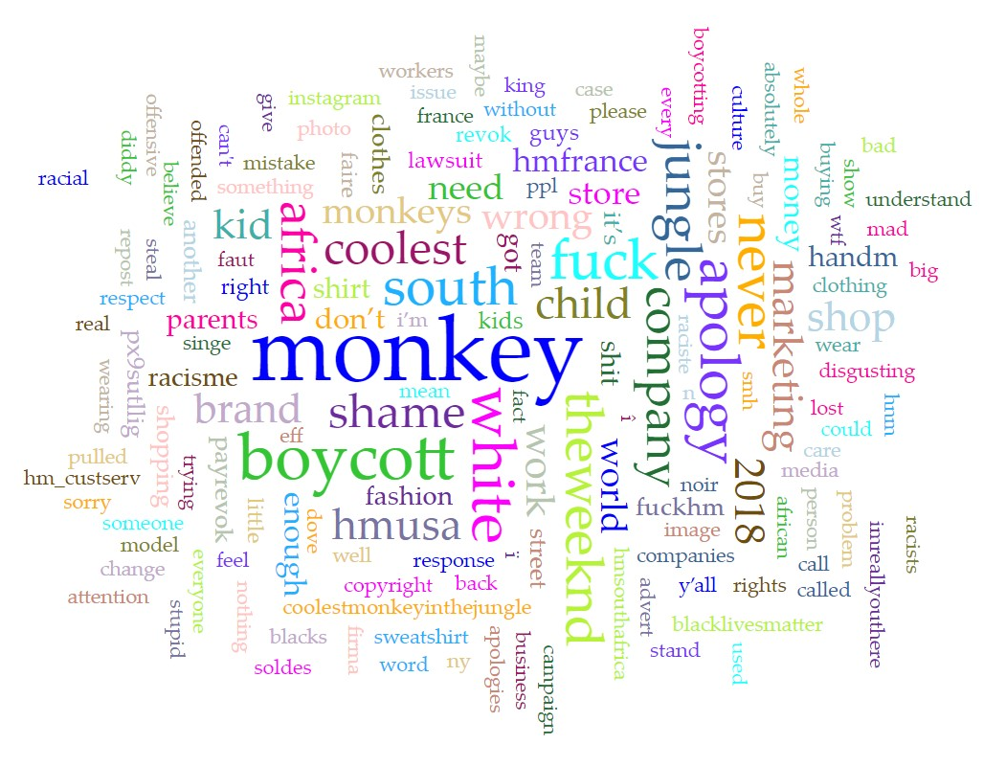
Figure 14: Result hen widened to 355 words According to frequency|
This figure shows more context as to what kind of language was used in the tweets.
All in all, it seems the language used showed that the ad significantly provoked many users. They used strong negative language to describe the controversy and brand: disgusting, fuck hm, eff hm, stupid, wrong, boycotting, shit, shame.

Part 4: Geolocation of the Tweets
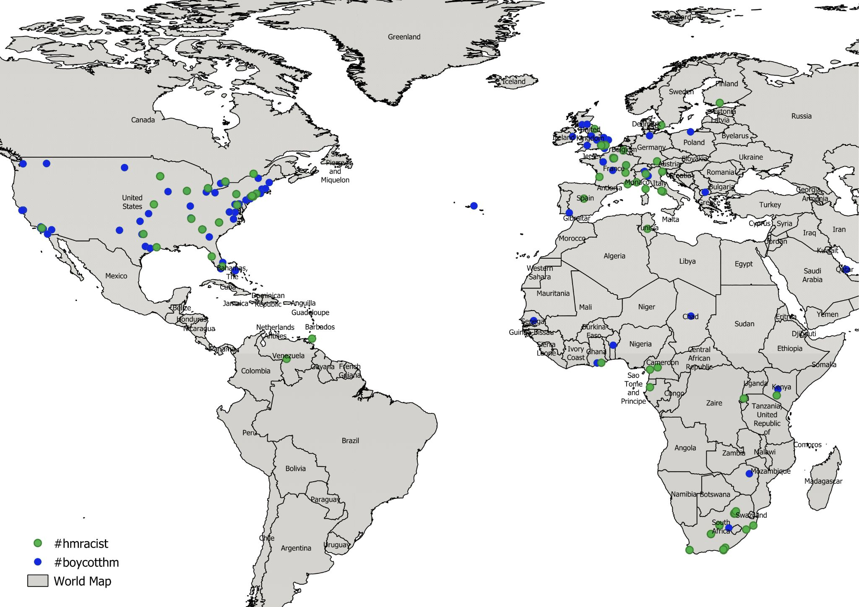
Figure 15: World Map of the Geolocations of Those Tweeting #hmracist and #boycotthm
This map shows the density of the tweets worldwide with either hashtags of #hmracist and #boycotthm. The blue represents #boycotthm, and the green represents #hmracist. Here are zoomed-in versions of some parts of the world to get a better picture of the density of tweets. There was a high volume of tweets from Europe and the United States due to how many American celebrities had tweeted about the ad.
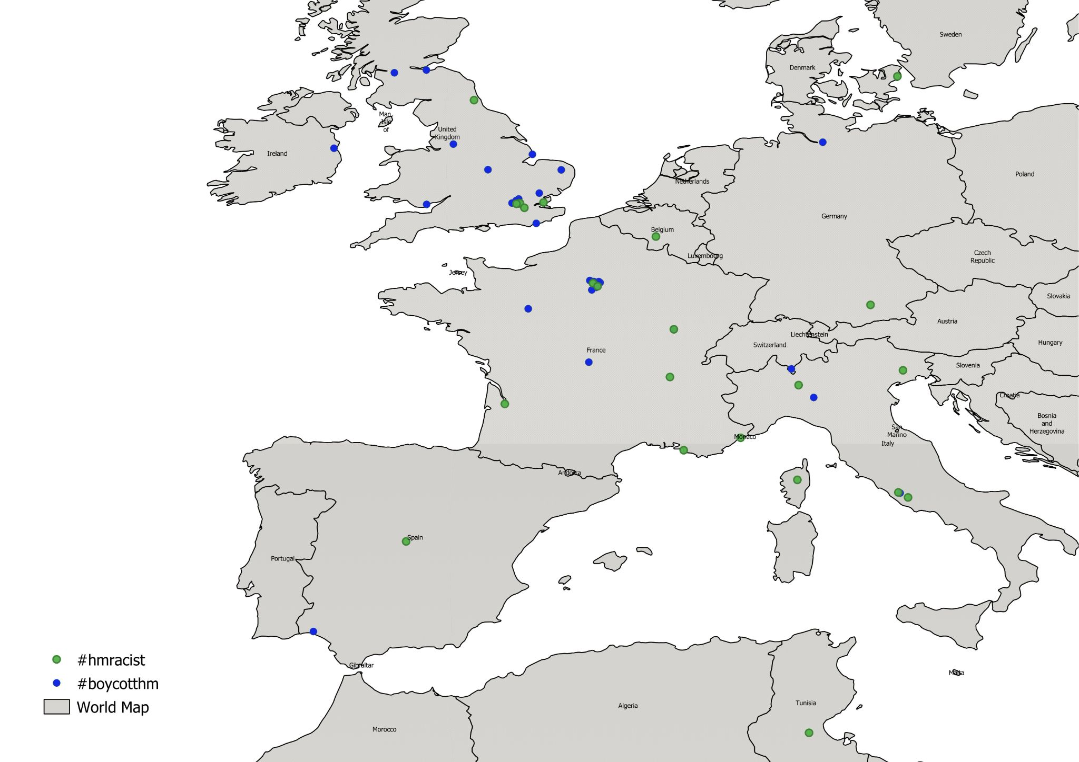
Figure 16: Tweets with #hmracist and #boycotthm Mapped in Europe
There were many tweets in France, mainly due to the large Black French community that is present there. It’s against the rules for the government to conduct official surveys according to race. Consequently, nobody even knows for certain how many black citizens there are. Estimates vary between 3 million and 5 million out of a population of more than 61 million. (Kimmelman, 2008)
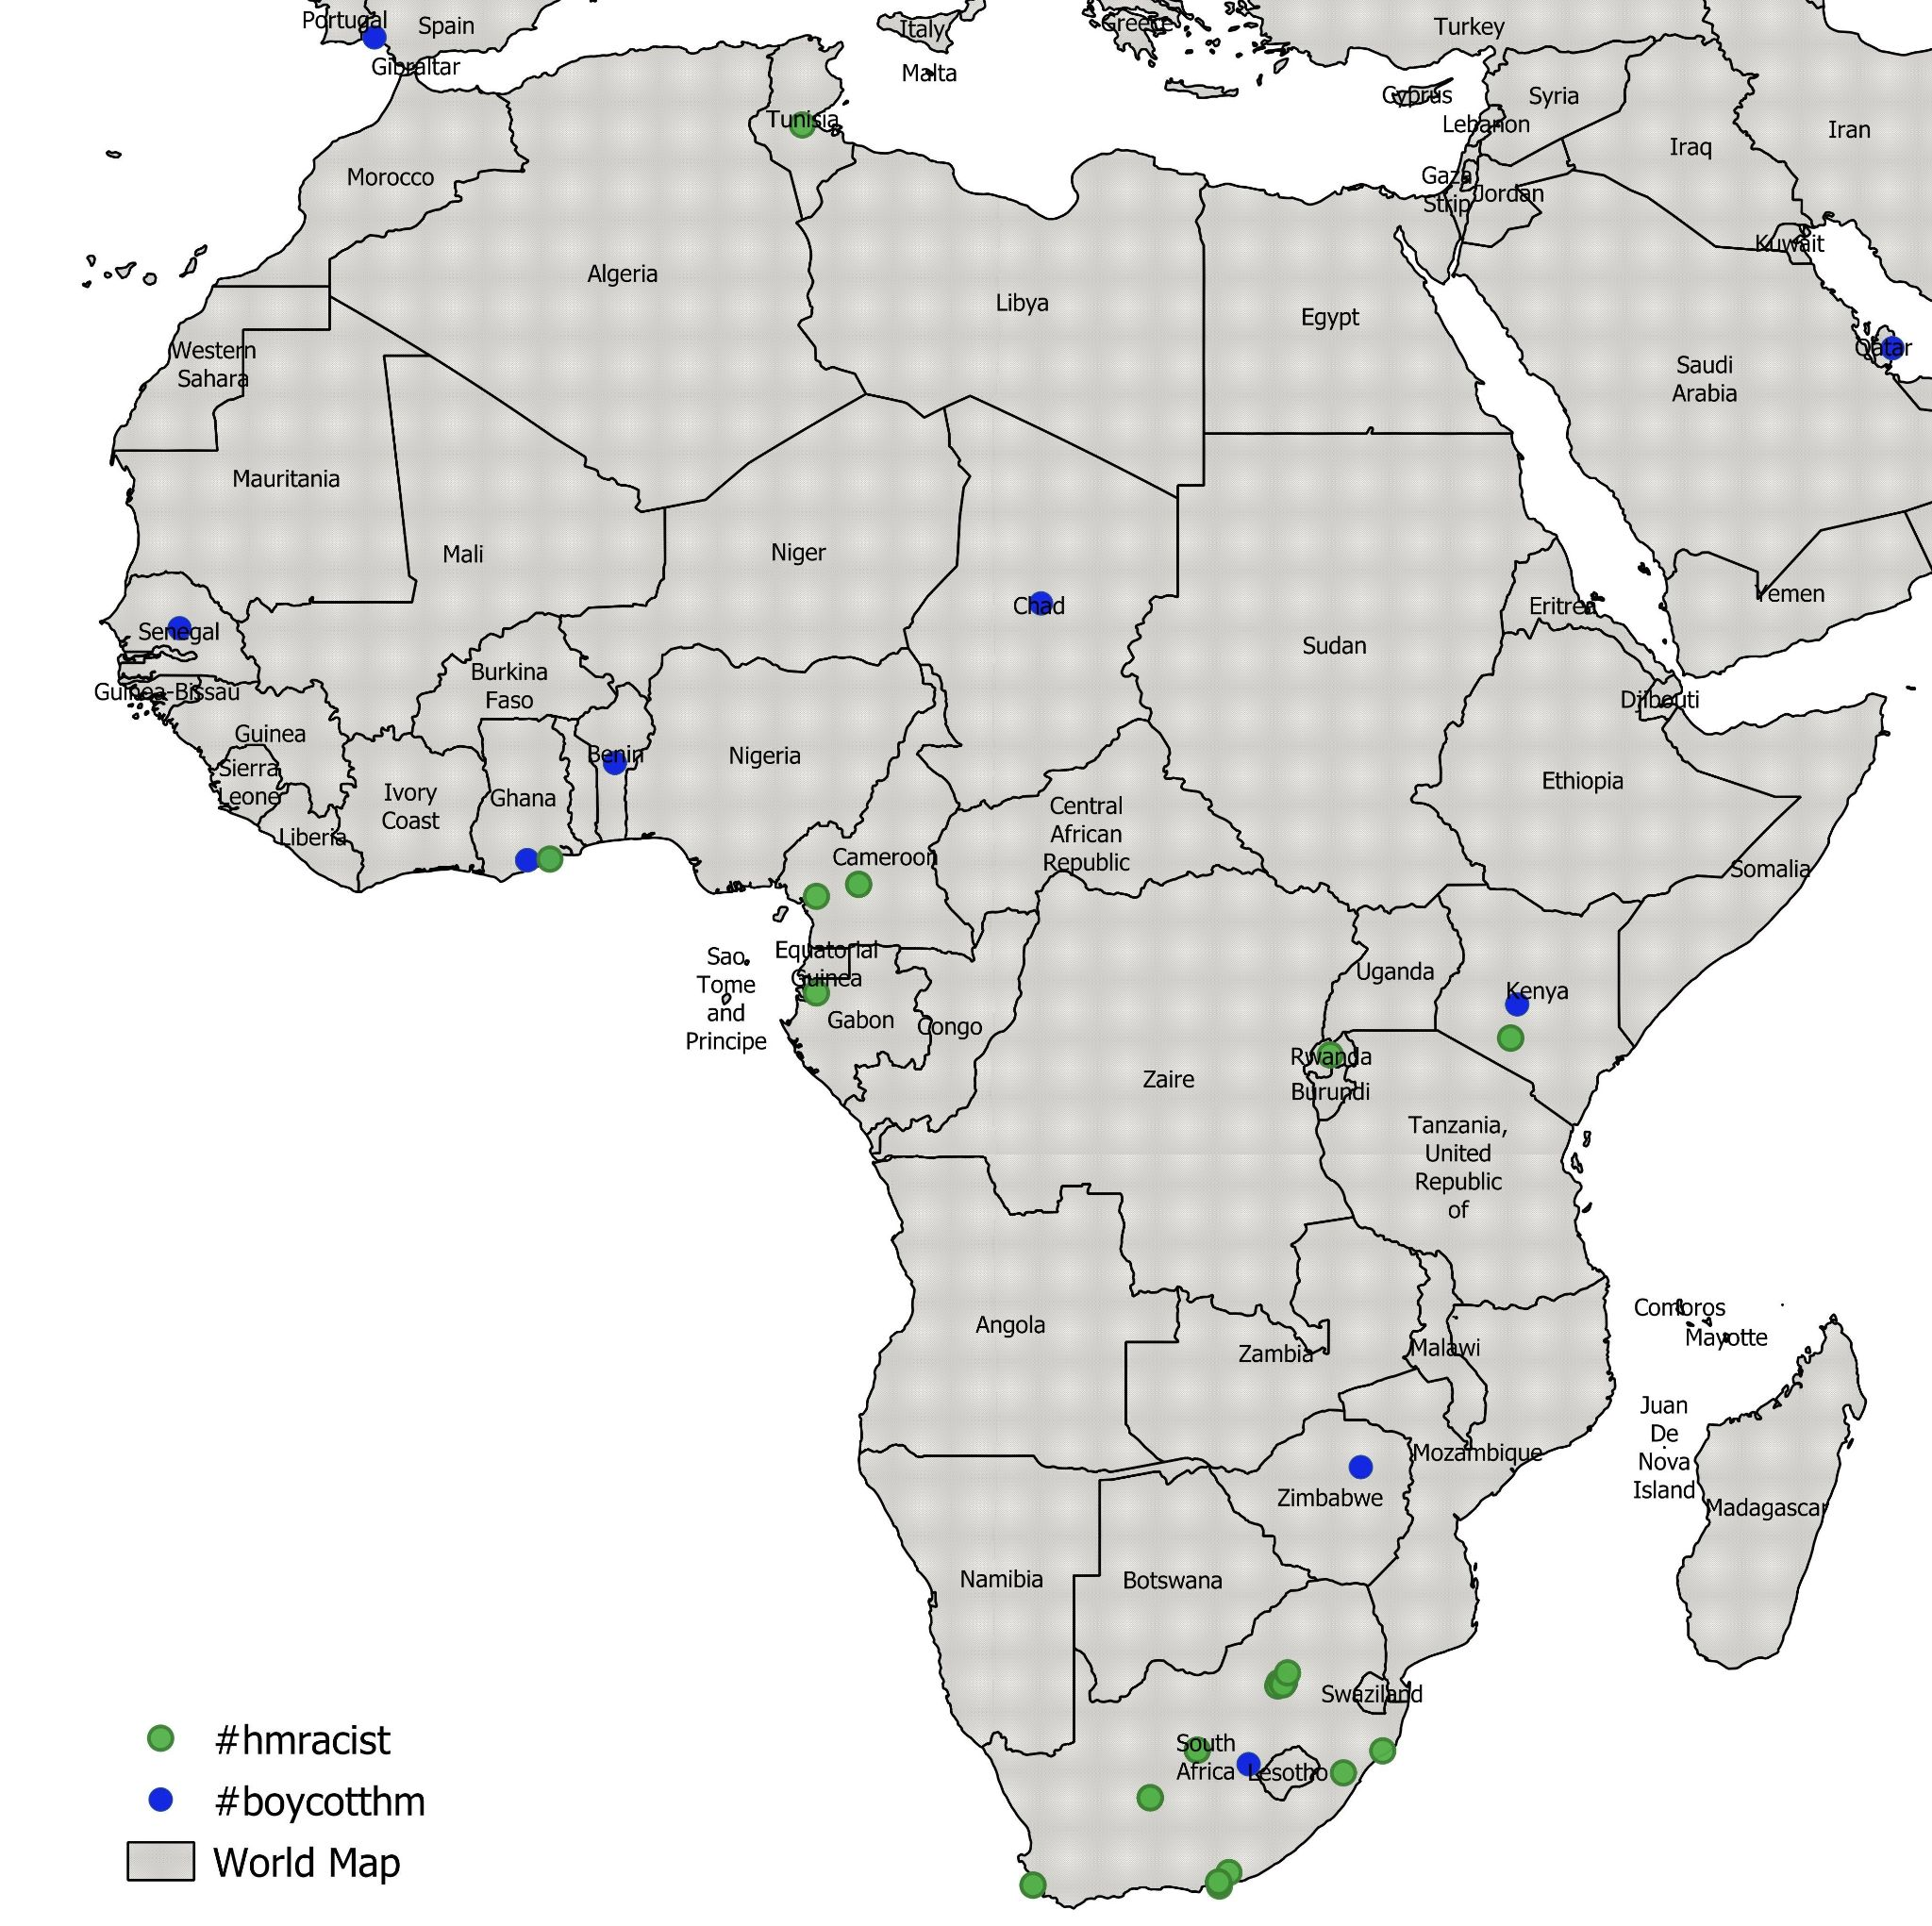
Figure 17: Tweets with #hmracist and #boycotthm Mapped in Africa
There is also a large concentration of tweets in some parts of Africa, particularly South Africa, where the big protests took place. This is not surprising considering how much damage the H&M stores across South Africa took. Since there was a high volume of South African tweeters, some of the dots are on top of each other.

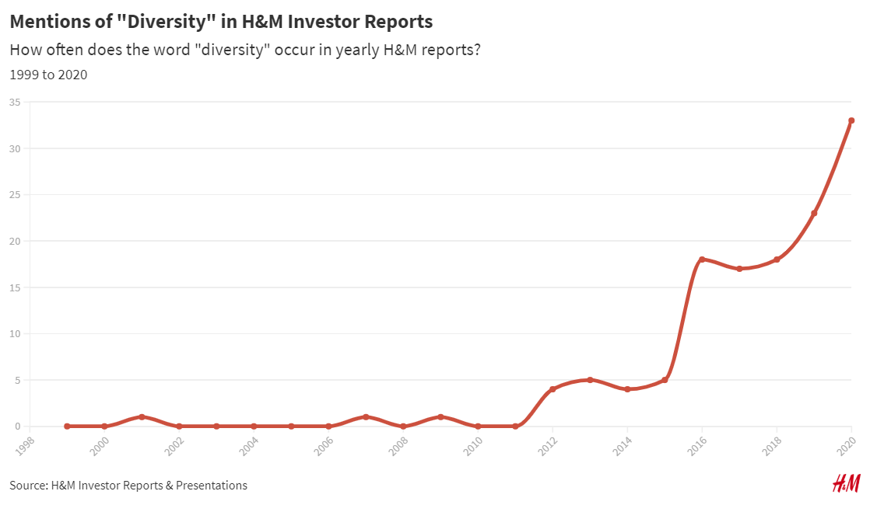
Part 5: Content Analysis of Yearly H&M Investor Reports from 1999 to 2020
Figure 18: Frequency of Mentions of “Diversity” in H&M Investor Reports
On their H&M Investors portion of their website, there are public reports of how the company is doing, what sort of values they uphold, and the yearly sales they make. To understand how important the concept of diversity is to a brand’s identity, it is integral to see how this information is delivered to investors. Brands usually like to attract investors that uphold the same values. It seems diversity was not a key value for the brand until around 2012. In a 10-year comparison, we can see that diversity was mentioned once in 2009 but was mentioned 23 times in 2019. This number jumped from 18 in 2018 to 23 in 2019 and finally 33 in 2020. This shows that the core values that the company presents to potential and current investors are evolving. It seems the concept of diversity has become an absolute priority for the brand when tracking the aftermath of the controversy.
Conclusion
When looking at the research findings, the Google Trends data seems to state that the controversy was only relevant in January of 2018 and some months following. However, since the quantity of Google searches is not the only criteria for evaluating the controversy, it is only fair to assess mainly the attention H&M got on social media.
The geolocations of the tweets show that the people who were tweeting about the H&M controversy the most were from the United States and South Africa. This is understandable, considering how many African American celebrities posted about the issue and how many protests happened in South Africa. The Voyant Tools analysis shows that the very aggressive language of the tweets that were used to describe the brand’s actions, and almost none of the tweets used neutral language about the situation.
The occurrence of the word “diversity” in the H&M investor reports shows us that H&M has started to put forth the narrative of respecting diversity as a big part of their brand.
When searching for recent tweets in 2021 under the term “hm racist,” one recent tweet was particularly telling. One South African recently tweeted a video showing her followers how nicely jeans from H&M fit on her. This prompted many angry replies to the tweet, criticizing the woman for endorsing H&M after the 2018 controversy.
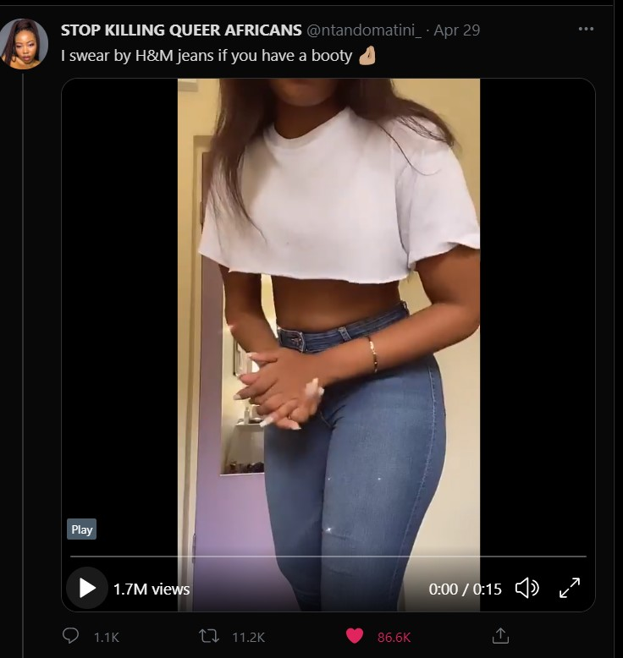
Figure 19: Tweet About H&M Jeans by a South African Woman on April 29, 2021
One user sarcastically tweeted under the thread, “I’m glad to see ppl still holding H&M accountable for being racist.” The following figures are some other reactions to the woman endorsing the brand:
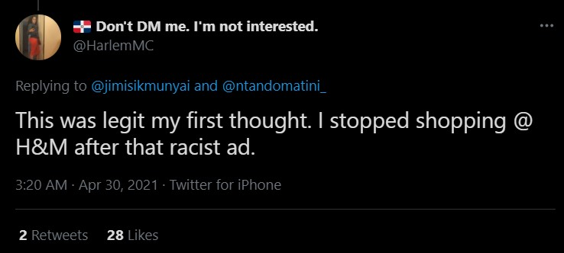
Figure 20: Reaction Tweet About H&M on April 30, 2021
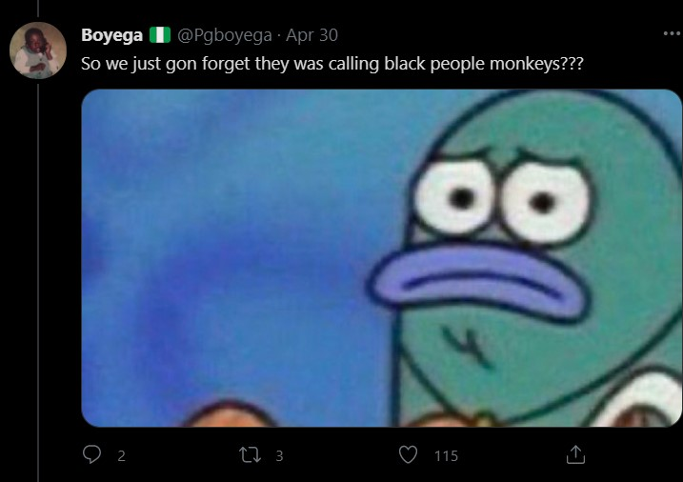
Figure 21: Reaction Tweet About H&M on April 30, 2021
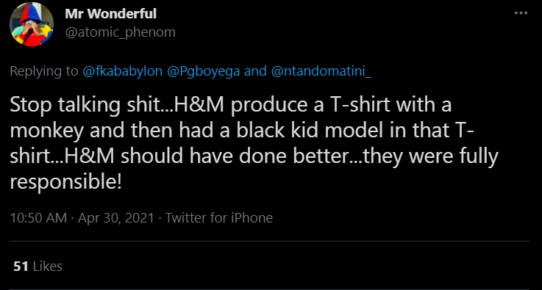
Figure 22: Reaction Tweet About H&M on April 30, 2021
All in all “a denial indicates that there is no need to rectify the organization’s behavior, and this can generate uncertainty about the company’s future conduct, particularly when its innocence has not been clearly established.” (Kim et al., 2004). A denial may even lead the crisis to escalate as it leaves important questions unanswered and frustrates people’s need to understand what happened.
This is precisely what happened in the aftermath of the controversy. When looking at the reactions on Twitter under the tweet pictured in Figure 19, it is clear that since the brand denied the claims, no one was clearly at fault. This recent tweet also shows that the “Twitter explosions” impact people’s perception of the brand and can even prevent them from ever purchasing from the brand.
In general, it seems the company has learned its lesson after the controversy, as proved by the 2020 Black Lives Matter donation that they made and included a nod to their past actions and mistakes.

Limitations and Avenues for Future Research
The most significant limitation of the current research was the language barrier in the tweets. Many tweets in certain alphabets couldn't be analyzed in the extracted tweets, such as Arabic script or Cyrillic script. Voyant Tools only analyzes texts that use the Latin alphabet only. Besides the other scripts, there were tweets in languages that I did not understand, such as Spanish or French. I could only properly analyze and present the results of English tweets. And since H&M's headquarters are based in Sweden, it would have also been beneficial to read and analyze texts or tweets written in Swedish.
The second limitation for my research was the low quantity of tweets with geolocation. 280 locations were mapped out of 3000 tweets because some users chose not to share their location.
The third limitation was how many stop words I added into the program. I added 1700+ lines of stop words in English, Spanish, French, and German. This was still not enough to filter out all of the symbols generated during the scraping process. Voyant Tools started to glitch out and would not accept any more stop words. I wanted to add more stop words to get a more precise map free of filler words and only containing adjectives or nouns.
Another limitation of the current research was that these types of "Twitter boycotts" happen very often nowadays; these are effects of the quick exchange of information on social networks. "Managers should be aware of their statements and behaviors specifically around issues that are strongly related to social values and beliefs...compromising these issues not only decreases perceived brand authenticity, but it also might lead to calls to boycott campaigns on social media." (Shiradastian et al., 2019) These boycott campaigns are also informally known as "cancel culture" which means that users refuse to endorse a brand or person, completely cutting them out.
Moreover, it is not a new phenomenon for brands to face backlash on social media and trigger waves of angry tweets. Brands such as Gap and Zara have also had the same backlash during previous years for similar insensitive ads. Zara had advertised a striped children's shirt with a sheriff badge on it, but the public thought it looked very much like a 'holocaust uniform.' Gap faced criticism for an ad that showed a white child with her arm resting on a Black child. It seems these heated controversies influence companies to have a fluctuating reputation because controversies usually come as quickly as they go. These peaks in searches can be seen by looking at Google Trends data over the past five years shown below. It seems "normal" for people to constantly be in the ebb and flow of getting angry about something a brand has done and then forget about it.

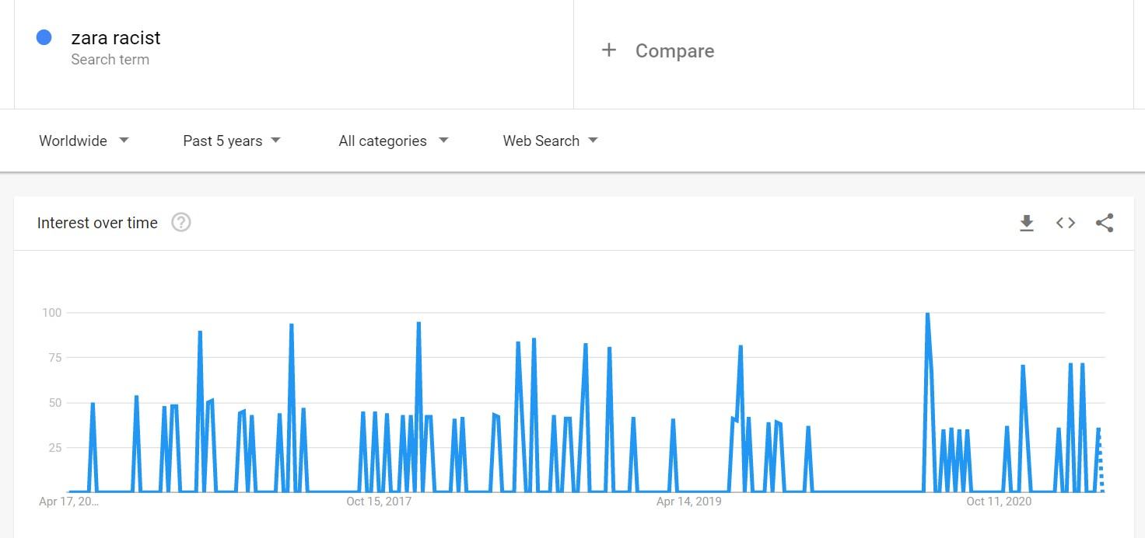
Figure 23: Google Trends Data of “Zara Racist”
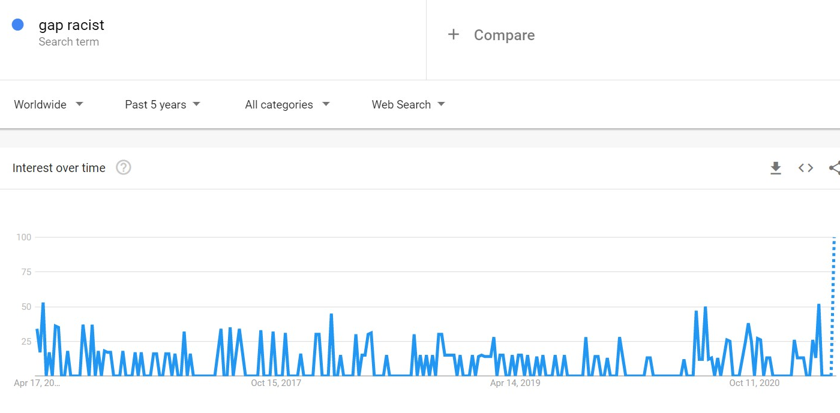
Figure 24: Google Trends Data of “Gap Racist”
As for avenues to future research, there should be larger-scale studies done on how these heated social media controversies and "cancel culture" affect a consumer's long-term perception of the brand. A survey should be done to understand whether there is a long-lasting perception of a brand being racist/homophobic/problematic. Since the public is the only fixed variable in these situations, further research should focus on the public's voices, particularly those affected by a company's insensitivity. In this case, more research should be done on how the Black community perceives the controversy.
All in all, do these explosive Twitter scandals affect a person's desire to purchase from a brand? After all, the brand's sales are directly linked to the public's perception of the core values that H&M upholds.

Bibliography
- BBC News. (2016. April 06) Is this Gap advert racist?. [online] Available at: https://www.bbc.com/news/blogs-trending-35968787 [Accessed May 1, 2021].
- BBC News. 2014. Zara's 'Holocaust uniform' and other clothing errors. [online] Available at: https://www.bbc.com/news/blogs-magazine-monitor-28944516 [Accessed 1 May 2021].
- Bjerre, M (2018, July) H&M & ”Coolest Monkey in the Jungle”
https://www.researchgate.net/publication/326271422_Coolest_Monkey_in_the_Jungle_-_A_study_on_correlations_between_crisis_communication_and_intentional_consumer_behavior
- Bradford, J., & Garrett, D. (1995). The Effectiveness of Corporate Communicative Responses to Accusations of Unethical Behavior. Journal of Business Ethics, 14(11), 875-892. Retrieved November 13, 2020, from http://www.jstor.org/stable/25072709sdhjdshf/
- Coombs, T. (1999). Information and compassion in crisis responses: A test of their effects. Journal of Public Relations Research, 11(2): 125–142.
- Coombs, T. and Holladay, S. (2005). An exploratory study of stakeholder emotions: Affect and crises. In The effect of affect in organizational settings, pp. 263–280. Emerald Group Publishing Limited
- Fortin, J. (2018, January 13). H&M closes stores in South Africa amid protests over 'Monkey’ shirt. The New York Times - Breaking News, World News & Multimedia. https://www.nytimes.com/2018/01/13/world/africa/hm-south-africa-protest.html
- Friedman, H.H. (2006) The Power of Remorse and Apology, Journal of College and Character, 7 (1), DOI: https://doi.org/10.1016/j.pubrev.2014.10.011.
- Fumo, N. (January 2018). H&M Hires Diversity Manager In Wake Of Racist Hoodie Fiasco. Retrieved from Forbes: https://www.forbes.com/sites/nicolafumo/2018/01/18/hm-diversity-manager-hire/#6bc3cf315337
- Fuoli, M., Van de Weijer, J., & Paradis, C. (2017). Denial outperforms apology in repairing organizational trust despite strong evidence of guilt. Public Relations Review, 43 (4), 645-660. DOI: https://doi.org/10.1016/j.pubrev.2017.07.007.
- Gonzales, E. (2017, February 27). The Weeknd's Full Campaign for H&M Is Here. Harper's BAZAAR. https://www.harpersbazaar.com/fashion/designers/news/a20353/the-weeknd-hm-collaboration-photos/
- Helmersson, H. (2020, June 1). We stand with and support the Black community – today, everyday and everywhere. H&M Group. https://hmgroup.com/media/news/general-news-2020/we-stand-with-and-support-the-black-community---today--everyday-.html
- Heller, S. (2018, January 08). H&M apologizes for using a black child in a 'racist' sweatshirt ad — but some people don't think it's enough. Retrieved from Business Insider: http://www.businessinsider.com/hm-coolest-monkey-sweatshirt-apology-reactions-2018-1?r=US&IR=T&IR=T
- H&m issues unequivocal apology for poorly judged product and image. (n.d.). Retrieved April 14, 2021, from https://about.hm.com/zh_cn/news/general-news-2018/h-m-issues-unequivocal-apology-for-poorly-judged-product-and-ima.html
- Interview with Annie WU. (2018, March 29). H&M Group. https://hmgroup.com/media/news/general-news-2018/interview-with-annie-wu.html
- Kešetović, Ž, Korajlić, N., & Toth, I. (2014). Apology as Crisis Communication Strategy Importance of Cultural Context. Collegium Antropologicum, 38 (1), 171-174.
- Kim, P., Ferrin, D., Cooper, C., and Dirks, K. (2004). Removing the shadow of suspicion: The effects of apology versus denial for repairing competence-versus integrity-based trust violations. Journal of Applied Psychology, 89(1): 104–118
- Kimmelman, M. (2008, June 17) For Blacks in France, Obama’s Rise Is Reason to Rejoice, and to Hope. Retrieved May 17, 2021 from the New York Times: https://www.nytimes.com/2008/06/17/arts/17abroad.html
- Kjærsgaard, M. (2018, May 31) A Case study of H&M’s online Crisis Communication
https://projekter.aau.dk/projekter/files/281488153/SAMLET_31_5.pdf
- My Son Modelled 'That' H&M Hoodie | This Morning. (2018, January 15). Retrieved April 7, 2021, from https://www.youtube.com/watch?v=Jkxko1xrrXY&t=1s.
- O’Hara, Erin Ann (2004). Apology and thick trust: What spouse abusers and negligent doctors might have in common. Chicago-Kent Law Review, 79(3), 1055-1089.
- Sellnow T.L. & Littlefield R. (2015). Risk and Crisis Communication : Navigating the Tensions Between Organizations and the Public. Lexington Books.
- Shirdastian, H., Laroche, M. and Richard M. (2019, October 1). “Using Big Data Analytics to Study Brand Authenticity Sentiments: The Case of Starbucks on Twitter.” International Journal of Information Management 48: 291–307. https://doi.org/10.1016/j.ijinfomgt.2017.09.007.
- Staples, B. (2018, June 17). The Racist Trope That Won't Die. The Racist Trope That Won't Die. https://www.nytimes.com/2018/06/17/opinion/roseanne-racism-blacks-apes.html.
- STOP KILLING QUEER AFRICANS, [@ntandomatini_]. (2021, April 29). [Tweet]. https://twitter.com/ntandomatini_/status/1387768539608715267
- Wattles, J. (2018). H&M closes all its stores in South Africa after protests. Retrieved from CNNMoney: http://money.cnn.com/2018/01/13/news/companies/hm-south-africa/index.html
- WPSU - Penn State Public Media. (n.d.). Case Study: H&M’s Coolest Monkey in the Jungle. https://pagecentertraining.psu.edu/public-relations-ethics/introduction-to-diversity-and-public-relations/lesson-2-how-to-reach-diverse-stakeholders/reaching-diverse-stakeholders-externally/.
- Xaviera (2018, January 8) H&M Posts Tone Deaf Apology For Ad Of Black Child Wearing A Monkey Hoodie. Available at: https://icecreamconvos.com/hm-posts-tone-deaf-apology-ad-black-child-wearing-monkey-hoodie/

Appendices
Appendix A
Raw tweets under #boycotthm (Python)
https://docs.google.com/spreadsheets/d/1_PmTt--3pc1dtqnVxE9ryMVwGYx0EV2cmNt2N1ElucU/edit?usp=sharing
Appendix B
Raw tweets under #hmracist (Python)
https://docs.google.com/spreadsheets/d/1YNIKptAa43DRbI6huHEEeo6B3-LUqqXEEurZa3QDFc0/edit?usp=sharing
Appendix C
Python Code for main results
https://drive.google.com/file/d/1dwnlx8gayNlzKEkaT_HJPhUQUfVvfgaz/view?usp=sharing
Appendix C
R Code for similar results to Python code
https://drive.google.com/file/d/1FRliTHKp1vmR3atSkfMzpIVlRloIrz42/view?usp=sharing
Appendix D
Investor reports and presentations raw data for calculating diversity occurrence
https://docs.google.com/spreadsheets/d/1KpULb3_1HakeTr3CpmhhFdVVmZHpeeG-Uuh7Fc2eVTU/edit?usp=sharing
Appendix E
Applications Used for Analysis and Data Visualization
Voyant Tools. [online] Available at: https://voyant-tools.org/
Google Trends. [online] Available at: https://trends.google.com/trends/?geo=US.
Twitter API. [online] Available at: https://developer.twitter.com/en/docs/twitter-api
QGIS 3.18.2 'Zürich’ [online] Available at: https://qgis.org/en/site/forusers/download.html
Flourish Studio [online] Available at: flourish.studio
List of stop words used: https://drive.google.com/file/d/1_99WEU2ffg6HaIjohlurMFi-nujcqTT8/view?usp=sharing

