More than Just Churches: Strategies for promoting Armenia as a Spiritual Tourism Destination
By

Mariam Hovhannisyan

Presented to the
Department of English & Communications in Partial Fulfillment of the Requirements for the Degree of Bachelor of Arts

American University of Armenia
Yerevan, Armenia

May 17, 2021

Abstract
This research studies and investigates the potential of spiritual tourism in the context of Armenia. The central research question of this paper is how could Armenia be marketed as a spiritual Tourism Destination? Sub questions discuss how people from diverse backgrounds perceive spiritual tourism and what PR strategies could promote and position Armenia as a spiritual tourism destination. The creative goal of this Capstone project is to come up with innovative tour packages, which will satisfy the needs and desires of travelers seeking spiritual journeys. In addition, there would be suggested some PR strategies which would contribute to the implementation of this idea. The methodology used for this research paper is face-to-face interviews with tour operators employed in the Armenia tourism industry. Likewise, there were done two online interviews with a PR specialist and culturologist employed in Armenia. There were surveys conducted among 1008 people from Armenia and abroad. Also, there were scholarly researches to examine the case studies of other countries. This paper examines the current gap in the industry of spiritual tourism in Armenia and, through the creative packages, suggests further opportunities for development.
Key words: Spiritual Tourism, Armenia, PR strategies, Tour packages

Introduction
In Armenia, Tourism is considered one of the biggest industries. According to the World Travel and Tourism Council, the contribution of travel and tourism to the GDP of Armenia increased from 4.2 % to 14.1 % starting from 2000 until 2019. In 2016, 38,500 jobs were supported by the industry of tourism. Meanwhile, Armenia is a small mountainous country in the Caucasus region it has become a traveling country for many tourists. Based on the research done for Ampop.am platform of data journalism, 49.8% of tourists came to Armenia for entertainment and rest purposes, 31.9% are business travelers, and 18.4% are in the other sector, including medical, historical, and cultural pursuits. Starting from the 1990s, tourism was one of the growing industries of the Armenian economy. According to the International Trade Administration records, the increasing number of tourists was directly connected to the Armenian huge Diaspora, who has numerous reasons to visit Armenia. As we know, the population of Armenia is around three million, and surprisingly, the communities living outside of Armenia are three times bigger than the locals are. Consequently, such statistics have its positive impact on the tourism industry of Armenia. According to the article of Hetq.am written by Seda Hergnyan, in the first half of 2019, 770.055 tourists traveled to Armenia. According to Armenia’s Statistical Committee, 71 % of them were diaspora Armenians. That means that the tourism field is mainly covered by people who are either Armenians who were born in Armenia but live elsewhere or by Armenians who were born in other countries. Such statistics mean that there’s a big untapped market for non-Armenian tourists. Annual Research of 2020 done by the World Travel and Tourism Council presents that in 2019 the contribution of travel and tourism GDP formed 11.8% of the total economy. The contribution to employment was 12.5%, and international visitors spent 23.9% of total exports. The ITA also provides data that in 2019 there were registered 1.9 million International arrivals to Armenia. Between 2018 and 2019, there was 14.7 percent of the growth in arrival numbers. Based on the World Tourism Organization Report, Armenia is among the 20 fastest growing tourism destinations globally. As well as, Armenia is considered a low-budget country to visit. Starting from 2019, Ryanair launched flights between the most famous European cities and Armenia. For instance, the two-way prices for travelers of Italy and Spain were between 100 and 150 dollars. Also, travelers from Western Europe could choose Georgia or Turkey as a stop country to visit Armenia. The website called Budget Your Trip has an article that consists of calculations of budgets of real travelers. According to their statistics, the average daily cost per person is around 20 dollars, and the price of accommodations like guest houses and hostels starts from 10 dollars. Transportation between the cities of Armenia through buses costs on average 6 dollars. Another website calculated the cost of 8 days vacation in Armenia was around 295 dollars. As a resident of Armenia, I would say that these numbers are real, and even the small pockets are suitable for the Armenian market. Many international portals and newspapers such as Forbes, CNN, Booking.com, The Daily Telegraph have reported Armenia as a must-visit destination. While researching Armenia as a place to travel, people will find various reasons to choose Armenia. Such reasons are the cultural heritage, religion, architecture, nature, mountains, culinary, etc. In such lists, there was impossible to find an approach that would focus on the spiritual factor of Armenia. According to Gayane Tovmasyan's work "Tourism Marketing in the Republic of Armenia done for European Journal of Economic Studies in 2015 from the State budget of the RA 188,4mln AMD was provided for tourism development. In 2015 Armenia participated in five international tourism exhibitions in Paris, Moscow, Berlin, Madrid, and Rimini. While reading the articles about the held exhibitions, it becomes evident that the focus was on Armenia's rich culture, history, and Christian heritage. Armenia was also presented to thousands of visitors, international agencies as a destination for adventure tourism, gastro tourism, and wine directions. Before deciding and finalizing the topic for my Capstone project, I did a small survey around ten people around me by asking what they understand when hearing concepts like spiritual tourism and spiritual destinations. Eight of them brought the example of pilgrimage and holy sightseeing. Among those eight, some of them brought specific examples of visits to Israel, Jerusalem, and Mecca. While two of ten respondents answered the question by saying that a place where they can feel harmony, calmness and satisfy their spiritual needs is considered spiritual destinations. Such responses raised an interest to survey a big group of local and international travelers to collect their ideas on spiritual tourism. By considering the results of surveys and various research on this topic, I decided to design various packages of spiritual journeys. In none of the Armenian sources related to tourism, there is the concept of Spiritual Tourism. The Trip Advisor offers Pilgrimage Tours in Armenia by emphasizing that Armenia is the first Christian country in the world. The itinerary of the tour includes only a few visits to the churches of Armenia. As a pilgrimage tour that visits, do not include differences compared to regular tour visits to churches. It becomes evident that there were no special promotions or campaigns to present Armenia's pilgrimage packages by doing online and offline research. Likewise, in Armenia, the tourism field representatives do not offer special packages to people interested in visiting Armenia as a pilgrimage journey. Therefore, Armenia is not famous for its pilgrimage destinations like Vatican, Jerusalem, or Mecca. Furthermore, one of CNN travel reports presents Armenia as a country of wine. In parallel, it presents Noah's history, who planted the first wine on the slopes of Ararat 6100 years ago. From the point of holy sites, Armenia has the full potential to be next to them. Although the survey done for this paper will show that the majority of foreigners are unaware that Armenia is the first Christian country in the world. Through strong PR strategies, it is possible to make Armenia famous because it has adopted Christianity first in the world. On the other side, spiritual tourism should not be limited to pilgrimages or holy sightseeing. Some countries are offering spiritual tour packages to travelers without any prerequisites such as religion or ethnicity. Armenia could develop some packages for people seeking spiritual destinations to travel by reviewing those countries' experiences. Among 1008 respondents of surveys, there was a question of what is their opinion and understanding about the concept of spiritual tourism is. So the presentation of packages will also include survey respondent suggestions. Those packages would consist of various sectors such as music, religion, culture, architecture, nature, yoga, etc. The reader would find the prototype of future spiritual tour destinations of Armenia. Armenia's geographical location, nature, and architecture require creative work, financial investments, and qualified specialists for positioning Armenia as a destination of spiritual tours. After getting the packages ready, the next phase is the marketing of that product. This Capstone project will include some PR strategies that will enhance Armenia's chance of being a recognized spiritual tourism destination. The offered strategies will be discussed with professionals of the field and taken from other countries' case studies. Through the e-marketing tools, packages could be presented in Europe, the US, and other world regions. Also, through e-marketing, the local travelers would be aware of the new product as well. Armenia could participate in annual tourism conferences and exhibitions and present the new packages to the international experts and audience. CNN, Trip Advisor, and other international boards may include the packages mentioned above as well. This paper aims to have prototypes of spiritual tour packages and strategies to be used in the tourism industry. Implementing these steps will make Armenia the next destination to travel to for those curious to satisfy their diverse spiritual needs

Literature review

People, ways, and destinations are a combination, which is called tourism. Based on the preferences of people, there have been formed a variety of types of tourism. Spiritual tourism is one of the forms of tourism, and some people perceive it as a new concept or a new type of traveling. The research paper "The perspective of religious and spiritual tourism research: a systematic mapping study" was done by four scholars of the University of Tehran and Shahrekord University. In their research paper, the authors have included a section defining the difference between religious tourism and spiritual tourism. According to the authors, religious tourism is associated with sacred places. Pilgrimage tours, participation in religious ceremonies, or other types of visits that aim to fulfill religious duties are considered religious types of tourism. Pilgrim tourists mostly pay attention to religious attractions rather than to culture or aesthetics. By analyzing this source, it could be proven that religious tourism includes spiritual experience while spiritual tourism itself could exclude religious activities, visits, etc.
According to Medhekar and Haq, "spiritual tourism is has been among the oldest forms of traveling for many millennia." The same source includes that spiritual tourism has been hidden under the veil of pilgrimage and religious tourism while it has a much broader and deeper understanding. Pilgrimage and holy sightseeing are the inseparable parts of spiritual tourism, but at the same time, spiritual tourists are considered cultural o experiential tourists. (Medhakar, 2012) According to Doncean, people are making decisions depends on their emotions (2014). A destination to travel to is one of those emotional decisions which they could take. Where and how those emotions come? Who is responsible for presenting a place as a spiritual destination? Historians, architectures, or specialists in tourism? The circle of responsible people should be broader, including marketing, PR specialists, etc. Taking into consideration the case study of India, "the marketing and growth of any type of tourism depend upon many factors, including the packages and programs offered by the tourism destination." Armenia has all the prerequisites and the potentials to have special packages and programs of spiritual tours offered to local and international tourists. By deeply analyzing the case studies of countries experiencing spiritual tourism, there can be taken some tricks and tactics for developing spiritual tourism in Armenia. In Ha Farooq and Wong "Branding Islamic spiritual tourism," the three types of spiritual travels are hajj/umrah, rihla, and ziyara. If the hajj/umrah and ziyara are categorized as a pilgrimage and devoted visits to Islamic destinations, then rihla is a journey for people seeking knowledge, health, or personal growth (2013). Through the years, they have succeeded in turning their traditional Islamic spiritual tourism into modern events and, by this method to attack a larger number of tourists from all over the world. They organize the annual Bumitra Islamic Tourism Expo in Malaysia and the annual International Halal Product Expo in Brunei. They present their architecture, such as the floating Crystal Mosque in Kuala Terengganu, as a spiritual theme park. After reviewing such experiences, Armenia could adopt some ways to represent the Armenian heritage, history, religion, and sightseeing to serve as spiritual destinations for people who want to have a spiritual experience. Based on the work of Tovmasyan (2016), "Armenia should be positioned in international tourism markets as the first Christian country with ancient history and culture, thermal hot springs and fascinating nature welcoming tourists for the religious, resort, cultural, eco-, agro- and other purposes." In this work, the author suggests different e-marketing tools that can influence the development of tourism. Although I don't share the opinion that in the international platforms, Armenia should be presented mainly focusing on the fact that it is the first Christian country, however, I accept that it could serve as one of the packages of spiritual tourism for grabbing the attention of religious people. Analyses and suggestions done by Tovmasyan (2016) could be used to promote the different sides of Armenia to foreigners.
To sum up the overall understanding and screenshot of literature and ideas, I would say that there is a noticeable gap in the field of spiritual tourism. None of the tourism-related companies has a package of spiritual tours for foreigners. There are only a few places called pilgrimage destinations. The tours of these places are offered only in the Armenian language for locals Christians. They could be included in the list of spiritual tourism and be a branch of it. For the final version of the Capstone project there would be done scholarly researches, interviews, surveys, and suggestions of specific packages of spiritual tours in Armenia. Using this work, the field specialists can promote among the travelers to choose Armenia for their next destination to travel. This work will include the SWOT analysis of the topic, and it can serve as a hint for others to develop spiritual tourism in Armenia. Armenia's strengths are its history, culture, architecture, religion, and mountainous nature. Thereby, there would not be difficult to find new approaches. After having discussions with the specialists of the field, it would be clear what destinations specifically would be addressed for this purpose. Overall the weakness, while doing this Capstone would be the lack of Armenian literature and materials related to this topic. As well as the fact that until now, the Armenian tourism market has not offered spiritual touts to travelers, it would be a new thing that can have a hard path to success. While considering that revenue generated by the tourism industry is a vital part of the economy, it costs to invest in developing this field.

Statement of central research question(s)

The central Research Question of this Capstone project aims to show how spiritual tourism could be developed in Armenia. The central research question is the following:
How could Armenia be marketed as a spiritual Tourism Destination?
This research also considers some major sub-questions:

1. How do people perceive spiritual tourism in general?
2. What kinds of spiritual tour packages could be arranged for international visitors?

Methodology
For writing my Capstone project, I have used various methods, called mixed methodology type. As the topic of the project is broad, first, I researched academic sources to go deep into the concept of spiritual tourism and case studies used by various countries. The scholarly sources were beneficial to give different definitions of the concept of spiritual tourism. Through the academic sources, it is possible to look into several countries' practices, which have used various strategies to be marketed as a spiritual destination. In addition, through these sources, it is possible to get familiar with the results of surveys done by various scholars. Also, different information from these sources helped to know the approximate number of tourists arriving in Armenia, the purpose of their journey, and what countries are providing the majority number of travelers of Armenia. I did scholarly research mainly in the Papazian library. It offers access to a wide range of online databases and resources. Via online research, I have found several international articles reported on Armenia from the perspective of tourism. There were also statistics by local and foreign researchers that showed the numbers related to the tourism industry of Armenia. Online resources and materials have contributed to this area of research and made it easier to have an overall overview of the tourism industry in general and particularly in Armenia. While finalizing the research questions, I did observations among Armenia's tour companies to investigate what type of packages they offer to their consumers. Through my investigations, I have found out that pilgrimage tours are not so famous in Armenia. The concept of "spiritual tourism" is not mentioned in any tourism-related content of the tourism industry of Armenia. In contrast, there were different types of offers such as visiting the churches, hiking, extreme tourism, city tours, etc. I did the same investigation on the international websites as well. By searching "Why to visit Armenia?", "What tourists can do in Armenia?" I found that things that should motivate people to travel to Armenia are mainly churches, nature, and sightseeing. There was a creative offer to extreme lovers to visit the "Yell Extreme Park," but still, it would be premature to say that there are no missing packages that will grab the attention of tourists. After making sure that spiritual journeys are missing in the market, I started to conduct interviews with professionals to know their opinions and hear their suggestions.
I picked five tour operators to conduct interviews with who are employed in Armenia. Two of them were private entrepreneurs while three were employed by "Hyur Service," "Erebuni Museum Archaeological Preserve," and "Caravan" tour agency, respectively. All of them are guiding tours in their native language Armenian, and of course, all of them master one or two foreign languages. Four of them are working in Russian and English languages while one of them was a specialist in the Spanish language. I told them the descriptions of my creative packages and asked a question whether they would suggest them to their tourist or not? Four of the responses were positive, and one was negative. After getting to know about my packages, the tour guides Anahit Torosyan, Syuzana Sargsyana, and Edita Hovhannisyan made some suggestions to include in spiritual packages that I have considered. Also, I discussed with them the destinations which I chose for implementing the ideas of creative packages. Another face-to-face interview was done with culturologist Siranush Arakelyan, an employee of "Institute of Culture and National Values" She greeted the idea of grabbing attention to Armenia with other features than churches. I discussed with her the destinations and the details of the activities. She mainly made comments on the package "Cultural evening in Armenia." She advised destination and activities which could be included in this particular package.
The next phase was the process of doing surveys for locals of Armenia and internationals who could be potential tourists of Armenia. Precisely 1008 people participated in surveys. One month was required to collect such an amount of responses. I used different ways to reach people of different interests. For both surveys, I mainly used social media to get responses. For targeting the locals of Armenia, I used several groups where I have posted the link of the survey. There is a group called “Where to go in Armenia?” The members of this group are the travelers of Armenia who share their experiences of visits around Armenia. From time to time, by updating the survey post, I got a few hundreds of responses to the survey. Then I posted the survey on the group “Armenian Travel Directory” In this group, mainly the members are tour guides operating in Armenia. Collecting the responses of locals was extremely easier to compare with the work done to reach international respondents. Actually, I found groups called “Student survey exchange,” “Dissertations surveys exchange,” and a few similar ones. Basically, there is such logic in those groups that you should fill out the surveys for those who have done yours. Every single person who fills out the survey puts a + in comments and asks you to fill out her/his survey. I spent quite a bit of time collecting 107 responses from people from all over the world then 901 responses from the locals.
The first three questions of the surveys provided some biographical information of respondents such as age, gender, and nationality. Starting from the 4th question, they were asked about their traveling experiences. In both surveys, there were various questions about their traveling experience and their understanding of the concept of "spiritual tourism'. Both surveys included the following question:
"What comes to your mind when you hear the concept "spiritual tourism."
This was perfect for finding out the society’s perspective on whether spirituality is limited in religion and pilgrimages or not. They were free to express their understanding of spiritual tourism, and this was helpful to answer one of the sub-questions of my Capstone project. Then there was the next question which will help to recognize what they consider as spiritual? Besides the religious rituals, what other field (activities) could provide you with the feeling that you are traveling to a spiritual destination? (Such activities could be yoga, visiting a priest, visiting temples/mosques/etc.)
The responses of this question provided diverse responses based on the imagination and preferences of people. Absolutely, their ideas were included in the creative part of this project. The last common questions which were asked to both groups were the following:
Do you know that Armenia is the world's first Christian country?
Do you think that Armenia has the potential to be a spiritual tourism destination?
By asking the first questions, I aimed to discover the awareness of my respondents on religion and especially their knowledge about Christianity. In addition, even for those unaware that Armenia is the first Christian country, this question served as an informative hint. When I was forming the survey questions, I hesitated to form the first question exactly in this way or ask them whether they know which country in the world has adopted Christianity first. When I realized that this survey would be conducted among more than 100 people, I used this chance to inform about the roots of Christianity to those unaware of it. Then, by asking the second question, I wanted to get their opinions to see if it is realistic to position Armenia as a spiritual tourism destination or it is just my exaggerated perception of Armenia.
The survey formed for international respondents was short as it generally asked about their traveling experience and viewpoints on spiritual tourism. It included only a few questions related to Armenia. In contrast, the survey for Armenians had questions about their traveling experience in regions of Armenia specifically. They were asked to mention Armenia's famous and non-famous destinations, which could serve as spiritual destinations. The reason for focusing Armenian respondents on asking some details about destinations in Armenia was based on my predictions that they would be more experienced and informed about Armenia. I was not mistaken, as the international survey results showed that none of the 107 respondents has traveled to Armenia. That is why I mostly asked foreign respondents to tell about their spiritual journeys and famous destinations generally.

Research findings and analyses

The results of the research finding had the most significant contribution to this topic. A few months were needed to gather the primary data through interviews with the tourism industry professionals. The surveys were done among the international communities and residents of Armenia. As the survey for locals was conducted in the Armenian language, while including some charts in this paper, I would bring the translations as well. Also, beneficial academic research gave the statistics of tourism in Armenia, overall understanding of "spiritual tourism," and various countries' case studies.

The analysis of interviews done with professionals of the field
During the first phase of starting the Capstone writing process, I talked to culturologist Siranush Arakelyan to hear her advice on this topic. In her view, for many years, Armenia was presented in the international communities only from the point of religion. She told about her experience of discussing the issue with international experts. According to her, foreigners lack knowledge about Armenia because of our narrow vision and limited methods used to position Armenia in the marketplace. As an expert on Armenian culture, Mrs. Arakelyan travels to various countries to attend conferences and training. She said that even the foreign experts of their field associate her with the first Christian country. While she brought some examples of history that prove that Armenia has an undeniable contribution to the universal civilization and modern world. I discuss the package called "Taste of Armenia," which includes cultural activities. I have finalized the choice of destination and activities included in the package after discussion with her. She made another suggestion as well. Mrs. Arakelyan brought an example of her traveling experience to some European countries as well. She emphasizes the fact that people use their history through modern approaches to make it famous among travelers. Mrs. Arakelyan brought some examples of inventions done by Armenians that could be used to present our history to foreigners. On this topic, I researched and found an article called Armenian Inventors, where all the inventions were presented in a modern way. According to Mrs. Arakelyan, inventions such as ATMs, automatic transmission systems, automatic wheelchairs, and color televisions are facilities that apply to Armenians and people worldwide. So, by visiting Armenia, they could be aware that they have visited the country of a person who made their life comfortable and modern. By discussing with Mrs. Arakelyan, we came up with the idea that there could be used the illustrated stickers in the hotels, guesthouses which will tell the story. Although this topic doesn't have a close connection to spiritual tourism, it can still show that Armenia is not so ancient, but it also has done a lot for the modern world. This suggestion could be included in the list of further development in the tourism industry.
While conducting the interviews with tour guides, I discussed my ideas on developing spiritual tourism in Armenia. Since they had the experience to work with tourists from various countries, they were more familiar with the gaps of the field and what could be new and attractive for foreigners to travel to Armenia. After discussing a bit of the tourism industry in Armenia, the current market, and tools used to boost the number of visitors, I told them about the prototype of spiritual tour packages. I will propose to hear their opinion on that. Then I asked the question, "Whether they would suggest it to their tourists or not?" Four of the respondents said that they would suggest them to their tourists. These creative packages will make their tourists always remember Armenia, and maybe it will be a factor to recommend Armenia as a traveling destination. In contrast, Vladimir Emeksuzyan, who is working in the tourism industry for ten years and mainly guides private and VIP tours, answered negatively, which raised the following question why?. He explained that these spiritual packages would be new in the market, and they have not had the chance to gather a significant number of travelers.
Consequently, he will not suggest them to his tourists to decrease his chances of leading their regular tours. As I have mentioned, three female tour guides made some suggestions to include in spiritual packages. Edita Hovhannisyan said that her group of tourists frequently ask her about the cuisine of Armenia and what Armenian dishes they could try here. So, she suggested that the package "Taste of Armenia: could include traditional Armenian dishes which would appeal to tourists. Although the menus of the two destinations have various offers, I separated a few Armenian words that can be made along with tourists. Megerian Carpet can conduct such a workshop during the event where the visitors would be able to participate in the cooking process. Then Anahit Torosyan suggested including a photography service. She liked the idea of shooting with Armenian folk costumes and emphasized that such offers are missing in the market. Miss Torosyan indicated that besides the shooting during the event, we could offer shooting packages to other destinations of Armenia, again with Armenian folk costumes. Syuzana Sargsyan made some notes that she always gets the tourists' feedback that nature in Armenia is incredible and they like the time spend in nature. As Armenia is a mountainous country itself, all the destinations included in spiritual packages include sightseeing. Each of the tour guides had 8 to 10 years of experience in the field, and by summarizing their thoughts and impressions, I estimate the results of interviews as motivating and helpful to the project.

The analysis of surveys and academic sources

By starting from the findings from local respondents, it is undeniable that they have contributed to getting more awareness about Armenia's destinations by sharing their traveling experience. After getting some biographical background, I included the questions regarding their experience as tourists of Armenia and abroad. Firstly the questions were formed in a way to investigate their traveling experience in Armenia. As was expected, the majority of respondents were active tourists of their homeland.
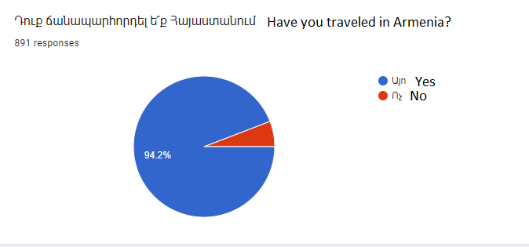
Among 901 people, 94.2% have traveled in Armenia, while 5.8% of respondents haven’t traveled in Armenia. Then I asked them to specify the region visited by them, and the chart of responses shows that the two top places are the Gegharkunik region and the capital city Yerevan. Also, the numbers show that all the areas are approximately equally visited by locals.
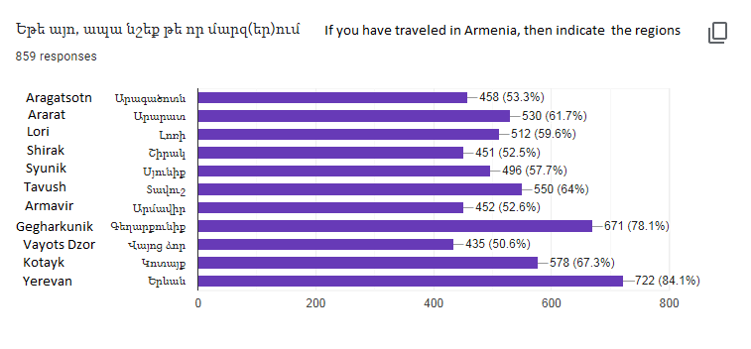
After gathering some general background about their traveling routines, I included some questions regarding the pilgrimage tours and spiritual journeys.
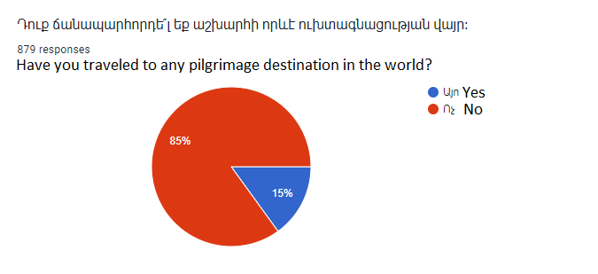

The following question was to mention the names of the places they visited as a pilgrimage tour. Among the answers of 85% of respondents, people were mentioning Jerusalem and Vatican. They also mentioned some countries, such as Spain, India, Greece, UK, and Saint Petersburg. The thing is that they haven’t mentioned any specific destination in that countries. So, we can assume that the tourism marketing of these countries worked in a way that the visitors associate with pilgrimage ideas. It’s important to note that they also mentioned about twenty places in Yerevan. The third leading places were Geghard Monastery, Etchmiadzin Cathedral, and Tatev Monastery complex. Absolutely, these three places are included in the pilgrimage package. To the question of what activities they would consider as spiritual, they have listed a bunch of activates. I have tried to combine their responses and, by summarizing the activities, make a list. The most recurrent activities mentioned by them were:
- Yoga and meditation.
- Visiting a church and talking to a priest.
- Getting familiar with the culture of Armenia.
- Being in the lap of nature.
These activities are all included in the packages as well. Then the last question which I asked the respondents was the following:
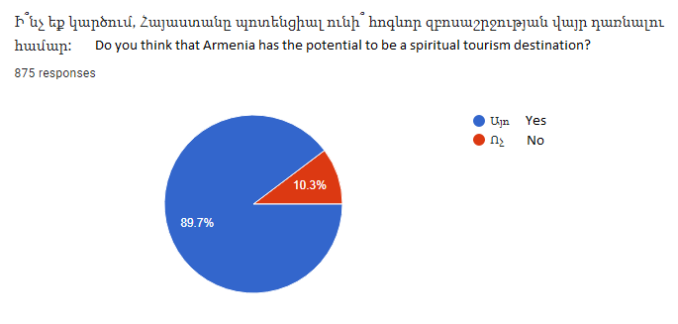
As you can see, 89.7 percent of Armenian respondents believe that Armenia has the potential to be a spiritual tourism destination. Then going to 107 international respondents who have to fill out the survey, there were people from around 40 countries. After getting their biographical background, the questions aimed to get information about their traveling experiences. Whether they like traveling or not, they have traveled to any pilgrimage destination in the world and several other questions regarding spiritual tourism and Armenia.
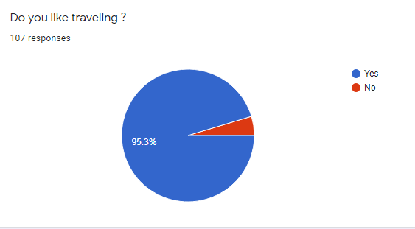
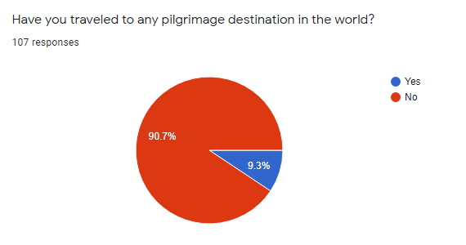
By looking into these two charts, we can see that 95.3% percent of respondents were fond of traveling, but only 9.3% have traveled to any pilgrimage destination in the world. The strange thing is that the respondents mainly have traveled to various countries but still didn’t consider them as pilgrimage destinations. The following picture will show only a short screenshot of their answers, and even in the responses of these random eight people, some countries are known as pilgrimage destinations. For instance, some people have traveled to the Vatican, but they consider it an ordinary country but not a pilgrimage destination.
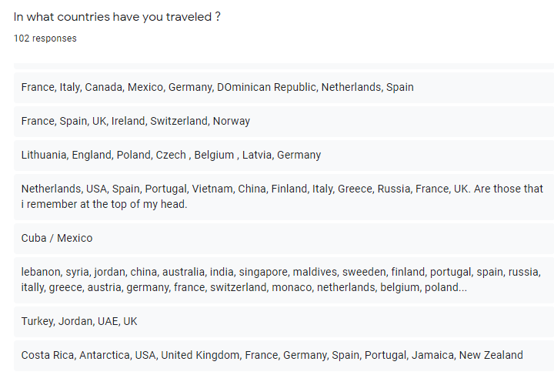
The same question regarding activities which they would consider as spiritual was asked to international respondents as well. That was very surprising that their responses were very similar to answers given by locals. Regardless of geographical location, age, gender, or ethnicity, all people are seeking spiritual satisfaction. The three leading activities mentioned by them were yoga and meditation, religious visits, and nature. I guess that in this overladen century is the reason for such preferences. In general, the places and activities that can disconnect them from their reality become satisfying and spiritual.
In the study of Farooq Hack, there is the following idea: “It has been observed that people are turning towards spirituality as a resolution from the anxiety created by the modern individualistic lifestyle (Blomfield 2009; Kraft 2007; Kale 2004; Mitroff 2003). After getting the responses related to spiritual activities, it becomes easy to make parallels between their preferences and these ideas. This research has some direct quotes from spiritual tourists of Australia and Pakistan. Here are some of them:
-When I go to a new place my first choice is just to find peace in the local church.
- Christianity is universal reality, my struggle to keep my connection with Christ only is enough for my salvation.
-When I get a chance I visit prayer centers of other religion and identify myself as spiritual rather than religious in everything including traveling.
-When I travel as a spiritual tourism my only intention is to connect with God, and it could happen at any Holy site.
-When I went to Mecca I really wished that my Christian and Hindu friends were also there to share the grate spiritual experience.
While reading what spiritual tourists thought and felt, it seems that the place could be considered a pilgrimage destination regardless of an individual’s faith. Being Christian for attending a Christian destination is not mandatory. People with any faith could find that peace in a pilgrimage destination. The RA Statistical Committee, which runs statistics on tourism according to the methodology of the UN World Tourism Organization (WTO), has reported that the number of tourists arriving in Armenia has increased by about 1 million 300 thousand over the ten years. The interesting fact is that the statistics show that Armenia is mainly selected by three countries: Russia, Georgia, and Iran. The state religion in Russia is Russian Orthodoxy. In Georgia, it's Orthodox Christianity, and in Iran, the state religion is Islam with Sunni and Shi'i branches. The fact that the tourists of Armenia are generally from two different religions proves that they have some common motives to travel to Armenia despite the religion. According to the same source, "Armenia appeared in international indexes and pages of influential news outlets as an attractive tourist destination, especially in 2019". Accordingly, 2019 reached its top with 1.9 million tourists visiting Armenia. Thus, appearance in the international tourism marketplace, with the proper packaging of destinations would bring spiritual tourism in Armenia in real.
The penultimate question of both surveys was given to know how many of the respondents know Armenia as a first Christian country. At the same time, it doesn’t just ask the question, but rather the question was informative itself.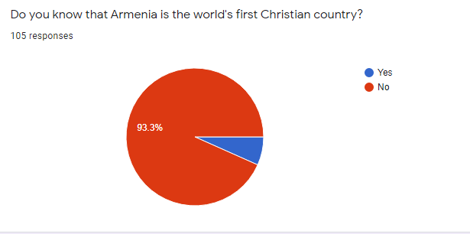

As it becomes clear from the chart numbers, only 6.7 percent of respondents in the number of 7 individuals were aware of Armenia as a first Christian country. Even though the following chart will show that most of the respondents think that Armenia has the potential to be a spiritual tourism destination.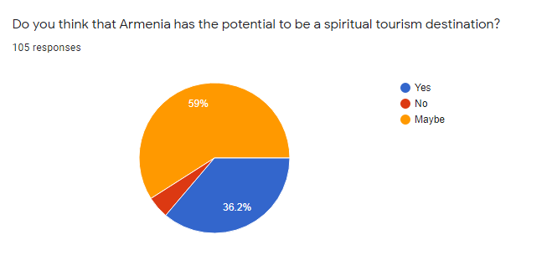
Among the 107 respondents, only five didn’t see that Armenia has such potential. Around 95% of respondents gave a positive response to this question. Getting such numbers from foreigners is inspiring. Although among the respondents, there were followers of other religions, though they consider that Armenia has the potential to be a spiritual tourism destination.
“A visit to a religious heritage site is often an aesthetic experience, one that may engage visitors at emotional, physical, intellectual, or spiritual levels (Heidari et al., 2017). According to the same research paper, the authors consider that the main activity of religious tourists is the worships and prayers. Pilgrims mainly concentrate on historical and religious attractions. Unlike religious tourism, The motives behind the spiritual journeys could be diverse. As spiritual tourism is explained in the same source, “it is a set of ideas that one can find in religious traditions but which also exist independently of them, including an emphasis and culture of the self, wholeness, holism and (inter) connectedness, meaning-, search/quest- and experience orientation, nontheistic cosmology, peacefulness/tolerance, and similar positive value commitments.” While researching this topic, various authors define that spiritual tourism as a much broader concept than religious pilgrimages. Since there are common features between religious and spiritual tourism, therefor people misconceive these two terms. In another research paper, there is the following definition of spiritual tourism:
“Spiritual tourism is not just religious tourism like a pilgrimage; a wide spectrum of travel forms deserves this name. Spiritual tourist seeks something worth being and can give their lives new richness or even new direction”(Melchers, 2006). This research paper discusses spiritual tourism in India and gives some suggestions that could be used to develop Spiritual Tourism. Among the proposed spiritual packages of Armenia, there are all the listed activities suggested by Melchers and Mintel to the exclusion of Ayurveda which is a traditional system of Indian medicine.
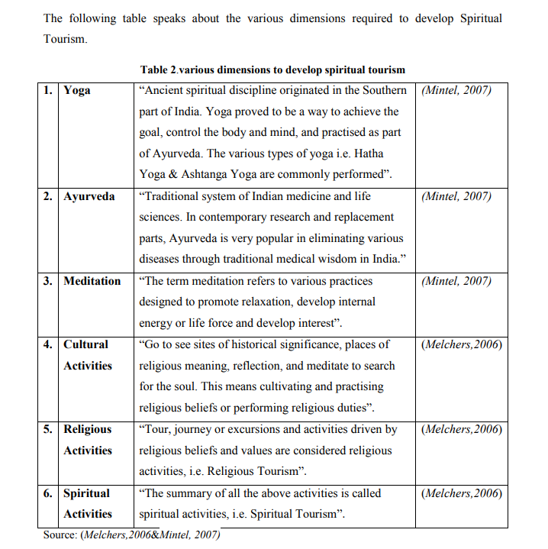

Among the proposed spiritual packages of Armenia, there are all the listed activities suggested by Melchers and Mintel to the exclusion of Ayurveda which is a traditional system of Indian medicine.

In the research paper “THE ROLE OF EMOTIONS IN THE PROCESS OF KNOWLEDGE OF TOURISM PRODUCTS” (Doncean, 2014), there is a section that represents tourism as a product and its various component. Such components are transportation, accommodation, food, leisure, etc. All these components are delivering emotions to tourists which creates positive or negative energy. Most of the visitors associate the country or city with their inner energy. So, while designing the packages of spiritual tourism, the team should pay attention to each component. As the author suggests:
-Inspire as many positive emotions as possible, indicating individual inner states, motivations, desires, needs, and even goals.
While designing the spiritual packages for the future tourism development of Armenia, all these points were considered. Besides the activities included in the packages, the other components should be satisfying as well.
On the other side, Medhakar and Haq define the spiritual tourists as “someone who visits a specific place out of his/her usual environment, with the intention of spiritual meaning and/or growth, without overt religious compulsion, which could be religious, non-religious, sacred or experiential in nature, but within a Divine context, regardless of the main reason for traveling.” In their research paper, the authors discuss the case of India and the ways India succeeded to be the leading countries of spiritual tourism. The solution for complicated marketing of spiritual tourism the authors consider the effective packaging. As stated in this paper, “spiritual tourism can grow and be marketed successfully by proper designing of packages for the right customers” Such a method allows to combine several activities and services presented to a tourist as a single price offer. India is an excellent example of succeeding in spiritual tourism by introducing specially designed packages to locals and foreigners. According to the Uttarakhand Tourism Development Board, 58.2% of the international tourists visited the state for holiday purposes, 21.9% for health/yoga, and 19.4%for pilgrimage/religious purposes. The packaging of spiritual tours was the core element of India’s success and the marketing which was done to present packages to foreigners and locals residents of India.
For proposing spiritual tour packages in Armenia, there could be taken some practices from the case study of India. Obviously, each county has its unique features so that the case studies could be analyzed and implemented according to the peculiarity, geography, and history of that particular country.

Creative part & PR strategies
For the creative part of this project, I would suggest six tour packages that would serve local and international tourists as spiritual destinations. These packages have been formed in a way to contain various activities and appeal to diverse background people. As was mentioned above, I have conducted surveys and interviews in order to know what people need in the context of spirituality. The question of “What comes to your mind when you hear the concept of “spiritual tourism” brought the respondents ideas on what they feel and what they need in order to consider that place as a spiritual destination. Based on my investigations and their responses, I will suggest the six specially designed tour packages which could be represented as “spiritual tour packages” Each of them has its name.

Pilgrimage to the first Christian country
Most people associate spiritual tourism with pilgrimages. Based on the suggestion list containing many notes about churches and religion and considering that Armenia has adopted Christianity first in the world, Armenian churches could serve Armenians and foreigners as pilgrimage destinations. So the first package will contain visits to the most ancient churches of Armenia. The first church which should be included in the list is the Etchmiadzin Cathedral. Some sources consider it as the mother church of Armenian Apostolic churches. Etchmiadzin Cathedral is considered as one of the ancient Armenian heritage. Next to the Cathedral, there is a museum of the church, which is a great place to get familiar with the history of Armenia and the origins of the religion. The next church is Khor Virap Monastery which is famous for being the birthplace of Christianity. Most of the Armenians associate Khor Virap Monastery with the story of King Tiridates and St. Gregory. With the command of the king, St. Gregory stayed in an underground hole for 13 years, which was like a prison. After being released, Gregory was the person to convert Christianity to others. By visiting this church, people have the opportunity to go down into the hole and feel the whole spirit of the religious power. Another church that many respondents mentioned was Tatev Monastery which is a 9th-century historical monument. In the early centuries, the monastery served as a cultural and educational center for Armenians. The Monastery complex is big, and it includes the following churches: the Poghos-Petros Cathedral, St Astvatsatsin, and St. Grigor. Tatev Monastery is also famous for its ropeway called “Wings of Tatev,” which is the world’s longest measuring, about 5752 meters. Other churches to include in this list could be the Sevanavank Haghartsin, Geghard, and Noravank Monasteries. This pilgrimage package includes seven holy destinations that are far from each other. Thus, the pilgrimage could be implemented in three days. The first-day routine could be started from Khor Virap Monastery, which is a 50-minute road from Yerevan. As the Khor Virp Monastery is located in Ararat Province, the next road is the Vayots Dzor Province, which is located Noravank Monastery. Then in southeastern Armenia in Syunik Province. This could be the last stop of pilgrims to attend Tatev Monastery Complex. In the region, there is a variety of hotels where the pilgrim group could spend the night. The second-day routine could start from Sevanavank Monastery, then Geghard Monastery, and end the second day by visiting Haghartsin Monastery. However, it takes an hour to reach Yerevan from Haghartsin Monastery, while the pilgrims could be offered to stay there overnight and come back to Yerevan on the third day. The last spiritual visit would be on the third day to attend Etchmiadzin Cathedral. By following these seven destinations in their three-day spiritual package, the pilgrims would be filled with religious and spiritual satisfaction. At the same time, it would be an opportunity to get familiar with ancient Armenian architecture. Here are photos from all spiritual destinations included in this package. These photos also could be used for marketing and PR purposes.
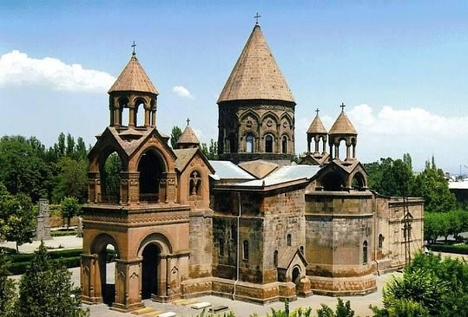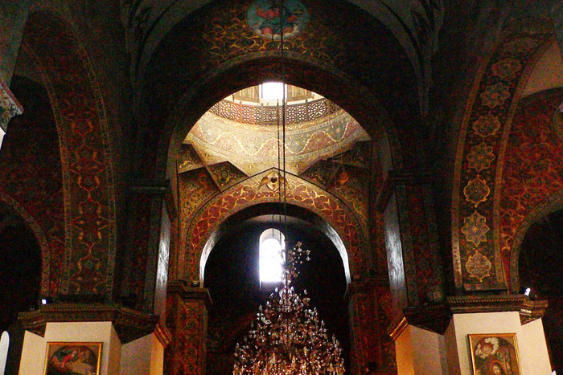Figure 1 Etchmiadzin Cathedral
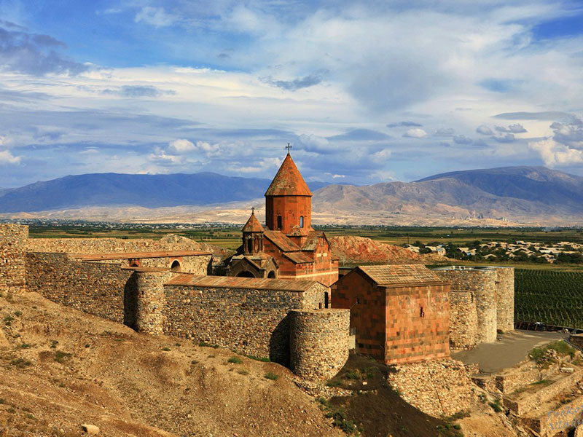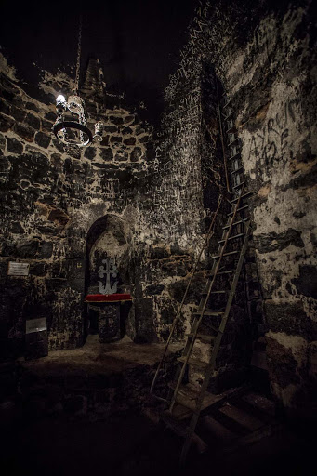Figure 2 Khor Virap
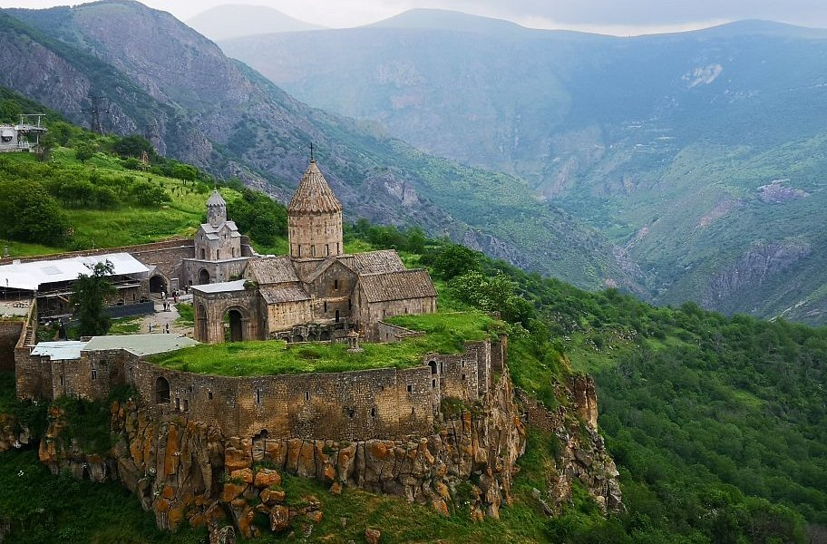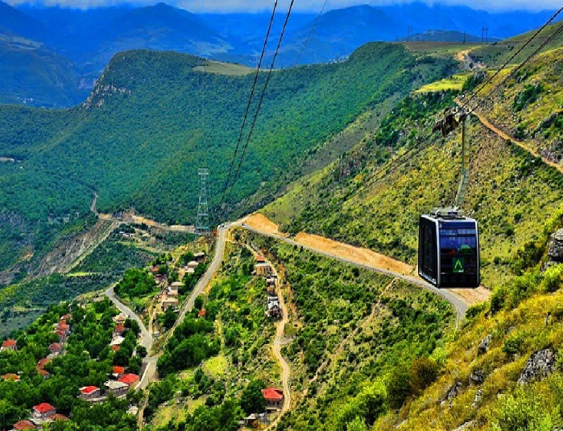Figure 3 Tatev Monastery & “Wings of Tatev”
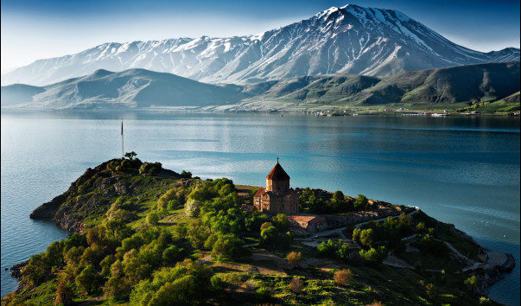Figure 4 Sevanavank Monastery & the Lake Sevan
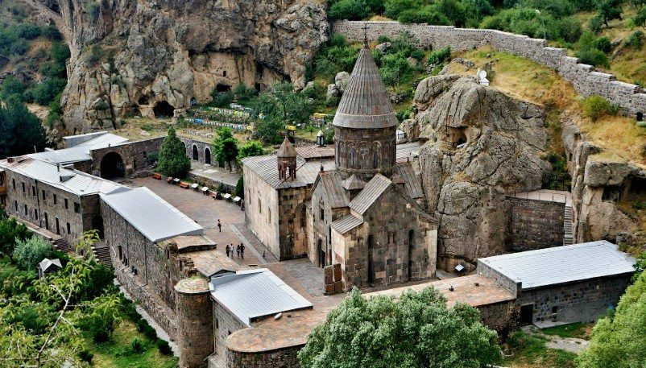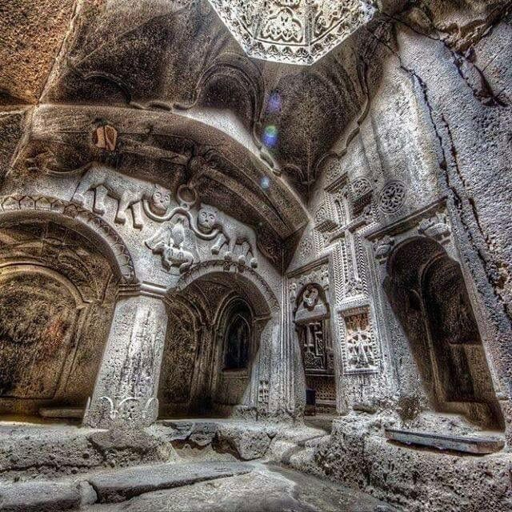Figure 5 Geghard Monastery; it is listed as a UNESCO World Heritage Site
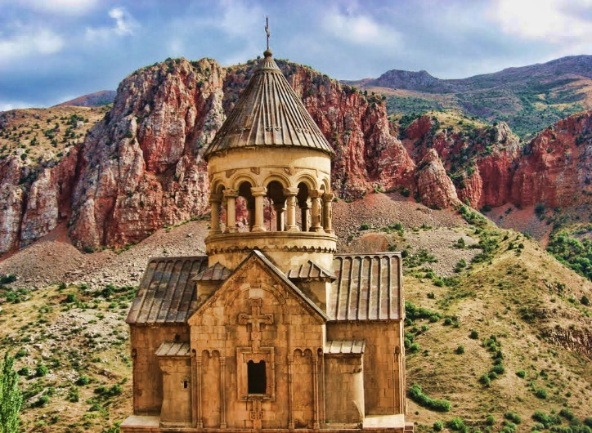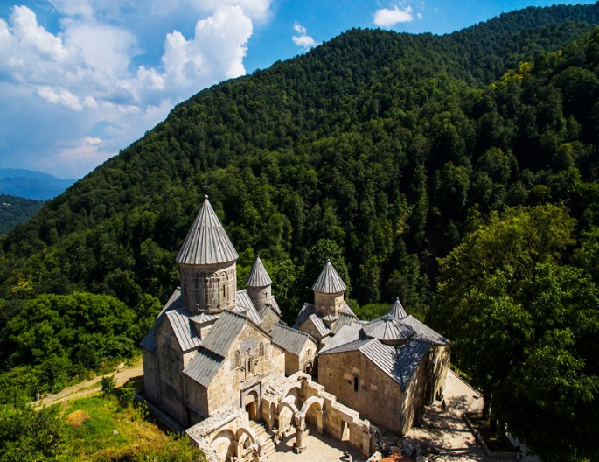 Figure 6 Noravank Monastery Figure 7 Haghartsin Monastery

Getting baptized in Armenia
Baptism, or famous to say among the Armenians, “knunk” is an essential Christian event in the life of each Armenian. Some people called it a second birth of a person, and through Baptism, one could be considered a real member of the Christian community and a member of Jesus Christ’s family. In the Armenian Apostolic Church, the ceremony of Baptism is organized uniquely. Some requirements should be part of the Church Ceremony. The Churches for the baptized could be different. The package could have more than ten suggestions, and the visitors could choose based on their preference. There should be a Godfather for a person who will be baptized, while if a person does not have someone, then the church provides a church servant as a Godfather. Godfather is considered as a second parent for a baptized child or adult. In Armenia, it is accepted that after the Baptism, the godfather becomes a relative of a family. Then there would be a required to have Baptism basket. The basket should include a red and white threat, a golden cross, two candles, a new towel, and a wine. In Armenia, various design stores are making baskets. There could be collected some suggestions and presents to tourists. In the end, the baptized person gets a Baptism Certificate from the church. This spiritual package would mainly be targeted toward Armenia Diaspora tourists. Besides being a religious ceremony, Baptism is considered a typical Armenian ritual as well. Even Armenians who live in other countries and do not have citizenship of Armenia, the Baptism certificate serves them as proof of Armenian nationality. This package is again a religious one but having a deep spiritual meaning in it.
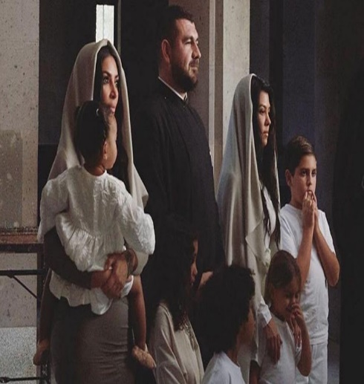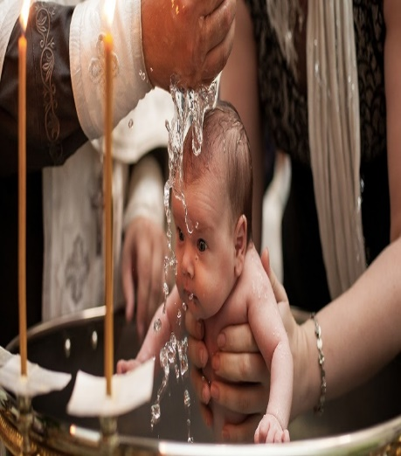
Figure 8 of Kim Kardashian’s children & a Baptism photo taken from Apostolic & Baptism basket

Yoga in mountains

As it was told before, about a hundred survey respondents define yoga and meditation as spiritual activities. Also, as there were many suggestions on nature, this package would combine them together and result in outdoor yoga in nature. This event could be done in Lori, Tavush, or Vayots Dzor Provinces. The reason for preferring these regions is their rich flora and the green mountains. In all three Provinces, there are guesthouses, hotels, and facilities to actualize this spiritual package. As we know, most Yoga lovers are fond of healthy food, as they believe that there should be a healthy soul in a healthy body. Along with yoga and meditation, the package would have offers of healthy food as well. There would be an opportunity to adjust equipment for providing the meditation music too. Everything possible would be done to make these days an unforgettable experience for spiritual tourists. While attending this event, the yoga lovers most probably would fully satisfy their spiritual needs. The event would last no less than three days. Some Yoga Studios in Armenia, such as Universal Yoga Studio, Luys Yoga Studio, have instructors working in several languages. The routine of this event could be developed by having discussions with yoga instructors.

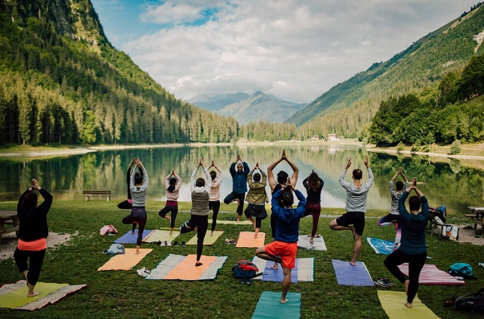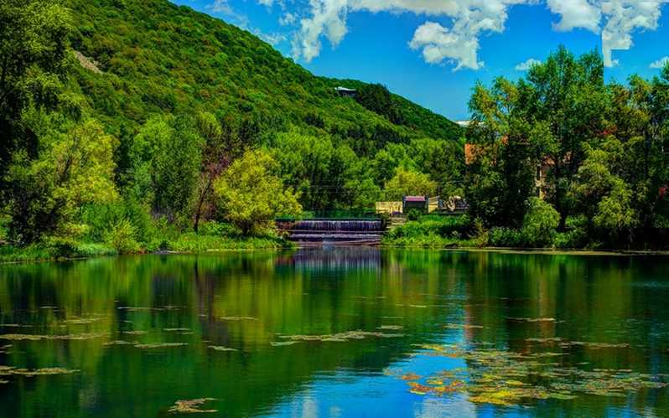
Figure 9 Outdoor Yoga in French Alps and a similar location in Jermuk, Armenia

Tea ceremony in Zvartnots Cathedral

Zvartnots Cathedral is one of the most ancient buildings of Armenia. It was constructed in the early 7th century CE. Zvartnots Cathedral was added to the UNESCO World Heritage list. By attending the Cathedral, the travelers would be able to enjoy the view of Ararat as well. This destination is unique from the perspective of architecture and history. The organizers should provide comfortable seats, a tea ceremony, and live Armenian music for travelers in the Cathedral. There would be invited Armenian classical orchestra and several other performers. In 4 hour event, there could be included some of the national dances as well. This package would provide an opportunity for visitors to touch the history. Unlike the “Taste of Armenia” this package would mainly include Armenian spiritual songs written by Komitas, Tigran Mansuryan, Charles Aznavour, etc. In the area of Zvartnots Cathedral, there could be conducted an exhibition of paintings of great Armenian painters like Martiros Saryan, Minas Avetisyan, Yervand Kochar, and a few others. The tea ceremony in the Zvarnots Cathedral is planned to last about 4 to 5 hours in the evening time. The package will include food and hospitality as well. The spiritual tourist will be accompanied from the city center to Zvartnots Cathedral. There would be entrance tickets which would be taken by hosts to accompany them to their seats. This would be an evening full of Armenian ancient history and art, which would create a spiritual atmosphere.
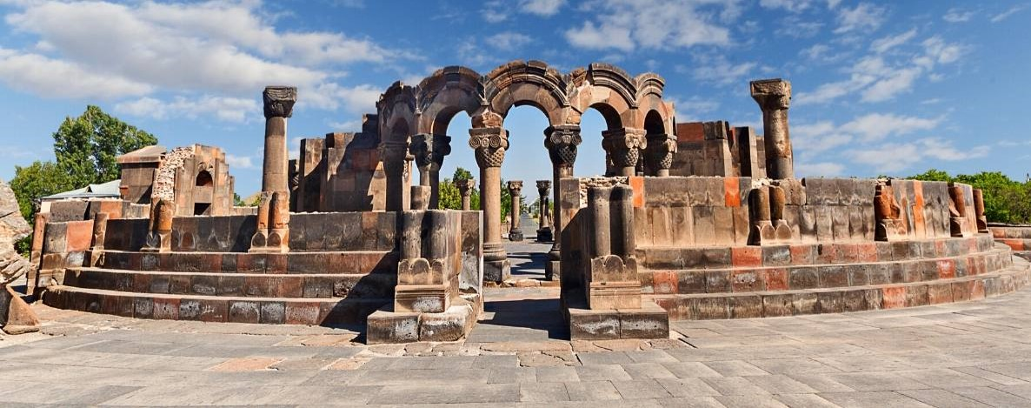
Figure 11 Zvartnots Cathedral
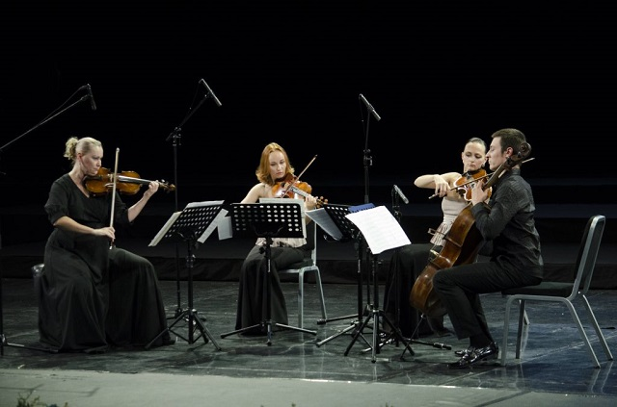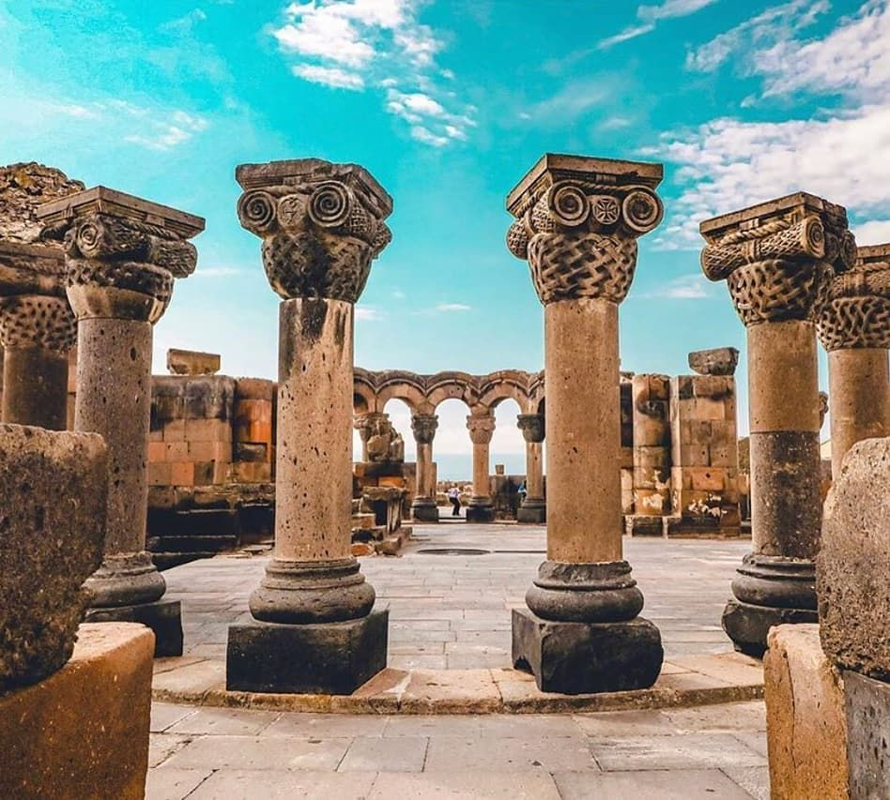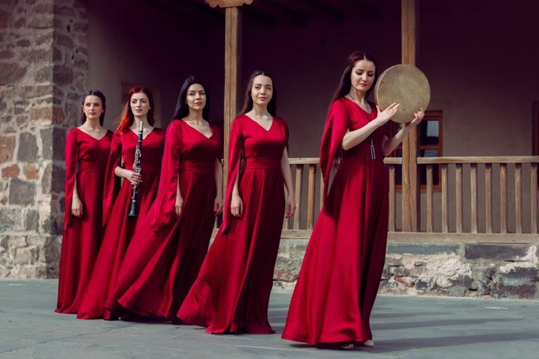
Figure 12 Armenian classic music orchestra & national dancers who would be a part of “Tea Ceremony in Zvartnots Cathedral’ package

Taste of Armenia
In this package, the travelers would have an opportunity to taste everything related to the culture of Armenia. There are ethnic places in Yerevan, Like Dalan cafe and Art Gallery or Megerian Carpet Armenia, designed with Armenian folk style. These places could serve as a destination to organize the main event. Guests could be invited starting from 6 pm and continue the event until midnight. There are Armenian folk dance groups like “Masunq,” “Akunq,” etc. One of such groups should be invited to the evening. They are making the atmosphere typical Armenian, and also their performances include interactive parts when they teach some dances to the guests. There would be time dedicated to tasting Armenian drinks and foods such as dolma, ghapama, Armenian brandy, etc. Then there would be a particular corner of shooting with a photographer where tourists would have an opportunity to wear Armenian folk costumes and then get their professional photos. Also, some Armenian folk singers and musicians could be invited to perform. For instance, duduk is mainly associated with Armenians. By spending several hours in such an atmosphere, tourists will know what Armenia is and who Armenians are. Travelers from Europe, the US, and Asian countries would enjoy such an experience as it would make them feel the spirit of Armenia.
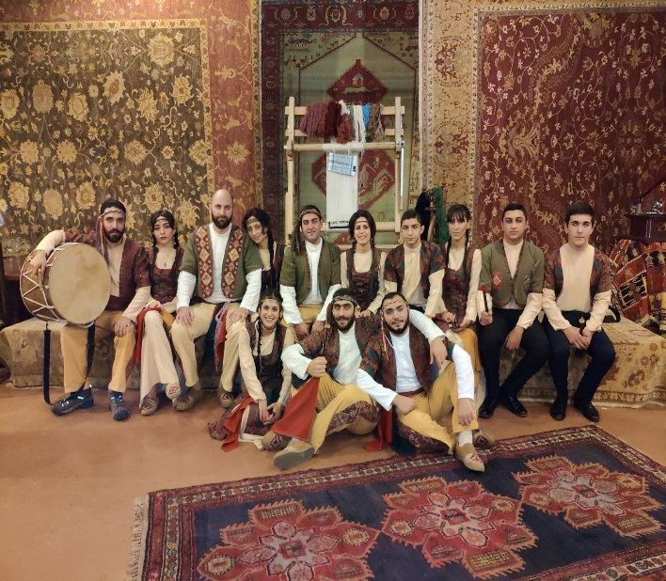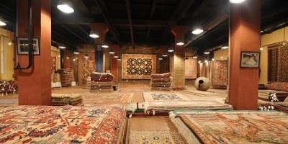 Figure 13 Masunq Folk Ensemble & Megerian Carpet’s hall

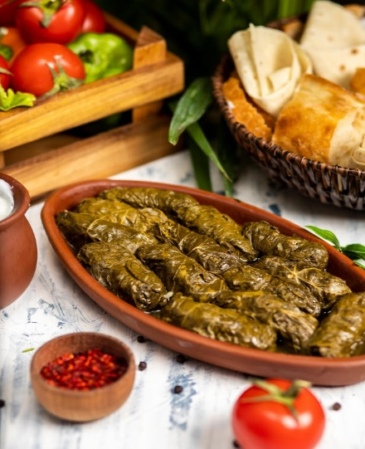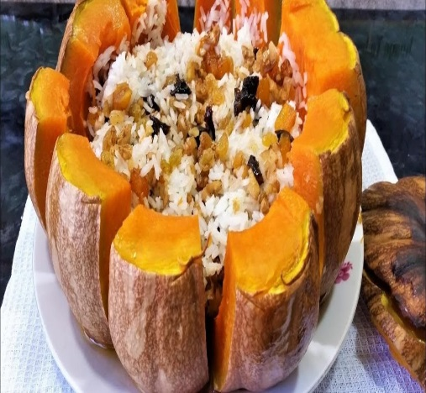
Figure 14 Armenian Dishes: Tolma, Ghapama, Pakhlava

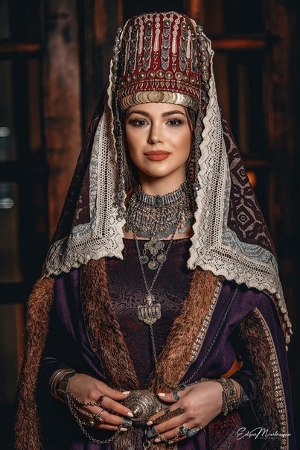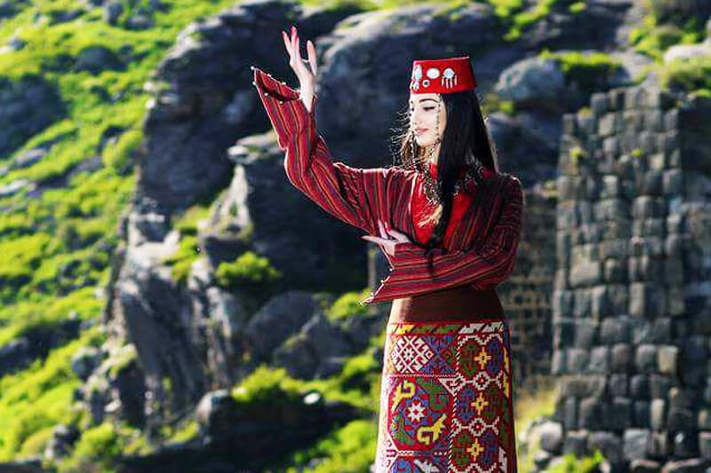
Figure 15 Examples of Armenian folk costumes

The first tool that could promote these packages among the international tourism portals is the promotion in Expos and Exhibitions. Participation in such activities could bring corporate partnerships as well. This way, it would be able to reach different audiences from a variety of countries. International tourism festivals and expos are great places for networking. Before the participation, there could be developed guidelines that will include all the background information a traveler needs to reach Armenia. For instance, the prices of flights, the calculated amount of pocket money, the list of hotels, and information about additional facilities. There should be well-designed brochures that will include all the suggested spiritual packages. The brochures might consist of photos, background information, and the website address, which will help them to investigate more about these packages, activities, and Armenia in general. Another tool to promote these spiritual packages to travelers is marketing through industry influencers Eva Zu Beck and Nas Daily. Both of them have a huge number of followers from different corners of the world. Nuseir Yassin is a blogger who makes short videos to leave an impact. He started his career by making 1-minute videos for 1000 days, and in this way, he reached 11.8 mln followers. According to the blogger, there is a lot of the world that is undiscovered. He went to the places that most other bloggers do not go. Nuseir Yassin is a citizen of Israel, and he is not allowed to travel to Pakistan with his passport. Even though Pakistan used Nas Daily’s 1-minute video to promote tourism in Pakistan, they made it remotely. In the video, we can see Pakistanis who show some places ad activities of their country under the speech of Nuseir Yassin. Nas Daily has done a video about Armenia as well. The first one-minute video only tells about the water fountains of Armenia, and the video itself is called “Armenia, the land of free water.” Another two videos are about how Armenia teaches kids to play chess and Armenia’s most popular rollerskater, Levon. This time Nas Daily blogs could be used for promoting spiritual packages among worldwide travelers. Likewise, Eva zu Beck is an adventurous traveler who visits countries and places that are not represented in mainstream media. Based on the analytics and demographics about the followers of Eva zu Beck, the interests of 66.13 audiences is Travel and Tourism, and the average likes for a per post are 20.731.
While inviting them to introduce these spiritual routines, these events should take place in real and make the influencers a part of a team attending these journeys. Only telling that such stuff existing in Armenia will not influence their audiences as effectively as possible through live examples of their participation. There could be made short inspirational and emotional videos which would grab the attention of their followers and other viewers.
Obviously, in the 21 century, one of the most widespread research methods is the internet. People mostly use search engines such as Google, Yandex, or others to gather information about what they are searching for. Consequently, the use of Google ads and the work done by Search Engine Optimization professionals could bring expected results in terms of the increasing number of travelers. There could be some keywords and hashtags which will help to appear in searching materials.
Another online tool that could be used for the same purpose is promotions through social media marketing. There are a variety of groups on FB which consist of people with the same interests. There are tourism-related groups with thousands of members. The advertisements and paid posts in such groups would be targeted marketing. All the tools mentioned earlier could be used for reaching the potential travelers while there could be the promotion of ‘spiritual packages” among those who have visited Armenia as well. By using PR, there could be launched partnerships with governmental and private sector bodies. Such partnerships would be beneficial for both sides involved as the common purpose is the same: to attract more tourists.

Works cited:

AIST Global. (n.d.). Tatev monastery. Retrieved from https://armeniadiscovery.com/en/place/tatev-monastery
Armenia - Travel and tourism. (2020, October). Retrieved from https://www.trade.gov/country-commercial-guides/armenia-travel-and-tourism#:~:text=International%20visitors%20contributed%20over%20%241.2,Com
Armenia - Travel and tourism. (n.d.). Privacy Shield | Privacy Shield. https://www.privacyshield.gov/article?id=Armenia-tourism-and-travel-services
Armenia contribution of travel and tourism to GDP (% of GDP), 1995-2019 - knoema.com. (2019, June 4). Retrieved from https://knoema.com/atlas/Armenia/topics/Tourism/Travel-and-Tourism-Total-Contribution-to-GDP/Contribution-of-travel-and-tourism-to-GDP-percent-of-GDP
Armenia travel cost - Average price of a vacation to Armenia: Food & meal budget, daily & weekly expenses | BudgetYourTrip.com. (2021, May 11). Retrieved from https://www.budgetyourtrip.com/armenia
Armenian potential of tourism to be introduced in Paris international exhibition [ARMENPRESS]. (2015). Retrieved from https://armenpress.am/eng/news/820377/armenian-potential-of-tourism-to-be-introduced-in-paris-international-exhibition.html
Arsyraf, R. (2020, February 22). 7 steps to go viral: The way nas daily did it. Marketing in Asia. https://marketinginasia.com/2020/02/21/7-steps-to-go-viral-the-way-nas-daily-did-it/
Avetisyan, A. (2020). Tourism in Armenia: The numbers are growing but there is no boom. Fact InvestigationPlatform. https://fip.am/en/10472#:~:text=The%20RA%20Statistical%20Committee%20runs,World%20Tourism%20Organization%20(WTO).&text=That%20year%2C%201%20million%20260,18.7%25%20more%20than%20in%202016
Bayrakdarian, K. A. (2017). Who comes to Armenia and why [EVN Report ]. Retrieved from https://www.evnreport.com/economy/who-comes-to-armenia-and-why
Benedict, T. (2018). Practicing Spiritual Care in the Japanese Hospice. Japanese Journal of Religious Studies,45(1), 175-200. doi:10.2307/26854475
DONCEAN, M. (2014). THE ROLE OF EMOTIONS IN THE PROCESS OF KNOWLEDGE OF TOURISM PRODUCTS. Agronomy Series Of Scientific Research / Lucrari Stiintifice Seria Agronomie, 57(1), 259-262.
Economic impact | World travel & tourism council (WTTC). (2020). Retrieved from https://wttc.org/Research/Economic-Impact
Evans, J. (2015). Experience and Convergence in Spiritual Direction. Journal of Religion and Health, 54(1), 264-278. Retrieved December 10, 2020, from http://www.jstor.org/stable/24485255
Ghazanchyan, S. (2021, March 19). Armenia’s tourism potential presented at MITT Moscow exhibition. Public Radio of Armenia. https://en.armradio.am/2021/03/19/armenias-tourism-potential-presented-at-mitt-moscow-exhibition/
Gómez-Barris, M. (2012). Andean Translations: New Age Tourism and Cultural Exchange in the Sacred Valley, Peru. Latin American Perspectives, 39(6), 68-78. Retrieved December 10, 2020, from http://www.jstor.org/stable/41702294
Greene, B. (2016). Furusato and Emotional Pilgrimage: Ge Ge Ge no Kitarō and Sakaiminato. Japanese Journal of Religious Studies, 43(2), 333-356. Retrieved December 10, 2020, from http://www.jstor.org/stable/japajrelistud.43.2.333
Haq, F., & Wong, H. Y. (n.d.). Exploring marketing strategies for Islamic spiritual tourism. Handbook of Islamic Marketing. https://doi.org/10.4337/9780857936028.00026
Harutyunyan A. (2021). Armenia presents its tourism potential at leading Russian travel show [ARMENPRESS]. Retrieved from https://armenpress.am/eng/news/1046533.html
Heidari, Ali & Yazdani, Hamid Reza & Saghafi, Fatemeh & Jalilvand, Mohammad Reza. (2018). The perspective of religious and spiritual tourism research: a systematic mapping study. Journal of Islamic Marketing. 9. 10.1108/JIMA-02-2017-0015.
Hergnyan, S. (2019, September 6). Number of Tourists to Armenia Up 12%; Most are Diaspora Armenians. Hetq.am. https://hetq.am/en/article/107046
How much does it cost to travel Armenia? (2020, August 30). Retrieved from https://www.bigworldsmallpockets.com/cost-to-travel-armenia/
Jilavyan, A. (2018, April 15). Inventions by Armenians! (Part 1). The Critical Hub. https://thecriticalhub.wordpress.com/2018/04/15/inventions-by-armenians-part-1/
Lawrence-Hart, G. (2016). Tourism and Intercultural Communication. In Iheanacho N. (Ed.), Intercultural Communication and Public Policy (pp. 221-238). Port Harcourt: M & J Grand Orbit Communications. Retrieved November 7, 2020, from http://www.jstor.org/stable/j.ctvh8qzvr.18
Medhekar, A., & Haq, F. (2012). Development of Spiritual Tourism Circuits: The Case of India. The GSTF Journal on Business Review, 2.
Melcher, W. (2006). Spiritual Tourism: Motives, Formats and Marketing.
Miller, C. (2016). "SPIRITUAL BUT NOT RELIGIOUS": RETHINKING THE LEGAL DEFINITION OF RELIGION. Virginia Law Review, 102(3), 833-894. Retrieved December 10, 2020, from http://www.jstor.org/stable/43923324
Mukherjee, S., Bhattacharjee, S., & Singha, S. (2020). Religious to Spiritual Tourism- An Era of Paradigm Shift in India. Journal of Xi'an University of Architecture & Technology. chrome-extension://oemmndcbldboiebfnladdacbdfmadadm/https://poseidon01.ssrn.com/delivery.php?ID=38808207406408802809401111000512006403905302001802605810906400310
Najarian, T. (2018, August 17). Baptizing children in Armenia. RepatArmenia. https://repatarmenia.org/en/blog/a/tamar-najarian/baptizing-children-in-armenia
Nas Daily: I show Armenia with its true colors. (2018, July 19). Mediamax. https://mediamax.am/en/news/interviews/29485
Phukan, H., Rahman, Z., & Devdutt, P. (2012). Emergence of Spiritual Tourism in India. https://mail.google.com/mail/u/0/#inbox/KtbxLwgddjVLQvMvSpzDdgvHjLWPDQncgq?projector=1&messagePartId=0.4
Piewdang, S., Mekkamol, P., & Untachai, S. (2013). Measuring spiritual tourism management in community: A case study of Sri Chom Phu Ongtu temple, Thabo district, Nongkhai province, Thailand. Procedia - Social and Behavioral Sciences, 88, 96-107. https://doi.org/10.1016/j.sbspro.2013.08.485
Tourism statistics - Country fact sheets. (n.d.). Retrieved from https://www.unwto.org/statistics/country-fact-sheets
Tovmasyan, G. (2016). Tourism Marketing in the Republic of Armenia. European Journal Of Economic Studies, 16(2), 358-363. doi:10.13187/es.2016.16.358
Tovmasyan, G. (2016, June). (PDF) Tourism marketing in the Republic of Armenia. Retrieved from https://www.researchgate.net/publication/307846205_Tourism_Marketing_in_the_Rep
Wikipedia contributors. (2021, March 4). Tourism in Armenia. In Wikipedia, The Free Encyclopedia. Retrieved 06:51, April 29, 2021, from https://en.wikipedia.org/w/index.php?title=Tourism_in_Armenia&oldid=1010258091
Wikipedia contributors. (2021, March 4). Tourism in Armenia. In Wikipedia, The Free Encyclopedia. Retrieved 13:05, May 11, 2021, from https://en.wikipedia.org/w/index.php?title=Tourism_in_Armenia&oldid=1010258091

