MIXED COMIC STYLES IN FANTASY GRAPHIC NOVEL WITH HORROR ELEMENTS

By
Lyudmila Asryan

Presented to the
Department of English & Communications
in Partial Fulfillment of the
Requirements for the Degree of Bachelor of Arts

American University of Armenia
Yerevan, Armenia

May 17, 2021

Abstract
The horror genre in graphic novels emerged at the very beginning of comic history. Depending on the topic of the comic, the medium that combines both text and images can be a versatile tool in creating horror settings. This project is a graphic novel that aims to combine comic properties inherent in European, Eastern, and Western cultures as well as shed light on stereotypical representations of witches in modern art. The goal of the narrative is to portray topics as victimization, feminism, primitivism, group thinking, etc., that can often be associated with witch history. The first stage of the project was the research part. After collecting enough references, the second “creative” stage started, which focused on making the graphic novel and combined illustration and text development. The graphic novel was created using Clip Studio Paint. In the end, the project turned into a fairytale-similar narrative with horror elements, centralized on the story of two witches and their multi-layered relationship that took place in Early Modern Europe.

Creative Goal
The purpose of this creative project is to test my understanding of comics as a medium. It is a chance for me to become closer to my long-time passion and share my experience with others. My project as a graphic novel mainly serves to entertain others and inspire them, as other artists inspired me. It is also a challenge for me to answer whether I can incorporate different comic genres and styles into one work or not. I present horror as a graphic novel genre and display it via plot. The plot of my project covers witch history and dark magic. It questions stereotypical representations of witches in fiction as well as the mystery behind the witch origin and history. The narrative focuses on psychological and social pursuits hidden in the witch history and analyzes humans’ inclination towards self-deception and ignorance.

Introduction
I have always been a huge fan of horror movies ever since I was a little kid. At first, this fascination with fear had lacked a profound reason behind it except a desire to experience intense feelings. The power that a horror movie could have on me, completely distracting me from reality and immersing me into various supernatural settings, is stronger than of any other genre. As I grew up, renowned bestseller fiction had replaced cliché Hollywood movies, which surprisingly, regardless of the medium's limitations, successfully delivered the same thrilling horror I could get from a film that utilized typical tricks such as jump scares or alarming audio effects. At this time, I was wondering which exact factors contributed to the human fascination towards fear. After reading numerous different stories, I began to notice similar patterns in the techniques the horror genre uses, all the unique rules and features that one can implement to manipulate the emotional states of his/her audience.
Taking into account my passion for writing and drawing, I considered as a must for me to possess skills for creating my own powerful stories, which would have the same emotional influence on my readers as the stories from my childhood had had on me. In turn, fear appeared to be the most influential and immersive emotion a reader could feel, which further led me into the horror genre as a more solid foundation for my project. However, having a significant experience both with horror movies and books, I also was able to see both the pros and cons of each medium. Hence, I came up with the natural conclusion that would allow me to use all the good aspects of each of these within the medium, and for me, that solution was a graphic novel.
One other reason why I chose the horror genre for my comic is the unique way it sets tension. Horror scenes in movies are flashy and loud, and sometimes the audience doesn’t even watch them as they are too scary. These scenes mainly serve the purpose of complementing the narrative – adding some “spice” to it. Horror in books is less aggressive as it gives you time to appreciate the scene fully and not miss any detail or hidden message. The graphic novel works the same way; however, when you add visuals, it gives you a space to work with one more sense – sight. Depending on your style and scenes, you can manipulate the amount of “scary.” Though, readers will still imagine everything the way they see it – facing their fears. And that is what makes horror fiction so powerful. As a comic artist, you are giving them direction. Also, the notion of silence works for your benefit. Silence in itself makes us uneasy, and in a horror graphic novel, this feeling is enhanced by the narrative and visuals.
The topic of the graphic novel is related to witches that, due to all the influence from a lengthy list of horror movies and books, seemed one of the scariest things for me and one full of pain and tragedy. Being equipped with all the tools necessary for proper research and depiction of the story, both from the mystical/superstitious standpoint and from the real one, I finally started developing the project. Following all the points in mind, I decided to research the primary techniques authors often use to induce terror in their audience, explore peculiarities of graphic novels and the process of its creation, as well as examine the subject of witches, which would help me to depict the story that is worth someone’s attention and work with a setting optimal for the adaptation of the elements of a horror story.

Literature Review
The horror genre has existed since the very beginning of comic history. Like any other genre, horror comic also has its sub-categories. However, horror as a genre can be simplified easier when compared to others. The simplicity behind that is hidden in the concept of fear. Based on psychology, even the most complicated type of fear can be broken down into small ones, which will help to get the whole picture in detail. In the article, “A comprehensive examination of the precode horror comic books of the 1950's” by G.M. Broxson, the author represents the history of the western horror comic and generalizes the topics it can include. However, the most valuable part of the book is the analysis of several horror comics and the story behind their success. The author shows social and psychological issues that horror graphic novels usually contain. The research presented in this book significantly contributes to the construction of the narrative for my project. These examples inspire and help me to construct a complicated plot using other authors’ experiences.
Scott McCloud’s “Making Comics: Storytelling Secrets of Comics, Manga and Graphic Novels,” is a necessary book for beginner comic artists. In his book, he presents numerous techniques used in graphic novels. This source delivers an immense insight into the graphic novel. It explains how comic using both human perception and imagination maintains the narrative flow by its visual features. The book is one of the main reasons I started this project. Due to it, I could analyze graphic novels more precisely and fully appreciate comics as a medium. I chose numerous detailed techniques presented here and transferred them to my project, for example, fading contours or masking effect that will be discussed later in the paper. When it comes to the horror genre, it is essential to consider the imaginative aspect of the observer’s perception as to lead them into the narrative filled with fictional creatures and entities in a natural manner. Thus, the more techniques one knows, the wider is the selection of “manipulative tools.”
While I already possess knowledge about the structure of American and European graphic novels and comics, I have also dedicated an extensive amount of time to reading Japanese graphic novels – manga. In addition to the structural aspect of the form of a graphic novel, I am also more acquainted with the visual style of Japanese artists. Hence, it is apparent that the result contains many aspects from it. One of my goals was to display the combination of various comic styles in one project; however, I primarily focused on manga while trying to enhance it with additional features from western culture. In the book “Manga: An anthology of global and cultural perspectives,” the authors compare history, genres, style of manga to other comics. The book contains numerous examples from various manga titles. It devotes the whole chapter to analyze the structure and form of manga, where it highlights differences between western and Japanese comics. Understanding stylistic differences helped me to produce original work, enhancing the basic principles of storytelling with a new approach, meanwhile staying within the reasonable boundaries of my comfort zone as an artist.
Additionally, the stylistic differences between various comics are also covered in the article “Manga story-telling/showing. Image & Narrative” by A. Rommens. This article explores manga as a medium and its influence on European and American comics. The author pays attention to the details like dialogues and visualization of sound in graphic novels. When it comes to the artistic differences, this book conducts a closer examination of the stylistic properties manga possesses in regards to the western counterparts, not only within the style of the drawings but also in the structural blueprint and the relation of the panels and the talk-sound bubbles. The presence of this type of blueprint was of immense use to me when I tried to distinguish the most appropriate approach for the construction of my panels.
All the sources mentioned focus on the narrative construction; however, as a beginner, I needed another material that helped in the technical side of the drawing. Framed ink: Drawing and Composition for Visual Storytellers by M. Mateu-Mestre is a beginner-friendly guide for drawing graphic novels. It doesn’t focus as much on drawing as on constructing it. It already considers that the reader has some drawing experience and can draw simple characters and environment. The author focuses on narration as well, but the essential parts in the book are composition and perspective, which are complicated to a beginner. Thus, this book is a tutorial on how to draw more dynamic and balanced scenes. The last chapter of the book contains a character development guide, which can help to create characters producing unique designs. This source further contributed to the development of my artistic style when it comes to the visual aspect of scene and character construction.
The plot of my project is focused on the 18th-century history of witches in Europe. However, as I know little about the subject, I chose two books on witch history which can fill the gaps in my knowledge. “The witch-cult in Western Europe: A study in anthropology” by Murray and Alice is the glossary for anyone interested in dark magic. Even though it focuses mainly on the witch cults in Europe, it also contains comparisons with New England’s cults. It covers historical and cultural aspects of witches, aiming to explain every ritual or symbol they had. Readers can find an overwhelming majority of terminological words related to the witches in the book and explanatory paragraphs next to the terms. The book is a part of my environment-making journey. But the glossary itself isn’t sufficient for understanding a complex socio-psychological construction as witch phenomena. The following source was “Witchcraft and magic in Europe, volume 4: The period of the witch trials” by S. Clark and W. Monter. It's a chronological book that focuses on the description of witch trials; also, the “magic” witches were believed to use. It provides immense details on witch-hunting in Europe, presenting facts about the most outrageous ones. As witch hunts are an essential part of witch history, it is crucial to include the topic in the project. The last section of the book has an insight into the witch rituals, which would complement my research. The combination of both of these works allows to depict the representations of witches from different cultures accurately. In addition to the characteristics concerning the aesthetical aspect of the depiction, I was also equipped with a factual foundation of the terminological and symbolical attributes and the magical abilities and witchcraft different cultures believed were associative to witches.
As the medium of graphic novels requires an appropriate and adequate visual contribution for the progression of the narrative, the last source covers the analysis of the visual representation of witches in a more in-debt manner. For illustrating, I need to research and compare famous representations of witches to understand the stereotypes and symbols behind them. “The journal Baldung and the Witches of Freiburg: The Evidence of Images” by L. Hults represents a historical factual analysis behind the images of witches or witchcraft. It shows how each item on the paintings was an essential aspect of the witch history. These paintings and the research behind them contribute to creating the characters and an environment that is true to itself. Moreover, the images served as an inspiration for my work. The presence of initial exemplary representations grants me the necessary tools for comminating and producing new designs based on the source material.

Research
Horror Comics
Unlike horror books that utilize the reader’s imagination, horror comics heavily rely on visual details. It is easier to work with horror as the readers are limited by their imagination only. When they are given a scene with few details, they can exaggerate it however they want and make their horror. In horror comics, artists use disturbing imagery, manipulate light and shadow, and the characters' body language to convey the chilling feeling and environment.
According to G.M. Broxson, critical analysis of the first horror comic books reveals that “they were like gruesome fairy tales” similar to European classic fairy tales, not the romanticized and watered-down American version. The horror genre followed after the golden age of western comics when superheroes were the main subject. American conservative society wasn’t ready for the new genre, which resulted in an anti-comics crusade in 1954.
I decided to focus on the fairytale-similar narration and imaginary. The main protagonist is the innocent young woman dealing with the unfortunate and “magical” events around her. She is rescued by her lover, who promises to take care of her. However, it has a feminist twist to it, as at the end, the woman is the one who saves herself, and being as powerful as she is, she doesn’t need any help at all. There is always a distinction between evil and good in fairytales; there is a black and white pattern in the created world. Yet, this project tries to mix two concepts into one and eliminates the classical antagonist in the story. For example, it is natural to think that the witch with her pile of dead bodies is a typical antagonist. Still, the comic makes us feel empathy towards her and make her character multi-layered, which isn’t the case in fairytales. Others can argue that the antagonist of my story is the society itself that, blinded by fear and self-deception, tries to kill the young woman. But the comic doesn’t criticize their actions or focus on them as much, which is one of the disturbing things here. The reader feels powerless in the story, as it doesn’t comment on injustice but depicts it, and neither reader nor the woman can do anything against it.
As mentioned above, comic artists do not rely on the imagination of readers as on illustration and text; however, they still provoke a small part of it to fill the gaps between panels or pages. As an author, I tried to enhance this effect, furthermore adding “the unseen narrative.” Many of the dreadful actions happen outside of the comic pages, such as scenes where the witch kills humans regularly and drags them into the secret room. It creates a sense of suspense as the reader is unaware of the intentions the witch has.

The Witch History
When writing a story about witches, it is crucial to also include some hints from the terrifying witch trials from the past. Throughout history, people, mostly women were misunderstood and accused of witchcraft. Women were confessing their use of witchcraft under the scapegoating and execution threat from society. Witch hunts in Europe began in the mid-1400s. Between 1500 and 1660, almost 80000 suspected witches were executed (History of Witches, 2017). Christians believed that witches were evil pagans doing devil’s work (Bailey, 2006).
One of the famous publications in 1486, “Malleus Maleficarum” further enhanced the witch mania. It is translated as “The Hammer of Witches” and was used to identify and prosecute witches. (History of Witches, 2017). The book claims that women are more liable to witchcraft than men; intrinsic female traits are inferior to male counterparts, which together with the inherent carnality of women, serve as a reason for them to get into diabolical magic, i.e., to increase their power (O' Leary, 2013). The book spread misogynistic beliefs and became a cause for even more witch executions.

The story of the comic takes place in 18th century England, Gelderland. According to the article by Erin Hillis, in England, witchcraft was manifested merely as inflicting harm upon others. For example, if someone refused to give money to a beggar and later felt ill, the beggar would be accused of witchcraft. The witches of England weren’t as strongly connected to the devil as in other parts of the world (Hillis, n.d.). The rate of executions was also low, which is not the case in my comic. After the townies find out that a young woman is the only survivor of a fire accident, she becomes an outcast. Later on, she makes the rapist blind, misogynist society “receives enough evidence” to accuse her of being a witch and prepares for her execution. The young woman becomes a victim of scapegoating. In the end, when she returns to the town, society accepts her despite everything as she is pregnant and has a family now, i.e., she isn’t “an immature” attractive woman anymore; she is a mother, and her purpose is to take care of her family.

Japanese Manga
Japanese shading style includes the excessive use of screentone, while it almost lacks or is unnoticeable in European and American comics. With screentone artists can easily save time adding texture to the page. In my project, I tried to compensate for the lack of details and drawing experience with the screen tone practice, which also resulted in manga style aesthetic (Wong, Xueting , Li, & Xie, 2020).
Manga is made in a black and white palette as the production of black and white comics is cheaper and saves time (Wong, Xueting , Li, & Xie, 2020). I focused on the line art and my specific shading method in my comic. Not being acquainted well with the color theory, I realized it is the optimal decision for me to emphasize the narrative and overall “feeling” of the comic and excludes colors that may distract readers. Moreover, the lack of colors in the artwork adds a sense of tragedy and desperation (Manwill, 2016), and for the horror graphic novel, it is a perfect match.
On some of the pages in this graphic novel, I added photo references as a background; after being edited and transformed, they lost significant resemblance to photographs.
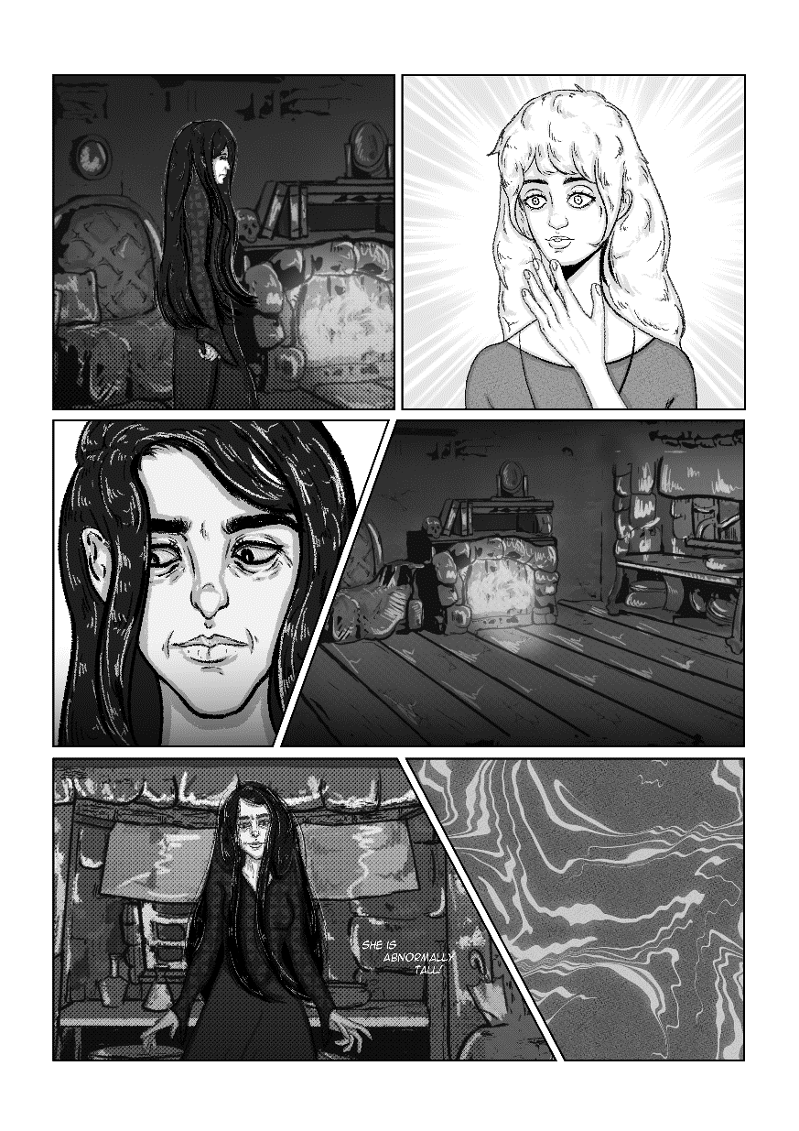
Manga backgrounds usually have a “photographic” style, while characters are drawn in a more cartoony style (Rommens, 2000). Most manga artists use particular premade backgrounds or create a new one using a 3D app; they can also make their photos, trace over them and edit in manga style. In one of his interviews, Kengo Hanazawa, the author of the popular manga I am a Hero, explains how he takes photos of backgrounds or even himself posing, and his assistant traces and edits them using the same software I did – Clip Art Studio (Hanazawa, 2014). I tried to apply the same method in my project to give a more photographic feel to pages. He also explains that this method speeds up the whole process as drawing a similar page by hand could take him an entire week.

European and American Comics
It is unlikely for someone to point out stylistic features of European comics as it sums up in itself many various styles from different countries (Is There Such a Thing as European Comics?, 2019). “Euro-comic” can follow any style as long as it's true to the comic fundamentals. However, there are some features that unities all European especially Franco-Belgian comic style. European comic almost always shares a political message to their audience (St-Louis, 2015). They are usually longer and are released in one go as a book with a hardcover. Unlike manga, they are very organized and use high contrasts with less shading (Martin, n.d.) One more distinction between European and American comics from Japanese manga is that both are read from left to right. Japanese read manga in the opposite direction because of their writing system (Baseel, 2013)
Western or American comic layout is less organized than European comic but not as close as manga. They contain colorful realistic illustrations with more or less realistic shading (Martin, n.d.). Also, the line art of American comics is thicker.

Text
One significant difference between the western and eastern comics from Japanese manga is the usage of text. According to both Rommens and McCloud, Japanese manga artists often define European and American graphic novels as “too wordy.” Manga appears lighter because it contains only the necessary amount of text. It emphasizes the mood on every panel and excludes the narrator's voice, focusing on balloons and sounds. In contrast, in eastern and western comics, the narrator is always present to give the reader the direction.
The way I applied my text is similar to the manga style. There are no narrators in this comic. Instead, there is a stream of consciousness presented by the main character. One of the crucial things about graphic novels and art is the presence of “a distinctive mood” in work. The use of symbols and illustration in directing the reader's eye and thought is far more effective in creating a “mood” than text. The dialogues are composed of modern speech. During the 1800s, the English language was proceeding into a new language period - Late Modern English (Lohr, n.d.), meaning that it was getting closer to the English we use nowadays. While working on this project, I realized that using Modern English would be the best solution. Adding elements from Old English will narrow the audience for the comic. Not everyone has an opportunity to familiarize themselves with enough references to understand the specifics of Old English. Moreover, additional research is needed to represent it accurately.
The font of the text is Anime Ace 3, which English editors use in their manga translations.

Panels and Layout
The lack of text in manga is compensated chiefly by the number of panels. For example, if an action happening in European or American comics is explained on one or two panels, in manga, the number of pages for that could double or triple (Rommens, 2000). Almost everyone who reads manga regularly remembers that two or three panels on a page filled with clouds only, which is a clear example of how manga sets the mood for pages. Besides, manga artists use panels more chaotically. For example, depending on the action or scene, they can change the shape of the panel or make two big panels on one page, even add borderless panels.
The layout in this project is highly influenced by manga. It contains numerous distorted and borderless panels. For an artist, it is essential to use every tool possible in transferring the message from a page to the reader. Panels together with text and illustration can manipulate the mood and tone of the graphic novel. An example of such manipulation can be noticeable on the 17th page.

I used two panels for the same illustration; panels divide the hand as if crossing it. The message behind this warns readers not to be deceived by events happening on the following pages.
The next example shows the effect of borderless panels. When the frame doesn’t have a panel border and expands on the whole page, it turns into a wide background for the subsequent events; hence it is more suitable to use with environments and settings where the action is happening.
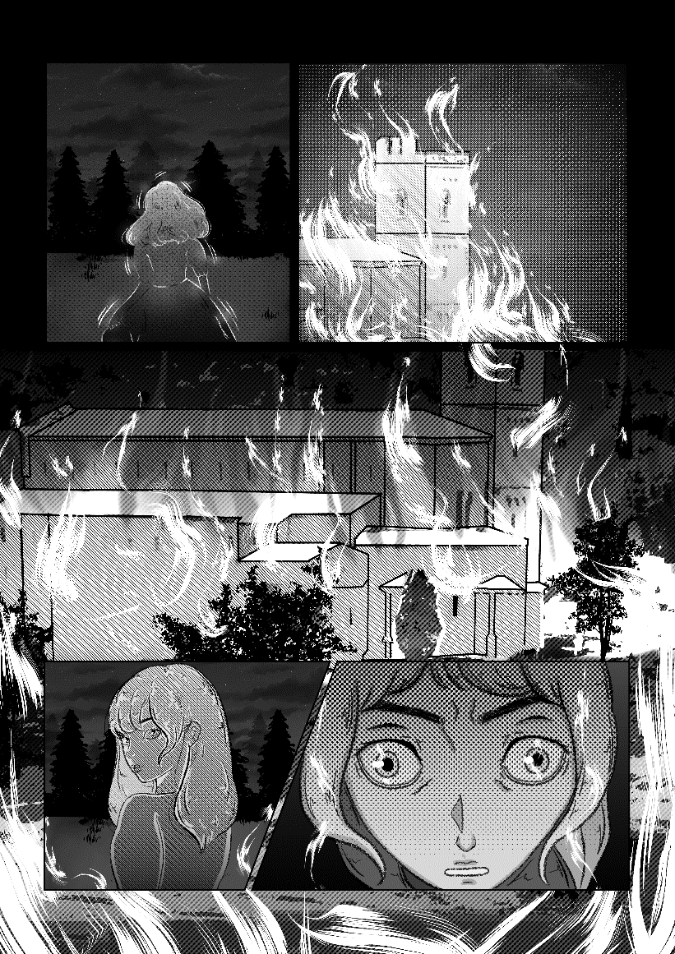

Process
The whole process was divided into three parts - plot development, illustration, and text application.
The research I did help me to develop a plot that contains the horrors of witch hunts and covers some of the psychological questions behind it. Even though the story itself is not focused on these details, each occurring event has a message behind it.
This graphic novel is a fantasy story with horror elements. The setting is 18th-century England. The story starts in an orphanage where the main heroine grew up. After mysterious events, the young woman becomes an outcast and later a witch in the eyes of the townies. After escaping from the town, the girl gets lost in the woods, where she encounters a real witch and lives with her. She becomes a mother figure for the young woman. The witch shows interest in her; she saves and teaches her everything she knows. The heroine is more than an apprentice for the witch, which is noticeable in her overprotective nature. However, after encountering the strong female character absent throughout her life, the young woman becomes aware of her inner fervor and mystical powers. She is no longer a timid, tortured soul. She is ready to face the witch. However, certain things didn't turn out the way she planned, i.e., the secret room. Nonetheless, the witch abandons her when the events turn out of control. The young woman returns to town and lives happily, still possessing secret powers.
There is a certain contradiction between the mentalities of characters. Some of the characters, like the townies, follow specific primitivity patterns common to medieval period folk, such as the fear and belief in supernatural forces. However, the witch and the young woman share a more complex way of thinking and appear wise and sensitive, which is noticeable in their interaction. This feature contradicts the fact that witches are cruel and ruthless creatures. Here witches comprehend the gravity of their atrocities; they remain true to their nature, still showing sympathy towards others. Hence, the readers perceive witches as wise and mature creatures that are above humans. Originally the story was longer, but as the process took me more time than I expected, I ended up shortening some transitions between acts and deleting few scenes.
The next stage - the drawing stage - was the most challenging one. After polishing the plot, the illustrating process had begun. The program that I used is called Clip Art Studio. It is software for making graphic novels – primarily Japanese manga. The lack of experience with the software was one of the biggest obstacles in this stage. However, after some tutorials, the process had sped up and attained a stable pace. At first, it was barely possible to produce one page in two-three days, but afterward, it went to four-five pages in a week.
The events were happening in 18th century Europe and certain research was needed to portray characters and environment accurately. I spent more time exploring and finding references for illustrations rather than drawing.
Not being a professional artist, I had to simplify some of the details and use external sources. I didn’t focus on details but rather on the shapes of the characters. The lack of anatomy knowledge I compensated with a special app that manipulates 3D objects (including its perspective and size) to get the necessary pose for characters. For example, the first panel here was created using the 3D model on the left as a reference.
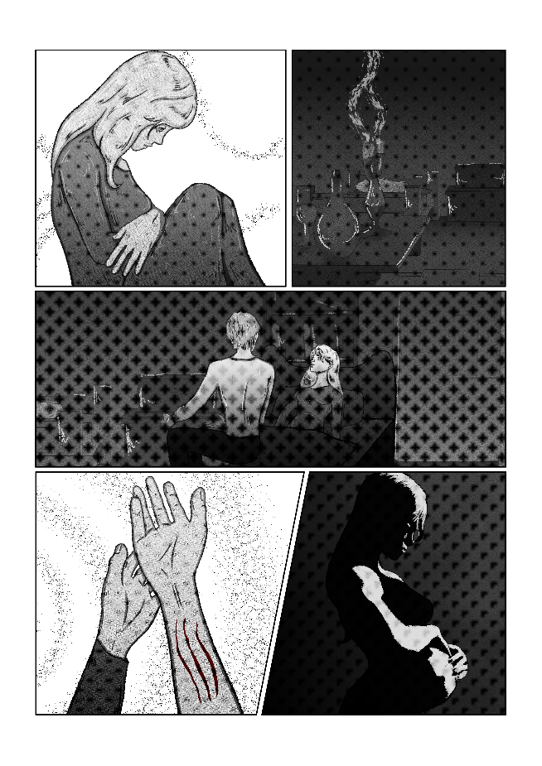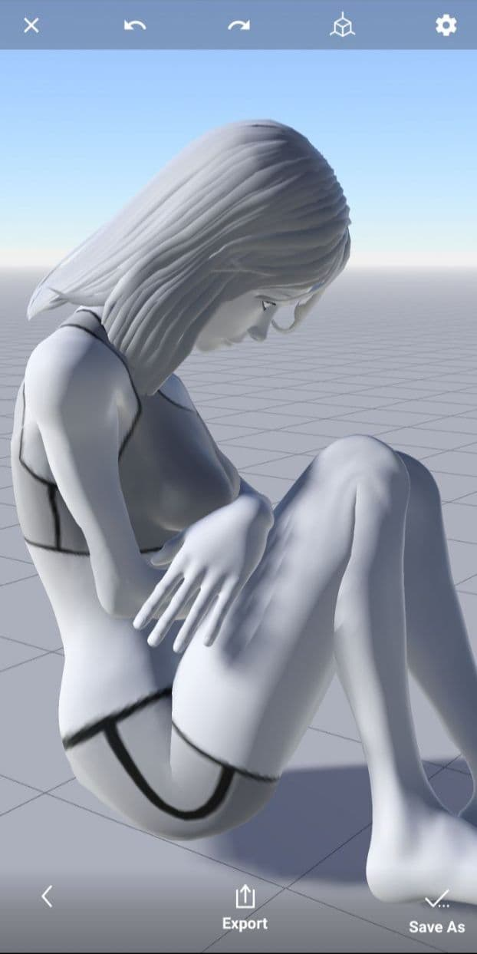
Magic Poser App

I would sketch pages first, make an outline, add tones and lastly, focus on the details.
The last stage was text application. When the plot for the comic was done, I made a draft of all the pages and dialogues. Hence, in the last stage, I added text to panels in the corresponding format.

Final Thoughts
This project was a huge challenge for me as even though I had always dreamt of making a comic, I had never had enough motivation to start it until last year. During every stage of a project, I faced numerous issues I had no idea of until now. Everything took longer than I originally planned. I wasn't familiar enough with the software I chose for the project but after some tutorials I got a hang of it. In the process, I realized that some scenes and items were too complex for me to draw as I don't have any professional art background. However, I was able to simplify them and manipulate scenes so that they will be way easy for me to draw. Luckily, my research and hobby of reading graphic novels backed me up whenever I had questions concerning illustrating. One of the most difficult things was the consistency of the style. Each page should have the same style and it took me a while before I could memorize all the steps that need to be finished before moving on to the next page. Also, in the first I would barely be able to draw half a page in one day but after a while I could complete one in a day, which is how I managed to finish the project in time.
I chose the witch thematic as it fit well with my drawing style. Originally, I planned to focus on a war theme, but later on I realized the necessity of distracting myself from war themes and changed it.
The project taught me various things I didn't know about myself, for example how hardworking one can be when he or she is working on something they love. It showed the importance of setting a goal, planning and researching as well as adapting. Thanks to this project, I have finally found something I want to spend my life on, meaning that I will continue to work on producing more graphic novels.

References
Ankerloo, B., Clark, S., & Monter, W. (2002). Witchcraft and Magic in Europe, Volume 4: The Period of the Witch Trials. A&C Black.
Bailey, M. D. (2006). Origins of the Witch Hunts. In Encyclopedia of Witchcraft: The Western Tradition (Vol. 3).
Baseel, C. (2013, May 2). Manga critic calls for Japanese comics to read from left to right. Retrieved from Japan Today: https://japantoday.com/category/features/manga-critic-calls-for-japanese-comics-to-read-from-left-to-right
Gene, M. B. (2003). A comprehensive examination of the precode horror comic books of the 1950's. Communication Studies. Theses Digitization Project. Retrieved from https://scholarworks.lib.csusb.edu/etd-project/2429
Hanazawa, K. (2014). Masterclass de Kengo Hanazawa en el XX Salón del Manga. Retrieved from https://www.youtube.com/watch?v=75OSLMAaIrk
Hillis, E. (n.d.). The unique concept of the Witch and the Witch trials in early modern England. Retrieved from Luther College at the University of Regina: https://www.luthercollege.edu
History of Witches. (2017, September 12). Retrieved from HISTORY: https://www.history.com/topics/folklore/history-of-witches
Is There Such a Thing as European Comics? (2019, February 6). Retrieved from Europe Comics: https://www.europecomics.com/thing-european-comics/
Johnson-Woods, T. (2010). Manga: An Anthology of Global and Cultural Perspectives. A&C Black.
Lohr, M. (n.d.). OpenLearn. Retrieved from From old English to modern English: https://www.open.edu/openlearn/history-the-arts/culture/english-language/old-english-modern-english
Manwill, R. (2016, February 12). Read Harder: Black-and-White Comics . Retrieved from Book Riot: https://bookriot.com/read-harder-black-white-comics/
Martin, A. (n.d.). Styles of Comics. Retrieved from BDnF: The Comics Factory: https://bdnf.bnf.fr/EN/fiches/2.%20Styles%20of%20Comics%20.pdf
Mateu-Mestre, M. (2010). Framed Ink: Drawing and Composition for Visual Storytellers. Design Studio Press.
McCloud, S. (2006). Making Comics: Storytelling Secrets of Comics, Manga, and Graphic Novels. New York: Harper Comics. Retrieved from http://www.yorku.ca/yamlau/readings/Making_Comics.pdf
Murray, M. (2016). The Witch-Cult in Western Europe: A Study in Anthropology. CreateSpace Independent Publishing Platform. Retrieved from https://www.gutenberg.org/files/20411/20411-h/20411-h.htm
O' Leary, J. (2013). Where there are many women there are many witches': The Social and Intellectual Understanding of Femininity in the Malleus Maleficarum (1486). Reinvention: an International Journal of Undergraduate Research, 6(1). Retrieved May 17, 2021, from https://warwick.ac.uk/fac/cross_fac/iatl/reinvention/archive/volume6issue1/oleary/
Rommens, A. (2000, August). Manga story-telling/showing. Retrieved from Image [&] Narrative: http://www.imageandnarrative.be/inarchive/narratology/aarnoudrommens.htm
St-Louis, H. (2015, July 12). European Comics. Retrieved from ComicBookBin: http://www.comicbookbin.com/euro.html
Wong, T., Xueting , L., Li, C., & Xie, M. (2020). ACM Transactions on Graphics. New York: Association for Computing Machinery. doi:10.1145/3414685

