“HATE SPEECH ON THE INTERNET FROM THE SIDE OF AZERBAIJAN DURING AND AFTER THE NAGORNO-KARABAKH WAR.”
By
Lyubov Oganova
Presented to the Department of English & Communications in Partial Fulfillment of the Requirements for the Degree of Bachelor of Arts
American University of Armenia

Introduction
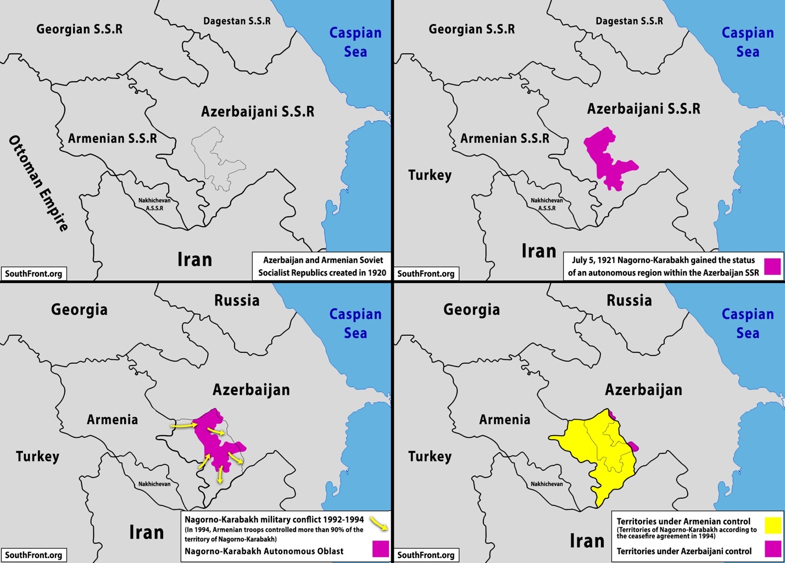
Historical background about Artsakh/Nagorno-Karabakh
Artsakh, internationally known as Nagorno-Karabakh, is one of the ancient lands of history. It is believed to have always been an inseparable part of Armenia since the Urartian era. In the earliest inscriptions found, Sardur II, King of Urartu (760-734 BC), refers to the territory of Artsakh as Urtekhini (The Office to the President of the Republic of Armenia, 2021). Later, in the first century BC, Tigran the Great, an Armenian king who made Armenia the most powerful state in the Near East, builds a town in Artsakh and names it Tigranakert, after him. The ruins of Tigranakert still remain in the area of Agdam in Nagorno Karabakh. (EVN, 2020).
Throughout history, the territory of Artsakh faces several conquers but could remain Armenian with its semi-independent status. Artsakh remains as part of Arshakid Armenian Kingdom between 66-428 A.D., In 387 A.D.. After the division of Mets Hayq (Great Armenia) Artsakh integrates into the Eastern Armenian kingdom. During the first Armenian and Persian division, the Albanian Kingdom takes over Artsakh. Soon Persians gain control over the territory (The Office to the President of the Republic of Armenia, 2021).
In 405 A.D, Mesrop Mashtots created the Armenian alphabet, thus strengthening Armenia and Artsakh. The second crucial step Mashtots took was founding the first Armenian school in Artsakh, specifically in the Amaras area. (EVN, 2020) In the following centuries, Artsakh again takes part in the Armenian kingdom. At the end of the 12th century and the beginning of the 13th, Artsakh enriched its Architectural monuments, some of which still exist, such as Dadivank built in 1214. In the 14th century, Turkic tribes destroyed and spoilt many monuments. This was the era when Artsakh territory became known as Karabakh (The Office to the President of the Republic of Armenia, 2021).
In 1795, Agha Mohammad Khan, a Persian ruler, gains control over some territories of Georgia, Azerbaijan, Armenia, and Dagestan. In 1813 the Russian-Persian war ends with a treaty, according to which the territory of Nagorno-Karabakh and the other parts under the control of Persia will be given under the control of Russia (The Office to the President of the Republic of Armenia, 2021).
The Nagorno-Karabakh conflicts
The “modern” conflict of Nagorno-Karabakh began in 1917 as a result of the collapse of the Russian empire. The collapse leads to the creation of the republics of Transcaucasia: Armenia, Georgia, and Azerbaijan. At that time, Artsakh (Nagorno-Karabakh) was 95% populated by Armenians. A congress was convened, and as a result, Nagorno-Karabakh was recognized as an independent political unit. In response to it, with the support of Turkey, Azerbaijani commits massacres against Armenians between 1918-1920. 40.000 Armenians were massacred only in Shushi in March 1920. In 1919, both sides agreed to discuss the issue at Paris Peace Conference, however, it did not happen. In August 1920, Armenians agreed to temporarily deploy Russian troops in Nagorno-Karabakh. (EVN, 2020)
New political systems were created in the republics of Transcaucasia. On 1920, November 30, the Revolutionary Committee of Azerbaijan declares the recognition of Nagorno-Karabakh, Nakhijevan, and Zangezour territories to be Armenian. And on June 12, 1921, based on the declaration of Azerbaijani RevCom, as well as the governments of both Soviet Armenia and Azerbaijan, the National Council of Azerbaijan SSR proclaims Nagorno-Karabakh as an inseparable territory of Armenia. In June 1921, Armenia also declared Nagorno-Karabakh as an inseparable part of the Armenian SSR. However, on July 4 in 1921, neglecting the legal agreement, the statement that Nagorno-Karabakh is an inseparable part of Armenia was reconfirmed during the session held in Tbilisi by the Caucasian Bureau of the Communist Party of Russia. During the night of July 5, Stalin, the Russian ruler makes a decision to incorporating Karabakh into Azerbaijan and declaring it as an autonomous territory. It is important to note that no procedure was kept, and all was done via force. The status of Nagorno Karabakh territory was defined on no legal basis. Moreover, everything was done not to have a border with Armenia. During the whole period of being an autonomous region within Azerbaijan, all the rights of the Armenian population were violated. Not only violations towards population happened but also towards Armenian Culture. Because of these, Armenians living in Nagorno-Karabakh migrated. If in 1923 Armenians living in Karabakh were about 95% percent, in 1989 they turned into 77%. Simultaneously, in Nakhichevan, they succeeded in carrying out ethnic cleansing of Armenians. Living in Nagorno-Karabakh sent tons of letters asking to reconsider the territorial decision made on Nagorno-Karabakh, but they were rejected and ignored. The national liberation struggle of the Nagorno-Karabakh people began in 1988 when demanding the republic of Nagorno-Karabakh to reunite with Armenia. On the other hand, as a response, the Azerbaijani authority organized massacres of Armenians living in the territory of Azerbaijan, mainly Sumgait, Baku, Kirovabad (EVN, 2020)
On December 10, 1991, in accordance with the international law norms and USSR laws, the population of the Nagorno-Karabakh declared the Nagorno Karabakh Republic establishment through a plebiscite. As a consequence, two equal states were formed in the territory of Azerbaijani SSR. This triggered the Azerbaijani aggression and large-scale military actions (The Office to the President of the Republic of Armenia, 2021).
In 1991, with the collapse of the USSR, a war erupted between Azerbaijan and Armenia over the Nagorno-Karabakh region. Thousands of people died from both sides. Many lost their houses, as the Azerbaijani population living in Nagorno-Karabakh were displaced. By 1993, Armenia already controlled the whole territory of Karabakh, plus a little of surrounding territory as a security buffer. On the other hand, Azerbaijani took the regions of Shahumyan and the eastern parts of Martuni and Martakert. In May 1994, a ceasefire was signed. Regardless of the ceasefire, skirmishes happened, and the situation on the borderline remain tense. In April 2016, the Azerbaijani side violated the agreement and began a large-scale attack. The war lasted for four days, causing hundreds of deaths. Again, both sides agreed on a ceasefire. (EVN, 2020).
On September 27, 2020, in the peak of Covid-19 pandemic, Azerbaijani side began a large-scale attack through the whole borderline of the Nagorno-Karabakh. The war lasted for 44 days. As a result, Nagorno-Karabakh lost most of its territories. Unofficially, 5000 soldiers were killed, not to mention the civilians. Tones of violations happened during the war. Azerbaijani side used internationally prohibited weapons, bombed hospitals, kindergartens, and civilian houses. Moreover, there are many pieces of evidence proving the presence of mercenaries and jihadists from Syria during the war. On November 9, 2020 a ceasefire was signed, according to which Armenian side gave up on some territories and opened transport link Nakhijevan. Also, Russian peacekeepers were deployed for the duration of 5 years. Most importantly, the prisoners of war should have been returned to both sides, which Azerbaijani side still doesn’t do.
Based on the evidence I bring up in the paper, we can say that Azerbaijani government spreads armenaphobia in the country. The hatred against Armenia is state supported. Having never visited Azerbaijan I got the impression of it as corrupted and freedom restricted country, where the visa-president of the country is the wife of the president. Additionally, I saw many videos on social media where peaceful protestors protesting against the president were being mistreated.
In my capstone project, I will refer to the hate speech spread by the Azerbaijani side towards Armenian people. I will bring up certain examples and analyze the discourse based on the international norms.
It is important to note that this paper presents the Armenian view which is based on both a personal experience and research conducted. In the scope of the research, many pieces of evidence were found that supported the point of view of the author. However, the paper also analyzes some evidence of Armenians writing offensive speech under Azerbaijani social media pages. The paper contains scholarly sources written by international experts based on the research they conducted. The discourse analysis of the evidence is based on internationally accepted standards about hate speech. Bringing up evidence from both sides and analyze them based on internationally defined guidelines is important for objectivity.
Literature Review
The European Convention on Human Rights defines the freedom of expression in Article 10, which states that people have the right to freely express their opinion, as well as receive and share information, without interference by public authorities (ECHR, 1950). However, the freedom of speech sometimes exceeds its limits and turns into hate speech. Even though there is no internationally recognized definition of hate speech, the UN understands it as follows “any kind of communication in speech, writing or behavior, that attacks or uses pejorative or discriminatory language with reference to a person or a group on the basis of who they are, in other words, based on their religion, ethnicity, nationality, race, color, descent, gender or other identity factors” (Guterres, 2019). Twitter terms and policies define hate speech similar to the UN definition, which is a direct attack, threat, and violence against people on the basis of ethnicity, race, sexual orientation, national origin, religious affiliation, age, gender, gender identity, disability, or severe disease. In legal literature, it is defined as any speech and expression that promotes or includes hatred against a person or a group of people based on the mutual characteristic they share or the group to which they belong (Gomez, Gibert, Gomez, & Karatzas, 2020). Hate speech is prohibited by law in many countries such as Denmark, Sweden, United Kingdom, and so on (De Smiedt, De Pauw, and Van Ostaeyen, 2018).
The invention of the Internet gave people more space to express themselves, but at the same time, it also became a ground for spreading hate and harassment (Gomez, Gibert, Gomez, & Karatzas, 2020). On May 23, 2016, several companies, including Microsoft, Google, Twitter, and Facebook agreed to remove speech containing hatred within 24 hours in accordance with the European Union Code of Conduct (De Smedt, De Pauw, and Ostaeyen, 2018). Throughout the past years, with the rising number of people being registered in Social Media, the number of hate speech being spread is growing. Hate speech on the Internet is of a different kind depending on the target group, such as the members of the LGBT community and racial hate speech (Fortuna, Soler, Wanner, 2020). It is a widely studied topic and is being measured, detected, and tracked through several means. Today, hate speech can also be expressed through pictures, memes, and videos. The detection system on the internet is mainly concentrated on language. That is, the system is generating certain keywords or uses the N-gram feature to detect possible hate speech (Sabat, Ferrer & Giero-I-Nieto, 2019). However, sometimes the keywords may be misleading and out of context. For example, the word nigga and cunt, which became a part of today’s slang. People may use the words “nigga” without referring to the African-American community and “cunt” without sexist intentions. Therefore, hate speech is not the offensive word itself but the meaning behind the word combination and visuals (Gomez, Gibert, Gomez, & Karatzas, 2020).
There is also a type of hate speech which is called Jihadist hate speech. Jihadist hate speech is most commonly spread by the fan-followers of Salafi jihadist militant groups, such as ISIS and Al-Qaeda. Jihadist hate speech spreaders promote violence and aim to threaten civilians through execution videos, war photographs and videos, news updates, interviews with famous jihadists, interpretations of Islam, terrorism videos, torture videos, and others. The most used platforms for hate speech are Twitter, Facebook, Youtube, Telegram, JustPaste.it (De Smedt, De Pauw, and Van Ostaeyen, 2018).
Armenia, a country with a population of 3 million people, has recently been affected by the COVID-19 pandemic with an extremely high number of cases and a large-scale war. On September 27 of 2020, Azerbaijan initiated a large-scale attack with the support of Turkey on the territory of Nagorno-Karabakh. Nagorno-Karabakh was a self-governed region, which was historically inhabited by Armenian people. Since the collapse of the Soviet Union, the status of the territory was disputed between Armenia and Azerbaijan. During the war, churches, kindergartens, and hospitals had been attacked heavily, causing deaths of civilian people. Internationally prohibited cluster bombs were used. A ceasefire was signed on November 9, 2020 (Kazaryan, Edwin, Darzi, A., ... & Gayet, 2020). Throughout the war, the Azerbaijani side spread hate speech against ethnic Armenians which was supported by the State. The main platforms were Facebook, Twitter, Tiktok, Instagram, and other social media platforms). The hate speech included calls for violence, inhumane treating, killings, torture and was done in an organized manner, mainly through group pages. According to the 2018 report of independent experts and the Ombudsman of Artsakh, hate speech towards Armenians (referred to as Armenaphobia) also existed during the 2016 Nagorno-Karabakh War. According to the report of the Hrant Dink Foundation, in Turkish media, Armenians are the most targeted group affected by hate speech. The open support of the Turkish government also affected Armenians living in Turkey. Armenians in Turkey also became a target of hate speech (Ad HOC Public Report, 2020).
In spreading hate speech against Armenians, many Azerbaijani officials were involved. Even the president of Azerbaijani, Ilham Aliyev, spread hate speech in his official public statements, for example, “There is no need to sit at the negotiating table with terrorists and vandals, you need to continue operations to destroy them,” “Armenia as a country is of no value. It is actually a colony, an outpost run from abroad, a territory artificially created on ancient Azerbaijani lands,” “We are driving them (Armenians) away like dogs! Azerbaijani soldiers drive them away like dogs." The aforementioned expression “we are driving them like dogs'' made by President Aliyev has become a hashtag and motto among the Azerbaijani people. Besides the President, other public people also openly showed hatred against Armenians.
“We must kill Armenians—no matter whether a woman, a child, an old man. We must kill everyone we can and whoever happens. We should not feel sorry; we should not feel pity. If we do not kill (them), our children will be killed”- a statement made by the Media and PR manager of Azerbaijani football club “Qarabag”. What is more tragic is the hate speech spread towards children, such as a statement made on Facebook by a lawyer “It is necessary to kill both the mother and the child of an Armenian” (Ad HOC Public Report, 2020).
In addition to the textual evidence of hate speech, the Azerbaijani side used polls and surveys in social media that aimed to encourage killings and torture. Besides polls and surveys, they also shared visuals such as photography and videography of beheaded, tortured soldiers and prisoners of wars. The state-supported hatred increases the amount of violence in the state. On April 12, 2006, Ramil Safarov beheaded Gurgen Margaryan in Budapest. Both Ramil Safarov and Gurgen Margaryan were participants of Nato English-language training courses in Budapest. In the trial, Ramil Safarov stated that he murdered Gurgen when sleeping, because he hates Armenians, and Gurgen was an Armenian. In Hungary, Safarov was sentenced to life. However, in 2012, Ramil Safarov was sent to Azerbaijan where the state considered the act heroic and declared him a national hero and granted him an apartment, a salary of eight years, and other awards (Walker, 2020). In addition to this, the human rights defender of Azerbaijani, Elmira Suleymanova, declared Ramil Safarov, an exemplary patriot. Another similar case happened during the Nagorno-Karabakh war of 2016, where Azerbaijani soldiers beheaded Kyaram Sloyan, an Armenian-Yezdi soldier, and uploaded it to Facebook. The pictures of beheaded Armenian soldiers were much welcomed and spread through social media. These all are encouragement acts to act violently against Armenians. Moreover, Azerbaijani soldiers used social media as a weapon to mentally torture Armenians, specifically family members of soldiers. A case was reported by the Human Rights Defenders of Armenia and Artsakh when an Azerbaijani soldier calls a family member of one soldier and tells them to check the social media page, where they posted a slain picture of their son. They also randomly send videos and pictures to Armenians through social media that contains hatred against the ethnic Armenians. The investigation of the Human Rights Defenders office showed that the profiles that share visual content are opened for particularly that purpose.
To sum up, hate speech on the internet is a growing issue across the world. Large companies try to monitor hate speech and remove it within 24 hours through algorithms that detect several keywords that may be considered offensive. However, it may be misleading sometimes, especially when it refers to the visual content. Such cases happened during the Nagorno-Karabakh War of 2020 when much hate speech content, both visual and textual, was spread on social media and not detected. The Ombudsman of Armenia reported cases where the hate speech was state-supported and led to inhumane and violent treatment of ethnic Armenians.
Research Question
RQ1: What kind of hate speech was spread through the internet during the Nagorno-Karabakh War of 2020?
RQ2: How Armenians reacted to the hate speech spread by the Azerbaijani side on social media?
Methodology
Hate speech on internet during the Nagorno Karabakh war is in the list of the human rights violations Azerbaijani side committed against Armenians. In the scope of the research on the topic “Hate speech on internet during the Nagorno-Karabakh war 2020,” various methods were used. As I primary method two interviews were conducted. The first interview was held with Arman Tatoyan, the Human Rights Defender of Armenia since 2016. The interview with the Human Rights Defender was of a vital importance as Mr. Tatoyan was a key figure in fighting against hate speech towards Armenians. As there is no internationally recognized definition of hate speech, the interview started with understanding the concept of hate speech, in personal and legal aspects. Moving forward, it was important to understand the differentiation between hate speech and offensive speech, as well as the message behind certain expressions used by the Azerbaijani people such as “These lands are Azerbaijani.” As, hate speech is not only the written and spoken communication but also the behavioral aspect of the other side, the interview also touched the topic of cultural genocide on the occupied territories of Nagorno-Karabakh during and after the war. On the other hand, not to be biased, the interview also tried to find out if the Armenian side also spread hate speech and what actions were taken. The interview with Arman Tatoyan was important because many of the evidence brough up in the paper are retrieved from his official page, not to mention the fact that he is the current human rights defender, and hate speech is considered to be a human rights issue. Another reason why I decided to interview Mr. Tatoyan is that many public figures including the former U.S. Ambassador in Armenia, John Evans , gave a high grade on his activities. Additionally, the Human Rights Defender of Armenia is considered to be a credible person In the human rights institutions as he works separately from the government, which is not the case in Azerbaijan. In other words, the Human Rights Defender of Armenia has advantages over the Human Rights Defender of Azerbaijan.
The second interview was conducted with Elen Mikaelyan, the social media supervisor of the “Armenian Social Media Army.” The Armenian Social Media Army (ASMA) was created on October 1, during the Nagorno-Karabakh war which aim was to gather together Armenians on social media and perform a coordinated action on those platforms. The interview with ASMA was important in terms of understanding the way Armenians reacted and fought against the hate speech coming from the Azerbaijani side. The interview began with understanding the goals and strategies, the number of people involved and the methods they used to achieve their goals. Next, it was necessary to understand the message discipline of ASMA, the kind of hate speech they encountered, the emotional control while being angry and hate speech from their side. As the social media platform algorithms are constructed in a way that it removes hateful speech, the interview also tried to understand what did ASMA learn during the process, the way algorithms work, strategy changes throughout the time, and suggestions. As social media is one of the innovations of the 21st century, and its contribution during the wars is not yet examined, the social media supervisor of the ASMA shared her opinion on the importance of ASMA contribution during the wartime, as well as their activities after war.
To be able to analyze the hate speech there needs to be some evidence, which I mostly took from the official page of the human rights defender, Arman Tatoyan. However, the paper also contains analysis found by me from Instagram, Facebook and Twitter. The purpose of adding evidence which is not reported by anyone anywhere is to show that there are still many hateful messages unrevealed as well to compare them with the already reported evidence. The evidence is analyzed through method of discourse analysis based on several definitions on hate speech.
Research findings
Interview with the Human Rights Defender of Armenia, Arman Tatoyan
It is essential to highlight that the interview with the Human Rights Defender of Armenia, Arman Tatoyan, was held in Armenian. Everything written in this paper is translated into English and paraphrased and is not direct quotations.
During the interview with Arman Tatoyan, I learned that hate speech is not protected under the guarantees of freedom of speech. Hate speech is very dangerous as it creates tension within the society, brings up serious issues regarding the human rights practice, makes the atmosphere aggressive, and becomes a cause for committing other crimes. Today, the level of offensive speech, swearing, and hateful speech on social media is very concerning. A dangerous case happened in Gyumri recently, which was a cause of hate speech. Two men swore at each other on Facebook and decided to meet in Gyumri. The meeting ended with a murder case. Besides the risk that hate speech may shift from the online platform into a real-life calling for violence personally, it is also dangerous for the system. When many people start to insult each other, it causes other crimes in terms of criminology. In essence, it disrupts mental immunity, violates human dignity, which is a constitutional right. It causes issues in personal and family lives. Hate speech towards one’s family may be more dangerous because when someone swears a family member, we become more sensitive. Today, the emotional state of Armenians is very high, and blaming one another by saying “traitor” may be dangerous, especially from the side of public officials, as the supporters of certain authorities repeat the exact words. To put it simply, two people blame each other, the supporters of both blame each other for supporting the opposing parties; thus, the society disunites. Some cases of divorces and friendship breakups have been recorded due to political hate speech. Consequently, hate speech should not be allowed. However, criticism is essential in politics, and it should not be affected by hate speech. Public officials should be very attentive when choosing their words and not use words that may be viewed as hate.
Moving forward, Dr. Tatoyan explained to me that offensive speech could quickly turn into hate speech, such as swearing of a sexual nature, which certain actions may accompany. On the other hand, a speech that does not contain any offense can be hate speech. For example, the President of Azerbaijan states, “Armenians are savages. They removed the corpse of Azerbaijani people and took out their golden teeth,” or another example “Armenians kept pigs and animals in our mosques.” It was an example of hate speech because these statements raise hatred and aggression towards Armenians, indicating that the speech does not need to contain certain offensive words. Sometimes statements like these causes more aggression and hatred than simple swearing and insulting words. The biggest problem with Azerbaijani hate speech is that it is state-supported. There had been two cases mentioning the state-supported hate speech in the European Court of Human Rights “MAKUCHYAN AND MINASYAN v. AZERBAIJAN AND HUNGARY” and “SARIBEKYAN AMD BALYAN v. AZERBAIJAN.” In the case of “MAKUCHYAN AND MINASYAN v. AZERBAIJAN AND HUNGARY,” when Gurgen Margaryan was beheaded in Hungary, the European Court states that there is an ethnically motivated crime in Azerbaijan. In the case of Azerbaijan, the difference is that the Azerbaijani public and cultural figures support hatred. Moreover, President Aliyev’s speeches are also hateful, which is a severe issue. In contrast to it, none of the Armenian authorities and public figures have ever blamed or spread hatred towards the ordinary people of Azerbaijani. Of course, there are some posts or comments of Armenians that contain hatful content, but it is not a state policy. The Armenian side - the president, the prime minister, or the defense minister, has never made a statement blaming the civil population of Azerbaijan. Such as “Azerbaijani people are savages,” they either blame the government or the military but never the ordinary people.
As I used evidence found on the website of the human rights defender, I asked Dr. Tatoyan about the principles they used when analyzing hate speech and learned that their analysis is based on internationally accepted standards. I also asked about the statement “these lands are Azerbaijani,” as it was one of the most used statements during the war, and I wanted to understand if it contains elements of hate speech. It turned out that the statement does not contain any hateful elements. However, if it was formulated otherwise, such as “these jackal Armenians, lived in our territory,”- it would contain hateful elements. Another critical element to note here is the cultural-historical and religious heritage destruction—for example the destruction of cross-stones, historical monuments, Armenian Churches like St. Ghazanchetsots.
Recently, a museum dedicated to the war of 2020 in Nagorno Karabakh was opened in Baku. It contained wax figures of Armenian soldiers and prisoners of war. I asked Dr. Tatoyan to explain to me how it can be “hate speech.” “They portrayed Armenian tormented and humiliated. It is not a simple mannequin, it describes the Armenian character, which is presented as humiliated. People come and make fun of them, beat the wax figures. It is a hate speech also because not only it provokes hatred in Azerbaijani society but also in Armenia towards Azerbaijani people.”

Interview with the supervisor of the Armenian Social Media Army
The Social media supervisor of ASMA explained me that their goal was to be prepared for the “war” on the social media platforms because besides what was going on in the frontline, Azerbaijani and Turkish sides were also actively working on social media platforms especially through extensive sites. “Our goal goal was to counterattack and spread pro-Armenian theses”- said the social media supervisor. As a strategy they decided to divide their work into several stages. They also had groups working on the platform, whose responsibilities were not to spread pro-Armenian theses on social media but rather to send all the necessary items to the frontline. As to the working group of Instagram, their responsibility was to work on Instagram platform, spread pro Armenian theses, and report anti-Armenian information there, as well as work on sites that had anti-Armenian theses. The team consisted of five people that worked on a fixed schedule which assumed to work 24/7. They also had about ten volunteers that worked with a comparatively free schedule. The same picture was within almost all the working groups. Generally, there were 10-11 working groups for different social media platforms, for instance, Telegram, Facebook, LinkedIn, Twitter, etc. To achieve their goal ASMA mostly worked on spreading pro-Armenian news. “The beginning was very difficult, because we had “less power” let’s say, and we couldn’t resist Azerbaijan theses. But we reached our goal in a sense that for example, our Twitter group gained about 140,000 followers in the last period, and the theses that were being shared through Twitter were mainly either pro-Armenian or at least natural and not pro Azerbaijani.” To the question whether it was difficult to express less anger they answered that in the beginning it was very difficult. Even there were instances when they even had to use their personal profiles to freely express anger. But what refers to the ASMA brand, they kept all the community rules.
ASMA had one big message to deliver “The land of Artsakh is historically Armenian, and the thesis that Armenians are occupants is a lie and does not correspond to the reality.” They had a clear policy not to spread any feeling of being powerless,” or seek for help in the messages, moreover, they were trying to depict Armenian from the maximum strong side. They can proudly announce that they worked 24/7 for 44 days and could reach their goal.
Looking back ASMA can say that they strongly followed the community rules, and as to the question “Looking back, what would you change in your strategy?” the supervisor answered “Well, in the beginning when we divided into groups, we chose very small teams and went too deep into some issues. I think it would be better if we chose bigger groups since the very beginning and look at the issues from a more global perspective, because the results of the 44 days’ work showed up quite late.”
It is hard for them to say what specific lesson they learned during the process, but they think the first and the most important thing they learned is to control their emotions. The second important thing was that they understood how beneficial it is to work hard within short deadlines, specifically in terms of thinking positively and calming mind.
Of course, during these processes they discovered some algorithms of social media about which they didn’t know as an ordinary user, and which they used to make their campaigns more effective. I don’t want to open the braces and talk about the algorithms in details” she added in the end.
The hate speech they encountered the most was mostly either ethnical-national, or personal, sometimes even both. And to those fighting online they have some suggestions. ASMA thinks that it would be easy if they understand and optimize algorithms, because for example there is algorithm on Instagram and Facebook that automatically deletes the post, the comment, reply or anything that includes the word “terrorism.” However, there were people who found alternatives, such as putting the symbol * instead of the letter “r”, so the system won’t recognize, and the algorithm won’t work. Anyway, these kinds of things are being restricted.
ASMA thinks that social media contribution is defiantly very important, because it is extremely important to have a reliable information on the international platforms. All the groups of ASMA on Facebook,” “Instagram,” “LinkedIn” “Twitter” sand others still working, and to see their activities one just needs to click the “follow” button. They can’t say for sure if they still continue to fight specifically against hate speech, as it much depends on the case, but they didn’t stop working and still continue to do their job.

Analysis
From September 27 till the end of November, an extremely huge amount of hate speech was spread on social media. Some of which have been recorded and reported by the Human Rights Defender’s office in Armenia. Of course, not all the insulting messages and comments by the Azerbaijani people are hate speech. Below some examples of hate speech and insulting messages are shown. The analysis of examples is based on the definition provided by the UN: “Any kind of communication in speech, writing or behavior, that attacks or uses pejorative or discriminatory language with reference to a person or a group on the basis of who they are, in other words, based on their religion, ethnicity, nationality, race, color, descent, gender or other identity factors” (Guterres, 2019).
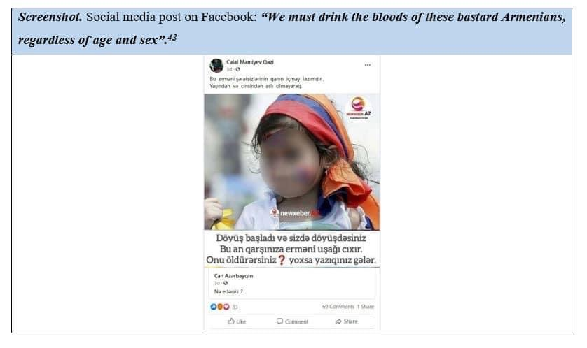
The first example is a screenshot of a post from Facebook which says, “We must drink the blood of these bastard Armenians, regardless of age and sex.” The piece of evidence is taken from the official website of the Human Rights Defender of Armenia. This written post is a clear illustration of hate speech as it is a call to commit a genocide based on ethnic and national background. The expressions “drink the blood of this bastard” is an example of a call to violence. The indicator “Armenian” demonstrates that the violence should be committed towards specifically Armenians based on their ethnic belonging. “Regardless of age and sex” is referring to kids, the elderly, and females which makes the statement a call to commit genocide. Additionally, there is attached a picture of an Armenian baby with an Armenian flag on her head, which is also a violation of children’s rights.
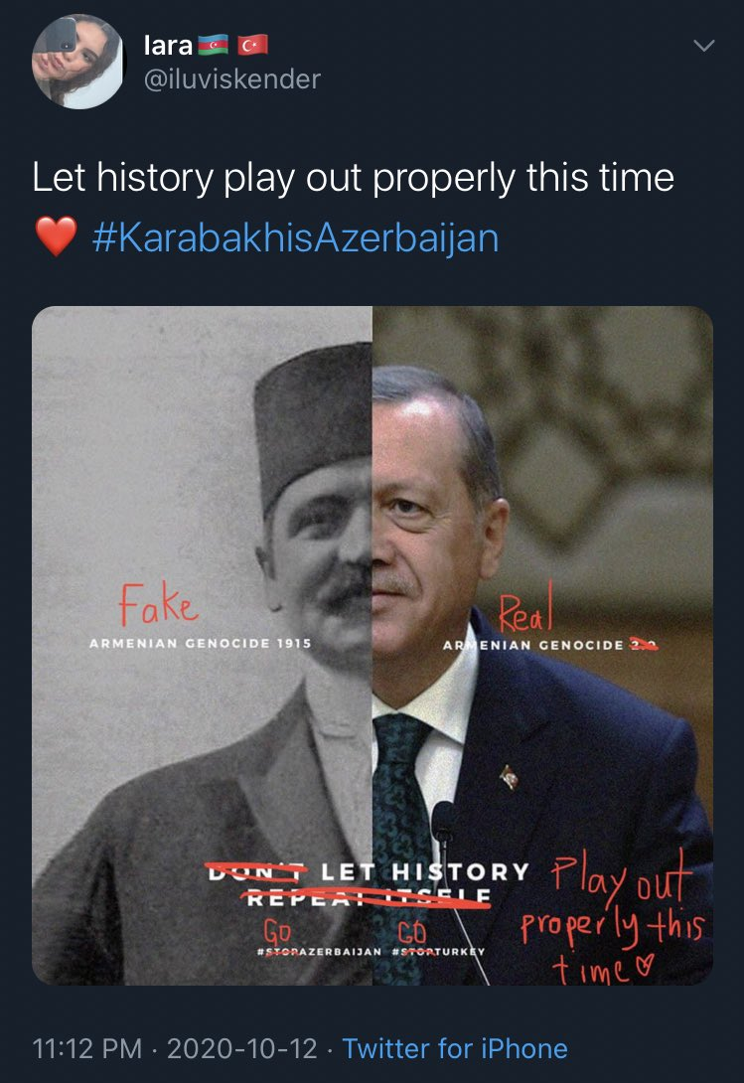
Most of the evidence brough up in this paper have a message to commit a genocide. Another example here is the picture screenshotted from Twitter which says, “Let’s the history play out this time.” The sentence does not include any hateful word itself, however the attached picture gives more inside. The user’s nickname is Iluviskander, and the profile picture is a mirror selfie of a girl. I tried to find the @iluviskaner profile after the war, but it was deleted. I believe, a girl would not write a nickname which contains a name of a weapon. Also, putting a heart emoji was done on purpose to look “sweet”. In my opinion this profile tried too hard to look “girly” but the nickname, and the fact that the profile was deleted after the war assumes it was just an Azerbaijani propaganda. In the case of the user @iluviskander, the hate is spread though visual communications. The picture is a combination of two photos. On the left one there is Talaat Pasha, one of the organizers of the Armenian Genocide in 1915. On the right there is the picture of Recep Tayyip Erdogan, the president of Turkey. The reason behind placing Recep Tayyip Erdogan’s picture is that in the Nagorno-Karabakh war of 2020, Azerbaijani side had the direct support from Turkey, so for many people the war was between Armenia and Azerbaijan/Turkey. There are corrections done on the picture with a red ink. On the left side, on the portrait of Talaat Pasha, there is written, “Armenian genocide, 1915”, and with a red ink it is noted “fake.” On the Portrait of Recep Tayyip Erdogan, there is also written Armenian Genocide with no date, with a red ink saying “real”. On the bottom it is mentioned “Don’t let the history repeat itself”, and with smaller letters #stopAzerbaijan, #StopTurkey hashtags, which lets us assume that the poster originally is pro-Armenian, possibly made my Armenians and Azerbaijani people took it and with red letters made a “correction” by deleting the phrases “Don’t”, “Repeat itself” and adding “Play out this time” next to “let history”, as well as changing the hashtags to #goAzerbaijan, #goTurkey. Even without the statement “Armenian Genocide”, it is obvious that the poster is a call for genocide against Armenians, as on one side there is the portrait of one of the organizers of the Armenian Genocide and on the other the biggest supporter of Azerbaijani’s aggression in Nagorno-Karabakh in 2020. Consequently, putting together and comparing these two leaders of Turkey is a way to express hate towards Armenians.
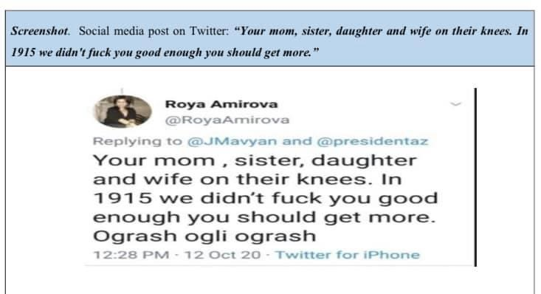
Twitter was one of the most used social media platforms during the war. Below, there is an example of a Twitter post retrieved the form the official page of the Human Rights Defender of Armenia. Roya Amirova wrote “Your mom, sister, daughter and wife on their knees. In 1915 we didn’t fuck you good enough you should get more, Ogrash ogli ogrash.” Even though there is no direct mentioning of the word “Armenians”, still it is widely acknowledged that in 1915 Turks committed the first genocide of the 20th century towards Armenians. So, as a woman, Roya Amirova wishes Armenian women to be tortured, raped and massacred. This statement is also a demonstration of a hate speech as it specifically targets Armenian women based on their ethnicity and is a call for a violence.
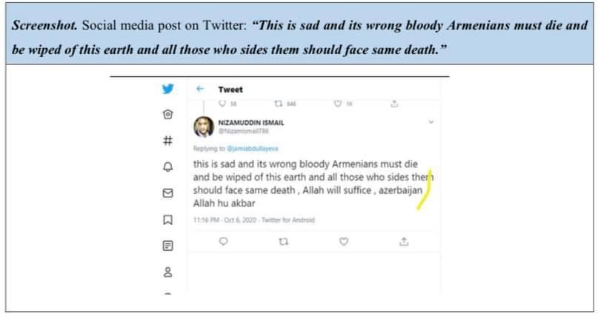
Another evidence taken from the Human Rights Defenders of Armenia official page is again an example taken from Twitter. It says, “This is sad and its wrong bloody Armenians must die and be wiped of this earth and all those who sides them should face some death.” This is an example of hate speech not only towards Armenians for their ethnicity, but also towards those who support Armenians. Key words in the statement are “Armenians must die,” “wiped of this earth,” “face the same death.”
Being free from torture is an absolute right. However, there were also calls for torture and inhumane treatment besides killing. A post made by an Azerbaijani civilian on Twitter “I want to tell my brothers who fought on the front, raise the white flag and kill the Armenians who
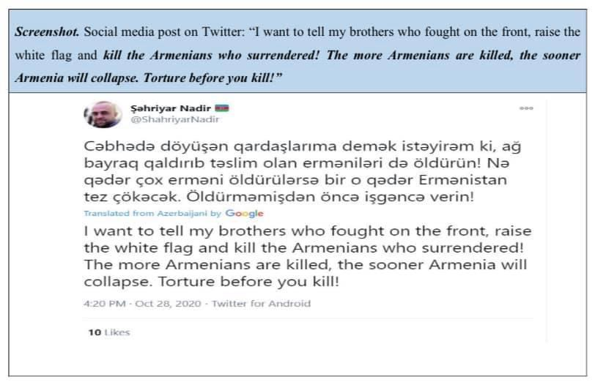
surrendered! The more Armenians are killed, the sooner Armenia will collapse. Torture before you kill!” This message is again an example of hate speech that promotes torturing and killing Armenians, “kill the Armenians,” “the more Armenians are killed the sooner…,” “torture before you kill”- are the indicators of hate speech based on ethnicity.
It is very disappointing to witness the support of hate speech towards Armenians on a national level. Below are some examples of statements of President Ilham Aliyev, former member of Parliament- Anar Mammadkhanov, Firuz Abdulla, Media and Communications Manager of Association of Football Federations of Azerbaijan, reported by the Human Rights Defender of Armenia, Arman Tatoyan.
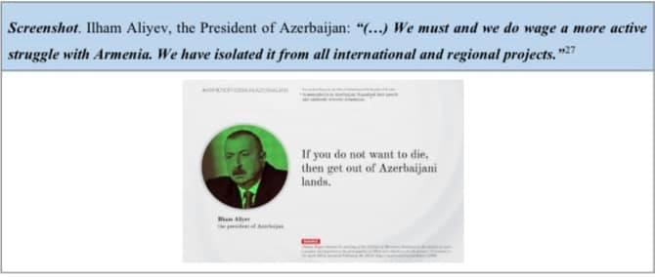
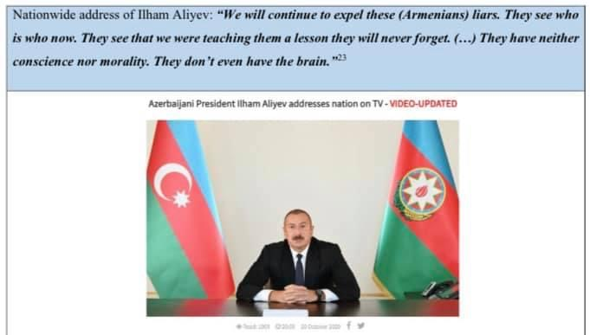
Impermissible statements containing animosity and hatred made by the President Aliyev: “We must and we do wage a more active struggle with Armenia. We have isolated it from all international and regional projects,” “For 30 years, it was in the hands of wild beasts, in the hands of predators, in the hands of jackals, the buildings have been demolished, our religious sites have been demolished, everything has been looted, the roofs of the houses, the windows, the belongings – everything. It was as if a wild tribe had taken over the city.” “We will continue to expel these liars. They see who is who now. They see that we were teaching them a lesson they will never forget.” These statements promote anti-Armenian attitude towards Armenians and support the hatred on the state level.
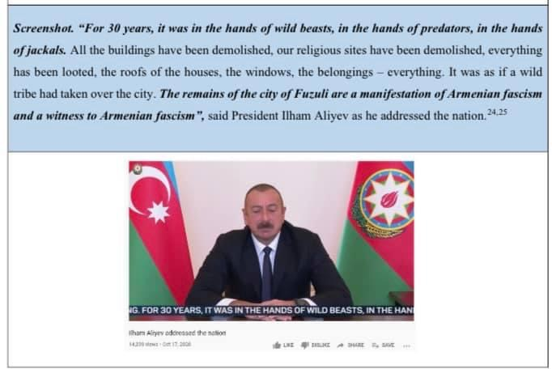
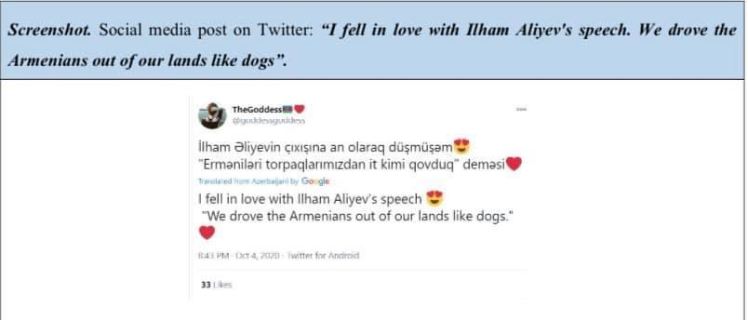
The Azerbaijani people extensively used the hateful expressions made by the President Ilham Aliev “We drove the Armenians out of our lands like dogs.”
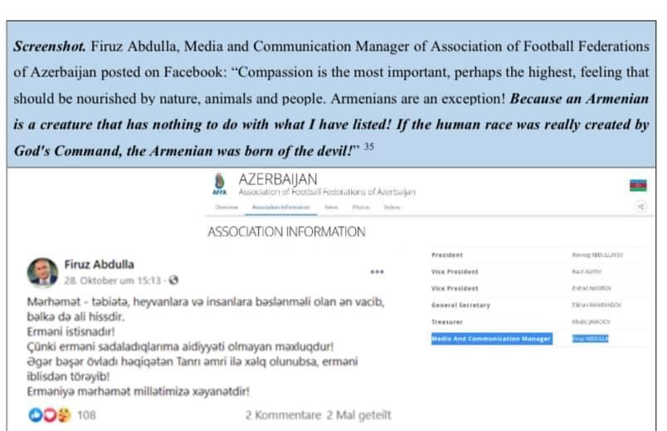
Even though, President Aloyev’s speech did not contain direct calls for killings, they are a great example of a state supported hate-speech. In his speech, Aliyev tries to appeal to the emotions of his nation and make them hate Armenians. In this case, the speech is considered hate based on its consequence. In Aliyev’s case, his followers also will repeat his words and justify their criminal actions with those statements.
Media and Communications Manager of Association of Football Federations of Azerbaija Firuz Abdulla stated “Compassion is the most important, perhaps the highest feeling that should be nourished by nature, animals and people. Armenia’s are an exception. Because an Armenian is a creature that has nothing to do with what I have listed! If the human race was really created by God’s Command, The Armenian was born of the devil”- the translation taken from the Human Rights Defender’s official page. The statement was another example where a public figure spread hatred towards Armenians. He uses discriminatory language towards a nation based on its ethnicity.
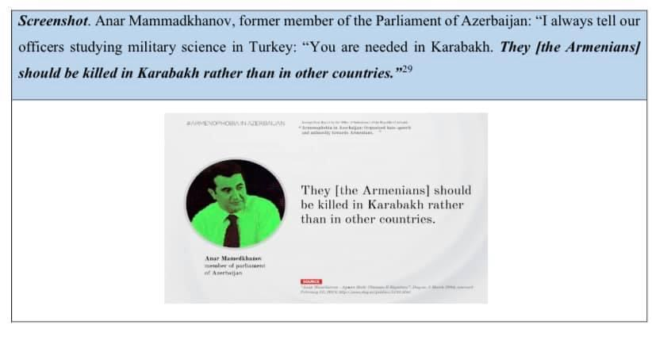
Last but not least, a former member of the Parliament of Azerbaijan, Anar Mammadkhanov, said “I always tell our officers studying military science in Turkey: “You are needed in Karabakh. They should be killed in Karabakh rather than in other country.” This statement encourages Azerbaijani people to kill all Armenians living specifically in Nagorno Karabakh territory, just for their ethnicity. “Armenians should be killed”- a hateful statement that violates the basic human right-the right to live. A person like Anar mammadkhanov, who promotes immoral crimes should not be a public figure and an example for his nation.
Cultural-Historical Genocide
The term genocide does not only refer to the physical extinction of a nation, but also the actions taken to destroy the nation’s culture. Cultural genocide is also a way to promote hatred.
As mention in the UN definition of hate speech “Any kind of communication in speech, writing or behavior” and destroying a cultural site is a behavior. As soon as war ended and Azerbaijani people occupied some territories of Nagorno-Karabakh, they began to destroy cultural heritage of Armenia. Below some pieces of evidence are shown.

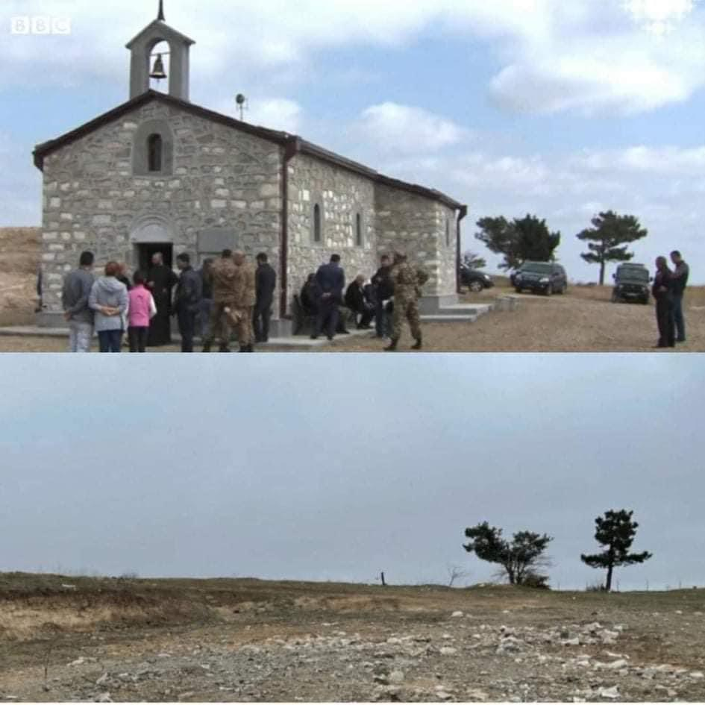
Holy Mother of God Church in Mexakavan (Jabrail), before and after Azerbaijani occupation, reported by the BBC.
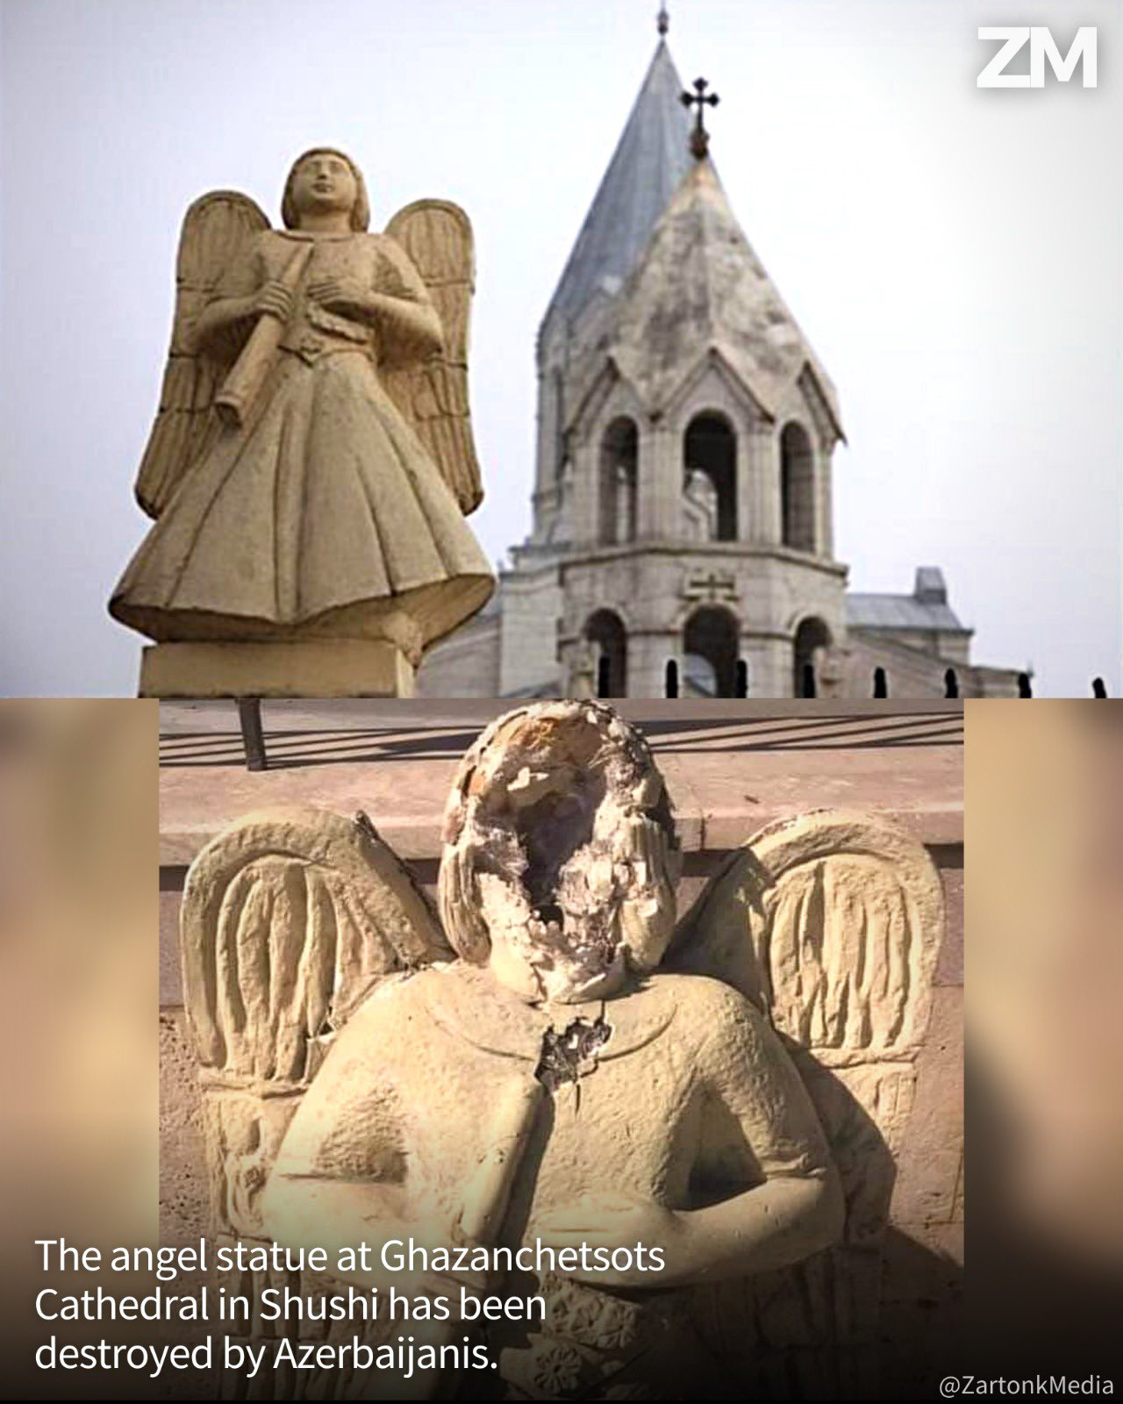
The Ghazanchetsots Cathedral in Shushi, which was heavily boomed during the war. After the war, Azerbaijani people vandalized the church. In the photo we can see the broken face of the angel of the Ghazanchetsots church.
Within few months, Azerbaijani people also destroyed the Armenian Genocide Monument in Shushi, together with its cross stone.

Besides destroying churches, cross stones, monuments and other historical Armenian heritage, the President of Azerbaijan claimed in one of his visits to Kharabakh that those churches in Karabakh are Albanian, and the carved Armenian letters are fake.

After the war the Azerbaijani side continues its propaganda
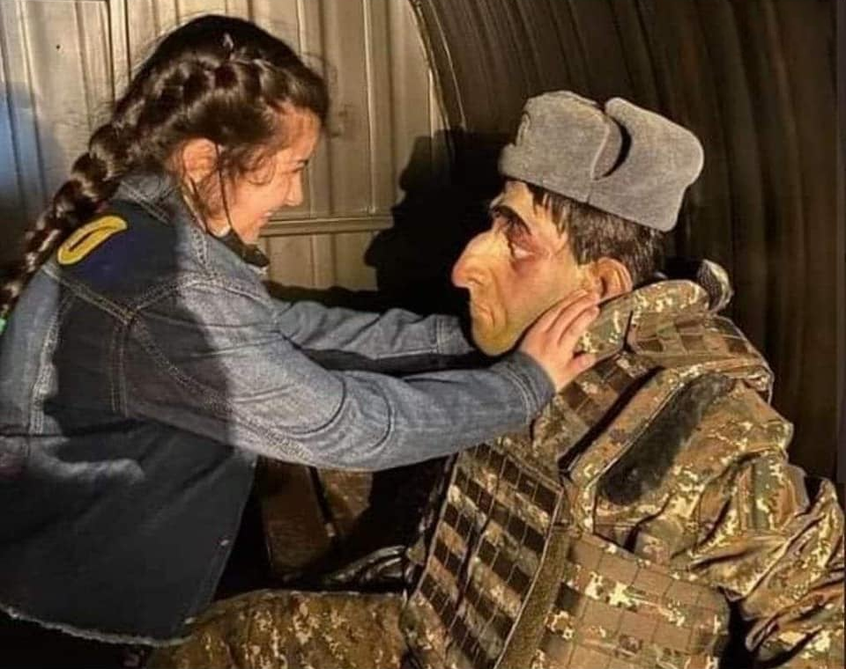 This is a picture downloaded from the Azerbaijani media pages. The picture is from the military Trephines museum, Azerbaijani government recently opened in Baku. The museum contains figures of dead, injured, chained Armenian soldiers and captives. It is open for the children even under six years old. The president of Azerbaijan has also visited the museum and took pictures which proves the state support in hate speech and anti-Armenian policy. In this picture a kid is trying to suffocate the Armenian soldier. In Azerbaijan, torturing Armenians is normalized, and they teach such behavior since the childhood of their kids, a proof of which is the picture of a young girl suffocating the Armenian solider. If you google, you’ll find other picture of kids in the museum. This may let us assume that “armenaphobia” is taught in Azerbaijan since the childhood, when they are not conscious enough.
Azerbaijani side knows that opening a museum of Armenian soldiers will cause emotional pain to Armenians, especially to those whose sons are prisoners of war, are missing or were killed.
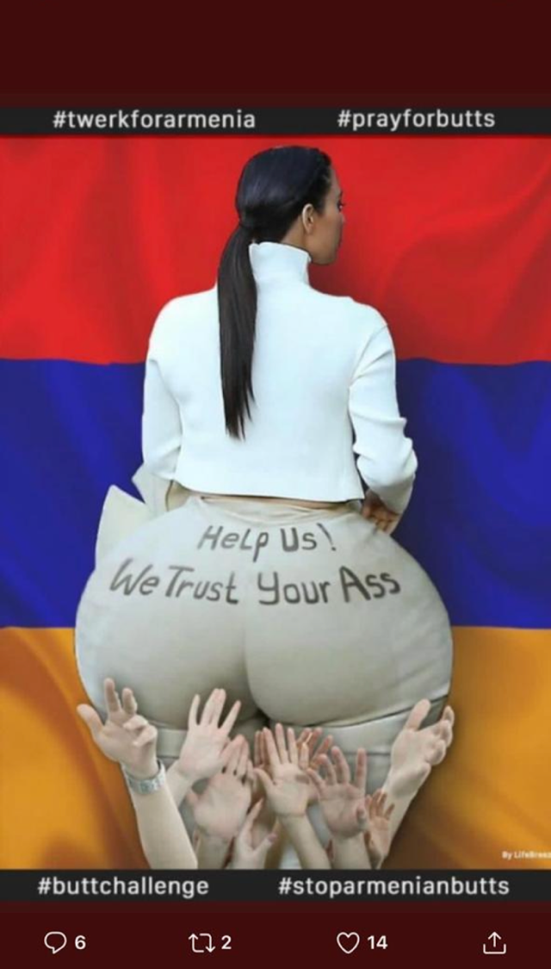
Some examples of insulting speech which is not considered to be a hate speech.
Picture of Kim Kardashian photoshopped with a statement “Help us! We Trust your Ass.” Kim Kardashian is an American Armenian who actively supported Armenians on social media during the war by donations and news’ spread. As Kardashian is also one of the most popular influencers on Instagram, Azerbaijani people made an insulting image of her. This is not a hate speech but rather a cynic action.

Here is a comment screenshotted from the comments section of an Armenian picture. It written in Russian; “Armenians are toilet paper.” This may not be considered as a hate speech taking into consideration the tone and word choice, but calling a nation a toilet paper is offensive. So, this one was more of an example of offensive opinion.
The next two comments state the following in Russian and are retrieved from Instagram page Wargonzo.
Comment 1: What’s wrong here, this man killed Azerbaijani elderly people and kids, and these people are just kicking him, where is your logic
Comment 2: This old man was a solider back in 1992 and he cut and severely killed children and women, made fun of them without thinking that life is a boomerang, and our soldiers knowing about his identity did not treat him brutally. Pay attention on how they took his hand and help him.
So, these comments were made under one very famous video of a very old civil Armenian man, who was being beaten by several Azerbaijani soldiers. Later, as a consequence it was announced that the man died. In this case we cannot say that spread hate speech, but this speech certainly contains aggression, irony, false statements that would support aggression towards Armenians and justification for brutal acts of their nation. On the other side, the video which I did not include is an example of visual hate speech.
The following three comments also are examples of ordinary aggressive speech. The third one in Russian states “You are crazy, no words, what else to expect if you state that dinosaurs were also Armenians. In these examples we see calls for not believing Armenians and their statements.
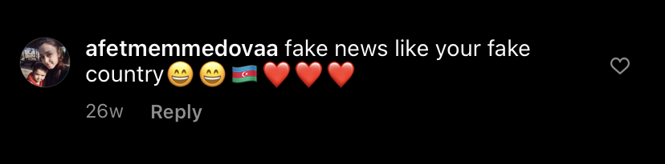
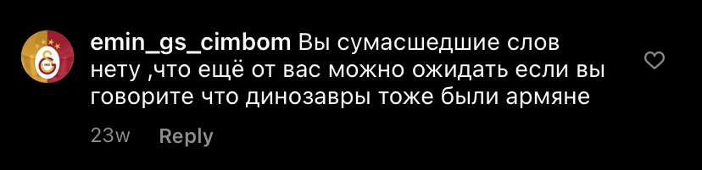

After was it was difficult to find much evidence. However, I also wanted to include some comments made by Armenians. These three comments were done under different post during the war. The comments were found under fake pages Azerbaijani side opened to share war information where they pretended to be Armenians.
Comment 1: Sheep
Comment 2: This is fake news, absolutely, sheep (in Armenian).
Comment 3: AzerSheep
Comment 4:Sheep of the year

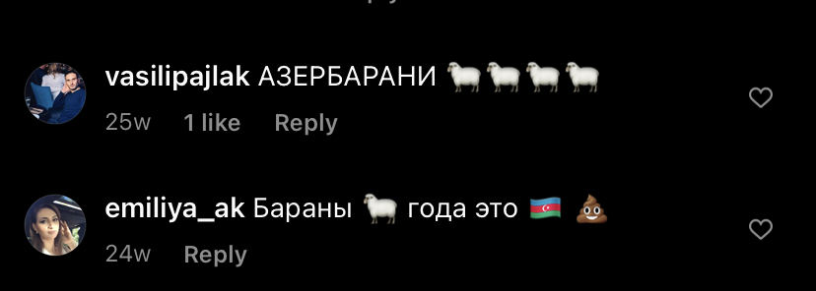

I

I believe the reason why Armenians mostly use the word “sheep” to describe Azerbaijani people is that sheep follow their flock without thinking. With this comparison they try to hint that the people follows the government without understanding the consequences and lies behind. In Aliyev’s speech the term “dogs” to describe Armenians is considered as hate speech, but the word “sheep” is offensive but not hate. First, there is a difference who makes the statement. Second, in the case with president Alieve, his expression “we drove them like dogs” became a driving force when using violence whereas Armenian government never used the word “sheep” to describe people of Azerbaijan. Also, dogs may be sometimes dangerous whereases sheep are harmless.

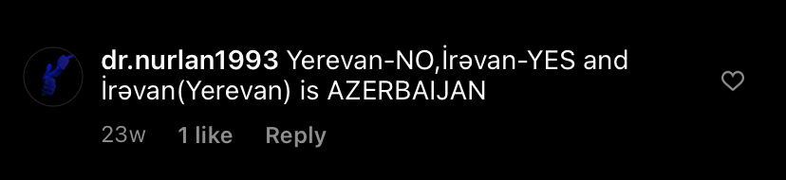
Threats to Armenians

This indirectly says that they want to come to the point when they will conquer all Armenia. Yerevan is the capital of Armenia and is war away from the borders. If in some cases they may say that this part is Azerbaijani because it has a border with it, in the case of Yerevan they can’t.

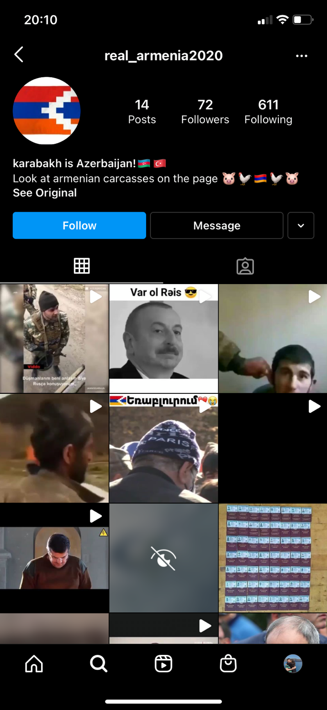
Example of Azerbaijani page pretending to be Armenian. The name of the page is real_Armenian2020. Many people when trying to find information about the situation in Armenia would search key words such “real” “Armenia” “2002.” So, Azerbaijani people made up a nickname which will be popular among Armenians’ search section. However, when entering the page and seeing the Azerbaijani and Turkish flags, the statement is Karabakh Azerbaijan and the pig emoji next to the Armenian flag it becomes obvious that the page is Azerbaijani made. The profile picture is the flag of Nagorno Karabakh which is a way to attract Armenian audience. First people would see the picture and assume it’s a real page. Then they would enter and see violent videos of Armenians being tortured. This page looks like a Jihadist page, where members of ISIS post violent videos from wars to threaten civilians. This may also be another evidence of the presence of mercenaries and jihadists from Syria during the war.
Conclusion
To conclude, hate speech was one of the crucial issues during the Nagorno Karabakh War of 2020. Based on the evidence brought up in the paper, the answers to the research questions are:
- Azerbaijani side spread hate speech about ethnical cleansing of Armenians. They use statements such as “Armenians must die,” “wiped of this earth,” “face the same death,” “must be killed.” Besides the statements, there is also destruction of Armenian historical monuments and churches, which is another reason to believe that the hate speech towards Armenians has a national-ethnical content.
- The most common statement that was used by Armenians to insult Azerbaijani people was “You’re sheep.” The statement tried to hint that Azerbaijani people blindly follow their corrupt leader, President Aliyev. To understand the social media behavior of the Armenian side, an interview with the Armenian Social Media Army was conducted. The ASMA has 2500 followers on Instagram, 140,000 on Twitter, and 138,846 followers on Facebook, and the observations are based on their experience on those social media platforms. The Armenian side was working collectively during the war and was mainly concentrated on spreading information rather than writing insulting comments. The social media supervisor of ASMA stated that ASMA members strictly followed the community rules. Another tactic that Armenian side used is not to answer or post under any post made by the Azerbaijani side, as doing so they would raise the popularity of the post.

Reference List
AD HOC Public Report, (2020). Organized hate speech and animosity towards ethnic Armenians in Azerbaijan as root causes of ethnically based torture and inhumane treatment by the Azerbaijani Armed Forces. Retrieved from https://www.ombuds.am/images/files/2bb83fd52ae0011eeaa6e77f42210cd3.pdf
Council of Europe., & Council of Europe. (1952). The European convention on human rights. Strasbourg: Directorate of Information.
De Smedt, T., De Pauw, G., & Van Ostaeyen, P. (2018). Automatic detection of online jihadist hate speech. arXiv preprint arXiv:1803.04596.
Fortuna, P., Soler, J., & Wanner, L. (2020, May). Toxic, hateful, offensive, or abusive? what are we really classifying? an empirical analysis of hate speech datasets. In Proceedings of the 12th Language Resources and Evaluation Conference (pp. 6786-6794).
Gomez, R., Gibert, J., Gomez, L., & Karatzas, D. (2020). Exploring hate speech detection in multimodal publications. In Proceedings of the IEEE/CVF Winter Conference on Applications of Computer Vision (pp. 1470-1478).
Gutteres, A. (2019). United Nations Strategy and Plan of action on hate speech. Retrieved from https://www.un.org/en/genocideprevention/documents/UN%20Strategy%20and%20Plan%20of%20Action%20on%20Hate%20Speech%2018%20June%20SYNOPSIS.pdf
Kazaryan, A. M., Edwin, B., Darzi, A., Tamamyan, G. N., Sahakyan, M. A., Aghayan, D. L., ... & Gayet, B. (2020). War in the time of COVID-19: a humanitarian catastrophe in Nagorno-Karabakh and Armenia. The Lancet Global Health.
Sargsyan. L,. (2017). Spotlight Karabakh, The Republic of Artsakh. EVN Reports. Retrieved from https://www.evnreport.com/spotlight-karabakh/spotlight-karabakh
The Office to the President of the Republic of Armenia. (2021). Artsakh Republic: History and Current Reality. Retrieved from https://www.president.am/en/Artsakh-nkr/
Walker, S,. (2020). Relatives of Armenian axed to death by Azeri officer call for justice. The Guardian. Retrieved from https://www.theguardian.com/law/2020/may/25/relatives-armenian-axed-death-by-azeri-officer-call-justice-ramil-safarov

