Capstone Paper

Louri Kirakousian
Presented to the
Department of English & Communication
American University of Armenia
May 17, 2021

Abstract

The following research analyzes how two coffee shops named Coffee House Company and The Green Bean Cascade found in Yerevan, Armenia, gain their customers' attention through their social media management. The research analysis process is done by the method of content analysis of the social media platforms such as Facebook and Instagram for both coffeeshops. In addition, the research also supported by an in-depth interview, online survey, and field research, for the exploration of how the online brand management of these companies affects their customers. The analysis also takes up the AIDA Model theory to look into the visual contents posted on the social media platforms to inspect how each shop advertises its brand's image to the public.

Table of Contents
Introduction 3
Literature Review 4
SME Business Brand Management 5
Sustainable Brand Management 6
The AIDA Model Theory in Advertising 7
Visual Social Media Management 8
Methodology 10
Content Analysis 11
Company # 1: Coffee House Company Prime 11
Post No. 1 - Platform: Instagram 12
Post No. 2 - Platform: Instagram 13
Post No. 3 - Platform: Instagram 14
Post No. 4 - Platform: Facebook 15
Post No. 5 – Platform: Facebook 16
Company # 2: The Green Bean Cascade 16
Post No. 1: Platform: Facebook 17
Post No. 2: Platform - Facebook 18
Post No. 3: Platform – Facebook 19
Post No.4: Platform - Instagram 20
Post No. 5: Platform - Instagram 21
Online Survey 22
In depth Interviews with the managers 31
Observation and Interviews with customer’s 37
Compare and Contrast 39
Limitations 41
Bibliography 42

Introduction
Advertising and promoting are essential components of a successful business. Their effects include brand establishment and growth, the development of customer loyalty, and defense against competition. Most small and medium-sized enterprises (SME) find difficulty in enduring their path to success and continuing for survival. Nevertheless, in Armenia, two coffeeshop industries, known as Coffee House Company Prime and Green Bean, have successfully grown and bear a fortunate brand image in Armenia's capital city in Yerevan. The achievement of a brand in a small country with a developing/emerging economy takes time and requires an active presence on both mass media and social networks. Located in Yerevan's most populated locations, such as North Avenue 18, Abovyan 18/3, Sayat Nova 8, Charents 10, and a couple more, Coffee House Company Prime continues to extend its name in more expansive areas. Coffee House Company Prime's menu ranges from trendy coffees and shakes. They personalize their stores with their popular black and neon color aesthetical artwork as well as always carry their logo at the back of their small shop, "Love and Coffee, In One Cup." Considering that Coffee House Company Prime does not have a sitting area but rather is a coffee booth where people can buy their coffee anytime and take it away, its price scale is cheap and low. Coffee House Company Prime is open every day of the week and has one open shop 24/7. Coffee House Company Prime's social media following holds 12,473 on Facebook and 24,700 on Instagram.
Meanwhile, Green Bean has a following of 4,396 on Facebook and 757 on Instagram. Green Bean is a larger coffee shop that does have a sitting area both indoor and outdoor. The coffee shop is open every day of the week but within a period of time, from morning to midnight. They specialize in much more pro-environmental aesthetics that follow the color green. Their menu ranges from a variety of international coffee to healthy and vegan dishes. Unfortunately, Green Bean currently owns only one location, and that is on Isahakyan street near the infamous Cascade complex of Yerevan. Their price is considered moderately expensive as they follow the price scope of international coffee shops and not local ones like Coffee House Company Prime. In order to understand the influence of the coffee shops, it is essential to analyze their brand management online. Therefore, the following capstone research is concentrated on the online brand management of Facebook and Instagram use to understand the techniques coffeeshop companies use in Armenia. All the scholarly resources established reflect on the topic of the brand image. Therefore, the brand image can push the customers to make decisions and turn them into loyal consumers. Finally, with the advancement of technology, online brand management has become much easier due to various management tools. Hence, examining the online marketing of both coffeeshops might provide clues to their success. Nonetheless, the research also takes up the theory of the AIDA model as a means to analyze the content presented on their social media. Understanding the methods of the use of attention, raise of interest, creation of desire, and the stand to take action will clarify how the coffeehouses use to gain their customers.

Literature Review

Many scholars have conducted different research methods through which SME businesses triumph. These include studies done on the uniqueness and effectiveness of SME brand building, sustaining the brand image and trust, forming a brand strategy via the AIDA model theory, and comprehending the importance of visuals on social media. Brand management is a technique to ensure how the brand's image is perceived in the market. It is a process that holds both a digital and analog system. Therefore, I will be looking into multiple aspects of successful brand management for my capstone project and how it is detected in an SME business. I have selected to look into theoretical and statistical studies that discuss the elements needed towards social media advertising, as it is a part of brand management online.

SME Business Brand Management
SME businesses are different from other businesses because they hold their own aesthetic and theme to match the owner's vision and taste. Based on the findings by Victor Tavares (2015),
"Brand management in the SME context seems to be distinct because it is essentially related to the intensity of entrepreneurial orientation for the brand as shown by the entrepreneur/owner-manager, and because the brand is especially a result of his/her own personality"(Tavares, 2015, p.139).
Tavares (2015) also adds that the empirical findings of his research revealed that "SME's owner-managers tend to simplify the use of brand instruments and synthesize the various brand procedures because they are normally constrained by a shortage of resources, time and experience in the field" (Tavares, 2015, p.144). This finding explains how SMEs' brand management is much more simplified and inexpensive, which is highly beneficial and essential for such enterprises.
The second research paper, titled SME brand building and management, analyzes the concept known as the country of origin. This exploratory study explored the concept in the use of the brand image of SME businesses. The authors illustrate that "consumers derive beliefs not only from direct associations to the brand but also from secondary associations such as the country of origin of the brand" (Spence and Essoussi, 2008, p.1039). The notion of the country-of-origin branding is developed to support its reputation and relation to its originality and values of the country it is produced in. Hence, many SME enterprises use the country of origin's perception to attract their audience on their core heritage. The authors add that another factor that differentiates SME Businesses is the "more efficient locations" that increase the company's overall efficiency and competitiveness and reduces cost (Spence and Essoussi, 2008, p.1048).

Sustainable Brand Management
According to the authors, HakJun Song, JunHui Wang, and Heesup Han (2019) one of the most essential attributes to a successful online brand management is to connect to the customer’s emotions specifically their trust and loyalty. The authors establish their study by conducting a theoretical data analyzes of Starbucks in Korea. Based on the authors findings, “Managers should strengthen the publicity of the brand image through advertisements and push media information to deepen a customer’s impression and to attract more people at the same time.” (Song et al., 2019, p.56)
Additionally, “In order to satisfy the customer, managers and practitioners should ac- curately identify individual customers’ preferences and characteristics.” (Song et al., 2019, p.56) Consumer’s follow the stores that specifically satisfy their needs. Therefore, online brand managers experiment in methods such as surveys, polls and satisfaction measures to understand the taste of their target customer’s.
Following Chapter 6 of Jean-Noël Kapferer (1997) book on Strategic Brand Management, Kapferer mentions, “Everywhere, cheaper alternatives to the major brands now hold significant market shares.” (Kapferer, 1997, p.138) Hence, purchasers follow the brands that deliver cheap but communicate an honest brand. Furthermore, according to the author, “adopting a short format for ads (10 seconds instead of the classic 30 seconds) maintains the frequency of the brand appearances, even with a reduced advertising budget.” (Kapferer, 1997, p.147) Thus, identifying that brief but repeated messages online linger longer with viewers and preserve the brand further in the consumer’s mind.
Sustaining the brand image, highlights the ways in which industries make use of their online management to reach out to their audience. By following such strategies companies regardless of their size or popularity will gain importance in their domain.

The AIDA Model Theory in Advertising
The AIDA Model Theory helps understand a company's use of different advertising strategies of Attention, Interest, Desire, and Action towards its consumers. According to the communication theory, the AIDA model implementation process is as follows:
"Attention is usually grabbed by the use of image, layout, typography, model, etc. Once the Attention is grabbed, interest is formed in the viewer's mind by using an attractive subhead. The element of desire is created by the body copy where the brand's features are explained, and towards the end, the action is initiated by the contact information of the brand" (Communication Theory, 2014).
For an advertisement to be successful, the consumer must view this information and follow through with the theoretical steps to understand a brand's message and avoid any confusion.
This theory was tested on a coffee shop known as Kopi Tepal Coffee found in Indonesia. The author's, Kartika Ardhanariswari, Krisnandini Pratiwi, Ninik Probosari, and Ari Wijayani (2020), use the theory of the AIDA model to decipher the branding strategy of the coffee shop. In the findings, the authors discovered that "the design, message, promotion, and communication of Kopi Tepal brand are designed in such a way to characterize historical values and identical culture of Sumbawa" (Ardhanariswari et al., 2020, p.537). However, due to the lack of social media use in Sumbawa, Kopi Tepal was able to advertise in Sumbawa via word of mouth because of their characterization. Additionally, the authors argue that although this strategy is adequate, multiple challenges emerge such as "the low quality and appearance of the product, the low marketing and access to information, as well as the lack of facilities and infrastructure of the branding strategy that is owned to popularize the coffee products" (Ardhanariswari et al., 2020, p.537).
Another application of the AIDA model's theory has targeted 22 SME entrepreneurs and analyzed the success of digital media use in their businesses' brand management. The study's findings presented both practical and theoretical contributions. Practically, the authors mention that social media is a successful marketing medium once used efficiently and effectively and in turn "can help SME entrepreneurs use social media in tandem with marketing through the new media revolution" (Hassan et al., 2015, p.268). Theoretically, the study conducted by the authors approves that "the [AIDA] model can indeed be applied in strategizing the use of social media for marketing purposes" (Hassan et al., 2015, p.269).

Visual Social Media Management
It is necessary to understand the importance of an effective supervision and management of social media posts to accomplish successful online brand management. In a successful business, visuals are crucial as they allow quick reaction and action by the viewing audience. Marius Manic (2015) emphasizes that the central point in a business's marketing strategy is its strong relation to the human senses and nature. He supports his statements by providing studies conducted by other authors who possess identical theories. Manic (2015) adds that "through visual content, the brand is "humanized" and easier to relate with" (Manic, 2015, p.91). Additionally, "the time needed for the comprehension of a visual ad is sensibly shorter than the one necessary for a message consisting mainly of text" (Manic, 2015, p.91). According to a 3M sponsored study at the University of Minnesota School of Management, "Visual ads are 43% more effective in convincing an audience to make a certain decision" (Manic, 2015, p.91).
Ciprain Pavel (2014) provides a similar argument. He mentions a survey conducted by the Stanford Persuasive Technology Lab that asked 2,440 participants how they viewed Web designs and their credibility. The study found that "almost half of the participants (46.1%) agreed that the Web site's design look is the number one criterion for discerning the credibility of the material" (Pavel, 2014, p.167). Pavel also specified that the bases of "use of images convey the tone of voice of a brand." (Pavel, 2014, p.167) Thus, highlighting the importance of image choice before application on social media.
Finally, Sarvotarzan discusses some statistical research executed by multiple academics.
Sarvotarzan (2018) discloses the importance of visuals via one of his sources, Brain Rules by John Medina, in which it is stated that "when people hear information, they are likely to remember only 10% of that information three days later. However, if a relevant image is paired with that same information, people retained 65% of the information three days late" (Medina as cited in Sarvotarzan, 2018). Moreover, prioritizing visual management in SME businesses and marketing strategies is crucial because a survey conducted by Megan O'Neill (2016) found that "76.5% of marketers and SME business owners who have used video marketing say it had a direct impact on their business" (O'Neill as cited in Sarvotarzan, 2018).
Following the discussion and analysis of my academic sources found on brand management, AIDA model theory, and visual social media management, we can confer that the studies established can contribute to my research analytically and theoretically. Nevertheless, in-depth interviews and lack of consumers’ viewpoints are missing components of this literature. I intend to fill this gap with my own research.

Methodology
The following research aims to understand the promotional methods in which Coffee house company prime and Green Bean use to obtain their customers. The research is applied to both the company's methods of popularity gain and the customer's perception. The method conducted was qualitative content analysis of Coffee House Company Prime’s and Green Bean’s Facebook and Instagram feeds online. This technique was used to understand the brand management strategy and use of visual the coffee shops utilize to entice their customers.
The time period in which the research took is post coronavirus from the start of 2020 till the end. However, exceptions were made for posts selected from Green Bean as their posts were inconsistent and scarce. One post used for Green Bean was taken from December of 2018 and a couple from 2021. The posts analyzed were selected according to platform popularity. Since Coffee House Company Prime holds a higher following on Instagram, 3 posts were picked from Instagram, each claiming the research and 2 from Facebook. Meanwhile, for Green Bean, their most popular platform is Facebook so, 3 posts were chosen from Facebook and 2 from Instagram. Additionally, each post content is analyzed by the theory of the AIDA model to understand the brand strategy of CP and GB and their use of the theory in their visual posts.
Meanwhile, primary research was conducted to assist or oppose the examination obtained on the content analysis. An online survey was implemented based in Armenia, in both English and Armenian languages. The following survey research collected data from people with different backgrounds, age groups, ethnicities, gender, and locations. Throughout the survey, the necessary information was gathered about people's views, attitudes, and reactions to the coffee shops and attracted them to purchase their product. During the examination, the AIDA model theory was also used to gather if the customers went through the psychological process or not.
The data collected also provided insight and highlighted the most effective online brand management methods of both coffeeshops that consumers prefer and are attracted to. Similarly, in-person interviews were conducted with the customers already present near or at the coffee shop to support the online survey results. The observations were conducted on a weekday and a weekend at different time periods.
Furthermore, an in-depth interview was conducted with both Coffee House Company Prime and Green Bean teams. The questions reflected both on the inquiries of the customers and the obstacles that arose while doing the social media content analysis and interviews.

Content Analysis

Company # 1: Coffee House Company Prime
'Coffee House Company Prime' is a coffee shop in Yerevan, Armenia. Their tagline is 'love and coffee in one cup.' They have a strong social media presence on the platforms of Facebook and Instagram. They continuously update their accounts with different yet aesthetic images and catchy captions written in Armenian. The social media marketing in the native language helps the local companies or brands reach out to the masses. In this way, the local brands can connect to the local audience and promote their product effectively (Daosue and Wanarat, 2019).
The following research presented below is a review of the online brand management of the Coffee House Company Prime on their social media platforms.

Post No. 1 - Platform: Instagram
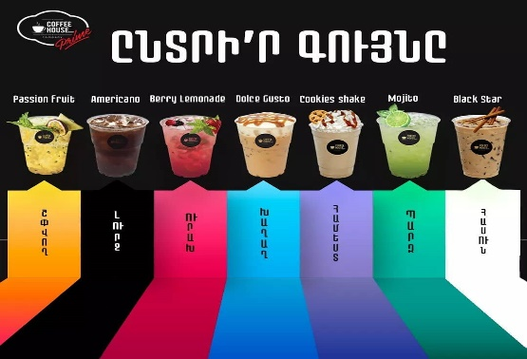
The following post by Coffee House Company prime is an interactive photo with a couple of their most selling items on 10th April 2020. According to the post, each color represents a mood which the drink associates along with to help the customer decide the drink of the day. They tried to develop an engaging caption in which they asked people to share the post and talk about their favorite coffee and mood in the comments. Despite the menu being inclusive in terms of language, the post managed to get only 237 likes that are relatively less than the likes on the previous month's posts. The post managed to get six comments, which is a relatively high number compared to the posts' previous performance.
Figure 1: Post on Instagram
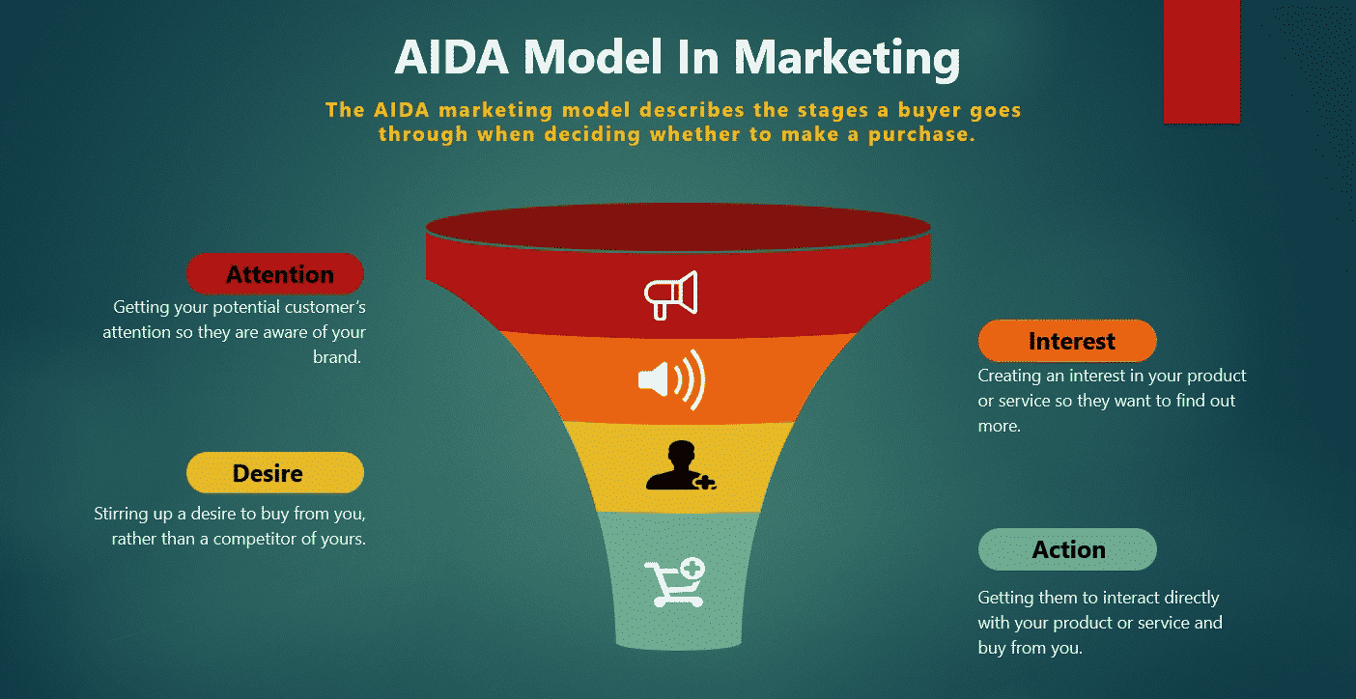
Analysis based on AIDA Model of Marketing
Based on the AIDA model, the customers' attention should have been grabbed by the colorful images related to the flavorful coffees. The interviewer's interests increased as they read the caption following the post to choose a drink according to their current mood. However, in order to increase the interest in a post on social media platforms, it is fundamental that the prices should also be mentioned. As well, the ingredients or a separate post for each flavor could have helped increase customers' desire to purchase. Meanwhile, the tagline calls its viewers action to buy the product they are looking into before their mood changes.

Post No. 2 - Platform: Instagram
Due to an increase in coronavirus cases, the company realized its social responsibility and shared a message in partnership with professional cleaning service providers called, 'All Clean,' on 04th May 2020. 6,526 viewers have taken an interest in a post where the company gave an inside peek in a video on how everything was cleaned and disinfected. In a caption following the video, the company expressed its concern for its customers. It encouraged everyone to enjoy their coffee cups while following all the necessary SOPs, mandatory to be taken for the spread of the Coronavirus. The comments on this post also appreciated their services as well as the quality of coffee produced by the company.
Figure 3: Second Instagram Post for Coffee House Company Prime
Analysis based on AIDA Model of Marketing
The colors, texture, and music of the video are entirely synchronized with its message creating strong attention among the viewers. The proper disinfection process drives people's interest in the company, thinking that people's safety is beyond any business gains. The interest is directly related to the desire. The desire to buy the product increases resulting to the growth of buying behavior of the people to be affected directly. Lastly, the action which is presented by the writeup associated with this post is very articulated. It gives a very positive message of how people need to stay safe and enjoy the time.

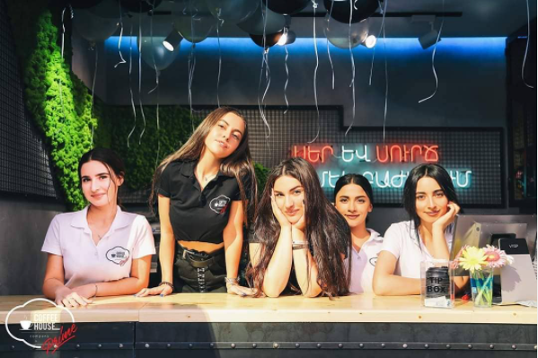
Post No. 3 - Platform: Instagram
On 15th May 2020, the company celebrated 'International Family Day.' It gave Armenian a very positive message about how all the people at Coffee House Company love and care for each other. They also shared a picture of their employees wearing shirts with the company's logo on them. The company tried to give a welcoming gesture through the image and related caption wholly aligned with their tagline. By the caption, Coffee House Company indicates the family environment of the shop as they ask their audience to name a friend that is like a family member although they aren't related by blood. The post managed to get 435 likes and four comments.
Figure 4: Third Instagram Post of the Coffee House Company Prime
Analysis through the Lens of AIDA Model
Coffee House Company raises attention by posting such videos that capture the audience's focus on their safety. The viewers' interest is sparked by customizing the message to their needs when precautions and safety measures are called for. Desire is produced by the ambiance of the background and the girls' dresses' color. Since the post shows how everyone at the Coffee House is so close to each other, it also helps customers feel more connected to the brand and influences their loyalty. Therefore, resulting in the customers taking action.

Post No. 4 - Platform: Facebook
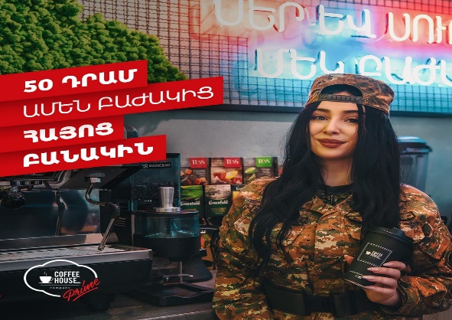
On 28th September 2020, the coffeehouse shared a very patriotic post in solidarity with its soldiers with the hashtag 'we will win.' The coffee shop took an excellent initiative to support its Army by donating 50 drams from each cup of coffee purchased to the Armenian Army. The post managed to get only 157 likes but did well in terms of comments and shares. It received 25 comments and was shared 08 times. This was a perfect move that helped the company support its Army and enabled it to attract more people and increase sales.
Figure 5: The Coffee House Company Prime’s Post at Facebook
Analysis through the Lens of AIDA Model
Attention is triggered by the provocative imagery with an exciting color scheme that could have done justice to the campaign. The campaign provided a very positive message by helping the Army with the purchasing of coffee. The patriarchal spirit of the post heightens the people's interest and desire. In the last step, i.e., action, a prompt and clear call for the act was provoked through the caption.

Post No. 5 – Platform: Facebook
On 14th December 2020, the Coffee House Company Prime celebrated its 5th anniversary. Their appreciation post thanked all their customers and employees for their constant support and love, which helped them grow into 15 branches in different locations. The post received the most popular reactions and liked with 435 and had 7 comments and 5 shares. Comparing it to the previous posts on Facebook, this is the most popular one as Coffee House shares its love and value towards its customers.
Figure 6: Second Post of the Coffee House Company Prime from Facebook
Analysis through the Lens of AIDA Model
Attention is by the thematic colors that correspond along with the girls’ outfits as well as the balloons. There is also the element of the color red that captures a surveyor’s awareness. The appreciation post grabs the interest of its viewer by the constructed caption which praises the customers as well as the employees. The desire of the viewer increases by the atmosphere Coffee House company presents which is not only of a family but also of one that is supportive and grateful. After being appreciated the customers will move in to action, as they start increasing the sales and become loyal customers towards the coffeeshop.

Company # 2: The Green Bean Cascade
‘The Green Bean Cascade’ is another popular coffee shop in Yerevan, Armenia. Although they have a moderate social media presence on the platforms of Facebook and Instagram, they still hold a popular reputation within Armenia. Their posts are far simpler and have less human appearance in their advertising and more of the products found in their menu.
The following research presented below is a review of the online brand management of the Green Bean Cascade’s social media platforms.

Post No. 1: Platform: Facebook
The Green Bean Cascade's latest post is on 7th March, as evident from the picture, a mug full of coffee and a croissant is shown. The caption posted with this image was perfect for its content. The caption expresses about the perfect blend of coffee and spring. The caption was crisp, but it did not manage to capture consumers' attention as there were only 11 likes and 3 love reactions on the post. The Green Bean Cascade's Facebook page has an audience of 4,246 people, but this post managed to engage with only 0.32% of its audience. In this post, almost 14 hashtags were used. Despite the usage of these hashtags, it failed to reach out to its targeted audience. So, it seemed unnecessary to use hashtags. Instead, the excessive use of hashtags shadowed the caption.
Figure 7: First post of the Green Bean Cascade on Facebook
Analysis through the Lens of AIDA Model
Now, let's analyze the image via the AIDA model, the post here does not outrightly capture one's imagination which might fail to grab the consumer's attention. The picture shows a mug full of coffee along with a croissant and a bouquet of fresh flowers. The picture reaches out to all the book lovers who enjoy reading in a cozy setting. The presence of a bouquet in a picture points towards the arrival of spring. However, despite the presence of a bouquet, the image isn't picturesque. The second role of an advertised post is to invoke interest in the consumer. By merely looking at this image, not all customer would be interested in coming to this place as they would believe it’s only for book readers and students as it doesn’t speak to the masses. The image is more of an advertisement of inspiring people towards cultivating book-reading habits. As the picture failed to invoke interest in the consumer, so there would be no desire among them to go to Green Bean Cascade for a good coffee unless they are in a mood. Resultantly, when there is no desire, a person does not take the necessary action to consume that product. Thus, based on the analysis, ' Green Bean Cascade' loses its charm on a marketing principle.

Post No. 2: Platform - Facebook
Figure 8: Second Facebook Post for Green Bean Cascade
This post is also a recent one dating to February 22, 2021 is quite captivating as opposed to the post discussed above. The caption begins with a playful correction of Tiramisu's pronunciation followed by the humorous dismissal of the requirement to pronounce it correctly when the cake itself is so delicious. The caption is brilliant and has all the elements to strike a chord with the audience. However, one trend seen consistently on these posts is writing down the address and phone number. The address and phone number are written just beneath the caption. It is difficult to concentrate on the content when the post is bombarded with hashtags and addresses. There are almost 16 hashtags used in this post. The use of hashtags for Facebook is inapplicable.
Analysis through the Lens of AIDA Model
When looked at from AIDA Model perspective, the image attracts one's attention. This image, unlike the post discussed above, is focusing on the product. The product that is Tiramisu cake is the center of attention. This image arouses your tastebuds, and one starts developing a sudden craving of consuming this dessert initiating interest. To satiate the desire to carve this delicacy, one would want to take action and try it out. The success of this image and caption translates into improved engagement with the audience. Resultantly, 21 people liked this post. There were also 2 shares. The numbers speak volumes of the engagement. Although this post interacted with a smaller audience, however, this post's impact was better than that of the previous one.

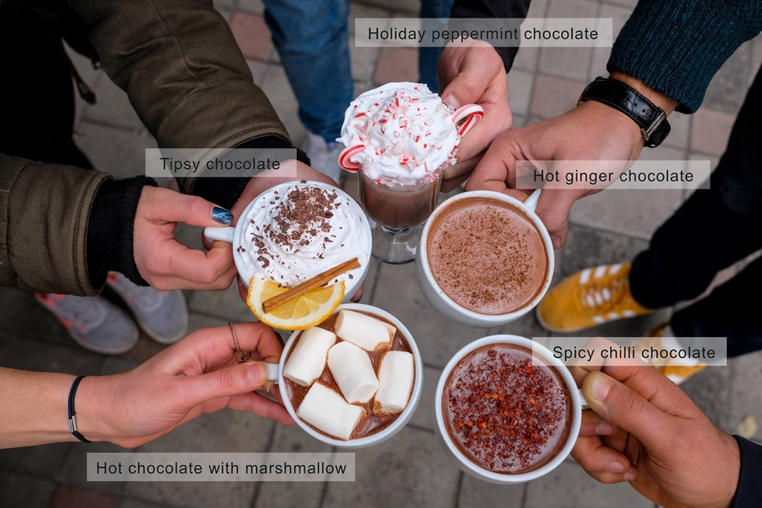
Post No. 3: Platform – Facebook
Although the following post is quite old, as it was posted on December 25, 2018, it is chosen as it is related to a similar advertisement from Coffee House Company Prime. The following post identifies wintery drinks that are for the comfort of the holiday spirit. It has one hashtag that provides the caption to stand out with its fun-related status. It also shows how the viewers were more attracted to the posts in the past as it received 80 likes, 14 comments, and 4 shares.
Figure 9: First post of the Green Bean Cascade on Facebook
Analysis through the Lens of AIDA Model
While looking through the lens of the AIDA model the post is a quite attention grab worthy one. With the different elements of the winter season presented on the hot chocolates the consumer would be interested to taste each one of the drinks as they also have captivating names. Interest raises the desire of the consumer to purchase such product leading them towards taking action. Green Bean fulfills the customers quick reaction by posting their address and number near the caption.

Post No.4: Platform - Instagram
This image was posted on February, 13, 2021, in Green Bean's Instagram page. The Instagram handle of Green Bean café has a smaller audience of 662 people. This post was done for Valentine's Day. The caption was quite cliché, but it still managed to gather 20 likes. Surprisingly enough, there were only three hashtags. Instagram is a platform renowned for gaining an audience through hashtags. The caption also had grammatical errors that provided for a discomforting read. In the caption, a reference was given regarding their cocktail menu. However, they hadn’t posted it on social media.
Figure 10: First Instagram Post of the Green Bean Cafe
Analysis from the View of AIDA Model
The image is quite captivating with different colors that grabs the attention of the viewer. It has all the colors required for Valentine's Day posts. The drinks look fresh and breathtakingly beautiful lifting the interest of the viewer. The sole point of attraction is this image. It arouses one's desire to go and enjoy drinks with the significant other. However, one takes action when it is given complete information. The complete knowledge is withheld as they don’t most the cocktail menu rather mention that customers ask for it. So, there is not a single comment on this post.

Post No. 5: Platform - Instagram
Posted on September 27, 2020, the caption of the following post is quite simple. It says a good breakfast puts a start to a great day. Due to the brilliant photography, it's hard to look at the caption. This post has garnered the greatest number of likes. There were 43 likes which means that the image was a hit among the audience looking back at the reactions of the other recent posts advertised on their page that barely got any attention.
Figure 11: Second Instagram Post of the Green Bean Cafe
Analysis from the Perspective of AIDA
The picture has said it all. It is beautiful, captivating, and holds an individual's attention. It is interesting to view to post as it clearly shows food found on the menu of Green Bean Cascade. The attention then sparks a desire to have such a kind of breakfast with family and friends. The caption which declares the importance of breakfast in the morning, entices the customer to take action and start their day with such meals from Green Bean.

Online Survey
The survey of the influence of brand promotion and advertising of Armenian coffee shops took place from start of February till end of March 2021. In total, the survey results consisted of 191 responses. The gender distribution consisted of 60% female and 40% male. The ages that responded to the survey were:
- 54% 20 to 24
- 31% 15 to 19
- 11% 25 - 29
- 3% 30 - 34
- 0.5% 35 - 39
- 0.5% 40 - 44
- 0.5% were below 15.
As the survey was sent out internationally there were multiple nationalities that answered the survey. However, 75% of the respondents were Armenians, the rest consisted of 8% were from America, 4% Syria, 3% Iran, 2% France, 1.5% Lebanese, 1% Russia, 1% Spain and lastly 0.5% were German. Per the vast distribution of the survey the respondents were asked whether they lived in Armenia. 76% answered yes while the rest 24% lived out of the country. According to the 45 people who responded no, they each live in different places. 40% lives in the U.S, 18% in the UAE,10% in France, 7% in Russia, 4% in Lebanon, 4% in Iran, 4% in Spain, 4% in Canada, 2% in Sweden and 2% in Germany. The online Survey consisted of 2 Coffee shops and each had separate 2 sections. The first part of the survey they had to provide feedback on the Coffee shops social media feed while the second they had to analyze the poster in the terms of the AIDA Model.
From the total respondents, 75 people answered the questionnaire to Coffee House Company Prime. Meanwhile, 49 responded to the Green Bean. While 79% of the respondents were familiar with Green Bean, 75% don't follow them on social media, and approximately 68% hadn't encountered any advertisement or witnessed their social media feed. However, the 32% that did answer yes to both questions and had a lot of interesting opinions to share about the social media management of Green Bean (as shown in Figure #1).
Figure 1: Chart of Green Bean of Social Media

From the 49 responses, 44 people follow them on Instagram and Facebook while the remaining only Facebook. Up to 78% were intrigued by the advertising presented on their feed, while the rest were not fond of their way of promotions. The most popular elements that attracted the customer's attention about the coffee shop were divided as the following:
- Twenty-three out of forty-nine respondents were engaged by the style, design, and logo of the store, which are more foreign than the other coffee shops found in Yerevan, Armenia.
- Twelve were allured by their healthy food menu and delicious coffee images.
- Seven loved the atmosphere and environment presented by the coffee shop.
- One person mentioned the location.
- The rest didn't have any specific answer.
Although Green Bean is located in Yerevan, Armenia, where the local language is Armenian, their posts are all posted in English. Therefore, when their customers were asked about the barrier, almost 82% said they don't face such issues, while the remaining 18% did. (as shown in Figure #1.2).
Figure 1.2: Chart of Green Bean for Language Barrier

As the respondents are diverse, this would mean that most of the social media visitors are not local non-English speaking Armenians. When asked how often the customers visit the coffee shop, the answers ranged from 28% visited most frequently, 49% Occasionally, and 22% least frequently. The follow-up question clarified why the frequent customers visited the coffee shop regularly. Over 63% of the respondents said because of their delicious coffee, 20% mentioned their style and aesthetic, 6% said because of their advertisement, 2% food, 2% staff, 2% because they were visiting Armenia, and another 2% selected all of the above. (as shown in Figure #1.3).
Figure 1.3: Reasons of visit to Green Bean

In the AIDA Model Interpretation section, an advertisement from their feed was introduced and asked what caught their attention from level 1 to 5 from the image. (as shown in Figure #1.4).
Figure 1.4: The ad used to implement the AIDA Model

77% of the viewers were first captured by the plate of food, while the second item that caught their attention was the logo, and the last was the "Rise and Shine" text. Moving to the second section of the AIDA Model is the interest. When questioned what their level of interest was towards the text provided in the advertisement and to what extent it made them want to know more about the product, 49% of the viewers were very interested. In comparison, 45% were slightly interested, and lastly, 6% were not interested at all. (as shown in Figure #1.5).
Figure 1.5: Product Interest of Green Bean Advertisement

While asked about the desire section of the theory, which understands the extent the customers craving was raised to purchase the product. 51% replied very much, 43% interest was raised slightly while 6% weren't affected. The last notion of the model is awareness. Finally, when asked how aware they were of the location and contact for the purchase of the product. 75% of the customers found it very easily, 24% took them a while, but they still found it, and none faced any issues with not finding a way to contact them or getting to their location.
In the end, the responders were given the option to present their opinions on the feed of Green Bean. From the six answerers, four acknowledged that they are missing from the social media platform currently as they haven't posted in a while, and the remaining mentioned a post that stood out to them from their social media feed.
Meanwhile Coffee House Company Prime’s results were interestingly different. As their total respondents corresponded to 75 of which were familiar with the Coffee shop, 92% didn't follow them on social media. However, 52% had encountered an advertisement or witnessed their social media feed. (as shown in Figure #2).
Figure 2: Chart of Coffee House Company Prime on Social Media

The fact that 65% of the answerers mentioned they follow the coffeeshop on Facebook and only 31% said they follow them on Instagram while 9% don’t remember where they follow them is highly shocking, taking in to consideration that on Facebook Coffee House Company has a total of 12,000 followers while on Instagram they have 24,700 followers. When the surveyors were asked whether the posts of coffeeshop company were attention grabbing 70% of the customers responded yes, while the rest of the 30% said no. Compared to the number of responses Coffee House received than Green Bean it is a lot and it corresponds to the number of reactions they receive when they post on Facebook or Instagram which is above 100. When asked what attracts them most about the feed or the coffeeshop the survey - takers responded accordingly:
- Forty-five of the respondents were attracted to the pricing of the coffee as well as the taste.
- Nine of the surveyors enjoyed the employees found in the coffeeshop.
- Eleven were fond of the design, logo and modern approach similar to that of the Russian Armenian style.
- Ten were intrigued by the design of the different seasonal cups.
Unlike Green Bean who post in English on their social media, Coffee House Company follows through their posts only in Armenian. So, when the customers were asked if they found any language barriers while viewing their advertisements 75% said no while 21% said yes and 4% said no (as shown in Figure #2.2).
Figure 2.2: Chart of Coffee House Company Prime for Language Barrier

According to the results it seems as though the percentage no is high meaning that their customers are satisfied and Coffee House Company analyzes the needs of their consumers and know their target audience. When asked how often the customers visit the coffee shop, the answers corresponded accordingly 44% visited most frequently, 43% Occasionally, and 13% least frequently. With the help of the next question, the responses justify why they visit the shop frequently. Over 70% of the respondents said because of their delicious coffee, 17% mentioned their style and aesthetic, 5% said because of their advertisement, 4% because of their food, and some 3% mentioned because of the girls that work there (as shown in Figure #2.3).
Figure 2.3: Reasons of visit to Coffee House Company Prime

Following the AIDA Model Interpretation section, an advertisement from their feed was introduced and asked what caught their attention from level 1 to 5 from the image. (as shown in Figure #2.4).
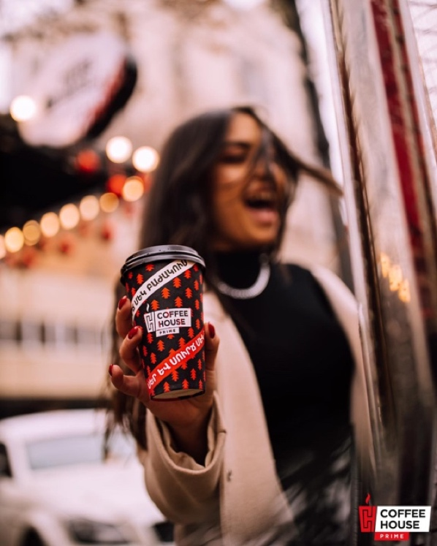
Figure 2.4: The ad used to implement the AIDA Model

From the 74 respondents 58% believed that the Coffee House Company Cup and the girl presented in the image are attention grabbing. While 45% were interested in the logo and 35% were concentrated on the blurred location presented in the background. It is not startling that the viewers found the coffee and the girl the first item on the advertisement to look at as they are at the center of the poster to amplify their value. When questioned what their level of interest was towards the provided item on the advertisement and to what extent it made them want to know more about the product, 38% of the viewers were very interested as well as another 38% were slightly interested. Lastly, 16% were not interested at all. Focusing on the desire section of the theory, when asked to what extent the customers craving was raised to purchase the product, 55% replied very much, 32% were slightly interested while 12% didn’t desire it at all.
Figure 2.5: Product Interest of Coffee House Company Prime Advertisement

As the last section of the AIDA follows through with Action, the surveyors were asked how aware they were of the location and contact for the purchase of the product. 68% of the customers found it very easily, 20% took them a while, but they still found it, and 12 % didn’t figure out the location all or were able to contact them.
In comparison to Green Bean, when asked if they had additional feedback, none had commented except for one person who requested to see posts in English.

In depth Interviews with the managers

- Coffee House Company Interview
The first in-depth interview was conducted with the whole team of Coffee House Company. They began the interview by providing a summary of the start of their business. They mentioned that they first started their business on October 5, 2015, by the current CEOs who used to be students at the University of the Yerevan state and the other from the Slavonic Russian-Armenian university. Narek, who was from the Slavonic Russian-Armenian University, came up with the idea and shared it with his colleague to open up a coffee house in front of his University. At the start, the employees were Narek's colleagues working different shifts for 2 months. Once the business started to grow slowly, they started to hire more employees and understood the benefits of opening the shop in popular locations such as universities, schools, or tourist locations in Yerevan, Armenia. When they were asked why they use only girl employees, they responded that in the beginning, they were hiring boys as the employees but because the majority of the applicants were girls and they noticed that both female and male ratio of their customers started to increase eventually leading a profit to the business.
When the conversation was led to how they began marketing their business, the owners stated that they didn't have a single idea on how to market their brand in the beginning. They would take random chances and risks until they decided to start studying the marketing of Starbucks. One of the examples of their marketing process was giving out unique cards after a couple of purchases. This was not a trend in Armenia, and no other coffee shops were doing it. When customers would purchase 6 cups of coffee, they would get the 7th for free. They didn't have specific marketing rules, but they did make one rule always to love the customer and appreciate them. They felt like that was not happening in Armenia, so they wanted to show appreciation to the customers. They created a customer-centric platform for their customers to show that they will always profit and always be correct.
Another example that gained popularity was creating cups for each season and putting the customers' names on the cups, which Starbucks influenced. As soon as they started producing these cups, they got extreme positive reactions on social media and advertising. The business started to gain popularity on Instagram. During that time, there were no stories for Instagram, and there were only posts. So, they would gain post tags, approximately 40 each day only of their cups.
Another branding and marketing technique that played a massive role in their business was putting a celebrity on the cups. One of the owners specifically mentioned, "The customers would approach us and tell us to give us a 2Pac cup, but they would forget about the coffee, which for us was very funny." One of the recent designs that they had was providing cups in a specific color during the war. Instead of writing #hakhtelunek (Hashtag, #We Will Win), they wrote #shnoragalenk (Hashtag # We are thankful). The central part of the marketing plan for Coffee House Company is designing the cups and creating trends through their specialized cups. The owners also definitely agreed that another factor that helped in their growth was word-of-mouth advertising.
When asked how they plan their posts, the media manager mentioned that they use content planning. They analyze the use of their previous photos and comments of customers to create new posts. Their creative process is based on the customer's feedback. If they have created a winter cup and distributed it amongst the customers, they would take photos, post them online, and comment. They would focus on the photos, comments both positive and negative, and generate new ideas. If the cup were dark blue for the winter season and the customers specified, "It would have been better if it was light blue," next winter season, they would focus on providing a light blue winter season cup with higher quality.
With the new built-in technology in Instagram, many businesses can track and see when the peak time is for customers to follow them or view their profile. For Coffeehouse company the peak-time of there is usually around 8 PM till 9 PM. When they start to post photos on Instagram because they know many of their customers come back from work during those times, they go and check their feeds. In the mornings, it is around 12 PM. So based on that information, the marketing group follows the time and posts stories, posts, videos, and advertisements online to gain customers. They also use the same built-in technology to understand which language is mainly spoken, written, or even understood. When asked why they don't use English captions or statements and only Armenian, they answered by providing different reasons for such use:
- They started their business in front of the Slavonic Russian-Armenian university, and we got the attention of their customers through the Russian language that is why it used to be all in Russian.
- Using Instagram's built-in technology, they understood the most used languages were Armenian and Russian.
- Their company is based in Armenia. Why should they not advertise in Armenian? The most populated location for English users is near the American University of Armenia, and they only recently opened a firm there.
- Lastly, they mentioned that it all comes down to the culture. That is why they try and keep promoting the Armenian language.
The owners and the marketing group did believe that visual content is important. One of the marketing members mentioned that the visual mattered to them the most. It was evident from the beginning that only posting the photo of a cup would not grab as much attention as perhaps to someone holding the cup for them. The people would be more realistic during that time, and they would see how happy their customers are. One of the visual content examples from Coffee House Company Prime was posting a photo of a girl holding a cup and a different picture of a guy holding a cup. The photo with the girl has a significant amount of likes and comments rather than the guy. They also agreed that by using the girls, they could gain the male population and promote their brand name. The owners mentioned that the girls are the lead-magnet for their customers, who are men and women. Their style and beauty attract the customers because they are ideal no matter the age of the customer.
They only one slogan, and they connected it to their customer:
"Love and Coffee, In One Cup"
The marketing campaign for Coffeehouse Company can be considered one of the main reasons why the business grew and gained profit. Their brand presence online, strong visual content, social media marketing, and finally, their sponsored cup set out to be their core profit base. With these couple of bases, they managed to create brand recognition, increase their public relations, gain market share, and stand where they are today. With their base set platform Instagram and Facebook, they created a brand presence and brand awareness. They created a community, a user-centric customer-based platform where all their customer communicates with each other through that platform. With such advertising and marketing, Coffee House Company Prime can grow more extensively than it already is.
- The Green Bean Cascade Interview
The Green Bean started its business approximately 7-8 years ago. The business owners were David and Elina, and they began the business based on combining the coffee shop culture of both American-Armenian. They used the American style and created American-based snacks and drinks. Eventually, the company grew more prominent, and they created their first non-smoking shop. During the previous times not, many people were familiar with environmentally and dog-friendly coffeeshops. Then many other competitors tried to copy and continue starting a business like the Green Bean, but they weren’t able to succeed because they weren’t familiarized with the American culture. Eventually, the actual owners sold their brand name, and the people who purchased it kept on continuing with the idea and concept of Green Bean.
Unfortunately, Green Bean does not have specific marketing for its business. When David started the business, he was focused on advertising and marketing, and during those times, they would gain a lot of customers; however, when they sold the brand name, nobody from the team followed up to do the marketing for the business. They did hire some marketers here and there within the past couple of years, but eventually, they didn’t create a marketing group. Although they don’t have any marketing, they still have a lot of customers that come into Green Bean. The reason is that the customers feel like they are coming home, and the interviewee mentioned that they feel appreciated and love the environment when they come by. As the staff work there for a couple of years, the frequent customers know them all, so they aren’t treated as restaurant customers but feel like they are in their home.
Usually, people come for the American experience, and Green Bean tries to provide Eco-friendly products. As mentioned previously, social media and advertising does not have a role at Green Bean. Green Bean used to be a franchise, and everything had to be the same in all locations, which attracted the customers. Their primary signature is their design, food, staff, and management. The way they do business is very different from many other coffee shops and advertising, or social media does not have a vital role in their success. Their social media posts are mainly food and snacks, and although many people purchase coffee from them, they don’t have many coffee posts. The reason for that is because they are treated like a bakery. People usually come in to have their lunch breaks, or they come to relax. Meanwhile, they decide to purchase coffee. That is why the main focus is on their food and not coffee drinks.

Observation and Interviews with customer’s
The observation took place for Coffee House Company Prime on Thursday, March 25, 2021 and Saturday, April 3, 2021. Based on the timings of visit from 1:00 pm to 2:00 pm at the locations of Northern Avenue and Abovyan Street Coffee House Company Prime was moderately crowded as students, children and people who passed by visited for a cup of refreshment. The percentage of girls who dropped in were higher than that of the boys. When the 8 customers on the Abovyan site were asked why they visited Coffee House Company Prime many responded because of the location and price while others mentioned that they visited it frequently because they craved it. In North Avenue, from 12 respondents some mentioned because it is on their way while other students mentioned it is their after-school ritual. From the total 20 respondents 16 had followed Coffee House Company Prime on social media while the rest had said they had encountered an advertisement from the coffee shop but don’t their feed. When asked what their opinions were of the posts that are displayed on their feed, the interviewees mentioned that they really enjoyed the colorful aesthetics Coffee House Company Prime uses as well as the style of the girls and cups presented in the images
Similar responses were provided when customers were interviewed at the timing of 7:00 pm to 8:00 pm. However, according to the observation the population of customers visited increased drastically and the consistency of girls to boys converted as more males dropped by the coffee shop. Due to the gender switch, when asked what attracted them most on Coffee House Company Prime’s social media feed many of them respondent the girls.
During the weekend visit to both stores of Coffee House Company Prime, the abundance of customer’s visiting was high. Approximately, 15 customers visited in the afternoon and likely 40 visited at night. The gender consistency of people who visited varied as there were many families who dropped in as well. The responses to the questions didn’t differ from that of the answers during the weekend. Nonetheless, many responded that they drop by as the workers are their friends and some mentioned because the workers are friendly and make really good coffee.
The observation of The Green Bean on Cascade took place on Thursday, March 25, 2021 and Saturday, April 10, 2021. The timings of visit ranged from 3:00 pm to 4:00 pm and 9:00 pm to 10:00 pm. During the weekday field observation, Green Bean did not have many customers. The amount of people who dropped by ranged from 3 to 4 while during the night time 8 to 10. Gender variety was mixed and the age of the visitors differed between adults and young adults. Many were there to study or work and did not want to be disturbed. Therefore, the respondents to the interview were much less than that of Coffee House Company Prime. The 6 who participated, mentioned that they visit Green Bean mostly after work or classes to continue on their projects while enjoying a hot drink or meal. Many highlighted on how much they appreciate the healthy options Green Bean supplies since there aren’t many cafés in Yerevan that provide that alternative. When asked if they follow them on social media or encountered any of Green Bean’s ads most of them said no, they didn’t while some said they follow them but haven’t seen a post in a while. Meanwhile during the weekend there were much more customers. Relatively 10 people came in to the coffee shop in the afternoon and 25 at night. When asked if they follow Green Bean on social media, most said no while some said they weren’t sure. Almost all of them were there to see their friends and have coffee or the notorious cheesecake Green Bean owns according to some. At the same time, there were also people completing their work and studies. There were also a couple of people who had come to rest up after walking their dog since Green Bean is a dog friendly coffee shop.
Considering the different styles and manner of serving, each coffee shop has its own target customers ghat kept visiting them for their own uniqueness and aesthetic. Green Bean was popularized for its healthy choice of food while Coffee House Company promoted for its cheap yet delicious coffee.

Compare and Contrast
After conducting the content analysis of both coffeeshops, it is highly evident that Coffee House Company takes far better care of their Online Social Media Brand Management rather than Green Bean. Following up the study, survey and interview it is apparent how each coffeeshop uses a particular strategy to gain their audience. Although Green Bean’s strategy was conducted in the past and are currently satisfied with their single shop at Cascade, Coffee House Company prime wants to move forward and expand their growth wherever they can in Yerevan, Armenia. Coffee House Company Prime takes pride on their social media management as they upload multiple modes of interactions with their customers as well as different, creative ways to capture their audience’s attention, interest desire and action on social media platforms. Meanwhile Green Bean seems to find gratification in the circle of customers they currently have and whoever, finds them by word of mouth, street corner or atmosphere.
The difference in the photography and visual presentation of Green Bean's café is much lower than that of Coffee House Company Prime’s. The quality of presentation and message extension becomes much stronger in Coffee House Company Prime’s feed than of Green Bean. Having a strong platform gives room for Coffee House Company Prime’s customers to interact with their posts more leaving them excited and interested.
Green Bean’s deficiency in posts is mostly the reason they don’t have the audience they require on social media. Per the survey results as well as the timeline of their posts, Green Bean currently relies mostly on the advertisement of word of mouth and the comfort of the atmosphere they provide customers that pass by their shop. However, they did carry a strong platform 2 years back. According to the analysis done on the single post found in the content analysis, a couple of years back Green Bean Cascade did have a strong platform but as the interviewer answered after selling the franchise their advertising online paused with minimum posts. Another difference is that the content on Green Bean's page is in English. Contents in English help connect with tourists as well people who are not well-versed with Armenian.
Another comparison between the two is that Coffee House Company Prime is working towards expanding their menu as recently they added milkshakes bringing diversity in to their flavorful coffee’s choices. While Green Bean has stayed with the same menu for a couple of years till now.
Advancements in Coffee House Company Prime continues as they find new creative ways to connect their consumers. Following the content analysis, survey and interviews Coffee House Company Prime will always find ways to gain their customers trust and loyalty implementing all the required tools to sustain and grow their brand image. While Green Bean does not hold a specific goal towards their future progress. They are satisfied with the number of loyal customers they currently possess and will work with them to keep their brand popularity.
In the end, in theory each coffeeshop has different aims and plans for their future and each rely on different modes to popularize their brand name and grab their customers.

Limitations
Every research has their own limitations and opportunity for further research. One of the most apparent limits in the following research was the factor that the fame of the coffee shops could have been dropped since the last year due to the pandemic that took place in 2020 and potential of war in Armenia. Another role that played in limitation of the research is the pro English bias that many of the surveyors might have had while the completion of the international survey.
For future research there would be more potential in looking at the online brand management of multiple other coffeeshops in Yerevan, Armenia. Specifically, since the beginning of Coffee House Company Prime many competitors have increased and are applying similar approaches as them. As well as, looking in to a specific target audience and applying the following research on those specific set of customers. Considering, both companies have their sets of reasons for using particular languages such as Armenian and English. For example, the Coffee House Company wanted to connect with the locals. At the same time, Green Bean's company targeted a wider audience, such as tourists. Therefore, another research with a targeted audience will provide more selected responses.

Bibliography
Ardhanariswari, K. A., Pratiwi, K. W., Probosari, N., & Wijayani, A. (2020). The Development
of Hierarchy effects AIDA (Attention, Interest, Desire, Action) Model in Communication Branding, strategy of Tepal-Sumbawa Coffee. Dinasti International Journal of Digital Business Management. 1(4). 536-547. Retrieved from https://dinastipub.org/DIJDBM/article/download/364/243/

Communication Theory. (2014). AIDA Model. Communication Theory. Retrieved from
https://www.communicationtheory.org/aida-model

Daosue, C., & Wanarat, S. (2019). The Effects of Advertising and Sales Promotion on Brand Awareness for A Food Product Brand in Wholesale Shops, Bangkok and Metropolitan Areas. ABAC Journal, 39(1), 57-75.

Hassan, S., Nadzim, S. & Shiratuddin, N. (2015). Strategic Use of Social Media for Small
Business Based on the AIDA Model. Procedia - Social and Behavioral Sciences, 172. 262-269. Retrieved from
https://www.sciencedirect.com/science/article/pii/S1877042815004000?via%3Dihub
Kapferer, J.-N. (1997). In Strategic brand management: creating and sustaining brand equity long term. essay, Kogan Page.
Manic, M. (2005). Marketing engagement through visual content. Series: V Economic Sciences.
8(2), 89-94. Retrieved from http://webbut.unitbv.ro/bu2015/series%20v/BILETIN%20I/12_Manic.pdf
Pavel, C. (2014). Using Visual Content in your Marketing. Quaestus Multidisciplinary research
journal, 5. 164-168. Retrieved from
https://www.quaestus.ro/wp-content/uploads/2012/03/pavel5.pdf
Sarvotarzan. (2018). 42 Visual Content Marketing Statistics You Should Know. Sarvotarzan. Retrieved from https://www.sarvotarzan.org/42-visual-content-marketing-statistics-you-should-know/
Song, H. J., Wang, J. H., & Han, H. (2019). Effect of image, satisfaction, trust, love, and respect on loyalty formation for name-brand coffee shops. International Journal of Hospitality Management, 79, 50–59. https://doi.org/10.1016/j.ijhm.2018.12.011
Spence, M. & Essoussi, L. (2008) SME brand building and management: an exploratory study. European Journal of Marketing, 44 (7-8) .1037-1054. Retrieved from www.emeraldinsight.com/0309-0566.htm
Tavares, V. (2015). Brand Management in SMEs: Conceptualization of Differences and Research Agenda. European Journal of Applied Business Management, 1(1). 128-153. Retrieved from http://citeseerx.ist.psu.edu/viewdoc/download?doi=10.1.1.1008.9406&rep=rep1&type=pdf

