INSTAGRAM, TELEGRAM, FACEBOOK & TWITTER: A COMPARATIVE ANALYSIS OF MARKETING STRATEGIES AND CONTENT CREATION FOR DIFFERENT NICHES

By
Erik Khachaturyan

Presented to the
Department of English & Communications
in Partial Fulfillment of the
Requirements for the Degree of Bachelor of Arts

American University of Armenia
Yerevan, Armenia

May 3, 2021
Table of Contents
Abstract……………………………………………………………………………………..…3
Introduction……………………………………………………………………………………4
Literature Review…………………………………………….…….…….……………………7
Research Question …………………………………….…….…….…………………………13
Methodology…………………………………………………………………………………14
Research…………………………………………….….…….………………………………24
Research Findings (Initial Observations)…………………………………………………….44
Data (Rough)………………….…………………………….……….……….………………48
Research Findings (Analysis)………………………………..……………………………….51
Bibliography……………………………………………………………………………….…63
Abstract

Social Media has slowly but steadily become an essential part of each of our lives. We no longer perceive the numerous social media platforms as digital environments for entertainment and communication, but instead actively use them for professional purposes; hence, today, it is more essential than ever to possess knowledge in regards to the proper means of promotional strategies that can/should be used, as well as which social media platforms are the most suitable option, taking into account the needs and wants of the user. This project focuses on the task of comparatively analyzing the response from 4 different social media platforms (Twitter, Instagram, Facebook & Telegram) to similar marketing strategies, as well as takes into consideration the variation of the niche and the properties of a social media platform that shape its optimal content. My findings indicate that even if there are a set of niches that work best with some of the social media platforms, it turns out that there isn't a direct correlation between the success of a social media platform and the niche. However, there are some differences in which the different social media platforms operate regardless of the niche. Finally, if a given niche is more prevalent in general, the negative or positive effects of a given social media platform are going to be further enhanced by the popularity of the niche..

Introduction

Nowadays, social media marketing is one of the most efficient and accessible means for advertising, no matter the goal. With the rise of social media culture, its role has slowly but steadily shifted from an entertainment lobby for the masses to a powerful tool that can serve its users in a variety of beneficial ways if used appropriately. For some, their social media presence may be closely affiliated with their businesses; for others, it can be a platform to advertise themselves as a skilled specialist within their sphere or just an environment to share their insights and opinions regarding various subjects. Even those of us who don't seem to seek a particular specific goal regarding our social media presence still tend to use it at least as a platform where they can raise their voice and share their perspective. The importance of social media and its role in our lives will only keep growing. Hence, for anyone who doesn't want to miss out on future opportunities related to their subjects of interest, it is also essential to be able to appropriately use the very tool that helps us grow our presence in the numerosity of all these platforms, which is a task that can only be achieved through the implementation of different Social Media Marketing strategies.
Being inspired by the rise of social media culture when picking a university major, I also had considerable expectations regarding the knowledge affiliated with social media marketing from my university courses. When I first started my studies at my university, I soon discovered that a half-year semesters' format wasn't enough for any university courses to fully dive into a given field and venture into a subject's peculiarities in-depth manner. On top of that, having a significant interest in the matter of social media marketing, I was also aware of the magnitude of the subject, so even though disappointed, I wasn't surprised that I didn't gain knowledge sufficient enough for conducting my own successful social media marketing campaigns in the future. On the contrary, as much as I didn't learn all the little details in regards to each individual scenarios or cases where I would need to implement an appropriate marketing strategy, I was provided with all the background knowledge, as well as all the tools that would grant me the opportunity of conducting my own investigations and research, as to establish the optimal solution for a given problem. Thus, one of the first things that came to my mind when pondering over all the different projects for my capstone was social media marketing.
However, as efficient and flexible as Social Media Marketing may be, it's also very fluid in its form, meaning that in order to reach the maximum efficiency, one must also be aware of all the peculiarities of each scenario; hence, the consideration of the numerosity of factors such as the social media platform, the niche of the product/page or the goal of the marketing company is of an essence, as all bear significant impact on the efficiency of a given marketing strategy.
Taking into account this variation and all the unique attributes of each of these factors, I decided to base my research not on the task of finding an optimal and universal formula that would work in any given scenario but instead to create a setting, which would enable me to gather my own data, all coming from different social media platforms and niches, as to evaluate the efficiency of all the most known and effective social media marketing strategies through a comparative analysis.
The format of the experiment consisted of three stages. During the first stage, I conducted initial research, that allowed me to pick which social media platforms were the most popular and practical ones. I also looked at the most popular niches, which were easier to maintain from the perspective of content creation. The second stage of the experiment started with the creation of social media pages. At the beginning of this stage, I focused on implementing the social media marketing strategies previously researched in the first stage. This step allowed me to gain some initial audience, which later on allowed me to gather data in regards to each individual theme page, as to further increase the size of my audience and help me collect more in-depth data. Finally, the third and the most crucial stage of my project focused on the analysis of my data. At this stage, I had the advantage of possessing data accumulated from different social media platforms and a variety in the output related to the kind of niches each of these pages were occupying. Thus, I didn’t only gain the opportunity to test and evaluate the efficiency of each social media marketing strategy, but I was also able to form documented data of the effects both social media platforms and niches had on the efficiency of a given social media marketing strategy.

Literature Review

In our age, social media plays a significant role in our daily lives. We use social media to establish our digital presence no matter who we are and what goals we are pursuing. Nevertheless, regardless of our initial intentions for the pursuit of the establishment of our presence within any single social media platform, whether it is for a business, hobby, or just to raise our voice, one is always facing the task of successfully establishing a link between themselves and their audience, which often presents itself as a difficult obstacle to overcome. Due to the overwhelmingly vast number of active social media platforms as well as different niches and a variety of marketing strategies associated with the process of their marketing, at first, it is essential to understand what social media platform is the most optimal for the establishment of a page or an individual social media presence in accordance with the moderator's chosen niche.
"How to Find Your Social Media Niche," an article written by Mridu Khullar Relph, tries to serve as a guiding manual on different social media platforms. The article possesses vital demographical data in regard to most of the currently popular social media platforms, which enabled me to distinguish an optimal platform for each of my theme pages or virtual communities. At the beginning stages of my research project, this data proved to be essential, as it significantly lowered the efforts I had to put to discover my target audience for each of my theme pages. The nature of my research project also allowed me to further test the data presented within the article through the creation of identical theme pages on different social media platforms, thus gaining the opportunity of evaluating the rate of their expenditure and drawing parallels to the original data. However, the most crucial key point from this article is that whatever you are doing, you should focus on conduction those digital activities at the platform that has the most optimal audience; which, in turn, can only be achieved through "being everywhere," hence, I also included a duplication stage in my project, that allowed me to sustain my theme pages across multiple platforms, and understand, which were the platforms with the most optimal audiences for the given niche.
In addition to Mirdu Relph's article, another source that was essential at the starting stages of my project was the article "Constructing the Platform-Specific Self-Brand: The Labor of Social Media Promotion," which presents an invaluable attribute of any given successful social media presence. The feature that the article presents is the factor of Self-Branding and its importance in the development of a medium which would increase the likelihood of naturally gaining more followers, as well as enhancing one's social media presence in a way that keeps those few gained from the natural traffic and converts them into faithful and loyal followers, who put their trust in the social media presence. In contrast to the vague and obscure definition of the term in a universal context, the article possesses data from interviews with over 52 legitimate online creators who successfully moderate various theme pages belonging to a very diverse set of niches. Having insight coming from successful moderators working with different niches helped me understand the peculiarities of each, as well as pinpoint what would work best for accomplishing the tasks that I was facing when setting the foundation for each of my pages. Such data allowed me to draw parallels with my project to gain a favorable starting point that helped me surpass the competition and granted me the luxury of increasing the efficiency of the organic flow of traffic. The key point from this article is that when it comes to specific actions that one can commit to boost his/her page's brand perception, original content creation and consistency are of an essence.
Finally, the third attribute that stands as an essential aspect of a successful and potent natural growth page is presented within the article "How virtual brand community traces may increase fan engagement in brand pages." Even though the paper's primary focus revolves around the social media platform Facebook, the work that Rosental does in his article can be extended towards the rest of social media platforms; however, the effectiveness of such a transition was still to be tested throughout my own project. The paper not only focuses on the attributes that a page should possess in order to create a virtual community ecosystem but also documents the increase in fan engagement such a sense of community adopted within the medium of the webpage, thus creating additional opportunities for organic reach.
When I was already set with all the prerequisite data and analysis required for the optimal choice of social media platforms and niches, it was the time for the actual implementation of such techniques and strategies through the generation of social media pages, a task for which I was using the book "Instagram marketing: How to grow your Instagram page and gain millions of followers quickly with step-by-step social media marketing strategies" by Mark Robertson. The book serves as a step-by-step guide for the creation of an Instagram page from scratch. It leads the reader towards the ultimate goal of effectively maintaining the page according to a set schedule, as well as the growth of the web page through both organic traffic and additional marketing strategies, both paid and free.
Now, even though the book only focuses on the social media platform Instagram, it still possesses a considerable advantage in the form of its length, which allowed the author to give a more in-depth plan of action, which can potentially be reshaped into a similar manual like guides targeted at other social media platforms. Though with the implementation of the strategies and techniques presented in the book I got the chance of evaluating their effectiveness both with Instagram pages, as well as with pages from different social media platforms. This, in turn, allowed me to establish which techniques were efficient universally and which social media platforms act as exceptions to the steps presented through the research done by the author.
Of course, the most optimal solution for the growth of any social media presence is organic growth; nevertheless, as much as it stands superior to other methods in regards to its effects on the long term and constant growth of a page, at the early stages of the development other methods are required, as to gain the initial audience which would allow one to hope for the flow of traffic through their interactions with the pages. Hence, a marketing technique that is widely used and considered one of the more efficient ones in terms of both effectiveness and budgeting is needed, which is Influencer Marketing. However, for choosing the right person when trying to achieve results adequately reflective of the investment, it is essential to understand who is the right person from which a given page can benefit most. The source that came in handy when pursuing this task was "Instafamous and social media influencer marketing." The research done throughout the article draws a comparative analysis when testing the efficiency of using celebrities for influencer marketing in contrast to pages that aren't run by real-life celebrities, but rather people who acquired their fame through the social media platform where they inhabit their social media presence. The primary outcome of the comparative analysis presented in the paper indicates that pages belonging to real celebrities are viewed as far less trustworthy compared to the latter. By basing my pick on the result of this article, I was not only granted the opportunity of lowering my investments, but I was also equipped with expectations for better results.
Another article that helped me choose which exact influencers were better fits for the type of marketing needed for my pages was "Marketing through Instagram influencers: the impact of the number of followers and product divergence on brand attitude."
The article looks at how the number of Instagram influencer's followers affects how they are perceived. Following the rational expectations, the fact that more followers grant an influencer a firmer sense of legitimacy turned out to be accurate; nevertheless, another significant correlation is discovered throughout the research. The research results show that besides the number of followers, it is also essential to look at the number of people the influencer is following himself/herself. As paradoxical as this might not sound, the study results indicate that it's not always that a page with the highest numbers of followers will prove to be the best pick. Throughout the research conducted by the article, a particular formula is established. One can calculate the proportional amount of followers in regards to the number of pages the social media page or individual follows. The following formula, together with the findings of the previous article, were used to help me pick better candidates when trying to promote my pages at the early stages of their development.
"How To Use Hashtags Effectively Without Being Annoying" by Ben Sailer is a short but highly informative step-by-step guide on how one should leverage hashtags in hopes of gaining the most beneficial end result, which in this case, is the increase in the organic traffic, or people who will find you post using those same hashtags. The key points derived from this source are that hashtags need to be experimented with and tested. When experimenting with hashtags, one should always focus on finding those that are most relevant to the content they share; however, it is also essential to use those that are popular. Neither of these two alone will successfully push the users to engage with your content and to achieve this kind of a synchronized combination, and one should always experiment with their hashtag use, as well as to measure their effectiveness. Finally, more hashtags don't always mean better results; hence, the goal is the quality rather than the quantity.
Lastly, "Follow for Follow on Instagram: Is it Worth It" by Olga Rabo is a detailed guide, derived from her experience and backed up with numerical data, on the practice of F4F practice, as well as an approximate estimation of the effectiveness of this strategy. The article addresses the stages of the conduction of this strategy, as well as some of the limitations and dangers associated with it, the most significant ones being the inability of measuring the level of investment one shares towards a given topic, as well as the “spamminess” of this model, which in some cases, if used inadequately, can lead to page restrictions. Even though I found Olga's experience both informative and relevant to my own project, I still believe that both of these shortcomings can be easily nullified through two simple steps; the first one being the process of filtering of your audience (through following people who are already invested in other similar pages, and the second one being the limiting of this practice to reasonable numbers.

Research Question

Throughout my research, I analyzed various properties of different social media platforms and social media marketing strategies applicable to those platforms. After the initial examination, I conducted my experiments by creating social media theme pages and applying the previously discovered techniques to gain additional in-depth data, which allowed me to answer the central questions of my research: Which marketing strategies are most efficient when trying to promote a social media page? Which marketing strategies work best when it comes to a specific social media platform but are less efficient when it comes to others? Are some theme pages revolving around particular niches more suitable to be sustained within the boundaries of specific social media platforms, or do the same strategies bring equivalent results regardless of the social media platform?

Methodology

To answer my research questions, first of all, I needed to conduct an extensive initial research, which would focus on the most popular social media platforms, as well as the niches that were believed to work best within the boundaries of specific social media platforms. This step was crucial because it established the initial approach that I used to progress through the initial stages of my pages' growth in the most efficient manner. Nevertheless, during the later stages of my project, when I mainly focused on the creation of my social media theme pages, I tried to avoid such dogmatic prerequisites to achieve more accurate and in-depth data, which allowed me to answer my research questions. Hence, when I already reached significant success with my social media pages, I tried to replicate the same pages on other social media platforms.
The next step was to research and determine the most efficient techniques and strategies for social media marketing, including adopting a sense of community to a social media theme page and a solid and original branding. This stage started during the third week of my project. At the beginning of this stage, I created four different social media theme pages.
Choosing Social Media Platforms and Niches for Theme Pages:

When choosing the theme pages that I was going to include in this project, the three prominent factors were their popularity, the flexibility of content creation affiliated with the niche, as well as my own personal interest in the subject, which in itself already has a significant impact on the success of a theme page, as someone who isn’t familiar with a given topic will most probably fail to deliver relevant content, that would pique the interest of their audience.
I knew that one of these pages was supposed to be about fashion/beauty as it is probably the most popular niche for any social media platform. With this niche, as beauty is something that we perceive with visual senses, I was optimistic that the most efficient platform would be the most visual one, which would be Instagram. For Twitter, on the other hand, as I already mentioned that it is a heavily textualized platform, I was searching for a niche that would allow me to gain the most out of it. In the end, I concluded that the easiest way for me to create such content would be to make a motivational theme page, and more often than not, use motivational quotes from famous people. Telegram channels allow its user to post both textual and visual content. With Telegram, the channels that are the more popular ones in contrast to the rest are those that are sharing some kind of concise and casual messages that would be catchy enough to attract the attention of the viewer, but won’t be complex or deep enough to engage with them, as there is no need to do so, due to the lack of functionalities like commenting or posting. In this sense, Telegram is a high-speed social media platform. Hence, I came up with the idea of finding 1-3 different historical/medieval facts and share them in a short message complemented by a relatable picture/visual element. Finally, for Facebook, things ended up being a little bit more complicated. The reason behind this is that originally I created a theme page about technological developments (tech-news); however, due to the harsh policies of Facebook, the page, together with the profile that was running the page were shut down. Hence, in order to proceed with my project and receive sufficient data for a valid analytical comparison, I ended up creating a new theme page, this time with the niche of gaming.

List of Theme pages and social media platforms:

As mentioned above, this project is conducted using four different social media platforms: Instagram, Telegram, Twitter, and Facebook. Hence, I believe that the description of the project, as well as the algorithm of my actions in regards to the decision I made concerning each of these social media platforms, would make more sense if provided with some background information about each of these four social media platforms.

1. Facebook

Even though not the very first social media platform that was ever created, many would claim that it was the most successful one at it, becoming a kind of a flagship social media platform and at the same time introducing the majority of the world to the cyber world. It was founded in 2004 by Mark Zuckerberg and reached the number of 1 billion active accounts in 2012. Facebook is one of the biggest and most versatile social media platforms currently available on the market. The long history of Facebook did not only allow it to grow to the gigantic platform that it currently is, but it also allowed Facebook to reshape and re-establish itself in so many different ways, which gives its current users an almost perfect environment for utilizing it the way they need. This abundance of various features is definitely one of the reasons why Facebook seems to be adequately sustaining any theme pages, regardless of their niche or their content type.

Tech Ideas (Phone accessories and household devices) “Facebook” - Tech Revolution
Due to unavoidable circumstances, which I will address later, I have replaced this theme page with a gaming niche theme page, “Gaming Culture.”

2. Instagram

The second social media platform that I will look at is Instagram. Initially, Instagram launched not as a platform for communications but more of a medium for people to exchange photos and videos. One of the key differences between Instagram and Facebook is that throughout the history of its development, Instagram tried to preserve the core ideas of its foundation rather than constantly transform itself to fit more audiences. It was launched in 2010 by Kevin Systrom; however, in 2012, Facebook acquired Instagram and hence started to work on creating a harmonic link between the two social media platforms.

Fashion (T-shirt designs) “Instagram” - “Fitting Pick.”

3. Twitter

Twitter was launched in 2006 by Jack Dorsey, Noah Glass, Biz Stone, and Evan Williams. Like Instagram, Twitter didn’t try to present itself as a universal and versatile social media platform that could accomplish all the tasks that one would want to. Instead, Twitter had one key goal of creating a social media platform where individuals could share their points of view or insights regarding specific subjects through brief messages (Tweets), which they eventually successfully accomplished.

Healthy Lifestyle (Food and workout routine) and motivation “Twitter” - Virtue Living

4. Telegram

The final social media platform is Telegram. It was launched for iOS in 2013 by Pavel Durov and Nikolai Durov. In contrast to the rest of the platforms mentioned above, Telegram hasn’t been launched as a social media platform, but instead as a simple messaging application, which mainly focused on delivering high-quality service to its users, meanwhile guaranteeing their privacy rights. Moreover, even today, Telegram hasn’t actually changed the platform much from its original variation. The difference is that with time people have started to use Telegram in a way that was utilizing its group/channel creation features and converting the platform into ones that share most of the crucial components that define a social media platform.

Historical facts “telegram” (In Russian) - Факты Истории

Choice & Process:

The choice in the social media platforms has been made by analyzing the demographics of each social media platform from articles such as Relph's "How to Find Your Social Media Niche." Even though the primary idea behind the determination of each social media platform for a given theme page was the demographics of each page, in practice, the difference is minimal, so I don't quite agree that most of the theme pages that I chose could be efficiently functioning only in one of these platforms. Evidently, the primary reason for such an opposing variety in my choice was my desire to start with at least one page in each of these social media platforms to be more versed in the peculiarities of each social media platform at the later stages of my project, when I would duplicate each of these theme pages across all the social media platforms of my choice. This gave me the opportunity of forming a more precise understanding of the effectiveness of each of these platforms in a given case, in contrast to the vague demographic statistics provided in Relph's article. When it comes to the niches of each of these theme pages, I was trying to pick niches that I would feel most comfortable maintaining, referring to the content creation. For content creation I was primarily acting as a content aggregator, rather than an original content creator, as my goal wasn’t to evaluate my adequacy at content creation, but instead the evaluation of the efficiency of marketing strategies for each social media platform and niche. I was posting from 2 to 4 times a day on each of these social media theme pages.
Similar to the first step, I still focused on the techniques and tactics, which I determined to be most optimal throughout the initial research, as to guarantee a maximally efficient and steady growth for my social media pages in a relatively quick manner, and give me the opportunity of gaining a significant number of followers. An example of these marketing strategies can be "Influencer Marketing," which, even though is one of the paid marketing strategies, is still one of the most accessible and efficient ones. Throughout the promotional campaign, I used both marketing strategies realizable without monetary instruments and different types of paid advertisements, which helped me get desirable results with minimum investment.
After the completion of the second stage, when I already had an adequately sized audience to work with and gain an amount of statistical data that would allow me to better evaluate the effectiveness and efficiency of implemented tactics, I was able to distance myself from the pre-researched strategies and techniques and try experiment free of the dogmatic and absolute rules of previous stages. Throughout this stage, I did not focus on using the techniques and tactics that were thought to be most efficient, but I was instead trying to implement every single strategy which I have encountered throughout the initial stages of my research to determine the exact efficiency of each in a comparative environment. Throughout this stage, I reproduced the same social media pages within other social media platforms to question the initial predetermined choice of mediums I made following the niches and their correspondence with specific social media platforms.
While the first two stages mainly were focused on the research of already known strategies without an in-depth analysis, an audience's presence presented me with the opportunity to evaluate those strategies from this point onward. Due to the nature of my project, the collection of data wasn’t an issue, as all of the popular social media platforms grant the administrators and moderators of groups and pages all the statistical data and the possibility of the integration of third-party tools meant to gather a relatively more in-depth statistical data in regards to a page's social performance. When collecting data, I did not only focus on the number of subscribers or followers my pages gained daily, but I also had the opportunity of viewing the exact sources of that daily traffic, which in turn helped me simplify the task of gaining the initial amount of audience suitable for the final stage of my project: the analysis of the statistical data.
Even though I had already partially analyzed the statistical data, the project's accurate results were only visible at the last stages. I already had several pages on different social media platforms, some of which were more successful than others. Firstly, I focused on the statistical data gained within the context of individual pages; hence, I analyzed which exact actions and inactions caused specific changes within the number of followers and other statistical data representing factors like engagement rate of organic growth.
Later on, after completing such individual analysis, the promotion and maintenance of several different theme pages in various social media platforms helped me further increase the accuracy of my results through comparative analysis, allowing me to find specific patterns and correlations. Even the absence of any patterns of correlations during certain stages of the growth positively influenced my project's findings through the illustrations of differences between different social media platforms and divergent niches.
Finally, even if the end result drastically varied regarding the success of marketing strategies, the comparative analysis helped me pinpoint a specific set of actions that were beneficial in the overwhelming majority of cases, thus set the foundation for a universal blueprint to a successful step-by-step marketing strategy for any given scenario that can be achieved through future projects of similar nature.

Tools Which Were Used:

Hootsuite: https://hootsuite.com/
Hootsuite is a platform that I mainly utilized during the duplication stage. It provides its users with the ability to integrate all of their social pages/accounts across all social media platforms. This integration allows one to schedule their content directly from the Hootsuite platform and post them across different social media platforms at the same time. Hence, the main benefit of using this tool was the optimization of content management, with more manageable and less time-consuming means of posting/scheduling one's content.

Telega.io https://telega.io
Telega.io is a web-based platform, which allows theme pages across the social media platform to sell promotional posts. The platform was used when trying to find a theme page for Telegram, with which I conducted influencer marketing.

#Heepsy: https://influencers.heepsy.com/instagram-influencers/
#Heepsy, similar to Telega.io, is a web-based platform that allows its users to find the most optimal influencer that best fit their needs and wants. In contrast to Telega.io, #Heepsy isn't a platform where the owners of the theme pages advertise their services, but rather a tool for users to filter out all the popular influencers' profiles from all of the existing Instagram profiles with a significant number of followers.

Canva: https://www.canva.com
Canva is a web-based photo editing tool that was primarily used when creating the visual elements of the theme pages (profile photos, background banners, etc.); however, it was also be used to edit and adjust the content for Instagram profiles.

Pinterest: https://www.pinterest.com

Pinterest isn't a tool but rather a social media platform. However, throughout my project, I used Pinterest extensively, mainly for generating content for my theme pages. (Always giving credits to the creators) I was mainly using Pinterest when trying to find content with beautiful visuals for Instagram theme pages.
Main Promotional Activities:

Organic:
- Hashtag optimization
- SEO
- Experimentation with the posting time (as taking into consideration the demographics, this will most likely play the most significant role for discoverability)
Paid:
- In-House paid advertising tools (for all except Telegram, which doesn't have one)
- Influencer Marketing

Research

Facebook

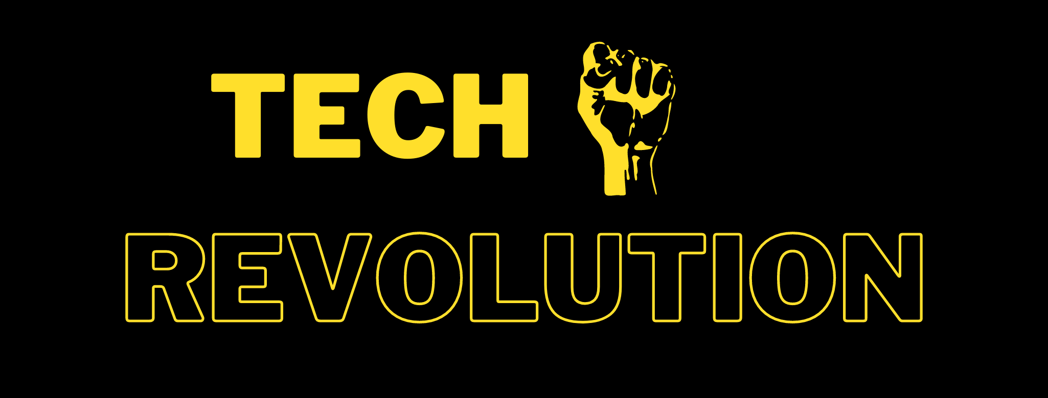
I knew that the creation and sustainment of so many theme pages at once would be a challenging task, taking into account the fact that I lacked experience and had no previous affiliation with the operation of such pages. Hence, I deemed it necessary to start creating my theme pages separately to keep up with the amount of work during the earlier stages of my project and later on increase it at a slow but steady pace. The first theme page that I created was Tech Revolution. For this theme page, I used Facebook as the initial social media platform; however, as mentioned above, all the theme pages that I would create were going to be duplicated in the rest of the social media platforms at a later stage of the project.
Figure 1: Tech Revolution banner

This theme page had a technology-based niche, meaning that all the content I would post had to be related to technological advancements or interesting devices that people would be interested in. These devices could include anything from a simple phone, keyboard, etc.
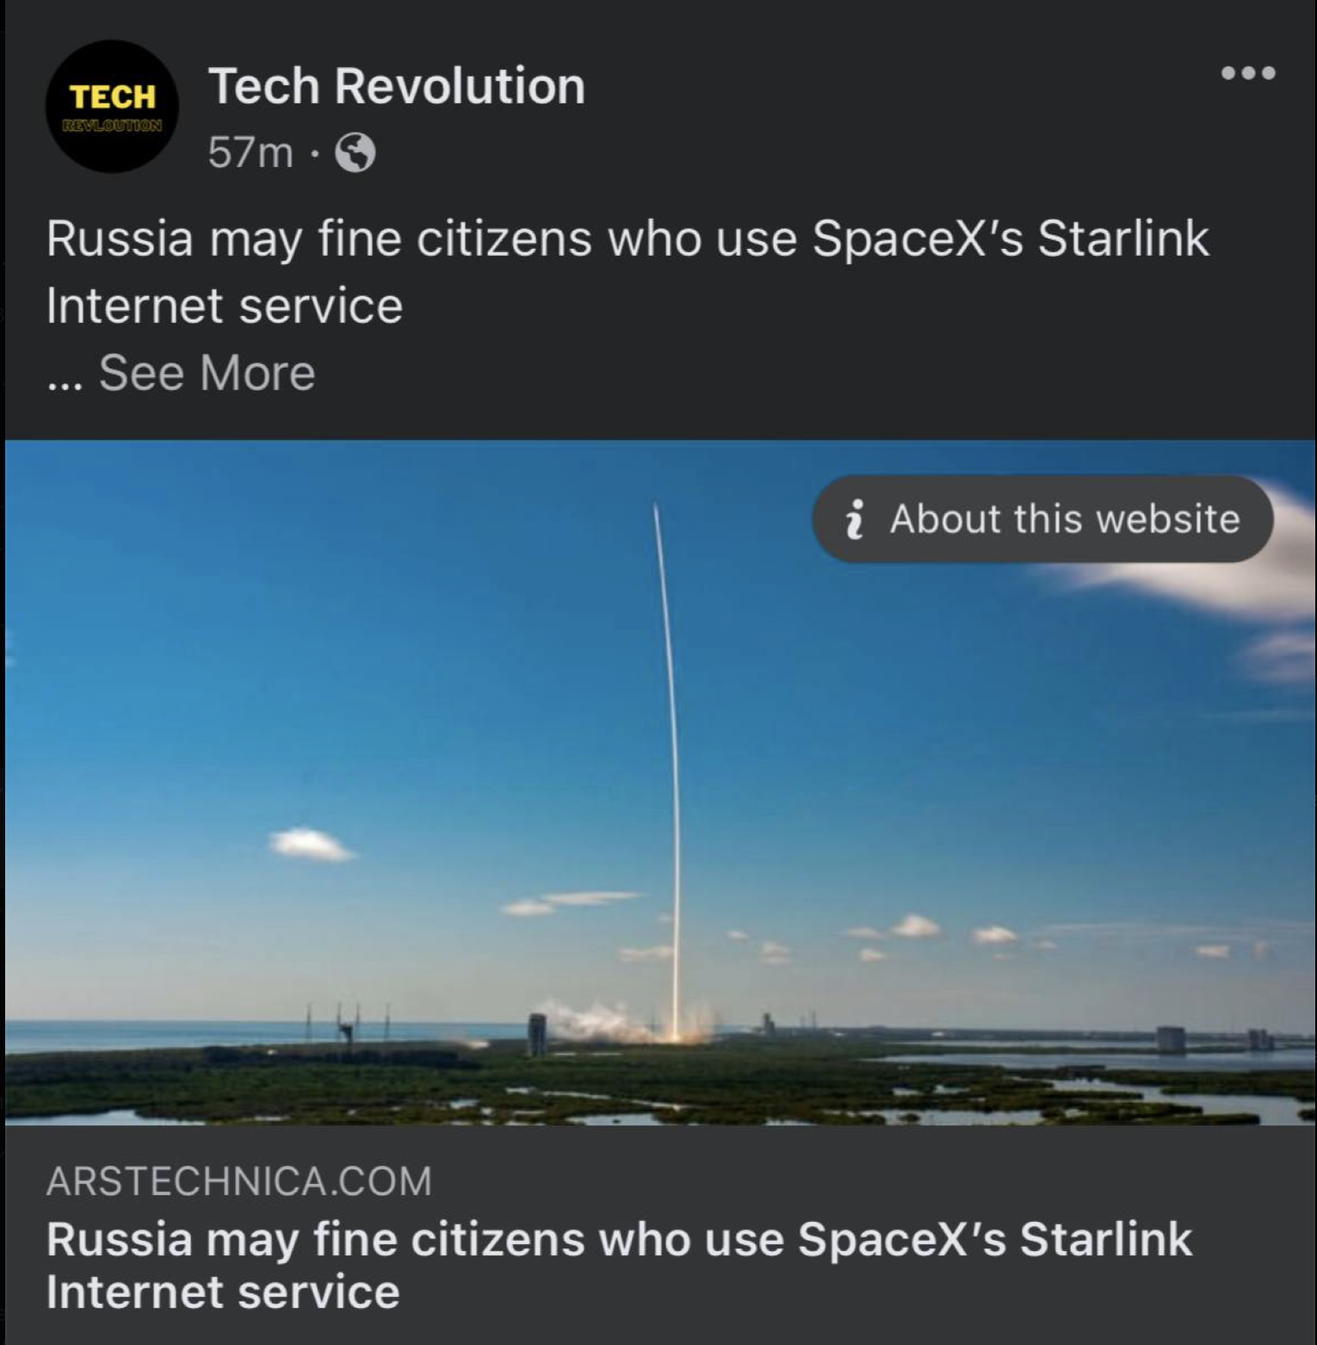
To further simplify the process of content creation, as a basis for the content that I would post, I decided to use the news aggregator model, which would allow me to optimize the process of content creation and grant me more freedom in my endeavors related to the aspect of marketing, which is the primary focus of this project. Thus, for content creation, I was mainly searching for news article related to technology or some updates on subjects (like an update on the AppStore policies).
Figure 2: Tech Revolution post example
After the page's launch, I started posting two posts every day to evaluate the initial organic growth of the page. After a few days of posting, I didn't notice any difference whatsoever; the page wasn't being viewed at all, which was highly expected, as I wasn't even using any hashtags.
The interesting thing happened when I started hashtag researching. I started implementing the findings of such a search optimization of my content. To sum it up, the implementation of hashtags was supposed to allow my posts (independent of my theme page) to appear in the search results of people that are interested in the subject of the content, which would both create an opportunity for engagement, as well as would serve as a link that could organically direct those viewers to my theme page.
Nevertheless, as I started to use hashtags, I didn’t notice any changes whatsoever. No matter what hashtags I used or how many of them I used for each of my posts, my overall content still had 0 views. Hence, at the end of the first week, even though I was constantly working on optimizing my theme page, no organic traffic was coming to it. (At this point of my project, I thought that the absence of any kinds of results was mainly due to my inadequacy; however, as will be seen later on, it is primarily due to the algorithms of Facebook itself)
Even though the results were worse than I expected, they were still pretty much in agreement with my understanding of how Facebook operated. Hence, to gain the initial number of users that would allow me to work with them and contrast a steady flow of organic traffic to my page through their interactions, I decided to launch my first paid advertising campaign. For that purpose, I used Facebook’s own Advertising Center.
For this campaign, I used 25 $ as a cumulative budget and scheduled the ad to spend that amount of money within five days. As expected, a paid advertising campaign indeed showed better results than the initial passive sustainment of the theme page. Every day I would get around 12-14 people, and by the end of the week, I had 68-page likes cumulatively. Perhaps this number might not seem as impressive; however, it perfectly follows the CPC of an average Facebook advertising campaign (0.36 CPPL (Cost Per Page Like)). Even more promising is that my conversion rates (the number of people that decided to like the page after viewing the advertisement) for this advertisement were as high as the average, even if the viewers who encountered the ad and followed it back to my page were greeted with a newly created page with 0 likes and engagement. Hence, given a certain timespan, when I would have a page that would be at least slightly more optimized for conversion (more active and legitimate-looking), the CPC would definitely increase. I am stating this in an assumptive manner because I never got the chance to implement a similar paid advertising campaign through Facebook for this theme page. The reason for this is that due to unforeseen circumstances, Facebook decided to block my theme page together with the profile that was running it.
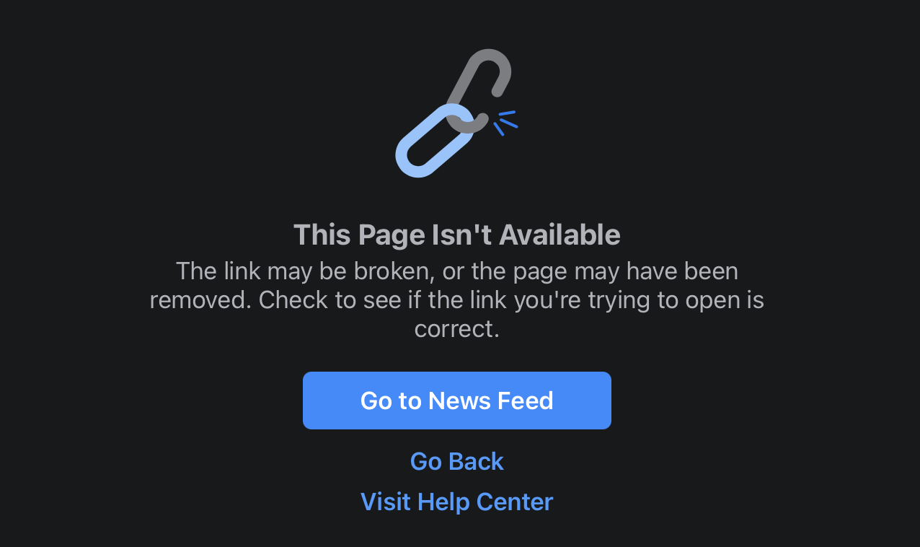
Figure 3: Tech Revolution blocked

Of course, this blocking significantly slowed down the advance of my project; however, it also served as an indicator of the risks affiliated with such an activity. Furthermore, the blocking was not provided with any relevant explanation, meaning that the possibility of being restricted was something that I wouldn’t even be able to avoid in the future, as I created the rest of my theme pages on Facebook. Nevertheless, I assume that one of the causes might have been that for Facebook, I made a new profile that would operate the theme page. Even though I was constantly active on my theme page, the profile, on the other hand, was completely blank. The only alternation that I have made to the emptiness of a default page was that I changed the profile picture. However, as the profile itself was in no way relevant to my research, I didn’t personalize it further, which is probably the most likely cause for this setback.

Facebook #2
Figure 4: Gaming Culture profile picture

As the blocking occurred just around when I was halfway done with my project, I decided to spend the time I was left with creating a new theme page that would now occupy the niche of Gaming instead of Technology. For content creation, I used the exact same strategy that I was using for the first page. I was again acting as a hub for news aggregation, meaning that I was collecting all the relevant and noteworthy news events related to the gaming industry and posting 2 of them per day. With each post, I would make sure to provide the links to the original articles.
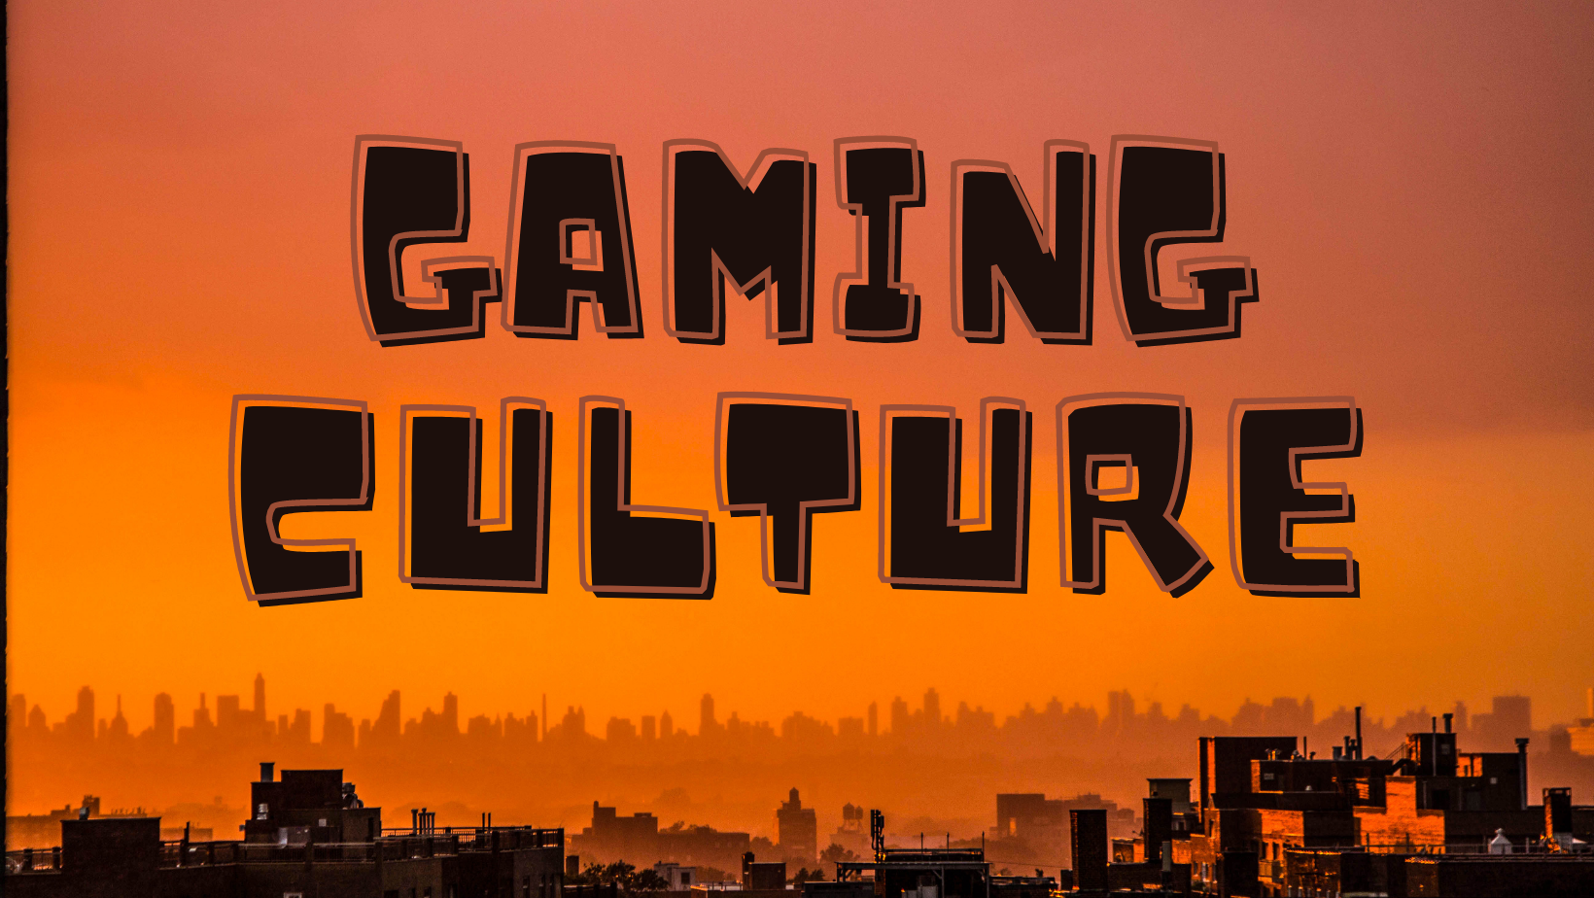
Once again, before I started paid promotional campaigns, Facebook wasn’t delivering any traffic to my page, no matter the combination of hashtags that were used or the time of the day I was posting. Hence, I concluded that this lack of organic growth is something that is fundamentally caused by the algorithms of Facebook, which with such a total absence of organic reach, pressure the user to utilize the paid promotional tools provided by the platform.
Figure 5: Gaming Culture banner

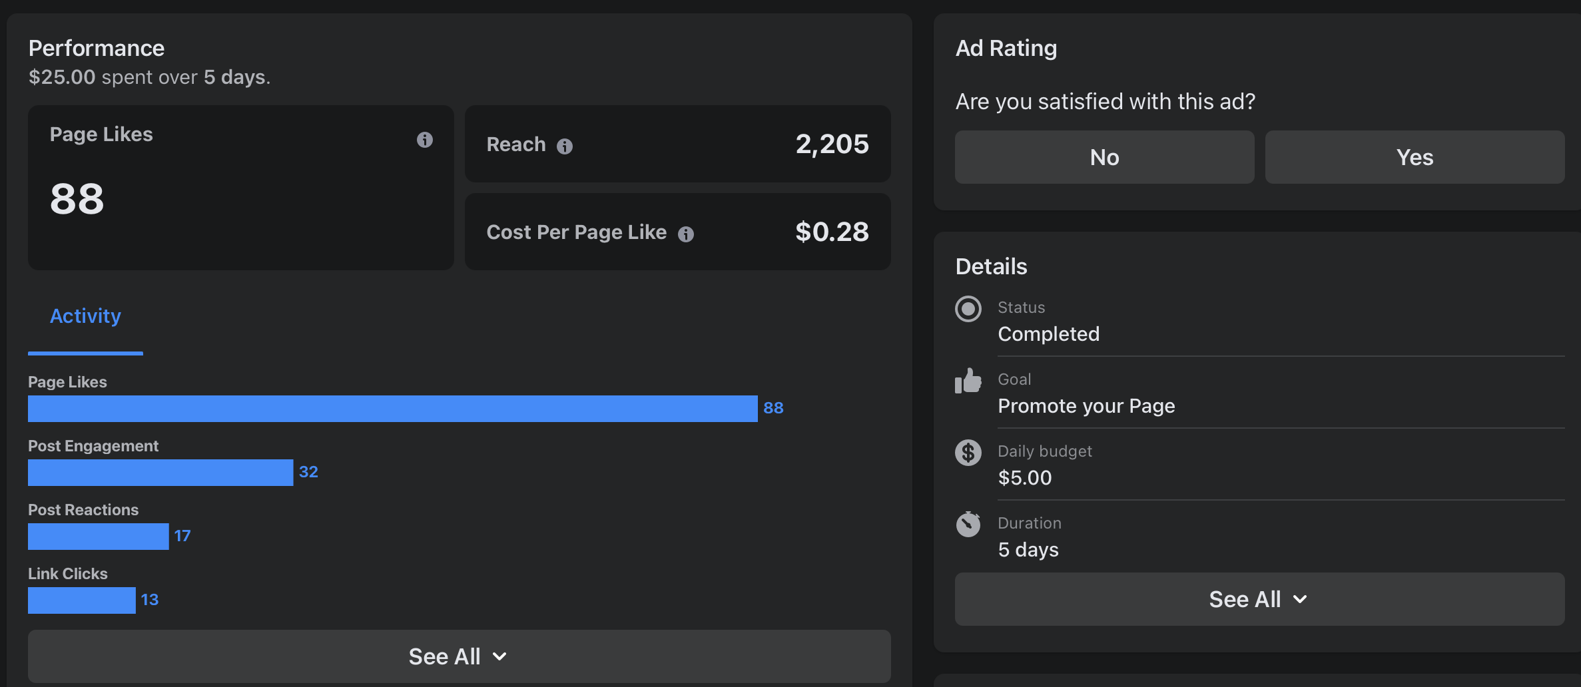
I used the exact same budget; however, this time, I adjusted the audience to one which would better fit the demographics of a gaming niche page. Similar to the first campaign, the results started to show as soon as the campaign became active. Even if this instant generation of results may appear to be a beneficial aspect, nevertheless, augmented by the stability and predictability of the numbers that Facebook provides when calculating the approximate price per click (in my case, like) take complete control over any promotional campaign. It's no longer the quality of the ads that matters, but rather the amount of money you are willing to pay. Of course, this is also the relevance of the conversion rate; however, with a budget that isn't big enough, the effects of such variables can not be accurately calculated or evaluated.
Figure 6: Gaming Culture FB ad

Finally, the last marketing strategy that I was aiming to implement for the Facebook Theme-Page was influencer marketing. As I was researching other pages of similar nature, I noticed a list of significant differences between Facebook and the rest of the social media theme pages. First of all, if we compare Facebook with Twitter, we can see that Facebook is a little bit more active on this front, given the complete absence of this culture amongst the Twitter pages. However, influencer marketing with Facebook isn't as accessible as with Instagram, as growing a big enough audience here, given the great difficulty in the organic acquisition of a large enough audience, is something that takes a lot of time and resources. Hence, there were a set of restrictions, which I, unfortunately, wasn't able to bypass. The first one was that it was significantly harder to contact the page owners in case of Facebook, rather than Twitter or Instagram, given the fact that with the Facebook messenger application, the messages received from the strangers don't appear in the inbox, but rather await in the archives until the user is verified. This process could take from a few days up to a month, assuming that you get verified eventually, which sadly isn't always the case. The second factor was that influencers were more eager to advertise a product (for gaming niche, those were games) than to promote a competitor's theme page. And the last one was the price factor, as most of the theme pages that were significantly smaller than that of the influencers I used for Telegram or Instagram demanded unreasonably high amounts of money for a single post. The cheapest option I was able to find demanded 350 $ for a promotional post of my own theme page, which he would delete after three days of display. Sadly, this option was way out of my budget that I could afford to allocate for this project; hence, I couldn't conduct influencer marketing with Facebook.

Telegram

As already mentioned, the niches that thrived the most on Telegram were either politics-related (which I didn't want to cover due to safety and privacy concerns, as well as the difficulty of content creation) and that of either news channels or entertainment channels. As I have already sustained one of my theme pages like a news aggregating page, I decided to follow the telegram channel's causal flow. As a niche of the theme page, I decided to use a historical niche. The niche would allow me to generate virtually unlimited content with extreme ease due to the amount of data on interesting historical events available on the web. Another beneficial aspect was that most of this content was not accessible for the Russian audiences in an accessible form of a short post; hence it was an obvious choice.
Figure 7: Telegram page profile picture
Once again, with the creation of my telegram page, I started to make two posts every day. As expected, similar to Facebook, Telegram doesn't promote your page, so it doesn't matter what type of content you create if no one sees it. Nevertheless, to prepare my telegram theme page for the only possible way of advertising it (Influencer Marketing), I kept creating two posts per day even when I knew it wouldn't make any difference. The reason behind this is that I didn't want to greet the newcomers (people that would arrive at my page following my username in the ad) with an empty page. Hence no additional actions were taken before the launch of the Influencer Campaign.
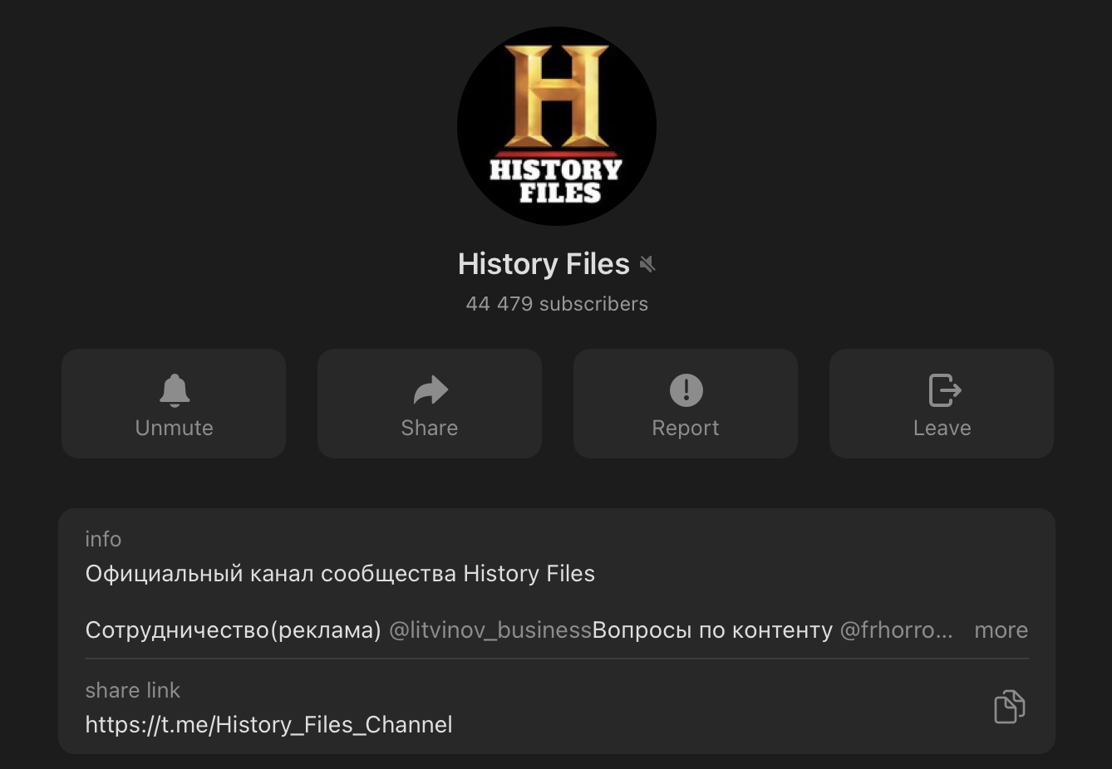
With Telegram, marketing is a little bit different from the rest of the social media platforms that I used for this project. While the rest had numerous ways of interaction, which created other variable aspects, which if optimized could create a theme page with better reach and organic growth, Telegram, being a messaging application rather than a social media platform, lacked this variability. There isn't a way of optimizing your theme page, and the only way one can find it is through a link or through a search with the exact "Username" of the page. The only way currently available for promoting a telegram page is through telegram influencer marketing. The way this system works is that you contact another theme page that is operating on the same or related niche which you are using for your page. You ask them to either share one of your posts on their channel or make a post of a similar nature to the content you share on your channel, at the end of which it will include the username of the main channel. This method is simple; however, it is incredibly effective because it doesn't seem as artificial as influencer marketing with the rest of social media platforms.
Figure 8: Telegram page followers number
Figure 9: History Files page

Figure 10: Telegram Influencer ad post
For Influencer Marketing, I used a theme page named "History Files.”

For an ad, I used an interesting story about Charlie Chaplin, who once participated in a competition of his lookalikes, and triggered the viewers' engagement by directing them to my theme page for learning the results of the competition.

Instagram
Figure 11: Fitting Pick profile picture

As already mentioned, the niche that I decided to cover for the Instagram theme page is Fashion. The name of the theme page is “Fitting Pick.”

With Instagram, I took a little bit of a different approach for content creation. As I am not a person who has a lot of experience creating content for this type of niche (especially with Instagram where content is supposed to be visual, hence requires a lot of real work), I came up with a solution that would both allow me to have a constant flow of content, meanwhile, benefit the original content creators. I ended up using Pinterest, which is another visual platform; however, it doesn’t act as a traditional social media platform. Instead, it operates as a search engine for Digital Articles, blog posts, and items from different e-commerce platforms.
In the end, I ended up using Pinterest for searching for different pieces of clothing and accessories (like bags), after which I would copy the photo and post it on my Instagram page. Under every single post, I was giving credits to the original creators of the content by providing the links to the store pages of the items, which also had the potential to create an additional source of traffic for them. Additionally, those types of store listings don’t have any copyright restrictions (unless you use anything for commercial purposes).

As soon as I started posting on Instagram, I instantly noticed a significant difference in which the platform reacted to my content. In contrast to Facebook, even if Instagram has an in-platform paid advertising tool for promoting one’s content, without the usage of such means, the platform was still allowing me to gain organic traffic, starting from the very first post. Similar to Facebook, the instrument that I used for attracting organic traffic was the usage of hashtags.

In addition, Instagram (also Twitter, however with Twitter it is a little bit of a different story) also presents its users with one additional way of gaining followers; however, this requires more active engagement from the users. Nevertheless, it is considered to be utilizing the organic reach of one's account, and there are no accessible ways of measuring the effects of this strategy. The strategy that I am referring to is called follow for follow, and the way it functions is that you first find an audience that has matching interests with the niche that your theme page is based on. To do so, you only have to find another theme page that operates on a similar niche and access the page's list of followers. When you find your audience, the only thing that you have to do is start following them. Instagram has a very high conversion rate when it comes to this method. On Average, 3 out of 20 people that I followed decided to follow me back. This is also the very reason why most of the smaller theme pages that are only starting to gain traffic have fewer followers than the people they are following. When one is only beginning to promote his/her theme page, this technique is perhaps one of the most efficient ones; however, as your page starts growing, you realize that it's not very optimal at all.
Figure 12: Fitting Pick post example
The most obvious shortcoming of this method is that you have to manually follow each of these potential followers every single day. Doing this doesn't take a lot of time; however, some risks are associated with it. If you try following too many people in one streak, Instagram algorithms may start to question your intentions and can likely restrict your page. Hence, one shouldn't spend too many follow requests in a single day but should instead try sending 20-100 requests per day. When considering the limitations of this technique, it becomes apparent that the only time one could benefit from this practice is only during the starting stages of a theme page, when an initial audience is needed. The final limitation is that there is a maximum number of people you can follow at a given time (10 000), which means that as soon as you reach this point, you are going to need to unfollow the people who are following you, which will also become a reason for some part of your followers to unfollow you back. To minimize the downsides of these limitations, some tools allow you to unfollow all the people who you are following while they don't follow you, which means that you can safely count on this method to get a little bit over 10000 followers (also taking into account the people who decided to continue following you after you unfollowed them)
So far, Instagram has provided me with the most rewarding experience of my goal of growing my theme pages, as far as organic growth goes. Now, it was time to test the paid means of advertisements for this platform. I am using the plural, as even though Instagram has only one official tool for advertising pages, there is also another less official alternative which is once again "Influencer Marketing." Out of all the platforms that I have covered in my project, Instagram is the most renowned one in this sense. In fact, Instagram is the platform that popularized this marketing strategy, as far as social media marketing goes.
First of all, I would like to address the advertising campaign launched through Instagram's in-house advertising tool. I will address the results in a more in-depth manner at the analysis stage of this project; however, it was as efficient as Facebook's ad tool, which isn't that surprising because Facebook owns both of these social media platforms.

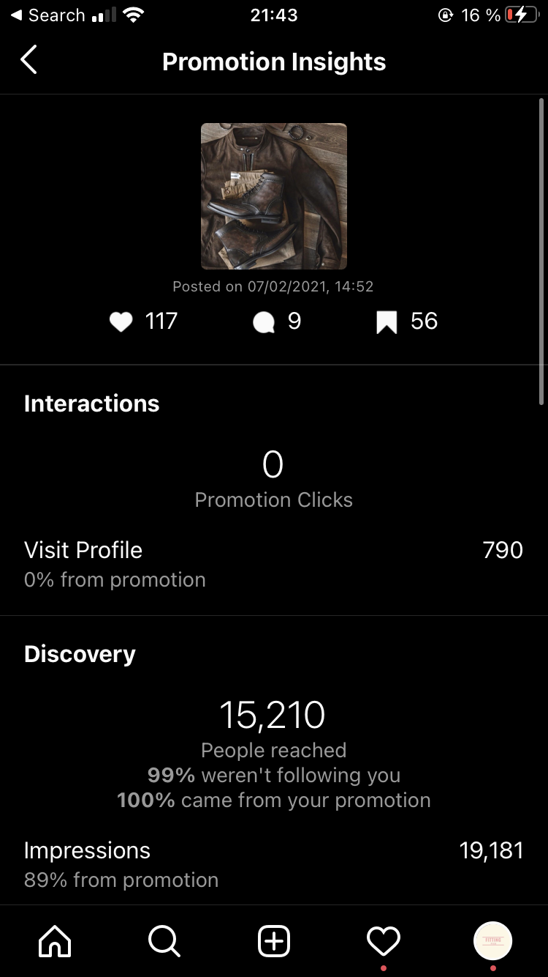
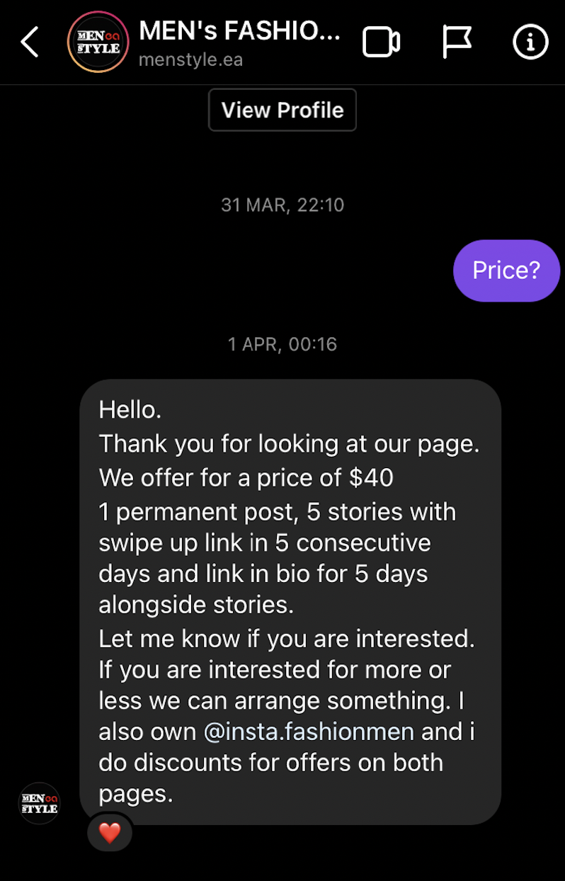
The second means of paid advertisement that I used for Instagram was, as already mentioned, Influencer Marketing. Nevertheless, from my own experience, Instagram didn’t perform as well from Influencer Marketing when you compare it with the rewarding manner in which it behaved during the organic growth optimization stage.
Figure 13: Fitting Pick Instagram ad
Figure 14: Instagram influencer pricing

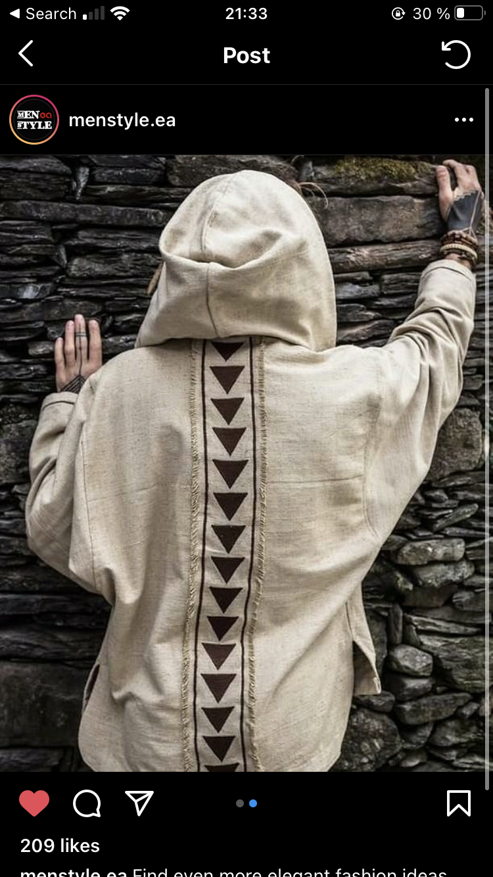
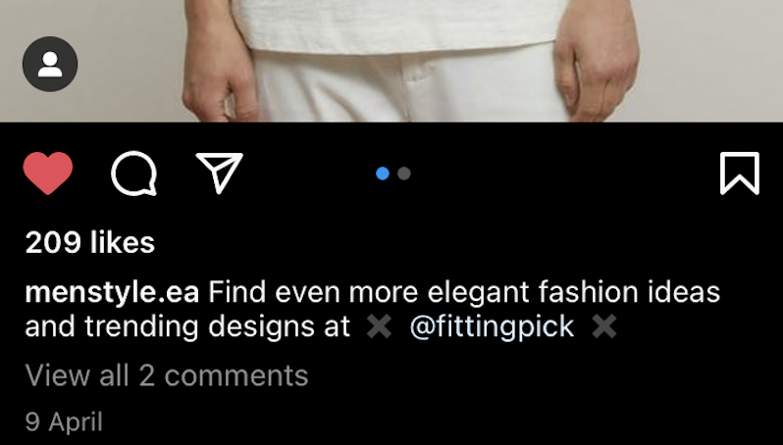
In contrast to Facebook and Twitter, where finding an influencer can often seem like a daunting task due to the absence of such culture throughout the theme pages, Instagram, on the other hand, feels like it was explicitly designed in a way to sustain such an environment. Instagram looks a lot like a marketplace rather than a social media platform. In fact, almost all of the theme pages that operate on the platform will have specifically dedicated contact information in their page descriptions or bios. There is even a way people contact influencers when they desire to get information on the pricing. The particular way people ask for this information is by simply typing “Price?” as the first and only message they send. The reason behind this isn’t that users are too busy to be polite. It’s that Instagram, like any other messaging application, shows a preview of the messages that they get, and the simplicity of the single word question “Price” allows the influencers (usually these aren’t the influencers but instead page managers who are responsible for scheduling promotional posts) to quickly filter which messages should be opened and responded and which are spam.
Figure 15: Instagram influencer marketing post
Figure 16: Instagram influencer marketing - post engagement
In the end, the page that I picked after a brief comparative analysis of the popularity and prices of several pages, I settled with the page “name,” the page manager of which was also responsible for another page of the same niche and proposed a discount in case I was willing to order two promotional posts at once. I agreed, which also allowed me to get more accurate data on the effectiveness of such a marketing strategy.

Twitter

Finally, I created the page for Twitter, “Virtue Living,” that has occupied the niches of healthy lifestyle and motivation. With this theme page, the process of content creation ended up becoming the most difficult one. Moreover, Twitter, more than any other social media platform covered in this project, tends to demand originality of the content and a considerable extent of personalization. This didn’t come to me as a surprise due to the fact that the platform itself is designed in such a way that it only allows the users to interact with each other through their main pages. The high emphasis on textual content also emphasizes the importance of personalized content, or the significance of an established speaker, which in itself already requires that speaker to be one of his/her own ideas and opinions, rather than one that repeats what other people say.
Figure 17: Virtue Living - Banner
Nevertheless, such an extent of originality was something unachievable within the context of this experiment. Hence I settled with a compromising decision of sharing two types of contents at once. The first type of content consisted of me searching for different motivational/inspirational quotes from famous individuals and acting as a hub from which these messages were spread to wider audiences. The second type consisted of me gathering various feature articles on relevant topics such as health or motivation and posting the links to those articles while giving credit to the original creators by directing traffic to them.
Figure 18: Virtue Living - profile picture
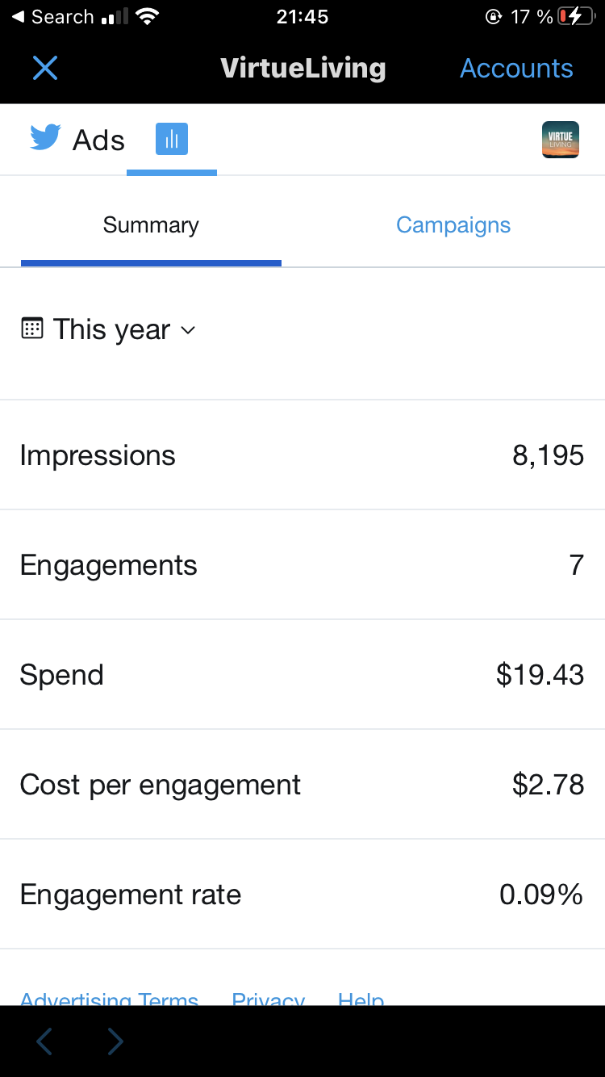
When it comes to marketing strategies, the first thing that I tried, similar to all the other pages, was the implementation of hashtag optimization. Even though Twitter didn't prove to be as effective as Instagram, when it comes to the direction of organic traffic to your theme page; nevertheless, it was still doing its deed, so it won't be fair to compare the effectiveness of this strategy with that of Facebook or Telegram.
Figure 19: Twitter ads
Once again, similar to Instagram, Twitter also allows the implementation of the Follow for Follow strategy, which in this case is a lot more limiting, caused by the extreme restrictions in the number of people you can follow on a daily basis. On average, Twitter wouldn't allow me to follow more than 20 people per day, and some days this number would fall as low as 10. There are no official explanations of how Twitter Algorithms work when choosing the maximum number of allowed follow requests per day; however, these are the results that I got from testing every day within the span of 3.5 months.
For Twitter marketing, I have also implemented the paid advertisement tool present in the platform, which showed the slightest merit. Once again, more in-depth data will be provided in the analysis section; however, I can confidently state that Instagram's in-house advertising tool offers the highest price per single page like out of all the social media platforms covered in this project (except for Telegram, which lacks such a tool).
Finally, I tried to implement the influencer marketing strategy; nevertheless, due to the lack of such culture on the social media platform, it was tough to find an influencer who was willing to make a promotional post and was asking a reasonable amount of money in return. In the end, when I settled with an influencer that seemed to be fitting my needs, something unexpected happened. Well, I say unexpected, but taking into consideration the lack of any regulations of such a marketing strategy, further affected by the lack of such culture on the platform, the fact that the influencer decided to ditch me after I sent the amount of money that we agreed upon isn't as unexpected after all. Even though, at first, I considered this experience as a major setback within the context of this project; nevertheless, I now believe that it also enhanced my experience in a way that allowed me to highlight some of the additional disadvantages affiliated with the practice of Influencer Marketing.

Duplication

As I tried all the above-mentioned marketing strategies with my original theme pages, I was now fully equipped with everything necessary to duplicate my theme pages across all of the social media platforms. However, it’s worth noting that there is one exception to this duplication, the Telegram theme page, as it was the only one that I used to target the Russian-speaking segment of the users, given the extreme popularity of this social media popular amongst those masses.
When starting the duplication, an immediate problem arose. As I managed each theme page across three different social media platforms, it would have been challenging and time-consuming to do this process manually. Hence, for duplication, I used the Hootsuite tool, a platform that allows its users to integrate different social media accounts and simultaneously schedule identical posts across multiple platforms.
The purpose of this stage was solely to find out how different niches performed on each of these social media platforms. Hence, when experimenting for this section, I didn’t utilize any paid means of advertising for this section, as practice from the last sections showed that the in-house paid advertising tools from each of the social media platforms (except for Telegram) are pretty predictable and measurable. I was measuring the organic growth of each of these social media theme pages across all the social media platforms and comparing their growth to that of other theme pages belonging to the same social media platform.
Right of the bat, I would like to talk about Facebook and its none-existent growth. Even if with the original Facebook theme page, I didn’t observe any organic traffic coming to my theme page without any paid means of advertisements, I was also questioning whether the Facebook algorithms caused it, or it was just the fact that I didn’t give it enough time to kick in. Nevertheless, with the duplicated pages, as I have had a time window of around two months (during which I was posting every day, twice a day), not a single soul discovered my theme pages. It’s not just about the initial audience. With Twitter or Instagram, when I was using optimized Hashtags, I could see how the traffic was reaching my page. In turn, I could also perceive and understand the correlative patterns of the amount of organic traffic coming to my Instagram and Twitter theme pages based on the number of Hashtags and, more loosely, the time of the day that I was posting. However, with Facebook, the use of hashtags seems to be completely ineffective, as no matter how bad my content wasn’t, or any other justification or explanation I can come up with; still, it’s hard to believe that throughout the whole time I was working on the project not a single soul checked at least one of my posts.
With Twitter and Instagram, things ended up being a little bit different. Similar to the initial stage, these pages performed a lot better than those from Facebook. Both Instagram and Twitter theme pages have been steadily growing, regardless of the fact whether I was utilizing any paid advertising campaign or not. The pages that I created on Instagram were growing significantly faster than those from Twitter, which was also something that was expected, based on the initial stage. The exciting part of this section is the comparative analysis of the growth rate between the theme pages from the same social media platform.

Research Findings (Initial Observations)

At this section, I would like to briefly address the peculiarities of each of these social media platforms and how they relate to their their designs and purposes. These insights were driven from my experience of interacting with them; however, they don’t include specific numerical data.

Instagram

I want to start this section with the social media platform that will allow me to present my hypothesis in the most accessible way. When we think of "Instagram" and the content that works best with this platform, most of us will surely be able to distinguish the key feature of this social media platform, which is pictures. Instagram, more than any of the social media platforms that I picked for this project, is a visual platform. Of course, all of these platforms that I mentioned above allow the users to share pictures/video; nevertheless, they aren't a defining feature for those platforms, but rather something that is there, and even if it is often used, they serve different purposes. The conclusion that I came up with is that no matter what type of niche you are trying to pursue, as long as it is something convertible into the specific form of content that works best with Instagram, then there is no reason for it not to be successful. An example of this conversion can be of a niche that focuses on text-based content, which is often seen with theme pages that operate through sharing motivational/inspiring quotes. Even if these type of content might seem to be the best fit for Twitter or Telegram (given the fact that both Twitter and Telegram are heavily text-driven), still there exist a lot of big/successful Instagram pages that operate in this niche, and the way they are able to bypass the limitations of the social media platform is through the alternation of the content.

Twitter

The second social media platform which I will like to address is Twitter. As mentioned above, Twitter is a platform that is explicitly forcing the user to work with content that is mainly textual and does not include any visual elements whatsoever. If we look at some of the most popular pages in the social media platform, we can observe that the overwhelming majority are presented in a very personal manner. A foundation for this personalized approach lies in the fact that Twitter isn't a platform designed to fit best for groups, theme pages but rather people. In turn, the fact that Twitter is very textual by its nature is a result of the intent of the platform, which urges its users to share their opinion in a very concise manner (given the rigid limitations put by character limitations for each post). Of course, as already mentioned above, any social media platform can be fit for any given niche; nevertheless, one should always think of the manner in which the content should be presented. More often than not, someone might come to the conclusion that Twitter may not be a fit platform for their needs due to the focus on text-based content, and this conclusion isn't always wrong, as there are a few niches (for example, fashion, cooking etc.) which work best when the content is supplemented with visual elements (photos, videos), nevertheless, this doesn't mean that one can’t adjust the content into the prerequisites of the platform (ex. For cooking it might be a recipe page, etc.)

Facebook

By far, Facebook is the most versatile platform out of all of the ones present in this project. Additionally, Facebook is one of the two platforms that allows its users to create one or multiple pages or groups, hence giving the users the chance of managing several pages at the same time, meanwhile preserving the originality of their personal page, that in case if they don't find necessary, will in no way be stated to be connected with one's theme pages or groups. In turn, the defining feature that might come to mind when viewing Facebook as a social media platform in contrast with the rest is the sense of community. Facebook is the most popular social media platform in the European and American market, and the way it is able to sustain its popularity is through constant modification of its platform and provision of numerous tools that allow content creators to adjust their pages, group in the most optimal manner for their niche, as well as the format of their content.

Telegram

The final social media platform that is going to be used for this project is Telegram. Telegram, in contrast to the rest, isn't as popular in the European and U.S. market; nevertheless, it is gradually gaining popularity. On top of that, if we look a little further from the U.S. and Europe, Telegram appears to be one of the go-to social media platforms for countries like Russia. Of course, this popularity also has a lot to do with the founder of the social media platform being from Russia. When it comes to the theme pages and the kind of content that is often spread through Telegram, it shares most of the strong points of the other three social media platforms. Similar to Facebook, Telegram allows its users to create groups and channels that act separately from their main/personal pages. On top of that, Telegram allows its users to use a number of bots that can be manually coded and adjusted to perform virtually any task that comes to mind. Because of the accessibility and absence of restrictions, even if the core functionality of the channels is minimal, there are many popular Telegram pages/channels that are able to reshape the platform in a way that fits their needs better than any other platform can. Another aspect of Telegram is that it is a social media platform that presents itself as the most secure one, which also promotes a kind of a safe environment for its users. This safety allows the users/content creators to freely express their thoughts and opinions while staying confident that neither their identity will be revealed nor the content that they share is going to be censored.

Data (Rough)

Facebook:
Tech Revolution:
Status: Blocked
Paid Ad:
Budget - 25$
Overall 68 page likes
Cost per Page Like - 0.36$

Gaming Culture: (Created Feb 24, 2021)
Status: 92 followers (4 organic likes, 88 paid)
Paid Ad:
Budget - 25$
Overall 88 page likes
Impressions: 2205
Cost per Page like - 0.28$
Fitting Pick: No Traffic (Created 18. 03. 21)
Virtue Living: No Traffic (Created 18. 03. 21)

Twitter:
Virtue Living: (Jan 16)
Status: 367 followers (360 organic, 7 paid)
Paid Ad:
Budget: 20$
Impressions: 8195
Engagements: 7
Cost per Engagement: 2.78$

Fitting Pick: (Created 18. 03. 21)
Status: 17 followers (All Organic)

Gaming Culture: (Created 18. 03. 21)
Status: 50 followers (All Organic)

Instagram:
Fitting Pick: ( Created Jan 26, 2021)
Status: 876 Followers (791 organic, 45 paid ads, 40 Inf. M)
Influencer Marketing:
Budget 70$
Followers 40 (19 from first, 21 from the second)
Paid Ad:
Budget: 13$
Impressions: 19, 181
Followers: 45

Virtue Living: (Created March 29, 2021)
Status: 117 Followers (Organic)

Gaming Culture: (Created March 29, 2021)
Status: 692 Followers (Organic)

Telegram:

Факты Истории (History Facts)
Status: 1136 Followers (all paid, no organic growth)
Influencer Marketing:
Budget: 13$
2295 Followers (1159 gradually unsubscribed)
Research Findings (Analysis)

Gaming Culture, Fitting Pick, Virtue Living - Cost per follow and cost per impression comparison:
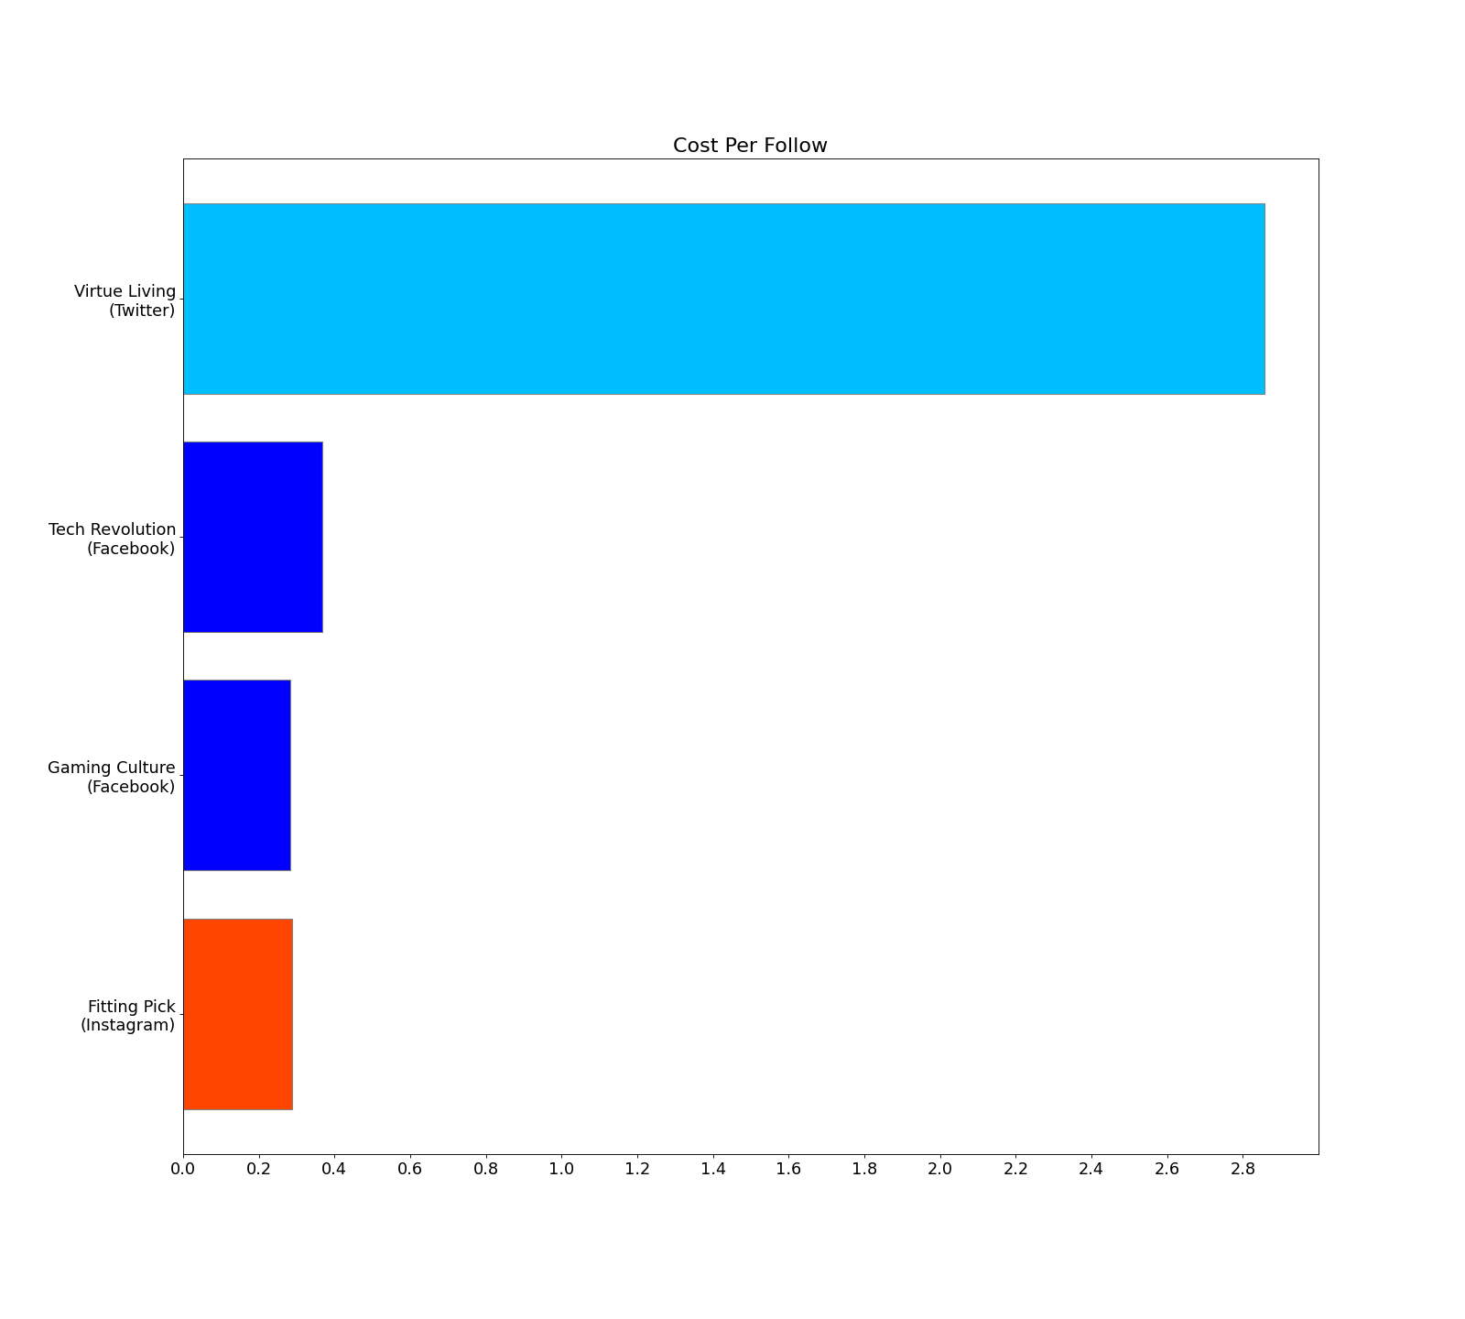

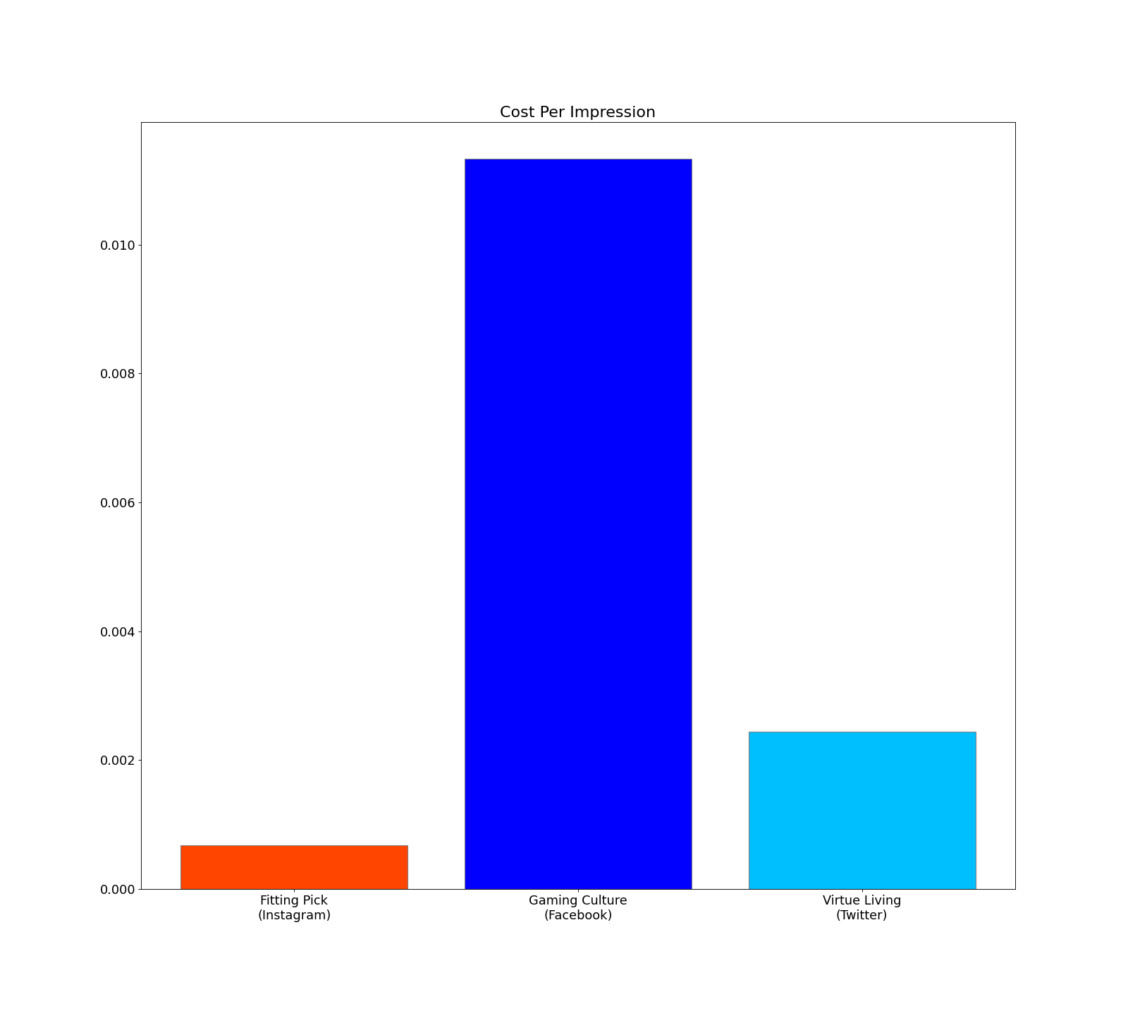

The first piece of data we have analyzed is the cost per impression/likes from the in-house advertising tools provided by Instagram, Telegram, and Twitter. The analysis of this data suggests that for paid advertising, Instagram proves to be the most rewarding platform in this aspect. We can see that Instagram has the cheapest cost per impression out of all the three; however, the cost per follow is almost the same for Instagram and Facebook. Twitter, on the other hand, proves to be the most expensive social media platform out of the three, as far as in-house advertising tools go.
Comparison of the organic growth of the same theme pages across different social media platforms:
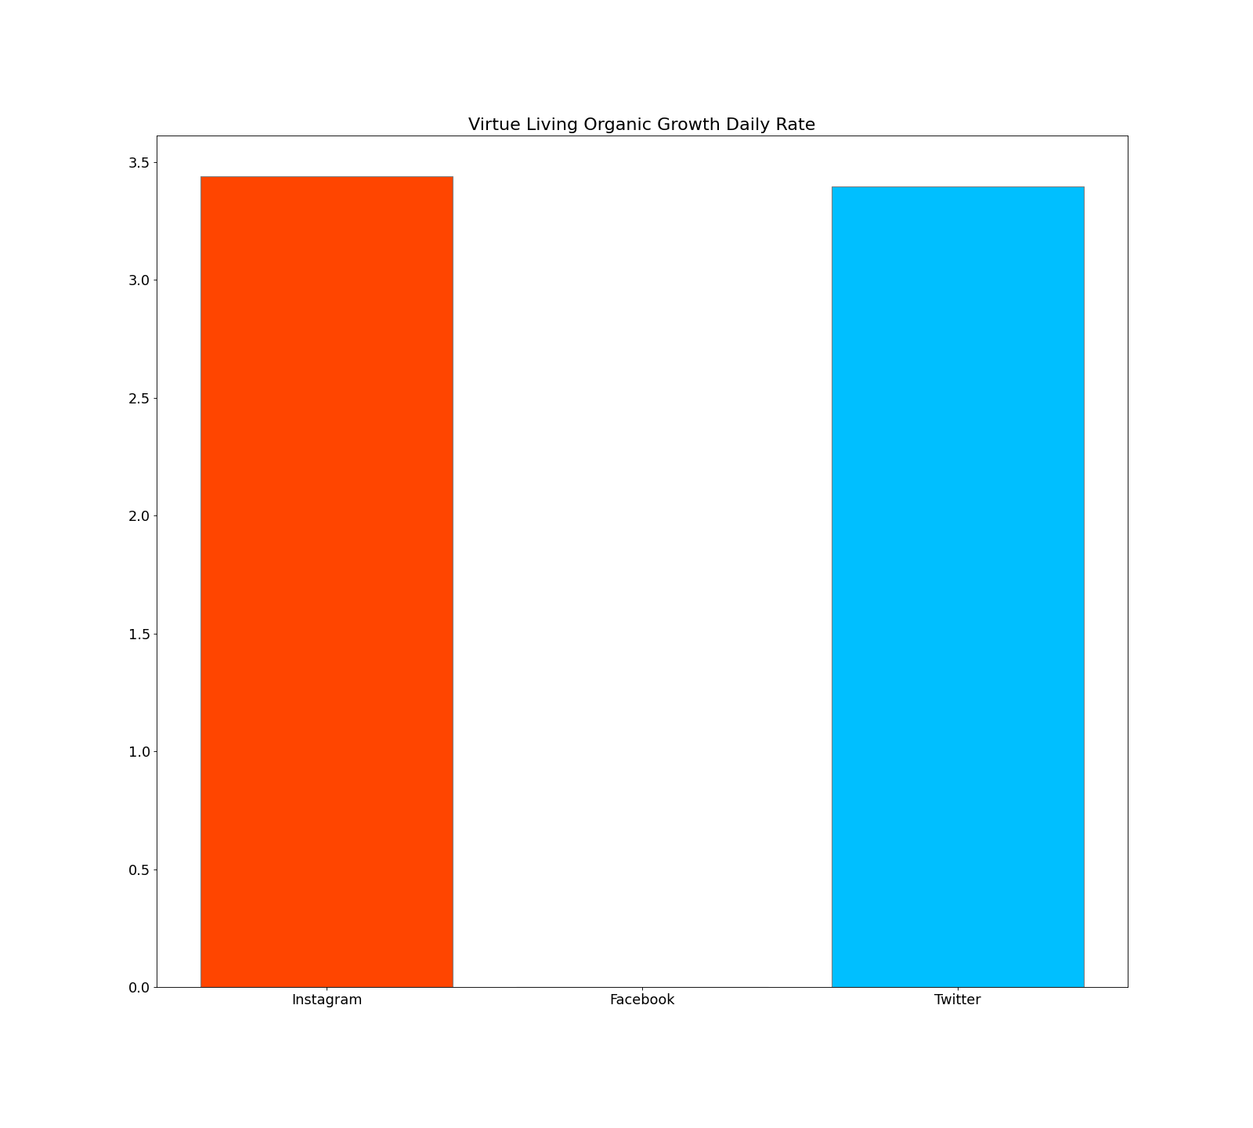

- Virtue Living

We can see that for Virtue Living theme page, which was based on the motivation and health niche, that wasn’t as easy to convert into Instagram from the content creation position, have basically the same rate of organic growth.
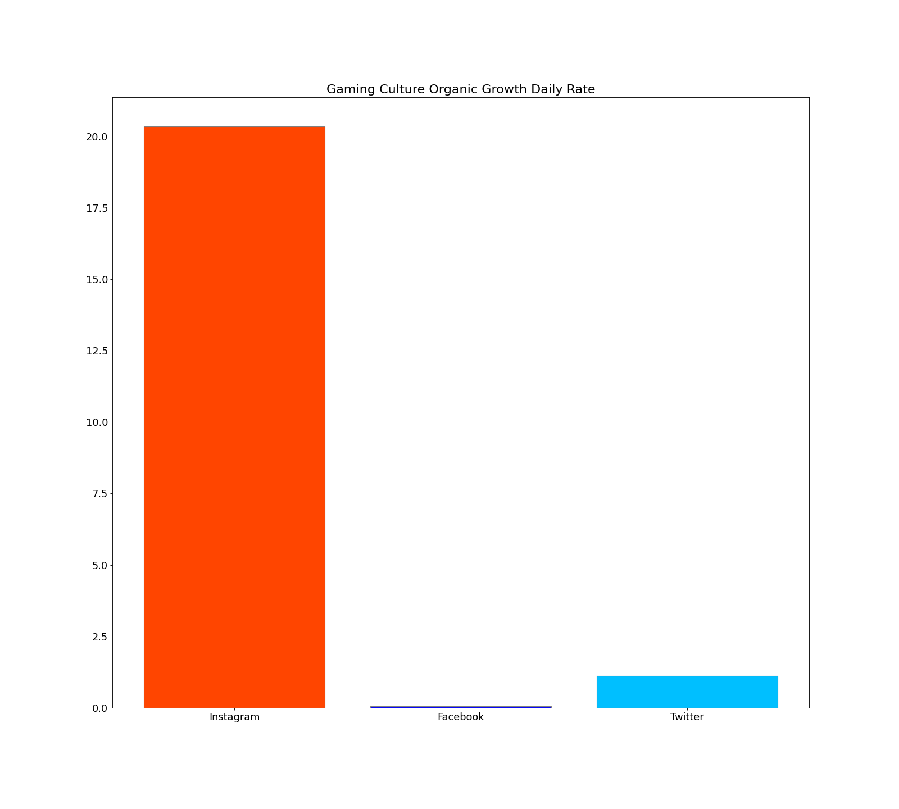
- Gaming Culture

Gaming Culture had a niche that was more easily convertible into the prerequisite conditions of Instagram, again, from the standpoint of content creation. Hence, it’s not surprising that the Instagram page drastically outperforms Twitter. As for the Facebook page, I have already concluded that Facebook algorithms don’t drive organic traffic to you; thus no activity was observed.

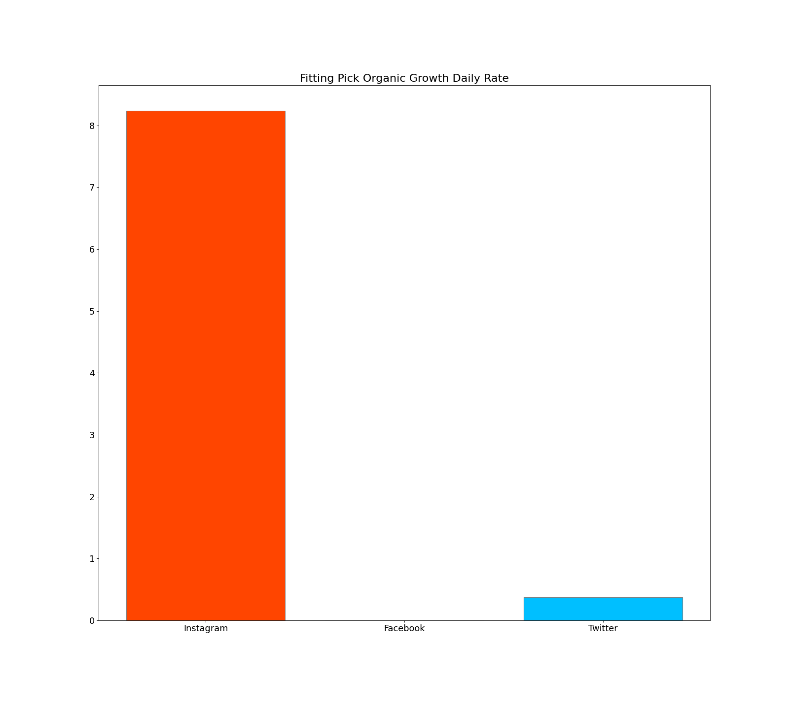
- Fitting Pick

The same goes for Fitting Pick. The results from this comparison match perfectly with each other, of course, with the exception of Virtue Living, for the above-mentioned reasons. This doesn't mean, though, that Instagram couldn't sustain another theme page in the motivation niche, as there are numerous theme pages that successfully do this; however, the content that they create (videos of cooking and working out) would have been tough to duplicate within the context of this experiment.

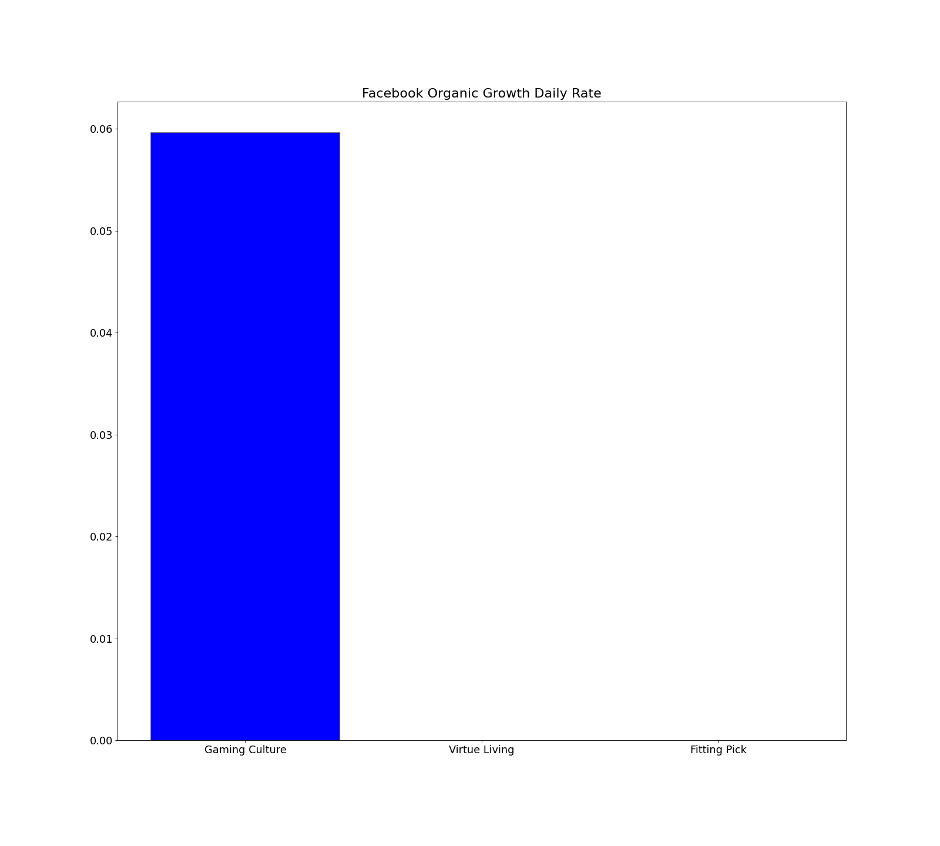
Comparison of the organic growth of all the theme pages from the same social media platform:

- Facebook

For Facebook, this aspect of growth lacks completely for pages that were not promoted using any monetary means. And even for the Gaming Culture page, which has been promoting, it’s so low that one shouldn’t count on it as a growth factor.
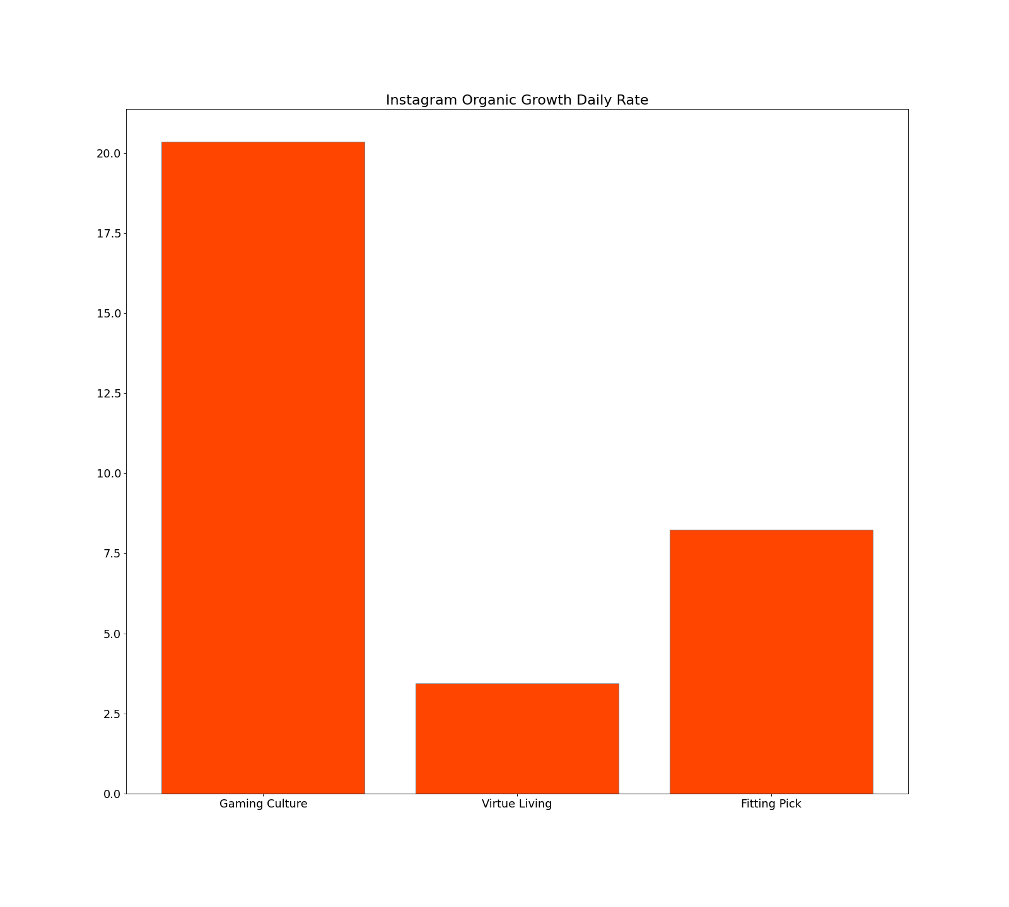
- Instagram

Instagram, on the other hand, shows more variable data, which finally allows us to draw some conclusions related to the differences that various niches bring to the table. However, these insights are only accurately representative of Instagram, only when observing pages that base their content creation process on similar logic to mine.
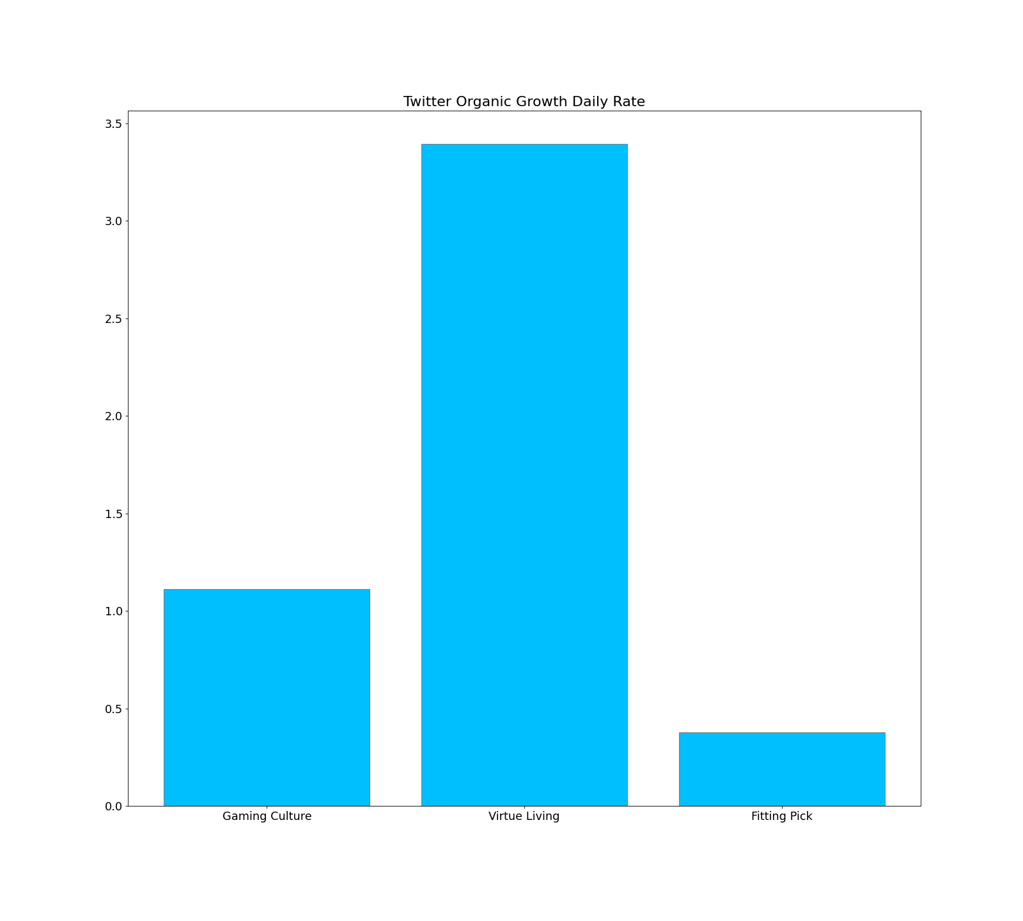
- Twitter

Another observation that was directly correlated with my observation was the fact that the theme page, which was the most visual one out of the three "Fitting Pick," received the least amount of followers (organic), hence, further strengthening the conclusion that Twitter doesn't work as well with Visual content as with a text-based one.
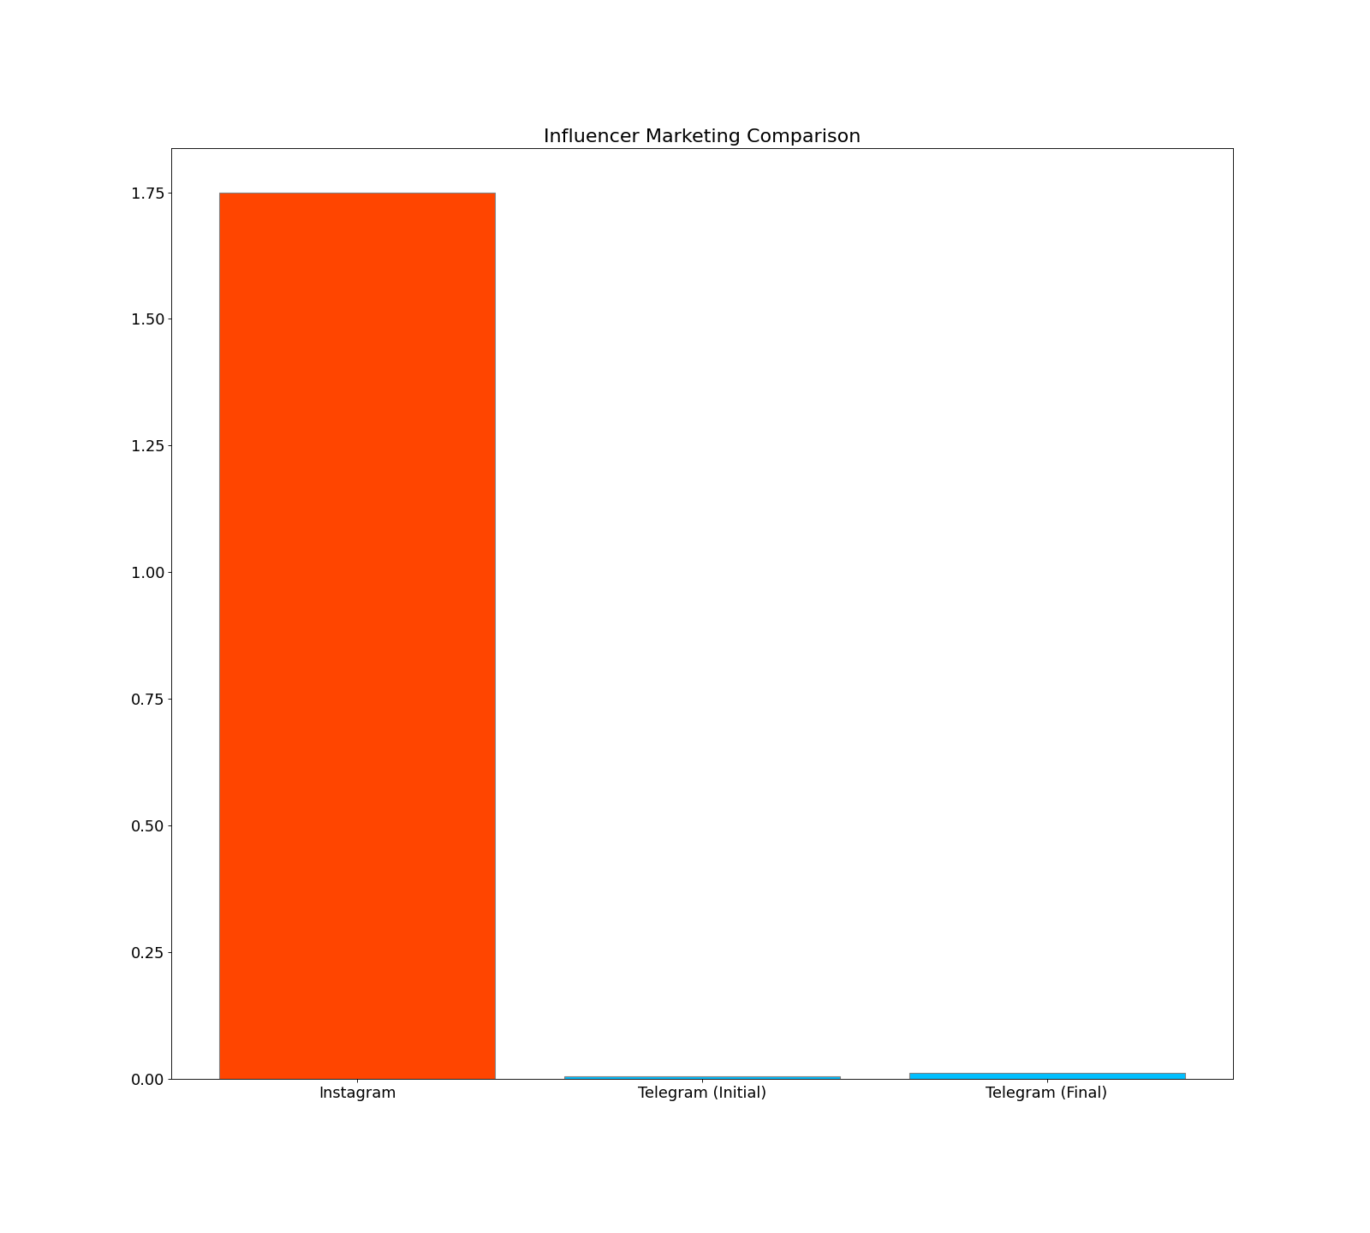
Comparison of Influencer Marketing (Telegram-Instagram):

Another fascinating insight from the experiment derives from the comparison of Influencer Marketing for Instagram and Telegram. As we can see, for Telegram, this promotional strategy was immensely more efficient compared to Instagram. I believe that there are two explanations for this result. The first one is that for Instagram, I was promoting a theme page rather than a product. The second, and the more impactful factor, is that Influencer Marketing is the only means for advertising Telegram channels, which is done in a very subtle and organic manner, hence, higher conversion rates.
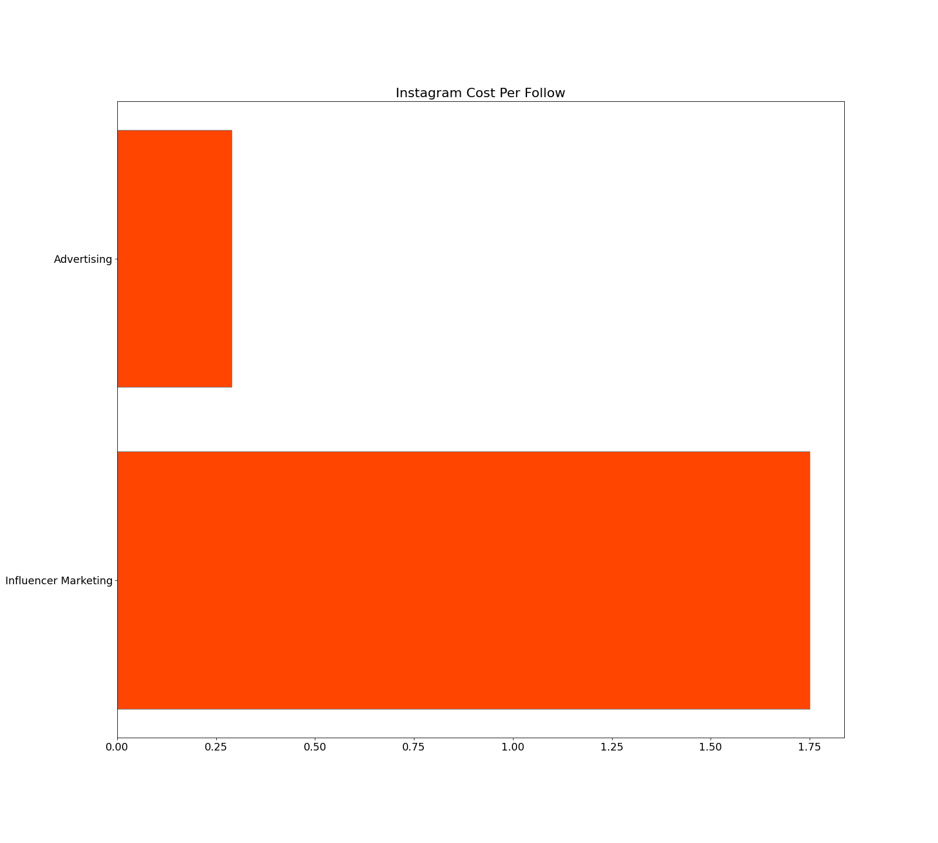
Comparison of Instagram Marketing (Influencer Marketing vs Paid Advertising):

From my experience, it looks like the effectiveness of Influencer Marketing might be a little bit exaggerated, at least when we talk about Instagram. Of course, Influencer Marketing isn't renowned for its uses affiliated with theme page marketing, but instead for product promotion, which might be one reason why it provided me with so little benefit for the amount of money I spent.

Limitations and Avenues for Future Research

Even though the project has successfully shed light on some of the critical differences that each of these social media platforms inhabits, it definitely could have been improved on various aspects, each of which I will address in this section.

Insufficient Initial Research and Lack of Experience

The most important limitation was that I didn’t possess enough background information regarding the amount of work it takes to sustain just one social media platform. Hence, the project was a little bit too ambitious for just one person. Additionally, this lack of experience also didn’t allow me to form realistic expectations, which, in turn, prevented me from following my peregrinated schedule.

Tiny budget, hence fewer opportunities to test different strategies

Due to the limited budget I wasn’t able to test all the promotional strategies that I initially planned. An example of this is that even though I found a Facebook influencer to advertise my page, I couldn’t afford it.

Lack of workforce when it comes to content creation.

Even though I mentioned that the project was too ambiguous for just a single person, still, the number of social media pages and platforms was an unavoidable requirement, given the nature of the project. The analytical comparison would not be possible with just one or two pages; hence, a small team of content creators would be a much-needed help for future projects.

Less accurate insights due to the lack of data (Time Limitation)

Due to the relatively short time frame, not enough time has passed to calculate the effects of long-term sustainment and the dynamics of the natural growth and organic audience acquisition. More accurate data can be gathered if conducted a similar experiment for a longer duration of time; however, given the scale of the conducted project, the results are more than satisfactory.

Bibliography

Relph, M. (2020, June 30). How to Find Your Social Media Niche. Retrieved October 31, 2020, Retrieved from https://buffer.com/library/choosing-a-social-media-niche/
Robertson, M. (2018). Instagram marketing: How to grow your Instagram page and gain millions of followers quickly with step-by-step social media marketing strategies. Retrieved fromhttps://books.google.am/books?hl=en&lr=&id=yA9bDwAAQBAJ&oi=fnd&pg=PP4&dq=how+to+grow+instagram+page&ots=i9S75-T6eT&sig=aRSZ0raEqE5INYYkFKG6l22UYrU&redir_esc=y#v=onepage&q=how%20to%20grow%20instagram%20page&f=false
Rosenthal, B., & Brito, E. P. (2017). How virtual brand community traces may increase fan engagement in brand pages. Business Horizons, Retrieved from https://www.sciencedirect.com/science/article/pii/S0007681317300095
Rabo, O. (2020, August 19). Follow for follow on Instagram: Is it worth it? Retrieved May 03, 2021, from https://blog.iconosquare.com/follow-for-follow-on-instagram/
Sailer, B. (2020, December 31). How to use hashtags the right way on every social network. Retrieved May 03, 2021, from https://coschedule.com/blog/how-to-use-hashtags

Scolere, L., Pruchniewska, U., & Duffy, B. E. (2018). Constructing the Platform-Specific Self-Brand: The Labor of Social Media Promotion. Social Media + Society, 4(3), Retrieved from https://journals.sagepub.com/doi/pdf/10.1177/2056305118784768
S. Venus Jin, Aziz Muqaddam, Ehri Ryu, (2019) "Instafamous and social media influencer marketing", Marketing Intelligence & Planning, Vol. 37 No. 5, pp. 567-579. Retrieved from https://doi.org/10.1108/MIP-09-2018-0375
Veirman, M. D., Cauberghe, V., & Hudders, L. (2017). Marketing through Instagram influencers: The impact of number of followers and product divergence on brand attitude. International Journal of Advertising, 36(5), 798-828. Retrieved from https://www.tandfonline.com/doi/abs/10.1080/02650487.2017.1348035

