ARMENIAN NEWS OUTLETS ON FACEBOOK

by

Anushik Davtyan

Presented to the
Department of English & Communications
In Partial Fulfillment of the
Requirements for the Degree of Bachelor of Arts

American University of Armenia
Yerevan, Armenia

May 17, 2021
Table of Contents:
Acknowledgments ---------------------------------------------------------------------------------
Introduction ----------------------------------------------------------------------------------------
Literature Review ---------------------------------------------------------------------------------
The central questions the paper asks -----------------------------------------------------------
The key hypothesis for the first question ------------------------------------------------------
The key findings for the first research question ----------------------------------------------
Answers to the research question number two -----------------------------------------------
Conclusion ----------------------------------------------------------------------------------------
Limitations and Avenues for Future Research ----------------------------------------------
References ---------------------------------------------------------------------------------------

Armenian News Outlets on Facebook

Acknowledgements

For this paper I am grateful to Dr. Mica Hilson, my family, and the Civil Contract political party.
Writing a scholarly paper is a difficult job. This paper would be impossible to write without the valuable feedback Dr. Hilson continuously gave to me. I remember D. Hilson gave the best feedback ever when I was a freshman at the American University of Armenia. When you start writing your first big scholarly article, you are usually confused with lots of information and need help to be able to move forward. Dr. Hilton is who helped me a lot. I am so thankful.
Writing a long paper is very stressful, especially for me, as I am working in the Information Technology field, where we are used to writing as concise and short as possible. Here I have to expand what I am writing about to make it understandable for large audiences and provide every detail imaginable. So, my family helped me to overcome the log paper fear and write it.
I am also thankful to the Civil Contract political party based in the Republic of Armenia, which hired me years ago as a media team member. I was doing media monitoring, specifically sentiment analysis. I guess that my love towards media monitoring and content analysis came from this job.
1
Introduction

There is a famous cliché that says “Journalism is the first rough draft of history”. Journalism is very essential for societies and has a significant influence on what people think about and how they feel about them. Journalism’s main aims include but are not limited to the following:
- Inform people about what is going on in the country the specific news outlet operates and about the significant events happening globally.
- Do research, analyze, and present helpful information for people who do not have time to do that research every day.
- Keep an eye on public affairs and share important news.

But is informing the only thing that journalists should be responsible for? What if there is only negative news in a country for some reason? It is not socially responsible to share only the negativity. Journalists should think about how their articles affect human psychology, specifically mental health. Even people are empathetic and know that they can impact the other person and try not to harm people’s emotions. News outlets have more power, as people see news articles more than their friends’ posts on social media.

Let’s forget the example of a country in which there is a lot of negative news daily. Every society needs “care” from journalists. There should also be psychological articles in news outlets' news feeds because psychology is also critical. There can be interviews with not only politicians
2
but also successful business people, as well, to motivate people, to show how many opportunities are there and what people can achieve. This is just only an example of (let’s call it) a socially responsible article.

I do not think that Armenians live in a dangerous and horrible country where there is so much bad news, scandals, political ups and downs, gossip, and so little good news. If I were an editor, I would surely see many positive things going on and write about them: successful Armenian IT projects, investments, and interviews with successful business people, charity done by small and big businesses, psychological topics, and so and so forth.
It is a long time that I have been watching what Armenian news outlets do share on their Facebook pages. They share news/articles, of course. But the question is: What kind of articles do they share? Are they predominantly just random news, such as politics, scandals, press releases, etc. ? I have noticed that they concentrate too much on the negative, which became the reason I decided to do research and find that out.

Literature Review

To give the big picture of the literature I have reviewed, I can say that most of the scholarly articles I have looked at agree that news media makes people stressed and contributes to anxiety development. This is a critical supporting detail for my research, the cornerstone on
3
which I build my research. I am concerned about people's mental health. Many people spend hours on social media, especially on Facebook in the case of Armenia, by scrolling down their News Feed all day long. This fact is already alarming, but what is more, they read negative news articles, which makes them stressed for sure. Imagine, people may have personal problems, issues connected to their workplace or studies, or the country may be in an unstable political situation or even at war. This is not enough; people face negativity on social media. We should prevent this. For example, the war between Armenia and Azerbaijan of 2020 was very stressful for Armenians. I did not see any article from news outlets talking about coping with stress during the war. Instead, I saw political scandals, fake news about the authorities, lots of negativity. We should not bear this. We should make editors and journalists understand their power, their power to make people feel good; I do not want them to lie and write, for example, that everything is going well in the country. I think they would rather show the actual situation but also post articles that will help people psychologically.
As McNaughton-cassill (2001) states, media coverage of disturbing news by television, radio, and print media can be a greater source of stress than we expect. This paper is about news shared on social media, but I assume the above statement can be true in this case, as well.

Hobfoll, Bridges, Lomranz, Eyal, & Tzemach (1989, as cited in McNaughton-cassill 2001) bring an essential example in accordance with which there was a significant relationship between the adverse events that happened during the 1982 Israel-Lebanon War as shown by the media and the rates of depression among a large part of Israel's population. This is vital
4
information that journalists working in a country where wars happen frequently, or there is a chance of war have to know. I see the gap of this knowledge and responsibility in most news outlets. After the Second Artsakh War, people were very depressed, but the news outlets continuously shared negativity by making people more and more sad and depressed. The only way to be saved psychologically is to log out from Facebook, but that is not very easy after nearly the two months of the war, during which everyone was on Facebook 24 hours a day.

Usually, people think that negativity catches attention, but that is not the case. Mcintyre (2015, as cited in Mcintyre, K., and Gyldensted, C. 2018) says that positive emotions, such as hope, engage people who want to continue reading and see the outcome. The author also thinks that experiencing hope makes people optimistic and goal motivated. This shows how much positive impact journalists can have on their readers. Trying to write positive news does not mean that they will lose the attention of their readers. We can assume that most journalists and editors of the Armenian media lack the knowledge to attract people without damaging their mental health.

Another opinion is that negativity attracts more than positivity, and that is not only in case of news articles. According to Abele (1985, as cited in Soroka and McAdams, 2015), people devote more time and energy to thinking about negative things than positive things.

News outlets should try to decrease the amount of negativity. But this is not enough. To help the society more, they can share educational articles. For example, educative articles about
5
suicide prevention, including personal experience, proved to be effective in suicide prevention (Till, Tran & Niederkrotenthaler, 2020).

It turns out that people skip over news articles about politics faster than articles about other issues (Vergara, Siles, Castro, Chaves, 2020). This gives some hope that people may not be affected by the negativity they read about politics. But actually, there is a lack of information about whether in Armenia this is the case. I guess it is vice versa in Armenia, specifically after the Velvet Revolution happened in 2018, after which people became very politicized.

Methodology

As a methodology, I chose option one: scholarly research, specifically content analysis.
First of all, earlier, I have decided to randomly select sequential days during which no abrupt change happened in socio-political life in Armenia to do research. But, unfortunately, for several weeks, I could not find a week during which no abrupt change or political ups and downs happened. The half of the days I analyzed included a political non-stable situation, as in the middle of the week տhe Chief of the General Staff of the Armed Forces of the Republic of Armenia, Onik Gasparyan, demanded the resignation of the Prime Minister. Then the Prime Minister's rally started.
Then, I had to decide whether I want to look at the articles posted on the news outlets'
6
website, physically published newspapers, or the posts of articles on social media. Physically printed newspapers were not the best choice, as not all or at least most of the people read them nowadays in Armenia. Websites were not a good option, as news articles are usually categories, and not all of them have a general news section. I chose social media, as I noticed that the news outlets typically do not share every single news article on social media, but they post only some of them. I can guess that they choose the ones that they want people to see. News outlets are usually in different social media platforms but because all of them had a Facebook page, I decided to choose Facebook.

Surprisingly, news outlets shared more than forty articles a day, such as Azatutyun Radiokayan, which made it impossible to research every single article. So, I randomly had to choose five pieces only from each news outlet. As an optimal option, I did in-depth content research of seven news outlets for five days. To sum up, overall, I did deep research of one hundred seventy articles or video posts from seven news outlets.

Third, I decided to do the analysis specifically for Azatutyun Radiokayan, Mamul.am, Lurer.com, FactorTV, Pan.am, Hraparak, Armtimes (the names of the news outlets are written in a way they are written as a Facebook page name). Why did I specifically choose these news outlets? First, I could not analyze all the news outlets, as they are more than one hundred. This is the reason why I tried to use a small but optimal number of news outlets. I had to analyze both pro and anti-governmental news outlets, neutral ones, and just some of those that have many followers on Facebook.
7
Azatutyun has 1.1 million followers, making it very important to analyze, as many people follow it. Hence, they read the news, and their mood is undoubtedly affected by what Azatutyun
Radiokayan shares. Hraparak is famous for its anti-governmental position. Armtimes is renowned for its pro-governmental approach, so I had to analyze them to show the accurate picture of the media. Pan.am is famous for being neutral. Lurer.com is a state-owned news outlet: it was interesting to see what they share. And finally, Mamul.am and Factor TV have quite a lot of followers, so they should be on the list.

It is also essential to separately highlight who are or who seem to be the owners of the above-mentioned news outlets. From Azatutyun Radiokayan's website, we see that the United States Global Broadcasting Corporation funds radio Liberty (Azatutyun Radiokayan) as a private grant. Mamul.am's owner is unknown. Lurer.com, as mentioned above, is legally owned by the Government. FactorTV's does not have an owner but has an editor-in-chief. In their website it was not mentioned who that person was, but previously she was Arevik Sahakyan. She seemed to be impartial and did not position FactorTV on any political spectrum. So, we can assume that FactorTV is impartial. Pan.am's CEO is Armen Azaryan, who seems to be a non-politicized person. Hraparak is owned by Armine Ohanyan, who is the Mother-in-law of the current Deputy Speaker of the National Assembly, Alen Simonyan but apparently positioned the news outlet on the anti-governmental spectrum. Nikol Pashinyan's family owns Armtimes. Pashinyan himself was the editor-in-chief of it for a while, then his wife, Anna Hakobyan, continued his duties.

Next, a five-point scale was chosen to perform sentiment analysis to see what
impressions I get as a person when I read a news article: positive, somewhat positive, neutral,
8
impressions I get as a person when I read a news article: positive, somewhat positive, neutral,
somewhat negative, and negative. After reading each piece, I took a note of my impressions of it. Below is a more detailed scale of the categories.

Impression | Detailed meaning
Positive | I get positive impressions after reading the news.
Somewhat positive | The author is talking about something negative by adding a little positivity; balanced.
Neutral | It brings facts up by not adding any opinion.
Somewhat negative | Almost balanced, but the negativity is apparent.
Negative | Negative, dramatic, and too emotional.

To make things obvious and understandable, it is important to bring an example for each category:
9
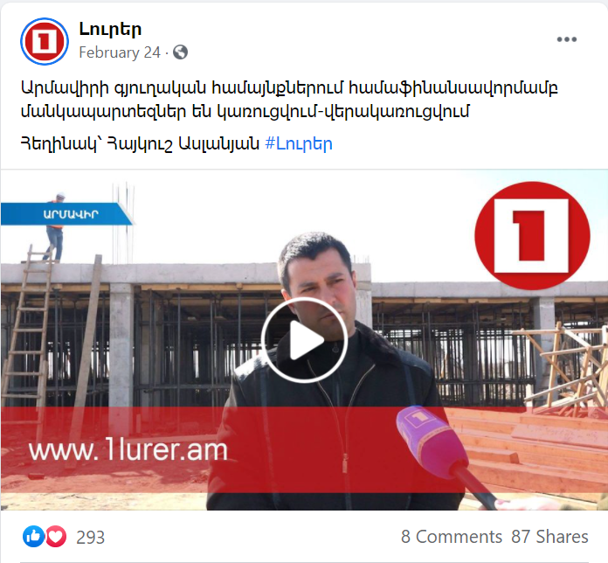
An example of positive news:

This news article informs that kindergartens are being built-reconstructed in Armavir rural communities by co-financing with the Government. This is excellent news. Thanks to the news outlet for sharing. From the reactions (like, love) and the number of shares, we can guess that people loved this, so it is more likely that this article raised people’s moods.
10
An example of somewhat positive news:
This news article informs that according to the Human Rights Foundation, there will be no lasting peace in Azerbaijan without democratic reforms. This news can be considered as positive, because with democratic reforms a new person will lead the country, who most likely will put people’s lives as priority and will not start or engage in wars. Also, the idea that in Azerbaijan peace is impossible can make some Armenian happy, as there is a hatred toward that country. Therefore, everything bad happening in Azerbaijan is a source of happiness for many
Armenians. On the other hand, no one can guess who can be that new leader, maybe he will be
11
worse than Ilham Aliyev. Maybe the author of this assumption is totally wrong, so there is no room for hope. These are the reasons why I decided that this article is somewhat positive.

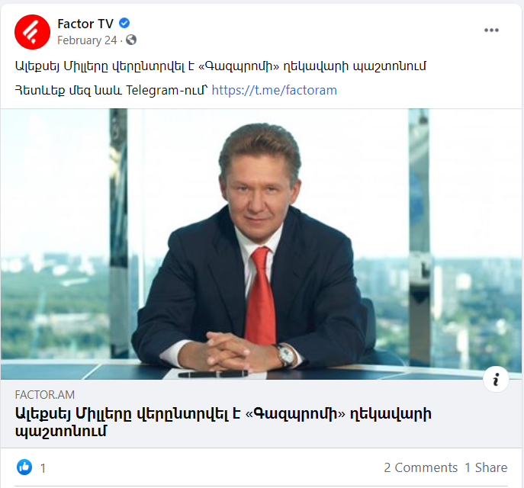
An example of a neutral article:
This news article informs that Aleksey Miller was re-elected as the manager of Gazprom (a natural gas supplier). This is neither good or bad news.There was no mention of him being an excellent or bad manager, no opinion just the fact. So, it is neutral.
12
An example of a somewhat negative article:
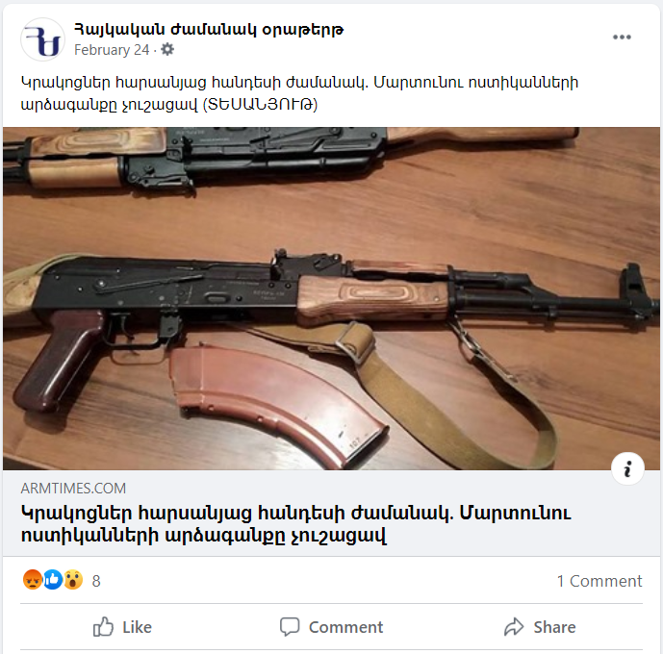
This news article informs that տhere were shootings during the wedding event in Martuni. The response from the police was on time.
The first part is totally negative, as having a gun is banned in most of the cases in Armenia and there is this person who illegally carries and uses it. Also, people may think about the bride and groom who did not expect their wedding event to be like that.
The second part of the news, however, brings a little positivity by mentioning that the police were on time. People may think that the police of Armenia are strong and they are able to protect people.
13
To sum up, the negativity is obvious but the overall article is balanced, so it is considered as somewhat negative.

An example of negative news:
This article informs that Vazgen Manukyan, a political opposition representative in Armenia said that “If the army is strong the police cannot do anything”.
14
In the video he also mentioned that the army should not obey Nikol Pashinyan, the Prime Minister and the Commander-in-Chief of the Armed Forces of the Republic of Armenia.
From the reactions we can assume how angry people are about his speech. Why did I consider this news article as negative? In February when this post was made, the situation in Armenia was still tense after the Second Artsakh war. At least once a week there was news about newly found corpses of soldiers. What Vazgen Manukyan suggests in the speech could lead to hatred between the army and the police and they could end up colliding with each other. This for sure could become a reason for more and more deaths. Second, he says that the army should not obey Nikol Pashinayn. This reason is self-explanatory.

The news articles were also separated in these categories: governmental, political, sports, weather and so and so forth.
An example of a governmental news article:
The title: The next meeting of the working group of the Russian Federation, the Republic of Armenia and Azerbaijan will be on February 27th. (link)
This article is about a meeting in which an Armenian Government representative participated. It
included an agenda about the Republic of Armenia, not about the representative’s political party, for example. These are the reasons why I chose this article to be Governmental.
15
An example of a political news article:
The title: Is the government that did not fulfill its pre-election promises legitimate? (link)
It is very obvious that this article should have been put in a political articles’ group, as the person cited is a representative of a political opposition and what he mainly says is that Nikol Pashinyan is not legitimate. Nikol Pashinyan was elected years ago by open, democratic elections, so he is legitimate. People calling him not legitimate are making political statements.

An example of an emergency news article?
The title: Rescuers found a RGD 5 grenade on Qajaznuni Street․ (link)
This is very important information for people to know, which could be life-threatening, so I put it in the emergency articles’ group.
The other categories are self-explanatory: weather, health, weather and so and so forth.

The central questions the paper asks:
1. What do Armenian news outlets share on their Facebook pages in terms of impressions they send?
2. What else Armenian news outlets can include in their content and why?
The key hypothesis for the questions:
1. Armenia news outlets share much negativity.
16
2. They can include educational, inspiring and psychological articles.

The key findings for the first research question:
Before starting my actual research I knew almost for sure that Armenian news outlets share lots of negativity. I have always noticed a fall in my mood every time I opened Facebook. This did not happen only during the last two years during which Armenia faced two major crises. I always noticed news oulet’s focus on negativity. I was so sure about it that I decided to write my thesis about it.
Below is one of the key findings, which is what I knew I would find out after doing the content analysis.
Finding N1: Armenian news outlets share more negativity (50%), than neutral articles (29%). In its turn, neutral posts are more than the positive ones (21%). Is this normal? People get at least 2 times more negative vibes than positive ones.
17
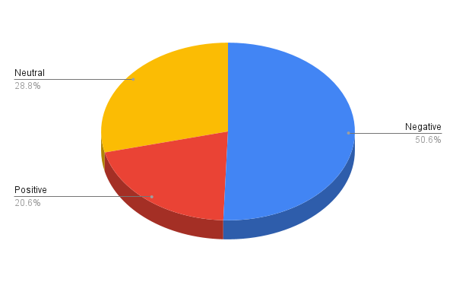

Finding N2: Armenian media lacks educational, psychological and inspiring categories of articles. Instead it includes governmental (43%), political (43%), weather connected (4%) and other themes.
Can you imagine? 86% of the news articles people see on Facebook are either governmental or political. Ordinary people (not deeply involved in politics or political science) do not have that much information about politics and government.
18
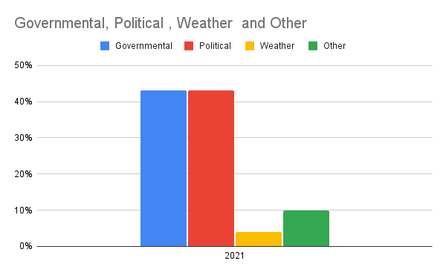
From my own experience I can say that after I read an article about personal growth, successful business people, innovations, psychology I feel so inspired, my mood becomes good and I feel like I can change the world. I am very attentive to what I see on my news feed. I configured my Facebook in a way that I do not see news articles about politics and government, instead I see things that contribute to my growth and development as a person and a professional. Unfortunately, most of the content I see is in English, so there is a lack of good content in Armenian.

If we try to compare what I see and what an average person living in Armenia sees on our news feeds, the difference will be obvious. I am really concerned about people, that is why I have come up with an idea of opening a blog in Armenain, where I will post translated articles
19
from Forbes, Entrepreneur, Economist, Harvard Business REview, Inc, Psychology Today and so and so forth. The articles will be about business, career, innovations, psychology, personal relationships and personal growth. I got lots of good feedback about this idea. I can assume that people need good Armenian content.

So, Armenians need to have more empathetic news outlets, which can put themselves on their readers’ shoes and not only try not to harm their mental health but also contribute to their personal and professional development.

From all the news outlets I analysed it was only Pan.am which posted educational and entertainment articles sometimes. They have a special post which they do every morning which starts by “While you were asleep…”.
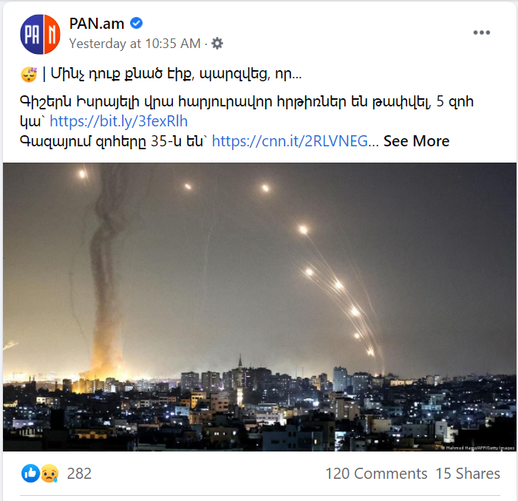
20
In these posts they always add positive things but the bad part of it is that this section always starts with negative news. I can assume that they do this to catch the attention of people. Imagine those people who follow them on Facebook start their morning with bad news. Wouldn’t it be better if the post started with positive ones? Below is one example of a post like that.
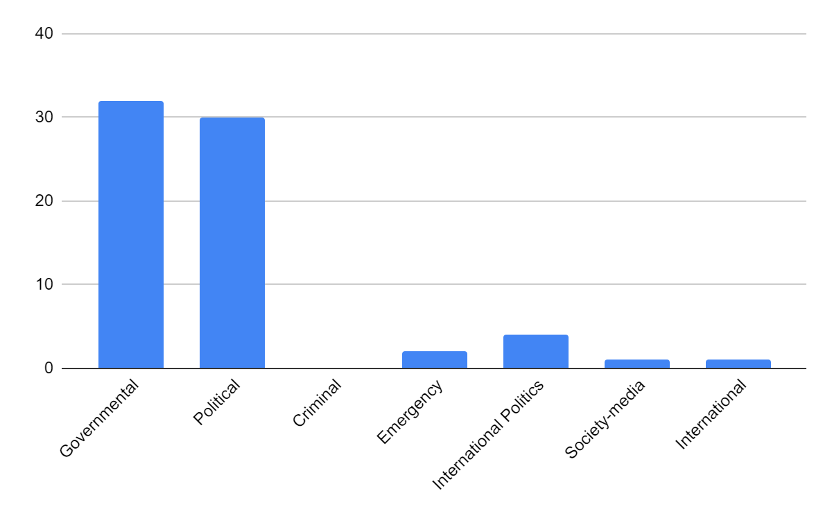
One can contradict my point by saying that bad news is of a big importance and people should be informed about them. I will say, yes, but the above screen shot shows that the author of this post wrote an international negative news in the first line. I assume this news has no major impact on Armenians and they should not be informed about that as soon as possible. Therefore, it seems like there is a silent rule to add the negativity in the first lines to catch attention. This is unacceptable.
Finding N3: Most of the negative and somewhat negative news are from the Governmental and
21
Political categories.

Another finding connected to this one is that most of the negative and somewhat negative news from the Governmental and Political categories have an anti-governmental (anti Pashinyan’s authority) sentiment.
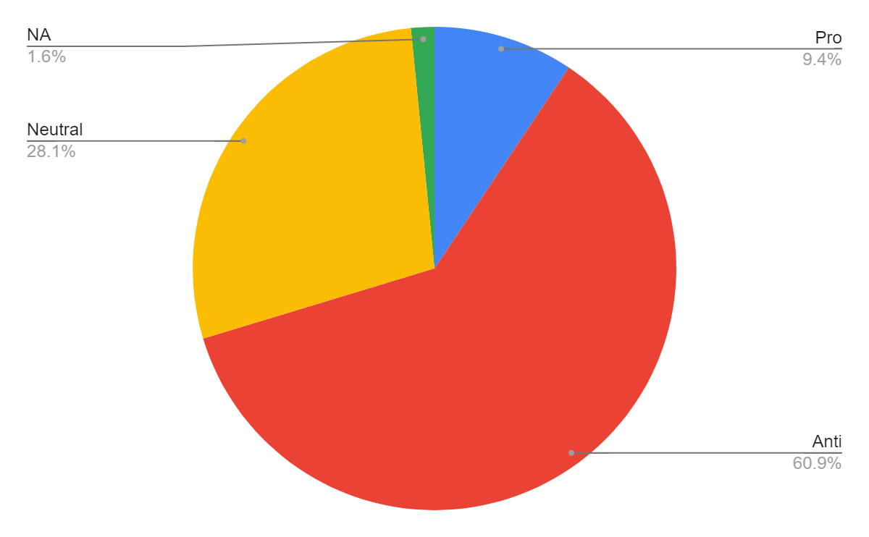
These two are very interesting findings. In Armenia there is a silently approved truth for most of the people that most of the news outlets are owned by Armenia’s second and third presidents and their acquaintances․ In case this information is right, all the reason for this huge
22
negativity in news outlets can have a political motivation. As the two presidents are in a political opposition with Pashinyan, they would like to share lots of negativity about Pashinyan’s authority, so that people will start disliking him. This is just a guess, as unfortunately there is no solid base showing who owns the news outlets in Armenia.
Finding N4: Most of the positive and somewhat positive news articles were from these categories: Governmental, Political, and International Politics.
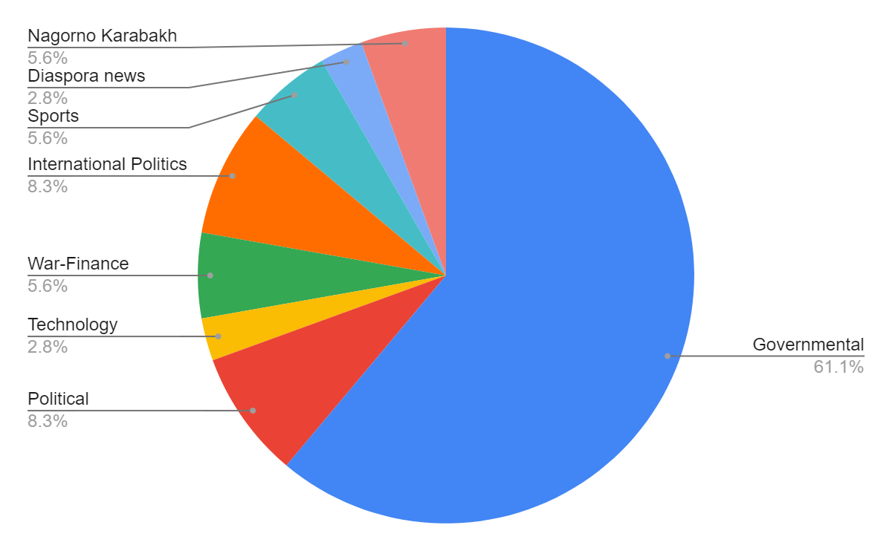
Another finding closely related to this one is the following: Most of the positive and somewhat positive news articles are pro-governmental or neutral. Anti-governmental was 0.
23
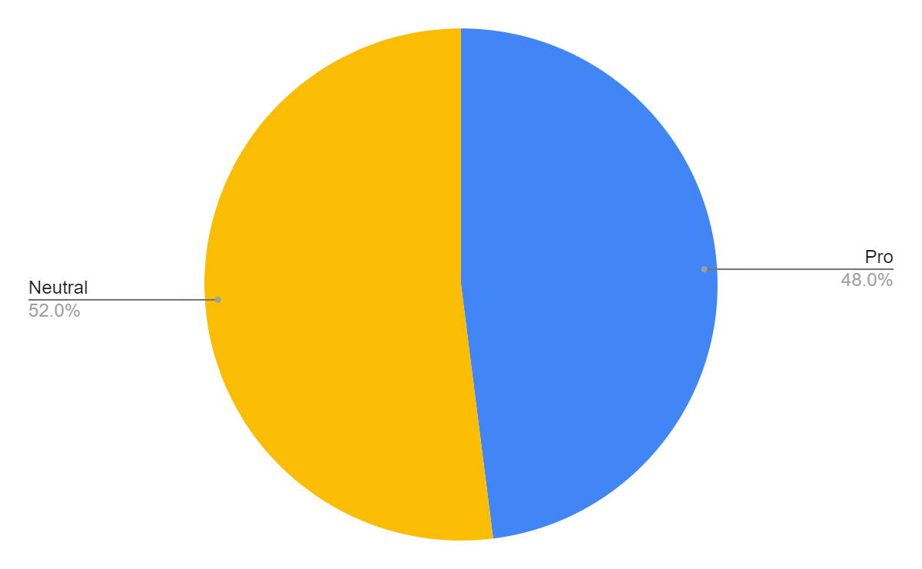
Actually, there is an interesting relation between the findings N3 and N4:

- Most negative and somewhat negative news articles are anti-governmental.
- Most positive and somewhat positive news articles are pro-governmental.

Finding N5: There were interesting findings which revealed some of the news outlets’ political bias. For example, Mamul.am shared the same article twice a day. The article was about Vazgen Mnaukyan’s speech, who is a political opposition representative

Another example is from Lurer.com, which is a public news outlet, the same as the public television. After Nikol Pashinyan gave an interview to 1in.am, Lurer.com shared the full
24
interview once, plus different cut parts of it for thirteen times during a single day.
Answers to the research question number two: What else Armenian news outlets can include in their content and why?
First of all, why do I think that news outlets should include some more different content?
This chart shows the situation now. News outlets fill people’s minds with governmental and political news, which is surely bad.

I think news outlets also need to think about adding educational, inspiring and psychological content, as well to create balance of what they show their readers.
25
- Educational articles.
The need and benefits of education are obvious. We study in high schools, universities, and have different training sessions. The knowledge we get from these institutions and sources may not help us stay focused and motivated in case whenever we enter Facebook we see negativity.
Educating people is helpful for all of society. If a journalist is able to educate the news outlets’ readers more by posting educative articles, he will have done good to himself. Why? When people in your country are smarter, you and the upcoming generations will most probably live in a better country in the future. An educated person will bring more value to the company she is working in, thus making the company more successful which in its turn will result in a stronger economy. A more educated family member most likely will be more empathetic, stress-resistant or emotionally intelligent from which the family will benefit. This will lead to better relationships inside the family, which will keep every family member happy and motivated. These are the reasons why I think adding more educational articles is worth the news outlets.
Now, what exactly do I mean by saying educational articles? One example can be the example of articles about personal experiences connected to suicides, as mentioned in the Literature Review section. When written after speaking to a professional, these aretices may end up being very helpful for people under the risk of self-suiside.
26
Other examples of titles of educative articles:
- The difference between a leader and a manager.
- How to become a more emotionally intelligent person?
- Why should you engage in your community activities?
- Ecological problems in Armenia and how you can help nature.
- What are different types of political ideologies?
…
And so and so forth. In case these kinds of articles were about 20% of the content news outlets share, we would have another society now, more developed and smart.
Now, as a reminder people read these kinds of titles on news articles:
- The secret intimate relationship between Anna Hakobyan (Nikol Pashinyan’s wife) and Jalal Harutyunyan (Previous Minister of Defense of Nagorno Karabakh).
- Did Nikol Pashinyan have a secret agreement to sell the territories of Nagorno Karabakh with Ilham Aliyev?
- This politician threatened that politician.
- The bodies of twenty soldiers were found․
- The opposition blocked this or that street.
…
This is the reality. This could be different. There are news that have to be written about, such as the deaths of the soldiers, but after that should be another educational one, so that people can cope with stress.
27
- Inspiring articles:
There are some international magazines which I follow and read their articles to stay inspired. One example is the Economist, which frequently posts about what is a business, what one needs to know to start one, posts interviews with successful startup founders and so and so forth.
Why don't Armenian news outlets interview business people sometime? These interviews can end up inspiring people who watch them, especially when business people talk about their failures, difficulties before reaching success.
Why don’t Armenian news outlets share about Armenian startups’ success? This kind of information can be so inspiring to people, especially now, in this after-war, politically unstable situation.
Inspiring articles will surely inspire and motivate at least part of the readers. Even if only 5% of the readers are inspired, it is worth doing it.
Some themes of news articles that could be posted by news outlets but were not:
- An interview with Davit Baghdasaryan, the founder of Krisp.
- How to start a business in Armenia?
- What are the market gaps and demands of the international markets?
- Takeaways from X entrepreneurial conference.
28
- Armenian Krisp received a $ 5 million investment․ This news fortunately was shared by a news outlet, CivilNet. From the reactions we can assume that people loved it and most likely would like to see more similar news.
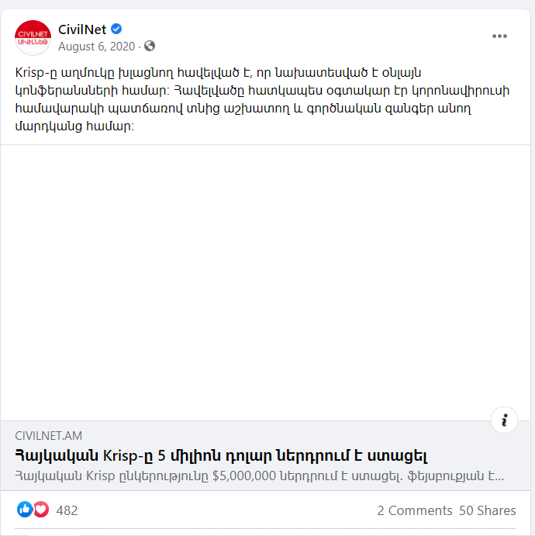

- Psychological articles:

Reading about psychology, knowing more about what is inside you, your mind and how you can control it, are very important for all human beings. This becomes more and more important when there is an unstable situation in the country: pandemic, war, and so on
28
and so forth. In case journalists have to report everythings and everything happening is negative, this should be an alarm for them, making them think that they should add more psychological articles.
The week during which the content analysis was done was very stressful like many of its previous weeks. During that week many negative events happened but I did not see any one psychological article among the randomly chosen one hundred seventy.

In Armenia whenever a person visits a psychologist, people think that the person has serious psychological problems. Because of this opinion of the society, many do not visit psychologists, so they need to get helpful and professionally correct information about psychology from somewhere else. The Internet is the best place. News outlets can do revolutionary changes in their readers’ s psychological education and awareness.
Examples of great psychological news article themes can be:
- How to cope with stress during a war?
- How to cope with a loss of a friend or a family member?
- How to control your emotions?
- Changes in parenting as children develop.
- Strengthening qualities to enhance love in our relationships.
…
In case the picture of the reality was like the chart below, Armenian society will
29
be far more developed and less stressful than it is now.
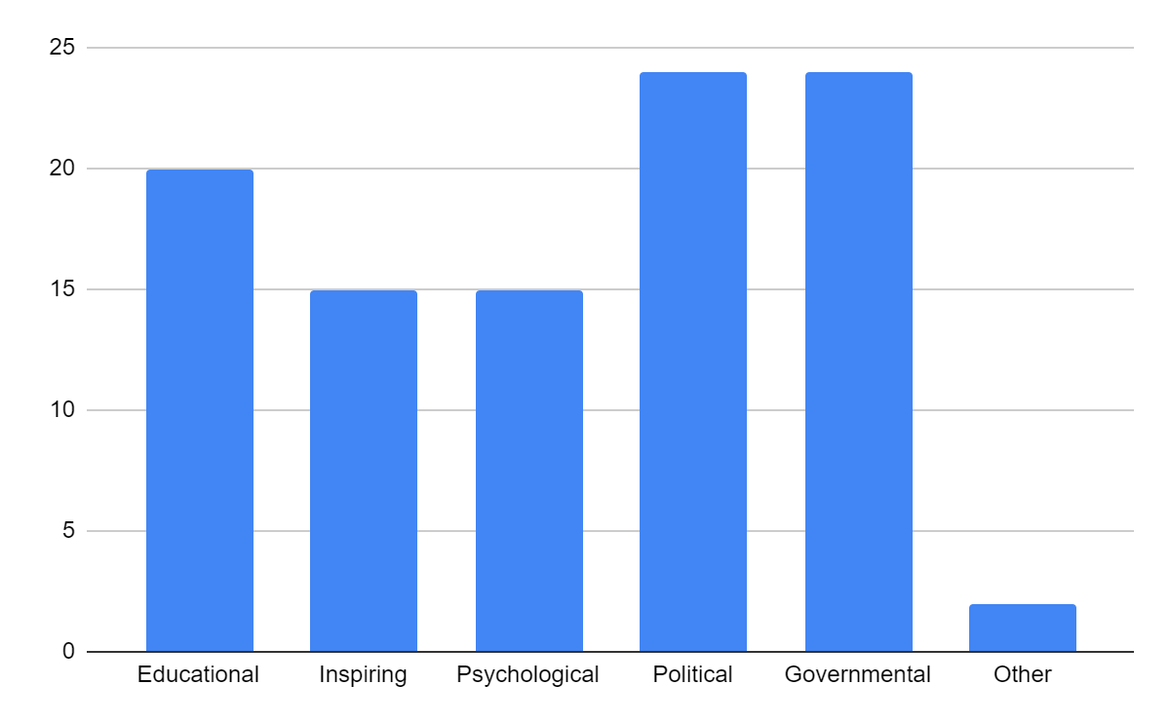
Conclusion

It turns out that Armneian news outlets share lots of negativity. These negativity mostly comes from the news about the Government and politics, in general. Armenin news outlets lack articles which are educational, inspiring, and psychological. In case they share much negativity, at least they should also add some psychological articles so that people can cope with the stress coping after reading all the negative articles.
So, the first thesis was proved right, unfortunately. I would like it to turn out to be wrong,
30
showing that positive news is more than the negative ones.

Limitations and Avenues for Future Research

For people interested in future research I would like to highlight that you may get a bit different results in case you do your research during a period of time during which no significant event happened in the country. Technically, when negative events happen in the country, the news will be negative, as well. Armenia was in a very insatiable situation when I was doing the analysis. It will be interesting to see the picture after the unstable situation passes.

An interesting thing to discover connected to this paper: During the content analysis, it was noticeable that Armtimes, a news outlet owned by Nikol Pahinyan’s family, sometimes shares more anti-governmental articles than those not connected to Pashinyan. When doing a bigger analysis, including more than one hundred seventy news articles the picture will be clearer. It is also an option to only concentrate on Armtimes, and see what percent are the anti-governmental, pro-governmental, and neutral news articles.

Another great theme is doing content analysis to see which news outlets share the most negativity. In case of finding them, one should also try to understand their motivation for doing so. It is also possible that news outlets’ journalists and the editor are not aware that they share mostly negativity So, it can be great to do this research and inform some of the news outlets that
31
they are mostly sharing negativity and highlight the scientific arguments about constant negativity being bad for people. This sounds great, I guess this can be one of my future research topics.

As mentioned before, there are hundreds of news outlets in Armenia. So see a more real picture of what people see on Facebook, it is a good idea to find out which news outlets have fifty thousand and more followers or likes and do the content analysis on them.

Another important but more difficult research theme will be trying to understand whether negative news are posted because of political motivations. For example, one political group can want to harm the other group by sharing negative news about them. This can lead to the media being filled with negativity for political reasons which will harm people’s health, ability to focus and so on and so forth.

In case someone has a certain amount of budget and wants to do something helpful for the Armenian society, it is a good idea to do research and find out lots of information about why constant negativity is bad for citizens or civil society. This information can be used to do training for all or most of the news outlets journalists and editors. Hopefully, these people are just unaware about what they are doing now (most of them sharing mostly negativity).

Fake news is a big topic in Armenia. Nearly every political party is blaming the other for sharing fake news. It will be very different, but very important to find out how many percent of
32
the negative articles, specifically those included in Governmental and political categories, are fake.

Finally, as mentioned in the Literature Review section, there is a lack of research to know whether Armenians skip over political news articles faster than over articles over other issues. This would be critical information for this paper, which unfortunately the paper misses.

33

References

Mcintyre, K., & Gyldensted, C. (2018). Positive Psychology as a Theoretical Foundation for Constructive Journalism. Journalism Practice, 12(6), 662-678. doi:10.1080/17512786.2018.1472527
https://muse.aua.am:3272/doi/full/10.1080/17512786.2018.1472527
Mcnaughton-Cassill, M. E. (2001). The news media and psychological distress. Anxiety, Stress & Coping, 14(2), 193-211. doi:10.1080/10615800108248354
https://muse.aua.am:3272/doi/abs/10.1080/10615800108248354
Soroka, S., & Mcadams, S. (2015). News, Politics, and Negativity. Political Communication, 32(1), 1-22. doi:10.1080/10584609.2014.881942
https://muse.aua.am:3272/doi/full/10.1080/10584609.2014.881942
Till, B., Tran, U. S., & Niederkrotenthaler, T. (2020). The Impact of Educative News Articles about Suicide Prevention: A Randomized Controlled Trial. Health Communication, 1-8. doi:10.1080/10410236.2020.1813953
https://muse.aua.am:3272/doi/full/10.1080/10410236.2020.1813953
Vergara, A., Siles, I., Castro, A. C., &amp; Chaves, A. (2020). The Mechanisms of “Incidental News Consumption”: an Eye Tracking Study of News Interaction on Facebook. Digital Journalism, 9(2), 215–234. https://doi.org/10.1080/21670811.2020.1813047

