The Impact of Video Games on Children's Mental Health in Armenia

By

Yana Gasparyan
Presented to the
Department of English and Communications
In Partial Fulfillment of the Requirements for the Degree of Bachelor in Arts
American University of Armenia Yerevan, Armenia (6250-10000)

May 14, 2020
Abstract
This study examines the effects of violent-theme videogames on children's mental health in Armenia, and is done in the field of communication. The impact of violence on children's mental health is a huge problem, which needs to be addressed in Armenia. Video games are a mediated form of communication, and it is crucial to understand that they are harming children’s mindset. This research has been conducted to indicate that video games have a negative impact on children's mental health, therefore surveys and in-person interviews were conducted as well. The overall results of both survey and in-person interviews show that the majority of parents do realize the threat of video games and recognize that it performs negative effects on children’s mental health. The aim of the research is also to raise awareness among parents in Armenia, as people do not recognize this issue as a public health problem. The research consists of experience-based knowledge, as well as theoretical, including academic readings about specific topics. The research’s methodology has indicated that video-games are a threat for children’s behavior, attitude and outlook as a whole.
Keywords: violent-theme, video games,children, mental health,Armenia
Table of Contents
Introduction ---------------------------------------------------------------------------------------3
Literature Review --------------------------------------------------------------------------------5
Research Question and Methodology ---------------------------------------------------------9
Research Analysis and Findings---------------------------------------------------------------11
Conclusion----------------------------------------------------------------------------------------19
Bibliography--------------------------------------------------------------------------------------21
Appendices----------------------------------------------------------------------------------------24

The Impact of Video Games on Children's Mental Health in Armenia
The impact of video games on children is a massive problem that almost every parent encounters nowadays. The harmful effects of video games, particularly those which contain a considerable amount of violence and sexually provocative scenes, have generated significant concerns among many parents, educators, and as well as health professionals. This paper argues that this is a problem in Armenia and sets out to prove this allegation. Violent-themed video games are a huge risk factor for aggression among children; they enhance aggressive thoughts, behaviors, emotions, and also decrease empathy (Goldbeck, L., & Pew, A, 2019). Such games contain violent animations and scenes, as well as scary sounds, screams, etc. Studies about violent video-games began in the 1980’s, and till today numerous experiments and studies are being implemented. The fundamental approach of the research is communicational: how do mentality and behavior form as a result of violent media games? Children's mental health is as important as their physical, and it is so vulnerable that it is immediately affected by violent-theme media games. Nowadays this is a crucial problem that needs to be solved, however, society has no clue how to do it.
The question of the harmfulness of games and TV was always a big problem mainly in vast and advanced countries like the USA, Canada, European countries (Scutti, 2018). This issue is also emerging in Armenia. This research will concentrate on Armenian children who play and watch video games containing violence. This problem arose in Armenia in the last 15-20 years, as before that, Armenian children rose watching soviet cartoons and if there were games, they preferred playing non-violent games. Admittedly, the children of the 1990s were the ones who have encountered the dangerous effects of television and games. In general, during Soviet times, many television programs were forbidden, especially violent-theme shows (Friehe, 2017). Assuredly, TV’s and video games’ problem is not considered a significant one, and no one recognizes it as a public health problem in Armenia. This paper aims to raise awareness also in Armenia and to make the government and parents take action to make changes in their children's lives. The research will cover many aspects; psychology, discussion of famous games (Mortal Kombat, Fortnite, GTA) online media games and so on. During these last ten years, the popularity of video games have increased in a rapid manner, eventually by becoming one of the most profitable entertaining mediums across the world. Dating back to the origins of video games, they were established in the lab of scientists. The first video game named “Spacewar” was developed in 1962 (King, L. 2012). The particular game was developed by MIT students and was considered the most groundbreaking game of that era. Furthermore, the industry of video games began to increase more and more, by providing us with video games such as “Lara Croft”, “Mortal Kombat”, “Pacman” and so further. By reinforced technologies of the 21st century, video games’ visuals are becoming more and more powerful, and characters are becoming indistinguishable from humans (King, L. 2012). The research's goal is to raise awareness regarding the danger of violence that exists in games and how it relates to children and their parents and society as a whole in Armenia. This paper argues that it is crucial to take into account your child's mental health, and for that, it is better to solve this problem as soon as possible, as violent-theme video-games, completely hypnotize children and change their mentality, behavior, and actions.Since the paper is about the effect on children, this research examines the effect of violent video games on the mental health of children.

Literature Review
Anderson and Bushman (2001) presents a meta-analytic review about the video game research literature and experimental studies. Their analysis reveals that violence-theme games develop aggressive behavior both in young children and adults as well. Its great meta-analytic study covers instances of how aggressive behavior, such as school shootings, occurs because of violent video games. Precisely, the fact that some highly publicized school killings were performed by those who regularly played violent video games is a definite proof that violent games do increase aggression (Anderson & Bushman, 2001). As statistics reported by CNN show, there are approximately 90% of children in the USA who regularly play video games. The number grows to 97% among kids between the ages of 12-17. Most importantly, 85% or more of video games contain various kinds of violence (Scutti, 2018).
Though videogames can be equally effective and dangerous, and television is also used, in the 21st century, video games are on their highest rank (Bushman, Anderson, 2001). The selected articles contain research, studies, experiments, diverse cases and theories that make claims about the harmfulness of specific video games. The article of Bushman and Anderson catches the eye with its meta-analytic review of the video game research literature. The analysis reveals that games that include any violence increase aggressive behavior in children and young adults. According to the article young people between the ages of 8 to 18 spend approximately 40 hours per week using entertainment media (television, games, etc.). About 10% of children aged between 2 and 18 play computer and game console more than 1 hour per day, and 8 to 13 years old boys play an average of 7.5 hours per week (Robers, Foehrs, Rideout & Brodie, 1999). The article mentions specific games that gained popularity after 1999's - Mortal Kombat, Street Fighter, and Wolfenstein 3D. All games include violence, as their main aim is to kill, harm, or to wound other people. The graphics include blood, scary sounds (e.g. scream, moan). Fourth-grade girls (59%) and boys (73%) state that the preponderance of their preferred games are the ones that include violence (Buchman, Funk, 1996).
The article of Anderson and Waburton discusses different sections about the effect of violent video games during youth. For instance, attention deficits, school performance, and increased aggression and so on. It discusses what is meta-analytic review and brings multiple examples related to the topic. Moreover, it presents us with many researches about the harmful effects of violent games. They have collected data from 136 articles, 381 tests of hypotheses. Approximately, 130,296 participants were examined. In this meta-analysis, examinations of research methodology were also examined. As a result, amongst the many findings was that studies with more conventional research methods managed to find more powerful and potent effects of violent video games performing on aggressive behaviour of individuals (Anderson & Warburton, 2012).
The next article regarding the violent video games “Exposure of Violent Video Games to Children and Public Policy Implications” by Collier, J., Liddell, P., & Liddell, G. The article is an overall summary of the dangers of video games, and it summarizes particular games like GTA (Grand Theft Auto), Pong, Pacman, and Laura Croft. According to the authors, in the 2000's the market value of videogames in the world exceeded both the TV and music industries. The market value of videogames is more than 25$ billion and is expected to increase to 56.4$ billion by 2009 (Farrand et Al,2006). The instance of fame gaining video games are Pong and Pacman, which have original scores, detailed artwork and more than 100 people working on them ( Collier, J., Liddell, P., & Liddell, G., 2008).The particular article discusses specific famous games that are relevant to the topic and the research as a whole.
Coleman (2019) has written about competitive video games. According to him, when a child spends many hours per week playing competitive video games, he/she is continuously interacting with a group of complete strangers, most of whom are adults (29%). As argued, a child who virtually interacts a lot with strangers is learning and copying just the same as they will learn from adults in the real-world. The article posits that competitive video games cause an increase in toxic behaviors and a decrease in self-esteem (Coleman, 2019). The author claims that certain skills and behaviors, both negative and positive, can be established while playing competitive games. On the other hand, Dietz (1998) examines the depiction of women and the use of violent themes in a specimen of 33 famous Nintendo and Sega Genesis videogames. Again, the author believes that such games hurt children's psychology. Moreover, the analysis reveals that traditional gender roles and violence are fundamental to many games in the sample — approximately 80% of the games included aggression or violence as part of the strategy or object. (Dietz, 1998). Both of the articles are used as a specimen of a perfect summary for the harmfulness of video games, exceptionally competitive ones.
According to the article “A Theoretical Model of the Effects and Consequences of Playing video-games” by Buckley and Anderson, a recent analysis discovered that approximately 89% of video games are violent-theme, and children prefer them over casual ones (Buckley and Anderson, 2006).The article answers many questions, but the main question is “How do games teach?” Admittedly, children ranging from the age of 9-14 report that the main action of their games is predominantly violent (Buchman and Funk, 1996). Moreover, the article includes the results of a survey: the children claim that they give preference to games that include violence, about two thirds of parents could not name their child’s favourite game, and 70% of parents were incorrect when it came to their children’s preference about games, whereas children described their games as violent games (Funk, Flores, Buchman & Germann, 1999). Nevertheless, the authors introduce the good side of the gaming world. They bring examples of games used for military and educational uses. The authors claim that the U.S. military is one of the largest groups that has supported the utilization of video games for training (Buckley and Anderson, 2006). For instance, the marine military used a game named “Game Doom” which was created for training, or military soldiers used a game called “Joint Force Employment” (DTIC, 2004). In schools too, some computer games were used to teach geometry, algebra, biology and so further. The article also represents a meta-analytic review of the video game research literature, where it was revealed that violent games do increase aggressive behavior not only in adults, but also children as well (Anderson and Bushman, 2001). A lot of experimental and non experimental studies have been done with both males and females in laboratories, and all of them support this statement. Most importantly, those experiments have revealed that there are five effects of violent media: humans tend to become meaner, aggressive and violent, tend to see world as a scary place, become more desentized to violence, get and increase appetite for seeing more violent entertainment and last, less like to behave prosocially (Gentile and Anderson, 2003).
The following article catches the eye with its content, which is about a famous game “Mortal Kombat”. “Violent video games and the Development of a short-term hostile attribution bias:Seeing the World through Mortal Kombat-colored glasses” introduces a study, which investigated the effects of playing violents and non-violent games on the interpretation of ambiguous provocation situations (Kirsh, 1998). The study was composed from two groups: the first group played very violent games, and the second group played relatively non-violent video games for many minutes. Therefore, children were exposed to read five stories, in which a same-gender person caused a clearly negative action, but the peer’s intentions were ambiguous. After reading each story, children were asked a series of questions about the peer’s intent, actions and possible punishment. As a result, children who played violent games responded more negatively on thee of the six ambiguous provocative story questions than those who were playing relatively non-violent games. Eventually, the data collected during this experiment once again shows that playing violent-theme games leads to a development of aggressive, hostile mindset and behavior. According to Kirsh, suggesting the social learning theory, games which contain violence allow children to practice aggressive behavior and to be rewarded for that actions (Silvern and Williamson 1987). Moreover, the violent games lead to anger, resulting in aggressive actions (Kirsh, 1998). Therefore, the article provides us with “Method” ,which is about the experiment and therefore it provided the audience with “Procedures” and “Measures”.
Research Question and Methodology
The central question of the research is, Does violent video games affect children’s mental health, behavior and attitude Armenia? Effects of video games are usually not considered as a public health problem and it is crucial to raise awareness concerning this topic in order to prevent mental health problems of our children.
To dig more into the research and topic, both quantitative and qualitative methods of research were conducted. The quantitative side provided with statistics of children who play violent theme video-games in Armenia. As there was no exact statistics regarding children who prefer and play violent video games, the survey has been conducted in order to raise awareness and provide an exact statistics of it possible. The number of participants exceeded 50 people, from which all of them were people who have children. The survey includes 9 questions overall, which is directed to the parents who have children of the age ranging from 7-12.
The questions were intended to give a basic understanding about Armenian parents and their opinions and outlooks on this issue. The main purpose of the online survey was not to collect a massive number of people, but rather to collect an adequate quantity of parents, who can adequately answer the questions and give a basis on statistics for this research. The surveys were spread through social media like Facebook, Instagram, especially in groups or communities within those websites where parents are members (Women’s Corner, Parents.Media, and so on). These two media sources were chosen as a platform for spreading the survey, since nowadays people spend most of their time on them, and also establish communities for different purposes. The two chosen communities are well-known among both Facebook and Instagram, and the purpose of the communities is to discuss different topics (mainly about children). Women’s Corner is a Facebook community, where women from Armenia (or Armenians from other countries) share their story by posting in the group. Parents.Media is an Instagram account where parents from all of the world gather together and discuss diverse issues concerning their children, and give different solutions to each other's problems.. The primary aim for the survey to send the surveys directly to those whom you identify as a potential parent who has a child, and that child plays violent video-games.
The in-person interviews were conducted to measure this problem in a more thorough way. The in-person interviews are divided into two parts: interviews with parents, and interviews with children. Interviews were conducted with parents of children to gather information about their opinion, actions, thoughts. As a second part of the in-person interview, interviews with children were conducted as well to get a deeper understanding of the particular issue. The first part of the interviews were concentrated on parents. Overall, 4 adults participated in the interview, of which 3 were women, and one man. One parent was interviewed online by Zoom application. The participants of the in-person interview were not chosen randomly, rather the target audience for the research were identified as people who have children, and their children play video games. The meetings with parents were held in the same manner and with the same questions. Later, after summing up the final results of interviews with parents, the second part of the interview was held with children(age 7-12). Since the primary purpose of the research is to analyze the negative effect of media games on children, the interviews were conducted with children who regularly play media games that contain violence. The children which participated in in-person interviews were the children of parent participants. Children are vulnerable, honest, and smart, that is why interviews with children give authentic results. For the second part of the interview, 3 children were interviewed. 3-4 questions were conducted for them not to be bothered. Overall, 2 of the children were female, and one was male. These interviews indicated psychological understanding whether parents notice anything strange in their children, and whether those children are affected by the games. The data collected by the interviews provided the research with an indispensable insight.
Research Findings and Analysis
Surveys
Online Survey
The data and analysis collected from the survey have shown that the majority of boys (67.65%) play violent-theme games, whereas girls (35.29%) do not prefer such games as much as the male part of them do. When it comes to time spent in front of the game console, the majority of parents (53%) answered 3-5 hours per day, whereas 15% was more than 5 hours, and 33% was 1-2 hours. Admittedly, 1-2 hour is also a threat because immediately after that the results of violence on the screen is apparent in the child's behavior. Most importantly, it is evident during their sleep time (nightmares, insomnia, bad thoughts). So, when it comes to the question of whether parents are okay with playing violent-theme games, the majority of parents (nearly 80%) answered that that phenomenon disturbs them. Whereas 9% were okay with that, and 21% did not care at all. According to the results to this question, not every parent acknowledges the harm and impact of games that contain violence, which is very bad for their child's mental health and well-being in Armenia. When it comes to parents that actually do not care as much, the results of those games on their children may not appeared yet. On the question of whether they have noticed anything strange in their child's behavior, attitude or discussion, again, 50% of parents answered yes, 35% haven't noticed, and 14% did not know. The following answers the particular question more on the situation because that most of the parents do not exactly realize the threat, whereas hopefully 50% of them do. To the question of whether the children accomplish their responsibilities (homework, reading, sports, etc.) dutifully, or not, the majority of them(almost 65%), as it was expected, answered "No." In contrast, only 35% responded that they regularly accomplish their responsibilities. According to the survey, 56% of parents realize and consider their child addicted to violent video games. On the question, will they prevent their child from playing violent-theme video games, most of them (91%) answered yes. The high percentage of the last question made indicated that if only they see a threat, they will prevent their child from playing video games; however, it is essential to raise awareness that it is vital to prevent your child from performing any type of violent-theme games before they see any harm on their child's mental well-being.
Overall, the results of the online survey indicate that the majority of parents in Armenia acknowledge the problem, but still, there are a lot of parents who do not understand the threat of violent video games. It leads to the conclusion that either child does not receive 100% attention, or their parents do not precisely realize their addicted child's actions are due to the violence that they have seen and used during their video-game time. It is imperative to raise awareness for every parent to understand that the threat of online games is enormous, and it does not appear immediately after playing it for once, rather it appears for playing it for weeks, and so. Some parents think that during their child's spare time, there is no harm to play games, but the question still remains, which type of games? It is crucial to follow what types of games your child plays because not all games are educational and useful. Once again, it shows that parents do not pay attention to what their child plays. Most of them find video-games as a way to entertain their child when they are busy and do not have time to play with them. That is why it is crucial to raise awareness about this question in order to prevent addiction and abnormal behavior.
Interviews
In-person Interviews
The purpose of in-person interviews is to gain more insight to the issue both psychologically and theoretically. As mentioned above, 4 parents were interviewed, one of them was interviewed online. The in-person interview began with Marine Karapetyan, a mother of 9-year-old Armen. During the interview, Marine mentioned that she has noticed Armen performs very badly in his studies at school; additionally, his behavior is very disrupting (Marine Karapetyan, face-to-face interview, February 5, 2020). By elaborating more, she reported that Armen is acting cowardly to his sisters (he has two sisters, 2-year-old and 15-year-old), he speaks in a very bad manner (bad words, bad tone), he refuses to spend time with his family (rather prefers time spent in front of the game console), and acts aggressively most of the time. Also, Marine said that during his sleep time, she noticed that in contrast to before he was playing violent-theme games, his sleep is distorted, he always calls for an adult to sit next to him (mother, father, big sister, etc.) and has very bad nightmares (someone dies, he dies in his sleep, he killed someone). Marine opened up that she has intentions to take Armen to a psychologist, as such addiction to games, disruptive behavior, and distorted sleep will lead to a very bad ending. Overall, Marine was very sad and concerned about her child's behavior. Most importantly, she realized that such behavior is a consequence of online video games (she mentioned a game "Fortnite", and “GTA”), and she reported that she is going to hide those games or throw them into the trash. To conclude, Marine said that it is crucial to raise awareness about this question, and she will volunteer as a corresponding specimen to this issue.
As the second part of the interview, an interview was held with Marine's child, Armen. To start off, he began to tell about his preferences of video-games and about his spare time (what he likes, what he does during spare time, etc.), Armen talked only about his favorite games (Fortnite, Minecraft, GTAetc.), and rushed to show what he does during those games. The permission was given by his mother to play with his child the game named “Fortnite”. Fortnite is a "free" download game, where you have to create a username, then the game assigns you to an accidental avatar skin, and users are provided with a common backpack, emote (dance move), pickaxe, and glider. In this game, gamers can purchase in-game currency (V-Bucks) to upgrade these skins, emotes, and accessories; naturally, these selections are gendered, cultural, and sexual, as exposed by Nakamura's (2001) study on avatars. When the game mode is being selected, the users are transferring to a "Battle Royale" and begin the survival. (Mainenti, 2018). It is worth mentioning it is an online game, you speak with different users of any age, and discuss the plan for the battle. According to Coleman (2019), a child who virtually interacts a lot with strangers is learning and copying just the same as they will learn from adults in the real-world. The article indicates that competitive video games cause an increase in toxic behaviors and a decrease in self-esteem (Coleman, 2019). So, as a result of our game, the conclusion about his behavior was made: a lot of bad words, nervous facial expressions, and gestures, gets aggressive when he loses, and does not pay attention to his surroundings. Overall, the child was not interested in sports, or any other kind of engagement, he performed aggressive behavior, he did not pay attention to his surroundings, he had bad sleep and did badly on his responsibilities as well.
Second in-person interview was made with a male participant, Ara Makaryan, who has a boy, Marc, an 11-year-old. As a father, he only sees his child after 6 p.m., and due to his observations and Marc's mother's reports, he does not acknowledge the threat of violent games and does not consider his child addicted, as he himself also plays them regularly. Nevertheless, Ara reports that Marc does not perform well at school, though he was the best student in class before. Later, Ara also said that Marc has been showing intolerance to any kind of activity, he performs bad manners and also does not show interest in any kind of responsibility that he was up to, though he does not understand why his son has changed so much. Ara was blaming the school and his classmates for such behavior and attitude rather than violent video games. At the end of our little interview, Ara said "I do not see any harm from playing video-games, but if I see such behavior growing more, I must forbid him from playing them", (Ara Makaryan, in-person interview, February 27, 2020). To conclude, Ara began to ponder the idea of the threat of violent video games, and hopefully actions toward forbidding violent-theme video games will be taken.
To continue on, an interview was held with his child Marc. During the interview Marc was fully engaged in the game, and for the first 10 minutes refused to talk. He was playing a famous game “Mortal Kombat”, but after 10 minutes of struggling, he began to talk. Observation was made that he performed poorly in school, as according to him school is not interesting for him, and the teachers are "a bunch of idiots" (bad manners though), he likes to play "Mortal Kombat" and "Manhunt", as it makes him happy, and also he said that educational or other types of games do not interest him, he likes shooting, he likes missions where you kill people and being rewarded for that (Marc Makaryan, in-person interview, February 27, 2020). Both of his favorite games are 100% violent games that depict blood, massive killings, disruptive voices, etc. To sum up, the second interview with a child has again shown that violent theme games flood children with their information and activities, and children do not want to perform any activities besides playing them.
For the third in-person interview, the interview was held with female participant Irina, who has a girl, Yeva, 12-years-old. It is worth mentioning that in contrast to previous parents (Marine and Ara), Irina is a bit more strict and tough when it comes to nurturing your child. Yeva is a calm girl, and she always loved butterflies, Barbies, and other typical things that girls of that age like. However, due to the expansion of the internet, Yeva has discovered a game called GTA (Grand Theft Auto). At first glance, GTA is a game where you ride a car; you play with a character and do various missions. However, it is way more harmful than it seems. Irina has not noticed anything bad about that game, so she reported that she let her play it for a little time (according to Irina, she played 1-2 hours). It is neither real nor fiction but hyperreal, a stylized rendition of 1990s California, containing a mixture of authentic and fictitious state landmarks and neighborhoods, where you have missions like to kill someone, steal a car, go to strip-clubs, and etc. (DeVane & Squire, 2008). For those missions, you are getting rewarded with a bunch of money, and you can buy houses, cars, clothes, and so on. Irina claims that she really did not see anything happening thereafter Yeva approached her with unusual questions, which she never asked about. Yeva asked her mother what is a "strip-club", what is a "strip-dance", and whether in real life you can kill someone and receive money for that? Irina reports, "I was shocked when I heard such questions, it is unreal, from where did she get that information, I asked myself... Then, I realized that this new game in her console contains all of the actions that she has mentioned” (Irina Arakelyan, March 3, 2020). According to Irina, she immediately deleted the game and began to pay more attention to what she is doing during her spare time. Irina noticed that Yeva gave up on "girly things", she began to use bad words, she did not do well with her studies, refused to go on a swim, and began to act aggressively when it concerned her behavior. Fortunately, it does not go deeper, and Irina deleted the game before it was too bad for her child. According to her, Yeva was not talking to her for more than five days because of that. However, she claims that she did it at the right time, and her child was not that addicted. Irina encourages all the parents to pay more attention to what their child is doing, and what she/he prefers to do in their spare time because it is a big threat to your child's mentality and his/her future overall.
Second part of this interview was held with Irina’s child, Yeva. At first glance, nothing strange was happening; she talked about dolls, pinky pegasus, and other girly things. Then, when she began to talk about her preferences, she still mentioned GTA and said that she liked to be rewarded for different missions. By digging more of those missions, she said: "Killings and stealing were fun online, and I got a bunch of money and got beautiful clothes for my character, also I have seen beautiful girls dancing on a pole, it was awesome!" (Yeva Arakelyan, in-person interview, March 3, 2020). Also, she said that she does not want to play with dolls anymore, they are "girlish", and she also talked in a bad manner, which was disruptive. However, due to her mother's strictness, her child had been saved from being addicted and the girl does not perform as aggressively as previous children did, and her child has not performed as badly as previous ones because of the time she spent in front of that game. To sum up, it is important to pay attention to the time your child plays, and if you see a threat, it is important to disable the game from the console, even though your child does not agree with you. It is also very important to sit and talk with your child, explain that such games only make threats, and it leads to aggressive behavior, bad manners, and so on.
Interviews
Online Interview
Due to social distancing and virus, the last interview was held online by using the application Zoom. The participant of the online interview was Helen, a mother to an 8-year-old child. The particular participant reached out as a volunteer for an interview from the Facebook community “Women’s Corner”. She was chosen as a participant due to her issue with her child who plays violent games for more than 2 years. According to Helen, the problem got so big that she was forced to hire a psychologist for her son. Her son, Andreas, got huge problems with addiction. He played video games for the biggest part of his day (6 hours and more), was getting hysterical when he was going to school, and eventually refused to communicate with parents/relatives/friends. According to Helen, first addictive symptoms were disruptive sleep, and aggressive behavior and exposure to bad values. Helen reported that her child seemed unfamiliar to her (Helen Gevorgyan, in-person interviews, April 27, 2020). Andreas tend to be a tolerant, calm and versatile boy with a bunch of interests. However, as a result of playing violent-theme video games he has changed abruptly. Helen reported that Andreas was playing football and was going to other classes like painting and piano. However, after playing violent video games he refused to attend those classes. As a result, Helen gave away the game console to the orphanage, however, the game disks she has thrown to trash. Helen identifies violent-video games as a huge threat for your child’s mental health and world vision as a whole. Eventually, her child spends every 40 minutes with a psychologist, and according to Helen, everything is going fine.
Conclusion
It is apparent that due to technological advancement in the 21st century, children have different interests and preferences. Parents play a huge role in their children's lives; therefore, with their assistance, their life can be healthier, safer, and more interesting. Violent-theme video games are a huge threat to a child's mental health, his/her future, and mindset as well. Children are a vulnerable group, and they do not realize how much they are being affected due to the violence they see in their routine lives. Due to that, many parents in European or American countries have taken restrictive measures, and forbid their children from playing violent games. Parents in Armenia yet do not fully realize the harm that comes from violent-theme video games. It is important to raise awareness in Armenia about the particular topic, because our children's future is our future as well, and we together have to make it bright, happy and full of positive emotions.
Limitations and Avenues for Future Research
Since children’s preferences tend to choose violent games, sometimes parents do not understand the risks and find it applicable for them to play those games during their spare time. Although the impact of violent-theme games is serious, the study duration (shortness of time and our last semester) the quarantine and the virus itself has been an issue. The participants of the interview could be more parents and children, however, the virus prevented the meetings with some of my in-person. As a result, an online interview was made, however, it is worth mentioning that online interviews did not give the same results as the in-person interviews. As for interviewing children, the difficult part of the interviews was identified. Not all children have a desire to talk about their “personal” life and their preferences, and not all children adequately answered the questions. Some were getting distracted, some were bored, some wanted to play games, some went out of the room etc. So, for the future research, it is important to manage time more efficiently, and also stay healthy. Moreover, it is important to gather more information on how to set a discussion with children of that particular age.

Bibliography
Kimmig, A.C. S., Andringa, G., & Derntl, B. (2018, May 16). Potential Adverse Effects of Violent Video Gaming: Interpersonal- Affective Traits Are Rather Impaired Than Disinhibition in Young Adults. Retrieved from https://www.ncbi.nlm.nih.gov/pmc/articles/PMC5964217/.
Kühn, S., Kugler, D. T., Schmalen, K., Weichenberger, M., Witt, C., & Gallinat, J. (2018, March 13). Does playing violent video games cause aggression? A longitudinal intervention study. Retrieved from https://www.nature.com/articles/s41380-018-0031-7.
Robles, J. (n.d.). Effects of Watching Violent s to the Children: A Document Analysis. Retrieved from https://www.academia.edu/11813894/Effects_of_Watching_Violent_s_to_the_Children_A_Document_Analysis.
Anderson, C. A., & Warburton, W. A. (2012). The impact of violent video games: An overview. Growing up fast and furious: Reviewing the impacts of violent and sexualised media on children, 56-84.
Buckley, K. E., & Anderson, C. A. (2006). A theoretical model of the effects and consequences of playing video games. Playing video games: Motives, responses, and consequences, 363-378.
Kirsh, S. J. (1998). Seeing the world through Mortal Kombat-colored glasses: Violent video games and the development of a short-term hostile attribution bias. Childhood, 5(2), 177-184.
Kirsh, S. J. (2005). Cartoon violence and aggression in youth. Elsevier Ltd. DOI: https://www.geneseo.edu/~kirsh/vita/AVB360.pdf
Mainenti, D. (2018). Fortnite: Addictive Berry Foraging with Algorithms. Information Science.
DeVane, B., & Squire, K. D. (2008). The meaning of race and violence in Grand Theft Auto: San Andreas. Games and Culture, 3(3-4), 264-285.
Kimmig, A.C. S., Andringa, G., & Derntl, B. (2018, May 16). Potential Adverse Effects of Violent Video Gaming: Interpersonal- Affective Traits Are Rather Impaired Than Disinhibition in Young Adults. Retrieved from https://www.ncbi.nlm.nih.gov/pmc/articles/PMC5964217/.
Kühn, S., Kugler, D. T., Schmalen, K., Weichenberger, M., Witt, C., & Gallinat, J. (2018, March 13). Does playing violent video games cause aggression? A longitudinal intervention study. Retrieved from https://www.nature.com/articles/s41380-018-0031-7.
Robles, J. (n.d.). Effects of Watching Violent Cartoons to the Children: A Document Analysis. Retrieved from https://www.academia.edu/11813894/Effects_of_Watching_Violent_Cartoons_to_the_Children_A_Document_Analysis.
Leonard, D. (2009). Young, black (& brown) and don't give a fuck: Virtual gangstas in the era of state violence. Cultural Studies? Critical Methodologies, 9(2), 248-272.
Anderson, C., & Bushman, B. (2001). Effects of Violent Video Games on Aggressive Behavior, Aggressive Cognition, Aggressive Affect, Physiological Arousal, and Prosocial Behavior: A Meta-Analytic Review of Scientific Literature. Psychological Science, 12(5), 353-359. Retrieved from http://www.jstor.org/stable/40063648
Coleman, R. (2019). "Good Game, Well Played": The Toxic Effect of Competitive Video Games. Retrieved from http://147.226.7.105/bitstream/handle/123456789/201987/2019ColemanRobert-combined.pdf?sequence=1&isAllowed=y.
Dietz, T. L. (1998). An Examination of Violence and Gender Role Portrayals in Video Games: Implications for Gender Socialization and Aggressive Behavior. Retrieved from https://link.springer.com/article/10.1023/A:1018709905920#citeas.
. Understanding video games: the essential introduction. Routledge.
Interview Bibliography
Karapetyan M, Karapetyan A. (2020, February 5) In-person Interview
Makaryan A, Makaryan M. (2020, February 27) In-person Interview
Arakelyan I, Arakelyan Y (2020, March 3) In-person Interview

Appendices
Appendix A
Charts of Online Surveys
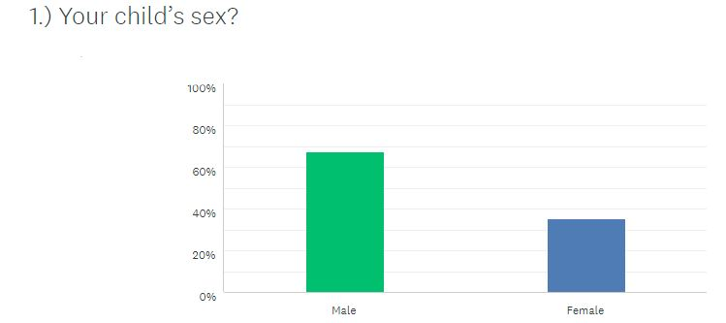
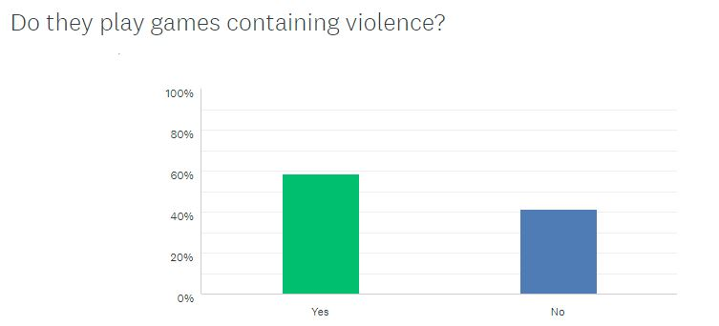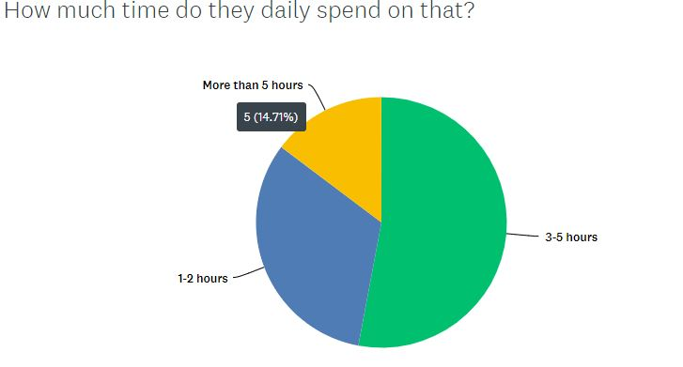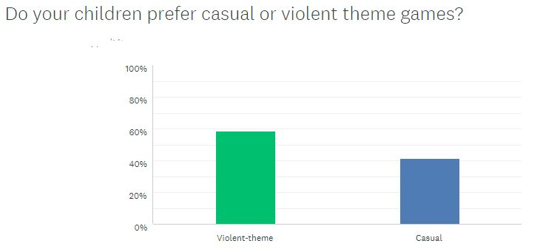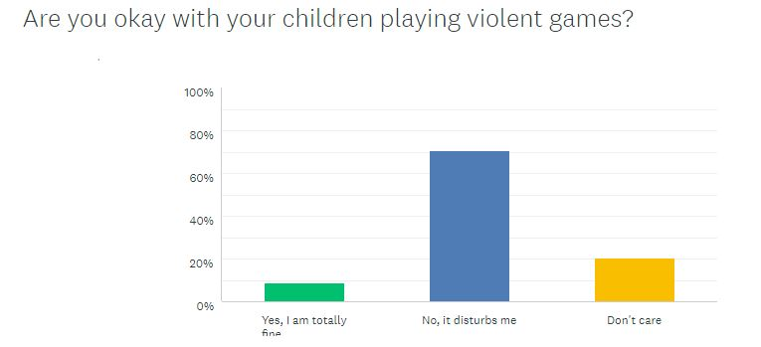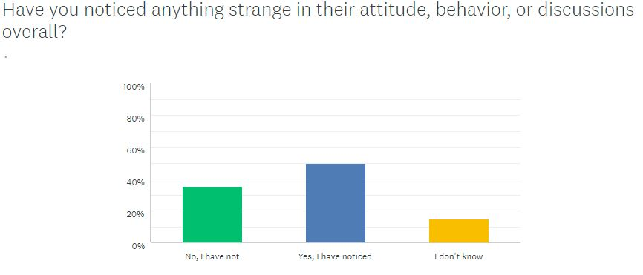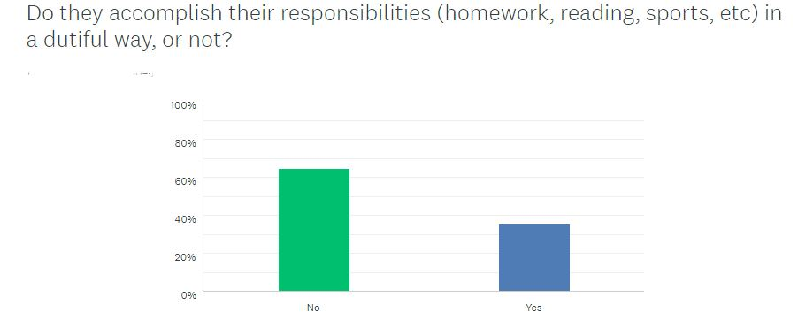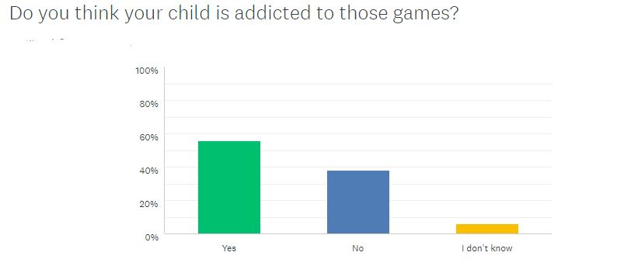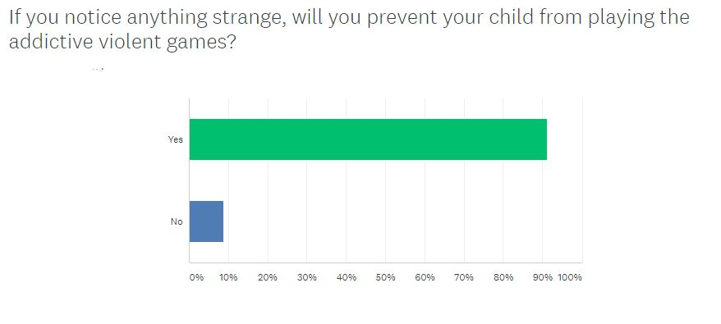
Survey Questions:
1.) Your child’s sex?
2.) Do they play games containing violence?
3.) How much time do they daily spend on that?
4). Do your children prefer casual or violent theme games?
5.) Are you okay with your children playing violent games?
6.) Have you noticed anything strange in their attitude, behavior, or discussions?
7.) Do they accomplish their responsibilities (homework, reading, sports, etc) in a dutiful way, or not?
8.) If you notice anything strange, will you prevent your child from watching the addictive violent games?

Appendix B
Face to Face Interview Questions Part 1 (Parents)
1.) Are you okay with your child playing games that contain violent themes?
2.) Whether you noticed anything strange in his/her behavior after playing violent video games?
3.) Do you have intentions to stop your child from playing violent video games?
4.) Do you consider your child addicted to violent video games?
Face to Face Interview Questions Part 2 (Children)
1.) Do you prefer games that contain action, shooting, killing, or educational games?
2.) What games do you play?
3.) What are you interested besides games?

