THE ROLE OF MEDIA IN RAISING AWARENESS OF SEX TRAFFICKING IN ARMENIA

by

Nare Janvelyan

Presented to the
Department of English & Communications
in Partial Fulfillment of the Requirements for the Degree of Bachelor of Arts
American University of Armenia Yerevan, Armenia

May 14, 2020

Abstract
Sex trafficking, along with other forms of human trafficking, is the fastest rising criminal operation which occurs all around the world. There are twenty-five million victims of sexual exploitation. This phenomenon is a poorly studied topic as a result of its illegal and secretive nature (Malloch & Rigby, 2016). This paper’s research aims to examine the significance of media in raising awareness of sex trafficking in Armenia. The paper also aims to investigate how Armenian media frames the problem regarding sex trafficking through the use of a methodology of in-depth interviews, online surveys and in-person surveys. The overall results of the research indicated that the majority of Armenians were not aware that sex trafficking was a serious problem in the country, nor understood that Armenian women were being trafficked for the purpose of sexual exploitation. The results further indicated that there was not enough media coverage on this social issue. The media outlets could reduce and even contribute to the prevention of sex trafficking in Armenia. However these topics are very sensitive and in order not to harm the victims, Armenian media outlets usually avoid interviewing the victims and writing articles or broadcasting stories about sex trafficking.
Belgian primary data also has been included as a comparative frame for Armenia regarding the issue of sexual exploitation, since Belgium is a transit country for sex trafficking because of its open borders. The results of the online interview showed that Belgium was able to psychologically support its victims and therefore, had no issues covering the topic of sexual exploitation
Keywords: sex trafficking, raising awareness, media coverage, Armenia, Belgium

Table of Contents
Introduction ----------------------------------------------------------------------------------------------- 4
Literature Review ---------------------------------------------------------------------------------------- 6
Research Question and Methodology --------------------------------------------------------------- 14
Research Analysis and Findings --------------------------------------------------------------------- 16
Conclusion ---------------------------------------------------------------------------------------------- 22
Works Cited--------------------------------------------------------------------------------------------- 24
Appendices --------------------------------------------------------------------------------------------- 26

The Role of Media in Raising Awareness of Sex Trafficking in Armenia
This research is a study about the Armenian media in raising awareness and portraying the issue of sex trafficking. This study also examines why Armenian media outlets avoid the topic of sexual exploitation, resulting in the lack of knowledge and misinformation of the phenomenon among Armenian citizens. The case of Belgium is also included to emphasize how different countries cope with this issue.
Sexual exploitation is a phenomenon spread throughout the world, where there are nearly twenty million victims. Sex trafficking or smuggling is a criminal offense related to the purchase and sale of people, as well as the recruitment, transportation, transfer, harboring, or obtaining by the threat of force (Laan, Smith, Busschers & Aarten, 2010). The phenomenon is a poorly studied subject due to its secretive and illegal nature. So, it is challenging to assess its true scope and describe it using adequate statistics. It is a global issue that does not recognize national boundaries. The phenomenon usually refers to the process by which individuals are being illegally transported or are remaining in exploitation to obtain economic benefits. In spite of the existing general international legal framework, every year, millions of children, women, and men continue to be victims of sex trafficking in all regions and most countries of the world (Denton, 2010).
Because of its open borders, Belgium is considered to be a transit country for sex trafficking, by giving access to the traffickers for transporting the victims to former Soviet Republics, Northern Africa and Southern Asia (Ruyver & Vermeulen, 2002). So there is a general issue of sex trafficking in Belgium which is the main reason the researcher had access to this particular European country as a part of the study. Moreover, the comparison between Belgium and Armenia would be essential, considering the different scopes of the issue in both countries.
Arnaud Bouvier, who represents the victims of human trafficking in Brussels and is the head of the Bureau of Coordination Platform against Human Trafficking, was interviewed in order to gain knowledge about the issue in other countries as well and make comparisons with Armenia. In the interview Arnaud Bouvier stated that it is important for the victims to cooperate with them and combine their efforts in solving the problem of sex trafficking. “In most cases, the victims are provided with shelters for few months and they have choice whether or not to testify against the criminals who sexually exploited them” (A. Bouvier, online interview, April 2, 2020). Arnaud Bouvier continued by saying that the majority of the victims usually refused accepting the fact that they were victims, which were the results of trauma. For that reason, Bureau of Coordination Platform against Human Trafficking thought it would be essential to provide specialists to the victims who would be able to take care of their psychological well-being. Since some of the sex trafficking victims were not residents of Belgium, Arnaud Bouvier added that the foreign victims also had a choice of returning to their country or testifying their traffickers. As for the laws against sex trafficking, he stated that his country adopted the law nearly twenty-five years ago, according to which the traffickers could be faced with twenty years of imprisonment (A. Bouvier, online interview, April 2, 2020).
In his article, Grigorian (2005) states that sex trafficking is an important issue that needs to be addressed, where “incorrect information or ignorance of this phenomenon leads to the fact that victims are often in the hands of traffickers” (Grigorian, 2005). She also claims that not only NGOs, the government and the Armenian diasporic communities should take according actions to stop this phenomenon, but media agencies, as well. He adds that the media play a key role in disseminating information and raising public awareness of the concept of human trafficking. (Grigorian, 2005). Therefore, it is essential to see how the Armenian media frames sex trafficking, since sexual exploitation is the most common form of human trafficking. In 2017, there were approximately six thousand reports on hotline regarding sex trafficking where the majority of them were related to escort services (Migration Data Portal, 2017).
The paper also aims to emphasize the importance of the media in playing a role and raising awareness of sex trafficking. If people, along with the trafficking victims, were aware of the situation, there wouldn’t be such a massive amount of people trafficked all around the world. So, it is essential to shed a light on the issue with the help of media.
Literature Review
Sex trafficking is a modern form of slavery, the total annual turnover of which reaches values from 7 to 12 billion US dollars (Laan, Smith, Busschers & Aarten, 2010). Likewise, Malloch and Rigby (2016) state that for decades, Southeast Asian countries (Thailand, the Philippines, and so on) have dominated female suppliers of international sex work. However, the collapse of the Soviet Union opened up access to the shadow labor market for millions of Soviet women, from which international human trafficking draws human resources. As a result, ex-Soviet republics took the place of one of the leading exporters of women for sexual exploitation in developed countries. Ukraine has made one of the prominent positions in this business (Malloch and Rigby, 2016).
Malloch and Rigby (2016), in their book Human Trafficking: The Complexities of
Exploitation, define trafficking as the exploitation of people for prostitution, forced labor, slavery, and organ harvesting. They also state that in Eastern Europe and the South Caucasus, most cases of trafficking are related to sexual exploitation, reaching 53%, whereas forced labour constitutes 40%. Forced labor trade is also booming in Central Asia. Sex trafficking may take place within the same country or between countries for different purposes, including forced and exploitative labor in factories, farms and private households, sexual exploitation, forced marriage, or organ harvesting. The secret nature of trafficking complicates the measurement of this phenomenon. According to the authors, in 2015, twenty-five million people were victims of forced labor and sexual exploitation around the world, where 51% of the victims were women, 21% were men, 20% were girls, and 8% were boys. Among these victims, 45% were trafficked for sexual exploitation, and 38% for forced labor (Malloch & Rigby, 2016). In another study regarding cross‐border human trafficking, Laan, Smith, Busschers & Aarten (2010) state that over the past thirteen years, the UN Office on Drugs and Crime has received information from twenty-five countries about seven hundred victims of human trafficking for organ removal. Two hundred twenty-five thousand people suffered from other forms of traffic (Laan, Smith, Busschers & Aarten, 2010).
There are also articles analyzing the significant role of media in raising awareness and preventing sex trafficking. Anti-trafficking is a process in which not only government agencies, public and international organizations, but also the media combine their efforts. The media play a significant role in mobilizing public support and engaging the public in the prevention and combating of sex trafficking. Due to the reach of a broad audience and the ability to shape public opinion, they are powerful tools for social transformation. Thus, as argued by Denton (2010), investigative journalism on trafficking should be encouraged. In the article she analyzes 191 incidents that involved sex trafficking. Those incidents were reported in international print media. She came to the conclusion that the research about the topic supports media representatives without clearly exploring incidents regarding sex trafficking, where there is a need for a better understanding of the trafficking act, which involves female trafficking offenders and trafficked male individuals (Denton, 2010).
By publishing articles or by reporting on this issue, the media not only educates the public but also sheds light on a question that is usually shrouded in mystery and even can contribute to the freedom of the trafficked people. In his book Hollow bodies: Institutional responses to sex trafficking in Armenia, Bosnia, and India, Dewey (2008) reviews case studies of three women from Armenia, India, and Bosnia-Herzegovina. The women tell their stories of how they became victims of sex trafficking. Without even realizing, they were forced to become prostitutes. For instance, in the case of Sophia from Armenia, she thought that she was hired as a waitress in Greece, as she was desperate for a job to feed her daughter. However, when she arrived in Athens, she realized that she was there for the wrong reasons. Despite wanting to go back to Armenia, it was already too late as she wasn’t allowed to do so. However, her life completely changed when she was able to reach out to the Greek media outlets. They published an article about Sophia where the government and law enforcements were also involved and took according actions. At the end, she was able to be freed with the help of media, which not only raised awareness of the issue among Greek people, but also played a huge role in freeing Sophia from the traffickers (Dewey, 2008).
In a similar manner, Pajnik (2010) states that credible studies conducted by international media can lead to the imprisonment of a trafficker. However, representatives of the mass media do not always undertake that role in this process. Often, sex trafficking is perceived as one of the simple social topics that do not require additional study and analysis. As a result, such a complex phenomenon is covered superficially, publications abound in stereotypes, assessments, and opinions prevail over facts. It leads to an even greater strengthening of stereotypes regarding sex trafficking and does not contribute to the overcoming of the problem (Pajnik, 2010). This article by Pajnik discusses the role and responsibility of the media in the field of preventing human trafficking in connection with the possibility of obtaining specific information during journalistic investigations. In addition to the vital role in raising awareness that the media should play, they can also perform other special functions. The media are indispensable for educating the public on issues related to the numerous manifestations of sex trafficking. Besides, they are obliged, being guided by a cautious approach to receiving advertisements, based on relevant information, to ensure that their affiliates do not unintentionally assist in the operation of certain persons by traffickers (Pajnik, 2010).
At the same time, as argued by Hackett and Harrington in their book An analysis of media coverage of migration and trafficking on the high seas (2018), in some regions of the world, journalists and news agencies are not well aware of the phenomenon of sex trafficking or don't properly understand the extent of the problem. As a result, in some reports, this problem is mixed with other issues, such as prostitution or the smuggling of migrants. When covering specific events, the media should take into account an approach based on the protection of rights and not allow violations of the rights of victims and persons who have been trafficked (Hackett & Harrington, 2018). Harkin (2019) points out the way the media write about sex trafficking is just as important as what is reported, and this information greatly affects the understanding of the problem by the public, politicians, law enforcement officials, and even other media representatives. He states that in recent years, many reports of trafficking were based on misinformation and outdated statistics, which accused the victims, and authors even used the wrong terminology. Instead of shedding light on the situation, such messages only confuse the public; the contained information was insufficient and distorted the public perception of the problem. As trafficking continues to be the focus of public attention, media representatives must carefully and responsibly approach its coverage and protect its victims (Harkin, 2019).
Nieuwenhuys and Pécoud (2007) make a valuable note that in many countries the problem is complicated by the reluctance of victims of sex trafficking to cooperate with media agencies and law enforcement because of fear of retaliation by criminals, mistrust of the authorities or because they do not recognize themselves as victims (Nieuwenhuys and Pécoud, 2007). However, it is of equal importance for the victims to cooperate with them, in order to raise awareness of the issue and prevent in in the future. For instance, in 2019, The United Nations Agency, with the support of the British Embassy, ​​hosted a national seminar for journalists in the UN building in Ashgabat, aimed at strengthening the capacity of local journalists in media coverage of anti-trafficking issues (Dearnley, 2019). David Perth, Deputy Head of the British Embassy noted that the British Embassy was pleased to support the UN in holding the seminar for representatives of the media and public organizations in the field of preventing sexual exploitation. The seminar was attended by media representatives: local newspapers and magazines, electronic media, television and radio channels, as well as young journalist students from local universities. The seminar program was based on the theoretical and practical principles of international human rights activism in the context of conducting information campaigns to raise awareness of the problems of sex trafficking. It also demonstrated the right approaches and tactics as to how cooperate with the victims, so they can feel comfortable and protected. The project allowed for closer cooperation between journalists, students and civil society representatives in covering aspects of sex trafficking and human rights. It also allowed for a detailed study and discussion of the role and responsibilities of the media in covering the aspect of trafficking in persons, and also stressed the importance of the integrated work of all participants (Dearnley, 2019).
The Organization for Security and Cooperation in Europe, as stated by Feingold (2005), has singled out the following main tasks that the media carry out: Informing about sex trafficking as a problem in general; Dissemination of information on the mechanism of human trafficking in order to prevent this crime; Assisting in the dissemination of information on combating and combating trafficking in persons; Dissemination of data on the conditions of legal employment abroad; Promoting the formation of a tolerant attitude towards victims; Dissemination of information about organizations and social projects working in the field of preventing trafficking in persons; Coverage of issues regarding the fulfillment / non-fulfillment by the authorities of their obligations to combat sex trafficking, the effectiveness of spending budget funds allocated to solve this problem (Feingold, 2005). Wallinger (2010) in her thesis analyzes the appearance of this topic in the media. She claims that some aspects of human trafficking are absent in newspapers and journals. It explores the phenomenal understanding of human trafficking, linking it to gender, labor, and migration. Also, the author labels trafficking as ‘criminalization,’ ‘nationalization,’ ‘victimization,’ and ‘regularization.’ All these together help in shaping an anti-trafficking paradigm, which makes trafficking crime and saves the victims by instilling stricter rules. (Wallinger, 2010).
There are efforts being made in raising awareness of the phenomenon all around the world. For example, Serbia took an anti-sex trafficking action, by creating a publication focusing on educating the journalists who were reporting on the issue. The publication included not only general information about sex trafficking, but also how the journalists should behave and what questions they should avoid, while covering this topic, in order not to traumatize the victims and shed a light on this issue (Cooray, 214). The same is true about the United Kingdom, where in 2007, The Newspaper Society, along with the Minister of Women and Equality decided to combine their efforts by creating advertisements. They were placed in the newspapers by raising awareness of the issue (Cooray, 2014). However, it is also possible to raise awareness through film productions as nowadays, the society is heavily influenced by motion pictures. In 2005, the film Lilija 4-Ever was distributed in Eastern European and former Soviet Union countries by the Government of Sweden, since those countries have significantly higher rates of sexual exploitation. The film was about sex trafficking which was aimed at educating women about the traffickers’ strategies and how to avoid becoming a victim. Small (2012) describes how the film acted as a base of shaping southeastern Europe’s understanding of sex trafficking (Small, 2012).
Thainiyom (2011) formed ECPAT International proposal guidelines for the development of an effective communication strategy on trafficking issues. These include an identification of needs by having formed an idea of the problem. Another thing is capacity assessment, which provides for listing available resources, like financial resources (available funds and capacity in the area of fundraising), human resources (specialized knowledge, experience, essential contacts), partners (at local, national, international levels, at the level of law government and the private sector), technical resources (material resources, equipment, documentation), dislocations (time and place are important factors in determining actions). Also, it is necessary to define a specific goal as part of the prevention of sex trafficking. After setting specific goals, it is necessary to plan on how to achieve them by using strategic communication planning, which includes tasks, the target audience, main idea, and finally, means of influence. One of the most important things is public awareness. There is thus a need to provide basic information so that the target audience is aware of the existence of the problem, knows what measures are being undertaken and what additional steps could be taken to prevent human trafficking. The choice of means of influence should be focused on the goals, the main idea, the target audience, and available resources, by using the media: newspapers, radio, television, and the Internet reach a broad audience. Materials produced by the media themselves should also be used, which include interviews, campaign activity reports, videos on the issue, documents distributed on the Internet. The main idea of the campaign should be carefully thought out to ensure its clarity. Real-life examples and case studies help stimulate interest (Thainiyom, 2011).
Nieuwenhuys and Pécoud (2007) suggest that the print media also can be used, as they allow the dissemination of a wide variety of materials, ensure the dissemination of accurate, detailed information, and involve the more active participation of the target audience. Not everyone will read long texts; in this connection, a combination of short effective messages with longer texts containing detailed information is necessary. The print media can take the form of leaflets, brochures, posters, billboards, tabs, reports, graphics, stickers. It is required to combine several types of media to increase the chances of reaching the target audience. Repeatability and continuity contribute to sustaining efforts and help the target audience remember and understand the main idea. Also, Nieuwenhuys and Pécoud’s (2007) research states that two types of assessment should be combined. First, it is qualitative assessment: an evaluation of what people know about sex trafficking, how they perceive it, and what they think about it. This assessment can be done using questionnaires distributed to representative groups. The next one is a quantitative assessment. It is necessary to establish quantifiable indicators characterizing the target audience, the goals of the campaign (i.e., the percentage of people reached in the total number of the potential target audience, the portion of the population, the number of broadcasts, and the number of brochures distributed) (Nieuwenhuys and Pécoud, 2007).
Overall, the main areas of the existing literature fit into the research, as, first of all, they briefly explain what sex trafficking is, by bringing statistics regarding the phenomenon. Secondly, the existing literature reviews the importance of the media regarding sex trafficking, as it shapes public opinion. Moreover, the existing literature touches on the subject of the responsibility of the media, which can prevent sex trafficking. Furthermore, proposal guidelines are included for the development of an effective communication strategy on trafficking issues, which are also an essential aspect of raising awareness of the problem of sex trafficking.
Research Question and Methodology
The research strives to find an answer to the following primary question: Can media coverage influence public opinion and raise awareness of sex trafficking in Armenia? Also, it seeks to answer another question including Why is there a lack of media coverage in Armenia regarding sex trafficking?
But in order to answer the above mentioned questions regarding Armenia, mixed methodology approach has been used. The research was an online survey, in-person survey, face-to-face interview and online interview. Also, as mentioned above, Belgian primary data has been used as a comparative frame for Armenia regarding the issue of sexual exploitation, since Belgium is a transit country for sex trafficking.

Methodology | Name | Position | Date
Online Survey | Community of the American University of Armenia | Students, professors, staff members | Jan. 25-Feb. 14, 2020
In-Person Survey | ---------- | ---------- | Feb 16-29, 2020
Face-to-face Interview | Ani Karapetyan | Assistant of the Head of Anti-Trafficking Department of the RA Police | March 2, 2020
Online Interview | Sahak Hambardzumyan | Reporter of Armenian media agency Aysor | March 6, 2020
Online Interview | Arnaud Bouvier | the Head of the Bureau of Coordination Platform against Human Trafficking | April 2, 2020

The online survey consisted of five questions with multiple choices. There were 126 respondents. Mostly, the community of the American University of Armenia participated in the online survey, where the questionnaires were sent via e-mails and were posted in both the AUA Undergraduate Students and the AUA Class of 2020 Facebook groups. The purpose of the survey was intended to gain an understanding of the Armenian society’s knowledge of the phenomenon and to find out whether or not the Armenian students were aware of sex trafficking. The online survey was created in January 25, and it took twenty days to gain the needed data (until February 14).
For the in-person survey, the participants were chosen randomly and weren’t a part of the AUA community. Fifty-eight participants were approached in various streets of Yerevan and were asked the same questions as for the online survey. The purpose of the in-person survey method was to find out if the Armenian society was aware of sex trafficking, and also to have different target audiences, and not to focus on a specific age group. For that reason, different genders and age groups were chosen as a target audience, since the answers were most likely to vary according the genders and the age groups of the participants. It took thirteen days to approach fifty-eight participants for the in-person survey, from February 16 to February 29.
As regards face-to-face interview, the interviewee was the assistant of the Head of Anti-Trafficking Department of the RA Police, Ani Karapetyan, since the Head of Anti-Trafficking Department Vache Hovsepyan himself wasn’t available. The interview took place in her office in March 2. The main purpose of the interview was to gain an understanding of how the Armenian police department frame sex trafficking.
Since the main focus of the project is raising awareness of the issue with the help of media, the reporter from the Armenian media agency Aysor, Sahak Hambardzumyan was interviewed via online in March 6. The questions were sent to him via e-mail. The purpose of the interview was to hear his thoughts regarding the sex trafficking issue in Armenia.
Another online interview included Arnaud Bouvier, who represents the victims of human trafficking in Brussels and is the head of the Bureau of Coordination Platform against Human Trafficking. The questions were also sent to him via e-mail on April 2. The questions were similar to that of Ani Karapetyan, the assistant of the Head of Anti-Trafficking Department of the RA Police. The aim of the interview was to look at the situation outside Armenia and see if faced issues were similar to each other. Also, this interview can be presented as a base for comparison between Armenia and Belgium.
Research Analysis and Findings
Surveys
Online Survey
The majority of the online survey participants were females (80%) and half of them were aged 16-20. Nearly 90% of the 126 respondents were aware of the phenomenon called sex trafficking. It is worth mentioning that almost half of the respondents indicated Eastern Europe to have the highest rate of sexual exploitation, whereas Southern Asia and Russia shared the second place. As for the U.S.A., only 13% of the participants noted its sex trafficking rate to be high. As regards the occurrence of the phenomenon in Armenia, 80% of the participants had no clue it took place in Armenia as well. On top of that, the answers ‘Maybe’ or ‘I don’t know’ were even higher than the answer ‘Yes.’
The results of in-person survey were quite similar to online survey, with an exception of age group, which ranked thirty-one and above. Half of the participants were males, and the other half were females where 91% of them were aware of sex trafficking. But, like in the online survey, 85% of participants were sure that there was no sexual exploitation in Armenia. Also, they stated Russia to have the highest rate of the phenomenon with 43%, whereas Southern Asia and Iran shared the second spot with 17%. Surprisingly, Eastern Europe accumulated only 10% which slightly differs from that of the online survey results, where the AUA community placed Eastern Europe on the first spot.
Overall, the survey results indicate that the majority of the citizens are familiar with sex trafficking, but aren’t aware of this global issue in Armenia. It leads to a conclusion that there is a lack of media coverage in the country. Therefore it was essential to interview the assistant of the Head of Anti-Trafficking Department of the RA Police and the reporter of the Armenian media agency to find out the reason for lacking the information regarding the phenomenon in the media.
Interviews
Face-to-face Interview
During the face-to-face interview, Ani Karapetyan stated that sex trafficking was flourishing in Armenia (A. Karapetyan, face-to-face interview, March 2, 2020). She continued on by telling that as of 2019, there were eleven criminal cases opened in Armenia that were related to sex trafficking. Ani Karapetyan noted that the majority of the sexual exploitation cases took place abroad, namely in Russia, Greece, Turkey and the UAE. The main reasons for becoming the victims of sex trafficking were difficult social and economic conditions, and a low level of legal awareness and educational qualifications. “Since there is no legal awareness, the victims are pushed into the sex trafficking industry, with the promises of high salaries in a short period of time. On top of that, the job doesn’t require work experience, knowledge or professional skills,” said Ani Karapetyan. She also added that such seduction often became the reason for the growth of cases regarding sex trafficking.
She continued on by stating that the Armenian government was making efforts in trying to organize awareness campaigns. “Ten years ago the Armenian government signed with NGOs an agreement to fund the victims of sexual exploitation which also included providing them a shelter for at least thirty days.” However, the number of identified victims decreased over the past years and in her opinion, the government, along with the Anti-Trafficking Department should have made more efforts in protecting and mentally supporting the victims. She pointed out that when the victims were being questioned by the police in the court, they had to face their traffickers. It most likely traumatized the victims by causing PTSD (Post Traumatic Stress Disorder). For that reason, the majority refused to identify themselves as the victims of sexual exploitation.
Also, Ani Karapetyan mentioned there was a law against sex trafficking, where according to Article 132, the traffickers could face from four to approximately fifteen years of prison. Overall, Ani Karapetyan concluded that there should be the creation of new structures which would take care of the victims and put an end to the sex trafficking in Armenia.
Online Interview
Another part of data gathering included online interview with Sahak Hambardzumyan, the reporter of Aysor. Firstly, he said that sex trafficking was a phenomenon spread throughout the world, and Armenia was one of those places (S. Hambardzumyan, online interview, March 6, 2020). “Although sexual exploitation is known to be spread in Eastern Europe or Southern Asia, it’s still present in our country. If you take into account that there are only three million Armenians in our country, even few cases of sex trafficking are considered to be very high for our small population.”
To his mind, media was one of the tools which could at least decrease the numbers of the victims. He stated that approximately 85% of nowadays information was spread through media platforms and, undoubtedly, it could play the role of raising awareness of the issue, which could let to preventing sexual exploitation in Armenia. Sahak Hambardzumyan went on by bringing an example of few years ago as to how the Armenian government provided money to their agency, so they could publish and distribute brochures about the negative effects of sexual exploitation. “For sure it did its job, and we were able to at least raise awareness regarding consequences of sex trafficking.”
They have done lots of efforts to cover sexual exploitation in their articles. However, they were faced with numerous problems which resulted in the lack of media coverage. One of the problems was the fear of traumatizing the victims. “As journalists, we should be careful of using such term as prostitution. We also don’t want to cover the stories of financially unstable girls, who started using drugs, and because of their actions became the victims of sexual exploitation. Unfortunately, there are lots of journalists all around the world who write their articles, without thinking how their actions will affect the victims. It also can have an effect of the way the readers get perception of this important issue, while at the same time shadowing its importance.”
On the other hand, Sahak Hambardzumyan said the majority of the victims weren’t eager to be interviewed which was also another form of trauma. In his opinion, the journalists should be able to find a way of comforting the victims, where psychologists should be involved. He stated that after the victims felt comfortable speaking with the journalists, they would have even greater chances of covering their stories, without traumatizing them. It surely would help to raise awareness in the public, especially when the articles were going to be about the survivors who had been through sexual exploitation. “It would be a great opportunity for both the victims to share their stories and for the readers to be educated about this issue in Armenia.”
Online Interview
In an online interview, Arnaud Bouvier stated that sexual exploitation was the most common form of human trafficking in Belgium (A. Bouvier, online interview, April 2, 2020). “Belgium is considered to be a transit country for sex trafficking. The majority of the victims are Asians, Nigerians and Eastern Europeans, where they are illegally moved to neighboring European countries through Belgium.” He continued on by saying that the exploiters and criminal organizations usually made use of Thai massage salons to hide from the authorities and to carry on their business of sex trafficking.
According to him, in order to prevent sex trafficking, Bureau of Coordination Platform against Human Trafficking was created few years ago, where Arnaud Bouvier was appointed as the head. He also added that, similarly, such kind of platform was created in Eastern Europe as well almost thirty years ago. He said that the coordination platform has made huge efforts in preventing sexual exploitation by making use of the police and even providing shelters for the victims. “Some of the representatives of the governmental administrations are also involved in preventing sexual exploitation, including media outlets.” Arnaud Bouvier also added that every year, their platform published reports indicating the results of sexual exploitation in Belgium which was also a great way of assessing its effectiveness. He said that their main goal would always be fighting against sex trafficking and assisting the victims both mentally and psychologically. The efforts of the coordination platform were positive, since during the last four years, the number of sexually exploited victims decreased in Belgium to 350, as opposed to 2016, where the number of the victims reached almost 600.
Both Armenia and Belgium are making efforts in not only raising awareness of the issue, but also trying to support the victims which is equally important. Since all of the interviewees mentioned the trauma of the victims, where the majority of them refused to accept the fact that they were victims or were afraid to face their traffickers in the court, the well-being of the victims should be taken into consideration by assisting with medical and psychological support. However, unlike Armenia, the Bureau of Coordination Platform against Human Trafficking of Belgium makes more effort in psychologically assisting the victims. The scope of the issue is very different in both countries, since there are not as many immigrants in Armenia as there are in Belgium, and Armenia is not considered to be a transit country for sex trafficking. So, both countries aren’t faced with similar issues, and therefore, they deal with the problem in a different way. However, the fact that there are awareness campaigns and organizations fighting against sex trafficking in both countries indicates that there is a progress in solving the issue.
Summary
By summarizing all the gathered data, conclusions about the lack of media coverage can be made, since the participants of the survey were positive that such kind of phenomenon never happened in Armenia. The Armenian media outlets don’t specifically cover the topic of sexual exploitation. Although the government tried to launch awareness campaigns, the psychological issues of the victims were a result of unsuccessful efforts. On the other hand, the selection of the appropriate terms regarding sex trafficking victims is a major issue in Armenia in order not to traumatize and spread misinformation. As for the comparison, the assistance of the victims is a priority in Belgium, whereas this sphere should be developed in Armenia. As all three of the interviewees stated, psychologists should be involved in this case, where the victims would feel comfortable talking about their trauma. Without the cooperation of the victims, it would be a challenging task to raise awareness of the phenomenon in Armenia.
Conclusion
This paper studied how media could raise awareness of the issue regarding sexual exploitation. Throughout the study, different aspects of awareness raising attempts were examined to understand the Armenian media outlets’ efforts in shedding light on the issue. The research found that the lack of Armenians’ knowledge of sex trafficking is directly linked to the lack of media coverage.
The role of media is very sufficient in raising awareness of the issue, as seen in some of the examples covered in the research paper. Lots of countries also make huge efforts in creating campaigns to protect the victims and educate the public, including Armenia and Belgium. However, the results of the research indicate that there is still a lack of media coverage, which can have a great impact of influencing public opinion and raising awareness of the problem of sex trafficking.
This paper’s research illustrate that the main issues of covering stories regarding trafficking is the sensitivity of the victims. On the other hand, journalists are faced with a serious challenge of stereotyping the issue by not understanding the scope of the problem and not covering it deeply. As a result, the fear of traumatizing the victims and misinterpretations of the journalists remain the main obstacles of not contributing to the overcoming of the problem. Also, journalists and news agencies sometimes don't understand the extent of the problem properly, by mixing it with prostitution or the smuggling of migrants. This problem is true about Armenia as well, where the media agencies tried to cover stories of sexual exploitation, but failed to do so, in order not to traumatize the victims. So, there should be a communication and respective understanding between the victims and the journalists, where they should take into account an approach to protect the rights of the victims. By finding solutions to these issues, Armenia will become one step closer of raising awareness and solving the problem of sex trafficking.
Limitations
Since sex trafficking is a serious and heavy topic, short study duration served as an obstacle in examining the topic even deeper. Also, another limitation for the research was in-person survey. Strangers weren’t feeling comfortable talking about sex trafficking. Although the goal was reached and there were fifty-eight participants, it was quite challenging to gather such amount of strangers and ask them about sexual exploitation.
Overall, sex trafficking is an issue of international concern and socio-cultural realities where different locations surround this problem. It is understandable that media alone can’t solve the problem of sex trafficking. Government, NGOs and legal factors also play a huge role and should be involved. Although it shouldn’t be limited to media, its coverage may lead to the beginning of solving this global phenomenon step by step. It also can be regarded as the start of raising awareness of the issue in order to prevent it in the future.

Bibliography
Bouvier, A. (2020, April 2). Online interview
Cooray, M. (2014, January). The Role of the Media in Combatting Human Trafficking.
Retrieved on January 29, 2020 from
https://www.researchgate.net/publication/271963308_The_Role_of_the_Media_in_Combatting_Human_Trafficking
Dearnley, R. (2019). Prevention, Prosection and Protection - Human Trafficking. Retrieved
on February 4, 2020 from https://www.un.org/en/chronicle/article/prevention-prosection-and-protection-human-trafficking
Denton, E. (2010) International News Coverage of Human Trafficking Arrests and
Prosecutions: A Content Analysis. Women & Criminal Justice, 20 (1-2), 10-
26, DOI: 10.1080/08974451003641321
Dewey, S. (2008). Hollow bodies: Institutional responses to sex trafficking in Armenia,
Bosnia, and India. Kumarian Press.
Feingold, D. (2005). Human Trafficking. Foreign Policy, 150, 26-32. Retrieved on January
29, 2020 from
http://www.jstor.org/stable/30048506
Grigorian, H. (2005). Human Trafficking in The Republic of Armenia. Armenian
International Policy Research Group. Retrieved on January 15, 2020 from
https://core.ac.uk/download/pdf/11870192.pdf.
Hackett, J., & Harrington, S. (2018). An analysis of media coverage of migration and
trafficking on the high seas. East Barnet, Herts, United Kingdom: John Libbey
Publishing Ltd. doi: 10.2307/j.ctt20krz85
Hambardzumyan, S. (2020, March 6). Online interview
Harkin, J. (2019, January 14). Covering Sex Trafficking: Journalists Can Do Better.
Retrieved on January 15, 2020
from https://archives.cjr.org/behind_the_news/covering_sex_trafficking_journ.php
Karapetyan, A. (2020, March 2). Face-to-face interview
Laan, P. H., Smit, M., Busschers, I., & Aarten, P. (2010). Protocol: Cross‐border
Trafficking in Human Beings: Prevention and Intervention Strategies for Reducing
Sexual Exploitation. Campbell Systematic Reviews, 6(1), 1–30. doi: 10.1002/cl2.65
Malloch, M., & Rigby, P. (Eds.). (2016). Human trafficking: The complexities of
exploitation. Edinburgh: Edinburgh University Press. Retrieved on February 22, 2020
from
http://www.jstor.org/stable/10.3366/j.ctt1bgzbwp
Migration Data Portal. (2017, August 8). Retrieved on January 23, 2020 from https://migrationdataportal.org/themes/human-trafficking
Nieuwenhuys, C., & Pécoud, A. (2007). Human Trafficking, Information Campaigns, and
Strategies of Migration Control. American Behavioral Scientist, 50(12), 1674–1695.
doi: 10.1177/0002764207302474
Pajnik, M. (2010) Media Framing of Trafficking. International Feminist Journal of
Politics, 12 (1), 45-64, DOI: 10.1080/14616740903429114
Ruyver, B. D., & Vermeulen, G. (2002). Strategies of the EU and the US in combating
transnational organized crime. Ghent University: Maklu.
Small, J. (2012). Trafficking in Truth: Media, Sexuality, and Human Rights
Evidence. Feminist Studies, 38(2), 415-443. Retrieved on April 10, 2020 from
www.jstor.org/stable/23269193
Thainiyom, P. (2011). A media campaign to increase awareness and prevention of human
trafficking in Asia: Background strategies and outcome evaluation of the MTV
EXIT campaign. Interdisciplinary Conference on Human Trafficking at the
University of Nebraska. Retrieved on April 3, 2020 from
https://digitalcommons.unl.edu/humtraffconf3/17/
Wallinger, C. S. (2010). Media Representation and Human Trafficking: How Anti-
Trafficking Discourse Affects Trafficked Persons. University of Nebraska-Lincoln,
19–20. Retrieved on February 12, 2020 from
https://digitalcommons.unl.edu/humtrafconf2/4/

Appendices
Appendix A
Online Survey Charts

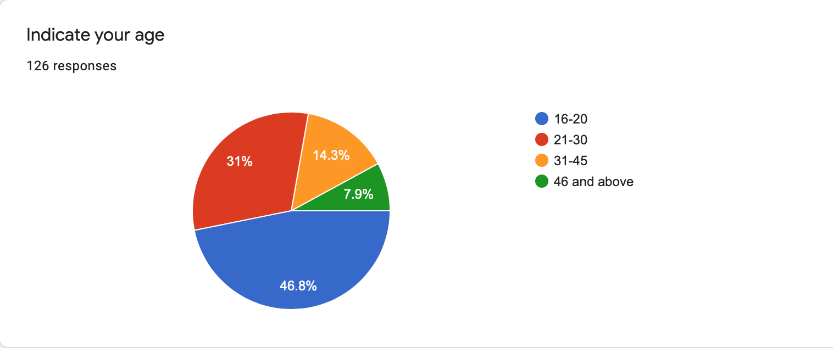

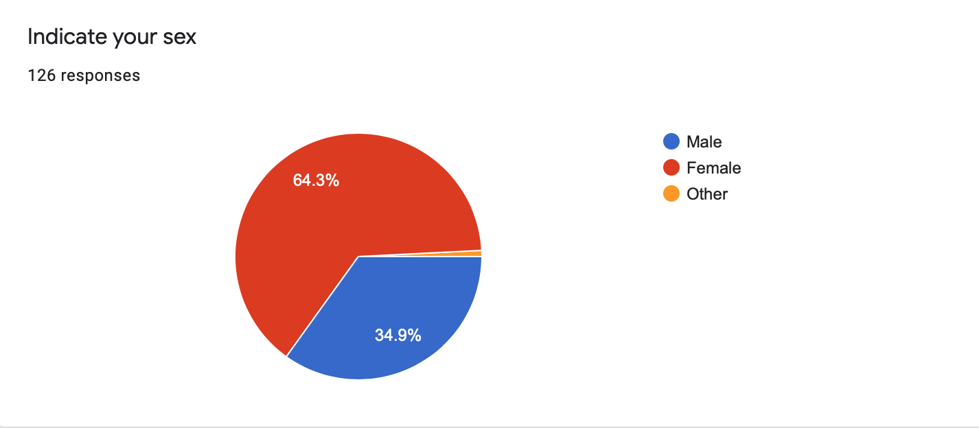

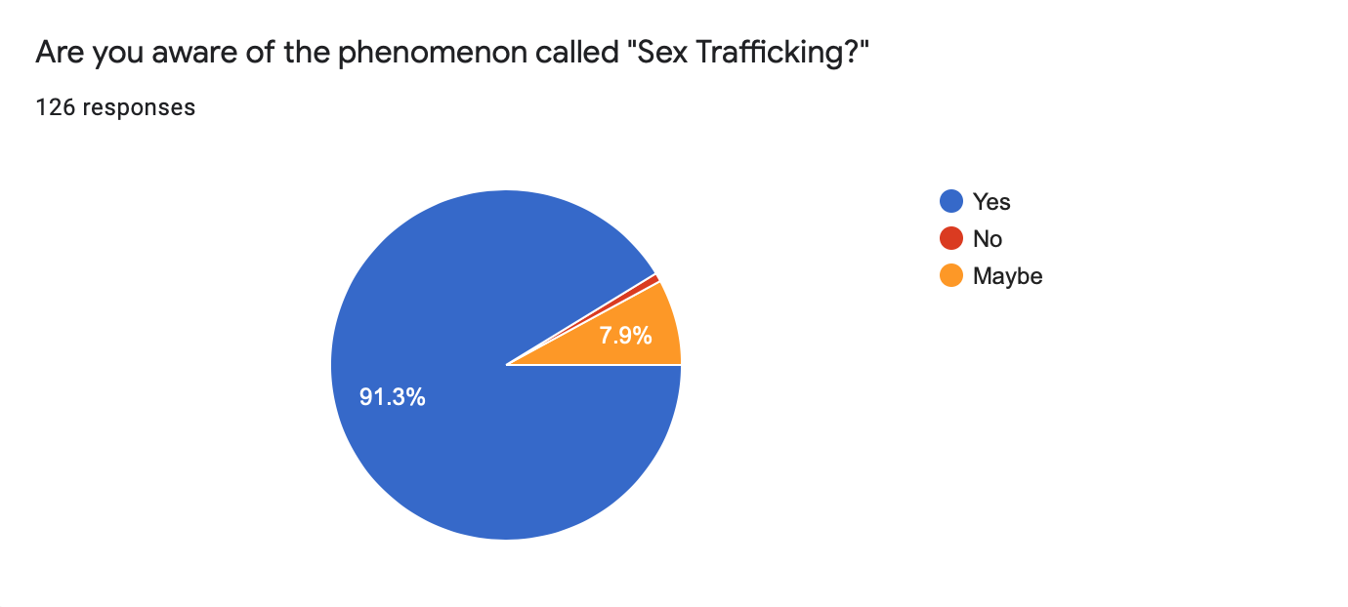

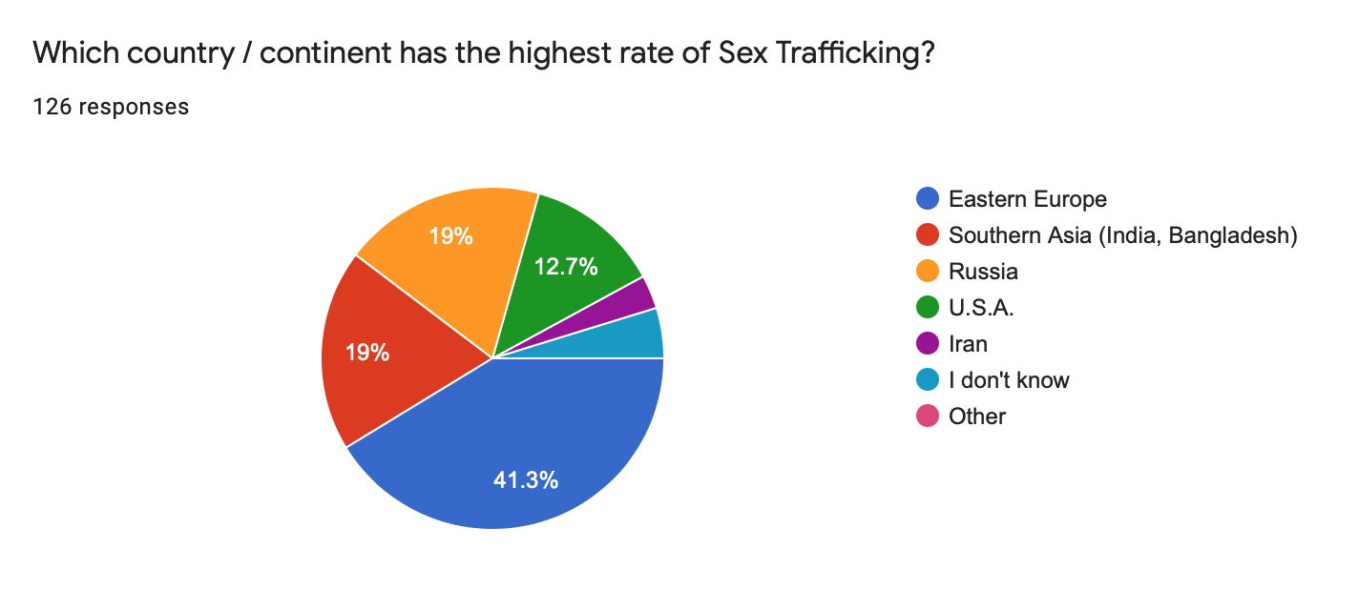

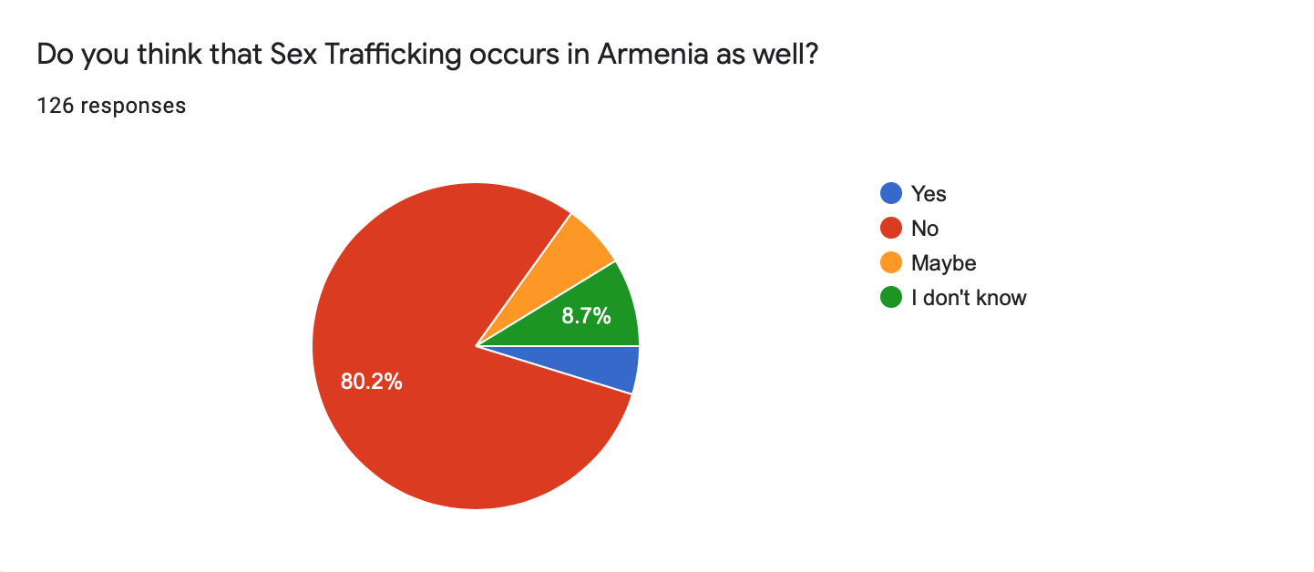

In-person Survey Charts

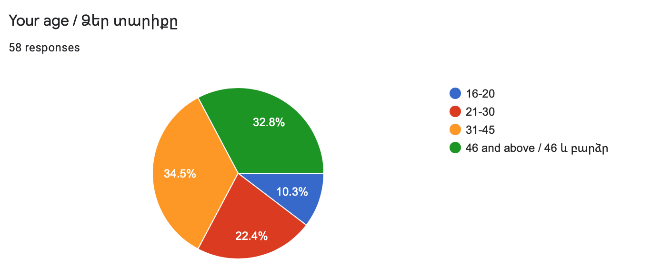

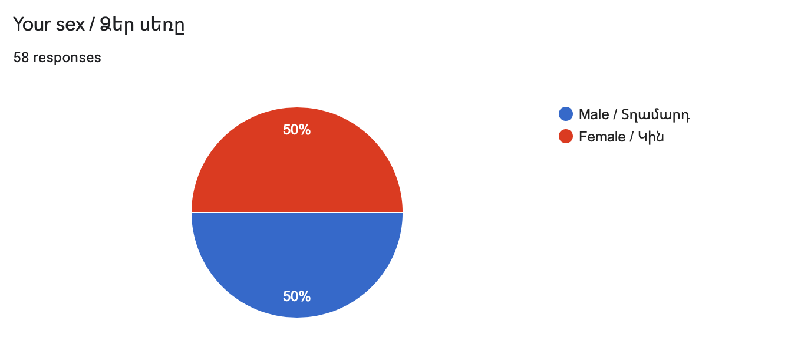

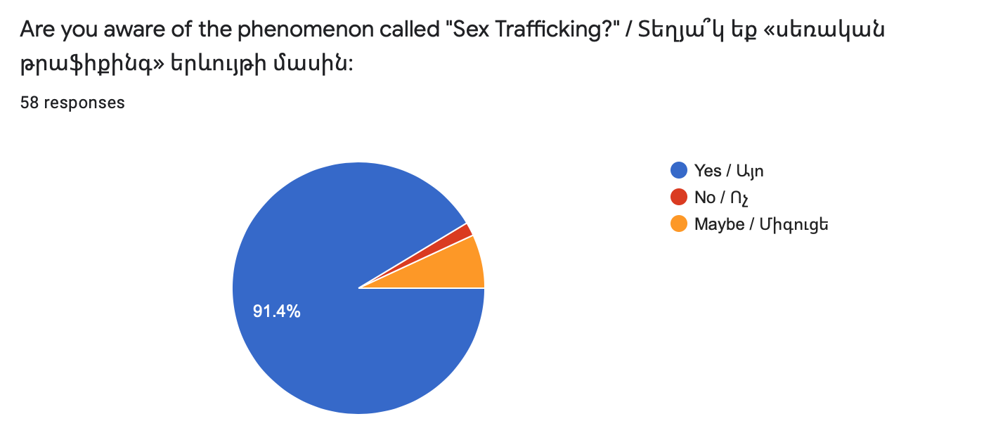

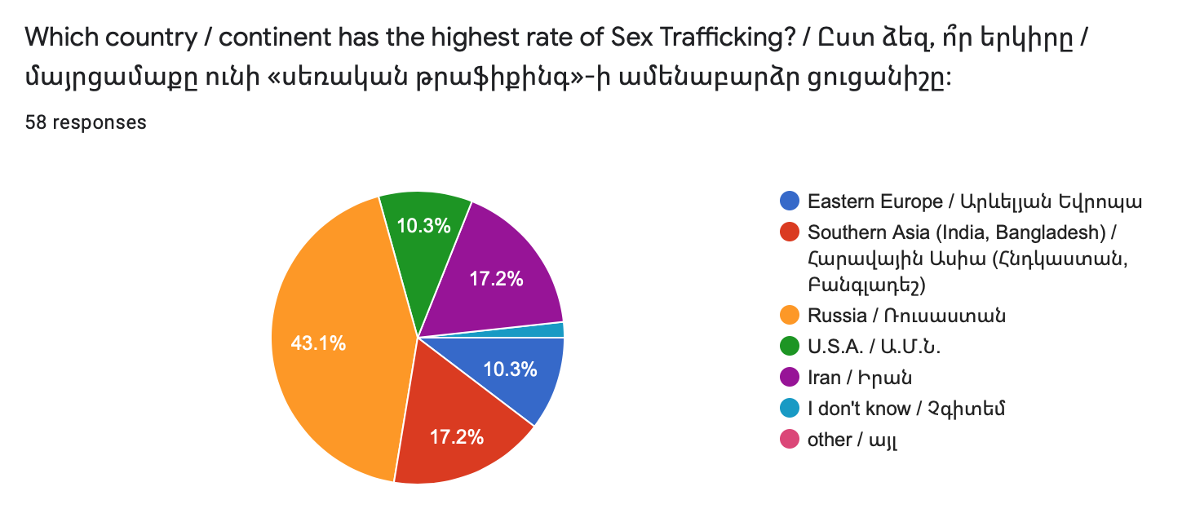

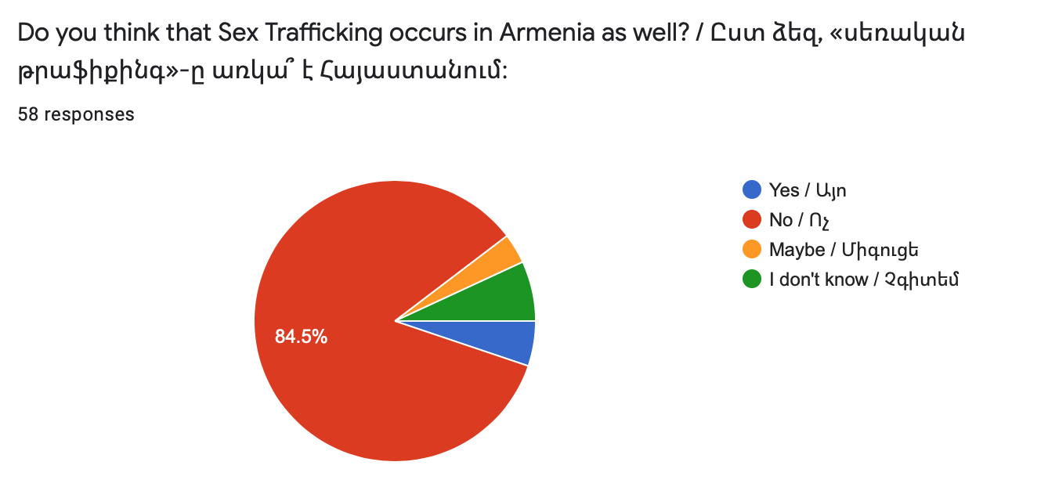

Appendix B
Face-to-face Interview Questions
- Do you have documentation indicating a precise number of sex trafficked people in Armenia?
- Does the police department have awareness campaigns or official websites which sheds a light on the issue of sex trafficking?
- Are there any laws against sex trafficking in Armenia?

Online Interview Questions No. 1
- What are your thoughts regarding the sex trafficking issue in Armenia?
- Can media and communication have an important role in preventing sex trafficking both in Armenia and worldwide?
- What can be done to raise awareness of the problem in Armenia?

Online Interview Questions No. 2
- Do you have documentation indicating a precise number of sex trafficked people in Belgium?
- Does the police department have awareness campaigns or official websites which sheds a light on the issue of sex trafficking?
- Are there any laws against sex trafficking in Belgium?

