Resublimation

by

Mariam Ghazaryan

Presented to the
Department of English & Communications
In Partial Fulfillment of the
Requirements for the Degree of Bachelor of Arts

American University of Armenia
Yerevan, Armenia

May 11. 2020
Abstract
This creative project is inspired by and mainly focuses on the concepts of abjection, disgust, and the formless. The paper aims to analyze the relationship between them, compare, and eventually dissect, explore, and analyze the photographs themselves. Abjection is the failure in the differentiation between the Self and the Other, of the object and the subject, or, in other words, the reaction one can get exposed to the inevitability and presence of decay of meaning and distinction, of form and content. The formless is something not elevated, primal, possibly disgusting, and at the same time having the potential to be of indefinite forms, it is debased and is in a state of formational and contextual decay, thus can evoke abjection. This piece of experimental photography is an attempt to understand the given concepts, dive into them, and perhaps discover something new.

Literature Review
The main themes of this project are abjection and the formless; their interconnectedness; disgust and horror; abjection of reality; abjection of the self and the body; and the two extremes of aversion and attraction.
Julia Kristeva’s “The Power of Horror: An Essay on Abjection” revolves around the subject of abjection. Kristeva defined the term “abject” as a reaction of the person who loses the distinction between the self and the other, which is horror or disgust. It is the borderline between the object and the subject, the “I” and “Not I”. Kristeva posits that abjection is something that we must experience in our psychosexual development. We define the boundaries between ourselves and the world, and that helps us to protect ourselves.
For example, our bodies. The human body is the vessel of the self. And when the self is contained in something so strangely impure, it shocks us. Impurity is what we might feel when we encounter urine, feces, menstrual blood, et cetera. It is potentially impure, because that’s unclean, anti-hygienic, a waste, possibly toxic or deadly. So, when we experience disgust or fear, we tend to detach from that something, the other, to save ourselves from being crushed by it, by the shocking identification. However, Kristeva says, “A wound with blood and pus, or the sickly, acrid smell of sweat, of decay, does not signify death. In the presence of signified death - a flat encephalograph, for instance - I would understand, react, or accept. No, as in true theater, without makeup or masks, refuse and corpses show me what I permanently thrust aside in order to live. These body fluids, this defilement, this shit are what life withstands, hardly and with difficulty, on the part of death. There, I am at the border of my condition as a living being. (1980, p. 3)” Moreover, according to Kristeva, that limbo of the passage from the self to the other is the area where everything loses its meaning. It is both what it was and what it will be, it is both the “I” and “Not I”, and, in Sartre’s style, everything and nothing. And thus, becomes indefinite and shapeless. It is symbolic, existing, of shape, too. And that is how it connects to Krauss and Bois and the informe.
According to Yve-Alain Bois and Rosalind Krauss and their “Formless: A User’s Guide”, the formless, l’informe, is something debased, simple, raw. It is nothing and, thus, can be everything and anything. It can be dirty, disgusting, but it can also be natural, intimate, familiar. It is something that is out of the battle between shape and content. The visual shape represents a metaphor for conceptual form. The shapelessness is the content and concept itself. “Matter cannot be reabsorbed by the image (the concept of image presupposes a possible distinction between form and matter, and it is this distinction, insofar as it is an abstraction, that the operation of the formless tries to collapse. (Krauss, Bois, 1997, p. 29)” The deconstruction leads to disorder, loss of meaning (which is what happens during abjection); however, it also gives a place for multiple meanings and indefinite forms to exist. The destructive and self-destructive tendency of everything is what creates the formless form within the essence of scatological experience and matter. In this conversation between Rosalind Krauss, Yve-Alain Bois, Hal Foster, Benjamin Buchloh, Denis Hollier, and Helen Molesworth, “The Politics of the Signifier II: A Conversation on the “the Informe” and the Abject”, Foster asks, “The problem of the informe arises in the circle of Georges Bataille. Why does it arise then, and why does it return? What different roles does it play in its various returns? How is the informe related to the abject, and how are both related to the “scatterological” impulse in contemporary art?” (1994, p. 3) Following Krauss, the informe is structural in its unstructuredness, and that way, the disorganized becomes organized, the meaningless - meaningful, and the primal - sublime. As the abject means the loss of differentiation between the self and the other, the person entering the space of abjection comes into the formless entity, which is, still, an entity.
In “The Informe” without Conclusion,” Rosalind Krauss elaborates on the concept of the formless and on the “User’s Guide.” Krauss starts with the origin of the concept of abject, “L’Abjection et les Formes Misérables” by George Bataille, and then proceeds with Kristeva’s “Powers of Horror”. At some point, Krauss aims to show the difference between the abject and the formless. “The other word to which Bataille turned to evoke this process of “deviance” was the informe, a declassement in all senses of the term: in the separations between space and time (pulse); in the systems of spatial mapping (horizontalization, the production of the lower-than-low); in the qualifications of matter (base materialism); in the structural order of systems (entropy). As this entire project has worked to demonstrate, these processes marked out by the informe are not assimilable to what the world of art currently understands as abjection. (Krauss, 1996, p. 105)” This difference is essential to note.
In “Abjection and the informe: Operations of debasing,” Konstantina Georgelou discusses the reading of abjection through the informe. She suggests observing the formless as related to the abject. In her work, she refers to the conversation mentioned above and notes that the main reason the participants did not come to a particular conclusion was the absence of certainty in a question whether the formless and the abject belonged to the scatological (excrements, dirt, obscenity, perversion) or scatterological (chaotic, decentralized) origin. Then, “Hal Foster considers abjection to be too oppositional, thus creating an ‘inside–outside’ model, while the informe suggests a different relationship to the body. An inside–outside model might solidify boundaries between races, sexualities etc. … The abject is more directly associated to social phenomena of violence and exclusion. (Georgelou, 2014, p. 31)” But “Both notions map an alteration in a structural manner: a process of undoing that does not arrive at a conclusion but is rather an ongoing operation of debasing. (Georgelou, 2014, p. 31)” The formless and the abject can be related; however, the existence of one of them is not necessary for the existence of the other. The formless is something that we can experience abjection for. Both of them can belong to scatological and scatterological origins.
The detachment which occurs from disgust serves to repress the unbearable thought of resemblance with something we do not want. For example, in his book “Disgust”, Winfried Menninghaus notes, “On the other hand, laughing at something, as an act of expulsion, resembles in itself the act of rejecting, of vomiting in disgust. Disgust, which undergoes a countercathexis (or a sublimation), and laughter are complementary ways of admitting an alterity that otherwise would fall prey to repression; they enable us to deal with a scandal that otherwise would overpower our system of perception and consciousness (2003, p.11).” But he also states that what is true is disgusting, and what is disgusting - is true. Like this, he establishes the sublimity of the other. He postulates the enjoyment of abjection - with all of its destructive nature - amazing and true.

Swiss Army Man
The work that inspired me to create this project is a 2016 movie written and directed by Dan Kwan and Daniel Scheinert, Swiss Army Man.
In Swiss Army Man, a strong connection with abjection is traceable. It all starts when Hank, the main protagonist, tries to hang himself and sees the cadaver Manny bloating with gases fiercely, laying on the shore. Farting in this movie most likely is a metaphor for being yourself, sincere, and alive. As the dialogues and visuals suggest in this scene, Manny is coming back to life and to the purity of not knowing anything about it. Hank was someone ashamed, excluded from society, and detached from himself. He considered himself disgusting because he saw himself as crazy, unloveable, he had potency issues, he was awkward and shy; the society found him disgusting because he had a mental disorder. Manny is a disgusting corpse, a real or a fantasized one, and he embodies the way of going through self-disgust, body-disgust towards acceptance, and eventually sublimation.
Quoting Manny, “If my best friend hides his farts from me, then what else is he hiding from me, and why does that make me feel so alone? (Swiss Army Man, 2016)” This is perhaps an example of identification of the self and the body. Hiding and being ashamed of the nature of the body equals hiding and being ashamed of the self. Many things our body is about are considered disgusting, not appropriate. That is something people detach themselves from. We learn that sweat, feces, farts, mucus, urine, and so on are repulsive, and we also come to that conclusion because of the actual essence of these things. We detach ourselves to repress the shocking realization of resemblance with something we do not want, whether it results in disgust or horror, which are non-identical. The borderline between the normal and the disgusting is the borderline between “I” and “Not I”, the self and the other. The formless frightens us, but it can also lure and excite us, because it is a hidden part of ourselves, intrinsic to I. That is how the abject can inspire, giving birth, for example, to the abject art, through sublimation of the abject.” Resublimating, but in the guise of desublimating. (Foster, 1994, p. 12)”
Manny’s genitals guiding them refer to sexual drive - he had a constant erection, and his sexual drive was guiding them. That was a journey of sexual and spiritual arousal. Hank himself is devoid of sexual pleasures, and Manny has something he does not have. He doesn’t have a girlfriend, he doesn’t have sex, and he can’t masturbate because he starts to think about his mother. Impotence here can be viewed in relation to the impossible object. “The phobic object is, in that sense, the hallucination of nothing: a metaphor that is the anaphora of nothing. What is “nothing”? The analyst wonders and answers, after “deprivation,” “frustration,” “want,” etc.: “the maternal phallus.” That, from his point of view, is not false. But such a position implies that, in order to bring fear to the surface, the confrontation with the impossible object (the maternal phallus, which is not) will be transformed into a fantasy of desire. On the trail of my fear, I meet again with my desire, and I bind myself to it, thus leaving stranded the concatenation of discourse with which I have built my hallucination, my weakness and my strength, my investment and my ruin. (Kristeva, 1982, p. 42)” He mourns the object, and dances on the “ruins” he built with Manny.
“There are lives not sustained by desire, as desire is always for objects. Such lives are based on exclusion. They are clearly distinguishable from those understood as neurotic or psychotic, articulated by negation and its modalities, transgression, denial, and repudiation. Their dynamics challenges the theory of the unconscious, seeing that the latter is dependent upon a dialectic of negativity. (Kristeva, 1982, p. 6-7)” And so is Manny, dependent upon a dialectic of negativity, a cadaver seemingly devoid of life, yet it’s not all he is. It is possible that Manny was a part of Hank’s imagination, Hank himself. If he was, he could be exactly “I”, whom Hank wanted to find, whereas he saw himself as the “Not I”. To save himself from horror and disgust, he detached a part of himself, Manny, and tried to learn how to love himself. If, on the other hand, Manny was real, he still incarnated someone who is a friend, someone who could have shown Hank that he is not disgusting, to accept his heart and his body. The kiss between them symbolized love, acceptance, change, and sublimation.
They engage in a fantastic denial, jouissance, dancing, and smiling. As Hank said, “We sang, and we danced, and it was beautiful (Swiss Army Man, 2016).” Hank dissected himself, strayed, in order to be saved. “The abject is the violence of mourning for an “object” that has always already been lost. The abject shatters the wall of repression and its judgments. It takes the ego back to its source on the abominable limits from which, in order to be, the ego has broken away - it assigns it a source in the non-ego, drive, and death. Abjection is a resurrection that has gone through death (of the ego). It is an alchemy that transforms death drive into a start of life, of new signifiance.” (Kristeva, 1982, p. 15) And Hank, the deject who dissected himself, all his life, with and as a Swiss Army Knife, restructured his whole world through death and rebirth. And as both in the beginning and the end, Hank and Manny race in the sea, driven by the force of farting, of freedom, of sincerity and life.

Image 1
An open space of formlessness, disturbed by pieces of the unknown scattered on the glancing, slippery surface, ungraspable. The belly of perceiving full of the void, a crater of never-ending depth. The darkness of the surrounding threatening and protecting.

What is depicted here is the unknown. The black background creates a feeling of suspense, yet embraces with it’s intimate and warm closeness, omnipresent nothingness of space. The scattered pieces represent the presence of Other, not disturbing unless looked at. The conscious and the unconscious completing each other, in the serenity of the unfocused experience. Through the inescapable realness of its existence, the disgusting, the formless, transcends and becomes a part of what we are. The world is chaotic, disorganized. Still, entropy is in itself a structure (philosophically speaking). It is formless, but since it exists, it cannot be indefinite, it only can be unreachable to us.

The image is not edited; only the frame is added. It was black and white during the shooting itself. It is the belly button of the model in the picture. A piece of chocolate with raisins and nuts was melted, spread on hands, and chaotically smudged on the belly. So, it was mostly experimentation, and the details of it were coming into the flow spontaneously. The objects on the photographs are casual, simple, and things we see every day, like food, but they are captured in a way they seem odd, defamiliarized. As they feel eerie, they enter the territory of the Other, the zone out of our perception of the safe space, and we experience abjection.

Image 2
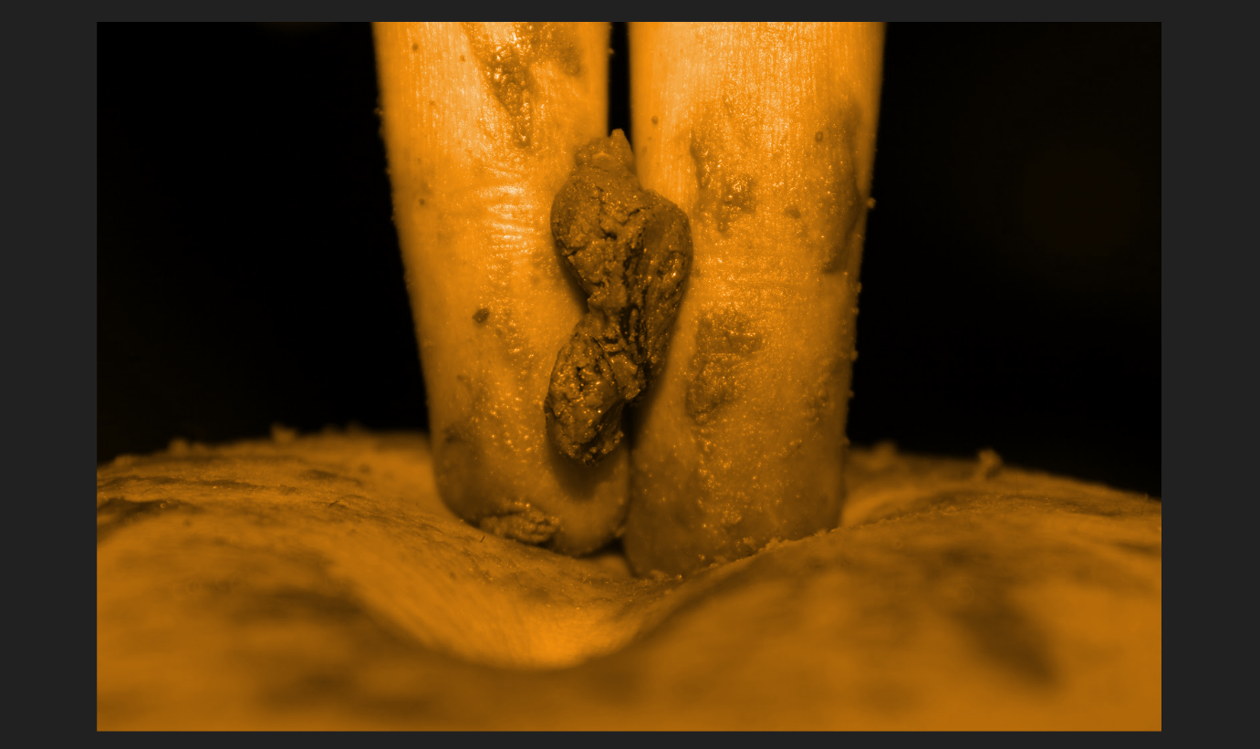
A body entering the surface, bringing threat and fear, standing up as a monument for what it causes, carrying the seed of awareness. The seed is to be planted to grow and shine. A wound of the Self, without blood. Ichor shines in the name of the Other.

When we experience the abject, look into that void, when we lose the line between the self and the other or, in other words, associate ourselves with the disturbing (which tells us something is out of order, belonging to the Outside, foreign), we get connected to something we detach ourselves from or at least realize it’s closeness and even realness, and that is why such an encounter may be terrifying. And what happens here is the intensifying comprehension of the realness of the other, gazed upon, noticed, establishing itself.

This image has the same setting as the previous one, however, it is the future of it. The surrounding is even more obscure, and not only the black is a bit darker, but also the gold/orange hue enhances the contrast. That is the color of attention, for the monument right under the spotlight, the color of burning, and the color of ichor, the blood of gods, and a foul-smelling watery discharge, lymph, from wounds and ulcers.

Image 3
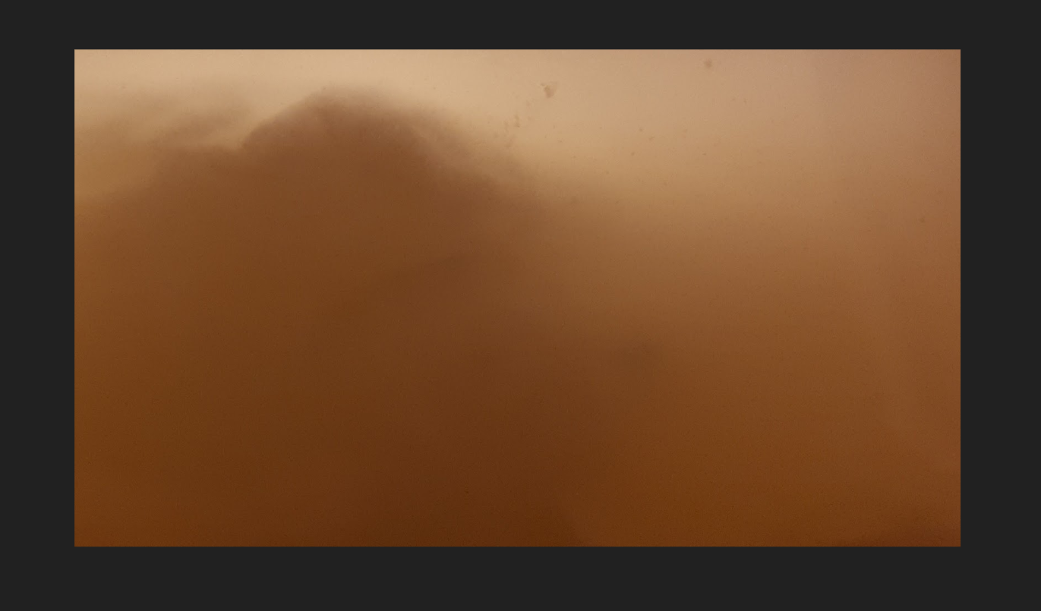
The formation of the realization that the Other exists, still blurry, away, but creeping, growing. Wandering in the water, caressed with warmth.

“Entering “The “unconscious” contents remain here excluded but in strange fashion: not radically enough to allow for a secure differentiation between subject and object, and yet clearly enough for a defensive position to be established - one that implies a refusal but also a sublimating elaboration. (Kristeva, 1982, p. 7)” It is beautiful, luring, formless, but also foreign, approaching, and that is why it alerts, causes uneasiness, a soothing, mute trepidation. The deject willing to rebuild the universe, start again, anew, betray the unsolid, find the definition. Straying and getting lost intentionally to fortify oneself with new definitions from the old disturbance, yet unaware they are the same, just feeling the need to construe and unsee the unknown.

This is cheese floating in its liquid in a transparent plastic container. Light is falling from above.

Image 4
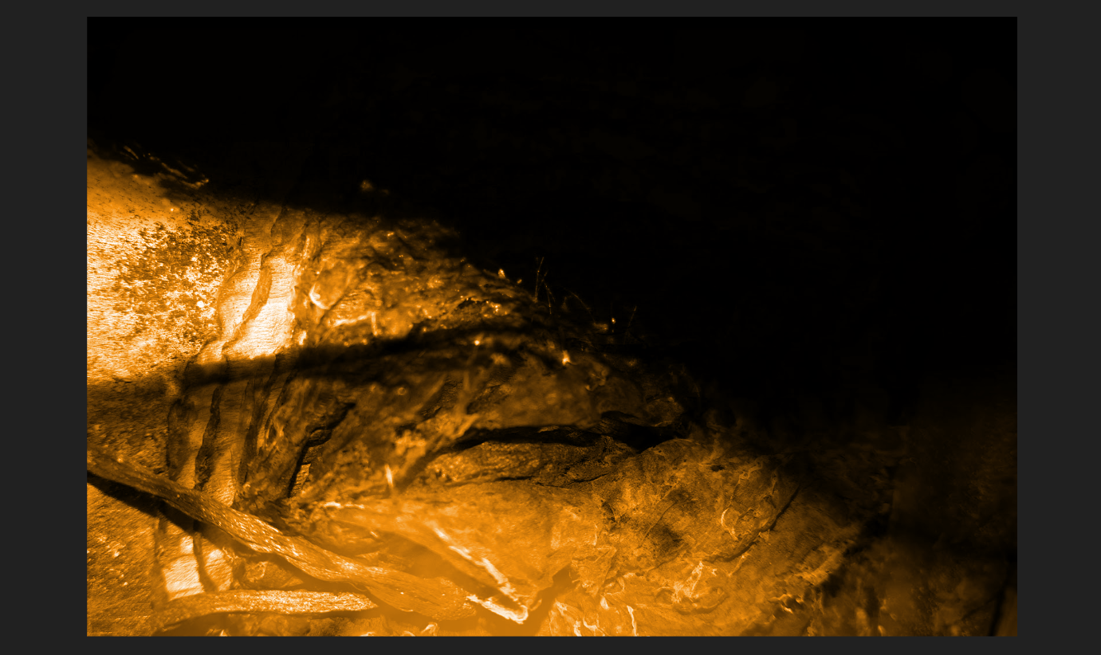
The inflammation of the thought, extreme awareness, the burning of sensation, and discernment.
We reject it, and then comes the abject, the awareness, the desire, with the Ouroborus of attraction and aversion.

The image was created using the double exposure tool and recolored to gold as well. It is a photo of a burning tissue over a picture of a hand.

Image 5
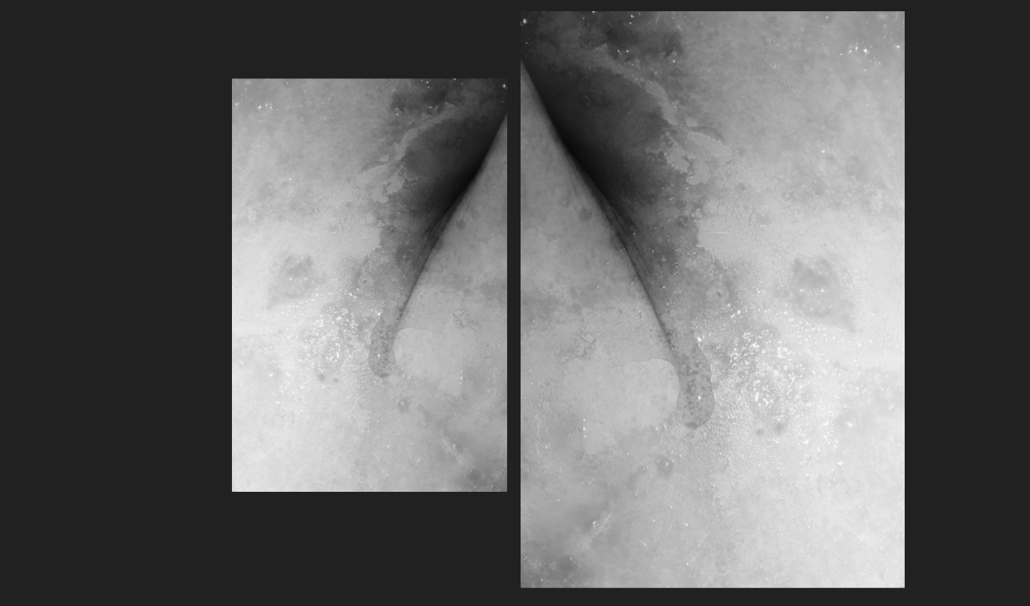
Transformation, disintegration, breakdown. That is me, but it is not me, and I See that.

Our reaction (horror, disgust, apathy) to a threatening breakdown in meaning is caused by the loss of the distinction between I and Not I, conscious and unconscious. The primary example of it is a corpse, ultimate symbol of decay, the waste of wastes, which reminds us of our mortality, and of the death being immanent to life. Some other examples of things-that-threaten are wounds, feces, bodily fluids, awful crimes, sex, food too, as symbols of sickness, desire, rebirth, putrefaction, of the continuity of matter living and dying. We may despise and avoid them, wanting to eject it from our perception, yet we acknowledge its presence, feel and sense it, hence we feed it with our attention, make it an imperishable, incessant part of ourselves. By rejecting them, we reject ourselves. And then engage in an everlasting journey with cyclic routes of attraction and aversion for ourselves. ““I” want none of that element, a sign of their desire; “I” do not want to listen, “I” do not assimilate it, “I” expel it. Since the food [body, self, or anything abjecting] is not an “other” for “me”, who am only in their desire, I expel myself, I spit myself out, I abject myself within the same motion through which “I” claim to establish myself. … I give birth to myself amid the violence of sobs, of vomit. … Shattering violence of convulsion … it reacts, it abreacts. It abjects” (Kristeva, 1982, p. 3).

One layer is an arm folded. The other - a plastic cap of a fish can covered with the oil and juices of that fish, month-old, unbearably stinking, determinedly, and unfortunately staying true to its mission to be disgusting. The differing sizes of the images represent the seeming resemblance the Other carries, yet remains odd to us. The direction of the images is like that because this creates an association with a groin, thus, womb.
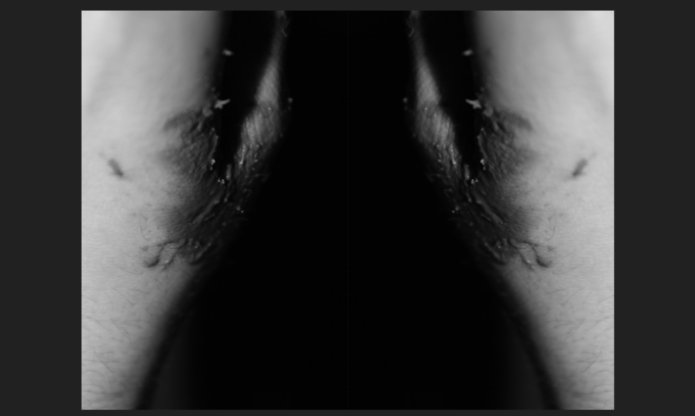
Image 6
Sudden identification, inability to tell what is I and Not I. The duality of the Inside and the Outside, entwisted in symmetry, goodness and evil, pureness and perversion of all. Against each other, with no visible line between them.
I, guided by structure and empowered my meaning, am afraid of the formless and indefinite, and faced with it, I freeze, I get lost. My holistic, heterogenous ego, threatened, finding its hidden alter-ego in the Other, and recognizing the Other in me. The more I stray, the more I am saved. No longer unconscious, filled with repugnance, fear, and disguised joy. Contemplating the lapse of the Other. I’ve lost myself. I desire myself. I see Me in the other.

A hand covered in chocolate, a thumb. The picture is mirrored, to emphasize the bilateral nature of everything, love, and sin, sublime and perverse, ego and alter-ego, I and Nor I, and as they always come together, innate. A barely visible line can be seen between them, but it is as subtle as is the line in abjection.

Image 7
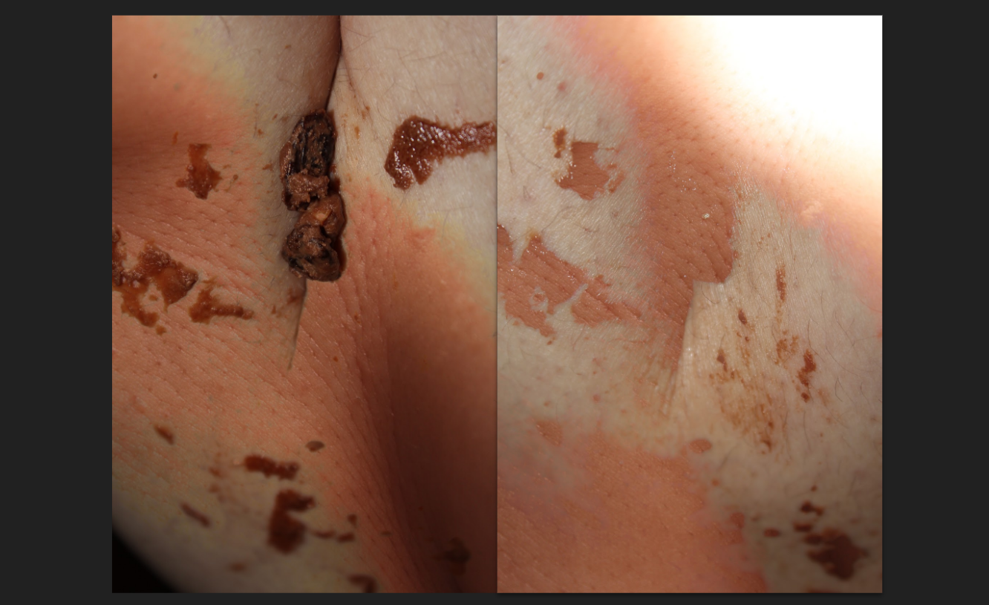
The striking awareness of the body, of hair and skin and bodily fluids, as if feeling the body is a new type of sensation, glimmering and darkening with its intensity in its becoming.
“Decay: privileged place of mingling, of the contamination of life by death, of begetting and of ending. (Kristeva, 1982, p. 148)”. Sinking in disgust to the Self, integrity of it, the body of it. Accepting the abject.

What looks like feces, as already mentioned, - is chocolate with raisins and nuts. Kristeva states that food is the most elementary form of abjection. She describes lips touching the surface of the milk, and explains her repulsion. And as simple as this choice of using chocolate was - the look of it on the hands and legs of the model, in this case, summoned that feeling of uncanny and disgust. Yet, enjoyment can be found in seeing that, in touching and spreading that, too. That indicated that perhaps I am on the right track and that maybe the project conveys meaning at least somewhat effectively. So, the process of creation was itself a journey into the realm of abjection.

Image 8
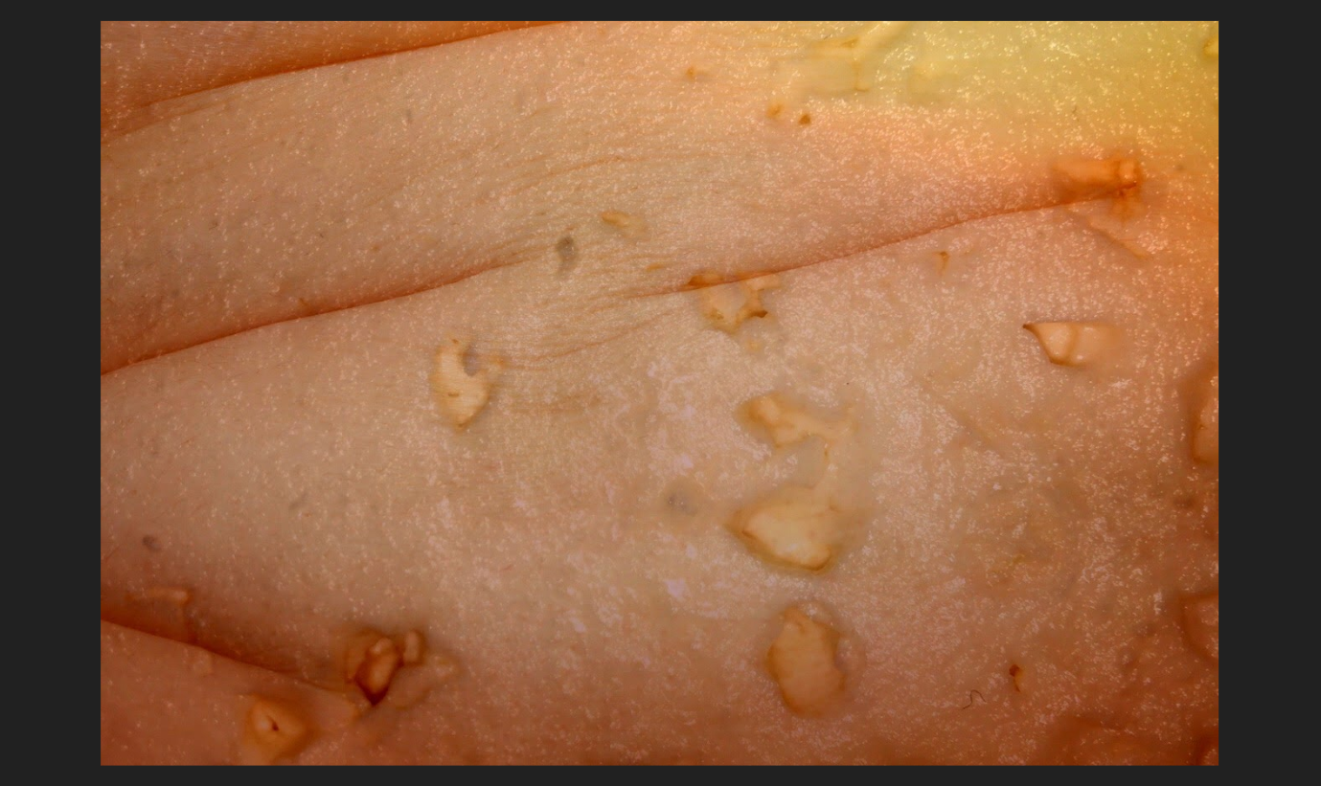
Decay striving, detexturizing, the smell, and disgusting limpness of the soma.
“The body’s inside, in that case, shows up in order to compensate for the collapse of the border between inside and outside. It is as if the skin, a fragile container, no longer guaranteed the integrity of one’s “own and clean self” but, scraped or transparent, invisible or taut, gave way before the dejection of its contents. Urine, blood, sperm, excrement then show up in order to reassure a subject that is lacking its “own and clean self. (Kristeva, 1982, p. 53)”

Purulent skin so revolting, ravenous in it’s decay, as a symbol of an utmost rejection of the body. The ego giving up its image to contemplate itself in the Other (Kristeva, 1982, p. 9). I can’t touch myself. I hate myself. I see myself.

This is a belly. Intentionally sitting in a way, the belly fat gets in folds. The overlay image is the cheese from Image 3.

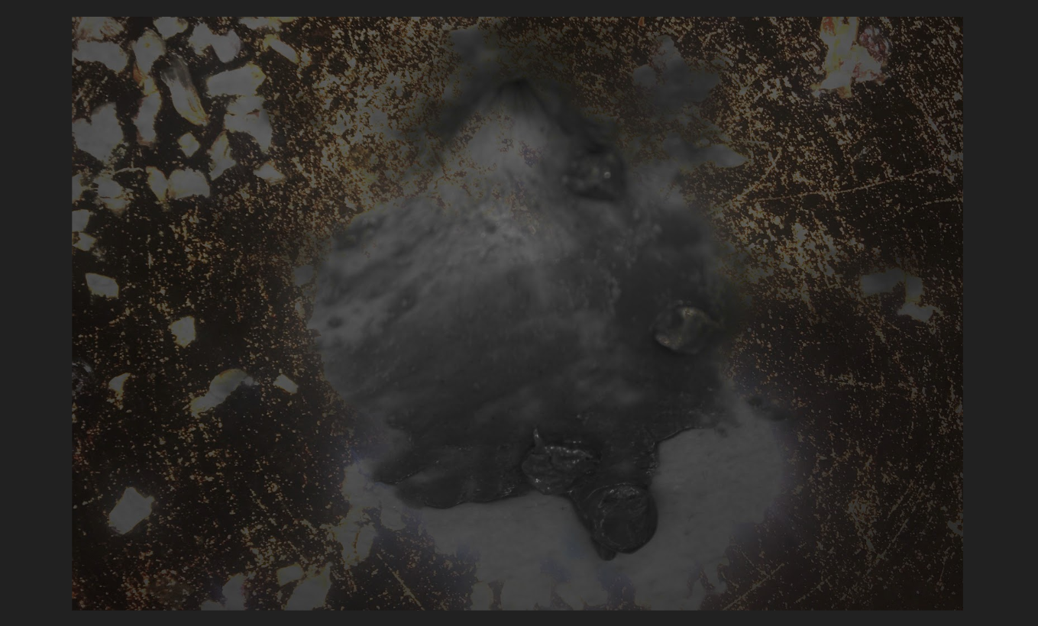
Image 9
Deconstruction and shriveling. The seed of awareness approaching. The debasement of the knowledge about the body, and the self, getting ready for reconstruction, protecting, straying.

Ichor scorched, pus stale on the skin decomposed. A body becomes separated from another body to be. A body separating from itself to be. Desublimed.

Chocolate and raisins and nuts on the belly meet a pan with onion frying sauce.

Image 10
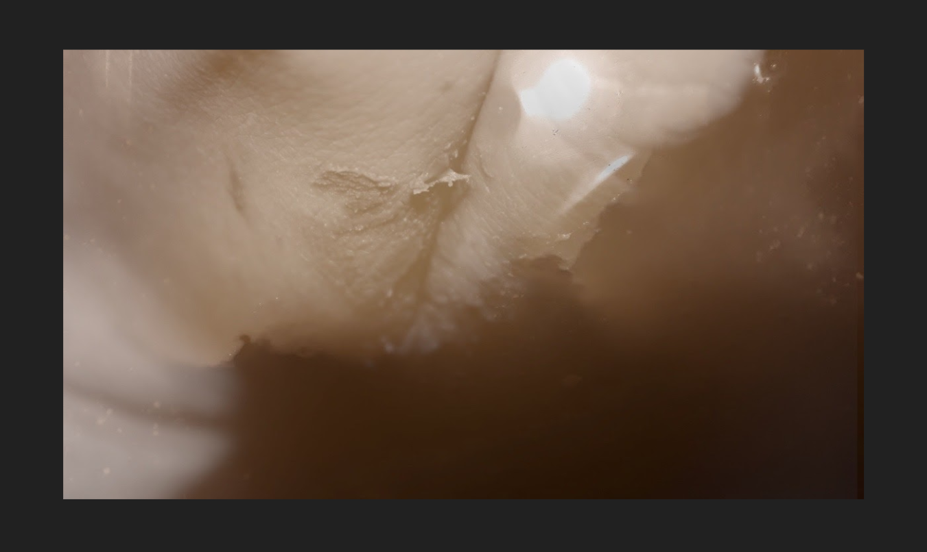
The new thought, idea, meaning, realization gestating through it’s wombly fluids, of color, closer, warmer. Forming the go, the world. The newborn of the embrace of the Self and the Other. Serene, and silent, soaring, radiant. Promising rebirth.

Again double-exposure. The water in the cheese container placed over the hand. That particular picture of the container was chosen because here, the colors look warm, and the light falling that way is perhaps soothing, hinting a new start, bright, of a sunrise.

Image 11
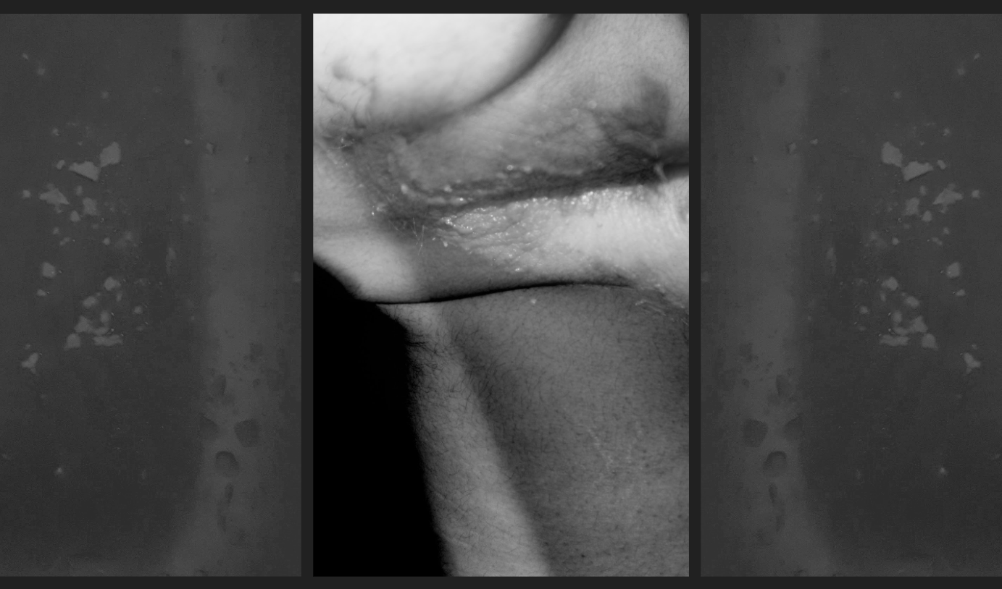
Getting clean of the fluids as of its previous form, arising like a bow-backed body, getting up from its knees, ceasing being a fetus. A change folding the matter and restructuring it. Enjoying the cracking of the new bones, transcended.

These are pictures of a back, of a hand, and of a belly mixed. The background grey is a kitchen sink with food leftovers. They constitute the particles of the old skin, the dirt left from the rebirth, scattered.

Image 12
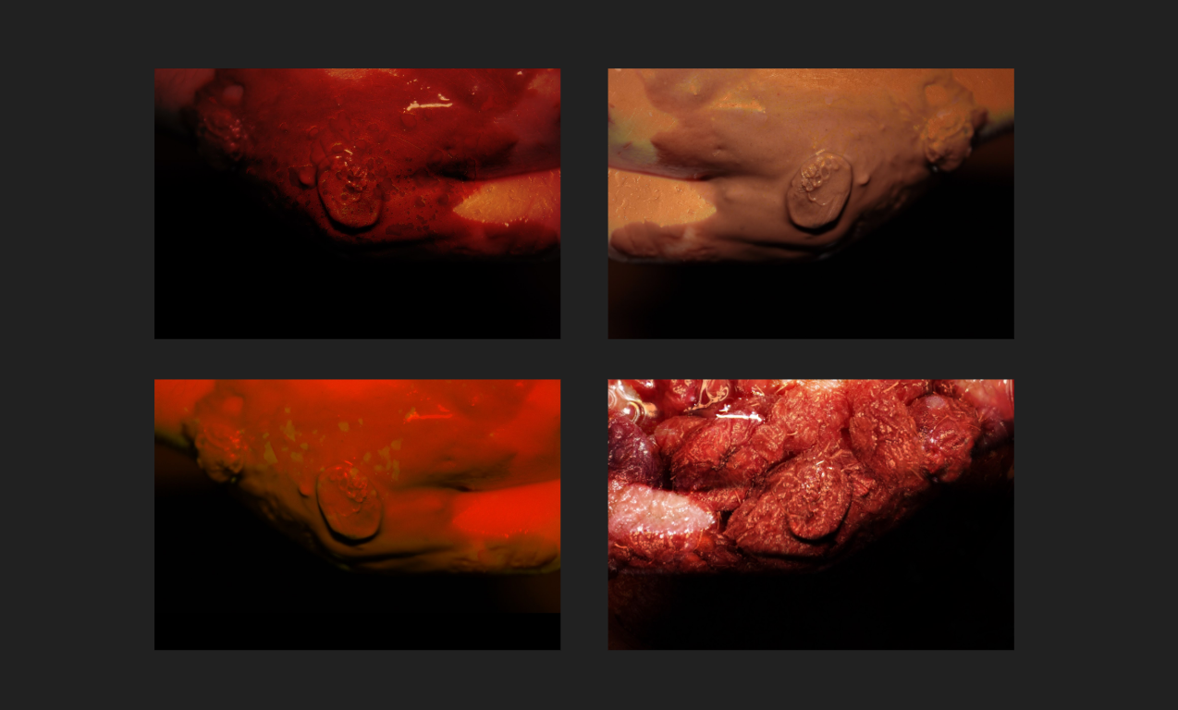
Blood, pus, flesh, feces, rebirth. The seed of awareness, of the abject, of all and nothing gazing.

The abject, a place to dwell, transformed. Splitting the Self and the Other, escaping, existing, desiring, tasting the Sublime, I am joyful.

Engaging in jouissance, I enjoy. Jouissance causes the abject to exist. The ego broken into pieces obscured and wandering, finds itself in the Other, the alter ego. The Other gives shelter, is shelter, and the Self finds itself. The Other protects the Self, by building a fortress of disgust around it, so it is not gone, scattered, strayed again.
“I experience abjection only if an Other has settled in place and stead of what will be “me.” Not at all an Other with whom I identify and incorporate, but an Other who precedes and possesses me, and through such possession causes me to be. (Kristeva, 1982, p. 10)”

All of these are variations of the photograph of a hand. Both of the images on the left have the sink with food leftovers in them, however, each of them is heavily edited. The top right is chocolate with a changed color range. The bottom right is raspberry jam. Such a structure denotes the structurality of the initial Self, and the tendency to debase.

Image 13
Resublimation of the desublimed.

Sublimation is rediscovering. Embracing the abject, I guide myself with meaning and non-meaning and reinvent. Sublime is excitement, enchantment.
“Sublimation, on the contrary, is nothing else than the possibility of naming the prenominal, the pre-objectal, which are in fact only a trans-nominal, a trans-objectal. In the-symptom, the abject permeates me, I become abject. Through sublimation, I keep it under control. The abject is edged with the sublime “(Kristeva, 1982, p. 11). “The sublime is a something added that expands us, overstrains us, and causes us to be both here, as dejects, and there, as others and sparkling. A divergence, an impossible bounding. Everything missed, joy - fascination. “(Kristeva, 1982, p. 12)

The first image re-edited. The “seed” here is another piece of raisin, clean of chocolate, looking like a mole, potentially cancerous, deadly. It is in the center, placed in the “crater”. It is slightly transparent, ghostly, of “another” world. The wider black frame is there for the purpose of indicating the centeredness, the definition, and the directed gaze.

A Bit More on the Methodology
The project belongs to the qualitative category. Multiple sources are described, interpreted, connected, and contextualized within the framework of the topic. This is a project that relies mostly on speculations, and theoretical thinking around the mentioned sources, it can turn out to be a Žižekian so-called “pure ideology” after all, but I sincerely hope it is not. It is not scientific and does not serve as universal truth/knowledge; it is a result of philosophical interpretation and can be subjective.
Abject art is the result of embracing the abject. When stumbled upon abjection, an individual can make a choice or naturally come to the acknowledgment of anything unwanted, accepting it, and even become inspired by it.
The visual choices were mostly taken under inspiration, conceptualized in the process. There wasn’t a plan from the beginning, but there was an idea, desire. During experimentation with different shapes and angles, many pictures were taken, until these pictures seemed like the right ones.
The project is a metaphor for abjection itself.
If we get so familiarized with the unfamiliar that we do not even consider seeing it as something “abjectifiable”. Whether it is coming from the way we see things, or we got an instant acceptance of the horror and the disgust we experience at the given moment, it is all again getting lost between the object and the subject, but we get the reverse effect of getting closer to the abject, through desire, jouissance, making it the part of our safe space allowing it to embrace us, consume and dissolve us. Resublimating, but in the guise of desublimating.

Works Cited
Bois, Y. and Krauss, Rosalind, E. (1997). Formless: A User’s Guide. New York: Zone Books.

Foster, H., Buchloh, B., Krauss, R., Bois, Y., Hollier, D. and Molesworth, H. (1994). The Politics of the Signifier II: A Conversation on the "the informe" and the Abject. October Magazine 67 , pp. 3-21. The MIT Press.

Georgelou, K. (2014). Abjection and the informe. Performance Research: A Journal of the Performing Arts, pp. 25-32.

Menninghaus, W. (2003). Disgust: Theory and History of a Strong Sensation. Albany: State University of New York Press.

Krauss, R. (1996). "The Informe" without Conclusion. October 78. New York: The MIT Press.

Kristeva, J. (1982). Powers of Horror: An Essay on Abjection. New York: Columbia University Press.

Kwan, D., Scheinert, D. (Directors and Writers). (2016). Swiss Army Man. Rimmon, E., Mann, L., Inglee, L., Wang, L., Bailey, M., Marshall, A (Producers). Tadmor, Astrakan Films AB, Cold Iron Pictures, Blackbird Films, Prettybird (Production Companies). Country of Origin: US.

