THE ROLE OF MEDIA AND DIPLOMACY IN THE PEACEBUILDING PROCESS OF
THE NAGORNO KARABAKH CONFLICT

by

Hayk Avetisyan

Presented to the
Department of English & Communications
in Partial Fulfillment of the
Requirements for the Degree of Bachelor of Arts

American University of Armenia
Yerevan, Armenia
May 14, 2020

Table of Contents
Introduction
Literature Review
Research Question
Methodology
Analysis and Findings
Conclusion
Bibliography
Appendix A
Appendix B

Abstract
Nagorno Karabagh conflict is considered as a frozen conflict which was raised at the beginning of 20th century among South Caucasus countries Armenia and Azerbaijan. After the ceasefire at the end of 20th century, the conflict is still in the process of peacebuilding. Nagorno Karabakh conflict includes ethnic and territorial-based causes, which may need more that an official political conflict settlement or meetings by top level officials of both countries. It is too early to examine the advantages and disadvantages of public diplomacy in the context of NK conflict, nevertheless, there are some chances that participation of a wider civil and intellectual society will create an opportunity for a broader political and civic discourse. This paper’s study examines the importance of diplomacy and media in the peacebuilding process. By combining the two spheres, the paper attempts to offer a glimpse into the negotiation process, attempting to consider media as a tool for communication between the publics of Armenia and Azerbaijan and diplomacy as major political tool in the peacebuilding process of Nagorno Karabakh conflict.

Introduction
This research paper contends that a peaceful solution of Nagorno Karabakh conflict can be better achieved by promoting more efficient platform of communication between the conflicting sides. In particular, the study examines the viewpoints of people from various age groups to better understand the role of media in shaping the perceptions of public and how media can foster a change in the context of Nagorno Karabakh conflict.
This study is based on the Nagorno Karabakh conflict, which was raised into military actions at the end of 20th century among South Caucasian countries Armenia and Azerbaijan. Starting from early 1988, “ The Nagorno Karabakh conflict comprised both irredentist and separatist elements; irredentist claims of Armenia and separatist demands of its ethnic kin in Nagorno-Karabakh for unification with Armenia, or independence” developed into a full scale war four years later when the Soviet Union was collapsed (Gahramanova, 2010, p. 135).
In 1994 the two conflicting sides signed a ceasefire and transferred the conflict settlement into the table of negotiation. Taking into account both characteristics of intra and inter-state conflict, the Nagorno Karabakh conflict includes ethnic and territorial-based causes, which significantly need more that an official political conflict settlement or meetings by top level officials of both countries. It requires the participation of a wider civil and intellectual society to create an opportunity for a broader political and civic discourse and as a result reach a peaceful settlement of the issue.
According to Yoel Cohen media-diplomacy is a method “ media impinge on the foreign policy process either in terms of having an influence on public opinion or in terms of being used by officials as channels to other governments” (1986). For creating an effective discourse among the publics of Nagorno Karabakh, Armenia and Azerbaijan the paper examines media and diplomacy as significant tools. With the advent of new technologies media became more effective and it is one of the primary sources of communication today. “It is in the light of this context, that the new media, social networks and track two diplomacy initiatives began to emerge in an attempt to open a ground for unofficial discussions between the communities, civil society actors and non-governmental organizations. Seeing the consequences of the unresolved conflict, surpassed with hatred, passion for revenge and lack of democracy and transparency a number of developments were initiated over the course of the last 17 years” (Gelbullayeva, 2010, p. 177). Moreover the track two diplomacy can be examined as another initiative in conflict management. “It is interactions between private citizens or groups of people within a country or from different countries who are outside the formal governmental power structure” (McDonald, 1987, p. 1).
“Each conflict must be understood in the context of its own political, social and cultural context in addition to its specific media system” ( Betz&Williams, p. 2, 2017). The paper examines media and diplomacy as tools for peaceful conflict settlement and it analyses the media systems of bot Armenia and Azerbaijan. Moreover, considering the NK as the third side of the conflict it is also very essential to understand the media’s role in this territory and among the public of NK. The paper will create a rubric to evaluate the three media systems as separate examples and formulate a ground of comparison to understand the similarities and differences of each media system. Moreover, the paper argues that media can have its positive effect on peacebuilding process by framing a ground of communication for the people living in Armenia, Azerbaijan and Nagorno Karabakh. This may be achieved through track two diplomacy tools , which according to John Warlick McDonald can serve as “laboratories for identifying the human obstacles to better official relationships” (1987).

Literature Review
Conflict, Conflict Management
Conflict is a general idea: it can be noticeable in various layers of society. According to Lexico dictionary conflict means “ a prolonged armed struggle” (Lexico Dictionary, n.d.). In his Conflict Management book Bob J. Holder divides conflict into five categories, each requiring different strategies of management: “ competing, compromising, accommodating, avoiding, collaborating conflicts “ (Holder, 1976, p. 3). Holder identifies competing conflict as win/lose style which is “ appropriate when quick action is required” (Edwardsville, Illinois) (Holder, 1976, p. 3). Compromising conflicts are called “lose/lose because both parties give up of what they want, so that all may have some of what they want” ( Holder, 1976, p. 3) According to Holder avoiding conflict is lose/lose style and “doesn’t address the conflict, and is appropriate as a temporary measure when tempers are hot” (1976, p.3). While the accommodating conflicts have lose/win style, according to Holder this type of conflict “ is appropriate when the issues are not as important to you as they may be to others” (1976, p. 3). The last category is collaborating conflict and according to Bob J. Holder “ this win/win conflict style allows all parties to get all of their need met” (1976, p.3). The author also discusses the methods of conflict management by mentioning that “Teams benefit from conflict when they are able to consider different viewpoints and ideas. Teams suffer, not from conflict, but from their inability to deal with it effectively” (1976, p.3).
Media and Public Diplomacy
The literature mentioned below has some conceptualizations of media and public diplomacy. Although the core idea of literature is the same, the examples are brough from different perspectives.
Kristen Allen and Cathrin Schaer mention in their Media and Media assistance in fragile contexts article that “Media and journalism should be understood as part of a wider ‘communication ecology’ that includes a wide range of stakeholders and practices.” (2016, p. 17). Eytan Gilboa, a professor of Communications and International Relations at Bar-llan University, comes up with a statement that “ the media determine the national interest and usurp policymaking from elected and appointed officials” (2009, p. 455). Moreover, Betz & Williams underline the fact that “there is not yet sufficient empirical evidence to confirm or reject claims that media promotes or prevents conflict and there is reliance on anecdotal evidence to illustrate the media’s positive impact on democracy, governance and accountability” (2017, p. 3).
Nowadays, the most visible usage of media can be found in politics, it is considered as “one of the most important tools that politician or state bodies use for reaching their political goals” (Owen, 2018). Jovan Kurbalija, a founding director of Diplofoundation states that “ Internet-driven changes in modern society have increased both the interdependence among major actors in world politics and the demand for diplomacy as a method of solving conflicts through negotiation and compromise” and Nagorno Karabakh conflict could be one of these. (2013, p. 159)
“The internet is a practical working tool in diplomacy” (Jovan Kurbalija, 2013, p. 150) and Diplomats are communicating actively through emails, use social media or searching engines to find some information. All these methods have an influence on the modern diplomacy. The internet and specifically social media tools affected significantly on communication between diplomats and public by transferring the public diplomacy to entirely new level ( Kurbalija, 2013). The existence of media and internet in diplomacy brought the most significant change, which is “ from traditional indirect communication between diplomatic services and the public, to direct interaction between diplomatic services and the public using such technologies as social media” (2013, p. 156). Traditional media, such as TV and newspapers, were just one-way communication. On the other hand, internet brought multidirectional communications methods by giving many opportunities to the public for sharing their views about any political issue or conflict (Vicki Coleman, 2013). With the access of internet and smartphones many citizens became journalists and have their active role in shaping the international community and in some cases influencing on international affairs of their country (Kurbalija, 2013). According to Kurbalija diplomatic services are adjusting to the changes that internet brough to diplomacy. He states that “ hardware and software are no longer major obstacles to running effective social media campaigns” (2013, p. 157). Social media also gave the opportunity to citizens to be engaged in the foreign policy making. Today, social media platforms such as Facebook and Twitter are engaging more citizens in political discourses and are crating effective diplomatic agendas. Thus, new media technologies brought their fundamental change in information and communication, which are the major basis of diplomacy in 21st century. Moreover, the changes which internet brought to the diplomatic society strengthened the bonds among the major political actors in the world and the demand for diplomacy as a way of solving various political conflict through negotiations and consensus (Kurbalija 2013).
Furthermore, new media has changed the way diplomacy is organized by altering changes in methods that diplomatic services use for communicating both with domestic public and with foreign public. New social media platforms such as Facebook or Twitter give the opportunity both for the public and state officials to communicate with each other directly. Additionally, with the advent of technological developments the new media became something more than just communication tool for the officials, it became one significant method to find the solution of different political conflicts in a peaceful manner. Using media as an instrument of peace conflict solution is something that was impossible ten years ago. However, in recent years, the significance of a professional, free and plural media in participating in effective and strong governance has attracted attention of international community. “A vibrant media gives people free flowing access to information, enables dialogue, encourages people to express their views, prompts greater political participation and encourages accountability” (Katy Williams, Oslo, 2017).
Media is one of the most significant source of getting an information and it is affecting to every aspect of our daily life. “Each conflict must be understood in the context of its own political, social and cultural context in addition to its specific media system if we are to understand the best media practices to peruse.” (Katy Williams, Oslo, 2017). While defining the media’s role in NK conflict it is significant to understand the media systems of both Armenia and Azerbaijan. According to Daniel C. Hallin and Paolo Mancini in their “Comparing Media Systems”, there are three types of media systems: The Mediterranean Polarized Pluralist, Northern European Model and Liberal or Anglo Atlantic model. Among these three models, the best model, which can characterize the media systems of both Armenia and Azerbaijan, is Mediterranean Polarized Pluralist model.
According to the study made by European Journalism Centre (EJC) and the Dutch Ministry of Education, Culture and Science (OCW) “the Azerbaijani media environment does not provide the population with sufficient, balanced information about their country” ( Kazimov, n.d.). The government in Azerbaijan is still the same as it was 25 years ago. Moreover, the study underlines that state intervention in public TV is very high and there is high level of political parallelism, as Kazimov states “ there is no competition and media are governed by the administrative system, not the market economy” (n.d.). There is increasing level of social responsibility judgment among journalists, which is also a characteristic of Mediterranean Polarized Pluralist model, and this phenomenon is continuing until today. On the other hand, the author underlines the importance of social media in political and social life of Azerbaijani people by stating that social media is “virtually the only way society can express itself and the only way the public opinion can be felt. It is not a coincidence that, whatever positive steps the government of Azerbaijan has been forced to make, it was under the pressure of social media” (n.d.).
According to the study conducted by European Journalism Centre (EJC) and the Dutch Ministry of Education, Culture and Science (OCW) “it is thanks to online media activities that in 2018 Armenia moved from the list of ‘partially free’ countries to ‘free’ ones” (Baghinyan, n.d.). As a result, the media is started to get off the control of the state bodies and be more self-regulated. decreases the level of Political Parallelism and helps to create an objectivity type of journalism. According to European Journalism Centre “ the country is going through a process of development of inline media”. Furthermore, a professor at the American University of Armenia Vahe Odabashyan underlines the importance of social media platforms, as a result of which, many citizens were engaged in variety of political discourses and debates. Odabashyan states that “The opposition used social media to mobilize people discontented with the situation in the country, coordinate and organize actions in a self-managed manner, instantly share information that the government-controlled traditional media kept silent about and do many other things that made the revolution very efficient, effective and successful.” (Odabashyan, 2018, p. 1)
The literature review mentioned above gave an understanding of what is conflict and conflict managements. Moreover it gave an understanding of media, public diplomacy and diplomacy by considering them as tools in the context of Nagorno Karabakh conflict management. Furthermore, the studies mentioned above illustrate the role of intrastate actors such as media and public diplomacy in formulating a common ground for the public of conflicting sides.

Research Question
The question addressed in this capstone project is mainly concentrated on the Media use and Media as a “tool” in political processes. Additionally, how Media became a significant component in the political sphere and how it was used not only for informing public about a particular political event, but also for using media as a method of solving political conflicts. Therefore, considering the common thread in these ideas, the research questions of this study are as follows:
R.Q.1 What is the role of Media in finding the peaceful solution of Nagorno Karabakh conflict?
R.Q.2 What is the role of Public Diplomacy on Nagorno Karabakh conflict management

Methodology
One of the main methods to gather enough information regarding the topic of Media and Diplomacy was to find information from various academic sources such as books on media relations with diplomacy, or the effects of media on diplomatic relations. Moreover, information was taken from journals, newspapers and articles by scholars to make the study qualitative and valid. Furthermore, the materials examined in the paper were beneficial in finding the relations and the effects that media has on diplomacy or in overall politics in the region of Caucasus. The research was only used to understand the fundaments of using media for effective diplomacy. The findings that were examined during the paper were used for the purpose of primary research. Additionally there is a reflection which include professional theories used in terms of semantics given by the authors in the bibliography.
Another method of collecting information is examining the perceptions of people regarding the role of media in the NK conflict. A survey was conducted among the Armenian public to understand the conflict deeper and look to the conflict from different angels as there is different opinions expressed by people having diverse backgrounds. The main purpose of the survey was to answer to the following questions:
• Are people aware enough of the NK conflict?
• What role does media play in the NK conflict?
• Do you consider the media as one major factor for the peaceful solution of the NK conflict?
For the purpose of making the study more qualitative, there is hold and interview with a professional in the field of Diplomacy, who voluntarily participated in a more in-depth discussion regarding the issue. The additional questions asked to the professional reflect the negative and positive effects of media on diplomacy and on the peacebuilding process of political conflicts such as NK. Also one purpose of the interview is to ensure the connection of the knowledge and the understanding of the research question with the mundane reality of the professional who is interviewed. The research combines both analyzed information of trustworthy sources, the results of surveys and interview with professional, and combines all gathered information with personal reflection to develop a strong capstone project.

Research and Analysis

Survey was conducted to the public in order to compare the public perception and the main aspects of the research, particularly the role of media and diplomacy in peacebuilding process of NK conflict, the willingness of communication between the conflicting parties and public perception of “Media Diplomacy” in negotiation process. Lastly, the research is based on in-depth interview taken from professional in the sphere.
The Armenian public perception of the role of media on Nagorno Karabakh conflict: Survey
There is conducted an online survey among Armenians who live in Armenia, Artsakh and throughout the world. As the survey was online it was conducted through different online platforms as well as social media such as Facebook, Instagram and also Email. In a limited time the number of participants reached to 54. The purpose of online survey was to find out the role of media in NK conflict and the Armenian public perception of Media Diplomacy as a tool in peacebuilding process.
Results
70% of the participants were male, 30% were female. As the research was online the majority of participants (90%) were students, the percentage of participants who were employed is 46% (Taking into account that there were students who also are employed), also there were two participants who were unemployed and there was no participant who was retired. As it was mentioned above the majority of participants were students, as a result the 70% of the respondents at the age of 19-21, the remaining being 22-30 years old. The majority of the respondents were from different cities of the Republic of Armenia (RA), 10% of participants were from Artsakh and 13% percent were living abroad.
One purpose of the survey was to find out the readership of Armenian public regarding the political news of Armenia and Nagorno Karabakh. The overwhelming majority of participants (82 %) were following the political news of Armenia and Nagorno Karabakh, whereas more than four times less people (18 %) answered NO. (See figure 1 in the Appendix A)
Figure 1: Do you follow political news of Armenia and Nagorno Karabakh?
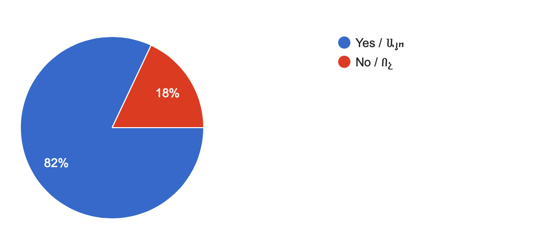
For the solution of the conflict it is vital to know the conflict’s history and origin. The online survey which was conducted, showed that nearly all (98%) of the respondents were aware of Nagorno Karabakh conflict, however, only 2% of participants were not aware if the conflict. (see Figure 2 in the Appendix A)
Figure2: The Awareness of Nagorno Karabakh conflict.
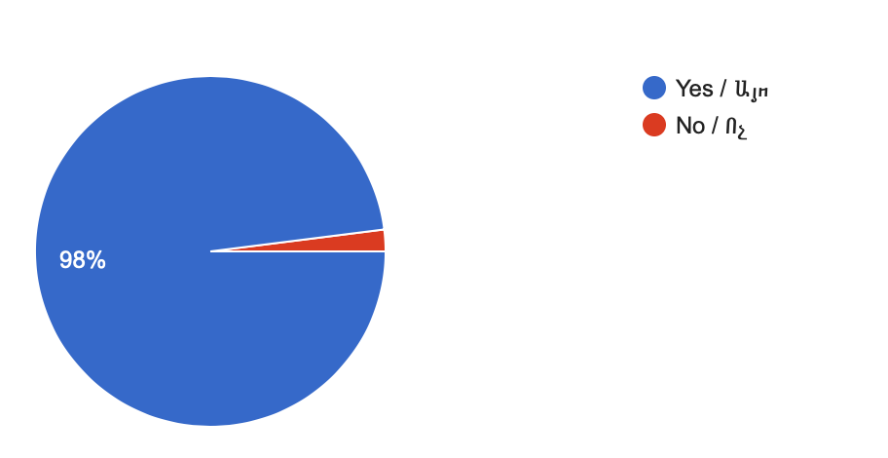

Another aim of the survey was to find out the media usage of participants. Out of 110 participants the majority (80%) used media every day, this percentage was high because as it was mentioned above the majority of surveyed people were young and they spent more time on media platforms compared to other social groups. While slightly low percentage of recipients (15.8%) used media 2-3 times a week. Finally, the remaining (4.2%) of people (the percentages are divided equally in 1.4%); used media once or twice a month; never used media; used not only media but also other sources. (see Figure 3 in the Appendix A)
Figure 3: The frequency of media usage as a source of information.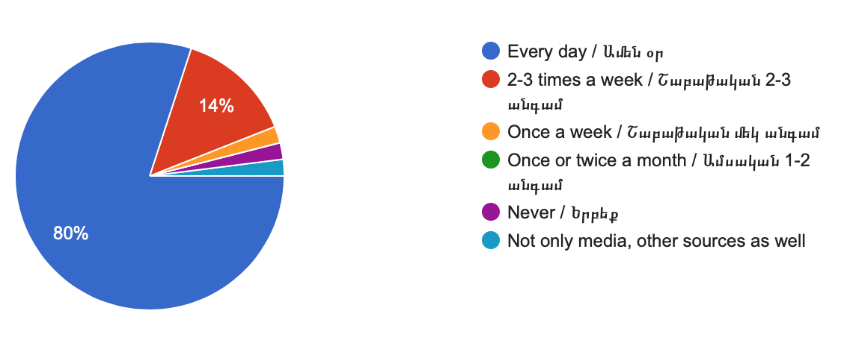

Also, one of the aims of survey was to examine the Armenian public opinion regarding media as one major factor for the peaceful solution of Nagorno Karabakh conflict. The percentages of answers for this question is distributed equally with little fluctuations. 38% of recipients were not sure whether media could be considered as a tool for the peaceful a solution of the conflict or not. The second highest value was 32% of participants who did not think that media can be a major factor for the solution of the conflict. Finally, the lowest percentage in this section was 30% of people who agreed that media can play a key role in the conflict solution. It is also important to mention that all recipients from Artsakh (9 participants) fall in the category of people who answered “Yes”. (see Figure 4 in the Appendix A)
Figure 4: Do you consider media as one major factor for the peaceful solutions of Nagorno Karabakh conflict?
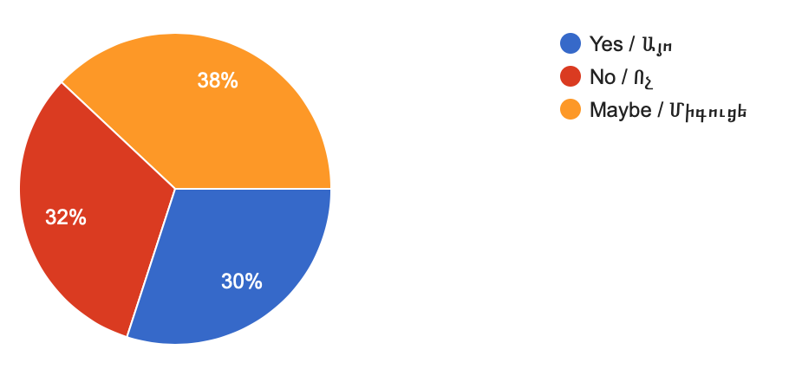

The final purpose of the survey was to understand the perception of Armenian public towards media as well as their opinion about the role that media can play in the peacebuilding process of NK conflict. For that purpose a short-answer question was distributed asking In your opinion, what role does media play in this conflict?.
Answers for this short-answer question were different and they can be divided into 3 categories; neutral, positive and negative. Also, there were some participants who did not give an exact opinion or statement regarding the question. They stated that they did not have an opportunity to study the influence of media on the conflict. “I think that I should be a professional in this field to give an appropriate and valid information regarding the conflict and medias impact on it” or “ Each conflict should be discussed in its cultural context and media’s influence can be different on each conflict”. It is also significant to mention that all participants who gave not an exact answer were from abroad and they justified the absence of opinion due to a lack of information regarding the topic of Nagorno Karabakh conflict.
In the first category there are people who have positive attitude towards media’s role. The majority of respondents fall under this category by giving answers such as “ The role of media important, as nowadays people do not like to read newspapers and they prefer to use media as a source of information, “Media shapes the narrative on both sides. If the attitude of the media changes so will the people’s.” Another respondent considered the media a tool by mentioning that “ The media can make the condition slightly more benevolent by a) spreading only truthful news b) spreading news that do not further aggravate the conflict.” Although there is little bit neutrality in this answer, the goal is positive. Furthermore, one of the respondents categorized media higher than politics by considering it the only method of conflict solution, as mentioned by one of the respondents “ Media is the only factor that can bring the two conflicting parties into the same ground of communication. Moreover, this process do not need any political intervention, the only thing that is required is the presence of humanistic action, which I am sure exists among the publics of both conflicting sides.” Interestingly, the author of this answer was from Artsakh.
The next category, which is the second highest by number of people responded, is the negative attitude towards media. The majority of answers included negativity towards media, the respondents used phrases such as “biased”, “non-plural”, “distorting the situation”, “unreliable”, “inaccurate.” A lot of answers highlight the fact that the level of media in conflicting countries is not enough to make it a major factor in the conflict solution. One of the participants mentioned that “ The media systems of both countries are not still ready to take the major role of solving the NK conflict as they still have a low readership and high level of state control towards media” This once again contributes to the statement mentioned in the literature review above, according which the, the media systems of both Armenia and Azerbaijan are more similar to Mediterranean Polarized Pluralist model. Also, one of the respondents stated that “ that the absolute freedom of media in the contexts of Nagorno Karabakh conflict can create ricks for the peacebuilding process. In my firm belief the irresponsible publications by media of both sides can only harm the situation instead of fostering a positive change.” Another respondent mentioned that there are number of other factors which disturb media to take the major role in this conflict’s peaceful solution by stating that “ Full and unbiased disclosure would certainly help to spread up the negotiations, but seeing that the whole conflict is based on nationalism, no news no matter how unbiased would change the people’s mind towards the issue in my opinion.”
The last category is neutral one, there were recipients who did not tough any positive or negative attitude towards media’s role in the conflict as well as there were participants that mentioned both the positive and negative role of media. The majority of neutral answers was given by recipients who came from abroad. Mostly, they states that “ I am not aware of the media systems in Armenia and Azerbaijan, so I cannot compare or give any evaluation towards media in the context of Nagorno Karabakh conflict.” Another respondent stated that “ Overall, taking into account the significance of Nagorno Karabakh conflict and it role on our society, I would like to mention that the role of media is to give an information to our public. Moreover, in the context of this conflict media also is considered as a tool for propaganda. More often the Azerbaijani media spread irresponsible and false information regarding Armenian side, which puts the authority of Armenia under the question. Of course this news are denied by our side. However, it should be mentioned that not all the readers are retrospective regarding this issue. For instance, if 10 people read that there are a lot of Coronavirus cases in Armenian Military Forces, it is not necessary that in future all these 10 people will know that the information was false and it is denied. As a result, it is very important that the Armenian side would not take the role of defendant in this information battle, but rather take an initiative position. Thus, by not encouraging false news, I would like that the Armenian side would actively participate in information battle.”
Overall, the figures shown above underline the fact that the Armenian public do not fully consider media as a major factor in the peacebuilding process. Some respondents were not fully informed about the topic and could not come up to any conclusion regarding the media’s role in conflict. However the overwhelming majority of surveyed people either considered media as a major factor or stated that in case of the development of media systems in both countries the media’s role in the Nagorno Karabakh conflict will be greater and consequently it will have positive outcomes.

The role of Media in Nagorno Karabakh conflict management: In-Depth interview with diplomat Vahan Bayburdyan
Vahan Bayburdyan is a former “ Ambassador Extraordinary and Plenipotentiary of the RA to the Islamic Republic of Iran, advisor of the foreign minister of the RA, head of the Chair of International Relations and Diplomacy at YSU”. Mr. Bayburdyan is also an editorial board member of “ ‘History of neighboring countries of Armenia’ in four volumes”. He has been included in various diplomatic meetings regarding the issue of peacebuilding in Nagorno Karabakh conflict. In his opinion, when there is a conflict between two people, the sooner these two people will communicate with each other the more successful they may be in reaching the solution of their conflict. As Bayburdyan mentions “ I firmly believe that whenever both Armenians and Azerbaijanis want to solve this problem in a peaceful manner, the conflict will be solved. The role of the third state is important here but it is impossible until the major conflicting sides would want to solve the conflict peacefully.” He underlines that the negative propaganda made by the both sides do not let the publics of Armenia and Azerbaijan to communicate with each other.
To the question whether he consider media as one major factor in the peacebuilding process of NK conflict, Bayburdyan underlined the significance of media by stating that “ I have spent long time on identifying the possible peaceful solutions of Nagorno Karabakh conflict, and I can firmly state that without vibrant media involvement in the conflict, the peaceful solution is impossible.”
Bayburdyan also talks about the possible negative effects of media and underlines the methods of preventing this negative effects by noting that “ where there is a light, there is also a shadow, although media can formulate a fertile ground of communication for the conflicting side, there is a rick of increasing the hatred among the publics. By spreading a biased and propagandistic information, media can make the things harder in the peacebuilding process.” However, Mr. Bayburdyan states that the developments in media systems of both Armenia and Azerbaijan increase the chance of medias positive role in the peacebuilding process. “ The establishment of social media platforms such as Facebook, Twitter and Instagram positively brough a chance for the communities to communicate with each other and find something in common, which in my firm belief will contribute to the peacebuilding process of Nagorno Karabakh conflict” states Bayburdyan.
From the interview, it is clear that Mr. Bayburdyan as an experienced diplomat, considers media as an important actor in peacebuilding process. As he noted, media’s role in the conflict management process is not direct. It can be identified through social media platforms and public diplomacy tools indirectly by creating new grounds of communication for Armenian and Azerbaijani publics.

Conclusion
This paper examined the Nagorno Karabakh conflict, the frozen conflict between Armenia and Azerbaijan in territory of South Caucasus. The paper argues that media and diplomacy can become a major factor in peacebuilding process and give a solution to the conflict that lasts more than 30 years.
Throughout the research, the opinions and attitudes of Armenian public were surveyed to get a better understanding of the perceptions of Armenian public towards media and diplomacy as major factors in the peacebuilding process. Additionally, various public diplomacy tools were examined throughout the study that may create some new paths for an effective conflict management. Taking into account the results of the survey, the Armenian public consider media as an instrument of peace in conflict prone process. The media systems of the conflicting sides are examined throughout the paper to understand the possibility of bringing the conflicting parties into a common ground of communication. Although the role of media and diplomacy are not still enough effective for the peacebuilding process, the study underlined the fact that there is at least a willingness by the public to create a common ground of communication.
As a result of limitations in time, the online survey was conducted among 54 participants. A stronger and more inclusive study would require much time to examine the perceptions and a deeper viewpoint of a wider scope of people. Nevertheless, the survey was conducted throughout different social groups and through various media platforms such as social media, thus, promoted objectivity and viewpoints from different angels.
For the purpose of understanding the opinions and perceptions of each side, it would be more efficient to take a survey both among Armenian and Azerbaijani publics. However, due to some political reasons, only research in Armenia was possible.
Moreover, variety of interviews were planned to be taken from different officials of Artsakh Republic to examine the Artsakh’s public perception regarding the topic in more profound way. However, due to the Coronavirus outbreak and quarantine, the possibility of going to Artsakh was lost. As a result, the only place were taking interview was possible was the Republic of Armenia.
Thus, considering the factors which are above mentioned the study may have some new avenues of research regarding the role of media and track two diplomacy as a major tool in peaceful solutions of Nagorno Karabakh conflict.

Recommendation
As the hatred level towards each other is high among the people of conflicting sides and the there is a low chance of face-to-face meetings, there should be more attention on creating this platforms and involve other factors such as education, art, science, sport and culture. Moreover, considering the fact that these two communities have been good neighbors during the Soviet times, the chance that the social platforms may help the people to have more humanistic understanding to each other will increase.

Bibliography
Conflict: Meaning of Conflict by Lexico. (n.d.). Retrieved May 11, 2020, from https://www.lexico.com/definition/conflict
Holder B. J. (n.d.). Conflict Management. Gray Matter Productions. Retrieved from http://www.geocities.ws/Eureka/Office/7479/conflict.pdf
Betz M. (2017). How Media Can Be an Instrument of Peace in Conflict-Prone Settings. UNDP Oslo Governance Centre. Retrieved from https://www.undp.org/content/dam/norway/undp-ogc/documents/UNDPOGC_Media_conflict%20roundtable%20background%20paper.pdf
McDonald, J. W., & Bendahmane, D. B. (1995). Conflict resolution: Track two diplomacy. Washington, D.C. (1819 H. St., NW, Suite 1200, Washington 20006): Institute for Multi-Track Diplomacy.

Burton, J. W (1988). Conflict Resolution as a Political System. George Mason University. Retrieved from http://wizwah.gmu.edu/johnwburton/files/original/1efa7cfc6161f59c6f0c7b53526e8e79.pdf

Stifung R. B. (2016). Observer, Agitator, Target-Media and Media Assistance in Fragile Contexts. FoME Symposium. Retrieved from https://fome.info/wp-content/uploads/2017/03/FoME-Observer-Agitator-Target-2016.pdf

Witman. P. D (2018) Social Media and the Velvet Revolution in Armenia. EDSIG Conference. Retrieved from http://proc.iscap.info/2018/cases/4776.pdf
Bercovitch, J., Kremenûk, V. A., & Zartman, I. W. (2013). The Sage handbook of conflict resolution. Los Angeles, CA: SAGE.
Azerbaijan: Media Landscapes. (n.d.). Retrieved May 11, 2020, from https://medialandscapes.org/country/azerbaijan
Armenia: Media Landscapes. (n.d.). Retreved May 11, 2020 from https://medialandscapes.org/country/armenia/conclusions/conclusion
Paolo Mancin, P., & Hallin, D. C. (n.d.). Comparing Media Systems: Three Models of Media and Pplitics.
Archetti, C. (n.d.). The Impact of New Media on Diplomatic Practice: An Evolutionary Model of Change. The Hague Journal of Diplomacy
Doi: https://doi.org/10.1163/187119112X625538
Kerp, P. A. & Wiseman, G. (n.d.). The Impact of the Internet and ICT on Contemporary Diplomacy. (pp. 141–160) In Diplomacy in a Globalizing World
doi: https://global.oup.com/academic/product/diplomacy-in-a-globalizing-world-9780199764488?cc=&lang=en#
Eytan Gilboa (2001) Diplomacy in the media age: Three models of uses and effects, Diplomacy & Statecraft, 12:2, 1-28, DOI: 10.1080/09592290108406201
Ramaprasad, J. (1983). Media Diplomacy: in Search of a Definition. Gazette (Leiden, Netherlands), 31(1), 69–78. doi: 10.1177/001654928303100107
COHEN, Y. O. E. L. (2017). Media Diplomacy: the foreign office in the mass communications age. Place of publication not identified: ROUTLEDGE.
Geybullayeva, A. (31AD). Nagorno Karabakh 2.0: How New Media and Track Two Diplomacy Initiatives are Fostering Change. Nagorno Karabakh 2.0: How New Media and Track Two Diplomacy Initiatives Are Fostering Change, 176–185. Retrieved from https://doi.org/10.1080/13602004.2012.694663
Iskandaryan , N., & Mikaelian, H. (n.d.). Media coverage of the Nagorno-Karabakh conflict in Armenia and Nagorno-Karabakh Caucasus Institute Policy Brief . Media Coverage of the Nagorno-Karabakh Conflict in Armenia and Nagorno-Karabakh. Retrieved from https://c-i.am › wp-content › uploads › Policy-brief-media_en_final-1
ԲԱԼԱՅԱՆ , Տ. Ի. Գ. Ր. Ա. Ն. (2018). Արտաքին Քաղաքականության Տեղեկատվական Ապահովումը . ԵՐԵՎԱՆ : ԵՊՀ ՀՐԱՏԱՐԱԿՉՈՒԹՅՈՒՆ . doi: http://publishing.ysu.am/hy/1545380054
Arslan, Z., & Gamaghelyan, P. (2017, April). FOUR DAY WAR IN NAGORNO-KARABAKH AND THE DISCRIMINATORY DISCOURSE ANALYSIS OF THE MEDIA IN AZERBAIJAN, ARMENIA AND TURKEY . Retrieved from https://hrantdink.org/attachments/article/722/FOUR DAY WAR IN NAGORNO-KARABAKH.pdf.

Appendix 1: Survey Questionnaire
(* - required field)
1. What is your age? *
- 5-10
- 10-13
- 14-18
- 19-21
- 22-30
- 30-40
- 40-50
- 50 and above
2 Your Gender *
- Female
- Male
- Prefer not to say

3. Your place of Living *
Your Answer
4. What is your occupation *
- Student
- Employed
- Unemployed
- Retired
5. Do you follow political news of Armenia and Nagorno Karabakh? *
- Yes
- No
6. Are you aware of Nagorno Karabakh conflict? *
- Yes
- No
7. How often do you use media as a source of information? *
- Every day
- 2-3 times a week
- One a week
- Once or twice a month
- Never
- Not only media, other sources as well

8. Do you consider media as one major factor for the peaceful solution of conflict? *
- Yes
- No
- Maybe

9. In your opinion what role does media play in the conflict?
Your answer

Appendix 2: Interview Questions for the Diplomat

- How Media can be an actor in Nagorno Karabakh conflict?
- Do you consider media as a major factor in the peacebuilding process of Nagorno Karabakh?
- Which can be the positive or negative effect of Media on the conflict resolution
- Which are effects that Public Diplomacy can bring to the conflict management?

Appendix C: Name of the Interviewee
Vahan Bayburdyan, Doctor of History, Scientific-secretary, senior scholar, former Ambassador Extraordinary and Plenipotentiary of the RA to the Islamic Republic of Iran, advisor of the foreign minister of RA, head of the Chair of international Relations and Diplomacy at Yerevan State University (YSU).

