Netflix and Twitter: Moulding a New Viewing Experience

by

Grace Hossepian

Presented to the
Department of English & Communications
in Partial Fulfillment of the
Requirements for the Degree of Bachelor of Arts

American University of Armenia
Yerevan, Armenia

May 11, 2020

Table of Contents
Abstract ……………………………………………………………………..………….………. 2
Introduction …………………………………………………………..………………………… 3
Literature Review …………………………………….……………………………………...… 5
Methodology ……………………...…………………………………………………………… 11
Research Findings and Analysis …………...………………………………………………… 17
Ⅰ- The Chilling Adventures of Sabrina ………………….……………………………… 17
Ⅱ- Sex Education ……………..……………………………...………………………… 23
Ⅲ- Orange Is the New Black ……………..…………………………………………… 33
Ⅳ- The Good Place ……………..……………………...……………………………… 35
Conclusions ……………..………………………………………………….......……………… 40
Limitations and Avenues for Future Research ………………………….......…………….… 41
Works Cited ……………….………………………………………………....………...……… 43
Appendices ……………..………………………...………………………....………….……… 47

Abstract
Social media has brought people around the world closer together, and Netflix is doing the opposite by fostering individualism through an AI-powered recommendation system that curates a personalized viewing experience. Social television, which is the marriage of social media and television, is emerging and changing the viewing experience. Guided with the uses and gratifications theory, this research explores the behavior of Netflix viewers on Twitter. Data has been collected through the cataloging of 800 tweets of four shows available on Netflix: The Chilling Adventures of Sabrina, Sex Education, Orange Is the New Black, and The Good Place. This study aims to understand if social television replicates the experience of watching television with other people and the types of needs that viewers gratify through posting messages on Twitter. It also challenges the arguments that viewers post shallow tweets. Instead, the research proves that viewers post substantial tweets when the show is intellectually stimulating. So, the content of the tweets mirrors the content of the shows.

Introduction
The internet is highly accessible now, which makes it easier for people to connect through social media. There's a new phenomenon where people use a second screen, such as smartphones or tablets while watching an episode of a series, whether it's linear or on streaming services such as Netflix. Viewers are using more and more digital devices, specifically to access social media, while consuming shows. This study is guided with the application of the uses and gratifications theory to comprehend the reason people resort to Twitter while or after watching Netflix.
The uses and gratifications theory, which was created by Lasswell in 1948, changed under the influence and effects of media. This mass communication theory suggests that people have agency, and they decide what to consume. Sven Windahl and Mark Levy explain that "media use is motivated by needs and goals that are defined by audience members themselves" (Miller, 2003). The theory also explains that people use media to satisfy needs, including entertainment and socialization.
Founded in 1997 and launched in 1998, Netflix is the world's first online store that rents DVDs ("Netflix Partners With All Movie Guide To Serve As Preferred DVD Rental Store"). The global decline in DVD sales led Netflix to offer movies and TV series on its website www.netflix.com starting in 2007 in the United States (Kyncl, 2017). Netflix entered the international market with Canada in 2010 ("Netflix stumbles as it launches in Canada," 2010). Users create an account and get access to all the content. Netflix is allowing viewers to watch a series whenever they are available. So, the study will also look into how Netflix changed the living room from a place where family members and friends socialize while watching a show to a space that witnesses less socialization. Although Netflix is useful in a way that it encourages people to watch series whenever they want, it also contributes to the lack of social and emotional connections that people seek when combined with social media (Rossi & Giglietto, 2016).
Thus, this research will examine:
- The Twitter behavior of Netflix viewers based on the types of tweets they're posting
- The contribution of Twitter, especially the backchannels created by hashtags, in recreating the experience of watching series with other people
I propose that using Twitter while watching a series on Netflix is simulating shared experiences by helping viewers feel that they are watching the show with other people. It is also giving viewers a platform to conveniently gratify needs, such as expressing fandom or raising awareness.

Literature Review
Twitter and television in the context of the uses and gratifications theory
The uses and gratifications theory explores the relationship between people and the media. Instead of asking, "What do the media do to people?" (Katz, 1959) the uses and gratifications theory tries to find the answer to "What do people do with the media?" (Katz, 1959) according to American communication scientist and sociologist Elihu Katz. The theory states that people use media to satisfy many needs, such as education, entertainment, and social needs. Canadian media theorist Marshall McLuhan predicted that media technology would make the world more interconnected than ever. He coined the term "global village" (McLuhan, 1962) to describe what is now the internet. The latter connects people with information, whereas social media connects people, which makes it a virtual village.
In her research, Gina Masullo Chen (2011) argues that Twitter is a social media platform that is satisfying people's psychological and social needs with other users. People resort to Twitter to connect and feel that they belong. Chen conducted her study in light of the uses and gratifications theory. She finds that the more people are active on Twitter, the more they feel connected. The uses and gratifications theory also postulates that people use media to consume entertainment to 1) live exciting experiences through the characters and, 2) escape from real-life problems. Chen's study adds to the uses and gratifications theory by exploring Twitter, an under-researched social media platform, and focusing on how it encourages conversations. What sets Twitter apart from other social media platforms is that it does not restrict conversations and interactions with friends and followers. Hashtags form backchannels where people can join discussions related to their topics of interest.
Twitter and hashtags: A fertile ground for social interactions
Twitter is a social networking site that allows users to post "tweets" that are limited to 280 characters. Users can also quote and reply to tweets and interact privately through direct messages. What makes Twitter stand out among other social media platforms is its hashtags.
Chris Messina proposed hashtags in a 2007 tweet ("Hashtag inventor: It was an 'accidental trip over a simple idea'", 2014). He suggested that hashtags could be used to group tweets according to topics. The purpose was to help users find tweets related to their topics of interest easily. Hashtags are not confined to Twitter anymore, but they work best on Twitter since they not only allow exposure but also encourage conversations.
Twitter hashtags make it easier for users to join topics and conversations. If a user wants to read tweets about the latest Real Madrid game, they can look up for the hashtag #halamadrid and find tweets related exclusively to this topic. Twitter hashtags act like clubs where people share the same interests and are ready to start a conversation around a particular topic. This feature makes Twitter a space that fosters communication and interaction.
Twitter and second screen
Television and the second screen go hand in hand. Watching a show while using the internet is a habit that is increasing year after year. According to Statista, 46.7 million adults in the United States accessed the internet while watching television (Clement, 2019). This number increased to 54.2 million people in 2018 (Clement, 2019). Earned media is causing feelings of FOMO, which stands for fear of missing out, that is pushing people to watch popular shows to become part of the conversation on Twitter, according to Nielsen (2014), an American data firm. Modern television viewers use more than one screen while watching a show. This habit encourages them "to start watching new shows" (2014) and "watch programs live" (2014).
Twitter hashtags create backchannels and allow users to engage in discussions with other users around a topic of interest, such as television shows, one of the most common forms of entertainment. In a day and age where the internet is highly accessible, social media and television meet and interconnect. Programs create and promote hashtags for their shows to guide the viewer to a page that contains posts related to the show. Promoting a show through hashtags is a Twitter marketing strategy. For instance, the hashtag for Netflix's Stranger Things is #StrangerThings. Shows that have longer titles use abbreviations. ABC's How To Get Away With Murder's hashtag is #HTGAWM. After finishing an episode, viewers can click on those hashtags and join a conversation to discuss theories and share opinions. However, the use of hashtags extends beyond that.
Fans also create hashtags to voice their demands. When Fox announced that it would cancel the series Lucifer, fans have created the hashtag #SaveLucifer. The campaign was a remarkable success, and the hashtag amassed 3.64 million tweets and 5.63 million retweets between May 8, 2018, and April 8, 2019, according to @twittertv. Using digital devices while watching television and creating show-related hashtags gave birth to a new phenomenon: the second screen.
According to the Nielsen Total Audience Report for the second quarter of 2018 ("Juggling Act Audiences Have More Media at Their Disposal And Are Using Them Simultaneously," 2018), 45% of American adults "always" and "very often" use a second device, such as a smartphone or tablet, while watching a show. The report, which is based on a survey, shows that 71% of the respondents use a digital device while watching television to look up for information related to the show they are watching, while 41% use digital devices to receive or send texts, messages, or emails related to the show. The report further demonstrates that 28% of the respondents read about TV content on social media. By combining the percentage of those who use a digital device to interact with people about the content through texts with the percentage of those who read about the content on social media, 69% of the respondents use a device to interact with other people directly (i.e., texting) or indirectly (i.e., read on social media).
Another research, which was conducted by Luca Rossi and Fabio Giglietto, aimed to study the behavior of Twitter users during an entire season of an Italian political talk show called Servizio Pubblico. The researchers found that the audience group of this show on Twitter is divided into two: a "core group," that is very loyal to the shows and produces the most content, and a "peripheral group" which is composed of casual viewers (Rossi & Giglietto, 2016). The study shows that although the core group is more active on Twitter, the members of this group did not display a community-like structure. Both groups used the backchannel to mostly express opinions (29.1%) and emotions (14.3%) (Rossi & Giglietto, 2016). In short, they used Twitter to recreate the "living room" (Rossi & Giglietto, 2016) experience where they can randomly express their thoughts. This finding further sustains that viewers use Twitter to gratify social needs. Studying the relationship between Twitter and television is worth exploring not only because this area is insufficiently researched, but also because it will expand the uses and gratifications theory.
Participatory communication
In a participatory culture, people are not merely passive consumers, but they are active contributors (Fuchs, 2014). The availability of the internet and digital devices made it more possible for people to create and contribute to internet content such as fan fiction, memes, playlists, and blog posts. Thus, the internet is a space where people can connect with people who share the same interests. One can also use social media to share their work to receive recognition. Social media is also a free space where people can engage in important discussions in an informal setting. In their research, Martín and González proved the previous statement to be wrong.
They studied the tweets generated by students while they were watching The Hunger Games movies. The study revealed that the interactions on Twitter were "virtual concourses rather than affinity or learning spaces" (Gutiérrez-Martín & Torrego-González, 2017). Instead of tweeting valuable analysis of the movies, the participants mainly used phatic language to tweet about superficial aspects of the content. The relevant tweets were about the revolution in The Hunger Games and how the situation in the films resembles Spain, where the study was conducted (Gutiérrez-Martín & Torrego-González, 2017). Also, the participants did not build community ties. The study concluded that media education needs to be developed to foster the perception of students on popular culture (Gutiérrez-Martín & Torrego-González, 2017). This research further proves how Twitter is considered a platform where people can place their random thoughts just like they do when they are watching a movie with other people. Even though the uses and gratifications theory postulates that one of the reasons people resort to media is to learn, it seems like Twitter usage focuses on entertainment and socialization only.
On the other hand, research that was conducted by Ivy Liu, Christen Chung, and Matthew Lee found a contradictory result (Liu, Cheung, & Lee, 2010). The study aimed to understand which factor leads people to continue using Twitter in the context of the uses and gratifications theory. The research is based on an online survey that collected 124 responses (Liu, Cheung, & Lee, 2010). The findings suggest that Twitter does not gratify social needs. Users are satisfied because they are receiving and sharing information. "Therefore, the process gratification was not significant to users' satisfaction with the use of Twitter" (Liu, Cheung, & Lee, 2010).
The contradiction of these two studies expands the uses and gratifications theory in the context of Twitter and television. The data of the study by Liu, Chung, and Lee will be taken into consideration to study the types of tweets that people post while or after watching a television show to detect the type of content that is usually produced. So, further research needs to be conducted to understand to what extent Twitter is gratifying social needs. In short, participatory culture on Twitter is focused mainly on entertainment and socialization, not producing valuable content.

Methodology
For the purpose of this research, I studied the tweets of four series that are streamed on Netflix to understand the types of tweets that people usually post and learn what needs Twitter gratifies. The series that I chose for this research are the following:
- The Good Place (TGP)
  - Season 1 and season 4
- Sex Education (SexEd)
  - Season 1 and season 2
- Orange Is The New Black (OITNB)
  - Season 1 and season 7
- The Chilling Adventures of Sabrina (CAOS)
  - Season 1 and season 3
For the remainder of this paper, I will use the abbreviations of the shows, as stated in the parentheses above. The reason why I selected these particular series is that they are different from one another. TGP is a fantasy comedy, SexEd is a comedy-drama series, OITNB is a comedy-drama series based on a memoir, and CAOS is a supernatural-horror series. The diversity in genres and target audiences helped me explore 1) the different needs that viewers gratify by posting tweets, 2) the types of tweets that viewers generate.
In order to get my hands on these tweets, I used Twitter's backchannel by clicking on the official hashtag of each series. I gathered 50 top tweets and 50 latest tweets from each season of every series. The top tweets are the ones who received the most engagement, while the latest tweets are tweets that are organized chronologically. The reason I decided to observe both top tweets and latest tweets is to learn what makes a tweet more engaging in the world of TV and web series.
To narrow down my research even further, I collected tweets that were posted within 30 days of the initial release of the season. For instance, the second season of SexEd was released on January 17, 2020. I studied the tweets that were posted between the release date and February 17, 2020. On the other hand, if a show releases episodes every week instead of dropping an entire season all at once, such as TGP, I studied the tweets that were posted between the first episode of the season and one month after the season finale.
I cataloged the tweets in tables on Google Sheets that are attached to the appendix. I dedicated one table for each season and type of tweet (top or latest). The tables attached in the appendix contain the following categories: Tweet, Link, and Purpose. The original tables, contains the following categories: Tweet, Link, Purpose, Media, Miscellaneous, and Number of replies, retweets, and likes. I used the Miscellaneous category to write down my observations. I excluded three categories because I found out they are not relevant to my research
As I was collecting the tweets, I noticed that a lot of them shared the same purposes, such as expressing feelings, sharing information about the actors and actresses, sharing fan art, and conveying opinions. So, I created ten categories in which all the tweets that I collected fit in.
- Fan production tweets have the purpose of sharing artwork, such as digital illustrations, that were crafted by fans. Fans create fanart to express their admiration to a particular show, character, or actor/actress.
  - Example: "My First project of 2019 Sabrina inspired skirt. I love the yarn for this #CAOS #knityourfandom" (Appendix D2)
- Stan tweets have three dimensions: admirer, shipper, and consumer, which are typical behaviors exhibited by fans. An admirer expresses their admiration to a show, character, cast member, couple, scene, or friendship. A shipper ships two characters together. And finally, a consumer buys branded merchandise related to the show.
  - Example: "Prudence Blackwood from @sabrinanetflix! I love how badass and dynamic her character is. #CAOS" (Appendix D3)
- Unstan tweets exhibit dislike to a show, character, cast member, couple, scene, or friendship.
  - Example: "NEVER has one character pissed me off this much, i swear wheelchair boy if you have RUINED maeve and otis i'll push you down a hill #sexeducation" (Appendix B3)
- Information tweets carry information, facts, and details about the show and cast members.
  - Example: "It just dawned on my why Otis was so familiar...he was in The Boy in the Striped Pyjamas. #sexeducation" (Appendix B1)
- Seminar tweets discuss the show since they carry comments, analysis, and opinions.
  - Example: "I was sick this week so I binge-watched #TheGoodPlace… ... & realized it's about the challenges & consequences of designing complex human-centered #systems & the long-term impact of extrinsic vs intrinsic motivation. In other words, it's a show about #gamedesign" (Appendix A3)
- Megaphone tweets voice the viewer's demands regarding the show's plots or its renewal.
  - Example: "Holy shirt #TheGoodPlace finale! I loved it. Great first season, need the forking second season now." (Appendix A1)
- Status Update tweets communicate what the author of the tweet is doing.
  - Example: "Finishing #OITNB today. I'm not ready" (Appendix C4)
- Couch tweets are used to air thoughts, express feelings, commentate, share quotes, and display humor.
  - Example: "Last episode of #OITNB has me feeling all kinds of feels" (Appendix C4)
- Woke tweets exhibit the viewer's understanding of the awareness message that the show is disseminating.
  - Example: “Sex Education also shows that a straight man can have a gay bestfriend, with a demonstration of affection without second thoughts. Teaches us that friendship is not defined by one's sexual orientation :) #SexEducation” (Appendix B3)
- Social invitation tweets invite other members of the viewers' community to connect.
  - Example: "i want a #caos gc where -all opinions are valid -all ships are welcomed -everyone is kind to each other -you can be active whenever you want to/whenever it's convenient for you -it's a safe space for us to express ourselves -WE ARE ALL BAD ASS WITCHES" (Appendix D1)
In a separate Google Docs document, I wrote down the categories and counted the number of tweets each category has for each season of each show. Next, I created charts in Google Sheets that illustrate my findings. I dedicated each show with its own document that contains seven charts, each located in a separate sheet. Here's how I divided each document:
- Top tweets of season A (sheet 1)
- Latest tweets of season A (sheet 2)
- Tweets of season A (sheet 3)
- Top tweets of season B (sheet 4)
- Latest tweets of season B (sheet 5)
- Tweets of season B (sheet 6)
- Tweets (Total) (sheet 7)
I created several charts for each show because they gave me an understanding of how the tweeting behavior of viewers is changing over time. I created a separate Google Sheets document to insert the total tweets chart of each show to compare them together. The charts can be found in the appendix.
While conducting my research, I noticed that in the Top Tweets section, tweets in English rank higher, and tweets written in other languages that might have the same engagement rate are in the Latest Tweets section. So, I came across many tweets written in languages other than English during my research. I did not want to exclude them from my study, so I used Google Translate to understand them. However, if the translation of a tweet was incomprehensible, I excluded the tweet from my research.

Research Findings and Analysis
I - The Chilling Adventures of Sabrina (CAOS)
A) Twitter for The Chilling Adventures of Sabrina: A Fertile Ground for Fandom
CAOS is about 16-year-old girl Sabrina Spellman who is half-witch and half-mortal. She is dealing with her double life while fighting the dark force that is threatening Greendale, her hometown. The show is set in Sabrina’s mortal high school and the Academy of Unseen Arts, where she learns magic. The collected tweets unraveled that CAOS viewers are using Twitter to gratify their need to exercise their fandom.
The uses and gratifications theory postulates that people use media to gratify needs, including cognitive, entertainment, and social needs, among many others. But what the tweets of the viewers of CAOS have proved is that practicing fandom is a need that can also be gratified through the use of social media, such as Twitter, for instance.
The chart below demonstrates the three top types of tweets for the first season and the third season of CAOS.
 | CAOS 1 | CAOS 3 | Total
Top 1 | Stan | Stan | Stan
Top 2 | Fan Production | Fan Production | Fan Production
Top 3 | Status Update | Seminar | Couch Tweets
The cataloging of the tweets revealed that the viewers of CAOS are practicing and expressing their fandom through tweets. Thus, the categories with the highest numbers of tweets are stan tweets, fan production tweets, and couch tweets.
Stan tweets are those in which viewers engage in typical fan behavior including
- expressing their admiration to the show, characters, actors/actresses, scenes, couples, relationships, and friendships,
- shipping characters together, and
- expressing their fandom by buying merchandise for the show.
To quote a few examples: "Obsessed with Sabrina on Netflix #netflix #CAOS" (Appendix D1); "u can stay pressed nabrina stans but us calbrina shippers are winning so u might as well join us on the smooth sail #caos #calbrina #sabrina" (Appendix D3) and "Didn't realize there was #CAOS merch and found this badass Salem ring at hot topic!! I'm gonna be a ring person now" (Appendix D3). These tweets are classified under the group stan tweets.
Fan production tweets are those in which viewers share the artwork they created. The creative activities include digital and non-digital drawings, cover songs, and cosplay.
Finally, couch tweets are messages in which Twitter users express their unarranged thoughts. Through couch tweets, viewers air their thoughts, commentate, express their feelings, share quotes, and display their sense of humor. To quote a few examples: "Me watching #caos and falling in love with every woman. EVERY. WOMAN. THERE. IS." (Air thoughts) (Appendix D2) ; "@Goldenforce772
Sabrina is in trouble. She ran from her dark baptism and is talking to a lawyer now. #ChillingAdventuresOfSabrina #ChapterThree #TheTrialOfSabrinaSpellman {#CAOS #SabrinaOnNetflix #Sabrina}” (Commentator) (Appendix D2); ““It’s not a tornado coming. It's something much much worse" #caos" (Quote) (Appendix D1).
Finally, viewers are communicating their demands by tweeting what they want using the official hashtag of the show. It is the easiest way to communicate to show creators. Their demands are mostly about renewing the show for another season. These tweets were categorized under the group' Megaphone.'
To note, some tweets belong to other categories. However, to understand how fans are gratifying their need to practice fandom, this part of the analysis will look only into the following categories: stan tweets, fan production tweets, and megaphone tweets.
B) Stan Culture Is Dominating CAOS Tweets
Stan tweets are dominating the charts. The word stan, according to Merriam-Webster, is "an extremely or excessively enthusiastic and devoted fan." ("Merriam-Webster") The reason why the word stan was used instead of the word fan is that stan culture traces its roots back to Twitter (Bellos, 2018). In fact, Stan Twitter is a community of fans on Twitter that posts about pop culture, including music, television shows, celebrities, movies, and music. The difference between stans and fans is that while fans admire their idols, stans put them on a pedestal. One could say that Stan Twitter is a backchannel on Twitter where people express their exaggerated fandom.
Compared to other shows that are included in this research, CAOS has the highest number of messages categorized under the group stan tweets with 82 tweets (Appendix H7), with 52 for TGP (Appendix E7), 29 for OITNB (Appendix G7), and 58 for SexEd (Appendix F7). However, the word stan is being watered down and used instead of the word fan on Twitter since stan is also a verb. So, instead of tweeting, "I love Sabrina Spellman," one could tweet, "I stan Sabrina Spellman." There is a significant gap between the verbs love and stan. The verb stan indicates the communicator's relationship to the object of the sentence. So, in the case of "I stan Sabrina Spellman," one could immediately understand that Sabrina Spellman is a famous artist or a character on a show or in a movie.
The stan tweets category comprises three subcategories that explain what the viewers of CAOS are doing on Twitter. These categories are: admirer, consumer, and shipper. The Admirer expresses their enthusiasm towards the characters, actors/actresses, show, scenes, couples and relationships. This is an example of an admirer message under the stan tweet category: "Prudence Blackwood from @sabrinanetflix! I love how badass and dynamic her character is. #CAOS" (Appendix D3). The consumer, on the other hand, expresses their fandom by buying merchandise (otherwise known as merch) related to the show. Viewers use Twitter to share pictures of the merchandise they bought. This is an example of a merch tweet that goes under the stan tweet category: "Didn't realize there was #CAOS merch and found this badass Salem ring at hot topic!! I'm gonna be a ring person now" (Appendix D3). Finally, shippers use Twitter to engage in a typical stan or fan behavior and that is pairing characters together in a romantic way. This tweet illustrates what a ship tweet looks like: "u can stay pressed nabrina stans but us calbrina shippers are winning so u might as well join us on the smooth sail #caos #calbrina #sabrina" (Appendix D3).
The stan tweet category has a counterpart, which is the fan production category. While stans express their admiration by tweeting what they like about their favorite characters and shipping characters with one another, viewers who tweet under the fan production category show their admiration by creating artwork such as digital drawings, for instance. The word fan was used instead of stan because fanart is old school compared to stanning. While fanart was a personal creative activity before social media, now artists have the opportunity to 1) display their talent, and 2) showcase their fandom all at once.
Twitter, in this case, is gratifying the need for fans to express their fandom. Although fans have existed long before the creation of the internet and social media, Twitter is allowing them to show their admiration to a larger audience, add a characteristic to their online persona, and show Twitter users who will stumble upon their profiles what are their likes and preferences. In light of the Uses and Gratifications Theory, the usage of Twitter is allowing viewers to gratify the following needs: 1) to practice fandom on a broader scale, and 2) to build their online persona.
C) CAOS Viewers and Older Cast Members
Given the fact that CAOS is set in a high school and revolves around the life of a teenage witch, one would expect the fans to cheer Sabrina the most. Surprisingly most of the stan tweets are about Miranda Otto, who plays Sabrina’s Aunt, Zelda Spellman, and Michelle Gomez, who plays Madam Satan. This finding is surprising because one would expect teenage viewers, the target audience for this show, to idolize a teenage character like Sabrina.
To put things into perspective, 18 of 27 (or ⅔) stan tweets that are directed to characters or actors/actresses are about Miranda Otto (or her character Zelda Spellman) and Michelle Gomez (or her character Madam Satan) in the first season of CAOS. Viewers expressed their admiration for the characters that Miranda Otto and Michelle Gomez are playing, especially their boldness. They even went on shipping them. Seven out of nine tweets in the first season CAOS expressed that Aunt Zelda and Madam Satan would be a good couple. To quote one of the tweets: “a power couple #MadamSpellman #CAOS.” See Appendix D1.
This behavior is surprising, considering that one would expect the viewers to ship the main character of the story with a love interest. It wasn’t the case with the first season of CAOS. This fan behavior could be considered as resistant reading: instead of stanning and talking about the main characters of CAOS, the attention of the viewers is instead geared towards older actresses. The characters that Michelle Gomez and Miranda Otto are admirable since they have bold personalities. The stan community on Twitter would call their behavior iconic. In addition to that, the actresses are well-known outside the CAOS universe: Michelle Gomez played the recurring character Missy on Doctor Who, and Miranda Otto played Éowyn in The Lord of the Rings: The Two Towers and The Lord of the Rings: The Return of the King.

II - Sex Education (SexEd)
A) Twitter for Sex Education: A Round Table Discussion
Twitter provides people with a platform where not only they can air their thoughts or update their statuses, but also post meaningful tweets. SexEd is a British comedy-drama that follows a socially awkward teenager named Otis on his path to sexual discovery. Although Otis is ambivalent about sex, he knows a lot about this topic since his mother, Dr. Jean, is a sex therapist. The coming-of-age series that features two seasons is targeted towards teenagers. The first season tackles topics such as safe sex, sexual orientations, and unplanned pregnancies, among many others. The second season gets real when it brought up sexual harassment when Otis’ classmate Aimee gets harassed in a bus on her way to high school. Since it is a coming-of-age series, SexEd engaged in fandom behavior similar to CAOS viewers by shipping characters and producing fan art. However, SexEd viewers also tweeted about the relevant topics that were tackled on the show.
In total, the top three categories of SexEd are stan tweets (58), couch tweets (48), and seminar and status update (34 tweets for both). Although the numbers do indicate a noticeable stan behavior among SexEd viewers, it would be more reasonable to put these numbers into context by comparing them with the tweets of CAOS, which is also a series targeted to teenagers, as mentioned in the previous section.
CAOS (Total)
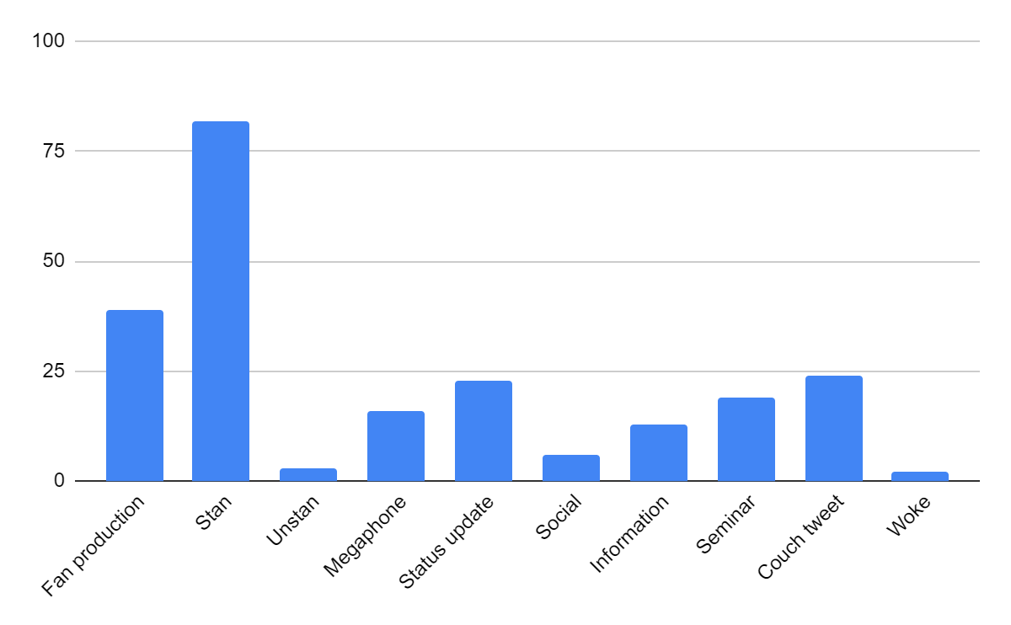
Chart 1: Total tweets for The Chilling Adventures of Sabrina
SexEd (Total)
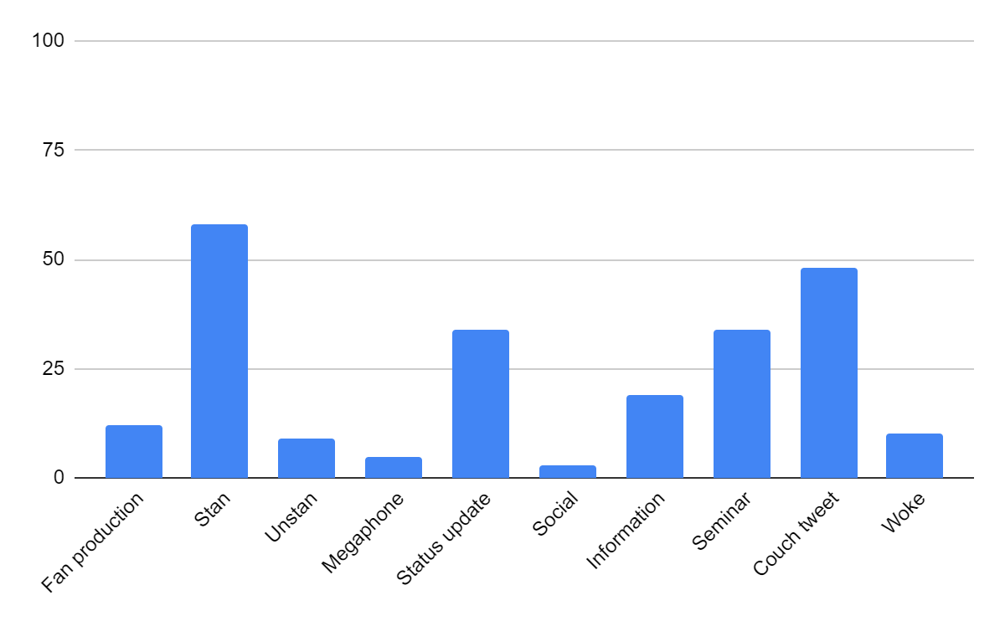
Chart 2: Total tweets for Sex Education
The two charts demonstrate that the distribution of tweets varies widely between CAOS and Sex Education. While CAOS viewers are displaying a strict stan behavior, Sex Education viewers are engaging in stan behavior, which is expected for a coming-of-age show. Still, they are also discussing the show by sharing comments, analysis, and information. These are examples of tweets from Sex Education viewers that carry comments and information, and exhibit comprehension of the message: “It just dawned on my why Otis was so familiar...he was in The Boy in the Striped Pyjamas. #sexeducation” (information) (Appendix B1), “#SexEducation was witty, engaging and thought provoking. Thoroughly enjoyed the show. Otis, Maeve, Eric and Adam are brilliant characters with lots of potential. Loved Gillian Anderson’s performance!” (comment) (Appendix B1), and “I wept after the detention scene in #SexEducation. For all the women and girls who have experienced unwanted groping, flashing, assault and rape. I wept for 17 year old me” (comprehension of the message) (Appendix B3).
To put thing into perspective, one can compare the difference between the number of couch tweets (48) and seminar tweets (34) for Sex Education. It is clear that there is not a significant difference, either, highlighting the fact that viewers understand the message the show carries.
These are examples of seminar tweets: “#Sexeducation should not include forcing preteens or teens to learn about the mechanics of sexual intercourse, STDs and the efficacy and side effects of bc in a classroom of their peers. Parents and guardians should educate themselves and the children under their care.” (Appendix B3) ; “I finished #SexEducation last night and I think that everyone should watch it. It so brilliantly delivers an enjoyable high school comedy/drama with relatable characters that then touches on important issues, making it extremely personal and understandable. Watch it!” (Appendix B3) ; “Sex Education also shows that a straight man can have a gay bestfriend, with a demonstration of affection without second thoughts. Teaches us that friendship is not defined by one's sexual orientation :) #SexEducation” (Appendix B3).
These findings go against those of Martín and González. Their study, which consisted of analyzing the tweets of students while watching The Hunger Games, showed that the students were tweeting about superficial aspects of the movies, instead of discussing the social and political content (Gutiérrez-Martín & Torrego-González, 2017).
B) Stanning the message
The word stan is often used to describe adoration to celebrities, characters, or content such as movies or songs. The findings of this study show that Sex Education viewers appreciate the message of the show, and this statement is especially true for the second season that raises awareness about sexual harassment. Aimee, one of the main characters, gets sexually assaulted on the public bus on her way to high school. This event traumatized her, so she started avoiding the bus until her girlfriends met her at the bus station and helped her face her fears. The bus scene, in which Aimee and five of her friends are seen sitting next to each other, symbolizes the struggles that sexual harassment survivors go through, the importance of a reliable support system to heal, and the strength of female unity. The bus scene not only made headlines but was also included in the tweets that are collected in this study.

Among 100 tweets that were posted after Season 2 was made available on Netflix, nine of them are about the bus scene. It is important to note that the bus scene was featured in Episode 3, and season two is made of seven episodes. So, the bus scene was overshadowed by the finale. However, it is possible to conclude the effect that the bus scene had on the viewers. Viewers appreciated the scene in six tweets, expressed their feelings in two tweets, and made a comment in one tweet. These tweets prove that it is not necessary to engage with a scene that carries an important message by posting tweets that feature analysis and comment. One Twitter, reacting to a heavyweight scene by expressing emotions is acceptable, which would not be the case in a classroom or in a round table discussion where stating insight is required.
The way in which Twitter users react to a scene of huge significance compared to a seminar shows that no matter how serious a message is, viewers are more likely to address it using emotions rather than reason. Rather than holding an intellectual discussion, viewers are employing affective language to communicate the intensity of their feelings. The following tweets are related to the bus scene and contain affective language: 1) “"Its just a stupid bus..." honestly loved this scene from #SexEducation” (Appendix B3); 2) “Best. Scene. Ever. #SexEducation #FemaleSolidarity” (Appendix B3); and 3) “MY GIRLS #SexEducation.”(Appendix B3) The first tweet contains the verb “love,” which is a stative verb that expresses a state of being. The adjective “best” in the second tweet is an interpersonal marker that indicates amazement. In the third tweet, the possessive pronoun “my” displays support to the characters in the bus scene.
C) Between insult and humor
Sex Education is a show that prides itself on raising awareness about relevant topics and addressing pressing issues to teenagers. Viewers are grateful for the work that the show is doing when it comes to awareness. However, sometimes some of them are not as "woke" as they are. In slang terms, to be woke is to be "aware of and actively attentive to important facts and issues," according to the dictionary by Merriam-Webster ("Merriam-Webster"). In the second season of Sex Education, a new character is introduced. Isaac is a paraplegic young man who lives near Maeve's place of residence in the trailer park. Maeve is one of the main characters, and almost all of the fans posting on Twitter are shipping her with Otis. Isaac was trying to win her over by pulling an unpleasant move which distanced Maeve from Otis. Fans were angry, so they created memes and shared them on Twitter under the hashtag #SexEducation to express their disapproval of Isaac's horrible behavior.
Hating a character is one thing, but making fun of their disability is another. In one tweet, a viewer called Isaac by the regressive term "wheelchair boy." In many others, Isaac's face is seen photoshopped on the body of Clair, a paraplegic character in the Japanese cartoon series Heidi, Girl of the Alps, and being pushed off a cliff (Image 1).
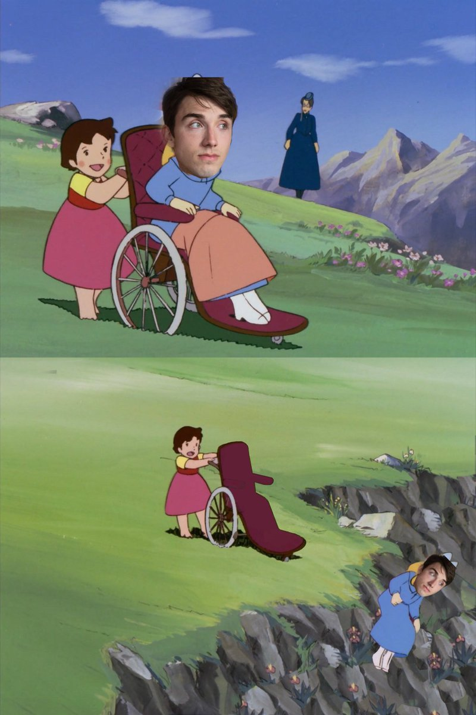
Image 1. A meme showing Isaac being thrown off a cliff
In other tweets, an image of a person burning in a wheelchair is accompanied by a caption that directs hate towards Isaac (Image 2). So, some Sex Education viewers are not refraining from using dehumanizing language to express their hatred towards a disabled character. This is an example of participatory fan culture gone wrong.
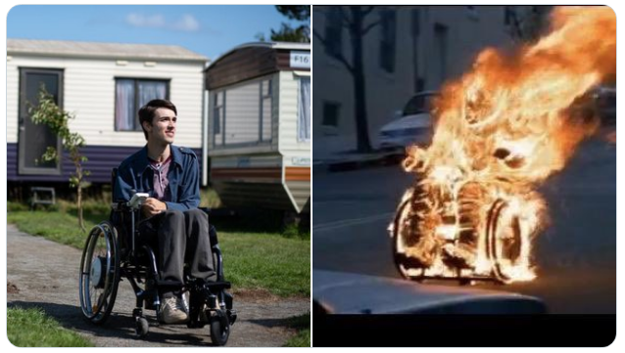
Image 2. A meme made of a collage of a photo of Isaac and a man burning in a wheelchair, alluding that Isaac is the one being burned.
Game of Thrones fans used the same meme templates to describe their hate towards Bran Stark, the person who won the Iron Throne (Image 3). In the series, people from different regions from the fictional land of Westeros were fighting over the Iron Throne to rule over the seven kingdoms.
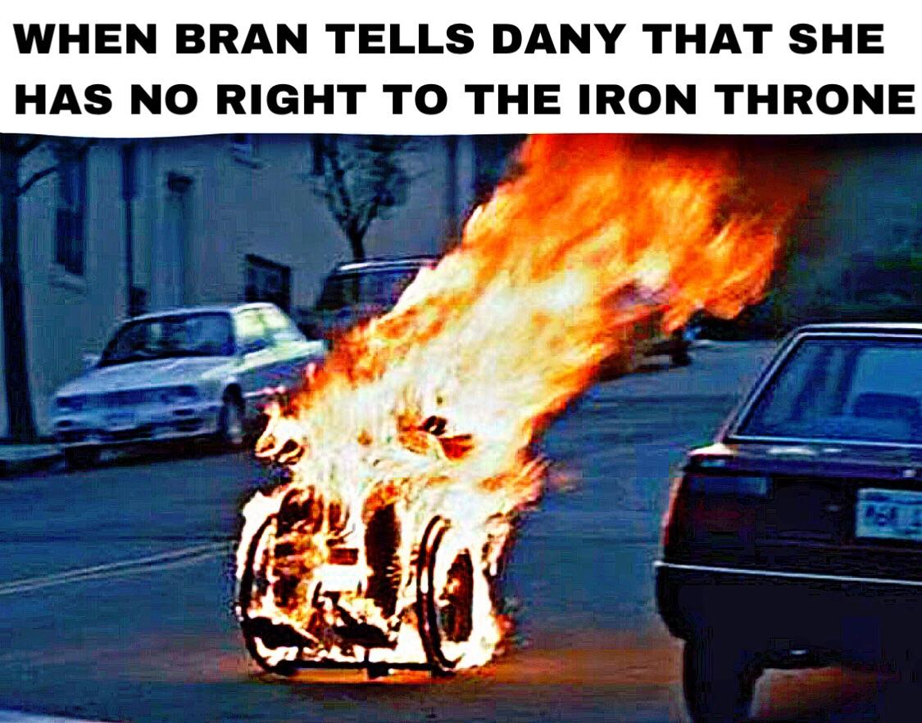
Image 3. A meme depicting Bran Stark being burned after challenging his rival Daenarys (Dany)
Bran Stark, who lost his ability to walk from the first episode, spent all the seasons in a wheelchair and did not make an effort to gain the right to as much as the rest of the characters did. He was chosen to be the king because of his magical abilities of mind control and seeing the past, present, and future.
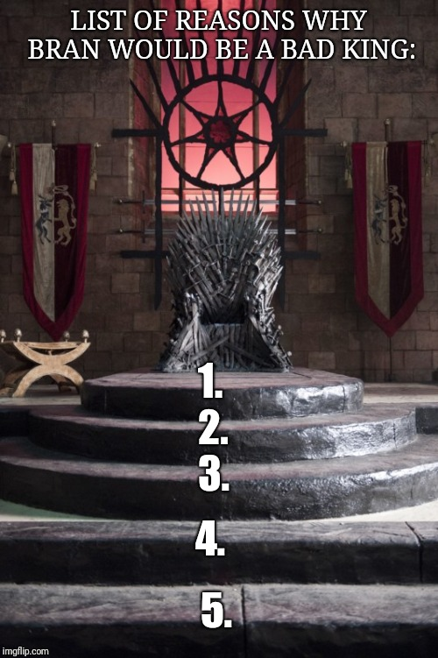
Image 4. A meme about how Bran Stark would be a bad king because he can’t climb the stairs with his wheelchair
Fans were disappointed by the ending, which caused a lot of controversies. They took their anger on Bran Stark by creating memes with his disability at the center, just like Sex Education fans did with Isaac (Image 4).

III- Orange is the New Black (OITNB)
A) Response to distress
The top three tweets for OITNB are: couch tweets (71), status update tweets (60), and stan tweets (29). The findings of OITNB demonstrate that when a show raises awareness about a cause, the viewers actively respond to it. The Netflix comedy-drama show OITNB is based on the memoir of Piper Kerman, which is titled Orange Is the New Black: My Year in a Women's Prison. The show follows Piper Chapman in Litchfield Penitentiary after she was sentenced for 15 months for money laundering activities.
Throughout the first six seasons, OITNB sheds light on different issues in the prison system of the United States: corruption, sexual harassment, racism, transphobia, and prisoner abuse. The seventh season, which is also the final one, highlights a hard-hitting issue that is related to modern-day America, and that is the horrific situation inside immigration detention centers.
In season 7, the show introduces a new group of inmates that are in Immigration and Customs Enforcement (ICE) custody. The final season addresses the situation of the detainees as realistically as possible and is used as a tool to advocate immigrant rights. The writers took their advocacy to the next level by speaking with detainees and visiting a deportation center to recreate the set as realistically as possible. When visiting the detention center, the writers handed out a hotline number that is run by Freedom for Immigrants to the detainees. Unfortunately, the hotline was shut down by ICE. (Fratti, 2019)
So, the final season mirrored the American reality that only detainees in ICE centers know about. OITNB viewers did not refrain from taking their anger to Twitter, where they posted about their frustration about the terrible conditions in detention centers. Season 7 has 23 woke tweets compared to two woke tweets for Season 1. The viewers posted woke tweets to 1) join the effort with the show and use Twitter to raise awareness about the cause (5 tweets), 2) share that the show taught them about the situation in detention centers (12 tweets), and 3) post about their appreciation of the message (6 tweets).
Here are some examples of "Woke" tweets for season 7 of OITNB: "This season of #OrangeIsTheNewBlack is so unbelievably deep. Extremely eye-opening to the current immigration and deportation crisis. #OITNB" (Appendix C3); "Wait this last season of #OITNB has me so sad. I'm glad they included what's happening with ICE in this season."(Appendix C3); "These ICE episodes of Orange is the New Black have me sobbing. #OITNB Just thinking of the real life situations occurring around us. Children being taken from their parents w/o any information. Lack of representation. My heart aches for those affected by these ICE raids / camps." (Appendix C3)
OITNB's seventh season not only demonstrates that a comedy-drama web series can be three-dimensional by taking on real-life events, but it also showed that the viewers could grasp the concept and act upon it by tweeting about these issues. It's in season seven when OITNB took a turn and became more of a documentary than a series that gives insight to prison and gives viewers the giggles. The relationship between the show creators and the viewers becomes a two-way street: the first party provides the information, and the second party adequately responds to it.
IV- The Good Place

A) Twitter for The Good Place: Bridging the Gap Between Viewers and Creators
Besides using Twitter to express fandom and raise awareness, Twitter users have found new ways to make the best use of the platform, and that is by making demands. The first season of The Good Place, an NBC fantasy-comedy television series, follows Eleanor Shellstrop in the afterlife. She lands in the Good Place, where people that have done good deeds in their life end up, as opposed to the Bad Place. The Good Place is utopia-like, and Eleanor figures out that she ended up there by mistake. The final episode ended with a plot twist which made Season 1 make a lot of sense. The viewers were amazed by how the show managed to trick them for 13 episodes, so they resorted to Twitter to demand a second season because the first one left them hanging.
Although the top three types of tweets for TGP are couch tweets (67), stan tweets (57), and status update tweets (47), it is worth shedding light on the megaphone tweets of Season 1. The latter carry the demands of the viewers. These tweets voice demands using verbs in the imperative mode, or make requests using the adverb please. The following tweets are examples of megaphone tweets that voice demands: "Binge-watched #TheGoodPlace and now I NEED a second season."; "Holy shirt #TheGoodPlace finale! I loved it. Great first season, need the forking second season now." (Appendix A1); "Well #TheGoodPlace had a forking brilliant finale. I must have a second season." (Appendix A1) These tweets, on the other hand, make requests: "#TheGoodPlace finale was so good. Please renew this awesome show, @nbc!" (Appendix A1) ; "I just finished #TheGoodPlace season finale. Holy. Shit. This show is brilliant. Please pick it up @nbc!!" (Appendix A1); "Holy motherforking shirt balls. I hope that #TheGoodPlace gets renewed. Do it, @nbc" (Appendix A1); "#TheGoodPlace finale was so good. Please renew this awesome show, @nbc!" (Appendix A1).
Twitter, in this context, is bridging the gap between the audience and the creators by giving the audience a platform not only to express their opinions but also to make the demands that will not go unnoticed, especially if they're tagging the show or using the show's official hashtag.
These findings can be tied to the case of the #SaveLucifer campaign that demanded the canceled Fox show be picked up (hence the word "saved") by another channel. After garnering more than 3.64 million tweets and 5.63 million retweets, according to @twittertv, Netflix saved Lucifer and is about to drop season 6.
Thus, Twitter is not only giving the fans a voice but also helping creators and channels know how to cater to the audience and deliver satisfying content. For this reason, companies use Nielsen, since it predicts consumer and market trends.
B) The Good Place Jargon Breaks the Fourth Wall
The “Good Place” was designed in a way where curse words are automatically censored by replacing them with other words that almost share the same letters.
Profanity | Alternative | Example
Shit | Shirt | “bullshirt”
Fuck | Fork | “motherforker”
Ass | Ash | “ash-hole”
Table 1. Glossary chart of The Good Place
Table 1 demonstrates the censored version of some profanities and how they are used in portmanteau curse words. The "Good Place" residents do not like swearing, that's one of the many reasons they ended up on the better side of the afterlife. However, since Eleanor Shellstrop was supposed to end up in the "Bad Place," she is often heard using these words, which make part of the show's glossary.
The same way Game of Thrones fans might greet each other with the Essos saying "Valar Morghulis," or how Harry Potter fans call people who haven't read or seen Harry Potter "muggles," The Good Place fans have picked up on the show's jargon and are employing them in their tweets. These are some examples of tweets that contain The Good Place jargon: "If you haven't been watching @nbcthegoodplace get on that shirt it's forking hilarious! #TheGoodPlace" (Appendix A2); "Just got done with #TheGoodPlace and Holy Forking Shirt the last episode kicked me deep in the feels! Good job!!!" (Appendix A1); "Just finished #TheGoodPlace finale. Holy fork that was great! I already miss @DarcyCarden I need more Janet in my life." (Appendix A2)
These words are what make The Good Place memorable. Aside from the unique plot, which combines comedy with philosophical fiction, the writers of the show created a fictional world that has its own version of the English language, which makes it more memorable. In a way, the writers are like the Architects (with a capital -a) that work in the headquarters of the Good and Bad Place. Their job is to learn about their residents and design the neighborhoods accordingly. So, each neighborhood is a world on its own, much like the show itself. The glossary is the cherry on top that is carrying the legacy of The Good Place beyond the fourth wall.
C) Moral Philosophy: From Chidi’s Place to Twitter
The Good Place teaches the viewers moral philosophy in the most unconventional way possible. After realizing she ended up in the "Good Place" by accident, Eleanor Shellstrop asks ethics and moral philosophy professor Chidi Anagonye to help her become a good person to earn her place in the "Good Place." So, he did what he only knew what to do and offered her philosophy classes. Eleanor and the viewer learn about the fundamental philosophical concepts, including but not limited to the categorical imperative by Immanuel Kant, the theory of moral particularism by Jonathan Dancy, virtue ethics by Aristotle, and deontological ethics.
The final episode of season 1 reveals what has been going on the entire season, and it is based on the line from the play "No Exit" by Jean-Paul Sartre, which is "Hell is other people." Eleanor Shellstrop was not in the Good Place after all; she was in the Bad Place along with three other people: Chidi, Tahani, and Jason. All of them ended up in the Bad Place for different reasons, and the Architect Michael was torturing them in an unconventional way. Instead of torturing them physically, he was abusing them psychologically. For instance, Chidi thinks multiple times before doing something because he wants to do what is ethically and morally right. So, Michael tortured him by putting him in uncomfortable situations, such as helping bad Eleanor earn her spot in the Good Place.
In season two and three, experiments are being run to see if humans can morally improve should they have good support. In the fourth and final season, the group created a new system that will help humans go to the Good Place after passing a moral development test. They can also choose to end their stay at the Good Place and end their after life if they feel like their existence means nothing anymore.
The four seasons are packed with plots with the afterlife at their center, which is one of the main philosophical questions: what happens after we die? Seminar tweets and couch tweets take over the feed for season 4, which is unusual considering that status updates, couch tweets, and stan tweets, are usually the top tweet categories. The show must have done something right to make this category rank high, and it did, by teaching philosophy in a fun way and providing a fulfilling answer to a question we always ask ourselves.
Seminar tweets are messages that contain comments, opinions, and analysis. The following messages are examples of seminar tweets: "#TheGoodPlace is having enough time with the people you love. I'm not crying, you are." (Appendix A3); "After watching the show, who else starting to feel like changing and being a better person so that if there really is a good place we could get in? And does that makes our effort to be meaningless cuz we're doing all this for the moral desert (get in the good place) #TheGoodPlace" (Appendix A4); "that I can really see the beauty of my life, my absolutely amazing wife, my awesome kids, my strikes and my gutters... Life is truly beautiful. A silly show reminded me of that today, and I'm also thankful for that. #TheGoodPlace." (Appendix A4)

Conclusions
The study of the combination of Netflix and Twitter expands on the uses and gratifications theory by showing the many ways viewers can gratify needs through media consumption. Instead of watching a series and calling it a day, viewers are using Twitter to practice their fandom, share valuable comments, and respond to the show's message by tying it to real life. Thus, the viewers are gratifying the need for participation. Whether they are tweeting about their love for a show or commenting on a scene, viewers are gratifying the need for participation with co-viewers. Participatory culture is on the rise thanks to social media, and the behavior that the viewers are exhibiting on Twitter reflects that. The research findings adhere to the uses and gratifications theory because they prove that viewers are not passive consumers; rather, they are active contributors.
Twitter is also making it possible for viewers to connect with show creators. The Good Place viewers did not refrain from using the official hashtag to ask for a second season after watching the brilliant Season 1 finale. The need to connect with show creators was gratified through Twitter. All one needs to do is write a tweet and hit send. Social media and the hashtag system is opening up new avenues for show creators and viewers alike.
It is now possible to track the viewer's reactions and demands. While showrunners would wait for TV rankings and the review of TV critics, they can now get an idea of how their show is performing by using social media. Therefore, social media has changed the way show creators analyze their show's performance. Could it be that the opinion of fans now matters more than the opinions of TV critics? Maybe that is why Netflix, which is home to the top-ranked shows, is also where one can find low-quality content. Studying how tweets have changed the evaluation of shows is one of the avenues that could be studied in future research.
Limitations and Avenues for Future Research
Although the study yielded fruitful findings, limitations regarding selection and sample size should be noted. First, the research covers four shows out of hundreds on Netflix. Since the data collection process was conducted manually, studying four shows instead of dozens, if not hundreds, was not convenient. Another factor, time constraint, was also added to the equation. Given the fact that I had four months to collect data and analyze them, studying four shows is a safer option. Second, the research studied 800 tweets. To break the numbers down: the study covered 200 tweets per each show, 100 tweets per each season. Due to the manual nature of the data collection process and time constraint, I found myself deciding to study 800 tweets only. However, this small sample, compared to the sample I could’ve got my hands on if I used a software, provided captivating results that are worth being expanded on.
The following are areas that can be considered for future research:
- How much do TV tweets have an impact on influencing Twitter users to watch Netflix shows?
- Are the official Twitter accounts of Netflix shows piloting the conversation of viewers on Twitter?
- Based on a study of tweets from viewers from different countries, can we say that comedy series on Netflix are globalizing humor?
- What type of shows receive the most Twitter engagement, and what are viewers gratifying by tweeting?

Works Cited
(n.d.). Retrieved from https://web.archive.org/web/20180323092554/https://media.netflix.com/en/press-releases/netflix-partners-with-all-movie-guide-to-serve-as-preferred-dvd-rental-store-migration-1
(2018, December 12). Retrieved October 11, 2019, from https://www.nielsen.com/us/en/insights/article/2018/juggling-act-audiences-have-more-media-at-their-disposal-and-are-using-them-simultaneously/
Advertising on Twitter drives audiences to watch TV. (n.d.). Retrieved October 11, 2019, from https://marketing.twitter.com/na/en/insights/advertising-on-twitter-drives-audiences-to-watch-tv.
Bellos, A. (2018, December 17). Did you solve it? Can you speak Twitter? The Guardian. Retrieved from https://www.theguardian.com/science/2018/dec/17/did-you-solve-it-can-you-speak-twitter
Building Time-shifted Audiences: Does Social TV Play a Role? (n.d.). Retrieved October 9, 2019, from https://www.nielsensocial.com/building-time-shifted-audiences-does-social-tv-play-a-role/.
Chen, G. M. (2011). Tweet this: A uses and gratifications perspective on how active Twitter use gratifies a need to connect with others. Computers in Human Behavior, 27(2), 755–762.
Clement, J. (2019). Second screen usage - Statistics & Facts. Second screen usage - Statistics & Facts. Statista. Retrieved November 10, 2019, from https://www.statista.com/topics/2531/second-screen-usage/
Fratti, K. (2019, July 29). How The 'OITNB' Season 7 Writers Kept The Immigration Plotlines "Depressingly Real". Bustle. Retrieved from https://www.bustle.com/p/how-the-oitnb-season-7-writers-kept-the-immigration-plotlines-depressingly-real-18360949
Fuchs, C. (2014). Social media as participatory culture. In Social media: A critical introduction (pp. 52-68). London: SAGE Publications Ltd doi: 10.4135/9781446270066.n3
Gutiérrez-Martín, A., & Torrego-González, A. (2017). The Twitter games: media education, popular culture and multiscreen viewing in virtual concourses. Information, Communication & Society, 21(3), 434–447. doi: 10.1080/1369118x.2017.1284881
Hashtag inventor: It was an 'accidental trip over a simple idea'. (2014, December 5). BBC News. Retrieved November 10, 2019, from https://www.bbc.com/news/av/technology-30340622/hashtag-inventor-it-was-an-accidental-trip-over-a-simple-idea
Katz, E. (1959). Mass Communications Research and the Study of Popular Culture: An Editorial Note on a Possible Future for This Journal. Studies in Public Communication, 2, 1–6. Retrieved from https://repository.upenn.edu/asc_papers/165/
Kyncl, R. (2017, September 13). The inside story of how Netflix transitioned to digital video after seeing the power of YouTube. Retrieved December 9, 2019, from https://www.vox.com/2017/9/13/16288364/streampunks-book-excerpt-youtube-netflix-pivot-video
Liu, I. L. B., Cheung, C. M. K., & Lee, M. K. O. (2010). Understanding Twitter Usage: What Drive People Continue to Tweet. PACIS 2010 Proceedings, (92). Retrieved from https://aisel.aisnet.org/pacis2010/92/
McLuhan, M. (1962). The Gutenberg galaxy: the making of typographic man. Toronto: University of Toronto Press.
Miller, T. (2003). Television: Critical Concepts in Media and Cultural Studies (Vol. 4). Abingdon: Routledge. Retrieved November 10, 2019, from https://books.google.am/books?id=KQzr_BTuefkC&printsec=frontcover&source=gbs_ge_summary_r&cad=0#v=onepage&q&f=false
Netflix stumbles as it launches in Canada. (2010, September 22). The Star. Retrieved from https://www.thestar.com/entertainment/2010/09/22/netflix_stumbles_as_it_launches_in_canada.html
Rossi, L., & Giglietto, F. (2016). Twitter Use During TV: A Full-Season Analysis of #serviziopubblico Hashtag. Journal of Broadcasting & Electronic Media, 60(2), 331–346. doi: 10.1080/08838151.2016.1164162
Stan. (n.d.). Merriam-Webster. Retrieved from https://www.merriam-webster.com/dictionary/stan
The Story of Propaganda. (n.d.). Retrieved November 10, 2019, from https://www.historians.org/about-aha-and-membership/aha-history-and-archives/gi-roundtable-series/pamphlets/em-2-what-is-propaganda-(1944)/the-story-of-propaganda.
Woke. (n.d.). Merriam-Webster. Retrieved from https://www.merriam-webster.com/dictionary/woke

Appendices
Appendix A1. The Good Place Season 1 (Top Tweets)
Tweet | Link | Purpose
UMMMM #TheGoodPlace better be renewed!! That ending! | https://twitter.com/MissyPrissy12/status/823292577789132801?s=20 | Fan demand
okay hear me out #TheGoodPlace would make a really good visual novel/otome game | https://twitter.com/sjmillerart/status/823998065203777536?s=20 | Fan art
Well #TheGoodPlace just went from being Amazing to Holy Motherforking Shirtballs Amazing. | https://twitter.com/darkingsrock/status/822659711912804352?s=20 | Stan tweet (show)
I finally watched #TheGoodPlace season finale and it was so mind blowing that I immediately rewatched it. | https://twitter.com/ScottJames__/status/825163018044600320?s=20 | Stan tweet (finale) + status update
Holy shirt! What a forking finale! | https://twitter.com/UGLYndDEPRESSED/status/822936650070261760?s=20 | Air thoughts
After marathoning #thegoodplace am sure we are in #thebadplace bc only the devil would give us 8 yrs of Obama and follow it w Trump. | https://twitter.com/NutterLee/status/825355681070989313?s=20 | Air thoughts
I was enjoying #TheGoodPlace. Then they called Minions an "ugly yellow toddler" and I flat-out cackled. Next level. | https://twitter.com/KristyPuchko/status/824084914429657088?s=20 | Express feelings
I accidentally read the comments on a #TheGoodPlace review and saw someone call Kristen Bell "a middle aged woman" so if you'll excuse me | https://twitter.com/MrEAnders/status/822662340135047168?s=20 | Status update
I’m writing a very delayed #TheGoodPlace season finale review. But I keep chuckling over "We get to stay, baby! We did it!” | https://twitter.com/TheEricGoldman/status/822818969757155328?s=20 | Status update
#TheGoodPlace finale was so good. Please renew this awesome show,  @nbc  ! | https://twitter.com/TVandDinners/status/822648586886320129?s=20 | Stan tweet (show) + fan demand
#TheGoodPlace got so meta with the whole "you'd be lucky to get 6 months out of this insane gambit," then left us thirsting for season 2. | https://twitter.com/TheodoraG13/status/823302721264553984?s=20 | Air thoughts
Spending this rainy ass Sunday with  @tiyasircar  on #TheGoodPlace | https://twitter.com/KellenCox/status/823368676313206784?s=20 | Status update
"Sidenote: I might be legit into Tahani." AAAAAAAHHHHH (I'm finally catching #TheGoodPlace finale) | https://twitter.com/alexandra_ewing/status/823401834370973697?s=20 | Status update
NBC has some prime shows right now. If you haven't watched #ThisIsUs or #TheGoodPlace. Do it. | https://twitter.com/madisonicole3/status/824080515250683906?s=20 | Recommendation
My mind is still bent from #TheGoodPlace finale you guys | https://twitter.com/MerylWilliams/status/823544068529647617?s=20 | Stan tweet (show)
If #TheGoodPlace gets a second season, I really hope they find a way to get Shelley Long in there as a regular | https://twitter.com/OliverSava/status/823710548495896577?s=20 | Fan demand
Bitch! This twist! #TheGoodPlace | https://twitter.com/katrinajax/status/825491066300334081?s=20 | Commentator
OMG #TheGoodPlace NAILING it with that outstanding season finale twist. I'm obsessed and need season 2 stat.  @nbcthegoodplace | https://twitter.com/jdpierpoint/status/823018894214524928?s=20 | Stan tweet (show) + fan demand
I must say,  @nbcthegoodplace  pleasantly surprised me with nicely flowing story elements, fun humor and unexpected twists! #TheGoodPlace | https://twitter.com/KewpieDoll83/status/822912876394450945?s=20 | Stan tweet (show)
Holy forking shirtballs! You need to watch #TheGoodPlace. Season 1 is on  @hulu  including this week's beautiful season finale. No, really. | https://twitter.com/tadleckman/status/823305139880497152?s=20 | Recommendation
Binge-watched #TheGoodPlace and now I NEED a second season. | https://twitter.com/insidethetube/status/824060028231372801?s=20 | Status update + fan demand
Forkin' fantastic #TheGoodPlace finale. | https://twitter.com/TVMcGee/status/823345509746282498?s=20 | Stan tweet (show)
As someone who regularly calls frozen yogurt "fraudulent ice cream" I can't believe how much #TheGoodPlace finale shocked me. | https://twitter.com/JenAshleyWright/status/825056749166194689?s=20 | Stan tweet (show)
Huh. So I had correctly guessed the "twist" in #TheGoodPlace after the first couple episodes, but then decided I must be wrong. | https://twitter.com/charliejane/status/824866423105216512?s=20 | Air thoughts
#TheGoodPlace "it ran for 16 years on the BBC--they did nearly 30 episodes" this is the funniest show I have ever seen | https://twitter.com/allprologue/status/824854566122303489?s=20 | Comment
Gotta say that I'm really enjoying the show THE GOOD PLACE! Just really refreshing and fun! #TheGoodPlace | https://twitter.com/RebekahMcKendry/status/824532077630468096?s=20 | Stan tweet (show)
OH MY GOD #TheGoodPlace FINALE | https://twitter.com/rushbomb/status/823995273219346432?s=20 | Air thoughts
The finale of #TheGoodPlace...um it's brilliant. How a show about ethics that makes one think can be so funny is a testament to the writers | https://twitter.com/clairecdowns/status/823940109217038336?s=20 | Opinion
Wow - I thought #TheGoodPlace was an ambitious show and then I saw the season finale. Mind is blown. | https://twitter.com/rising/status/823710374713118721?s=20 | Stan tweet (show)
Rewatching #TheGoodPlace S1. Keep having to go back to IMDb to confirm that this was really Jameela Jamil's first acting job. She's so good. | https://twitter.com/NussbaumAbigail/status/823653727542411265?s=20 | Status update + information
Still can't believe how good the season finale of #TheGoodPlace was. I must have another season, @IMKristenBell. | https://twitter.com/alexandergold/status/823292452639358976?s=20 | Stan tweet (show)
The more I think about it, the more obvious it is that #TheGoodPlace accomplished all the things unsuccessfully attempted by #Westworld | https://twitter.com/NussbaumAbigail/status/823180939547250689?s=20 | Observation
Holy forking shirt, #TheGoodPlace needs to be renewed. Rather genius, that ending. More please! | https://twitter.com/jopinionated/status/822673182469390336?s=20 | Stan tweet (show) + fan demand
Holy shirt #TheGoodPlace finale! I loved it. Great first season, need the forking second season now. | https://twitter.com/chrisharnick/status/822662377011343363?s=20 | Stan tweet (show) + fan demand
I just finished #TheGoodPlace season finale. Holy. Shit. This show is brilliant. Please pick it up  @nbc  !! | https://twitter.com/pmiscove/status/822638312519254016?s=20 | Stan tweet (show) + fan demand + status update
Tonight’s viewing agenda: Respective 3rd episodes of #The100 and #Legion screeners (finally!) and #TheGoodPlace season finale (no spoilers!) | https://twitter.com/TheEricGoldman/status/822596844123471872?s=20 | Status update
Well #TheGoodPlace had a forking brilliant finale. I must have a second season. | https://twitter.com/JarettSays/status/822314603379994624?s=20 | Stan tweet (finale) + fan demand
#TheGoodPlace finale was INCREDIBLE. Honestly one of the best I've ever seen NBC would be stupid to not renew it for a second season. | https://twitter.com/Bilal_Mian/status/822308779525967878?s=20 | Stan tweet (finale) + fan demand
Holy motherforking shirt balls. I hope that #TheGoodPlace gets renewed. Do it,  @nbc | https://twitter.com/SteveBryantArt/status/822296791181914117?s=20 | Fan demand
#TheGoodPlace Pilot: How is this going to last more than a season?  #TheGoodPlace Finale: SEASON TWO SOUNDS AMAZING GIVE IT TO ME NOW. | https://twitter.com/Memles/status/822285189787320320?s=20 | Fan demand
Imma let you finish, but  @nbcthegoodplace  had one of the best plot twists in recent TV finale history. #TheGoodPlace | https://twitter.com/JustAboutWrite_/status/822275708089204738?s=20 | Stan tweet (finale)
I am shook #TheGoodPlace | https://twitter.com/Hanza802/status/822269782640721922?s=20 | Feelings
Holy motherforking shirtballs, the twist in tonight's #TheGoodPlace is fantastic. | https://twitter.com/HistoryofHaz/status/822269771257446401?s=20 | stan tweet (finale)
Watch #TheGoodPlace. That's all I have to forking say. They weren't lying when they said it was Judgment Day...  PLEASE #RenewTheGoodPlace | https://twitter.com/Thisisntflying/status/822265053713993731?s=20 | Recommendation
Wow, #TheGoodPlace finale. Just wow. | https://twitter.com/chaneyj/status/822264196435996674?s=20 | Stan tweet (finale)
i am actually so excited for u to see the hour long season finale of #TheGoodPlace tmrw it is so good | https://twitter.com/meganamram/status/821855647444545536?s=20 | Status update
"So far it's genocide and leggings as pants." Great start to your hate list, Janet. #TheGoodPlace | https://twitter.com/Dusti_C_A/status/819724406196936704?s=20 | Quote
Gonna start calling people my favorite yogurts, lol #TheGoodPlace  @nbcthegoodplace | https://twitter.com/buffyfan_5/status/817189188659515392?s=20 | Air thoughts
Stability has returned to my life in the form of #TheGoodPlace | https://twitter.com/_kellyQ/status/817182822465150978?s=20 | Stan tweet (show)
“There’s something so human about taking something great and ruining it a little so you can have more of it.” #TheGoodPlace #BestTVLines2016 | https://twitter.com/sarahdkatz/status/809832617814163456?s=20 | Quote

Appendix A2. The Good Place Season 1 (Latest Tweets)
Tweet | Link | Purpose
Bitch! This twist! #TheGoodPlace | https://twitter.com/katrinajax/status/825491066300334081?s=20 | Gogglebox
AAAAAAAAAAAAAAAAAAAAAAAAAAAAAAAAAAAAAAAAAAAAAAAAAAAAAAAAAAAAAAAAAAAAAAAAAAAAAAAAAAAAAAAAAAAAAAAAAAAAAAAAAAAAAAAAAAAAAAAAAAAAAH #TheGoodPlace | https://twitter.com/RhesusNegatif/status/825489078078550017?s=20 | Gogglebox
Real Eleanor is dumb. I'm over her in this scene. #TheGoodPlace | https://twitter.com/katrinajax/status/825488591421898754?s=20 | Air thoughts
Holy Forkin Shirt Balls!  Can't forkin BELIEVE how #TheGoodPlace ended.  This show was such a surprise  @TheGoodplace  Is S2 is out already?! | https://twitter.com/WillowBlack13/status/825488297191419904?s=20 | Air thoughts
Très bonne surprise la série #TheGoodPlace avec une Kristen Bell au top ! | https://twitter.com/DarkseidTV/status/825472160655347713?s=20 | Stan tweet (show)
I'm not a mountain of strength. I'm a canyon... of poo-poo. #TheGoodPlace | https://twitter.com/carrieggs/status/825466172577611776?s=20 | Quote
After watching the show "The Good Place", I'm convinced that the world we're currently in is the bad place. #TheGoodPlace #thebadplace | https://twitter.com/d_vaz/status/825461158333145088?s=20 | Analysis
They played digital get down at the wedding. #TheGoodPlace | https://twitter.com/katrinajax/status/825460809115566083?s=20 | Detail
Beaucoup aimé cette première saison de #TheGoodPlace, j'espère qu'elle sera renouvelée, pas envie de rester sur ma faim | https://twitter.com/Alex26140590/status/825460464029224962?s=20 | Stan tweet (show) + fan demand
Tragic Mike. Honestly I'm dead. #TheGoodPlace | https://twitter.com/katrinajax/status/825460119311937536?s=20 | Gogglebox
Jason and Janet. #TheGoodPlace | https://twitter.com/katrinajax/status/825459114851569664?s=20 | Gogglebox
Che cosa fantastica e geniale, non me l'aspettavo proprio #TheGoodPlace | https://twitter.com/sejcapsq/status/825458002434150401?s=20 | Stan tweet (finale)
Everybody loves Chidi and Tahani. Everybody is Eleanor. #TheGoodPlace | https://twitter.com/katrinajax/status/825457210088112128?s=20 | Air thoughts
Watched  @NBC  The Good Place "Chidi's Choice" (1.9)  @nbcthegoodplace  #TheGoodPlace #Brilliant http://uverse.com/tv/show/the-good-place | https://twitter.com/ioyg/status/825454220333686785?s=20 | Status update
Re-watching the pilot of #TheGoodPlace and saw this..... | https://twitter.com/snarky_bee/status/825438395719618560?s=20 | Detail
#TheGoodPlace 01x12, isso sim é um plot twist imprevisível, aprende #westworld! kk | https://twitter.com/dneoboom/status/825438085861277696?s=20 | Comment
GENTE, SOCORR, EU ASSISTI O EP12 DE #THEGOODPLACE E MINHA CABEÇA TÁ TIPO ????? | https://twitter.com/dneoboom/status/825437566358929408?s=20 | Social
I've never experienced a rewatch as immensely and uniquely satisfying as #TheGoodPlace. It is a perfect season of television. | https://twitter.com/Richie_Trnr/status/825431447053934592?s=20 | Stan tweet (show)
Hi I'm shipping Eleanor/Chidi but also Eleanor/Tahani goodbye. #TheGoodPlace | https://twitter.com/katrinajax/status/825410564545454080?s=20 | Shipping tweet
I'm honestly dead at how funny this show is! #TheGoodPlace | https://twitter.com/katrinajax/status/825409187681275904?s=20 | Air thoughts
Oh no, I'm out of episodes. #TheGoodPlace | https://twitter.com/caitlin_kelly11/status/825408307204616192?s=20 | Air thoughts
One of my fave things about #TheGoodPlace is that froyo is in the after life. | https://twitter.com/HitzhusenLauren/status/825397781334482946?s=20 | Air thoughts
"Romeo was the name of the my and Juliet was my Roomba." Dying. #TheGoodPlace | https://twitter.com/caitlin_kelly11/status/825390935794135040?s=20 | Quote
Just watched an entire season of #thegoodplace  @nbc  in 3 days thanks for I  @goldinisis | https://twitter.com/JanellicaT/status/825389133661163522?s=20 | Status update
@readingtheend  After repeated mentions of #theGoodPlace on the podcast I have finally dived into the show and it is charming and delightful! | https://twitter.com/butnotdegeneres/status/825383996880277505?s=20 | Status update
Je reste quand même très dubitatif sur #Thegoodplace. C'est au mieux sympathique mais l'écriture est trop maladroite. Dommage. | https://twitter.com/imnotgenekelly/status/825383586824065024?s=20 | Opinion
"Congratulations, Chidi. You filibustered recess." I love Chidi so much. #TheGoodPlace | https://twitter.com/caitlin_kelly11/status/825381774234628096?s=20 | Stan tweet (character)
I'm starting #TheGoodPlace later since it's been making  @allprologue  happy recently. | https://twitter.com/katrinajax/status/825363447063932929?s=20 | Status update
J'espère vraiment que #TheGoodPlace aura droit à une saison 2 parce que la 1ère était vraiment excellente, et ce final... | https://twitter.com/Tch1X/status/825319270359916544?s=20 | Fan demand + stan tweet (finale)
NUNCA eu poderia ter imaginado isso, toda a armação, e tudo fez tanto sentido... Genial!! #TheGoodPlace | https://twitter.com/brunnomorai/status/825290170475880449?s=20 | Comment
Oki hier j'ai commencé #TheGoodPlace et c'est grave cool! | https://twitter.com/tommovato_/status/825258109761417216?s=20 | Status update
#TheGoodPlace it become a good story tho | https://twitter.com/echabulet/status/825229334700896256?s=20 | Comment
Watching #TheGoodPlace season 1 again after seeing the finale is REVELATORY  YOU GOT US GOOD  @nbcthegoodplace | https://twitter.com/LeahIsMagical/status/825213497785122816?s=20 | Status update
Did not see that twist coming! #TheGoodPlace | https://twitter.com/cmw628/status/825210218904694784?s=20 | Gogglebox
That plot twist for the season finale of #TheGoodPlace I'm shook!!! And I can usually predict these shows!! | https://twitter.com/celineison/status/825201796805038080?s=20 | Gogglebox
The Good Place = 👌🏼 #TheGoodPlace | https://twitter.com/StephMucci/status/825201229961650176?s=20 | Stan tweet (show)
Watch #TheGoodPlace. I thought it was good before and now I'm blown away. #Itsgood | https://twitter.com/HollyWilB/status/825193748351037440?s=20 | Recommendation
The cacti. I can't #theGoodPlace | https://twitter.com/caitlin_kelly11/status/825193473712218112?s=20 | Gogglebox
Honestly can't recommend #TheGoodPlace enough. If you like Communtiy, The Office, Parks&Rec, or Brooklyn 99, I bet you'll dig it. | https://twitter.com/The_Doc_Webb/status/825185450964971522?s=20 | Recommendation
Loved #TheGoodPlace season finale twist. | https://twitter.com/Nazreen1810/status/825183396301115392?s=20 | Stan tweet (finale)
Just finished #TheGoodPlace finale. Holy fork that was great! I already miss  @DarcyCarden  I need more Janet in my life. | https://twitter.com/chrispapagikos/status/825181902306942978?s=20 | Stan tweet (finale)
"She's so pretty. Like Nala from the Lion King. And she talks so smart. Like Nala from the Lion King." #TheGoodPlace | https://twitter.com/caitlin_kelly11/status/825177255475281921?s=20 | Quote
They totally did want to swing. I love this show. #TheGoodPlace | https://twitter.com/caitlin_kelly11/status/825174575419969541?s=20 | Air thoughts
@TedDanson  @IMKristenBell so obsessed with #TheGoodPlace I've watched it 2 times. Might even make it 3. #nbc | https://twitter.com/jherethere/status/825171670289768448?s=20 | Status update
If you haven't been watching  @nbcthegoodplace  get on that shirt it's forking hilarious! #TheGoodPlace | https://twitter.com/StacieTheon/status/825170126647341056?s=20 | Recommendation
#TheGoodPlace season 1. | https://twitter.com/davidclarksally/status/825167442301317120?s=20 | Status update
I finally watched #TheGoodPlace season finale and it was so mind blowing that I immediately rewatched it. | https://twitter.com/ScottJames__/status/825163018044600320?s=20 | Status update
"He's an idiot from Florida. He's a Floridiot." #TheGoodPlace | https://twitter.com/caitlin_kelly11/status/825159891677503489?s=20 | Quote
"None of these philosophers is ever talking about masturbation." I'm crying. #TheGoodPlace | https://twitter.com/caitlin_kelly11/status/825158114689290245?s=20 | Quote
omg. #TheGoodPlace finale was not at all what i was expecting. i'm interested in seeing where it goes. | https://twitter.com/MarioPadilla/status/825156487240675332?s=20 | Stan tweet (finale)

Appendix A3. The Good Place Season 4 (Top Tweets)
Tweet | Link | Purpose
#TheGoodPlace  was incredible this week.  Life is only worth living because it ends.  It’s such a shame that this wonderful, funny, moving and intelligent bit of TV is ending next week, but the last 4 seasons have been utterly incredible stuff. The smartest dumb show ever made. | https://twitter.com/GargantuanAppl1/status/1220794556746170368?s=20 | Learned something
2 more episodes left #TheGoodPlace | https://twitter.com/bwaystokes/status/1220514674694856704?s=20 | Express feelings
#TheGoodPlace  is having enough time with the people you love. I'm not crying, you are. | https://twitter.com/RCMtalks/status/1221138845669916672?s=20 | Learned something + express feelings
There are so many things I love about #TheGoodPlace  but my favorite thing is how it's the only show I've ever watched where I truly have no idea what will happen.  Every episode I'm surprised.  Every season I'm surprised.  I have truly no idea how it will end and that's special. | https://twitter.com/alexandergold/status/1220867430072762368?s=20 | Stan tweet (show) + comment
If you look up at the word “cute” in the dictionary this is what you see  #cheleanor #TheGoodPlace |  | Stan tweet (couple)
“Life is only worth living because it ends” #TheGoodPlace | https://twitter.com/Willoughby_Jack/status/1221142017453043713?s=20 | Learned something
Michael: "Are you gonna sit there and tell me that every single Friend belongs in hell? I mean, maybe Ross and Rachel, and Monica and Joey, and definitely Chandler, but Pheobe?"  @nbcthegoodplace and @LisaKudrow: "Bitch, please..."  #thegoodplace | https://twitter.com/priceofmxgic/status/1220588671377793024?s=20 | Detail
He wasn't technically designed for this, but to be fair, he wasn't designed for anything. Trainer Derek wants to battle!  #TheGoodPlace #art | https://twitter.com/dandiestdaisy/status/1232804109390090241?s=20 | Fan art
yall wanna talk about range?!?!  NO ONE has this range.  #TheGoodPlace | https://twitter.com/issaberds/status/1230495018713927680?s=20 | Stan tweet (actress)
It will take me 1000 Bearimys to get over #TheGoodPlace finale. One of the most perfect hours of TV I’ve seen.  @nbcthegoodplace | https://twitter.com/Claire_Hodge/status/1230240110890901505?s=20 | Expressing feelings
I've heard #TheGoodPlace is a real feel good series, gonna give the first episode or so a try! | https://twitter.com/karatecorgi/status/1232765184332255234?s=20 | Status update
Arm twisted....watching #TheGoodPlace | https://twitter.com/zoidberg95/status/1231226979623546882?s=20 | Status update
“I argue that we choose to be good because of our bonds with other people and our innate desire to treat them with dignity. Simply put, we are not in this alone.” #thegoodplace | https://twitter.com/michikosketch/status/1230234206707437568?s=20 | Quote
Matchy matchy #whatthefork #thegoodplace  @KristenBell | https://twitter.com/kelsisutherland/status/1230983979358203904?s=20 | Merch
first favorite immortal being done Pleading face three more to go  #thegoodplace | https://twitter.com/sleazyjanet/status/1231403085232246784?s=20 | Fan art
Through all the reboots & different versions, Eleanor & Chidi always found their way back to each other #TheGoodPlace | https://twitter.com/ohsnapsitsriri/status/1231842558302515200?s=20 | Air thoughts
Just got a job rejection, so I shall be watching Chidi make peeps chilli in his Who What Where When Wine t-shirt on repeat.  #TheGoodPlace | https://twitter.com/foleynotrose/status/1232691569519734786?s=20 | Status update
Okay, I am totally late to the party, but I LOVE The Good Place. I don't even like sitcoms. Just not my thing. But this show! It is so good! Just finished season 3, and the finale killed me. Chidi and Eleanor!! #TheGoodPlace | https://twitter.com/terrasum/status/1230319389355806720?s=20 | Stan tweet (show+couple)
MY TEAM COCKROACH HAS ARRIVED I love them so much, I miss my showwww #TheGoodPlace | https://twitter.com/theschittplace/status/1233529529521582080?s=20 | Merch
Peter when he realizes the last woman who’s wife material just went home and he’s left with a pathological gaslighter and a girl who still lives with her parents.  #TheBachelor #TheGoodPlace | https://twitter.com/MalloyniumFalcn/status/1232184577378013184?s=20 | Funny caption
Slowly making my house completely #TheGoodPlace themed. Thanks  @adamavenir  ! | https://twitter.com/lynnandtonic/status/1230897443417407489?s=20 | Merch
Episode 1x06 of #TheGoodPlace had so many Friends references.  One word: Amazing | https://twitter.com/ahoydinguses/status/1230871355450589192?s=20 | Detail
What’s up, my little chilibabies? #TheGoodPlace | https://twitter.com/terfle/status/1233139883390251020?s=20 | Merch
days 17-20 #28DaysofShipping  #TheGoodPlace #teleanor #StarWars #finnpoe #stormpilot #Monk #TwilightSaga | https://twitter.com/Khiroptera/status/1230666209621954561?s=20 | Fan art
What if Bellamy and Clarke slept together and had a relationship on another planet like Chidi and Eleanor did in one of the versions of the #TheGoodPlace? | https://twitter.com/ahoydinguses/status/1231635351225196545?s=20 | Analysis
This has probably been pointed out before, but has anyone ever seen Michael from #TheGoodPlace and USA volleyball and beach volleyball legend Karch Kiraly in the same room? | https://twitter.com/Winn1/status/1230208372537950208?s=20 | Detail
“if all you care about in the world is the velvet rope, you will always be unhappy, no matter which side you’re on”  happy birthday  @jameelajamil  #HappyBirthdayJameela #jameelajamil #tahanialjamil #thegoodplace #draw #illustrator #fanart | https://twitter.com/itsnerdish/status/1232513381543895040?s=20 | Fan art
*starts heavy sobbing* #TheGoodPlace | https://twitter.com/JB_AU/status/1231538459036151808?s=20 | Express feelings
I'm STILL laughing at this.  #TheGoodPlace | https://twitter.com/HairlessThoctar/status/1229615538747383813?s=20 | Air thoughts
I was sick this week so I binge-watched #TheGoodPlace...  ... & realized it's about the challenges & consequences of designing complex human-centered #systems - & the long-term impact of extrinsic vs intrinsic motivation.  In other words, it's a show about #gamedesign | https://twitter.com/amyjokim/status/1230896185767911425?s=20 | Analysis
I owe it to let you go.  #TheGoodPlace | https://twitter.com/chidi_anagonye_/status/1230570898954035201?s=20 | Quote
Can you guess what I just finished binge watching? That’s right  @nbcthegoodplace  and it made me ugly cry when it finished... So I decided to make this as a kind of a fan art, my personal good and bad place. (No pp flattening here, just psychological torture) #TheGoodPlace #comic | https://twitter.com/siberianlizard/status/1232310202466107392?s=20 | Status update + expressing feelings + fan art
Cartography as a hobby for a professor of ethics and moral philosophy doesn't sound so bad. #TheGoodPlace | https://twitter.com/_Fpk_/status/1232032534252396547?s=20 | Air thoughts
"Imagine a wave in the sea. You see it, you measure the high, how the sun reflect ,you know it's a wave. But then it crush on the shore, and It isn't more. But the water still there. The wave was a water form.The wave come back to the sea, where it comes from" #TheGoodPlace | https://twitter.com/fariasillos/status/1233009825170280450?s=20 | Quote
I am so amazed with how they made Janet in #TheGoodPlace, but this scene got me with another hand giving her bunch of papers. A Janet's Janet? Janetception. | https://twitter.com/psychokenetics/status/1231477956951756801?s=20 | Comment
My Michael and Janet  @OriginalFunko  Pops are perfect- but it was the box lid that made me squeal in delight! #TheGoodPlace | https://twitter.com/mlroth84/status/1230269683309383680?s=20 | Merch
Watching #TheGoodPlace and Shawn just told Michael he’s gonna be in the Bad Place being choked by him and where do I sign up for this cos choke me daddy Shawn plz | https://twitter.com/AdamskiJonDicky/status/1232044757192527874?s=20 | Status update + gogglebox+ funny
Just got done with #TheGoodPlace and Holy Forking Shirt the last episode kicked me deep in the feels! Good job!!! | https://twitter.com/JackGeekstalk/status/1231190776459255808?s=20 | Status update + expressing feelings
When you’re frustrated that Funko made the wrong Janet with a cactus, so you make your own Janet. #TheGoodPlace | https://twitter.com/little_pop_work/status/1231383358736826368?s=20 | Status update
I’m starting off the day feeling amazing: my gym sis got me a dirty chai this morning, just because. Generosity and kindness is the salve this world needs, so, in the words of  @MarcEvanJackson  , go do something good. #TheGoodPlace | https://twitter.com/lisa_kath/status/1230195284476489729?s=20 | Status update + learned something
Do you ever think about the contrast between Jason and Chidi both being ready to leave the Good Place, and how Jason is able to stick around for thousands of extra Bearimys calmly and at peace, while Chidi is in near-agony at staying for like an extra day? #TheGoodPlace | https://twitter.com/inkasrain/status/1231999249803612162?s=20 | Air thoughts + social
So I've been sneaking in #TheGoodPlace images and quotes into my ethics lectures. Week 1: | https://twitter.com/DrJessC/status/1233241521517821952?s=20 | Status update
I just found out there’s episode 13 of season 4 of #TheGoodPlace. (Spoilers ahead)  I kinda don’t want to watch it. I thought episode 12 was the perfect ending.  How can it be better than Eleanor & Chidi holding each other looking toward an eternity together... or however long? | https://twitter.com/GideonOnGaming/status/1231407401456340992?s=20 | Status update + comment
Off to: make/eat pancakes; binge watch the final series of #TheGoodPlace; read for pleasure | https://twitter.com/earlymodatLancs/status/1232377534303653888?s=20 | Status update
My last Pop of the night... who wants some Peep chili? #TheGoodPlace | https://twitter.com/little_pop_work/status/1231450709196976128?s=20 | Merch
Thanks  @VuduFans  for the awesome mat! Now my guests can feel in a “Good Place” before coming in. #TheGoodPlace #vudu | https://twitter.com/xhollister21x/status/1230624748838637568?s=20 | Merch
I'm sure I'm late to this, but just watched #TheGoodPlace finale. I haven't openly snot cried like that in years. What a great show. | https://twitter.com/DreamPharmD/status/1232490205782822912?s=20 | Status update + finale + expressing feelings
This is the best show I’ve ever watched. Please go watch #TheGoodPlace | https://twitter.com/UnlockedVerses/status/1230959893403836417?s=20 | Stan tweet (show) + recommendation
Caught up on the last season of #TheGoodPlace and the finale had me in tears. Especially, the wave reference. | https://twitter.com/urlgrl/status/1230308536975937538?s=20 | Status update + expressing feelings
One of the best TV monologues I've ever heard. So poignant. Chidi + Eleanor = everything that's right with the world. #TheGoodPlace | https://twitter.com/melodymccune/status/1230328087654490113?s=20 | Comment

Appendix A4. The Good Place Season 4 (Latest Tweets)
Tweet | Link | Purpose
I’ve put this off for so long but it was finally time to watch #thegoodplace. I’m ugly crying. | https://twitter.com/yasminleighw/status/1233541392477102080?s=20 | Status update + expressing feelings
He terminado #TheGoodPlace y estoy puto llorando. | https://twitter.com/iviYoHaNe/status/1233540239588839424?s=20 | Status update + expressing feelings
Non piangevo così dal finale della terza stagione di stranher things #TheGoodPlace | https://twitter.com/mjmccartney23/status/1233538571363061761?s=20 | Expressing feelings
Penso che il rewatch sarà d’obbligo... #TheGoodPlace | https://twitter.com/mjmccartney23/status/1233537787212783617?s=20 | Air thoughts
Ho appena finito #TheGoodPlace e sono in mille lacrime e sconvolta aiuto | https://twitter.com/mjmccartney23/status/1233537070737559552?s=20 | Expressing feelings
Recently started watching #TheGoodPlace and wtaf either I’m just a bit thick (likely) or that plot twist end of series 1 was bloody brilliant because I DID NOT SEE THAT COMING ?!?! | https://twitter.com/_Suzanne_W/status/1233532980662022150?s=20 | Air thoughts + stan tweet (finale)
Voy súper tarde pero acabo de ver el final de #TheGoodPlace | https://twitter.com/iPaulaDunham15/status/1233530792627900416?s=20 | Status update
MY TEAM COCKROACH HAS ARRIVED I love them so much, I miss my showwww #TheGoodPlace | https://twitter.com/theschittplace/status/1233529529521582080?s=20 | Status update
The ending of #TheGoodPlace has hit me harder than anything | https://twitter.com/ellarmccarthy/status/1233521111348006913?s=20 | Expressing feelings
I cried my eyes out. It was so well written #TheGoodPlace | https://twitter.com/iknowhim/status/1233515490686926848?s=20 | Expressing feelings
#TheGoodPlace binging what I missed and S3 E10 has made me laugh today more than I have all week | https://twitter.com/whatsonnow1/status/1233511894507556864?s=20 | Status update
#TheGoodPlace just might be the most perfect TV show ever created. | https://twitter.com/MisterAbobo/status/1233503033973182464?s=20 | Stan tweet (show)
Just watched ep1 of #TheGoodPlace and quite like it but a)Jameela Jamil is annoying as fuck and b) how the hell did they get 4 seasons out of this?? | https://twitter.com/rachelanyfranny/status/1233494288060817408?s=20 | Comment + status update
I haven't watched the last episode of The Good Place because reasons. Thank you #TheGoodPlace for titling the last episode "Whenever You're Ready". Because I so am not  @nbcthegoodplace | https://twitter.com/WinterholdWrath/status/1233492905320493056?s=20 | Air thoughts
Hey Janet, I have a simple question: what the fork will I do now that #TheGoodPlace is ended? Can we reboot everything? My mind something? Chidi you can give me some answers if you're ready. Idk what I will now and on other that crying obv | https://twitter.com/gaia_pera/status/1233491102457638913?s=20 | Air thoughts
Finally got round to watching the finale of #TheGoodPlace I now have to accept that it’s over, perfect ending though. #netflix #finale | https://twitter.com/CarrieGagen/status/1233490705215098882?s=20 | Status update + stan tweet (finale)
Infelizmente eu comecei a assistir #thegoodplace quando acabou! Que série maravilhosa SOCORRO | https://twitter.com/_imchoi/status/1233487739837964290?s=20 | Stan tweet (show)
"Janet" was acting acting in #TheGoodPlace . Killed it!!! | https://twitter.com/TenziMavima/status/1233486912494751745?s=20 | Comment
Viendo #TheGoodPlace solo dan ganas de morirse rápido para ir al lugar bueno! | https://twitter.com/fabireyes_/status/1233484100868149249?s=20 | Air thoughts
un millenial es alguien que ha torturado personas por mil años...  #TheGoodPlace | https://twitter.com/Melissita1204/status/1233459275617402886?s=20 | Quote
Finally got to it and finished watching #TheGoodPlace 's final episode.  It was a really good show. Many thanks to everyone involved in its creation | https://twitter.com/Aerisnoir/status/1233455768747347968?s=20 | Status update + comment
L'ours tronçonneuse, meilleur screamer de tous les temps.  #TheGoodPlace #ChainsawBear | https://twitter.com/SNamizuge/status/1233454649707040774?s=20 | Air thoughts
Encontré una frase que me define en la serie #TheGoodPlace.  "No encontré al amor de mi vida, así que decidí crearlo yo mismo". | https://twitter.com/lewisrimart/status/1233448053291524096?s=20 | Quote
Finished #TheGoodPlace last night. Wrecked. Also, I love that Tahani's fulfillment came from pursuing a career. What a great arc for her! And while women can do both career & relationship, I like that this one goes out to many #SingleLadies. | https://twitter.com/jenna_payne/status/1233439949543755776?s=20 | Appreciates a message + status update
La verità è che tutti nella vita abbiamo bisogno di una Janet #TheGoodPlace | https://twitter.com/AuroraDangelo7/status/1233434899031437312?s=20 | Air thoughts
Took me 10 nights to finish 4 seasons of #TheGoodPlace and I have zero regrets. What a beautiful / clever / thought-provoking, yet wacky as all hell ass show. The finale had me in my Pams. Love love love | https://twitter.com/ToniSmailagic/status/1233433348586057728?s=20 | Status update + Stan tweet (show)
OK, ça c’est de l’humour « unrelatead » mais ça l’a fait rire. #TheGoodPlace | https://twitter.com/Timekeeper/status/1233432939888857088?s=20 | Air thoughts
When that hell fire bound Caucasian woman from The Good Place said to Chidi Anagonye, who is Nigerian, "Your English is SO good", it pissed me off, her dumbass pissed me off, that entire franchise pissed me awf!  #TheGoodPlace  #wtfiswithracistpeople  #gotohellEleanorShellstrop | https://twitter.com/KodyySage/status/1233432719604015105?s=20 | Expressing feelings
굿 플레이스의 {엘레너 셸스트롭}  너무 작게 그려버림(ㅠㅠ)  #엠마러버_스케치북  #굿플레이스 #TheGoodplace  @nbcthegoodplace  #크리스틴벨 #KristenBell | https://twitter.com/_E_L_A_B/status/1233425345010794497?s=20 | Fan art
Ayer comencé a ver #TheGoodPlace y hasta ahora muy bien | https://twitter.com/MarceloHdezA/status/1233423077436010496?s=20 | Status update
Perché la terza stagione di #TheGoodPlace è così noiosa?! Faceva così ridere prima :/ | https://twitter.com/emanotthewriter/status/1233420184003608577?s=20 | Comment
굿 플레이스의 {타하니 알자밀}  배우님 매력 쩔ㅠㅠㅠ  #엠마러버_스케치북@nbcthegoodplace  #TheGoodplace  #굿플레이스 #굿플  #타하니알자밀 #TahaniAlJamil  #자밀라자밀 #JameelaJamil | https://twitter.com/_E_L_A_B/status/1233418494667964416?s=20 | Fan art
About to finish #TheGoodPlace I dont want this to end | https://twitter.com/_emma__mc/status/1233413779569938432?s=20 | Status update
llorando con el último capítulo de #TheGoodPlace | https://twitter.com/lewondernicole/status/1233398407923937280?s=20 | Expressing feelings
Now I've finished watching The Good Place I have some thoughts;  1) ultimately disappointed that they didn't once say Dammit Janet. Not even in the bad place.  #TheGoodPlace | https://twitter.com/Q_T_patootie_/status/1233390654182608897?s=20 | Comment
Shout out to the #TheGoodPlace for being amazing from beginning to end. Keep it sleazy | https://twitter.com/ging_lovee/status/1233385224995823616?s=20 | Stan tweet (show)
Ontem terminei de ver #TheGoodPlace e eu me emocioneiz. Que final lindo! Bom pra refletir, processar e relembrar | https://twitter.com/2_w4rri0r/status/1233368477492219904?s=20 | Status update + learned something
Can we all just agree Janet is a badass #TheGoodPlace | https://twitter.com/zikky_three/status/1233352508724121600?s=20 | Stan tweet (character)
I love you, Cheleanor  @KristenBell  @dubjackharper  @nbcthegoodplace  #TheGoodPlace | https://twitter.com/RealDeniceC/status/1233318863548248064?s=20 | Stan tweet (couple)
Something reminds me of something.  @nbcthegoodplace  @nbcbrooklyn99  #TheGoodPlace  #Brooklyn99 | https://twitter.com/RealDeniceC/status/1233316120980905986?s=20 | Detail
¡Y Vicky! Nadie habla de Vicky. La amé horrible Ella, Shawn y la Jueza fueron geniales 👏🏾  Definitivamente #TheGoodPlace se quedará por un tiempo conmigo.  Algún día la vuelvo a ver para reír y llorar una vez más. | https://twitter.com/iAnthonyFrank/status/1233313909651779584?s=20 | Stan tweet (character)
El final perfecto para una serie PERFECTA. Qué agradable experiencia fue #TheGoodPlace para mí.  Jason Mendoza y Janet por siempre en mi | https://twitter.com/iAnthonyFrank/status/1233311186097201153?s=20 | Comment
After watching the show, who else staring to feel like changing and being a better person so that if there really is a good place we could get in? And does that makes our effort to be meaningless cuz we're doing all this for the moral desert (get in the good place) #TheGoodPlace | https://twitter.com/travellinnorth/status/1233290456282341376?s=20 | Reflection
#cheleanor #TheGoodPlace | https://twitter.com/sibangko/status/1233288774752358401?s=20 | Stan tweet (couple)
Janet is the best character in #TheGoodPlace | https://twitter.com/Leonotcaprio/status/1233280034112065536?s=20 | Stan tweet (character)
Favorite parallels.  @KristenBell  @thelonelyisland  @nbcthegoodplace  @nbcbrooklyn99  #TheGoodPlace  #Brooklyn99 | https://twitter.com/RealDeniceC/status/1233274824379682816?s=20 | Detail
Okay so I looked up  @jameelajamil  after watching a bunch of #thegoodplace and turns out she's a really cool person? Fr tho love it when characters you like turn out to be played by good people. | https://twitter.com/BamadeusPlays/status/1233273737635680256?s=20 | Information
Y si tienes la oportunidad de ver está serie te la Recomiendo si la quieres ver se encuentra en Netflix, nunca te encariñaras tanto unos personajes como lo harás con esto, "THE GOOD PLACE" fue la mejor serie que ví. Cierro el Hilo #netflix #TheGoodPlace | https://twitter.com/En_Lineahdp/status/1233271750097588224?s=20 | Recommendation
You know my Thursday’s just a little sadder without #TheGoodPlace | https://twitter.com/gillianheitman/status/1233267914372812801?s=20 | Expressing feelings
that I can really see the beauty of my life, my absolutely amazing wife, my awesome kids, my strikes and my gutters... Life is truly beautiful. A silly show reminded me of that today, and I'm also thankful for that. #TheGoodPlace | https://twitter.com/magichj/status/1233263832711168000?s=20 | Learned something

Appendix B1. Sex Education Season 1 (Top Tweets)
Tweet | Link | Purpose
"Mom, please do not sleep with Ola's father"...  "My son really likes your daughter"...  What will happen next?  #sexeducation  @sexeducation | https://twitter.com/MarchelaYu/status/1094277435070337024?s=20 | Conversation starter
otis: but seriously, what’s wrong with boyfriends?  maeve: it’s just just someone else to let you down, isn’t it?  #sexeducation | https://twitter.com/iiping_/status/1094641310152110080?s=20 | share fan art
IF THEY ARENT TOGETHER IN SEASON 2 IM GONNA FIGHT SOMEONE #OtisandMaeve #SexEducation (vc @/my.aedits on insta) | https://twitter.com/Dreamluvv/status/1093847289188085761?s=20 | Shipping two characters
Loved #SexEducation. Totally recommend it :) | https://twitter.com/drhannahshort/status/1094374178126524418?s=20 | Recommendation + stan tweet (show)
I really don't want to have to ship Adam and Eric because I don't but it looks like I might not have any choice #SexEducation | https://twitter.com/allthegaysontv/status/1094521081258422272?s=20 | Air thoughts
mood  #sexeducation | https://twitter.com/darthvdcr/status/1094644891265781766?s=20 | Air thoughts
#SexEducation has got to be one of the best series on Netflix at the moment! | https://twitter.com/fleurdubelle/status/1094389576678948865?s=20 | Positive opinion about the show
I’m still perplexed by this Eric and Adam kissing, this is the same guy who bullied him day in day out at school. Then after doing whatever they did he asked Eric to never mention it to anyone to only go to lab and brush his fingers. Then Eric saw him leaving #SexEducation | https://twitter.com/Vutivi_M/status/1094540963802955776?s=20 | Emotion
Always feel awkward when non-Polish movies/TV series feature a character with my name... Rolling on the floor laughing #sexeducation | https://twitter.com/AleksandraWucka/status/1093986971628781574?s=20 | Air thoughts
Sooo anyone else cry when Eric went to church and realised Jesus loves him? #SexEducation is breaking me | https://twitter.com/revrosejones/status/1094334456045940737?s=20 | Emotion
There aren't enough fanarts of Sex Education on the Internet and that cannot be allowed.  Btw I REFUSE to draw Eric without his makeup on  Hope you like it  #SexEducation  @sexeducation  @NetflixUK | https://twitter.com/ArtOfNe/status/1094299759739891713?s=20 | Share fan art
LOLOLOLOL binging more #SexEducation. This scene is fabulous  https://youtu.be/VOP5hkmc6sg | https://twitter.com/ashleyb121384/status/1094020071171727360?s=20 | Gogglebox
I can confirm that #SexEducation is excellent. | https://twitter.com/cinebean_/status/1094675706854981633?s=20 | Stan tweet (character)
HANNIBAL LECTER REFERENCE #SexEducation | https://twitter.com/BeezyGrey/status/1094392567834312704?s=20 | Detail
Just one last episode of  @sexeducation  to watch. What a great series! Ok hand  #SexEducation | https://twitter.com/SnowAndBeach/status/1094722038269468672?s=20 | Opinion
absolutely loved #SexEducation, coming-of-age teen show. It's so much fun, so charming. It effortlessly manages to be heartfelt and clever. Emma Mackey is | https://twitter.com/itsNaCool/status/1094594664873652226?s=20 | Opinion
bisexual culture is having a crush on both of them #sexeducation  @Netflix | https://twitter.com/kb_emi/status/1094614974880714755?s=20 | Stan tweet (character)
It just dawned on my why Otis was so familiar...he was in The Boy in the Striped Pyjamas. #sexeducation | https://twitter.com/IraSnave/status/1094545000166174720?s=20 | Information about an actor
new review up on my blog about the iconic show: sex education ,a show which normalises taboo topics which all young adults go to and n has beautiful self acceptance story about a queer, black man. would be cool if u checked it out! #sexeducation #bloggers | https://twitter.com/katie_uske/status/1094666164901474305?s=20 | Share link to her article (positive opinion about the show + representation)
maeve and otis needed to be together. terrible ending #sexeducation | https://twitter.com/colejcmo/status/1094439277725773824?s=20 | Shipping two characters + opinion
Watching #sexeducation with my adult siblings and mom tonight b/c why the hell not let myself experience a whole new level of cringe? #familybonding | https://twitter.com/AuthorSarahS/status/1094408123383635969?s=20 | Status update
What is it with #sexeducation on  @NetflixUK  specifically the retro futurism. I'm seeing characters with iPhones dealing with 90s issues dressed in 80s clothes set in some sort of 70s Scandinavian drama environment. I'm not hating it but my mind is boggling | https://twitter.com/Grocket18/status/1094257014610509824?s=20 | Observation
So #SexEducation has pretty much cracked the “Teen Comedy” genre code.. hidden by John Hughes and although many have tried, the secret formula remained buried for decades.. it’s funny, sincere, has moments of utter brilliance and is shot beautifully. Bravo  @NetflixUK | https://twitter.com/MikeMakesFilms/status/1094706512570826754?s=20 | Opinion
Please tell me i’m not the only one who thinks Emma Mackey (Maeve Wiley) looks like Margot Robbie?!?!  #SexEducation #MaeveWiley #MargotRobbie | https://twitter.com/TheDragonsKhal/status/1094412801622360064?s=20 | Detail
Idk if there's technically a ship name for them yet, but may  @bi_bi_eli  and I present #Adic! #SexEducation | https://twitter.com/ItsAQueerThing/status/1094452647413850113?s=20 | Shipping two chacaters
I'm quite annoyed at #SexEducation for making me ship multiple m/f relationships | https://twitter.com/BeezyGrey/status/1094652997269901313?s=20 | Air thoughts
For anybody who was wondering “ why is sex education my current day 80s/90s nostalgia aesthetic” #sexeducation #Netflix | https://twitter.com/paige_skate/status/1094065196325318656?s=20 | Share information about the show
Loved #SexEducation for it’s unashamedly positive stance on sex, sexuality and general inclusiveness in all areas of life. The costumes too are Fireand Ncuti Gatwa absolutely steals the show. | https://twitter.com/CWMadge/status/1094662780970565632?s=20 | Awareness
“What do you get for someone who’s getting an abortion?”  “Sunscreen. Coz she’s going to hell.”  #SexEducation | https://twitter.com/fredbaa/status/1094507045795942400?s=20 | Quote
First thing: I want Otis' jacket. Second thing: I hate this American highschool bullshit #SexEducation | https://twitter.com/AzzyChill/status/1094166875481591808?s=20 | Air thoughts
I tried to digitally color my Otis’ drawing but since I’m shit a it I only did the eye, it makes  @asabfb  look like a white walker #sexeducation x #GameofThrones | https://twitter.com/aude_pluie/status/1094621525511045123?s=20 | Fan art
it's too early for this pain #sexeducation | https://twitter.com/jemmaleopold/status/1094540650303942656?s=20 | Express feelings
Otis is such a shitty person and he wants to play victim and THEN maeve want to hurt everyone around her then be like oh i’m poor sorry #sexeducation | https://twitter.com/izzaaymonet1/status/1094426242672144384?s=20 | Comment + unstan tweet (character)
It’s time for your #sexeducation #soundtrack by  @joanrafartmusic  Great playlist! #Netflix | https://twitter.com/MoonDreamsMusic/status/1094528957213491205?s=20 | Share song
absolutely loved #SexEducation, coming-of-age teen show. It's so much fun, so charming. It effortlessly manages to be heartfelt and clever. Emma Mackey is | https://twitter.com/itsNaCool/status/1094594664873652226?s=20 | Recommendation + stan tweet (show+actress)
This day has been emotionally challenging. I have four more hours of paid work and two more unpaid and then I can crawl in bed and finish #sexeducation. Send the good vibes. | https://twitter.com/KCGibbons/status/1094686282549211136?s=20 | Status update
#SexEducation was witty, engaging and thought provoking. Thoroughly enjoyed the show. Otis, Maeve, Eric and Adam are brilliant characters with lots of potential. Loved Gillian Anderson’s performance! | https://twitter.com/MundaKamaal/status/1094606714710695936?s=20 | Comment
I was very apprehensive about #SexEducation when I first heard of it, because sometimes teen/young adult themed netflix shows have a weird level of cringe to them but I was pleasantly surprised this time - it was genuinely hilarious, fun and at times very strikingly emotional. | https://twitter.com/imakedoodleslol/status/1094387702882013184?s=20 | Comment
Find you a man who can be a sexy plumber and a skin changer. #sexeducation #thehobbit | https://twitter.com/jonnykarlwade/status/1093956236343693312?s=20 | Funny caption + detail
#SexEducation is SO great. Like really really great. | https://twitter.com/MichaelaWalters/status/1094696507759099904?s=20 | Stan tweet (show)
Why is everyone in #sexeducation English, but it’s clearly set in an American high school? #confused | https://twitter.com/benjaminclynes/status/1094692158626582528?s=20 | Observation
Ola In #SexEducation looks like a younger version of Oreka Godis  @Rhecks | https://twitter.com/Sirkastiq/status/1094718021556453378?s=20 | Observation
Almost at the end of the series! Would definitely recommend it... any recommendations for a new stripes once we have finished this one?!  @asabfb  @NetflixUK  #SexEducation | https://twitter.com/jaidillon/status/1094671150926438400?s=20 | Recommendation
#SexEducation on Netflix is brilliant! It made me laugh, cry, and cheer. .  @GillianA  's character is how all parents should be, and the other actors were superb in their storylines. I can't wait for season 2! | https://twitter.com/princewonder/status/1094652042642161664?s=20 | Comment
Finished #SexEducation and between that and #RussianDoll it’s some of the best television I’ve seen in a long time. | https://twitter.com/CareyTorg/status/1094519062598541312?s=20 | Comment + status update
Binge watching #SexEducation - actually LOVE IT! So much more than I expected.  @NetflixUK  I really like Otis, Eric and Maeve. | https://twitter.com/tvphangurl1/status/1094354819924545536?s=20 | Status update + stan tweet (characters)
Can’t sleep...catching up on #SexEducation on  @netflix  & on episode 5. Absolutely impossible to give two F’s about the Straight White (Possible) Couple when an attack on a QPOC has just happened.  Just sayin’. Will keep watching but just saying. | https://twitter.com/JMunozActor/status/1094102405669625856?s=20 | Status update + comment
Are you mental? She is a slag.  Yeah, you're right.  BUT SO AM I  #SEXEDUCATION | https://twitter.com/zzxxssnn/status/1093748632950427648?s=20 | Quote
Episode 7 of #SexEducation has TOO MANY FEELS | https://twitter.com/mckellogs/status/1093637883129487360?s=20 | Air thoughts

Appendix B2. Sex Education Season 1 (Latest Tweets)
Tweet | Link | Purpose
Oh no Adam #SexEducation | https://twitter.com/DawnMarissa1/status/1094747473891987456?s=20 | Express feelings
-¿Que le compras a alguien cuando está abortando?  -Bloqueador solar para el infierno  #SexEducation | https://twitter.com/NatalyeRojas/status/1094747201182552065?s=20 | Quote
Maratón #SexEducation | https://twitter.com/LadyClavijo10/status/1094746914262790146?s=20 | Status update
My boy Eric on his way to detention now!!! #SexEducation | https://twitter.com/DawnMarissa1/status/1094746537350127617?s=20 | Funny caption
“Você esperou!”  #SexEducation | https://twitter.com/SexEducationBR/status/1094744101596078083?s=20 | Quote
I've just watched episode S01E04 of Sex Education! #sexeducation #tvtime https://tvtime.com/r/VgWn | https://twitter.com/smaia89/status/1094742718155231232?s=20 | Automatic status update
I've just watched episode S01E03 of Sex Education! #sexeducation #tvtime https://tvtime.com/r/VgVi | https://twitter.com/castieIsz/status/1094742172677664768?s=20 | Automatic status update
@kwiatkowskioff  idol, może obejrzymy to razem? #sexeducation | https://twitter.com/lokatypudel/status/1094742110597771264?s=20 | Socializing invitation
I've just watched episode S01E02 of Sex Education! #sexeducation #tvtime https://tvtime.com/r/VgUR | https://twitter.com/lucihawke/status/1094741961574100992?s=20 | Automatic status update
Paralel evrende ben = Eric  #sexeducation | https://twitter.com/gizomichko/status/1094741442843627523?s=20 | Comment
"Ela é uma vadia!  Sim, tem razão!  Mas eu também sou!"  #sexeducation #sexeducationnetflix #serie #seriesnetflix #bitch #love #instagood #friends sexeducation emmatmackey aimeelouwood em… https://instagram.com/p/BtuEemzHsoI/?utm_source=ig_twitter_share&igshid=1o63jaxgq97dz | https://twitter.com/Sexeducationbrz/status/1094741104417624064?s=20 | Quote
ADAM IS GAY I CALLED IT MATE I FUCKIN CALLED IT stereotypical closeted boy with a demeaning father who forces his son to be everything he’s not bUT I CALLED IT!!! #SexEducation | https://twitter.com/gypsywinchestr/status/1094741007600627712?s=20 | Analysis
J’ai commencé #SexEducation cette après-midi et je viens de terminer le dernier épisode. C’est une série plutôt cool qui aborde pleins de sujets différents.👌🏼 | https://twitter.com/stitchness/status/1094741006795321344?s=20 | Status update + comment
Me encanta Maeve  Ya solo me queda un capitulo para acabar la temporada #Sexeducation  Buenas noches!! | https://twitter.com/HectorFer777/status/1094740476383715328?s=20 | Status update + Stan tweet (character)
Disculparse no es solo un acto de educación es un ritual humano muy importante que unifican las relaciones y ayuda a la gente a avanzar .  #sexeducation | https://twitter.com/savedemme/status/1094739497114394624?s=20 | I learned something
Американский сериал: «Она любит хорошую музыку - Joy Division, Bikini Kill”. Brilliant! #SexEducation | https://twitter.com/atmoravi/status/1094739374380666881?s=20 | Quote
I've just watched episode S01E06 of Sex Education #sexeducation #tvtime https://tvtime.com/r/VgPB | https://twitter.com/BrunoSilvano/status/1094738974755770374?s=20 | Status update
I've just watched episode S01E08 - Episode 8 of Sex Education! #sexeducation #tvtime https://tvtime.com/r/VgOu | https://twitter.com/adcaddict/status/1094738295710466048?s=20 | Status update
@TanyaLReynolds  character is #SexEducation is adorable and I want to be her friend. Not for any other reason than she's weird as fuck! | https://twitter.com/Captainbeard22/status/1094735536810614790?s=20 | Stan tweet (actress)
Good lawde, Otis's mom is alot!!! #SexEducation | https://twitter.com/DawnMarissa1/status/1094735185264947202?s=20 | Unstan tweet (character)
Vista la 1T de #SexEducation. ✔  Nota: 9'4 / 10  Serie muy necesaria a día de hoy. | https://twitter.com/Edu_Real_/status/1094734873007394817?s=20 | Status update + Awareness stan
Erick e Adam in #SexEducation. Solo una parola : Awwwww (è una parola lol???)  Non ho trovato una gif di loro due quindi sono triste | https://twitter.com/_leilaroha_/status/1094734609319903232?s=20 | Stan tweet (couple)
Acabei de assistir o S01E01 de Sex Education! #sexeducation #tvtime https://tvtime.com/r/VgGY | https://twitter.com/paivapaddy/status/1094734492290420736?s=20 | Status update
Adam is clearly gay and he clearly likes Eric!! He's always watching Eric or happens to be around him!! #SexEducation | https://twitter.com/DawnMarissa1/status/1094734275709227010?s=20 | Analysis
This show #SexEducation is actually really good, you guys should check it out. | https://twitter.com/I_AM_BRIANJONES/status/1094733681934123009?s=20 | Recommendation
Netflx me ha roto el corazón con el final de #SexEducation | https://twitter.com/buhosdebarro/status/1094733422080262147?s=20 | Express feelings
„ICH BRAUCH N SAFEWORD! FLAMINGOS!“  #sexeducation | https://twitter.com/westernwendy_/status/1094733049802174464?s=20 | Quote
This chick, Maeve, could be Margot Robbie's twin!!! The resemblance is insane, wow!!! #SexEducation | https://twitter.com/DawnMarissa1/status/1094732989869772802?s=20 | Detail
I've just watched episode S01E08 of Sex Education! #sexeducation #tvtime https://tvtime.com/r/VgEf | https://twitter.com/tonu27/status/1094732938988654593?s=20 | Status update
ma maeve che capisce di essere attratta da otis? e eric che finalmente torna quello di sempre? ma soprattutto ADAM E ERIC?  io innamorata #sexeducation | https://twitter.com/akobsara/status/1094732876430462976?s=20 | Stan tweet (show)
If you haven't seen it and you're wanting something new to watch #SexEducation is awesome | https://twitter.com/Captainbeard22/status/1094732560729628673?s=20 | Recommendation
mano essa cena do eric e do adam (?????) #sexeducation | https://twitter.com/adcaddict/status/1094732308953874432?s=20 | Express feelings
#sexeducation is BRILLIANT | https://twitter.com/gillsher_/status/1094732128506576898?s=20 | Stan tweet (show)
Watching #SexEducation and that  @gillinghamjoe  cameo was just | https://twitter.com/NatsinNY/status/1094731502988988421?s=20 | Detail
assisti essa porra S01E05 of Sex Education! #sexeducation #tvtime https://tvtime.com/r/VgAE | https://twitter.com/favspiderman/status/1094730940830625794?s=20 | Status update
Eric's father is just everything!!! Loving him!!! #SexEducation | https://twitter.com/DawnMarissa1/status/1094730939794628608?s=20 | Stan tweet (character)
Terminé de ver el 1x01 de #SexEducation y sólo puedo decir que quiero mucho a Asa Butterfield. | https://twitter.com/Helloisa_7/status/1094730379737681920?s=20 | Status update + Stan tweet (actress)
Finished #sexeducation on  @NetflixUK  . Absolutely loved it, more please | https://twitter.com/smidge1975/status/1094730226356154369?s=20 | Status update + Stan tweet (show) + Fan demand
EPISODE 27 PART TWO IS HERE!!Police cars revolving light  we're talking about #netflix's latest smash, #SexEducation (which you should watch ASAP!)  it's a ~spoiler-filled discussion~ as we review the whole season: our highs, our lows and where we hope it'll go in season two:  https://soundcloud.com/thethirstpod/lets-talk-about-sex-education-episode-27-part-two | https://twitter.com/TheThirst/status/1094730056339939328?s=20 | Share podcast
I've just watched S01E05 from #sexeducation #tvtime https://tvtime.com/r/Vgxs | https://twitter.com/brume_rose/status/1094729470383149056?s=20 | Status update
Ohhh, Eric. #SexEducation | https://twitter.com/allJELLY_nojam/status/1094729030350356480?s=20 | Express feelings
I've just watched episode S01E01 of Sex Education! #sexeducation #tvtime https://tvtime.com/r/Vgwv | https://twitter.com/evansheroes/status/1094729014038708226?s=20 | Status update
Le pauvre Otis... ça me rappelle que les gens sont de vraies merdes égoistes #SexEducation | https://twitter.com/Gonee2Soon/status/1094728702385156096?s=20 | Express feelings
#sexeducation | https://twitter.com/gayeozer/status/1094728409459105793?s=20 | Quote
não acredito que a maeve vai se ferrar por causa do encosto do irmão dela #sexeducation | https://twitter.com/adcaddict/status/1094728392228958213?s=20 | Express feelings
Terminei #SexEducation e é uma série maravilhosa. Eu queria que todos se pegassem, ficassem juntos. Aí sou muito apaixonada. Quero 2 temporada logo. | https://twitter.com/FeitosaThai/status/1094728350973808640?s=20 | Status update + Fan demand
Role Model #SexEducation | https://twitter.com/rike_tweet/status/1094727918004158465?s=20 | Stan tweet (character)
Terminei de ver #SexEducation e mais uma vez a teoria de que eu me atraio pelos cafajestes é provada, o homem da vez é Adam Groff | https://twitter.com/mathmachadao/status/1094727213176578048?s=20 | Status update + Stan tweet (character)
I have watched S01E08 of Sex Education! #sexeducation #tvtime https://tvtime.com/r/Vgqy | https://twitter.com/sjb107/status/1094726654814011392?s=20 | Status update
Maeve Willy as #harleyquinn  #Sexeducation #PhotoEditing  #photomanipulation #emmamackey #SuicideSquad  #BirdsOfPrey #manipulation | https://twitter.com/HellblazerArts/status/1094726582671937536?s=20 | Share fan art

Appendix B3. Sex Education Season 2 (Top Tweets)
Tweet | Link | Purpose
When they were all waiting at the bus stop for Aimee #SexEducation | https://twitter.com/revolutionarvie/status/1219763046135943168?s=20 | Expressing their feelings
My girl Viv needs a larger role next season!!!  #SexEducation | https://twitter.com/JasmynBeKnowing/status/1219836020453076993?s=20 | Stan tweet (character)
ok but I think we can all agree that maeve wiley #SexEducation | https://twitter.com/prattwatts/status/1219707697135869954?s=20 | Air thoughts
I hope this sh!t happen to this Isaac guy in the first episode of season 3  #Sexeducation | https://twitter.com/MitchMill21/status/1219863296700035072?s=20 | Unstan tweet (character)
Maeve Wiley's essay had us all. #sexeducation | https://twitter.com/BesttOfEmma/status/1220193365469188097?s=20 | Air thoughts
Anybody else feels like, idk, doing this...  #SexEducation | https://twitter.com/sccisneross/status/1220189665967263745?s=20 | Unstan tweet (character) + meme
Sex Education also shows that a straight man can have a gay bestfriend, with a demonstration of affection without second thoughts. Teaches us that friendship is not defined by one's sexual orientation :)  #SexEducation | https://twitter.com/omarnatics/status/1220292721878790145?s=20 | Learned something
Probably one of my favorite scenes ever! I'm really glad media is starting to discuss these things openly.  #SexEducation | https://twitter.com/AikaIntongVA/status/1220371120479588352?s=20 | Stan tweet (scene) + appreciates a message
I miss them so damn much  #SexEducation | https://twitter.com/bestofemmasa/status/1229158615153598464?s=20 | Stan tweet (couple)
the way her face lights up into a smile  #SexEducation | https://twitter.com/bestofemmasa/status/1228795244352851969?s=20 | Stan tweet (actress)
I wept after the detention scene in #SexEducation. For all the women and girls who have experienced unwanted groping, flashing, assault and rape. I wept for 17 year old me. | https://twitter.com/Jardisliketardi/status/1228144274757177344?s=20 | Expressing feelings
On #SexEducation, are we ready to talk about how we’re forced to believe this house only has one bathroom | https://twitter.com/MistrGill/status/1229007960447356928?s=20 | Air thoughts
True confession: until this week I had never seen  @sexeducation  , but I watched season 1 and loved it! So, I’d like to introduce you to Dr. Jean Mowlburn, a wise old owl indeed, complete with coveted jumpsuit. #SexEducation #DrJeanMilburn | https://twitter.com/CeeDoubleUBee/status/1228708469127221249?s=20 | Share fan art
"Its just a stupid bus..." honestly loved this scene from #SexEducation | https://twitter.com/Lilhottie_art/status/1228143427902197762?s=20 | Stan tweet (scene) + fan art
Please don't remove the Watermark as it is part of the copyright!!! Gill​ian Anderson and Asa Butterfie​ld  @GillianA  @asabfb  #Netflix #sexeducation  @sexeducation | https://twitter.com/gi82ll/status/1229128805714931712?s=20 | Share pics of actors from the show
I was watching #SexEducation and wild #Asexuality visibility appeared.  Felt so good. | https://twitter.com/AraideSensei/status/1228239382538096640?s=20 | Appreciates a message
You get what you fuckin deserve!  #SexEducation | https://twitter.com/HAHAHAHamees/status/1228923099778707457?s=20 | Meme collage
#Sexeducation should not include forcing preteens or teens to learn about the mechanics of sexual intercourse, STDs and the efficacy and side effects of bc in a classroom of their peers. Parents and guardians should educate themselves and the children under their care. | https://twitter.com/MomC98765/status/1228663603231969280?s=20 | Comment
This scene is everything #SexEducation #Netflix | https://twitter.com/lucyandrealp/status/1228572408539492352?s=20 | Stan tweet (scene)
Girl power AF #SexEducation | https://twitter.com/SerieouslyFR/status/1229110696945815552?s=20 | Feminist caption
Watching  @sexeducation  Season 2 is even better than season 1 #SexEducation #Netflix | https://twitter.com/marksteven69/status/1229171187986636802?s=20 | Comment
I’m new to #sexeducation and I know Otis and Maeve are it, but every time they are on screen, I’m like, can we please get back to Eric? | https://twitter.com/caselchris1/status/1228974847637807104?s=20 | Air thoughts
Best. Scene. Ever.  #SexEducation  #FemaleSolidarity | https://twitter.com/Annemarijke/status/1228407947685957635?s=20 | Stan tweet (scene)
MY GIRLS #SexEducation | https://twitter.com/SapphiresOfWest/status/1228407862185033730?s=20 | Stan tweet (scene)
I just watched season 2 of sex education in a day. Please tell me I’m not the only one? #sexeducation #latetotheparty | https://twitter.com/FaithBarorot/status/1229110957391130624?s=20 | Social
Me trying to explain how I feel about the fact that I have to wait like 11 months to see season 3 of #sexeducation | https://twitter.com/alwaysgoldenhl/status/1229160669871656960?s=20 | Meme
We need more shows like #sexeducation and #spinningout bc honestly the way these shows deal with current issues are truly incredible and portayed in a honest way. Not sexualised, dramatised or made to be anything other than people’s daily challenges | https://twitter.com/hannahgilberto/status/1229130320160620545?s=20 | Appreciates a message
There’s so much I love about #SexEducation (s2e5) but one thing I really love is  @NcutiGatwa  ’s laugh. Is there a supercut of all his laughs in the series? | https://twitter.com/myronmy9/status/1228919938158481409?s=20 | Stan tweet (actor)
Season 3 of #sexeducation better come soon bc I am so in awe of this series I need more in my life. | https://twitter.com/maaikedm_/status/1228218450452959232?s=20 | Fan demand
What I was thinking at the end of #SexEducation season two. | https://twitter.com/fakerholic/status/1228598994005303296?s=20 | Air thoughts
Finally binged #SexEducation S2. What a show. Love it. And a bonus of such a great soundtrack.  More shows like this please. | https://twitter.com/MiteshSoni_1/status/1229082103960293377?s=20 | Status update + stan tweet (show)
"sex doesn't make us whole, so how can you ever be broken"  i'm sorry, but this scene is beautiful  #asexuality #asexual #SexEducation | https://twitter.com/Alexxx_Grant/status/1229044331320762368?s=20 | Quote + stan tweet (scene)
Finished season two of #SexEducation and oh man, that show, might be the most perfect thing. Even though that final episode frustrated me to no end, it’s such a good show, everyone needs to see it | https://twitter.com/Ryulota/status/1228859768728584194?s=20 | Stan tweet (show)
I’m only on episode 2 of #SexEducation but I am already *so deeply connecting* to this show. It’s hitting all the marks: visuals and aesthetics, healthy and pro-consent representation, charming, but also nails a lot of the authentic dynamics we go through at the characters’ ages. | https://twitter.com/colocha_rachel/status/1228520065047441408?s=20 | Stan tweet (show) + appreciates a message
#SexEducation i forgot to post these EUEUFURIJFJDJCJDN these will be available as heart button pins this otakufest 2020 ʕ ꈍᴥꈍʔ otis is supposed to b looking @ maeve oogf WHATEVER im tired gnight | https://twitter.com/ctrl_zen/status/1227956476666241026?s=20 | Share fan art
i finally uploaded my #sexeducation video!! its a short little guy but i worked v hard on it so check it out <3 | https://twitter.com/StaticLinez/status/1227879036082257920?s=20 | Share compilation video
Just spent the last week watching series 1&2 of #sexeducation. It’s an incredible show & EVERY character is brilliant.  @hanwaddingham  you’re fantastic | https://twitter.com/killiandonnelly/status/1227768213955629057?s=20 | Comment + stan tweet (characters)
i know im late but a serve... a literal serve we ARE ready for more eric/adam #SexEducation | https://twitter.com/buckleysdiaz/status/1227721918721249280?s=20 | Stan tweet (couple)
This scene is so important ❤  #SexEducation | https://twitter.com/EmmaMaeveWiley/status/1227664151381565440?s=20 | Stan tweet (scene)
I finished #SexEducation last night and I think that everyone should watch it. It so brilliantly delivers an enjoyable high school comedy/drama with relatable characters that then touches on important issues, making it extremely personal and understandable. Watch it! | https://twitter.com/NoobsliceZA/status/1227545144783708160?s=20 | Recommendation + analysis
I can’t believe the damn pregnancy pomegranates were right in front of us the whole time. #sexeducation | https://twitter.com/CaliGirlKandi/status/1227073264213606400?s=20 | Detail
When you find out there’s going to be a season 3 of #sexeducation | https://twitter.com/laurencec123/status/1226995238759256069?s=20 | Express feelings
NEVER has one character pissed me off this much, i swear wheelchair boy if you have RUINED maeve and otis i’ll push you down a hill #sexeducation | https://twitter.com/lheartsup/status/1226949985066831873?s=20 | Unstan tweet (character)
Can we all agree that even though it's only February, this is possibly the best moment in TV this year, maybe even the decade #SexEducation | https://twitter.com/TheSimonC90/status/1226781073876623360?s=20 | Comment
I think #SexEducation might be one of the best shows I’ve ever watched | https://twitter.com/KristofAdamson/status/1226612184215687175?s=20 | Stan tweet (show)
I am WELL late to the #SexEducation party. Jesus CHRIST this is so wonderful.  Thank you  @ScottQuinnell  and  @lisapalfrey  for nudging me today.  LIFE. CHANGED. | https://twitter.com/caryseleri/status/1226594952911691786?s=20 | Stan tweet (show)
you've been deflowered #sexeducation | https://twitter.com/ceejurs/status/1226516141637419009?s=20 | Share fan art
I love how #SexEducation emphasizes the importance of communication using teenagers as the vessel to pass the message.  If kids can communicate so well in their relationships. what's your excuse as an adult? | https://twitter.com/PazqalEriq/status/1226436970987098117?s=20 | Appreciates a message
Everyone deserves an Eric in their life. #SexEducation | https://twitter.com/bonnyroseanne/status/1226172189755551745?s=20 | Stan tweet (character)
can ruby and otis be a couple next season? i mean,, just for few episodes before he and maeve be together because they very pleasing to look at, and everything about them was so unanticipated✊🏻 #SexEducation | https://twitter.com/theleatherwood/status/1225754404365586434?s=20 | Shipping two characters

Appendix B4. Sex Education Season 2 (Latest Tweets)
Tweet | Link | Purpose
¡¡El soundtrack de #SexEducation es una fucking joya!! 👏🏼👏🏼👏🏼 | https://twitter.com/Filmikes/status/1229192931942305792?s=20 | Soundtrack
Este cover de “I can change” hecho por Ezra Furman merece todo 👏🏼 #SexEducation | https://twitter.com/Filmikes/status/1229192345012391936?s=20 | Cover of soundtrack
When Aimee said shes ready for a hug and Steve’s face lights up.........  YEAH IDK A BETTER MAN #SexEducation | https://twitter.com/creationofgodga/status/1229192017017700352?s=20 | Stan tweet (character)
I love the relationship Eric has with his dad. He’s trying to understand Eric but he’s scared for him. Still trying to show him love the best way he can. #SexEducation | https://twitter.com/Poonchi_/status/1229191960025534465?s=20 | Comment
El episodio 7 de la segunda temporada de #SexEducation es fuerte y real Identificada. | https://twitter.com/Niaraigoza/status/1229191575835697153?s=20 | Comment
Yo después de terminar #SexEducation: | https://twitter.com/Filmikes/status/1229191321954504705?s=20 | Stan tweet (finale)
Es difícil querer a quien no se quiere así mismo... #sexeducation | https://twitter.com/katicoBG/status/1229190227182399488?s=20 | Comment
ok so I need season 3 of sex education like now #sexeducation | https://twitter.com/elenarankinn/status/1229187969678008320?s=20 | Fan demand
The headmaster snapped!!! #SexEducation | https://twitter.com/edjohnsontv/status/1229187745182109697?s=20 | Gogglebox
#SexEducation lgbt alignment charts | https://twitter.com/SecretlySPG/status/1229187284798464006?s=20 | Meme
Dlaczego #sexeducation się tak skończyło? Irytujący człowiek który popsuł wszystko | https://twitter.com/julanoszka/status/1229185378432823296?s=20 | Comment + Unstan tweet (character)
TERMINEI A CAÇAMBA DO EPISÓDIO: S02E08 of Sex Education! #sexeducation #tvtime https://tvtime.com/r/1hvQm | https://twitter.com/parcimonioso/status/1229184100575203328?s=20 | Status update
Ich liebe Gillian Anderson! #SexEducation | https://twitter.com/carovonchaos/status/1229182657327697922?s=20 | Stan tweet (actress)
saibam que me sinto péssimo por gostar do Eric e do Adam juntos ok #sexeducation | https://twitter.com/brunoxfonseca/status/1229181851849367553?s=20 | Stan tweet (couple)
Ahhh. Watching #SexEducation S1E7 and Eric just gave the guy with the fierce nails directions and felt like it was ok to be himself again. Everyone needs to feel like it's ok to be themselves. | https://twitter.com/NaylorMatthew/status/1229181442556616705?s=20 | Appreciates a message
when otis dad said "As you grow up, you'll meet people that'll love you beyond your fault, and then if you discard them, they'll never come back. so when you meet those people you just hold on really tightly and don't let them go" It hit hit home  #SexEducation | https://twitter.com/sitodavid_/status/1229181277137461254?s=20 | Expressing feelings
Yes yes and yes #sexeducation | https://twitter.com/Hell0bird/status/1229180668644659200?s=20 | Stan tweet (character)
Que genial que existan series como #SexEducation | https://twitter.com/LeonelMenaOk/status/1229176065991610368?s=20 | Stan tweet (show)
Me muero #maeve escribiendo en español y encima la palabra finde  #sexeducation | https://twitter.com/LuGarcia94/status/1229175632543744005?s=20 | Detail
Finished s2 of #SexEducation on netflix. This show is so great. Fantastic writing, fun soundtrack. Yes, it’s mostly set around high schoolers, but the adults in their lives are involved as well. NSFW, so don’t be watchin in the office. | https://twitter.com/spazzdog/status/1229174778449231872?s=20 | Status update + comment
Me ha encantado, he visto las 2 temporadas en menos de una semana, me he reído muchísimo, muestra el sexo en todo sus sentidos y formas de manera natural, y con una gran diversidad de personajes.  4/5⭐  #SexEducation | https://twitter.com/laestanteriadeM/status/1229174150499098624?s=20 | Stan tweet (show) + Recommendation
Rahim deserves better #SexEducation | https://twitter.com/Ems09dg/status/1229173800501153792?s=20 | Comment
just watched episode S01E01 of Sex Education! #sexeducation #tvtime https://tvtime.com/r/1hvMO | https://twitter.com/txzierz/status/1229172392343281665?s=20 | Status update
Watching  @sexeducation  Season 2 is even better than season 1 #SexEducation #Netflix | https://twitter.com/marksteven69/status/1229171187986636802?s=20 | Comment
Je suis en train de regarder l'épisode 7 de la 2e saison de #SexEducation et la chanson "Mystery of Love" du film #CallMeByYourName y est !  Elle est magnifique, écoutez-la !  https://youtube.com/watch?v=4WTt69YO2VI | https://twitter.com/loonz_sk/status/1229171167140945922?s=20 | Detail + Soundtrack
Does this Mr. Groff actually do anything or does he just walk around being a miserable killjoy? #SexEducation | https://twitter.com/HannahOJx/status/1229171095481339906?s=20 | Unstan tweet (character)
Llego tarde para odiar al paralítico de #SexEducation? | https://twitter.com/julibrick/status/1229170551907930113?s=20 | Unstan tweet (character)
Oh my god, the amount of diversity in #SexEducation we absolutely love to fucking see it! | https://twitter.com/HannahOJx/status/1229170385683468288?s=20 | Appreciates a message
In #SexEducation season 2  Was that an "oranges are not the only fruit" reference?  I think it was, especially when it was advice given by a red headed lesbian.  I was fascinated by that as a kid | https://twitter.com/Wooden_MariaGO/status/1229170159237189633?s=20 | Detail
Cara, assistir #sexeducation me faz pensar o quão importante é a terapia para o nosso desenvolvimento pessoal! | https://twitter.com/Im_vinnysouza/status/1229169858144763906?s=20 | Learned something
What do you get someone who' having an abortion?  Sunscreen... They'll need it in hell  #sexeducation | https://twitter.com/VerticalVartic/status/1229169499556974594?s=20 | Quote
Almost forgot, my mother also loves how Jeans acts around Jakob. She thinks it’s so funny. #SexEducation | https://twitter.com/thatgirlxf/status/1229167900277268480?s=20 | Stan tweet (character)
I’m a big bag of emotion after watching the last episode of #SexEducation | https://twitter.com/Spiceyben/status/1229167466418507777?s=20 | Expressing feelings
Binge watched #SexEducation on Netflix for the past 3 hours. Why is it so good ?! | https://twitter.com/MxndaJay/status/1229165967751643137?s=20 | Status update + Stan tweet (show)
Amo a la Aimeeeeeee #sexeducation | https://twitter.com/Javierafht/status/1229165793717473280?s=20 | Stan tweet (character)
yooooo the principal suckss #SexEducation | https://twitter.com/dejasoverit/status/1229163464138067979?s=20 | Unstan tweet (character)
I've just watched episode S02E08 of Sex Education! #sexeducation #tvtime https://tvtime.com/r/1hvJS | https://twitter.com/Tommyramp/status/1229163099107794944?s=20 | Automatic status update
#sexeducation Listening to “Too good at goodbyes” while thinking about Adam and Eric hurts | https://twitter.com/adamanderic/status/1229163097505484801?s=20 | Expressing feelings
Ola in #SexEducation looks like Groot. | https://twitter.com/JonPaxton6/status/1229162767321640961?s=20 | Air thoughts
Ahhhh loved hearing Mystery of Love by Sufjan Stevens on #SexEducation makes me wanna watch Call Me By Your Name again | https://twitter.com/juliacoejj/status/1229162440572665858?s=20 | Soundtrack
-¿Por qué no tener novio?  -Es alguien más que te decepcionará. | https://twitter.com/NonitaJaimes/status/1229162322431762437?s=20 | Quote
#SexEducation  OMG wie süß ist bitte Adam?!  Ich lieb den so.  (Wehe einer von euch versaut mir das indem ihr hier rumspoilert das der irgendwie schlimm wird. WEHE!) | https://twitter.com/urban_Sqirrel/status/1229162277024215040?s=20 | Stan tweet (character)
My mother is definitely hooked on #SexEducation now. We just watched episodes 4-5. And now she’s asking me:  1. Are Otis and Maeve ever going to get together?  2. When is Otis and Eric going to fix their friendship?  3. Is Adam going to get into trouble? | https://twitter.com/thatgirlxf/status/1229162262784598016?s=20 | Status update
io sono innamoratissima #sexeducation | https://twitter.com/esserequi/status/1229160008308461571?s=20 | Stan tweet (actress)
Finalmente caí en la trampa de #SexEducation | https://twitter.com/CavaNico/status/1229158807953166336?s=20 | Stan tweet (show)
I miss them so damn much  #SexEducation | https://twitter.com/bestofemmasa/status/1229158615153598464?s=20 | Expressing feelings
véi acabei de ver S02E08 de Sex Education! #sexeducation #tvtime https://tvtime.com/r/1hvHF | https://twitter.com/descabriado/status/1229156630744444928?s=20 | Automatic status update
El sexo no nos completa, así que no hay nada malo contigo.  #SexEducation T2E4 | https://twitter.com/sebasarena/status/1229156030724104197?s=20 | Quote
Terminei hoje de ver a segunda temporada de #SexEducation  Já quero a terceira temporada.  #Netflix | https://twitter.com/lopes_taffarel/status/1229154756096077831?s=20 | Status update + fan demand
I’m absolutely loving #SexEducation | https://twitter.com/Dan_Cymru/status/1229153507481137152?s=20 | Stan tweet (show)

Appendix C1. Orange Is The New Black Season 1 (Top Tweets)
Tweets | Link | Purpose
If you have watched  @madkbrew  in #OITNB and didn't question your sexuality a little, you are a liar. | https://twitter.com/jintaebin/status/366332948246577152?s=20 | Stan tweet (actress)
Crazy Eyes doing Shakespeare is everything. #OITNB | https://twitter.com/jessfazari/status/366338447218184193?s=20 | Air thoughts
Listening to @Lavernecox on CBC!! So good hearing ppl breaking down stereotypes! "Everyone has a rich emotional life." #OITNB | https://twitter.com/CarolPumpknspce/status/366190469115416577?s=20 | Appreciates a message
Holy hell, Poussey can sing! #OITNB | https://twitter.com/EmeraldFirefly/status/366256329494495234?s=20 | Commentator
Matt McGorry I would let you be my correctional officer if you know what I mean #OITNB | https://twitter.com/haff_time/status/366298238212509696?s=20 | Stan tweet (actor)
I LOVE CRAZY EYES AND HER SHAKESPEARE TALENT #OITNB | https://twitter.com/jessiknewso/status/366326615258574848?s=20 | Stan tweet (character)
That chicken trolled the fcuk outta Piper. #OITNB | https://twitter.com/LookNIIMyEyez/status/366220805497036800?s=20 | Air thoughts
On the recommendation of the ENTIRE INTERNET, I am about to dive into #OITNB. | https://twitter.com/JulieHammerle/status/366229689137762307?s=20 | Status update
"You know how people have imaginary friends? I think you have imaginary enemies." #oitnb | https://twitter.com/stephkanavy/status/366077621961895936?s=20 | Quote
I basically went all marathon on Orange Is The New Black and only have a few episodes left...and as promised It. Is. BRILLIANT! #OITNB | https://twitter.com/davidsingletary/status/366236670577754113?s=20 | Status update + stan tweet (show)
This show has seriously affected me, crawled under my skin, and feels like it has completed my puzzle. #OITNB | https://twitter.com/MLEMermaid/status/366158059204116481?s=20 | Express feelings
The real background story to #OITNB http://refinery29.com/2013/08/51192/orange-is-the-new-black-real-story?utm_source=facebook.com&utm_medium=post | https://twitter.com/demitashe/status/366209940358049792?s=20 | Information about the show
Today I saw Pornstache's doppelgänger. I couldn't stop staring. #oitnb | https://twitter.com/marcidarling/status/366034807215497216?s=20 | Status update
Orange is the New Black was probably one of my favorite new series I watched this summer. #Netflix #OITNB | https://twitter.com/taylernick/status/366324589644623874?s=20 | Stan tweet (show)
"A lot of shit is gong to come down" @totallykate in her Russian accent on season two of #OITNB #STLV | https://twitter.com/startrekcon/status/366318430854451200?s=20 | Quote
So I just finished #OITNB... I'm pretty much ready for 9 more seasons immediately. | https://twitter.com/GetAGripGym/status/366135026389229570?s=20 | Stan tweet (show)
ummmm watching Pennsatucky in #OITNB is making me a littttttle nervous for my psych rotation | https://twitter.com/laurassicpark/status/366328526363820032?s=20 | Air thoughts
HOW DO YOU EVEN TWEET ABOUT THE #OITNB FINALE | https://twitter.com/menonrad/status/366067588578557953?s=20 | Air thoughts
Just finished #OITNB! Holy flippin amazing!! Love! | https://twitter.com/evol_annabellee/status/366311218241216512?s=20 | Status update + stan tweet (show)
I want to go to prison. But like the lady prison on #OITNB. I feel like boy prison would just be scary. | https://twitter.com/alextobey1/status/366242816176832512?s=20 | Air thoughts
I love how Taylor Schilling's acting improves with each ep. Her blackmail scene in the season finale was ace. #OITNB | https://twitter.com/josesolismayen/status/366215481595658243?s=20 | Comment
"Ok, when chick steps up, kick her skraight in the cooch. Hurts just as much on girls as it do on guys." #OITNB Jesus this show is the amaz. | https://twitter.com/ReaganGomez/status/366309801875095552?s=20 | Quote + stan tweet (show)
Amen! “@OITNB : You gotta hit rock bottom before you know which direction to go. #RedKnowsBest #Netflix #OITNB” | https://twitter.com/FOX26RUBEN/status/366338516982042624?s=20 | Inspirational quote
OMG just found out the lady who plays Constance Shulman on #OITNB was also the voice of Patty Mayonaise on Doug! D: #nickelodeon #Coolaso | https://twitter.com/StephRendon/status/366334799532658688?s=20 | Information about an actress
"I'm gonna go ahead and guess that one of the issues here is your need to say that a person is 'exactly' anything." #TheWisdomOfCal #OITNB | https://twitter.com/Finesse117/status/366317222714556416?s=20 | Quote
Just finished the season finale of #OITNB and as Chapman would say.... " Holy F*ck!!!" | https://twitter.com/KatieMowgli/status/366276460148822016?s=20 | Status update
#OITNB fan quiz. Worryingly I got 10/11...possibly too obsessed! http://buzzfeed.com/skarlan/orange-is-the-new-black-quiz-who-said-it?s=mobile | https://twitter.com/HollyJenko7/status/366132216738222080?s=20 | Status update
The actress playing the widow is the magnificent Lorraine Toussaint  @LPToussaint  She's been added to the cast of #OITNB  #OrangeGladiator | https://twitter.com/Jazzyguy19/status/366292587813933056?s=20 | Information about an actress
On the recommendation of the ENTIRE INTERNET, I am about to dive into #OITNB. | https://twitter.com/JulieHammerle/status/366229689137762307?s=20 | Status update
"A lot of shit is gong to come down"  @totallykate  in her Russian accent on season two of #OITNB #STLV | https://twitter.com/startrekcon/status/366318430854451200?s=20 | Quote
Here we go. Re-watching #OITNB . Don't judge me. You don't know me! | https://twitter.com/TeamOITNB/status/366037050484465664?s=20 | Status update
Orange is the New Black might just be my favorite show ever. #OITNB | https://twitter.com/shawn_da_mon/status/365903497914355713?s=20 | Stan tweet (show)
They lesbianing together' #Concepto #OITNB | https://twitter.com/annomally/status/365743251430440960?s=20 | Quote
One day I'll make friends with someone who was once in a federal women's prison and I'll totally be able to empathize. Thx,  @netflix  . #OITNB | https://twitter.com/michaelkent/status/365679879678738433?s=20 | Aware
Lmao! Piper and this damn chicken. #OITNB This show is kind of amazing. And by "Kind of" I mean, it really is. #Netflix | https://twitter.com/ReaganGomez/status/365674587104624642?s=20 | Stan tweet (show)
Gotta love Red and her chicken! #OITNB... http://fb.me/32RfGCkuL | https://twitter.com/totallykate/status/365275189946224640?s=20 | Stan tweet (character)
I'm pretty sure Pousey and Tastee are the scene-stealing, Rosencrantz and Guildenstern of "Orange is the New Black" #OITNB | https://twitter.com/theblairbutler/status/365269252212670465?s=20 | Stan tweet (characters)
Once you go Orange Is The New Black, you never go back! #OrangeIsTheNewBlack #OITNB | https://twitter.com/StarryMag/status/365253230424358912?s=20 | Stan tweet (show)
25 Moments When The Women Of Color On “Orange Is The New Black” Gave You So Much Life http://buzzfeed.com/hnigatu/times-the-women-of-color-on-orange-is-the-new-black-gave… #OItNB | https://twitter.com/AlexPSerrano/status/365247019205398528?s=20 | Information
Genius! A tumblr that lists the books/literary references in Orange is the New Black. #oitnb http://ow.ly/nIh35 | https://twitter.com/OpenBooks/status/365208555550691328?s=20 | Information
as someone who uses the bi label, people say i'm "straight" when i'm with men & "lesbian" when i'm w/ women. #OITNB pulls the same stuff. | https://twitter.com/gogreen18/status/365166350764752897?s=20 | Comment
so, i love #OITNB. BUT I think there are some issues w/ how bisexuality is (not) addressed on the show. erasive & reinforces stereotypes. | https://twitter.com/gogreen18/status/365165838963195904?s=20 | Comment
I am officially addicted to #OITNB & I ship Piper and Alex so hard. | https://twitter.com/Calzona_GA/status/365073959391207424?s=20 | Shipping tweet + stan tweet (show)
Orange is the New Black is filming at the Rockland Children’s Psych Center, Convent Rd, in Orangeburg, NY again tomorrow #OITNB | https://twitter.com/olv/status/364971362051297280?s=20 | Information
Also, all the world loves a femme top. #OITNB | https://twitter.com/BeMissH/status/364954672508841985?s=20 | Air thoughts
"I used to have a temper. Now I have a passion for justice." #OITNB, I love you, and not in an only-because-we're-in-prison way. | https://twitter.com/MeredithBlake/status/364945185496506368?s=20 | Quote
Our beloved  @TaySchilling  is following us now! We're celebrating #OITNB style -- REWATCHING OITNB! | https://twitter.com/TeamOITNB/status/364921211228131329?s=20 | Status update
After careful deliberation: Crazy Eyes is my favourite. #OITNB #obligatorypopcultureopiniontweets | https://twitter.com/deptofhighfives/status/364917380041814016?s=20 | Stan tweet (character)
"Why do you always feel so inevitable to me?" Piper Chapman - #OITNB | https://twitter.com/theoldphib/status/364692537388187649?s=20 | Quote
"Don't touch me you dyke faggot bitch" #OITNB | https://twitter.com/theemare/status/364630593897639939?s=20 | Quote

Appendix C2. Orange Is The New Black Season 1 (Latest Tweets)
Tweets | Link | Purpose
OITNB=da nu crack!RT  @ReaganGomez  :just finished the first season of #OITNB now on to #HouseOfCards . Guess it's a #Netflix kind of Saturday. | https://twitter.com/glee_gee/status/366348083262521345?s=20 | Status update
"I don't need you to translate it for me, Honey Boo Boo." - #OITNB | https://twitter.com/AnitaM86/status/366347784145747968?s=20 | Quote
iShip Alex & Piper. #OITNB | https://twitter.com/melodramaticart/status/366346859117158400?s=20 | Shipping tweet
Just got this #OITNB sticker. Check out my 391 other stickers on #GetGlue http://gtg.lu/14xUyav #OITNB | https://twitter.com/cselzer21/status/366347710309212160?s=20 | Link post
Just got this #OITNB sticker. Check out my 270 other stickers on #GetGlue http://gtg.lu/11V7VjW #OITNB | https://twitter.com/Mister_Gore/status/366346791832137728?s=20 | Link post
Fan of #OITNB? Join me on #GetGlue http://gtg.lu/198GDJ8 | https://twitter.com/xpapichulo13x/status/366346696625627136?s=20 | Link post
Just got this #OITNB sticker. Check out my 593 other stickers on #GetGlue http://gtg.lu/14EvGR7 #OITNB | https://twitter.com/xpapichulo13x/status/366346695241515008?s=20 | Link post
Just got this #OITNB sticker. Check out my 1397 other stickers on #GetGlue http://gtg.lu/16HYAhg #OITNB | https://twitter.com/JC_LOSEZ/status/366346678246195201?s=20 | Link post
Just got this #OITNB sticker. Check out my 623 other stickers on #GetGlue http://gtg.lu/1coiVxg #OITNB | https://twitter.com/nursechelle34/status/366346667596840960?s=20 | Link post
Just got this #OITNB sticker. Check out my 51 other stickers on #GetGlue http://gtg.lu/19jXa0f #OITNB | https://twitter.com/andresmora_a/status/366346442568253441?s=20 | Link post
Come on Chapman...#OITNB | https://twitter.com/AnitaM86/status/366345536720211970?s=20 | Commentator
Just got this #OITNB sticker. Check out my 1481 other stickers on #GetGlue http://gtg.lu/13a4WHm #OITNB | https://twitter.com/AshleyBoulden/status/366345503744593922?s=20 | Link post
Watching #OITNB on Netflix and having a ball. | https://twitter.com/NOTJUSTTHEMRS/status/366345444890132480?s=20 | Status update
Just got this #OITNB sticker. Check out my 755 other stickers on #GetGlue http://gtg.lu/11V782o #OITNB | https://twitter.com/Hypershift/status/366344909344608257?s=20 | Link post
Just got this #OITNB sticker. Check out my 37 other stickers on #GetGlue http://gtg.lu/19jWGau #OITNB | https://twitter.com/josegonzalez16/status/366344835562602497?s=20 | Link post
Just got this #OITNB sticker. Check out my 234 other stickers on #GetGlue http://gtg.lu/19jWtUx #OITNB | https://twitter.com/fckksteenwolf/status/366344407282237441?s=20 | Link post
Just finished #OITNB. Needs more Bennett. | https://twitter.com/carolineliddick/status/366343714219626498?s=20 | Status update + fan demand
Lets talk about #OITNB on #GetGlue http://gtg.lu/165Y2kS | https://twitter.com/TIMEtravelFool/status/366343597840277505?s=20 | Link post
Just got this #OITNB sticker. Check out my 225 other stickers on #GetGlue http://gtg.lu/14xS2Bb #OITNB | https://twitter.com/Bohemian_Muse_/status/366343391459553280?s=20 | Link post
Crying over taystee and poussey's friendship, they are so damn cute #OITNB | https://twitter.com/knee_dgaf/status/366343289563127808?s=20 | Expessing feelings + Stan tweet (friendship)
Lots of conversation about #OITNB happening on #GetGlue http://gtg.lu/13a3Tal | https://twitter.com/DinaJ/status/366342986717597696?s=20 | Link post
Just got this #OITNB sticker. Check out my 750 other stickers on #GetGlue http://gtg.lu/19jW0lk #OITNB | https://twitter.com/DinaJ/status/366342984448491520?s=20 | Link post
"These shoes look like Toms!" Can't get enough of the show, can't wait to read the memoir #oitnb http://instagram.com/p/c2fS_1mzuz/ | https://twitter.com/JolieJolinne/status/366342975606890496?s=20 | Quote + Stan tweet (show)
I'm not crazy. I'm chosen. #oitnb  @OITNB | https://twitter.com/AmesP/status/366342778554290176?s=20 | Quote
-Just 3 more episodes of "Orange is the New Black." Dam, I don't want to run out of eps. to watch. #Season2Please #OITNB | https://twitter.com/aileen_garcia_/status/366342554897235968?s=20 | Status update
Lets talk about #OITNB on #GetGlue http://gtg.lu/14NTjj7 | https://twitter.com/iuti/status/366342442074636288?s=20 | Link post
Just got this #OITNB sticker. Check out my 39 other stickers on #GetGlue http://gtg.lu/11V65zy #OITNB | https://twitter.com/iuti/status/366342439994269698?s=20 | Link post
Just got this #OITNB sticker. Check out my 648 other stickers on #GetGlue http://gtg.lu/1cDqLlB #OITNB | https://twitter.com/TAdoubleMY/status/366342339737829376?s=20 | Link post
Lol every quote from #oitnb is hilarious.. i want more episodessss #pronto | https://twitter.com/cspencce/status/366341959763243009?s=20 | Comment
@TarynManning  What do you think of the artwork  @victoryvague  created of #Pennsatucky #OITNB | https://twitter.com/Duracells/status/366341824106856448?s=20 | Share fan art
Lets talk about #OITNB on #GetGlue http://gtg.lu/13a3ftm | https://twitter.com/JennAshleigh/status/366341611900252162?s=20 | Link post
Just got this #OITNB sticker. Check out my 85 other stickers on #GetGlue http://gtg.lu/1cDqrDt #OITNB | https://twitter.com/JennAshleigh/status/366341609035534337?s=20 | Link post
Just got this #OITNB sticker. Check out my 1263 other stickers on #GetGlue http://gtg.lu/14xQV4h #OITNB | https://twitter.com/iwantstickers/status/366341525539946496?s=20 | Link post
Catching up on #OITNB. Did you watch it? #GetGlue http://gtg.lu/1cDqort | https://twitter.com/iwantstickers/status/366341525082357762?s=20 | Link post
Just got this #OITNB sticker. Check out my 88 other stickers on #GetGlue http://gtg.lu/1cDqlvK #OITNB | https://twitter.com/bitenc0urt/status/366341388259962880?s=20 | Link post
"Wow twitter ain't got shit on prison" #OITNB | https://twitter.com/ekadut/status/366341374888513536?s=20 | Quote
I'm losing my mind over Orange Is The New Black....it should be a crime to make people wait this long for the new season to come!! #OITNB | https://twitter.com/Stargirl126/status/366341243917189122?s=20 | Air thoughts
Just got this #OITNB sticker. Check out my 524 other stickers on #GetGlue http://gtg.lu/13PboBQ #OITNB | https://twitter.com/taebabi/status/366341206671761409?s=20 | Link post
Lots of conversation about #OITNB happening on #GetGlue http://gtg.lu/14xQEhO | https://twitter.com/spipasucci/status/366341054573715457?s=20 | Link post
Just got this #OITNB sticker. Check out my 186 other stickers on #GetGlue http://gtg.lu/13PbklB #OITNB | https://twitter.com/spipasucci/status/366341051390234624?s=20 | Link post
i need to get home so i can watch #OITNB | https://twitter.com/CCCait/status/366340744224587778?s=20 | Status update
Just watched  @OITNB  for nearly 10 hours straight. #crazyeyes #lesbianprisondrama #OITNB | https://twitter.com/PerennialPapa/status/366340539865513984?s=20 | Status update
I got my hairs cut today. I asked for "The Chapman." #OITNB  @OITNB | https://twitter.com/KTFralick/status/366340327105245184?s=20 | Status update
I can't wait til next year for more of #OITNB that's too long | https://twitter.com/vocalbeing/status/366340314035785728?s=20 | Status update
i need more #oitnb in my life | https://twitter.com/_ohhhMorgasm/status/366340311103971328?s=20 | Fan demand
Just got this #OITNB sticker. Check out my 197 other stickers on #GetGlue http://gtg.lu/11V5b67 #OITNB | https://twitter.com/FLueNT/status/366340182544367616?s=20 | Link post
He's not an eggplant, he's retarded. #OITNB | https://twitter.com/marionismagical/status/366340021181095936?s=20 | Quote
Lots of conversation about #OITNB happening on #GetGlue http://gtg.lu/13PaNAb | https://twitter.com/jujujghgth/status/366339951740203010?s=20 | Link post
cute guard is soooo cute #OITNB | https://twitter.com/snakehabitats/status/366339489095884800?s=20 | Stan tweet (character)
Watching #OITNB for the 7th time. No, I am not ashamed. | https://twitter.com/NeemieNima/status/366339482426941440?s=20 | Status update

Appendix C3. Orange Is The New Black Season 7 (Top Tweets)
Tweet | Link | Purpose
ICE retaliated against us just weeks after being featured in #OITNB  By blocking access to  @MigrantFreedom  hotline, #ICE furthers community disenfranchisement and prevents the public from knowing about what happens inside these facilities | https://twitter.com/CMarGalaz/status/1164948654722936832?s=20 | Raising awareness
Okay pennsatucky is still dead this isn’t funny anymore bring her back #OITNB | https://twitter.com/SanctxmEmori/status/1164753265436721152?s=20 | Air thoughts
SO #OITNB CAN COVER WHAT HAPPENED TO THIS IRRELEVANT BITCH AFTER SHE GOT DEPORTED, BUT NOT MARITZA?! | https://twitter.com/SomaBinLaden/status/1165129743982833664?s=20 | Air thoughts
“I’ll think about you every day for the rest of my life. I hope you think about me, too.” - Alex Vause #OITNB | https://twitter.com/oitnbnl/status/1164545429582880768?s=20 | Quote
Nahh #OITNB really wild out with this season. That scene with the kids in the courtroom bruh this country is fucking disgusting. The next revolution is close and I’m fucking ready | https://twitter.com/Daribbean/status/1165168944472367105?s=20 | Learned about a cause
Just watched the last ever episode. As devastating as that already is - this was just too much #OITNB | https://twitter.com/JenneLouise/status/1164581382363987968?s=20 | Status update + Express their feelings
Gloria out, Alex is in Ohio, Piper moved on, Cindy reconciled with fam, Taystee good, Maria got to see her kid, Suzanne is Suzanne, Flaca helping the detainees, Daya probably dead, Blanca a legal citizen, Red helping Lorna & the others doing well in their new environment #OITNB | https://twitter.com/nofilterking/status/1165012223867199488?s=20 | Googlebox
Before #OITNB there was... Women in Prison, by Mike Avallone. Midwood Books, 1961. | https://twitter.com/PulpLibrarian/status/1165649987205849089?s=20 | Information about the show
Best character #OITNB | https://twitter.com/Heatedmery/status/1165377927908921344?s=20 | Stan tweet (character)
Doggett is one of THE HARDEST fictional deaths I’ve gone through in a while.. I’m not okay, someone check on me after this last episode #OITNB | https://twitter.com/poodle_chri/status/1165319147372339200?s=20 | Expressing feelings
It should really tell you something when a government agency is this afraid of people accessing lawyers. #Resist #AbolishICE #OITNB #OrangeForever | https://twitter.com/ImmDef/status/1164992516577513472?s=20 | Comment
This season of #OrangeIsTheNewBlack is so unbelievably deep. Extremely eye opening to the current immigration and deportation crisis. #OITNB | https://twitter.com/the_pynk/status/1165677477810855936?s=20 | Learned about a cause
It was nice to see Larry not be as much of a dick for once. I think Polly probably holds him to a higher standard than Piper ever did. #OITNB7 #oitnbforever #oitnb #oitnbseason7 | https://twitter.com/KatieKQuesa/status/1164729302958501889?s=20 | Comment
I love this outfit #piperchapman #oitnb | https://twitter.com/TbVauseman/status/1164924960630071298?s=20 | Air thoughts
if someone would have told me i’d be screaming fuck daya 5 years ago i woulda laughed but here we are... FUCK DAYA. #oitnb | https://twitter.com/dearstephh/status/1165129584196456448?s=20 | Unstan tweet (character)
Finally finished #OITNB Piper and Alex storyline annoyed me til the very end this is why I stopped watching after season 4! Why the hell would she choose Alex dumbass rather than Zelda. So glad this show is over!! | https://twitter.com/Edwardboutique/status/1165345834319450112?s=20 | Unstan tweet (show)
I can’t believe Daya is a fucking crackhead now. #OITNB | https://twitter.com/Cherokilla_/status/1164443523002724352?s=20 | Air thoughts
Whoever made Karla’s ending on #OITNB I JUST WANNA TALK | https://twitter.com/JBoycie/status/1165579057431490562?s=20 | Air thoughts
“i like you. in fact, i know i like you. i’m vulnerable.” found my wedding vows #OITNB | https://twitter.com/ohheyits_ray/status/1164711395209961472?s=20 | Quote
ICE just shut down @MigrantFreedom's hotline for detained immigrants 2 weeks after it was featured on #OITNB . "Now we see life mimic art in the most destructive way" -- @MsLauraGomez | https://twitter.com/JPRose5/status/1165055421276491776?s=20 | Raising awareness
It’s time to say goodbye to mass incarceration—a system that has seen skyrocketing rates for women in recent years. Former Spitfire @Piper joins the cast of #OITNB to push for an end to the devastating ripple effect of the over-incarceration of women. | https://twitter.com/SpitfireSays/status/1164930253703172096?s=20 | Raising awareness
Vauseman Forever! Drawn with love.. Happy Friday #fanartfriday #vauseman #vausemanforever #orangeforever #oitnb @OITNB @LauraPrepon @TaySchilling | https://twitter.com/stonecoldpiper/status/1164961000786923521?s=20 | Fan art
I don’t know if anyone else still watches #OITNB but ever since Daya had a baby, I’ve been sooo curious about what happened to her and at the very end of the OITNB final finale, they showed a small clip of p**nstache giving Daya’s daughter a good home and I really started bawling | https://twitter.com/kailslewis/status/1164735336641118208?s=20 | Expressing feelings
Wow #OITNB really making a powerful depiction and statement on immigration detention centers. Just makes you feel even more gross for being apart of this country | https://twitter.com/russianplatypus/status/1164945793037611011?s=20 | Learned about a cause
Wait this last season of #OITNB has me so sad. I’m glad they included what’s happening with ICE in this season. | https://twitter.com/scummartist/status/1165754042443653121?s=20 | Learned about America's immigration and deportation crisis
Just finished #OITNB. Time will be kind to this show even if it’s watchers at the time were more fairweather than they should’ve been. It really went into some powerful and dark places in its final seasons; essential places that we never see on screen or in culture more broadly. | https://twitter.com/glenndunks/status/1164883259991347200?s=20 | Status update + comment
Finishing the last season of #OITNB and my stomach is churning. Seeing those children immigrants in the court room make me sick, and the worst part is, this actually happening today in America. Where you are born shouldn’t dictate whether you live or die. | https://twitter.com/imashleaa/status/1165436877664595968?s=20 | Learned about a cause
I had absolutely no idea that the hotline swapped between detainees on #OITNB was real! ICE shut down hotline for detained immigrants after it was featured on 'Orange Is the New Black': | https://twitter.com/noelle_larue/status/1165435910202068992?s=20 | Raising awareness
I just finished the last episode of #OITNB...... Whew they put me through it. Can't believe it's over. So Tastee is just going to do life for a crime she didn't commit? I mean it happens all the time irl but I wanted more for her... The last few episodes had me like | https://twitter.com/MsIsisKing/status/1165325504129294336?s=20 | Learned about a cause
I don’t think I’ve cried over a tv show as much as I’ve cried over #OITNB especially the final season. Taystee. Red. Lorna. Karla. Maritza. Pennsatucky. Suzanne singing the Mountain Dew song. I’m an absolute mess | https://twitter.com/frombeewithlove/status/1165227662023057411?s=20 | Expressing feelings
This final season is HARDCORE. Lorna. Taystee. Red. The whole detention centre is heartbreaking and the fact it's based on real events is fucking horrific. #OITNB | https://twitter.com/sophstar007/status/1164253249278488576?s=20 | Googlebox
A question for #OITNB watchers: Are you struggling through this last season as much as I am? 2 episodes to go & I cry hysterically every show cuz of the ICE story lines I’ve gained deeper compassion for the migrants fighting for their children & their right to stay here Thoughts? | https://twitter.com/KikiAdine/status/1163645020475396096?s=20 | Social invitation
I was told "échenle ganas" by a man detained in an immigrant prison in CA after I told him that  @MigrantFreedom  National Hotline was shut down by ICE in retaliation to being featured in #OITNB  And that is exactly what we'll keep doing! La Lucha Sigue! #EndDetention | https://twitter.com/CMarGalaz/status/1164974725816127489?s=20 | Raising awareness
Just finished the last season of #OITNB . Going to miss those ladies. Also not a fan of ICE. | https://twitter.com/znerdforever/status/1164741902681423873?s=20 | Status update + learned about a cause
Watching the new season of #OITNB and I’m enjoying it. I love how they are bringing awareness to ICE. But I am also very sadden by the whole thing. Just sickening and heart breaking. | https://twitter.com/Bri_Rollin/status/1164712625982324738?s=20 | Appreciates a message
These ICE episodes of Orange is the New Black have me sobbing. #OITNB  Just thinking of the real life situations occurring around us. Children being taken from their parents w/o any information. Lack of representation. My heart aches for those affected by these ICE raids / camps | https://twitter.com/MisPris/status/1164020817887256578?s=20 | Learned about a cause
Having recently watched the final season of #OITNB and now Season 3 of  @GlowNetflix  , I'm reminded just HOW interesting, different and complex us women are. It's such a joy watching shows that portray so many of them. | https://twitter.com/BridgetOnTV/status/1163980038141816833?s=20 | Appreciates a message
It’s been a long 7 seasons of not caring about Piper’s storyline in #oitnb | https://twitter.com/oliviamango_/status/1163964337737928707?s=20 | Air thoughts
Janae was one of my favorite #OITNB characters. Shoutout to  @VICKYJEUDY  . | https://twitter.com/kidnoble/status/1163280461189341184?s=20 | Stan tweet (character)
The focus on immigration  Detailed yet simple discussions on racism and sexism (among other issues)  The brutal reality of life after prison  Hope, loss, truth...  The final series of #OITNB was beautifully done. Thank you | https://twitter.com/itsbeadux/status/1163210665630322689?s=20 | Appreciates a message
Their facial expressions  #OITNB #OrangeForever | https://twitter.com/PiperSchilling/status/1163136170773176320?s=20 | Googlebox
The new season of #OITNB sheds light on the immigrant situation in USA rn and it’s really heart breaking | https://twitter.com/Safia_Mahmood/status/1163116928157851648?s=20 | Learned about a cause
BulltrueCollision symbol #OITNB | https://twitter.com/wsophum/status/1163097261141741569?s=20 | Fan art
„I get I‘m not the person you want me to be. But isn‘t that what family is supposed to be? You get who you get and love them despite all that?“ #OITNB | https://twitter.com/Wortpiratin/status/1162805164429979648?s=20 | Quote
Latest season of #OITNB addressing the immigration issue in the US is the most real and sad thing you’ll watch for now. It could just be sensationalism of a Netflix show, but it is our hard and desperate reality. #OrangeIsTheNewBlack | https://twitter.com/Priscillissimas/status/1161723162788290561?s=20 | Learned about a cause
let us not forget this iconic ice story #oitnb | https://twitter.com/aIexsvause/status/1161404078007570432?s=20 | Air thoughts
I understand that there were so many unjust, unfair and cruel endings to our beloved characters that replicate what is actually going on in the American criminal justice system right now, but this series has broke my heart. What can we do to fix this in our world? #OITNB7 #OITNB | https://twitter.com/lauraplant_/status/1161323929606209538?s=20 | Learned about a cause
Goodbye orange.  #OITNB | https://twitter.com/airmuisc/status/1161122990890848258?s=20 | Expressing feelings
Question:  Le plus beau couple ? #oitnb | https://twitter.com/OitnbConvention/status/1165585337508405248?s=20 | Social invitation
“I’ll think about you every day for the rest of my life. I hope you think about me, too.” - Alex Vause #OITNB | https://twitter.com/oitnbnl/status/1164545429582880768?s=20 | Quote

Appendix C4. Orange Is The New Black Season 7 (Latest Tweets)
Tweets | Link | Purpose
I wondered if what they were portraying on #OITNB was a true representation of what is going on in America | https://twitter.com/NadiaIngham/status/1165771202260013056?s=20 | Learned about a cause
And that's it. Thanks @netflix for #OITNB. The greatest show you've ever created. | https://twitter.com/JAS0Ntweets/status/1165766631890534400?s=20 | Stan tweet (show)
Although I enjoyed most of the last season, The last episode of #OITNB was wild underwhelming. | https://twitter.com/ProfessorBLove/status/1165765883668701184?s=20 | Comment
*SPOILERS* Okay so I knew it was gonna happen and I know I’m way behind but Poussey that was intense #OITNB | https://twitter.com/paigedick/status/1165765375201546244?s=20 | Air thoughts
Wait this last season of #OITNB has me so sad. I’m glad they included what’s happening with ICE in this season. | https://twitter.com/scummartist/status/1165754042443653121?s=20 | Expressing feelings + appreciates a message
i just gotta say Piper and Alex’s storyline managed to be the least interesting in every season and they were the main characters,,, clownery luv #OITNB | https://twitter.com/twjensoo/status/1165753987850743808?s=20 | Comment
I just watched the end of #OITNB and that really hurts. So many real issues. This world is effed up. What an extraordinary show. Incredible. Thank you @OITNB . The finest single series of tv I’ve seen. Sat here blubbing! | https://twitter.com/tobygilles/status/1165752510038118405?s=20 | Is more aware + stan tweet (show)
that toll-free immigrant hotline number that was mentioned in #OITNB was a real number, and since the show aired they’ve disconnected the number. supposedly by ICE. smh | https://twitter.com/KEYSgoforThirty/status/1165750421085986821?s=20 | Information
finally finished watching oitnb... i’m a mess i’m gonna miss this show and cast so much eye- #OITNB | https://twitter.com/twjensoo/status/1165749774525652992?s=20 | Status update + expressing feelings
7 seasons and piper was the stupidest character in every single one of them #OITNB | https://twitter.com/doyoungandten/status/1165745552618872832?s=20 | Unstan tweet (character)
Afff a Piper me irrita #OITNB | https://twitter.com/EsterOlinski/status/1165775237419544576?s=20 | Unstan tweet (character)
It’s so mad in season 4 episode 13 of #OITNB that poussey and Baylee crossed paths. Little did she know that was gonna be her killer | https://twitter.com/MsLowkeyShawty_/status/1165775007483604992?s=20 | Air thoughts
nao tem como assistit #OITNB sem chorar e ficar puta!! | https://twitter.com/4vairus/status/1165774380435234817?s=20 | Expressing feelings
not everything was wrapped up in a nice little bow, but i love how #OITNB ended & how we got to revisit all of our favorite stories & characters.  #PousseyWashingtonFund | https://twitter.com/emoleechen/status/1165771771368394753?s=20 | Comment
There's strength in admitting what you can't do.  ~ Red  @TheKateMulgrew  @nlyonne  #OITNB | https://twitter.com/lsborch/status/1165770948303360000?s=20 | Quote
Watching the final season of #OITNB & the intro song just brings me back to binge watching in my room at Harbor Place #allthefeels | https://twitter.com/Kara_June/status/1165768609714573315?s=20 | Status update
1 minuto da season finale de #OITNB e eu ja to chorando | https://twitter.com/jadestouch_/status/1165767802042617856?s=20 | Expressing feelings
i really stayed up all night for #OITNB man...got me fucked up and sad all of a sudden | https://twitter.com/nrledayu/status/1165767628805197825?s=20 | Expressing feelings
And that's it. Thanks  @netflix  for #OITNB. The greatest show you've ever created. | https://twitter.com/JAS0Ntweets/status/1165766631890534400?s=20 | Stan tweet (show)
Although I enjoyed most of the last season, The last episode of #OITNB was wild underwhelming. | https://twitter.com/ProfessorBLove/status/1165765883668701184?s=20 | Comment
Aye look at her. ohhh, she wants her some Voss. #oitnbseason7 #OITNB | https://twitter.com/friezsnake/status/1165761413903597568?s=20 | Gogglebox
I hope someone whoops #daya’s ass on #oitnb because she’s just a complete moron this season.  @OITNB | https://twitter.com/Jenni__D/status/1165760924747259904?s=20 | Unstan tweet (character)
En serio cada capítulo de #OITNB me hace odiar más este mundo y sus injusticias. | https://twitter.com/melcoronelc/status/1165760860884783105?s=20 | Is more aware
Reina is ALIVE !! #oitnbseason7 #OITNB #PowerPremiere lol | https://twitter.com/friezsnake/status/1165759801076244480?s=20 | Gogglebox
Finishing #OITNB today. I’m not ready | https://twitter.com/MARIAH__CURTIS/status/1165755834745442304?s=20 | Status update
Wait this last season of #OITNB has me so sad. I’m glad they included what’s happening with ICE in this season. | https://twitter.com/scummartist/status/1165754042443653121?s=20 | Appreciates a message + expressing feelings
their storyline should’ve ended in season 3 period #OITNB | https://twitter.com/wizjisoo/status/1165753992087056384?s=20 | Comment
like why would Piper choose Alex over Zelda??? it just don’t make no cents #OITNB | https://twitter.com/wizjisoo/status/1165753990694522880?s=20 | Air thoughts
#OITNB final episode yuh .. good bye Waving hand and welcome #PeakyBlinders | https://twitter.com/meka___20/status/1165752250142248960?s=20 | Status update
Last episode of #OITNB has me feeling all kinds of feels | https://twitter.com/Sharice_Jade/status/1165751695307083780?s=20 | Expressing feelings
"it's breakfast for dinner...for breakfast." - suzanne to doggett's bunk //  @UzoAduba  @TarynManning  #OITNB | https://twitter.com/emoleechen/status/1165751338732576768?s=20 | Quote
I finally finished #OITNB  @nlyonne  I’m dead | https://twitter.com/tweetletwattle/status/1165750207512031233?s=20 | Status update + expressing feelings
Taystee, ily #OITNB | https://twitter.com/emmakirkhowell/status/1165750113999949826?s=20 | Stan tweet (character)
I will not cry, I will not cry #OITNB | https://twitter.com/atiyah9369/status/1165749386816753665?s=20 | Expressing feelings
"that sharp pain didn't last forever; i had other good things, things i didn't expect." - poussey to taystee //  @samirawiley  @thedanieb  #OITNB | https://twitter.com/emoleechen/status/1165749617029521409?s=20 | Quote
me when poussey showed up:  @samirawiley  #OITNB | https://twitter.com/emoleechen/status/1165749278234554368?s=20 | Expressing feelings
Had to put on The Office after crying from finishing #OITNB | https://twitter.com/BBD_Earp/status/1165748659868307456?s=20 | Status update + expressing feelings
I just cried on the last episode #oitnb | https://twitter.com/millidollababe6/status/1165745503423868928?s=20 | Expressing feelings
The old crew was sent to Ohio #oitnb | https://twitter.com/millidollababe6/status/1165744730967351298?s=20 | Information
Blanca, Black Cindy and Gloria got the best endings. That’s for sure #OITNB | https://twitter.com/slim_izzy_/status/1165741611445346311?s=20 | Comment
Namorido trabalhando no domingo e eu garrei na Netflix. 7 episódios da última temporada de #OITNB que realmente valem a pena. | https://twitter.com/Shymenne/status/1165740771653427204?s=20 | Status update
#OITNB esta terminando muy deprimente | https://twitter.com/Allejjo/status/1165739086168109056?s=20 | Expressing feelings
Comecei a ver #VisAVis na  @NetflixBrasil  e to curtindo a versão espanhola de #OITNB | https://twitter.com/NataliaBalbino_/status/1165738676644712448?s=20 | Status update
#OITNB es la mejor serie y no pienso discutirlo con nadie. | https://twitter.com/AngietoHM/status/1165738000661323784?s=20 | Stan tweet (show)
Chorando horrores com #OITNB | https://twitter.com/nihsuburbia/status/1165775536645378050?s=20 | Expressing feelings
Eu acho que glória é minha personagem favorita de #OITNB. Não entendendo como a Aleida saiu antes dela.  Amo a Taystee e a Nick.  Achei muuuuuuuuuuita sacanagem a Flaca ter sido presa, pq ela não cometeu crime nenhum. Não consigo shippar quase ninguém, mas o casal mais | https://twitter.com/itstime4darvey/status/1165775236635271168?s=20 | Comment
Nooooo, do not listen to Sam #oitnbseason7 #OITNB | https://twitter.com/friezsnake/status/1165774969982160897?s=20 | Gogglebox
#ointb | https://twitter.com/ptoothfish/status/1165730525895483392?s=20 | Fan art
Das war die letzte Folge der letzten Staffel von Orange is the new Black und ich bin ehrlich gesagt sehr sehr traurig...  #OITNB #OitnbForever | https://twitter.com/DerHenrich/status/1165731259039068161?s=20 | Expressing feelings
Think of all the roads, think of all their crossings... Watching #OITNB | https://twitter.com/DerHenrich/status/1165731259039068161?s=20 | Status update

Appendix D1. The Chilling Adventures of Sabrina Season 1 (Top Tweets)
Tweets | Link | Purpose
Obsessed with Sabrina on Netflix #netflix #CAOS | https://twitter.com/KirstyHutton_/status/1080520646600347650?s=20 | Stan tweet (character)
OUR MADAM S #CaOS | https://twitter.com/missygomezfan/status/1083314651302109184?s=20 | Stan tweet (character)
i want a #caos gc where -all opinions are valid -all ships are welcomed -everyone is kind to each other -you can be active whenever you want to/whenever it’s convenient for you -it’s a safe space for us to express ourselves -WE ARE ALL BAD ASS WITCHES | https://twitter.com/shipkaslut/status/1082473621682089984?s=20 | Social invitation
“It’s not a tornado coming. It’s something much much worse” #caos | https://twitter.com/madersunicorn/status/1082050190704549888?s=20 | Quote + share fan art
got inspired by this idea, wrote some Spellman family fluff real quick. Happy New Year, #caos fandom. You're all amazing, I can't say how grateful I am for everyone I have gotten to know this far | https://twitter.com/zeldaottos/status/1079964000530690048?s=20 | Share fan art
Kiki and GoGo with more of their ‘jargonology’ #CAOS #MichelleGomez #KiernanShipka | https://twitter.com/missy_fanpage/status/1081240894794289152?s=20 | Information
The lovely Michelle Gomez being amazing as usual video from her instagram #MichelleGomez #CAOS | https://twitter.com/missy_fanpage/status/1079529822790004741?s=20 | Stan tweet (actress)
Hilda standing her ground against the Red Angel of Death all by herself on #caos 1x10 is such a great way to show that she's not only kind or sweet; she's also powerful. I stan powerful women. | https://twitter.com/MsZSpellman/status/1083170004940406785?s=20 | Stan tweet (character) + feminism
and by looking into her eyes she entered her heart without touching her #madamspellman #CAOS | https://twitter.com/seli_na_w/status/1084547125743108098?s=20 | Shipping tweet
Aunt Zelda saying “that’s a good girl” is an actual kink #caos | https://twitter.com/starshine_hello/status/1080317517845819392?s=20 | Air thoughts
“It’s not a tornado coming. It’s something much much worse” #caos | https://twitter.com/madersunicorn/status/1082050190704549888?s=20 | Quote + share fan art
a power couple | https://twitter.com/seli_na_w/status/1083459972678197248?s=20 | Shipping tweet
Thank you for make 2018 better #caos | https://twitter.com/Evilquenni/status/1079891155519750145?s=20 | Stan tweet (characters)
Me,watching #Luther: ah yes, the pretty pyschopath one, I like her.  Me,watching #KillingEve: ah yes, the pretty psychopath one, I like her.  Me,watching #CAOS: ah yes, the pretty psychopath one, I like her.  Me,watching #DoctorWho: ah yes, the pretty psychopath one, I like her. | https://twitter.com/ellacannotdance/status/1080575822203891712?s=20 | Stan tweet (character)
miranda otto’s voice is absolutely angelic, she’s literally a siren #CAOS | https://twitter.com/houseofblck/status/1079079936638533634?s=20 | Stan tweet (actress)
[PHOTO] "Set Bros. #chillingadventuresofsabrina #caos" (via michellegomezofficial on Instagram) | https://twitter.com/DailyRoss/status/1083062096122777601?s=20 | Share photo of two actors behind the scenes
me  |  |  | _ _ _ _ _ _ _ _ _ _ _ _ _ _  |  starting a new tv |  show |  _ _ _ _ _ _ _ _ _ _ _ _ _ _|  |  |  |  rewatching #CAOS | https://twitter.com/oliviacoImans/status/1077921431424561157?s=20 | Joke format + stan tweet (show)
She CRUSHES #CAOS | https://twitter.com/missygomezfan/status/1083964951465787393?s=20 | Stan tweet (character)
Sabrina Spellman'  badass of the witches #caos | https://twitter.com/praimheda/status/1084107262162026496?s=20 | Stan tweet (character)
Chilling Adventures of Sabrina' Cast Reveals Their Dream 'Riverdale' Crossover Ideas!  #riverdale #caos | https://twitter.com/RiverdaleTheCW/status/1078761682900606977?s=20 | Information
I'm less bitch and more saucy in this costest of Prudence Night, but I think I'm still cute nonetheless! #CAOS | https://twitter.com/BreeTheV/status/1082860056788504576?s=20 | Cosplay
Here are some of my latest artworksCherry blossom i didn’t post anything on twitter for a long time, i‘m sorry xx #CAOS #TheChillingAdventuresofSabrina | https://twitter.com/Maaya_Kitsune/status/1083850746607685632?s=20 | Share fan art
Sometimes Lilith likes to turn into a moon and hide in heaven, watching what Zelda’s up to in the mortal world #CAOS⁠ ⁠⁠ ⁠ #madamspellman | https://twitter.com/sacred_night_/status/1080652641347223552?s=20 | Share fan art
Watching #CAOS like... | https://twitter.com/nowherechey/status/1081932006529925127?s=20 | Stan tweet (character)
Blep, Aunt Hilda art because I love a sweet bean <3 #caos #aunthilda #hildaspellman #ChillingAdventuresOfSabrina #fanart | https://twitter.com/thosetigerseyes/status/1081515556526800896?s=20 | Stanning a character + sharing fan art
I did some @sabrinanetflix fanart because I’m in love with the fashion and @kiernanshipka using @Procreate #CAOS | https://twitter.com/laurelmaeart/status/1079089262975479811?s=20 | Sharing fan art
Easily my new favorite photo of myself @sabrinanetflix #caos #sabrinacosplay | https://twitter.com/stephrich14/status/1084583344480743425?s=20 | Cosplay
#caos stans ignoring harvey’s ptsd | https://twitter.com/whoreIock/status/1081309828490891266?s=20 | Funny tweet
Completely out of practice but have a little Spellman sisters edit before I go to bed #caos  @RealLucyDavis | https://twitter.com/madersunicorn/status/1078787329723125760?s=20 | Share fan art
I wonder why most of characters in #caos are motherless? | https://twitter.com/mariespeIIman/status/1082643437189517314?s=20 | Air thoughts
The #CAOS cast is adorable | https://twitter.com/lightwoodswifts/status/1079087426667204616?s=20 | Stan tweet (cast)
Let Zelda Spellman sing in every single episode of #CAOS challenge | https://twitter.com/AndryPresh/status/1084184622844518401?s=20 | Stan tweet (actress)
my mum came to visit me for the weekend and all she’s done is watch #caos with me and do my dishes | https://twitter.com/drakeshunt/status/1079529355070660610?s=20 | Status update
The sweetest girl I’ve ever met. So proud of this one and all her success.  @TatsBGats  #UD3 #UNITYDAYS2019 #The100 #CAOS | https://twitter.com/_XoKrys_/status/1081701936859095045?s=20 | Stan tweet (actress)
forced my mum to start #caos the other night and today she watched 2 episodes by herself whilst i was at work, #1 hilda spellman fan !! | https://twitter.com/drakeshunt/status/1079419981983551490?s=20 | Status update
I’m not a fan of using hashtags in tweets but the cat next to #caos is the cutest and I can’t help myself  Is that an Otto effect? | https://twitter.com/mariespeIIman/status/1082952668874715137?s=20 | Air thoughts
vinegar tom confuses me every single day, guys.  @sabrinanetflix  #caos | https://twitter.com/LexiVincent/status/1080948059805233153?s=20 | Air thoughts
when i saw Father Blackwood in #caos, i kept thinking where have i seen and gotten this vibe before  and then it hit me (literally rn, weeks after watching sabrina) HE WAS HECKIN JEFF IN COUPLING i meannn how | https://twitter.com/_bangstea_/status/1079627055669616645?s=20 | Information
First official  @sabrinanetflix  merch from my best friend in the whole world!!  @_angelinaraquel  @adelinerudo_  @TatsBGats  @RossLynch  @kiernanshipka  @JazSinclair  @ChancePerdomo  @gtleatherwood  @RealLucyDavis  @MichelleGomez  #CAOS #ChillingAdventuresofSabrina | https://twitter.com/R5foreternity/status/1083835700754165760?s=20 | Merch
Feeling me definitely like aunt Hilda, making some potions and somethings to keep my family's safe of all the bad energies..  Maybe Hilda can tell me some of her spells what you think  @RealLucyDavis  ?  And yes, I'm a "good witch" has been a few years ago.  #CAOS | https://twitter.com/blanchettlips/status/1081000133800669184?s=20 | Status update
My ‘Betty and Veronica’ Sabrina shirt got here (after I spent a fortune getting it out of customs) and I love it!  First outfit is what I wore it with today  #OOTD #retro #sabrina⁠ ⁠ #CAOS⁠ ⁠ #sabrinatheteenagewitch #archiecomics #archie #riverdale | https://twitter.com/taschadear/status/1081958143758876677?s=20 | Merch
I don’t know how Miranda is doing it, but I haven’t felt so inspired in such a long time. I’m enjoying vidding Aunt Zelda so badly, I’ve missed this! #CAOS | https://twitter.com/Daisy_94e/status/1084177866739408897?s=20 | Stan tweet (character)
And if there’s any witches out there looking to adopt a great familiar to rewatch #CAOS⁠ ⁠episodes with until Part 2 arrives on April 5th, we have some magical kitties like Momo or Nelson who’d love to assist you: http://morrisanimalrefuge.org/adopt! #Sabrina | https://twitter.com/MorrisAnimal/status/1082693160248266752?s=20 | Using the show tomarket cats that need to be fostered
Next up, Sabrina  Equal parts show and comic inspiration for this one. I’m a giant fan of  @kiernanshipka  ’s portrayal AND  @Robert_Hack  ’s depiction!  #digitalart #procreate  @ArchieComics  #sabrina #caos #chillingadventuresofsabrina  @sabrinanetflix | https://twitter.com/your_pal_bucky/status/1081928784536842241?s=20 | Share fan art
New drawing  @RossLynch  here's a birthday present for you (I know I'm late) I'd love to give this to you in personRed heartHappy Birthday and Happy New Year  @StormieLynchR5  @thedriverera  #RossLynch #drawing #art #CAOS #NewYearsEve #NewYearNewHopes | https://twitter.com/_MissKreole_/status/1079772909483294722?s=20 | Share fan art
Sabrina and Harvey cast a spell on our hearts this year! They're on our list of favorite couples from 2018; check out the full list here: http://bit.ly/2PRDRSg  @WriterRAS  @sabrinanetflix  @kiernanshipka  @RossLynch  #CAOS #ChillingAdventuresOfSabrina #Sabrina | https://twitter.com/TellTaleTV_/status/1078700857598844929?s=20 | Stanning a couple
After strongly encouraging my mother-in-law to watch CAOS, she has determined that Hilda is her favorite. Not only does she ship Madam Spellman, but she has great taste. #imarriedwell #caos  @RealLucyDavis | https://twitter.com/ubiquitousmixie/status/1078134439639764992?s=20 | Status update
"In a town of Greendale, where it always feels like Halloween, there lived a girl who is half-witch, half-mortal, who, on her 16th birthday would have to choose between two worlds..." #CAOS  Congrats on the renewal!!!  *this poster is based on caos comic issue #1 | https://twitter.com/loudestdork/status/1076833224091885569?s=20 | Fan art
WE WILL HAVE AT LEAST 4 SEASONS OF ZELDA SPELLMAN #CAOS | https://twitter.com/silviasi22/status/1075046040250798081?s=20 | stanning a character
Merry Christmas, Witches! #CAOS | https://twitter.com/autojoy/status/1075041495252639747?s=20 | share fan art

Appendix D2. The Chilling Adventures of Sabrina Season 1 (Latest Tweets)
Tweets | Link | Purpose
Easily my new favorite photo of myself🕯  @sabrinanetflix  #caos #sabrinacosplay | https://twitter.com/stephrich14/status/1084583344480743425?s=20 | Cosplay
"Enamorarse es como encontrarse un moreton y no saber con que te lo hiciste. Te pasó. No importa Cómo , te marcó" #caos  @magalitajes | https://twitter.com/valeRLP/status/1084582049401442306?s=20 | Quote
#Caos  I love how this show encourage young women not to be afraid to be powerful .. | https://twitter.com/salmafouad175/status/1084573726195310593?s=20 | Appreciates a message
#CAOS 1x09-nek nekiálltam, 25%-ig jutottam ma. Folyt. köv. | https://twitter.com/JollyR_sub/status/1084563912522190849?s=20 | Status update
and by looking into her eyes she entered her heart without touching her Dizzy symbol  #madamspellman #CAOS | https://twitter.com/seli_na_w/status/1084547125743108098?s=20 | Shipping tweet
Odd that Aunt Zelda isn't using her witchcraft in this movie... #caos #chillingadventresofsabrina #LOTR #thetwotowers | https://twitter.com/giegru/status/1084539938618703873?s=20 | Information
Finally catching up on #CAOS and omg Ambrose just said "Grant Morrison" but also omg Ambrose | https://twitter.com/comicbookqueers/status/1084519009737994241?s=20 | Status update + stan tweet (character)
Living for Aunt Hilda #CAOS | https://twitter.com/TJH_93/status/1084480397726179328?s=20 | Stan tweet (character)
Watched  @sabrinanetflix  Chapter 11: A Midwinter's Tale 🎞📽 #CAOS #Netflix | https://twitter.com/reghhernandez/status/1084445920316424192?s=20 | Status update
my first and certainly not last video of this super badass woman! #ZeldaSpellman #MirandaOtto #CAOS | https://twitter.com/Daisy_94e/status/1084423177718153216?s=20 | Fan art + Stan tweet (character)
FINALLY WATCHING #CAOS | https://twitter.com/yourdearoldad/status/1084309363160956928?s=20 | Status update
This black magic woman has my heart.Black heart  #caos #madamsatan | https://twitter.com/moorea_94/status/1084256303478984704?s=20 | Stan tweet (character)
@sabrinanetflix  I'm going Airplane to watch #caos for the thousandth time | https://twitter.com/prfctshawns/status/1084232573918896128?s=20 | Status update
Me and Salem aka Legolas having a cuddle #CAOS #SabrinaNetflix #Sabrina  @ArchieComics  @sabrinanetflix  @kiernanshipka | https://twitter.com/ECosplaygirl/status/1084218655540432899?s=20 | Cosplay
Let Zelda Spellman sing in every single episode of #CAOS challenge | https://twitter.com/AndryPresh/status/1084184622844518401?s=20 | Fan demand
Ten świąteczny odcinek #CAOS jest genialny>>  Chcę już drugi sezon | https://twitter.com/jeonsdipity/status/1084178034603761664?s=20 | Stan tweet (show) + fan demand
I don’t know how Miranda is doing it, but I haven’t felt so inspired in such a long time. I’m enjoying vidding Aunt Zelda so badly, I’ve missed this! #CAOS | https://twitter.com/Daisy_94e/status/1084177866739408897?s=20 | Stan tweet (character + actress)
creo que va siendo hora de que confiese de que tengo un crush bastAnte fuertE con Ambrose Spellman de #CAOS | https://twitter.com/LolinMoon/status/1084139913623363586?s=20 | Stan tweet (character)
@RealLucyDavis  just out of curiosity, how hard was it to film that fight scene? Were you all hugging each other after that bc I sure would have wanted to if I was Kiernan #CAOS ❤ | https://twitter.com/Heiti693/status/1084125857164201985?s=20 | Social
Sabrina Spellman'  badass of the witches #CAOS | https://twitter.com/praimheda/status/1084107262162026496?s=20 | Stan tweet (character)
My First project of 2019 Sabrina inspired skirt. I love the yarn for this #CAOS #knityourfandom | https://twitter.com/Robotmeile/status/1084098701654704128?s=20 | Share fan art
Baphomets has always been meant to strike FEAR into the initiates heart testing their courage. As well as keep away enemies who happen to stumble upon a Grove. Here are some of Baphomets Hidden Meanings.~NewWitchOrderSix pointed star with middle dot #NewWitchOrder #NWO #Witchcraft #Magick #CAOS #Power #Honor | https://twitter.com/NewWitchOrder/status/1084075769519849472?s=20 | Informative tweet
She CRUSHES #CAOS | https://twitter.com/missygomezfan/status/1083964951465787393?s=20 | Stan tweet (character)
#madamspellman #CAOS | https://twitter.com/RegalHoodie17/status/1083959862428684290?s=20 | Shipping tweet
Al fin terminé de ver  @sabrinanetflix  y me quedé así  Quiero más yaaaaa  #CAOS | https://twitter.com/angelyis_/status/1083931534405578752?s=20 | Status update + fan demand
I’m watching #caos for the second time and I can’t believe how wonderful and flawless  @MichelleGomez  is.  Hell, you took my heart Michelle! I’m totally in loveHeart with arrow | https://twitter.com/moorea_94/status/1083869911489884160?s=20 | Stan tweet (actress)
I'm watching Chilling Adventures of Sabrina 1x06 "Chapter Six: An Exorcism in Greendale"  #ChillingAdventuresOfSabrina #ChapterSex #AnExorcismInGreendale {#CAOS #SabrinaOnNetflix #Sabrina} https://trakt.tv/shows/chilling-adventures-of-sabrina/seasons/1/episodes/6 #trakt | https://twitter.com/SamusAran2020/status/1083853568904445953?s=20 | Status update
Here are some of my latest artworksCherry blossom i didn’t post anything on twitter for a long time, i‘m sorry xx #CAOS #TheChillingAdventuresofSabrina | https://twitter.com/Maaya_Kitsune/status/1083850746607685632?s=20 | Fan art
Me watching #caos and falling in love with every woman. EVERY. WOMAN. THERE. IS. | https://twitter.com/IrisOdair/status/1083835542310174720?s=20 | Stan tweet (character)
I suddenly want  @paulfeig  to direct #Caos... this what happens when you start watching shows from your child hood | https://twitter.com/Unseelielostboi/status/1083830380015177728?s=20 | Fan demand
I'm watching Chilling Adventures of Sabrina 1x04 "Chapter Four: Witch Academy"  #ChillingAdventuresOfSabrina #ChapterFour #WitchAcademy {#CAOS #SabrinaOnNetflix #Sabrina} https://trakt.tv/shows/chilling-adventures-of-sabrina/seasons/1/episodes/4 #trakt | https://twitter.com/SamusAran2020/status/1083825102943408128?s=20 | Status update
love is tender  the softest touch  love is sweet  oh so much  Heart suit  #MadamSpellman #CAOS | https://twitter.com/seli_na_w/status/1083819485818245120?s=20 | Shipping tweet
@Goldenforce772  Sabrina is in trouble. She ran from her dark baptism and is talking to a lawyer now. #ChillingAdventuresOfSabrina #ChapterThree #TheTrialOfSabrinaSpellman {#CAOS #SabrinaOnNetflix #Sabrina} | https://twitter.com/SamusAran2020/status/1083814628096966656?s=20 | Commentator
Some of us have finally been watching (the) Chilling Adventures of Sabrina. It's not "great television" by any means but it is extremely fun with memorable performances and lots of heart.  But THIS SWEATER THO. #CAOS | https://twitter.com/EHMONcast/status/1083806738724327425?s=20 | Opinion
Out of the two witchy reboots that have graced our screens  @sabrinanetflix  is definitely my fave #TheChillingAdventuresofSabrina #CAOS | https://twitter.com/RRGanger/status/1083802013987733504?s=20 | Opinion + stan tweet (show)
Crystal ballCOMING SOONCrystal ball  From the academy of unseen arts...a Sabrina & Prudence pin set Black heart  Follow @tomslairr on IG !!  #sabrina #caos #SabrinaNetflix #Draw #wicked #drawings | https://twitter.com/thomasjdewarr/status/1083789373202563072?s=20 | Fan art
roughly 15 hours after finishing #caos I feel so deprived. come fast fifth of April. | https://twitter.com/jamicoxcris/status/1083746273449000960?s=20 | Status update
#mirandaotto #CAOS #Sabrina #SabrinaNetflix | https://twitter.com/gabys_spellman/status/1083738864303464453?s=20 | Stan tweet (actress)
looking for new mutuals, here's what I stan/watch:  - #LanaParrilla  - #MerylStreep  - #MirandaOtto  - #MichelleGomez  - #PamelaRabe  - #JessicaLange  - #JemmaRedgrave  - #MiddleAgedActresses  - #CAOS  - #TDWP  - #OUAT  - #SwanQueen  - #Timeless  + more  and I'll follow you back | https://twitter.com/ImsoJessa/status/1083738151766642691?s=20 | Socializing invitation
It’s surprising how I could not bring myself to watch more than two episodes of Riverdale yet I’m now two episodes shy from finishing #CAOS | https://twitter.com/efamante/status/1083734784067522560?s=20 | Status update
if you think I’ve brought my laptop at work so I could continue vidding then you’re absolutely right #CAOS | https://twitter.com/Daisy_94e/status/1083719776411766789?s=20 | Status update
Binge watching Sabrina, ugh. Part 2 na pls #caos | https://twitter.com/alvintimothytan/status/1083623048496861184?s=20 | Status update
ok I guess I’ll wait #caos  @sabrinanetflix  @kiernanshipka | https://twitter.com/m_popps/status/1083617909727846400?s=20 | Status update
The only man I would ever wanna see Madam Satan with is if John Simm came on #caos because he and Michelle’s chemistry is so intense | https://twitter.com/RaelynnKahani/status/1083534649777967112?s=20 | Shipping tweet
I'm just really obsessed with Zelda Fiona Spellman and I desperately need Part 2 of  @sabrinanetflix  NOW #CAOS | https://twitter.com/Lala_BabyX/status/1083516995591651328?s=20 | Stan tweet (character) + fan demand
When I find myself in times of trouble Zelda Spellman comes to me, speaking words of wisdom... #CAOS | https://twitter.com/Lala_BabyX/status/1083516754758959104?s=20 | Stan tweet (character)
a power couple  #MadamSpellman #CAOS | https://twitter.com/seli_na_w/status/1083459972678197248?s=20 | Shipping tweet
Gold foiling the underpainting #Prudence #CAoS  @TatsBGats  @sabrinanetflix  WIP | https://twitter.com/aztlanean/status/1083409918684815362?s=20 | Fan art
OUR MADAM S #CaOS | https://twitter.com/missygomezfan/status/1083314651302109184?s=20 | Stan tweet (character)
#SabrinaNetflix #caos | https://twitter.com/sabrinascoven13/status/1083283015973761024?s=20 | Shipping tweet

Appendix D3. The Chilling Adventures of Sabrina Season 3 (Top Tweets)
Tweets | Link | Purpose
I have to say out of all of things on #CAOS part3, I did NOT expect this. But yass I’m here for it | https://twitter.com/BXBKVL/status/1228485822497710080?s=20 | Stan a couple
Prudence Blackwood from  @sabrinanetflix  ! I love how badass and dynamic her character is. #CAOS | https://twitter.com/eluvianna/status/1229954225666285568?s=20 | Fan art + stan a character
I need some mutuals. I swear I'm going to start tweeting more now that I settled into my job rt if you like the following shows:  #NewAmsterdam  #ThisIsUs  #allrise  #svu  #purgetv  #caos  #911LoneStar  #deadtome  #LockeAndKey  #dynasty  #12monkeys  #chuck  #GreysAnatomy  #GoodGirls | https://twitter.com/WhatSheWatches/status/1231278320777662465?s=20 | Wants to connect with people who watch the same shows as them
So I drew a thing... Eyes  #madamspellman #caos  https://instagram.com/p/B8kOlWQpV9A/?igshid=1r073eavxt5b4 | https://twitter.com/Lxrsonswxn/status/1228465258198642688?s=20 | Fan art + ship two characters
Hilda Spellman is the most cute and beautiful thing in the world, I shall protect her at any cost. She. Is. My. Everything.  @RealLucyDavis  #CAOS #CAOS3 | https://twitter.com/gabo_andaluz03/status/1229974431608561666?s=20 | Stan a character
nick and harvey both wearing the same Hick Nation shirt in the same scene for the p4 finale is confusing yet intriguing #ChillingAdventuresOfSabrina #CAOS | https://twitter.com/DailyRoss/status/1231446664885493760?s=20 | Detail
my #caos tarot prints from  @softerspell  are here and they are gorgeous | https://twitter.com/starshine_hello/status/1229162891699314688?s=20 | Merch
Didn't realize there was #CAOS merch and found this badass Salem ring at hot topic!! I'm gonna be a ring person now | https://twitter.com/trianglegod/status/1228018279265992705?s=20 | Merch
╱ look at her,  she is so cute,  precious bean,  #mirandahotto #mirandaotto #caos #zeldaspellman #cutecute | https://twitter.com/ofverbisdiablo/status/1228457564737855488?s=20 | Stan a character
#TBT to one of my first makeup transformations - Michelle Gomez as Lilith in  @sabrinanetflix  . I sacrificed the outer half of my eyebrows for this, and I have no regrets.  •  #caos #caoscosplay #madamsatan | https://twitter.com/FaceOfBoaz/status/1230526465667674112?s=20 | Cosplay
My sketch, and finished painting, for the interior panels of the  @sabrinanetflix  Soundtrack album from  @waxworkrecords  . Available to order now on the WW site.#ChillingAdventuresOfSabrina #CAOS | https://twitter.com/Robert_Hack/status/1230215298957168641?s=20 | Fan art
11 ships to know me:  1. Olicity #Arrow  2. Shaun & Lea #TheGoodDoctor  3. Lexie & Mark #GreysAnatomy  4. Nabrina #CAOS  5. Feysand #ACOTAR  6. Eric & Sookie #TrueBlood  7. Booth & Brennan #Bones  8. Carmuel #EliteNetflix  9. Bangel #BTVS  10. Stelena #TVD  11. Ryan & Taylor #TheOC | https://twitter.com/Olicity_News/status/1229941989749084160?s=20 | Shipping two characters
New ink! My name is Sabrina Spellman and I will NOT sign it away.  @sabrinanetflix  @kiernanshipka  @MichelleGomez  #CAOS #SabrinaSpellman #chillingadventuresofsabrina | https://twitter.com/soapstarjoey/status/1229202999408562176?s=20 | Tattoo of a character
All hail Sabrina Midsommar-star, floral hell queen of #CAOS  @netflix  @sabrinanetflix | https://twitter.com/captainmarvhole/status/1229182177230884867?s=20 | Fan art
Sabrina Spellman: Queen of Hell  I saw the last season and I loved it Star-struck  ♥ Please if you like it, retweet it ♥ and DON´T REPOST IT ♥  #chillingadventuresofsabrina #caos3 #sabrinaspellman #CAOS #KiernanShipka #QueenOfHell #chillingadventuresofsabrinapart3 | https://twitter.com/LaliPattFenty/status/1229181815270838272?s=20 | Fan art
Same 👏🏾 Energy 👏🏾  #CAOS | https://twitter.com/ThiccBoiRights/status/1228127345510420484?s=20 | Air thoughts
A moment most pleasing to me in #CAOS | https://twitter.com/turnandstomp/status/1227596728666394625?s=20 | Liked a scene
So much thirst FireFireFireSplashing sweat symbolTongue#GavinLeatherwood #KJApa #CAOS #CAOS3 #Riverdale #shirtlessstars #shirtlessactors #tuesdayvibes #TuesdayThoughts #tuesdayMotivation #TuesdayTreat | https://twitter.com/ShirtlessStars/status/1227256951270182913?s=20 | Thirst tweet
thinking about Dorcas from #CAOS | https://twitter.com/Pschlarm/status/1226291129903087616?s=20 | Stan a character
u can stay pressed nabrina stans but us calbrina shippers are winning so u might as well join us on the smooth sail #caos #calbrina #sabrina | https://twitter.com/cloudyfakesmile/status/1225559880465100807?s=20 | Shipping two characters
The Chilling Adventures Of Sabrina Season 3: Hell Has Never Been Hotter. (My Review For  @FortressofS  )  @sabrinanetflix  @NetflixSA  @netflix  #CAOS #ChillingAdventuresofSabrina | https://twitter.com/JustChar83/status/1224973917347033088?s=20 | Link to article about season 3
The whole time I’ve been watching #CAOS I keep thinking if only my momma and grandma knew I was watching something so demonic. | https://twitter.com/Steph_I_Will/status/1224531617177391106?s=20 | Thoughts
#CAOS isn’t at all perfect and they do some questionable things but overall I like this show way more than I thought I would. Probably because I got way more Prudence and Ambrose than I was thinking which was like very minimal. | https://twitter.com/Steph_I_Will/status/1224529897017823234?s=20 | Opinion
I literally gasped when I saw Prudence in this outfit  #SabrinaNetflix #CAOS | https://twitter.com/JDavidsen/status/1224485829453676544?s=20 | Fan art
Mobile phone| Sam Corlett via Instagram Stories.  #CAOS #OMundoSombrioDeSabrina #ChillingAdventuresaOfSabrina | https://twitter.com/RossDailyBra/status/1224348862401392640?s=20 | Stan actors
nick and sabrina were made for one another #nabrina #caos | https://twitter.com/barchiexx/status/1224140864273944582?s=20 | Stan a couple
i still wanna forget this season and pretend it didn’t happen just need happy nabrina because it’s what they deserve  #caos | https://twitter.com/sizzysfitz/status/1224008211684085763?s=20 | Stan a couple
Anyone else think this part of  @sabrinanetflix  was pretty gay? Because literally the first thing I thought when I saw it was “wow that’s pretty gay” #CAOS | https://twitter.com/jeffbrutlag/status/1223625174261600256?s=20 | Opinion about a scene
We got Tricky twice but no Madam Satan number? Disgraceful #CAOS | https://twitter.com/SophieOrchard/status/1223103180512251904?s=20 | Fan demand
Bro #CAOS part 3 had me rolling on the floor | https://twitter.com/thedriversarah/status/1222674776491200517?s=20 | Feelings
#CAOS | https://twitter.com/DecodnLyfe/status/1222277130006028290?s=20 | Opinion about characters
she floats #CAOS | https://twitter.com/matnae_/status/1222249279143776256?s=20 | fan art
Literally no one:  Caliban: I'M MADE OF CLAY  #CAOS #SabrinaNetflix | https://twitter.com/_FarahMahmoud/status/1222227437842587648?s=20 | Joke format - making fun of a character
nicholas scratch is the only one for sabrina spellman  #nabrina #caos | https://twitter.com/sizzysfitz/status/1222186854923096069?s=20 | Shipping two characters
AH YES ZELDA SPELLMAN BIG DICK ENERGY #caos | https://twitter.com/wandaslizzie/status/1221860179634843652?s=20 | Stan a character
#CAOS #ChillingAdventuresOfSabrina This was one of my favorite moments between Lilith and Sabrina. It shows that Lilith actually cares about her. I need more of this, please. Btw, Lilith should teach Sabrina how to use her powers!! They could be a very powerful duo | https://twitter.com/mrspockian/status/1221545157054599170?s=20 | Opinion about a scene
Who else binged #CAOS in one day?🙋🏼‍♀️ | https://twitter.com/linabugz/status/1221512439436431361?s=20 | Cosplay
#caos zelda seeing blackwood suffering, chained up in a prison was probably so satisfying for her. | https://twitter.com/kajolsunibrow/status/1221508094041214976?s=20 | Comment about a scene
Unpopular opinion but, I ship Lilith with that crown. #caos | https://twitter.com/kyloqren/status/1221325869664428036?s=20 | Stan tweet (character)
That look of approval from Prudence and Caliban We stan a Queen #CAOS #ChillingAdventuresaOfSabrina #CAOS3 | https://twitter.com/AiLuvvit/status/1221321328021532672?s=20 | Stan tweet (scene)
So far my favourite part of Sabrina season 3 (Caliban’s hot ass comes a close second) is a very sexy, very stylish Prudence and Ambrose just sashaying their way round the world in their hottest outfits while hunting down her father. #CAOS #CAOS3 #slaywithstyle | https://twitter.com/M_Salonniere/status/1221292344030314498?s=20 | Stan tweet (couple)
How r girls straight when Tati is out her looking like this #caos | https://twitter.com/euphoriabassett/status/1221276637519589376?s=20 | Air thoughts
@sabrinanetflix  I mean Sabrina is all queen of hell and all, but Prudence still stay the baddest bitch. #CAOS #SabrinaNetflix | https://twitter.com/Laahrawraw/status/1221207781174390784?s=20 | Stan tweet (character)
the poet the poem  #CAOS | https://twitter.com/sadderdazee/status/1221146257307111424?s=20 | Joke format - making fun of a character
okay i wanna make a nabrina gc so rt/like/reply to be apart of it #caos  -must stan nabrina  -have dms open  -be kind  -be active pls  if this flops blackwood tweeted it | https://twitter.com/NABRlNA/status/1221131056243445765?s=20 | Connect with other people who ship the same characters
me to the writers who broke Sabrina/Nick and Prudence/Ambrose up in this season. #caos | https://twitter.com/medranolovely_/status/1221099306528067586?s=20 | Express feelings
when they name dropped riverdale... #CAOS | https://twitter.com/daisysmutants/status/1221068817276665856?s=20 | Funny tweet
prince of hell  #SabrinaNetflix  #CAOS | https://twitter.com/iamkylaa11/status/1221033389064507392?s=20 | Thirst tweet
the writers broke them up but if prudence ends up with nick in part 4 i’m gonna #caos | https://twitter.com/BalzureenS/status/1221009637803081728?s=20 | Feeling
Children of the night! Waxing crescent moon symbolFull moon symbolWaning crescent moon symbol  Are you watchin new season already?  Ph -  @Lunar_Lament  #sabrinaspellman #sabrinaspellmancosplay #caos  @netflix  @sabrinanetflix  @kiernanshipka | https://twitter.com/wallflower_cos/status/1220981852233773057?s=20 | Cosplay

Appendix D4. The Chilling Adventures of Sabrina Season 3 (Latest Tweets)
Tweets | Link | Purpose
the cheerleading thing in caos p3 was the stupidest thing I’ve ever seen on tv  #caos | https://twitter.com/selfstiles1/status/1231715083887075328?s=20 | Opinion
Watching #CAOS  @sabrinanetflix  on a lazy Sunday with my familiar. | https://twitter.com/leadinglatte/status/1231705624729309184?s=20 | Status update
Agora vou ver minh série #CAOS | https://twitter.com/ahmandinha8/status/1231701194172751872?s=20 | Status update
Caliban is the literal worst #CAOS  @sabrinanetflix | https://twitter.com/maria_carmela23/status/1231700024641425409?s=20 | Unstan tweet (character)
Sabrina looks better dressed to be the queen of hell over that god awful hair she has normally #caos | https://twitter.com/TeriCLC/status/1231698507683287040?s=20 | Opinion
Maybe I would have been more for zelda and Marie if it wasn't spoilt for me but I'm Really not seeing the spark #caos | https://twitter.com/TeriCLC/status/1231698332214493184?s=20 | Opinion
Idk who needs to hear this, but watch the Chilling Adventures of Sabrina. It has everything, including a "women helping women" storyline. #CAOS | https://twitter.com/lyfeisacomedy/status/1231697467755974656?s=20 | Stan tweet (show)
Although they did Lilith SO DIRTY in this season; she deserves a show all by herself #CAOS #andcaliban #bloodylovedcaliban | https://twitter.com/_eatsleepteach/status/1231696408253796355?s=20 | Fan expectation
Legit fuck all of sabrina’s mortal friends except Theo. They are so messed up when all she’s ever wanted to do was help them  I’m soo over them  I don’t like Harvey.  I liked Roz, and not so much anymore  Like come onnn  #CAOS #ChillingAdventuresOfSabrina | https://twitter.com/angelicanunez61/status/1231695895873425415?s=20 | Unstan tweet (characters)
It's opened with a really stupid scene I hate. Me from the future has come to free me from the past.  Yes but how did this loop start? #caos | https://twitter.com/TeriCLC/status/1231687261520941056?s=20 | Opinion
I am so glad it didn't end on episode 7. Episode 8 better have the answers #caos | https://twitter.com/TeriCLC/status/1231685794336792577?s=20 | Fan expectation
This scene is so underrated! I shipped them from the beginning but after this scene I was totally in love with nabrina! The way he looks at her, when she kneels before him. Their Kiss was hot! Perfect perfect! #giernan #nabrina #caos #ChillingAdventuresOfSabrina | https://twitter.com/Karo101010/status/1231685394577731584?s=20 | Stan tweet (couple)
Omg you know what blackwood. I fucking hate you. How DARE you stab zelda?! #caos | https://twitter.com/TeriCLC/status/1231684949679517696?s=20 | Unstan tweet (character)
Petition for #CAOS to make an Ambrose & Prudence spin-off instead of season 4. | https://twitter.com/cheekyhardy/status/1231675019341844481?s=20 | Fan demand
I was about to cry and then she took one last toke on her fag before falling to the floor after being shot and now I'm crying with laughter #caos | https://twitter.com/TeriCLC/status/1231666961601499136?s=20 | Express feelings
Kiernan is much pretty i like her a lot ❤ #caos #sabrina  @kiernanshipka | https://twitter.com/babymoon23/status/1231645148620230656?s=20 | Stan tweet (actress)
The thing that #CAOS is missing are just the casual, fun, quick spells that Sabrina use to do in like every episode of The Teenage Witch. Magic up a coffee or cast your homework done once in a while | https://twitter.com/frankiecavaa/status/1231637449782243328?s=20 | Opinion
Sam Corlett's beautiful smile ❤ #caos #caliban #samcorlett | https://twitter.com/babymoon23/status/1231635147415543808?s=20 | Stan tweet (actor)
Досмотрела 3 сезон «Леденящих душу приключений Сабрины» и уже не могу дождаться 4-ый. Жаль, что он выйдет только в конце 2020го или в начале 2021го года.  I already want season 4. Too bad to wait so long.  #CAOS #chillingadventuresaofsabrina #netflix #sabrinamorningstar #sabrina | https://twitter.com/lkondrasova271/status/1231625302180290560?s=20 | Status update + fan expectation
#CAOS is getting cringey, it seems the heroine's true power is the power of speech. Find a room full of people who disagrees with her and BOOM! She speeched her way to everyone's brain | https://twitter.com/a_hadeli/status/1231497326985826306?s=20 | Opinion
Il me reste plus qu'un épisode de #CAOS et j'ai fini. Par contre vu la merde de l'épisode que j'ai vu hier je sais absolument pas comment ils vont s'en sortir. | https://twitter.com/Payne_Centineo/status/1231491481917104128?s=20 | Status update
Who approved this cheer rapping on Sabrina | https://twitter.com/brothasoap/status/1231491174684336129?s=20 | Air thoughts
Icónica  #CAOS | https://twitter.com/ccharls977/status/1231469525213876224?s=20 | Stan tweet (character)
nick and harvey both wearing the same Hick Nation shirt in the same scene for the p4 finale is confusing yet intriguing #ChillingAdventuresOfSabrina #CAOS | https://twitter.com/DailyRoss/status/1231446664885493760?s=20 | Detail
Sabrina Spellman Morningstar had the ending that Daenerys Targaryen deserved. #CAOS #GameofThrones | https://twitter.com/mklopez/status/1231430844851589120?s=20 | Opinion
I'm watching Chilling Adventures of Sabrina 2x08 "Chapter Twenty-Eight: Sabrina Is Legend" #CAOS https://trakt.tv/shows/chilling-adventures-of-sabrina/seasons/2/episodes/8 #trakt | https://twitter.com/mklopez/status/1231414055048445953?s=20 | Status update
I've been putting off the last episode of #Sabrina for a while. I think is time to rip off that band-aid, hair and all. #CAOS | https://twitter.com/mklopez/status/1231403327222624257?s=20 | Status update
Credo, essa série da Sabrina na Netflix é uma das piores coisas que já vi na vida. #caos | https://twitter.com/guilhermepb/status/1231386671356239872?s=20 | Opinion
I really hope part 4 of #caos will be the last one | https://twitter.com/Umineko_Lover/status/1231333977115496448?s=20 | Fan expectation
I’m loving every minute of this. #ChillingAdventuresofSabrina #CAOS | https://twitter.com/oldheadforlife/status/1231305571145572353?s=20 | Stan tweet (scene)
#CAOS | https://twitter.com/Todo_LoRico/status/1231301572270882819?s=20 | Stan tweet (scene)
The ammount of Greek mitology ... i’m living ! Speak-no-evil monkey #CAOS | https://twitter.com/Todo_LoRico/status/1231298970628087808?s=20 | Detail
what kind of casting is this on #caos it looks like nick is sleeping with his awkward little sister or cousin. sabrina looks 13 and they keep trying to sexualise her. pls. | https://twitter.com/jeuneflower/status/1231255852977475584?s=20 | Comment on something problematic
I fucking stan  #CAOS #ChillingAdventuresofSabrina | https://twitter.com/Al_Sarmen/status/1231242708313923585?s=20 | Stan tweet (character+actor)
No one:  Literally no one:  Caliban: ALL HAIL KING CALIBAN  #CAOS #caospart3 #SabrinaNetflix #ChillingadventuresofSabrinapart3 #ChillingAdventuresOfSabrina | https://twitter.com/ssaraexposs/status/1231241642163699716?s=20 | Joke format
Well I tried. I’m slowly getting better at doing fan-art and drawing in general. #CAOS #ChillingAdventuresofSabrina #fanart | https://twitter.com/bellasweetcospl/status/1231227882388762625?s=20 | fan art
I’m kinda mad at Zelda for being the high priest’s pet while he’s harassing her niece #CAOS | https://twitter.com/AChippedCup/status/1231227383275020289?s=20 | Express feelings
Make 100 episodes or more of #caos | https://twitter.com/navarromaje/status/1231224236447977473?s=20 | Fan expectation + connect with creators
Jaz Sinclair, Tati Gabrielle, Sam Corlett, Miranda Otto et Lucy Davis ont terminé le tournage de la Partie 4 #CAOS #SabrinaNetflix | https://twitter.com/SabrinaWitchFR/status/1231220496194244608?s=20 | Information
@sabrinanetflix  #sabrinaspellman #caos #ChillingAdventuresofSabrina #netflix #fanart #illustration #drawing #portrait #procreate #digitalportrait #witch #art #artist #digitalart #illustrator #artoftheday #kiernanshipka | https://twitter.com/radvelii/status/1231201514347167744?s=20 | Fan art
Just clocked that Miranda Otto aka Aunt Zelda from #CAOS is also Eowyn from #LOTR and I’m gagging | https://twitter.com/averagegreekgod/status/1231197578982809603?s=20 | Information
How cute are these girls?? #CAOS  @kiernanshipka  @sabrinanetflix | https://twitter.com/rachele_nucci/status/1231173996282077184?s=20 | Stan tweet (actresses)
DITEMI CHE PARTE IL CROSSOVER CON RIVERDALE! COSA VUOL DIRE CHE LA CORONA LA SEPOLTA BLOSSOM OH #CAOS | https://twitter.com/auro__catlady/status/1231154304465145859?s=20 | Gogglebox
ho cominciato #CAOS e che dire... non malaccio, non è molto il mio genere ma pensavo prendesse tutta un’altra piega (ho visto solo due episodi). già sotto mille treni per ambrose | https://twitter.com/naathanscott/status/1231151241423675394?s=20 | Opinion + stan tweet (character)
I would die for Theo Putnam and that’s on Satan. #caos | https://twitter.com/Esta33Gabs/status/1231107681336713217?s=20 | Stan tweet (character)
@sabrinanetflix  Okay.. I just love these two pairings! #Nabrina #Amdence #Caos  @kiernanshipka  @gtleatherwood  @ChancePerdomo  @TatsBGats | https://twitter.com/lakeW88/status/1231092755805462528?s=20 | Shipping tweet
I know it’s probably intentional since the Church of Night is super ummm advanced when it comes to how they love their lives but Sabrina’s mortal friends just seem so childish compared to the witches and warlocks #CAOS | https://twitter.com/briasoboojie/status/1231057127332032512?s=20 | Opinion
Nick and Lucifer wrestling. I love how gay this show is Lmaoooo #CAOS | https://twitter.com/briasoboojie/status/1231054367614210048?s=20 | Air thoughts
Has anyone else felt conflicted with this season of Sabrina? #CAOS  Idk. It’s really good but has some very weak moments that throw me off. | https://twitter.com/_ClaytonA_/status/1231051329004539904?s=20 | Express feelings
THEY JUST PLAYED THE DRAMATIC DRAG RACE SOUND EFFECT WHEN CALIBAN POPPED UP AT THE COUNCIL MEETING #CAOS | https://twitter.com/briasoboojie/status/1231050837394444289?s=20 | Detail

Appendix E1. Categories of the top tweets for The Good Place Season 1
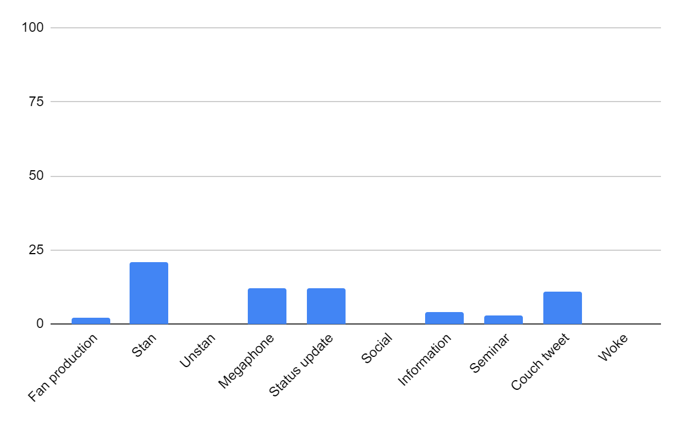

Appendix E2. Categories of the latest tweets for The Good Place Season 1
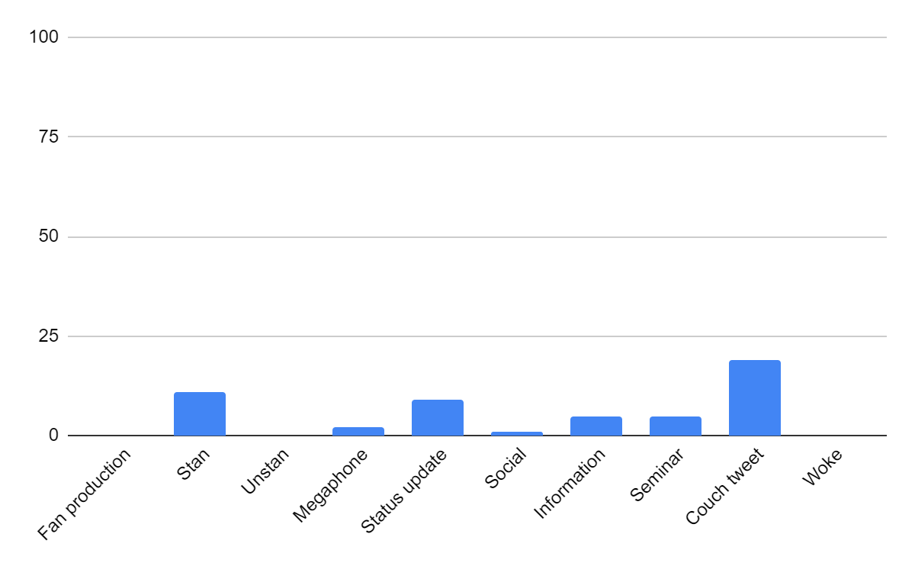

Appendix E3. Categories of all the tweets for The Good Place Season 1
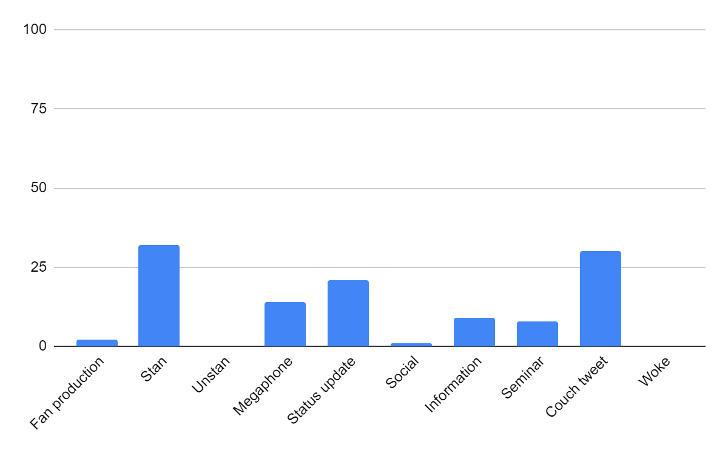

Appendix E4. Categories of the top tweets for The Good Place Season 4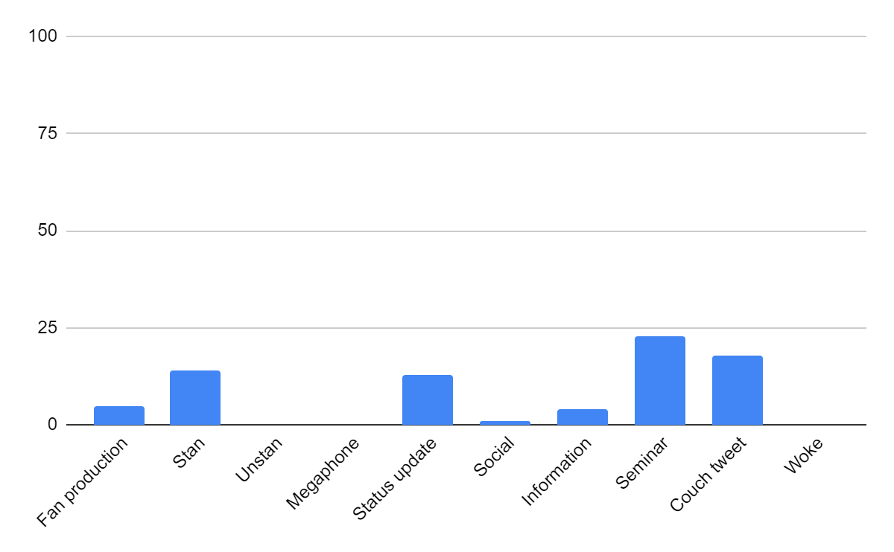

Appendix E5. Categories of the latest tweets for The Good Place Season 4
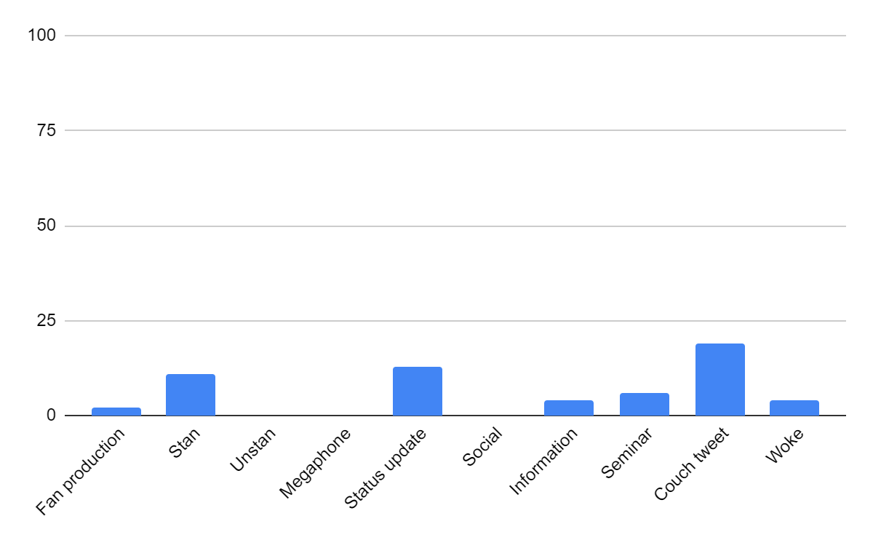

Appendix E6. Categories of all the tweets for The Good Place Season 4
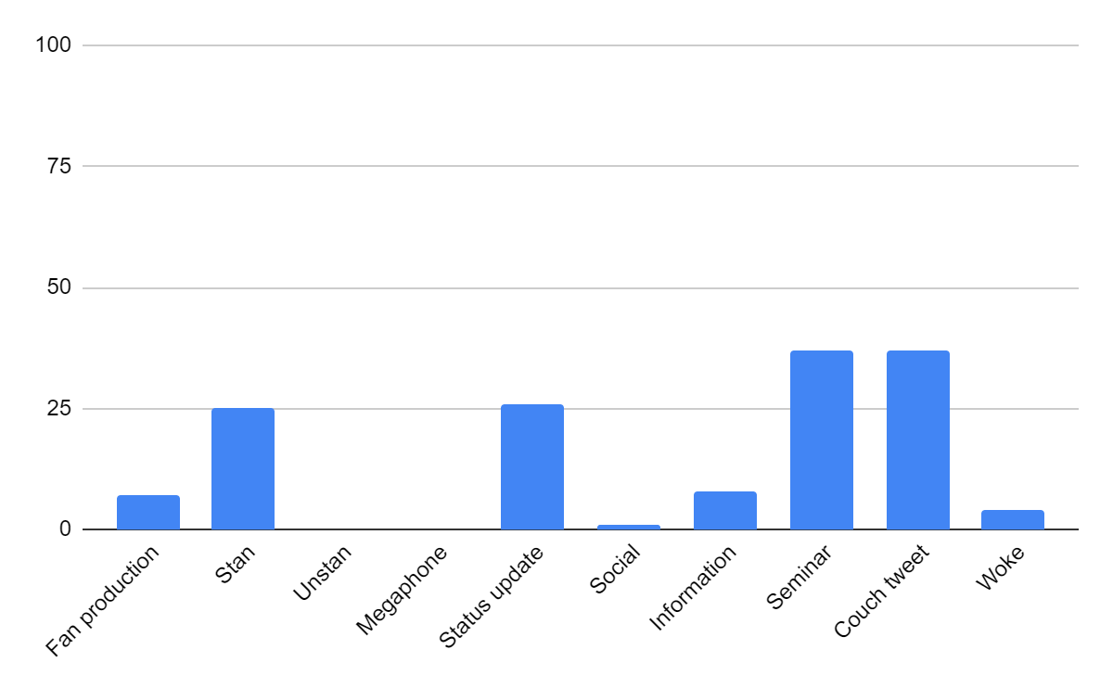

Appendix E7. Categories of all the tweets for The Good Place Seasons 1 and 4
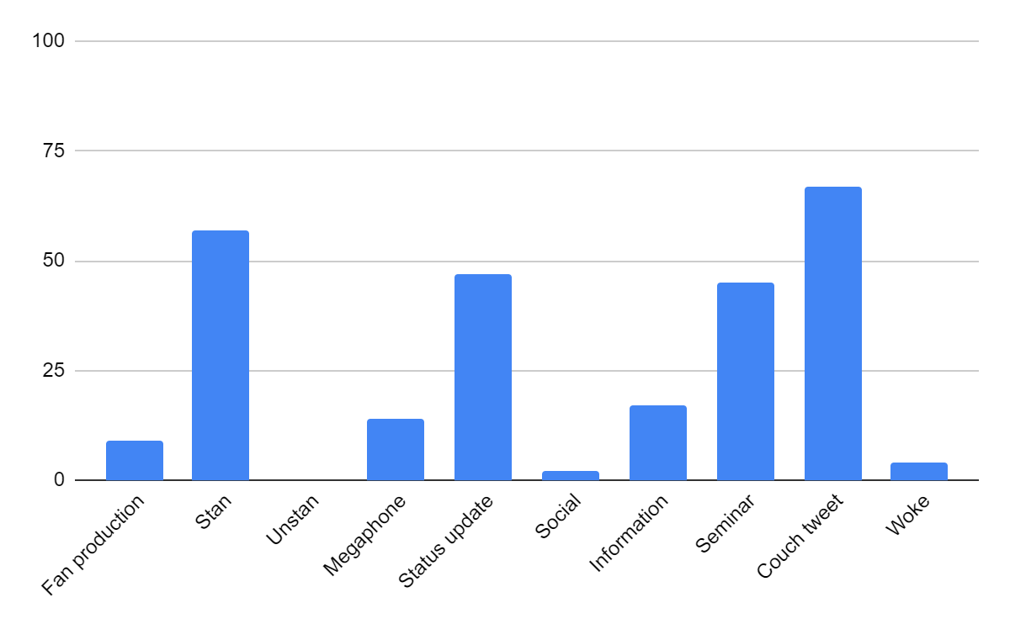

Appendix F1. Categories of the top tweets for Sex Education Season 1
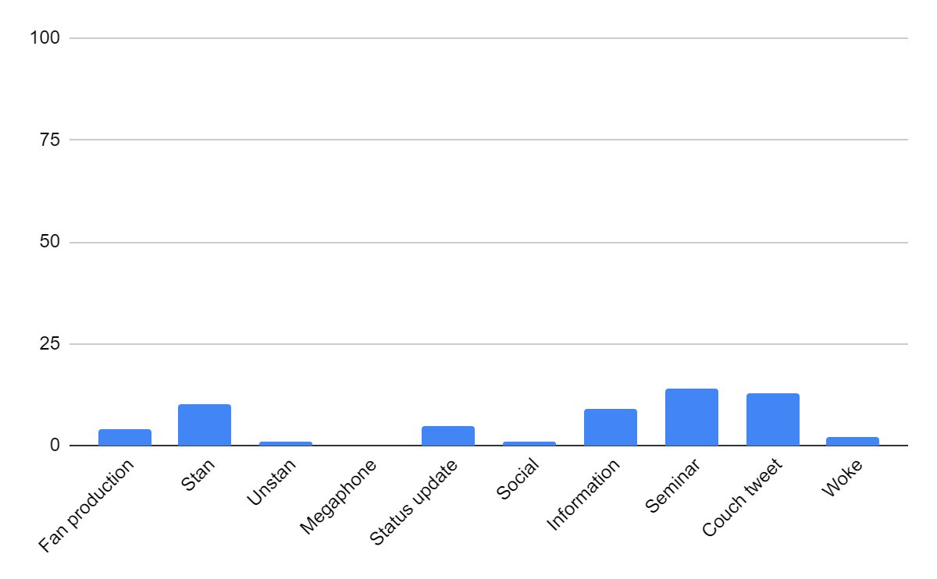

Appendix F2. Categories of the latest tweets for Sex Education Season 1
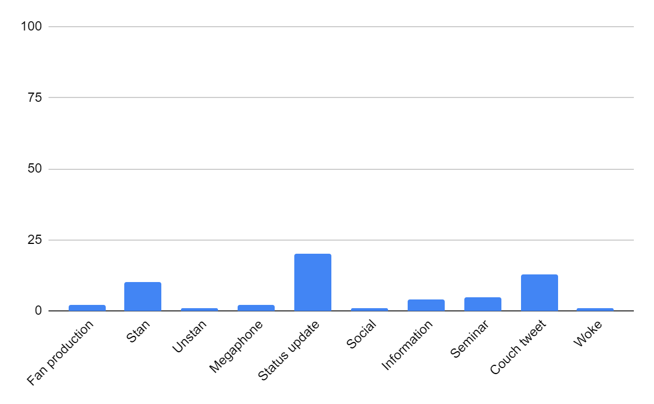

Appendix F3. Categories of all the tweets for Sex Education Season 1
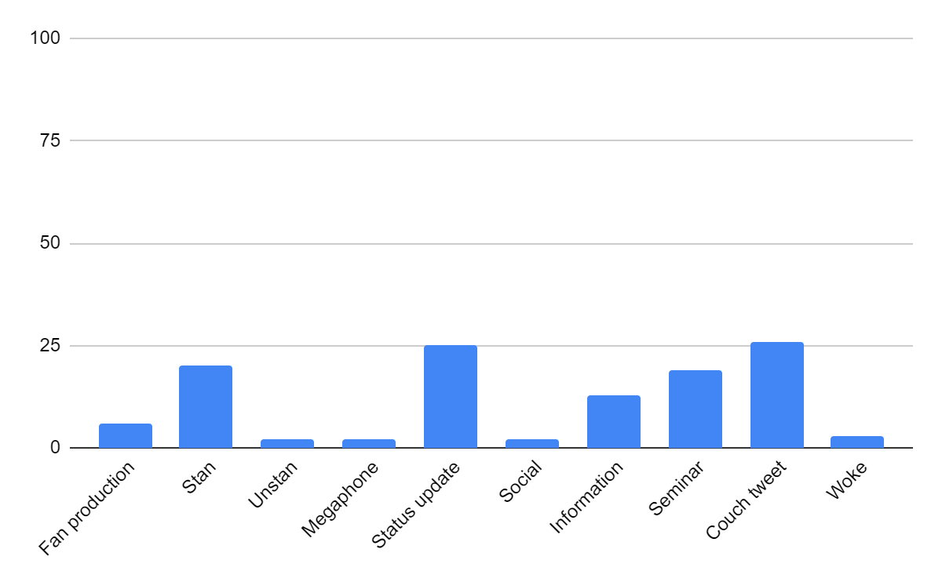

Appendix F4. Categories of the top tweets for Sex Education Season 2
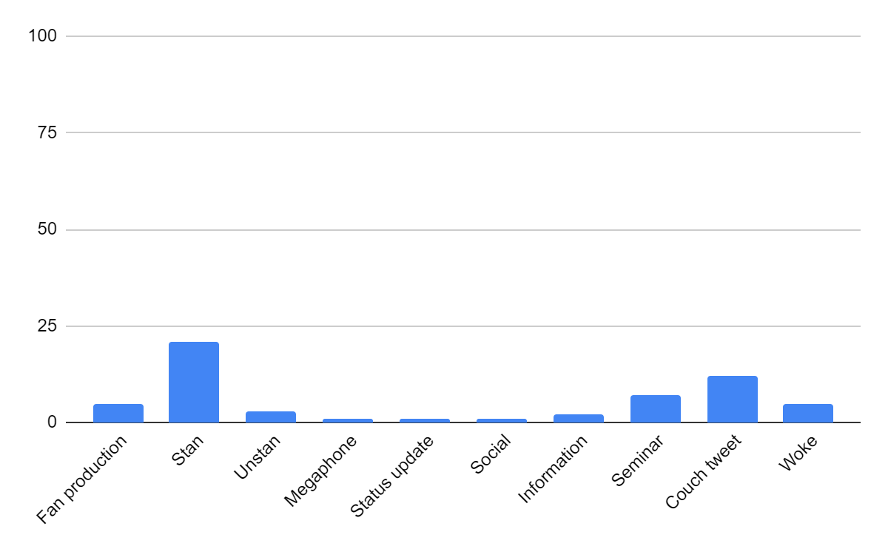

Appendix F5. Categories of the latest tweets for Sex Education Season 2
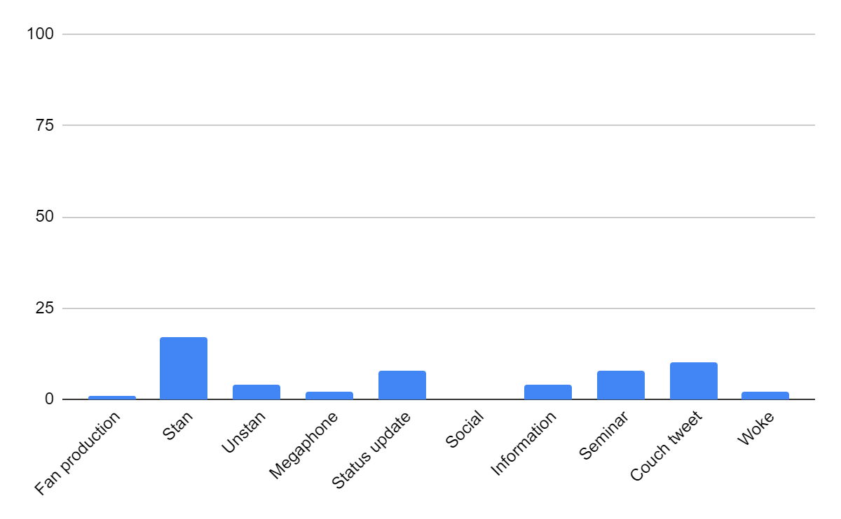

Appendix F6. Categories of all the tweets for Sex Education Season 2
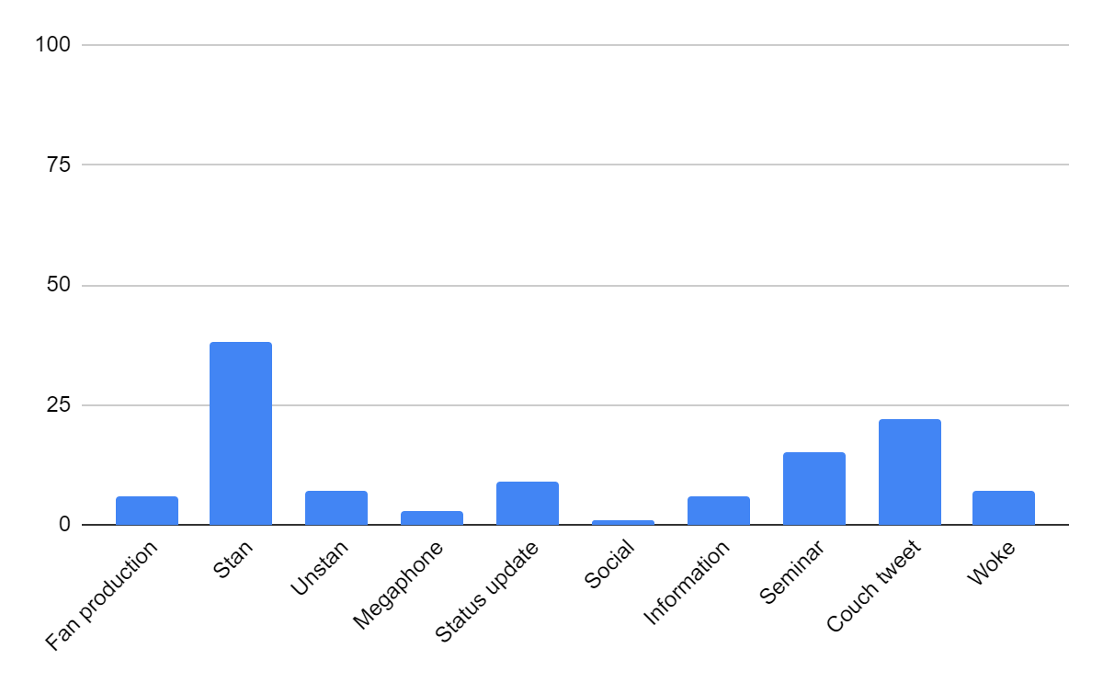

Appendix F7. Categories of all the tweets for Sex Education Seasons 1 and 2
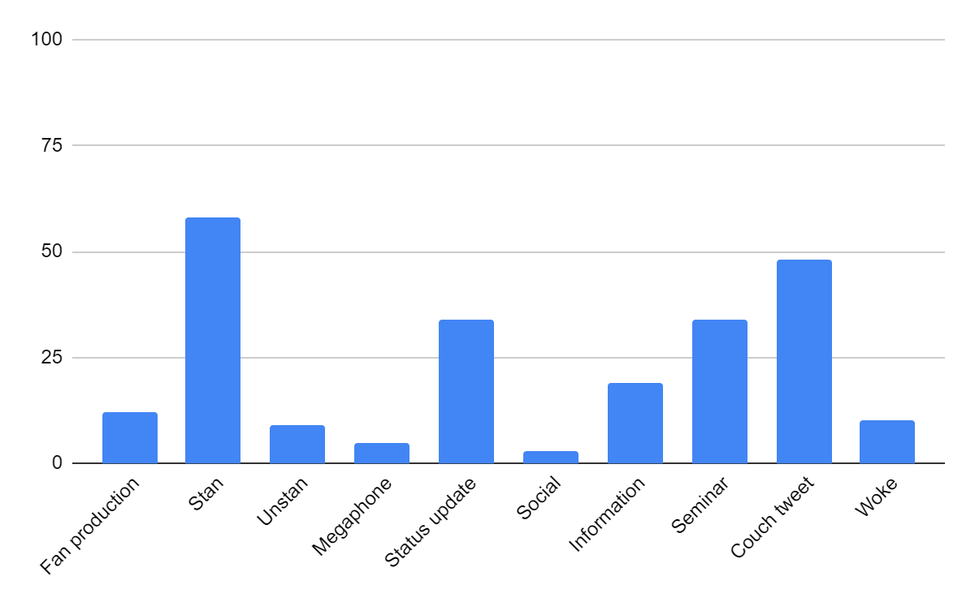

Appendix G1. Categories of the top tweets for Orange Is the New Black Season 1
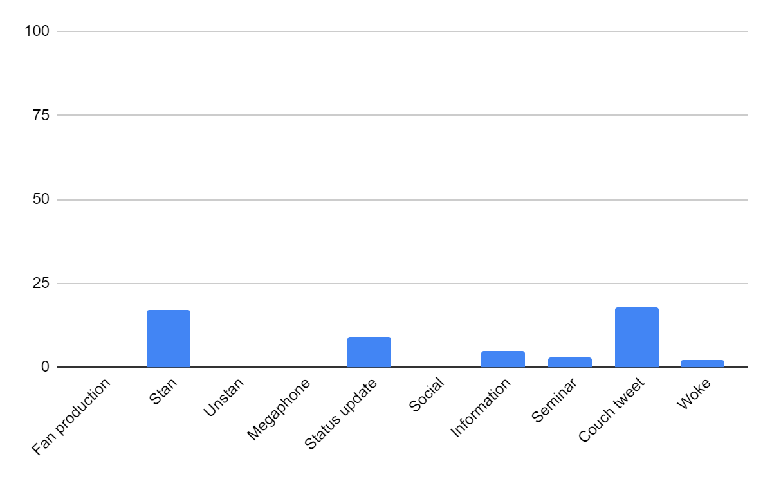

Appendix G2. Categories of the latest tweets for Orange Is the New Black Season 1
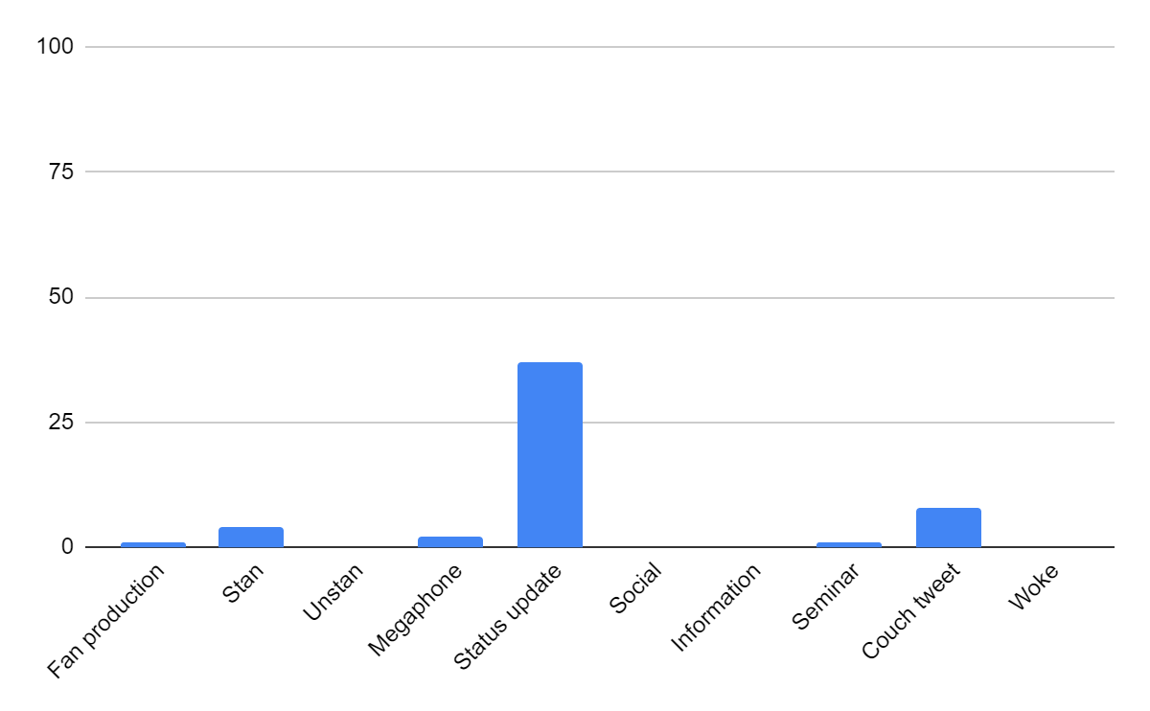

Appendix G4. Categories of the top tweets for Orange Is the New Black Season 7
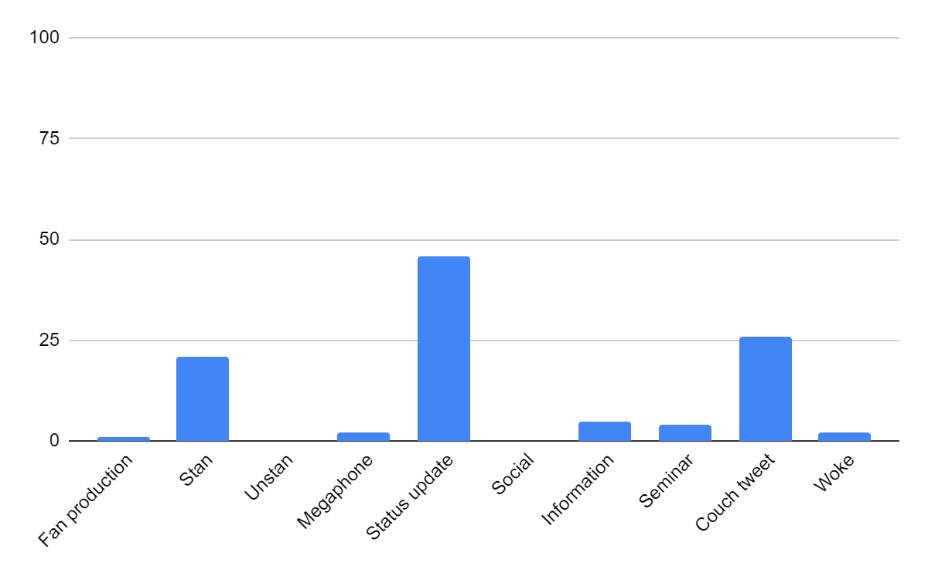

Appendix G5. Categories of the latest tweets for Orange Is the New Black Season 7
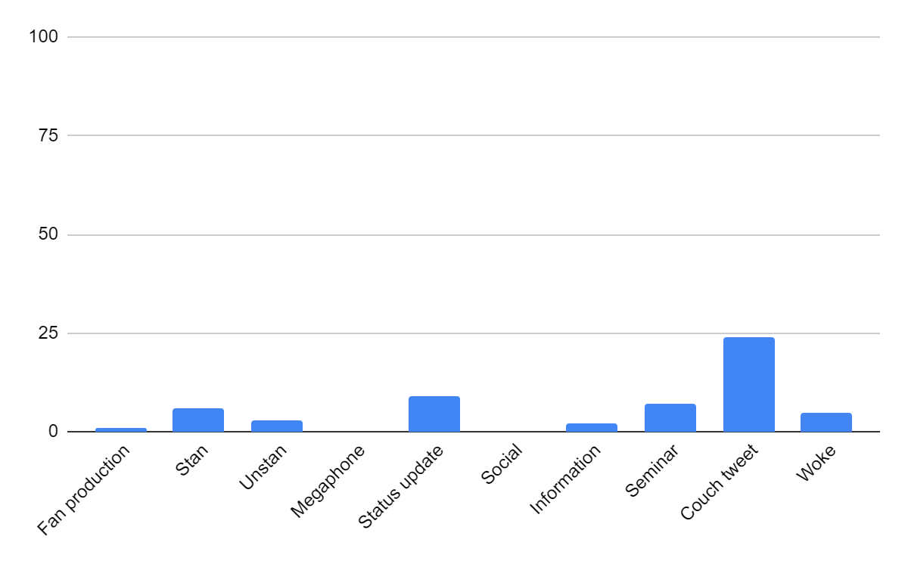

Appendix G6. Categories of all the tweets for Orange Is the New Black Season 7
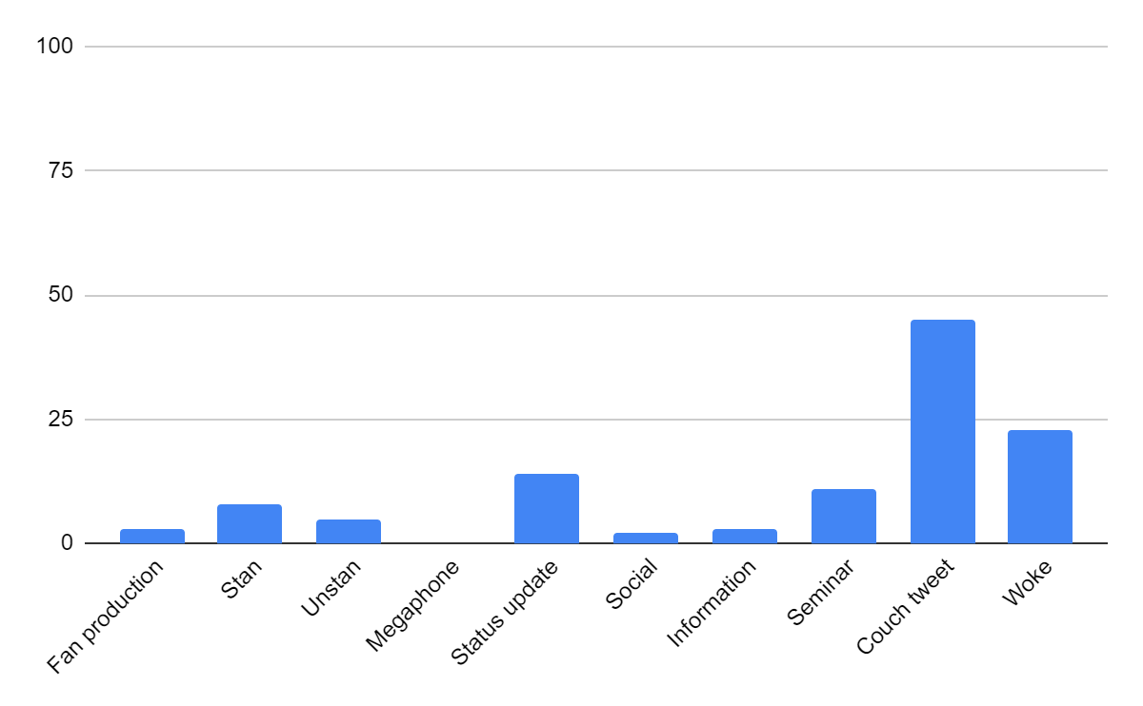

Appendix G7. Categories of all the tweets for Orange Is the New Black Seasons 1 and 7
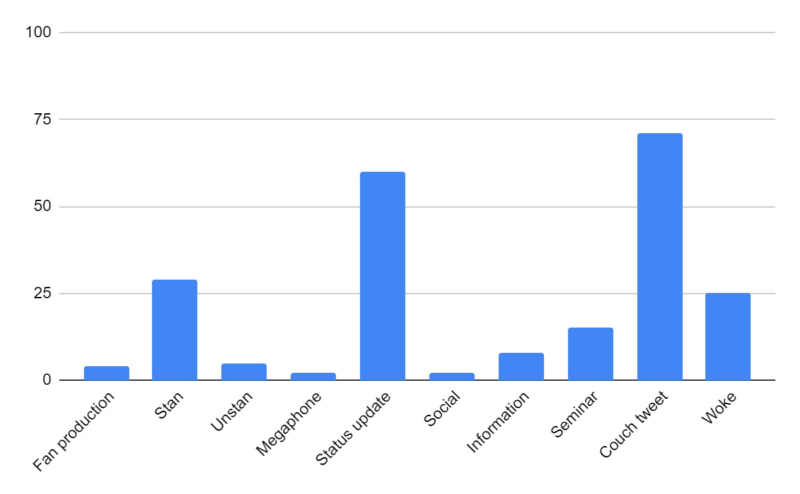

Appendix H1. Categories of the top tweets for The Chilling Adventures of Sabrina Season 1
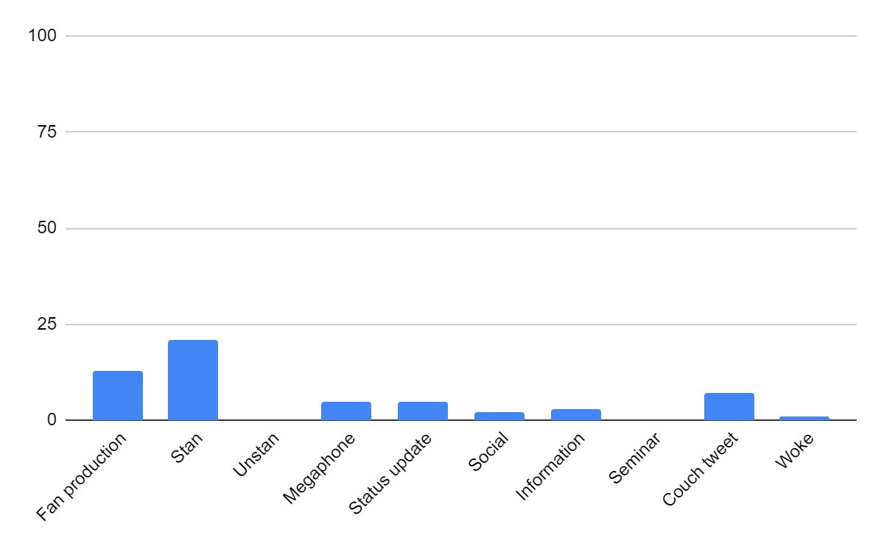

Appendix H2. Categories of the latest tweets for The Chilling Adventures of Sabrina Season 1
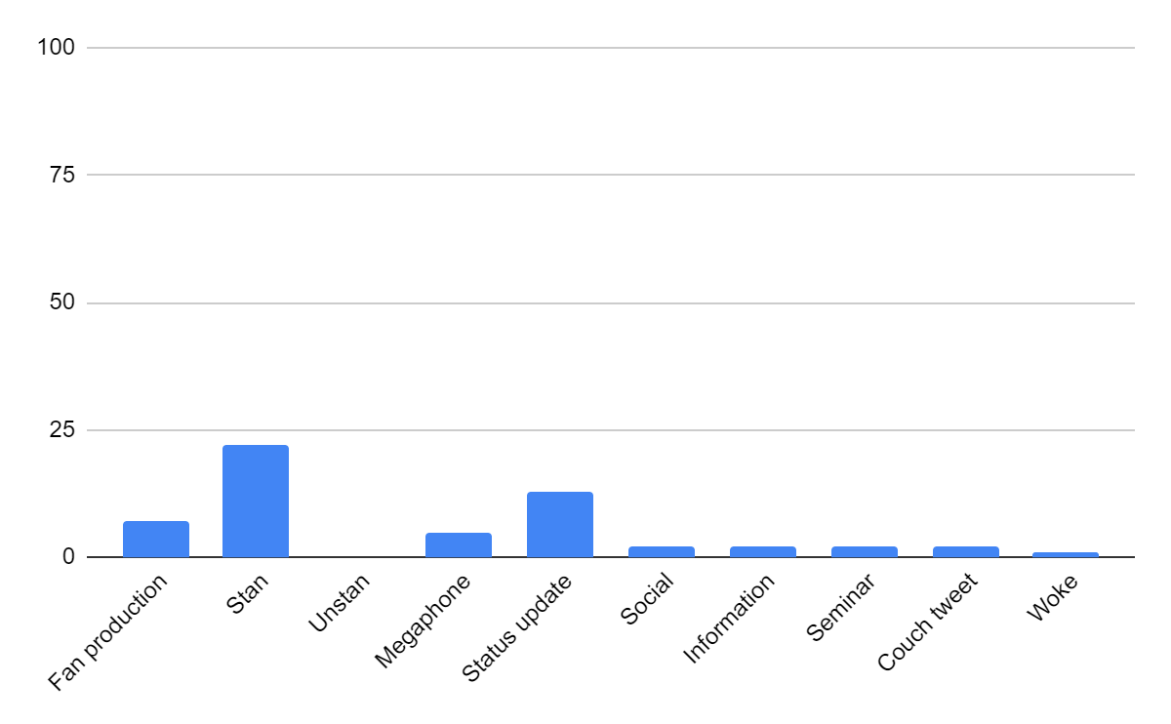

Appendix H3. Categories of all the tweets for The Chilling Adventures of Sabrina Season 1
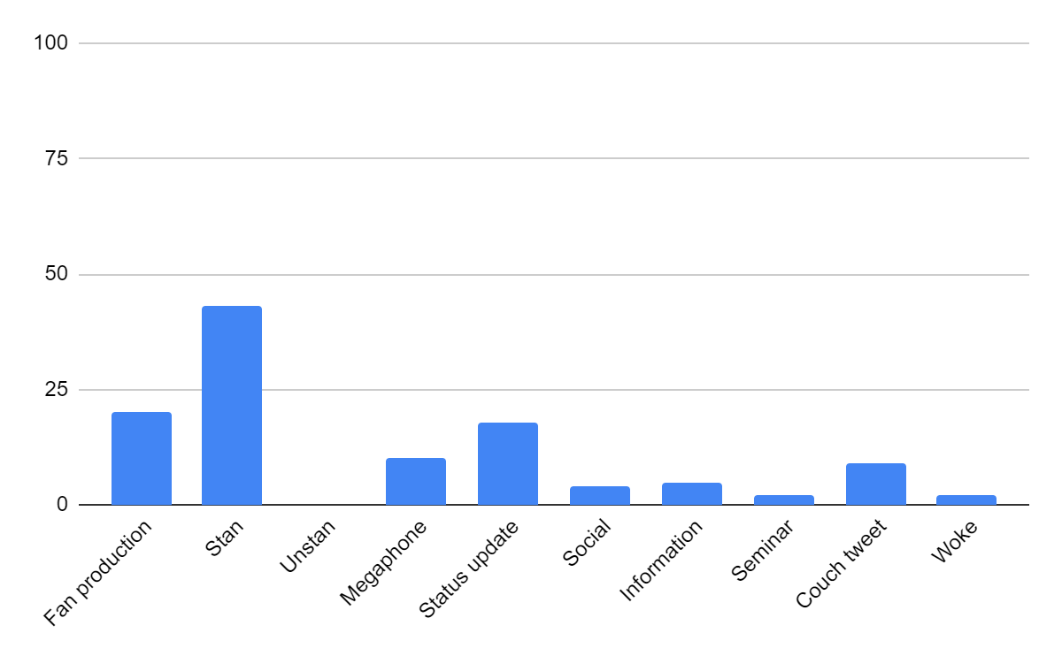

Appendix H4. Categories of the top tweets for The Chilling Adventures of Sabrina Season 3
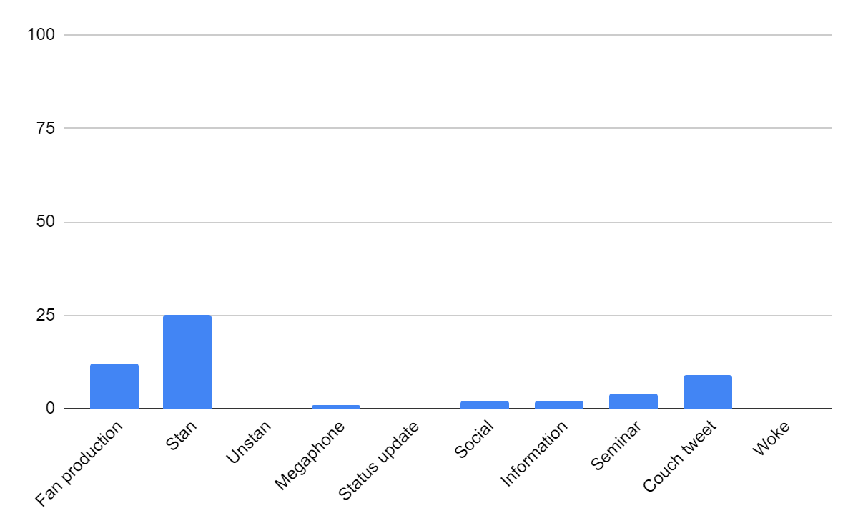

Appendix H5. Categories of the latest tweets for The Chilling Adventures of Sabrina Season 3
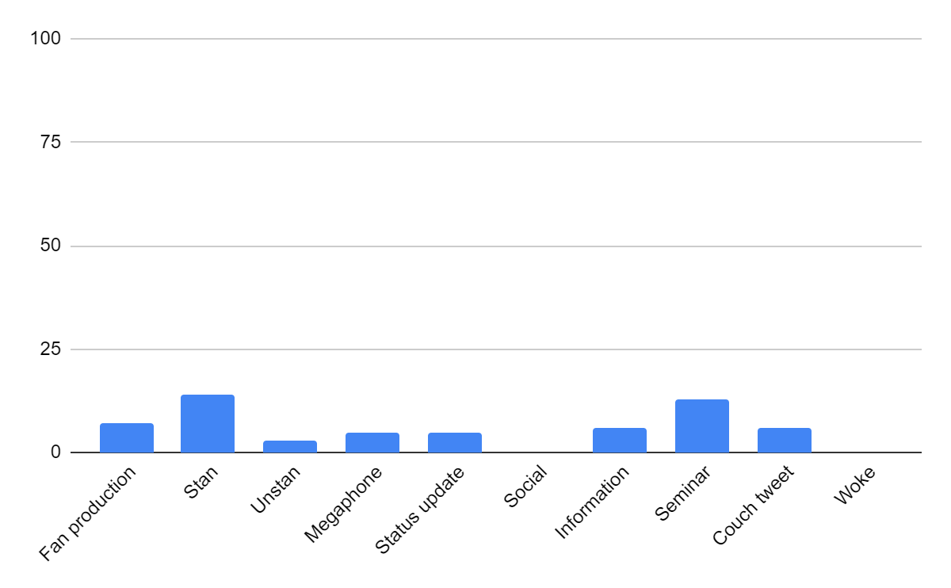

Appendix H6. Categories of all the tweets for The Chilling Adventures of Sabrina Season 3
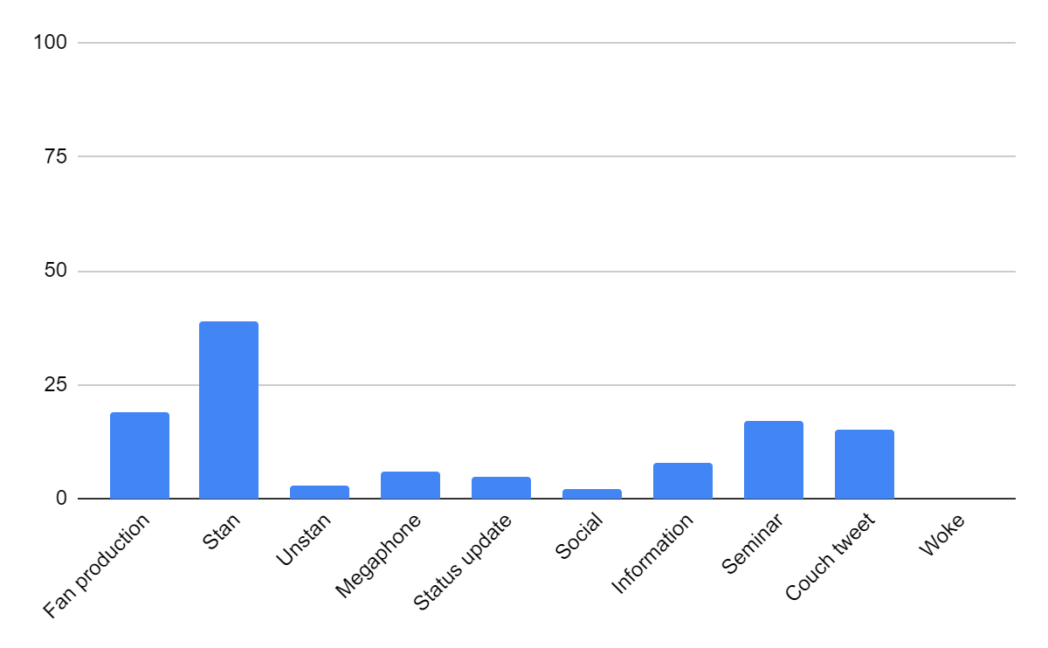

Appendix H7. Categories of all the tweets for The Chilling Adventures of Sabrina Seasons 1 and 3
