CHAIN HOTEL BRAND COMMUICATION IN ARMENIA

by

Gagik Aghabekyan

Presented to the
Department of English & Communications
In Partial Fulfillment of the Requirements for the Degree of Bachelor of Arts

American University of Armenia
Yerevan, Armenia

May 10, 2020
Abstract

This study examines the experience of brand management of the Holiday Inn Express, a global brand, and the Paris Hotel Yerevan, a local brand in the context of the hotel industry of Armenia. It aims to understand how they establish and maintain communication and long-term relationship with their customers through branding. Moreover, it explores the difference of branding between chain and local (independent) hotels. The argument of the study is that international chain affiliated hotels in Armenia have better communication with their local and foreign guests through brand management and branding communications. The methodology of the research is Action Research as Narrative Inquiry, online interviews with the marketing representatives of both hotels, project manager of a branding company, a Public Relations expert and an online survey with the potential guests. The results showed the international brand hotel in Armenia has more advanced branding strategy which in its turn, results it to have more developed brand communication with its guests. The interviews indicated that the brand promise is a very crucial factor in hotel-guest relationship. Furthermore, visual factors such as a well-designed logo, a memorable slogan and a well-defined target audience also play a vital brand communication role in such relationships. Branding appears to play a significant role in Armenia for global brands in successful hotel-guest relationship and it greatly differentiates the hotel from local (independent) competitors. Thus, this study concludes that the effective branding makes the chain affiliated hotels build brand loyalty and affect to the good positioning in the Armenian market. As a result it gets effective brand communication with guests through well-thought messages, attractive visual elements and wide variety of means of transferring a message.

TABLE OF CONTENTS

Introduction …………….………………………………………………………………… 3
Literature Review …….…………………………………………………………………... 6
Research Questions ….……………………………………………………………………. 10
Methodology ……….……………………………………………………………………… 10
Analysis and Results .………………………………………………………………………12
Discussion and Conclusion ……………………………………………………………….. 29
Bibliography ………………………………………………………………………………. 33
Appendices ………………………………………………………………………………… 35

Introduction

This is a study of brand communication of two hotels, Holiday Inn Express Yerevan, an international brand, and Paris Hotel Yerevan, a local hotel and brand management in the Armenian market. Many huge chain hotel companies continue to create or acquire new brands and broaden their audience’s horizons Chain hotel brands already have developed and effective brand management strategies that help the hotels to maintain their relations effectively as well as keep constant communication with potential guests (O’Neill and Matilla, 2010, p. 30). Their branding strategies include from the entrance, welcome speech, and check-in process, to the way the staff speaks with guests and cups they provide for coffee (Brand Identity Guidelines and Collateral Toolkit, 2017). The brand architecture of global hotel brands is already developed which makes them competitive for local ones.
In Armenia, currently, there are not many chain hotels, and most of the hotels are local independent ones, but recently, many new chain hotels were opened here, and some of them are under construction process (“Brand Hotels in Armenia”, n.d.). During the Soviet period all the hotels in the entire union, were locally established some of which, after the collapse of the Soviet Union, joined to international brands (Kreck, 1974, p.71). In Armenia, some local hotels joined to international brands as well as chain hotels already have developed branding management strategies cultivated by experts whereas, the local independent hotel which has just opened its doors has to start from scratch, which needs money and time (Ivanova et al.,2016, p.222).
Corporate identity which is also one of the most crucial factors of a brand, highlight the visual appearance of the brand including logo, website design, stationery, signage and many other things (Balmer, 1998, p. 978). So, each of these is about building loyalty among the guests who will return after their first visit. Branding has become the main driver of the hotels’ business success (Ivanova et al.,2016, p.222). Chain hotels continue to invest more and modernize their strategies in order to bring the customers even closer. Besides this, most of the chain hotels have loyalty programs which are another way of keeping constant communication with guests, understand their needs and provide the best service. The local and independent hotels do not have such programs and most of them attract guests by providing more services than the rate includes. This research examines the two hotels as representative examples for better understanding hotel brand management in Armenia. This study aims to better understand chain hotel brand management in Armenia, its key factors and strategies in branding which help them maintain effective communication with guests, and compare them with local independent hotels’ strategies and branding. Local hotels may be poor in branding in comparison with international hotels. Because of advanced branding strategies including attractive visual appearance, brand promise, well-defined target audience and clear messages, chain hotels have better communication with the guests which leads to building brand loyalty and differentiating with local competitors.
Holiday Inn Express Yerevan is a part of Intercontinental Hotels Group (IHG). It is one of the fastest-growing brands in the hospitality industry (Holiday Inn Express Stay Smart Campaign, n.d.). The first hotel was opened in 1991 which was aimed to deliver limited services with affordable price. One of the integral parts of the hotel’s history is its 1998 campaign. Its “Stay Smart” marketing campaign in which ordinary people were achieving superior accomplishments like a saving a life or preventing a nuclear disaster. When they were asked if they were professionals, people answered: “No, but I have stayed at Holiday Inn Express last night.” The objective of the campaign was to make business travelers choose the “Smart” hotel (Holiday Inn Express Stay Smart Campaign, n.d.). Furthermore, Intercontinental Hotels Group (IHG) has acquired a certain way of informing guests about existing facilities or amenities. “Go Ahead Pancake My Day” – one of the sayings of the hotel, which promotes Holiday Inn Express’ signature pancakes (Brand Identity Guidelines and Collateral Toolkit, 2017, p. 47). All the Holiday Inn Expresses in the world share the same branding elements and Holiday Inn Express Yerevan which was opened in the early 2019 is not an exception. It is part of IHG Rewards Club which offers additional benefits to the customers (IHG, n.d.)
Opened in 2014, Paris Hotel Yerevan is a locally established hotel and not affiliated with any international brand. The hotel is located in the center of the city and is near to the Republic Square. It is a full-service hotel with a restaurant in the roof, many meeting rooms, pool and gym. The hotel offers free Wi-Fi connection in its area. It is focused on providing the best possible experience to its guests. Paris Hotel Yerevan does not have any loyalty programs or marketing campaigns (Paris Hotel Yerevan, n.d.).
Having experience in working as a Marketing Coordinator in one of the chain hotels in Yerevan, the author is interested in discovering the Holiday Inn Express Yerevan use to build successful communication with the local and foreign guests. As Armenian hotel market is being developed and newer chain are being constructed there, it is important to keep competency through communication with the guests (Courtyard by Marriott Hotel to be built in central Yerevan, 2019). Thus, there is a need to understand some components of effective relationship of both types of hotels. Seeking to continue career in the hospitality sphere the researcher is able to directly apply the knowledge to the study.

Literature Review

The study aims to understand how international chains manage their brands to have effective communication with guests in Armenia and to compare that with local hotels which establish their brands from scratch. Branding is one of the most important aspects of hotel management (Ivanova et al.,2016, p.221). Various political, economic and media forces have played a significant role in brand concept transformation. Even though, the concept of branding was an old term itself, it was not a part of marketing and the term brand entered into marketing in early 1922 (Bastos et al., 2012, p.353).
The majority of hotels in Armenia are local, and try to establish their image in the developing and competitive market. However, starting 2000s many well-known international hotel chains such as Marriott, Hilton, Radisson Blu, IHG, and others opened branches in Armenia, which are now competing with the local ones for market share.
Local and international hotels are considered to have tremendous effects on the hospitality industry. According to The Routledge Handbook of Hotel Chain Management (2016), over 80% of the hotels in construction in the world are chain affiliated. Moreover, the five largest brands in the hotel industry, Marriott International, Hilton Worldwide, Intercontinental Hotels Group (IHG), Wyndham Hotel Group and Choice Hotels International, hold more than one million rooms. So, how do they become that successful? Brand management is one of the tools which makes a hotel become prominent and build customer loyalty (Ivanova et al.,2016, p.221). Chain hotels have already developed brand strategies and corporate identities that lead to effective communication with the guests, whereas newly established and local hotels have to go through a time-consuming experience and in order to create an image. Balmer (1998, p.978) suggests that each of these facts refer to corporate identity which helps to shape an effective visual appearance starting from logo and website design to the pens and mugs. The theory of corporate identity is directly connected with “what an organization is” including its mission, vision, philosophy services or products it offers and its communication It is called organizational symbolism through which a consistency is established and maintained. The choice of welcome speech, or employees’ uniform and fonts and page design of the websites, hotels always have something to say (Balmer, 1998, p.978). However, there are many types of corporate identity including good, bad or unknown. According to Balmer (1998, p. 978) a good strategic identity is the one which matches the company’s mission and philosophy. There can also be a case when the company’s identity might be good but the overall perception and image held by its stakeholders can be bad. On the other hand, it can be the opposite when an organization might have a positive image but a poor identity (Balmer, 1998, p.979).
One of the goals of each hotel is to establish loyalty among guests and make them return. Green marketing, which has become one of the most effective marketing strategies, aims to make the guest voluntarily participate in sustainable programs (Lee and Oh, 2013). It includes reusing guestroom towels and linens. This is another level of communication that persuades guests to believe that the hotel cares for the environment and on the other hand, it cuts the hotel’s expenses. Seonjeong (Ally) Lee and Haemoon Oh, the authors of Effective Communication Strategies for Hotel Guests’ Green Behavior, argue that in order to encourage guests to take the challenge and make a green choice, there needs to be a proper message. It refers to the presentation of two sides: gain vs. loss (Lee and Oh, 2013). The authors disclose the strategy of how hotels make the guests participate in the programs. So, hotel branding is a whole discipline based on research and analysis.
On the other hand, So et al. (2012 p.31), argue that in this developing world, where product and service values have reached their peak, hoteliers need to worry about their products and to set them apart from others in the market in order to stay competitive. The same authors also think that branding is one of the most dominant trends in the hotel industry worldwide. Moreover, one of the indicators of brand strategy success is the customer’s brand loyalty, which has to be strong. International chain hotels have their loyalty programs (Marriott Bonvoy, IHG Rewards Club, etc.), which encourage guests to join them and get benefits. Once a person joins, the hotel keeps constant communication with the guest, offering different attractive offers to make them return. Besides attractive offers, hotels also work on discourse to keep the communication friendly and personal. This way, they bring their guests even closer. On the other side, very few local hotels offer such programs. If a guest likes the hotel and returns, a local hotel might give them advantages, but in the global scope, it will not work as well as huge loyalty programs with millions of customers (Xie & Chen, 2014, p. 115).
Another effective method that chain hotels use to be distinguished among competitors is brand personality and brand identification. Kim, Han, and Park (2001) explain that the brand personality has to have attractiveness, distinctiveness, self-expressive value, and positive word-to-mouth status. The interactive communication between the brand and guests are significant in consumers’ identification of the brand (Kim et al., 2001, p.196).
A publication about brand equity by Keshav Prasad and Chekitan S. Dev is also an important aspect to understand the key drivers of a chain hotel’s success. The objective of the article is to provide a diagram to the top managers of hotels, which will maximize the value of their brands, thus having positive effects on the hotel’s brand loyalty. The key concept of brand equity is that it helps to be different, thus making brands more premium and foster customer loyalty. “A brand symbolizes the essence of the customers’ perceptions of the hotel chain” – one of the keys of lodging management (Prasad, Dev, 2000, p.23). A brand is created for a long period of time, and it is very expensive (up to $150 million) (Prasad, Dev, 2000, p.23). Similar to the other scholar publications, this one, too, highlights the importance of proper and effective communication with guests. Everything depends on communication. Each corner and fact in the hotel and about the hotel has to have a message for guests. It has to be able to bring the guests closer and make them return.
O’Neill and Mattila (2010), in their work about hotel brand strategy published by Cornell Hospitality Quarterly, explain that hotel chains distribute their brands into classes such as luxury hotels, family hotels, business hotels, etc. in order to have wide customer range and brand the hotels appropriately. If a business hotel where people go just to sleep at night and work the rest of the day offer room service, luxury pool, SPA services, children’s room, cinema or such other things, then the target market, in this case, is not well-defined because business hotels tend to be limited-service but may include amenities such as iron, refrigerator and bathroom amenities (O’Neill & Matilla, 2010, p. 28).
To conclude, analyzing and reviewing numerous articles and scholar publications about chain hotel brand management gives an understanding that factors like brand personality, corporate and strategic identity as well as branding strategy help hotels in building relationship with guests. However, there are not any publication about Armenia hotel sector’s branding and advertising. Existing publications have different approaches to the chain hotel brand management as each of them suggests several solutions. However, there is one main point that every reading touches upon, effective communication with guests, which results in making guests remember the brand and prioritize it. Once an effective communication is established, guests will return. In order to establish proper communication, hotels do research, spend millions to find the best solutions which may include interior design, colors, furniture, the way staff speaks, and even used fonts.

Research Questions

To understand research area and the specific thesis of the topic extensively and discover more differences between managed and local hotels, this project aims to study one managed and one independent hotels in Armenia which are Holiday Inn Express Yerevan, an Intercontinental Hotels Group (IHG) hotel and Paris Hotel Yerevan, a local independent hotel. The first question this study attempts to answer is “Do chain affiliated hotels in Armenia have better communication with guests for the domestic market than local hotels?” The other one is “What role does branding play in establishing successful relations with guests in Armenia’s domestic market?” Another question is “What is the difference between their branding and local ones’?” and the answer may indicate why customers choose brand hotels or local ones.

Methodology

In order to be able to find how chain hotels operate in Armenia in comparison with local Armenia based hotels both qualitative and quantitative data were used. For qualitative data, action research as narrative inquiry and interviews with the representatives of the hotels were conducted. An action research experience was conducted in Holiday Inn Express Yerevan, an IHG hotel and Paris Hotel Yerevan in order to generate data as a narrative by the researcher. It identified the experience how they welcome and treat guests and how it all make the guests return again and again or vice versa. The narrative was conducted in Holiday Inn Express Yerevan, a chain IHG hotel, and Paris Hotel Yerevan, a local hotel. The staff of the hotel perceived the researcher as a real guest and there was no word that it was a research.
The other part of qualitative data included interviews with the sales and marketing directors of both hotels, a Public Relations specialist working for a PR agency and the Project Manager of the branding company called Braind. This provided data of how they manage their brands in order to have returning customers as well as how they shape a corporate identity. Furthermore, as chain hotels just started to enter into Armenian market the interview with the sales and marketing director of Holiday Inn Express Yerevan explained how they adapt the brand to the local market as every market has its specific needs.
For the quantitative data, an online survey was conducted. The survey understands which type of hotels do guests prefer and why. As the study examines how the two hotels communicate with their local and foreign guests, over 18% of the responses were received from other parts of the world which was done by foreign friends’ sharing of the survey among their friends on Facebook. It enabled to understand the perception of diverse people. The results of research will help to draw parallels with each other and help conclude whether the branding of chain hotels enable to have more effective communication with their guests and if there are any major factors that differentiate them from local hotels and attract guests more.
The methodology done through qualitative and quantitative data gave a detailed information. Action research by the researcher helped to experience what it was like to establish a connection between brand and a guest whereas, the interviews provided data how it all done. During the quantitative data, survey gathered responses from a variety of people from many countries which helped to understand what is the perception of different people from different parts of the world.

Analysis and Results

This part of the paper analyzes the research data gathered by the methodologies of narrative, interviews and survey.

Qualitative data
“Holiday Inn Express Yerevan, an IHG Hotel” – Narrative of experiencing a chain hotel

Narrative inquiry is the process of gathering information for the purpose of research through storytelling. It was done to have a clear understanding what guests experience once they take a step into the hotel and how they are being “tied” to the brand. During the research the emphasis was on how the hotel welcomes guests, any brand specific interactive elements that transfer a certain message, colors and the discourse used in the signs and in the speech of the staff:
“The Holiday Inn Express had a specific design with specific colors and furniture that all the Holiday Inn Expresses in the world must only use them. When I saw them, they had been memorized in my mind and in future, every time I see those colors, I will know that it is a Holiday Inn Express. It creates a communication between guests and the hotel and makes the guests recognize the brand through details such as colors or furniture, whereas Paris Hotel Yerevan didn’t have any brand related components such as furniture or colors.”
In order to have a better understanding of how guests are being “tied” to a brand, on March 2020 there was a narrative inquiry in the hotel Holiday Inn Express Yerevan, an IHG hotel, conducted.
As Holiday Inn Express Yerevan is a part and one of the most famous brands of Intercontinental Hotels Group (IHG), one of the largest chains in the world, it has a specific design with specific colors and furniture that all the Holiday Inn Expresses in the world must use them. One of the noticeable things was the round sticker “Hello.” attached to the main entrance (see APPENDIX A). So, when someone passes by or sees the hotel, there is a warm greeting which is one of the signs that brand has an identity and a friendly character:
“When I stepped in, my first impression was good as I saw a big “Hello” and “Always Welcome” sign in front of me which turned out to be one of their brand components. It was followed by a smiley welcome face of the front-desk worker Nelli who was interested in helping me.”
The hotel strictly follows IHG brand standards. Interior features of the hotel including colors, furniture and signs were based on brand guidelines. The hotel has specific colors which needs to be used throughout the hotel as the brand identity guidelines demand. The furniture also comes with brand standards and all the Holiday Inn Expresses in the world have to use the same furniture. There were different interactive signs attached to the walls which tried to convey a message in a friendly discourse (see APPENDIX B). Some of the signs were informative but at the same time interactive and whereas, many of them were simply talking to guests. Such approach can play a crucial role in building relationship between the brand and guests as they will immediately remember the brand once they see that expressions or visuals somewhere else.
As the rooms are the places where the guest spends most of its time, it was also important to have a look on them and highlight some key points about them. The brand specific blue color dominated in the room as well, matched with some other colors including red. To the question of why the rooms are so small, the worker answered that it is the concept of the hotel because it is a Simple and Smart hotel for business travelers. Simple and Smart turned out to be one of the hotel’s slogans. Everything was smartly located and there were signs in the room as well including towel reuse, pillow choice (soft or firm), hotel and area info with signature design, signs that indicated that the hotel is a part of a sustainability program as well as if a guest forgot some sanitary items (APPENDIX C).
Besides the stickers and signs, a user-friendly smart-TV with their signature software was also noticeable. Once it was turned on, it welcomed with soft background music and offered to choose options of watching TV. The overall atmosphere in the room was very pleasant and attractive to be in. There were not any luxury or superficial elements but the friendly discourse of every sign, journal or poster can make the guest not to feel alone but with the brand.
All these site monitoring was accompanied by one of the front-desk workers who was also very friendly. The way that the staff has to talk is also based on brand standards. Prior exploration of their brand book stated that the style of staff talking is one of the key elements of Holiday Inn Express as it has to contain some humor but not sarcasm, help the guest feel at home and always make the guest be involved with the brand. The interesting thing was that it was not noticeable presumably thanks to trainings.
What happened at the end was one of the most important benefits of chain hotels. Before leaving the hotel, the front-desk worker offered to join IHG Rewards Club to get from additional discounts and special offers to earning free nights. The worker asked for email and some credentials. To the question whether the system sends emails about new offers or not, she mentioned that every new program or offer or just the summary or account is being sent in a weekly basis. Apparently, it can be one of the most effective tools and a huge advantage to keep constant communication with the guests.
To sum up, based on the narrative inquiry in the hotel, it can be highlighted that Holiday Inn Express, an IHG hotel, had a strong brand identity. The colors, interactive signs and posters play a crucial role in establishing brand-guest relationship. Moreover, the IHG Rewards Club is also a powerful tool to maintain those relationships after building it as it is always easier to create relationships rather than sustain them in long-term basis.

“Paris Hotel Yerevan” – Narrative of experiencing a local (independent) hotel

Paris Hotel Yerevan is an independent local hotel of the same category as Holiday Inn Express Yerevan, an IHG hotel. A narrative of experiencing the hotel was conducted there as well in order to note some components in the brand that are different from the chain affiliated one.
Paris hotel is a cozy place in the center of Yerevan. The entrance of the hotel is separated with special cones a big red carpet. Once entered in, a small reception can be spotted in tan color. The overall style is similar with the name of the hotel, Paris, in terms of a small souvenir of Eiffel Tower and a huge map at the bottom of reception desk (see APPENDIX D). However, one thing was obvious that there is not any brand specific design. The colors were matched but there was not anything that could stick into the guests’ mind and make them remember it in the future. Such matching of colors can be seen in other hotels as well. Moreover, the logo couldn’t be seen anywhere in the lobby. After some explorations, it was found on the wall of the hotel outside. According to Balmer (1998) corporate identity is one of the most important factors of a brand which also includes logo. No interactive signs were noted or any brand specific elements. However, it was a nice and cozy place to have a stay.
“When I entered into the hotel, I immediately noticed that the reception area was small and without any specific design. It mainly had light tan colors but it was a modern place. However, I couldn’t notice any detail that would make me memorize that place. I think the design was not so good in terms of communication with guests. I couldn’t feel I was part of the brand. It was nice and cozy but not interactive.”
Moving forward, the next stop was one of the rooms of the hotel. They were modern and pleasant but not in terms of establishing communication with the guests. Nearly everything was in tan color. It could be the color of the brand, but the impression that it could create relationship between brand and the guest was not clear. One thing to mention some posters and signs were found in the working desk but being attentive to their discourse gave the understanding that they were informative but not interactive. There was not the feeling that the brand had character and it transferred a message to the guest. A sign was noted in the bathroom but with the same informative-only discourse. Moreover, nothing about sustainability programs were noted there.
Obviously, the hotel did not have any loyalty programs as neither anything indicating about it was spotted nor anything was offered.
As a summary based on the narrative conducted in Paris Hotel Yerevan, it is important to point out that there was not anything that could help remember the brand. Interactive signs which are also a powerful tool to bring the guest closer to the brand were absent in the hotel with an exception of informative templates that gave general information rather than transferring a message. Furthermore, the hotel was not involved in any loyalty programs to offer its guests additional benefits remotely and constantly.
After having a real experience in both brand and independent hotels, it was also important to know how they create and maintain the relationship between the brand and guests. In order to do this, four online interviews were conducted as due to Covid-19 quarantine, face-to-face interviews were impossible. The first one was conducted with the Director of Sales and Marketing of Holiday Inn Express Yerevan, an IHG hotel through email. The second interview was conducted with the Marketing Specialist of Paris Hotel Yerevan through the email as well. The other one was conducted with a specialist in Public Relations sphere who also works for one of the PR agencies in Armenia. The last interview was conducted with a the project manager of branding agency called Braind. All the people being interviewed kindly answered all the questions asked and gave more detailed overview of how they make guests remember the brands.

Interviews
Interview with the Director of Sales and Marketing of Holiday Inn Express Yerevan, an IHG hotel

As the project is focused on exploring whether chain affiliated hotel have more effective communication with guests, an online interview was conducted with the Director of Sales and Marketing of Holiday Inn Express Yerevan, a part of Intercontinental Hotels Group, Yeznik Mikayelyan.
Mr. Mikayelyan firstly highlighted the part that the hotel is a Simple and Smart hotel. It offers the smartly designed facilities for the guests along with the most essential services that a person needs for a night or two. The hotel is targeted on business travelers so, it is interested to have guests who are traveling for work with short stays. The brand Holiday Inn Express has to be associated with business traveling. IHG supports the purpose of True Hospitality and aims to have a positive effect on the people who communicate with them. Actually, IHG brand standards are one of the strictest among other famous brands. Every little detail in the hotel is thought to give the guests what the brand promises. From the provided brand book, being built on the current brand equity, constant expansion of the design toolkits with modern design styles, allow the brand to shape Simple and Smart concept through visual elements which create a distinctive brand identity and a unified visual style. To the question of how the branding of the hotel communicates with the guests, Mr. Mikayelyan answered: “Holiday Inn Express Yerevan is an IHG brand and it follows all the main IHG brand communication strategies and guidelines. Hotel guests are the most important stakeholders for brand communication. Hotels unique interior and exterior design, printing materials, social media posts, other online sales and review platforms are one of the main ways of brand communication.”
Holiday Inn Express pays much attention to its brand identity, thus creating value for customers. Once it establishes a communication with a guest, it becomes harder to keep it in the future. However, the brand has its channels where both individual and corporate clients are in constant communication with the hotel. Such channels include IHG Rewards Club, through which the client continually get emails, IHG Business Rewards Club for corporate clients and social media. As a response to the question what are the key drivers to build effective communication with guests, Mr. Mikayelyan answered in a following way: “Market analysis, right audience, clear and well thought message, right timing and correct ways of message delivery are some of the key drives to build effective communication”. If the hotel has a well-defined target audience it becomes much easier to manage the brand in terms of building communication with guests. Transferring well-formed messages to them at the right time plays a huge role in hotel-guest relationship as it makes the guest think that the hotel cares.
According to Mr. Mikayelyan, building communication is always easier then maintaining it long-term. Once the communication is established, the brand owners shall constantly collect and analyze the feedback of the receiver, strictly follow the changes in the guest behavior and mainstream developments. The hotels needs returning customers, it needs that once a guest stayed in the hotel, the brand can be remembered in the mind. Business travelers are the ones who are more probable to return back but first they have to understand that Holiday Inn Express is the best choice. Recently, special stickers were pasted on the elevator walls with the QR code of the Instagram account and a unique design. It attracts guests and makes the follow the hotel page which is another way to transfer messages to them, Mr. Mikayelyan added. Besides it, each guest is offered to join IHG Rewards Club to get additional benefits and discounts. Mr. Mikayelyan also stated: “Revalue the efficiency of the ways the message is delivered and make adjustment in the message itself if needed, to keep it always relevant for the guest.”
Branding is a powerful tool to make guests remember something. In hospitality sector, where the competition is huge, every hotel has to somehow differentiate itself. It helps to interact with guests, transfer message without direct conversation. Actually, a good branding is the one which is able not to only transfer that message but also make guests remember that specific message. To the question if branding plays any crucial role in hotel-guest communication, Mr. Mikayelyan added: Branding embodies the message which the owner wants to deliver. It plays a very important role in these relations. Branding and the communication strategy shall walk side by side in this journey.
The last question was what are the differences between your and local/chain hotel brand management in terms of guest relations. As an answer Mr. Mikayelyan stated: “Armenia is a country where every day a new hotel is opened.” He noted the fact that there are not many chain affiliated ones but they are being opened, too. Holiday Inn Express Yerevan has many competitors who are local and do not belong to any international chain as well as major chain affiliated ones. However, Mr. Mikayelyan added that Holiday Inn Express has a very strong brand identity and it is mainly focused on a specific types of travelers, which makes the guest relationship tools to be specific, rather than that it has almost the same management strategies as the other chain hotels in the market.”
To conclude, it can be mentioned that based on the answers Mr. Mikayelyan gave during the interview, Holiday Inn Express Yerevan is mainly relied on IHG brand strategies and guidelines. A strong brand identity, various mediums of transferring the message are able to keep the long-term and effective relationship between the brand and the guest. The interview also highlights the point that correct market analysis and target audience also play a crucial role in managing the brand. If the there is a well-defined strategy and audience along with a brand that can satisfy their needs, than the hotel has an advantage in effective communication with guests. In the overloaded market, brand is a powerful tool to make the business unique.
Local Brand
Interview with the Marketing Specialist of Paris Hotel Yerevan, a local (independent) hotel– brand management

As the project also aims to examine some of the differences between the brand communications of chain and local hotels, an online interview was conducted with the Marketing Specialist of Paris Hotel Yerevan, Madlena Ohanyan.
Ms. Ohanyan started the interview by stating that the hotel’s brand matches with its name. Interior design and branding have been done in a way so that the guest can draw parallels between the hotel and Paris. She highlighted that the brand of the hotel had been created from scratch and it is not affiliated with any international brand. The hotel is targeted on international travelers who prefer a premium hotel with all the necessary amenities for a good stay and a restaurant on the roof. According to Ms. Ohanyan, there are two ways to deliver a message which are visual and personal. The visual part has to be consistent with its content including logo, colors, fonts and messages. Concerning to personal part, the brand has to show its attitude, tone of voice, service quality and approach to each guest as a unique one. To the question of how the brand communicates with its guest, the interviewer answered: “If the employees interact with guests, they’re representing the company’s brand in everything they do for better or for worse. If the hotel has a well-defined brand strategy, it already knows the value proposition, brand promise and brand personality traits.” Thus, the hotel’s staff communication with guests is in the core of building relationships with them. However, a well-defined brand strategy also plays a huge role in such communication in terms of making guests remember the brand and return in the future.
Recognizing the importance of effective guest communication is important, as in this way, the hotel actively works to improve the guest experience at the property, Ms. Ohanyan stated. There some points that the hotel takes into consideration: connecting with the guests on a personal level will make them understand that they are treated individually, being proactive and responding to the feedbacks to show that the hotel cares and offering multiple communication channels including Facebook Messenger, Viber, WhatsApp and mobile friendly interactive website.
Once the communication is established, it is also important to maintain them long-term. To the question of how to do so, Ms. Ohanyan highlighted that hotels that are able to deliver a memorable experience through unique services, amenities, personal touches will be rewarded with repeated guests. In order to have long-lasting guest communication/satisfaction, Paris Hotel Yerevan offers complimentary services, rewards returning guests, creates an exclusive experience once they arrive, gives them discounts or special offers and pays attention to the guests’ unique preferences to show that the hotel cares.
In spite of offering more than the guests expects, branding also plays a huge role in making a guest to return. Ms. Ohanyan noted that combining the organization's branding with the exceptionally good attitude of the employees, allows the guests to tattoo the name of the brand in their memory and become regular customers.
Paris Hotel Yerevan is an independent hotel and has a quite developed branding strategy, Ms. Ohanyan emphasized. Treating guests well has nothing to do with chain or a local hotel. Every hotel or simple organization, whether international or local, must have its own unique style and provide guests/customers the best available experience as it is the core element of making guests come back.

Interview with the project manager of branding agency Braind

Braind had its contribution to some hotel’s branding process. For finding out how they do create a brand that can communicate an interview was conducted with the Project Manager of the branding agency Braind, Masha Hayrapetyan.
When creating a brand, the positioning of it is very crucial, but when it's already on the market, it has to be maintained as there is already a created auditorium of the company’s consumers depending on that specific positioning. Ms. Hayrapetyan stated that the enterprises make sure that their marketing strategy, management mix 4P, matches their branding and the brand values established initially. What is more important is having proper marketing promise, sticking to it and never breaking it. If it is changed, it will be needed to manage to change also the other components of the marketing strategy.
When talking about hotel branding specifically, Ms. Hayrapetyan mentioned that the agency has experience in creating a brand for hotels. She also added: “The main factors that you should consider when branding a hotel can be included in a brief list (list of questions for the client before starting the branding project) as questions and be revealed for a better understanding in which direction you should move.” Some of the main factors include well-defined target audience, price category, hotel type (business, resort, hostel, etc.), proper market segmentation and whether it is a chain or local/boutique hotel.
As a branding agency and brand professionals a question of what makes a brand attractive was asked. Ms. Hayrapetyan organized her answer in the following way: “We are deeply sure that it's people, the staff/team standing behind the brand. It's the core of the brand as the customer journey cuts across business processes and the people across the organisation need to deliver the brand promise.”
Once a brand is created and developed, there is a need to measure if it is successful. Ms. Hayrapetyan noted that measuring is part of creating a brand. Obviously, communication is impossible without sender and receiver whether it is just a conversation, branding or negotiation and it is important measure the results in order to understand the needs of potential receivers. Besides this, the medium of transferring a message also plays significant role and branding is one of the most effective mediums if it is attractive and matches to its philosophy. Thus, it is believed that it's best to do brand analysis five years after it enters the market. However, there are industries, for example, the hotel business, that are recommended to be analysed even after 5-10 years depending its specifications, she added. This is done to give the brand time to position itself and gather loyal customers. Trying to understand if a brand is successful, it's important to refer to the brand image and conduct brand image analysis with the two sides: the business owners and the customers to measure their brand satisfaction and numerous other criteria.
Interview with a working professional from Public Relations field

Public Relations agencies use to manage the relationship of company or brand and its stakeholders. In order to understand how they manage brand-customer relationship and how they understand if a branding is effective or not, an online interview with a specialist from Public Relations field was conducted. The interviewer preferred to give anonymous interview.
The specialist firstly emphasized the fact that it is very important to keep constant communication with the customers through different mediums. To the question of what are some elements that establish a brand loyalty, the specialist answered: “From the Public Relations (PR) perspective brand loyalty builds on certain aspects of exchange and cooperation between the company and its stakeholders”. In the responses, there had also been highlighted the fact that if a company has well-defined and specific target market, brand communication and the message it tries to transfer will better serve its purpose. The expert added that some of this factors include a clear massage including the visual elements that stands out among other brands and make the customers remember it.
A brand story and brand promise are also crucial elements as if a brand has a character, history and promise and acts based on those principles, the communication can be successful. The other factor is the relationship that is maintained based on trust and mutual benefit and it is important to protect and support that trust once it is established. The next one is social responsibility and ethical practice which also have great effects on customer’s perception of a brand. As an ongoing process it is all about listening to the customers and managing their expectations.
To the question what are some components of a branding that make a brand appealing, the expert noted some important elements including a professionally well-designed logo and a memorable slogan or jingle which can help the customers get attracted to a brand. However, the foundation of the relationship between a brand and its publics is delivering the brand promise, whether it is a quality product, service, experience or consultancy.
As most of the chain affiliated hotels already have strong brand identity it was needed to have an idea whether PR specialists, too, consider popular and known hotel’s communication better because of brand name recognition. The specialist answered in the following way: “Probably yes, on the awareness level. People may become customers of the hotels the names and stories of which they know or have heard as a reference.” However, there is much more to customer relations than just the brand name. It is about delivering a quality service. For example, a small local B&B with a quality service and professional amicable team may as well beat a well-known hotel brand if the latter fails to meet customer expectations. The expert also added that forewarning, expectations are a combination of the brand promise and the perceptions about that promise. For many people subjective perception is the reality.
To conclude the interview, one of the cores of brand communication is the combination of brand promise and the perception of its guests. A brand with distinctive visual appearance, character and promise along with integrated unique features or services is how it communicates with the society and builds long-term relationships.

Quantitative Data – Online Survey

Online survey was conducted to understand people’s perception of both local and chain affiliated hotels and whether they believe if chain affiliated hotels in Armenia have more effective communication with their local and foreign guests rather than local independent hotels. Moreover, it could give the understanding whether people consider branding to play a key role in successful hotel-guest relationship. The gathering of quantitative data was conducted through an online survey which was posted on social media, more specifically on Facebook, and was shared by different users as well as was posted in different groups in order to have even broader audience responses and the opinion of foreign people. The aim of the survey was to understand what kind of hotels do people choose and why specifically. As the survey was focused both on Armenia and abroad, the questions were bilingual, English and Armenian. At the very beginning of the survey, there was a large visual poster with the logos of many famous hotel chains in order to attract people and give an idea what is the survey about. Moreover, there was a brief description both in English and Armenian to make people have better understanding of the survey they are about to fill.
All the questions were in multiple choice type except the last one. Moreover, some of the questions let people add their own option. The survey was consisted of 7 questions, 3 of which were concentrated on gathering demographic information. Basically, those 3 questions asked about age, gender and the origin of the person. Considering the assumption that older (60+) people in Armenia do not have enough skills to fill in an online survey, the age range was 18-55. 76% of the people who took the survey were men and only 24% were women. The rest of the questions were accordingly about the choice of the hotels whether one would choose a chain affiliated hotel or a local independent hotel. The other question was one of the key questions about why people choose such kind of hotel. The answers were as follows services, design, guest communication, loyalty programs, price and a free option where a person could add its own option. The survey also included questions whether chain hotels have better communication with guests and why.
The survey was open to accept responses for a month. During a month 50 responses were collected. As the survey was shared by Facebook users who were not only from Armenia, 76% of the answers were from Armenia, 50% of which from capital Yerevan and 16% from regions. The significant difference of answers was connected with the fact that most people who shared the survey or the groups where the survey was posted originated from and targeted at Yerevan. The other 24% of the responses from the Unites States, more specifically South Carolina and Los Angeles. The share of some American professors on Facebook, gave the opportunity to have diverse answers which in its turn gave an opportunity to broad the scope of research. The majority of participants and the most active ones were young people with the age range of 18-24. The most passive participants were people aged 40-55 as only 12% of the respondents were people of that age range. Moreover, only 2% or 1 person have aged 55+ participated in survey.
To the first question whether which kind of hotel would guests prefer while traveling, the majority of respondents preferred chain affiliated ones. More specifically, 76% of the respondents answered to choose chain affiliated hotels whereas, 24% would choose locally established hotels (Chart 1).
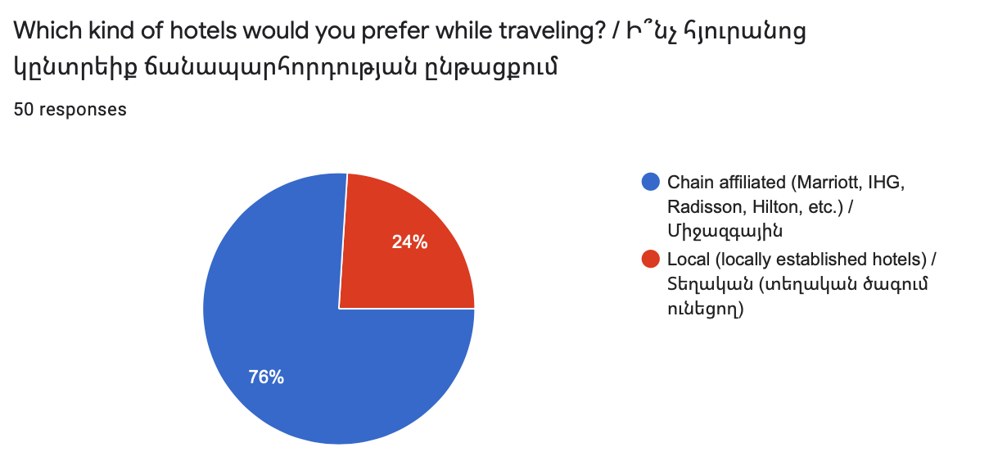
Chart 1: Participant’s preference of hotels

The other question was the continuation of the first one and had the context of why they would choose that kind of hotel. The question included multiple choice answers and an option if a guest prefers for another reason. The majority of respondents, 78%, answered that they choose hotel based on services, 44% pay attention to design, 38% of people value guest communication, 26% prefer chain hotels because of loyalty programs and 32% choose hotels based on the price. Moreover, 10% of respondents wrote their options (Chart 2). 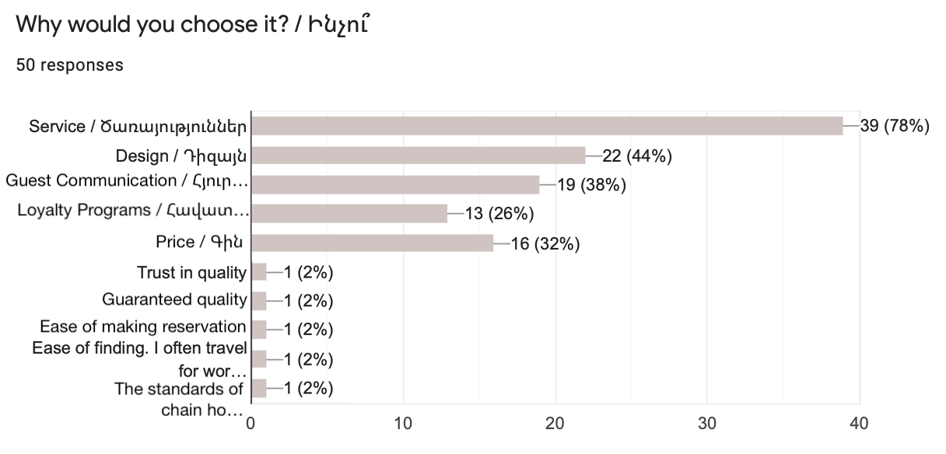
Chart 2: Participant’s reasoning of choosing hotels

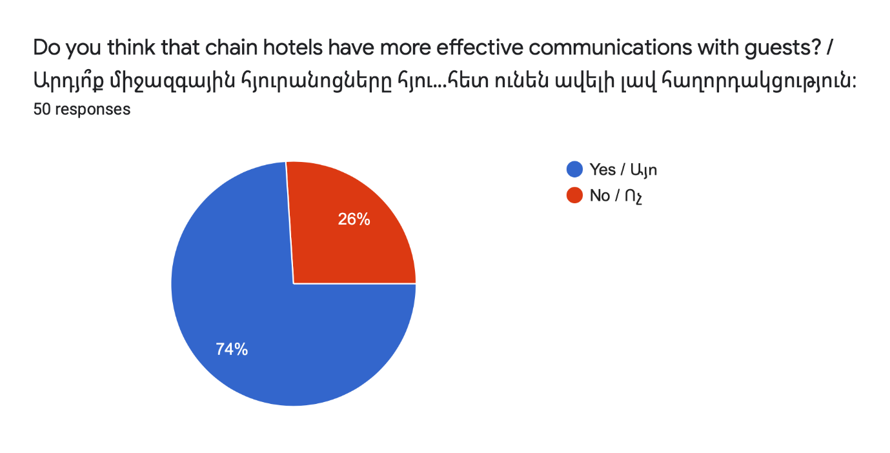
In order to have information about the perception of participants whether chain hotels have more effective communication with their guests, such question was asked. In this question, too, chain affiliated hotels had advantages as 74% of respondents answered that chain hotels have better communication with guests and only 26% answered that they do not (Chart 3).
Chart 3: Whether chain hotels have more effective communication with guests.
Based on the previous answer, the last question asked during the survey aimed to understand why participants consider chain affiliated hotels to have effective guest communication. There were various answers but most of the participants answered professional communication, brand recognition, experience and loyalty programs are some of the factors why they would choose a chain hotel while traveling. However, there were also opposite answers. Some of the participants mentioned that even chain hotels might have poor communication or services. Moreover, some local hotels are more friendly and open to price negotiation.
As the data indicates, the majority of participants tend to prefer chain affiliated hotels. Many of the respondents consider them a better choice because of the services provided, design, price and loyalty programs. Furthermore, many of the participants would choose a chain hotel as they are more professional and have more experience in the hospitality sphere. However, some of the respondents might consider local hotels to be quite friendly and poor communication and service can happen in both types of hotels.

Discussion and Conclusion

Based on the conducted research and findings, this study concluded how Holiday Inn Express Yerevan, a chain affiliated hotel, and Paris Hotel Yerevan, a local hotel, manage their brands in terms of establishing and maintaining communication with their potential guests. As a result chain-affiliated Holiday Inn Express Yerevan had a more effective ways and mediums to establish and maintain its brand communication with stakeholders, whereas, Paris Hotel Yerevan didn’t achieve its branding to be as effective and interactive as Holiday Inn Express’.
The results of Action Research as Narrative Inquiry in both hotels, indicated that both Holiday Inn Express Yerevan and Paris Hotel Yerevan had their branding strategies. However, Holiday Inn Express Yerevan, which is a part of Intercontinental Hotels Group, had its specific brand standards which it needs to strictly follow. IHG is an international brand with years of experience and developed brand strategies. Thus, the way the hotel is designed makes the guests to remember the brand. The colors, furniture and interactive signs of the hotel were some of the components that the hotel as way for transferring its messages to its guests. Having a well-defined target audience lied in the core of the hotel’s branding. If there is a correct audience it becomes much easier to transfer a message as the hotel can further define needs and wants of that specific audience and do its branding and marketing based on those needs.
Paris Hotel Yerevan, a local hotel, also had quite developed brand strategy. On the other hand, it seemed that the hotel still needs to define its final target audience. Based on the narrative inquiry conducted in the hotel the hotel is flexible and convenient for both business and leisure travelers. The branding of the hotel aimed to establish a relationship with the guests but did not create strong communication between the brand and the guest which meant that the chances of having long-term relationship were low. The lack of interactive elements which could make the brand directly transfer a message to its potential customers might lower the brand-customer communication or establish poor relationship. Thus, the brand communication of the hotel still needed further development.
The results of the interviews conducted with the representatives of both hotels indicated that both of them aimed to provide the best available service for their guests. However, the strong brand identity of the hotel was one of the main differences of the hotel among the local ones. Holiday Inn Express Yerevan paid much attention to its brand identity and stayed focused on its specific target market, business travelers. It enabled them to directly reach them through different mediums including interactive elements throughout the hotel, IHG Rewards Club and social media. From the interview it can pointed out that the hotel has achieved to effective brand communication with its stakeholders as it has well-defined branding strategy, variety of means of transferring messages as well as making guests remember the brand by communicating with them through interactive signs and brand specific colors, fonts and even furniture.
However, the interview with the representative of Paris Hotel Yerevan, a local hotel, gave the idea that the hotel is focused on providing good services and additional priorities for its customers. On the other side, it doesn’t pay much attention of creating a distinctive brand identity which will make people remember the logo, colors or anything else. It is also focused on staff-guests communication which is also a crucial point. However, the lack of loyalty programs may greatly affect to keep constant communication with guests in distance. So, Paris Hotel Yerevan have not achieved to distinctive branding yet because of not having a well-defined target audience and not paying much attention to brand details.
Based on the results of the survey, it can be pointed out that chain affiliated hotel was a more preferable choice among the participants. As the results showed, most of the respondents would choose chain affiliated hotel while traveling. The main reasons were services, guest communication and design. However, many of the participants highlighted the fact that local hotels were more open to negotiation and could be as good as chain affiliated ones. As a result, the majority of the respondents thought that international hotels have more effective communication with their guests. It might be connected with the fact that chain hotels already have developed branding strategy, specific design and specific communication channels such as interactive signs, loyalty programs or regular email sending.
Even though the study made conclusions based on the gathered data, there were met some limitations which prevented to make further research. First, during the research period, because of Covid-19 pandemic, there were difficulties of finding tourists to conduct surveys. The other limitation was connected with the same issue as further development of pandemic, made it impossible to conduct face-to-face interviews or surveys and all the interviews and surveys were conducted online.
The possible further research which could include surveys of tourists and face-to-face interviews, could give broader understanding whether chain affiliated hotels in Armenia have better communication with their guests and it makes the guests to choose chain hotel. It would help to get more ideas if branding strategy plays a huge role in hotel-guest relationship.

Bibliography

Aaker, D. A., & Biel, A. L. (2013). Brand Equity & Advertising. Advertising's Role in Building Strong Brands (1st ed.). New York, NY: Psychology Press.
Aaker, D. (2006), "Brand Portfolio Strategy", Strategic Direction, Vol. 22 No. New York, NY: Free Press/Simon & Schuster
Balmer, J. M. (1998). Corporate Identity and the Advent of Corporate Marketing. Journal of Marketing Management, 14(8), 963–996. doi: 10.1362/026725798784867536
Bastos, W. and Levy, S.J. (2012), "A history of the concept of branding: practice and theory", Journal of Historical Research in Marketing, Vol. 4 No. 3, pp. 347 368. https://doi.org/10.1108/17557501211252934
Brand hotels in Armenia. (n.d.). Retrieved April 18, 2020, from https://araratour.com/brand hotels-in-armenia
Courtyard by Marriott Hotel to be built in central Yerevan. (2019, July 11). Retrieved May 10, 2020, from https://news.am/eng/news/523387.html
The Shorty Awards. (n.d.). Holiday Inn Express Stay Smart Campaign. Retrieved April 18, 2020, from https://shortyawards.com/7th/holiday-inn-express-stay-smart-campaign-2
Intercontinental Hotels Group (n.d.). Experience IHG® Rewards Club: Rewards That Travel With You. Retrieved May 10, 2020, from https://www.ihg.com/rewardsclub/content/us/en/enjoyrewards?cm_mmc=OFMAM 6C-US-EN-LOY-Vanity-MemberBenefits
Ivanova, M. P., Ivanov, S. P., & Magnini, V. P. (Eds.). (2016). The Routledge Handbook of Hotel Chain Management. New York, NY: Routledge.
(Karen) Xie, L. and Chen, C. (2014), "Hotel loyalty programs: how valuable is valuable enough?,” Vol. 26 No. 1, pp. 107-129. Bingley, West Yorkshire, UK: Emerald Group Publishing Limited
Kim, C. K., Han, D., & Park, S.-B. (2001). The effect of brand personality and brand identification on brand loyalty: Applying the theory of social identification. Japanese Psychological Research, 43(4), 195–206. Malden, MA: Blackwell Publishers Ltd.
Kreck, L. A. (1974). Management in the Soviet Union. Cornell Hotel and Restaurant Administration Quarterly, 15(3), 71–77. doi:10.1177/001088047401500312
Lee, S. (Ally), & Oh, H. (2013). Effective Communication Strategies for Hotel Guests’ Green Behavior. Cornell Hospitality Quarterly, 55(1), 52 63. Amherst, MA: University of Massachussets
O’Neill, J. W., & Mattila, A. S. (2009). Hotel Brand Strategy. Cornell Hospitality Quarterly, 51(1), 27–34. Pennsylvania, PA: Pennsylvania State University
Pant, D. R. (2005). A place brand strategy for the Republic of Armenia: “Quality of context” and “sustainability” as competitive advantage. Place Branding, 1(3), 273 282. doi:10.1057/palgrave.pb.5990028
Paris Hotel Yerevan (n.d.) Features & Services. Retrieved May 10, 2020, from http://www.parishotel.am/en/yerevan/featuresservices
PRASAD, K., & DEV, C. (2000). Managing Hotel Brand Equity: A Customer- Centric Framework for Assessing Performance. The Cornell Hotel and Restaurant Administration Quarterly, 41(3), 22–4. Ithaca, NY: Cornell University
So, K. K. F., King, C., Sparks, B. A., & Wang, Y. (2013). The influence of customer brand identification on hotel brand evaluation and loyalty development. International Journal of Hospitality Management, 34, 31–41. Columbia, SC: University of South Carolina

Appendices

Appendix A
The main entrance of Holiday Inn Express Yerevan with Hello.
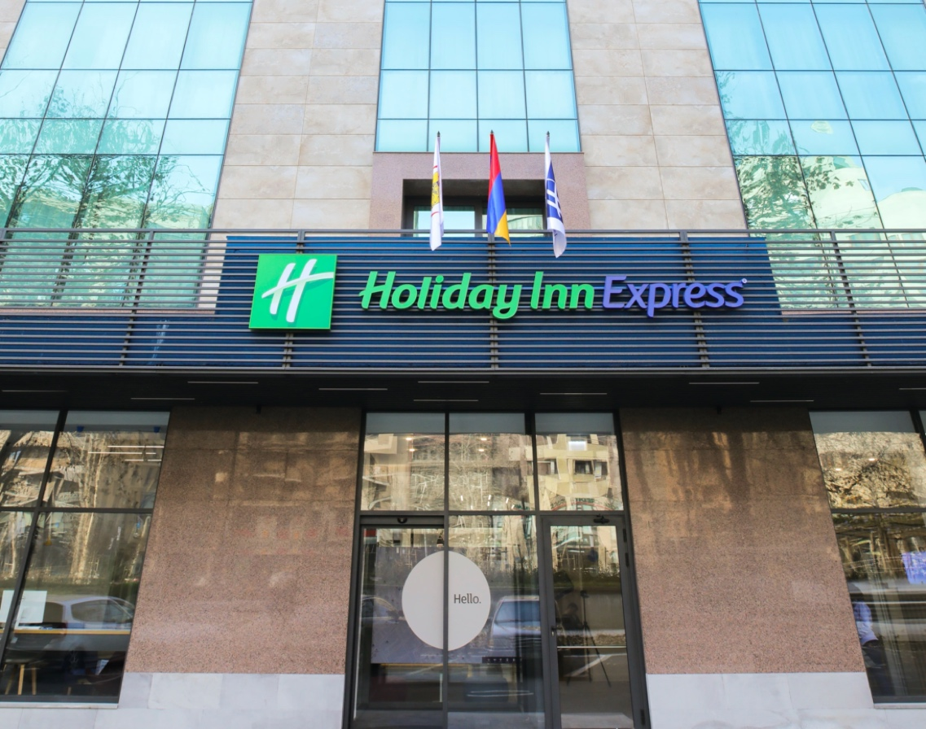

Appendix B
Interactive signs of Holiday Inn Express Yerevan.

Appendix C
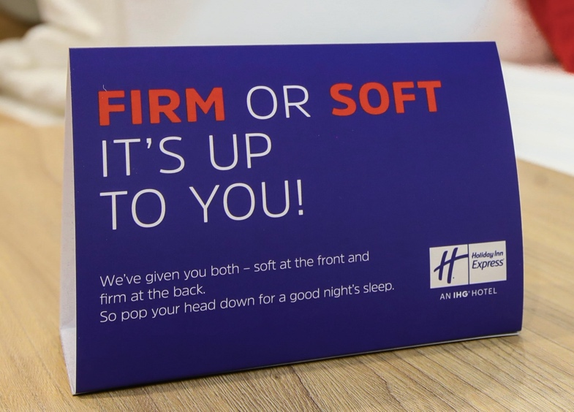
Room stickers.

Appendix D
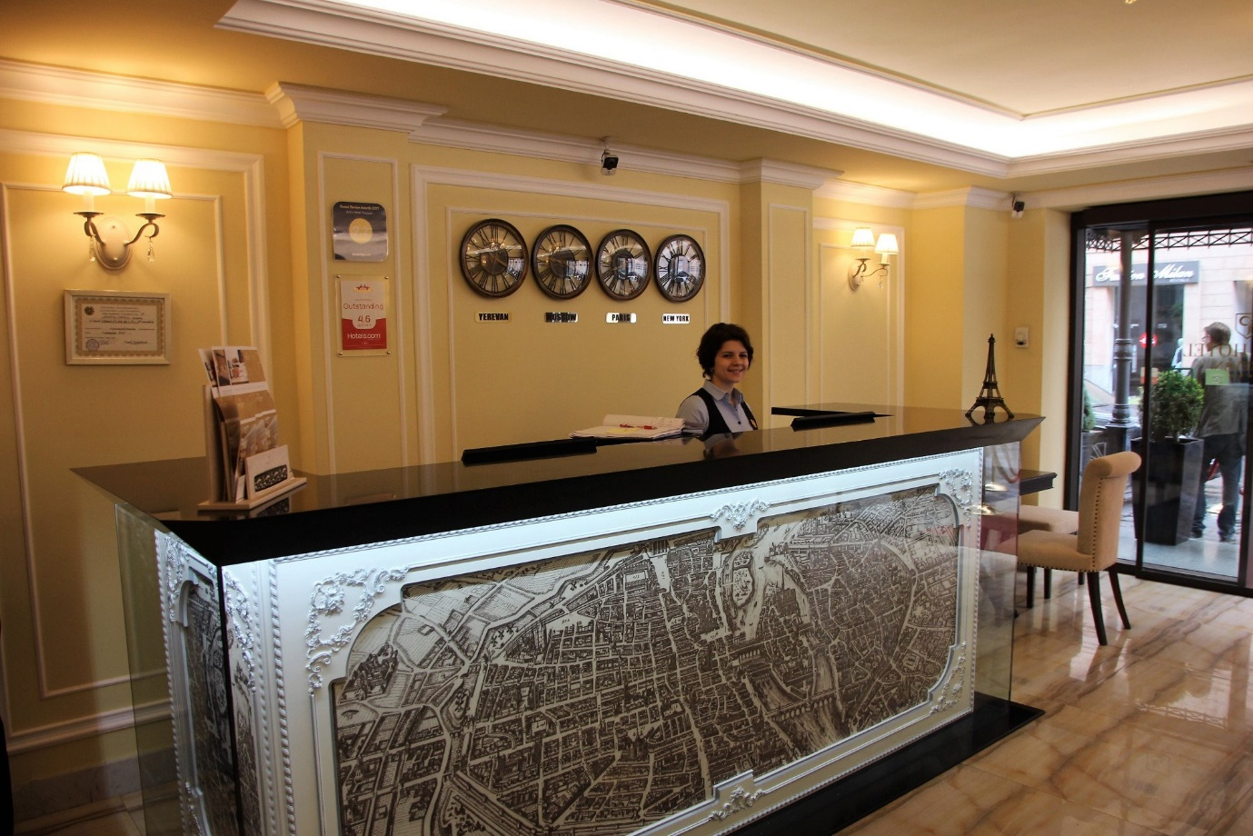
Reception desk of Paris Hotel Yerevan.

Appendix E

The Narrative Inquiry: Holiday Inn Express Yerevan

It has a specific design with specific colors and furniture that all the Holiday Inn Expresses in the world must only use them. When I saw them, they had been memorized in my mind and in future, every time I see those colors, I will know that it is a Holiday Inn Express. It creates a communication between guests and the hotel and makes the guests recognize the brand through details such as colors or furniture. As it is a hotel designed for business travelers, I could see the breakfast area which was integrated with the 24/7 bar. One thing to highlight was the scent of the area. I could see different interactive signs on the walls that informed about the area or hotel rules but what I liked the most was the signs on the walls that were kind of talking to you. As I also wanted to see the rooms, the worker very pleasantly showed me the rooms. I understood how smart was everything located and I could see signs in the room as well including towel reuse, pillow choice (soft or firm), hotel and area info with signature design and signs that indicated that the hotel is a part of a green engage program (sustainability program). Moreover, when I turned on the signature smart TV, I was warmly welcomed and offered to choose the options from a user-friendly menu. The overall atmosphere was great. I presented myself as a walk-in guest who wants to have a room for 2 nights, so I would have a chance to talk to the staff (reception) and understand the way they behave in brand hotels. When I stepped in, my first impression was good as I saw a big “Always Welcome” sign in front of me which turned out to be one of their brand components. It was followed by a smiley welcome face of the front-desk worker Nelli who was interested in helping me. After exchanging a few words and being familiarized with the prices, she offered me to join the IHG Rewards Club to get additional benefits and discounts all across the world. At the end I said that I would think and thank you to them and went out.

Appendix F

The Narrative Inquiry: Paris Hotel Yerevan

Paris hotel is a cozy place to stay. When I entered into the hotel, I immediately noticed that the reception area was small and without any specific design. It mainly had light tan colors but it was a modern place. However, I couldn’t notice any detail that would make me memorize that place. I think the design was not so good in terms of communication with guests. I couldn’t feel I was part of the brand. It was nice and cozy but not interactive. Talking about the rooms I would like to mention the same issue. They were, again, modern with all the necessary facilities that at guest would need to have a good stay but I could notice items such as furniture which I could see in most of the places. So, to conclude I couldn’t find any signature detail that would make think of Paris hotel in the future. I entered into the hotel and again, presented myself a walk-in guest. The front-desk worker was polite and responsive. There were not any problems I could notice while talking to them. They didn’t have any rewards programs.

Appendix G

Interview Questions with the Representatives of Holiday Inn Express Yerevan and Paris Hotel Yerevan

- How does your branding communicates with guests?
- What are the key drivers to build effective communication with guests?
- Once the communication is established, how to maintain them long-term?
- What role does the branding play in this relations?
- What are the differences between your and chain hotel brand management in terms of guest relations?

Appendix H

Interview Questions with “Braind” Branding Agency

1. How branding establishes and maintains effective communication with customers?
2. What factors do you consider while creating a new brand for hotels?
3. What does make a brand attractive?
4. How do you measure if a branding is successful?

Appendix I

Interview Questions with a Working Professional From Public Relations Field

1. What are some elements that establish a brand loyalty?
2. How do brands communicate with customers
3. How PR/Marketing agencies constantly maintain the relationship between brand and its stakeholders?
4. Which components are used to make a brand appealing
5. Do popular or known hotels communicate with their guests (customers) better because of their brand name recognition?

Appendix J

Online Survey Questions

- Age
- 18-24
- 25-40
- 40-55
- 55+

- Gender
- Male
- Female

- Where are you from?

- Which kind of hotel would you prefer while traveling?
- Chain affiliated (Marriott, IHG, Radisson, Hilton, etc.)
- Local (locally established hotels)

- Why would you choose it?
- Services
- Design
- Guest Communication
- Loyalty Programs
- Price
- Other ...

- Do you think that chain hotels have more effective communication with guests?
- Yes
- No

- Why do you think so?

