by
Artur Aslanyan

Presented to the
Department of English & Communications
in Partial Fulfillment of the
Requirements for the Degree of Bachelor of Arts

American University of Armenia
Yerevan, Armenia

May 1, 2020

Table of contents
Abstract
Introduction
Literature review
Research question & methodology
Research findings and analysis
Suggestions based on the research
Limitations and avenues for future research Bibliography
Conclusion

Abstract
This is a proposal for research on recycling campaigns in Armenia that discusses the effectiveness of campaign communication. The following research will introduce what recycling is while highlighting its importance to the environment. The paper also analyzes the effectiveness of certain types of appeals, such as the fear appeal and the positive appeal. In the proposed study, the question being addressed is, "what kind of rhetorical appeals in environmental campaigns can effectively change Armenians' behavior to sort and recycle?" Through which kind of modalities, it would be better to utilize different rhetorical appeals and why? Within the merits of the following paper, previous research will also be discussed to understand the current situation and the best practices. The methodology used for this research project consists of various parts starting from a thorough research of previous findings, an online survey of people from completely different segments, and in-person interviews both with field professionals and with randomly selected people. Based on the analysis of all the findings, several creative components have been created (designs for the billboards, trash bins, and an ad copy for use on social media). Moreover, the research also revealed that there is considerable ignorance that people have while severely lacking educational content. Otherwise put, there is a need for a general understanding of the existence of the current issues that may soon become serious threats.

Introduction
There have been, and there are recycling and waste management campaigns in Armenia that aim at changing people’s behavior towards sorting and recycling. “Recycling is the process of sorting and re-using materials that would otherwise be thrown away” (Rinkesh, 2016). According to “The Armenian Weekly,” the dumpsite located in Nubarashen has accumulated almost 10 million tons of waste since 1950. Currently, within 300,000 tons of waste, approximately 30% is Recyclable plastic. One of the common beliefs that Armenians hold about recycling is that the country does not have the necessary resources for recycling and that it is not a severe issue at all. Hence, almost the whole population in Armenia does not sort the litter and tends to ignore all the types of messages that are transmitted by different organizations operating in the environmental sphere.
By having that in mind, several organizations launch PR campaigns with the primary purpose of changing this behavior while promoting the idea of an eco-friendly lifestyle. The question is, do they work? In short, they don’t. However, they still have a certain amount of impact due to their specific communication strategies. One of the famous companies in Armenia that deals with this issue is “Eco Aghb.” Its communication tactics will be touched upon the paragraphs of this paper.
In any campaign, PR specialists or marketers utilize various appeals with the primary purpose to be persuasive and influence people’s minds by guiding them to the desired action. One of the appeals that is commonly used is the fear appeal. According to Tannenbaum, “fear appeals are messages that successfully persuade people about the potential harm that may occur” (Tannenbaum et al., 2015). Obviously, appeals, including fear appeal, work at their best if used where they are needed the most. It happens to be so that one of the major fields that need recognition of the seriousness and immediate solution plan is healthcare and the environment. Nevertheless, positive appeals to people’s emotions also have a huge impact, and individuals tend to like it more (Alpetyan, 2019).
Apart from the usage of rhetorical appeals, the paper will also demonstrate a separate suggestion paragraph that aims at providing a creative but still very detailed approach towards the issue. By relying on the fundamental concepts of the literature review, there will be provided information based on which individual creative components have been made to understand the current perspectives of different individuals. The design creatives are in the form of billboards, printouts for the trash bins, and advertising on social media (Facebook & Instagram). The designs that are made are based on the research analysis and its findings. Thus each model is specifically targeted for a specific segment of people. Various components have been carefully taken into account, such as color usage, rhetorical appeals, wording, type of illustration, typography, and original creative solutions. These are created and shown to the public for testing and validation purposes, meaning that if people like them, they can certainly be realized.
Aside from the creative component in this paper, there will also be provided detailed information in terms of its implementation. There will be provided a table illustrating the type of advertising medium, the exact chosen location, and last but not least important the monthly required price. The research paper will showcase the avenues for further research because of the limitations that were present during its research, writing, and analysis processes. At the end of the paper, one can find the research data that was gathered via an online survey and online in-person interviews with all the numbers and other information available for the public.

Literature Review
According to the report made by UNDP Armenia, the result of environmental pollution in Armenia has already caused financial losses. “there is a plastic range within the range of 5000 to 6000 tons annually”(Global Compact in Armenia 2013). Armenia is losing a lot of money because the plastic waste is neither properly recycled nor resold. Furthermore, since the tone of plastic waste is worth $1000, Armenia has had the potential to generate approximately five to six million dollars. The following study has confirmed that there is an issue in Armenia that is growing while also showing the financial opportunities that could be utilized.
As per the solutions for this kind of a problem, there have been suggested various implementation strategies with specific usage of rhetorical appeals. Jacob Hornik, a professor of marketing and communications in his journal of advertising research, analyzes the effect of different emotional appeals, where he explains the key differences that appeals lead to. “Even though fear appeals turn out to be less effective than humor appeals, they are still used by many people and organizations to change the behavior and attitudes of people” (Hornik, 2017). What is more, he also found out that a combination of different kinds of appeals work well together as they manage to trigger more emotions while being not that easy to forget. This theory has helped to come up with the design suggestion ideas for the public to test and validate if they are experiencing certain emotions while also checking the likelihood of remembering what they have seen. The concept of triggering at least 2-3 types of emotions such as fear, guilt, and amusement in Hornik’s opinion will be a great combination of factors that will make the advertising memorable by attaching to people more deeply.
Some may think that when awakening negative feelings and emotions within people, the result will not be good; however, that is not necessarily applied to any situation. Professor Michael S. LaTour from the University of Mississippi analyzes in more detail the relationship between the fear appeals and communication stimuli to show the actual responses. In his journal, he explains the primary use of threats, which is “to showcase the effects or common undesirable outcomes of our everyday actions or behavior” ( Latour, 1997). According to him, different people react to fear appeals differently, and in any message communication, the target audience should be chosen very carefully. Based on his idea of the particular segment, the surveys with the designs were shown to specifically targeted people while their reactions were carefully analyzed. Apart from the notion that fear appeals have high chances to be effective message communicators, they are not easy to be used. According to Ioni Lewis, fear-based appeals should be used very carefully because people very quickly get accustomed, and no effect is produced. Even though the most potent form of fear appeal is the shock based fear appeal, it is not always practical. Based on the study made by Lewis, the results show that in today’s world, “society is no longer shocked” (Lewis, 2007) by shock based appeals. The method that Lews used was to have a focus group consisting of people that had completely different demographics with the primary purpose of having a clear picture of the effectiveness of shock based appeals. In his research, he illustrates the amount of exaggeration that is put under threat appeals and argues that because the overall picture looks “too much,” the likelihood of being persuaded may be very low. The main point of the whole research was to show that the amount of threat in any campaign should be very carefully measured and then put into action. So based on the following study, it can be inferred that the usage of fear appeal in any communication should be very moderate and balanced.

Moreover, while the fear appeal may be considered to be one of the most powerful rhetorical appeals, it can be used at its most if done the way Merrill Warkentin and Mikko Siponen suggest. Based on the research that they have done, "the manipulative tool (fear appeal) significantly affects its recipient's existing notions when the threat is directed to the self" (Warkentin & Siponen, 2015). In other words, messages that are related to someone's health and safety are the top themes that one may be affected by the most. Nevertheless, in the study, authors also argue that even though those appeals are robust and influential, they are still very subjective. Although a lot of research has already been made on this topic, research is still under process to understand the best utilization method of fear appeals.
Another interesting study that explains the behavioral stages of people when experiencing fear and yet is very similar to this study is the study done by Ron Lennon and Randall Rentfro. The similarity is seen in the selected segment of the audience consisting of young males and females aged 18-25. In their published journal called "Innovative Marketing," they introduce the concept of the acceptance of the fear in 3 various ways. The first way is called "a null effect," which means ignoring the threat. Second, is called "an intended result," in which a person tries to restrain the aroused fear. The third is "unintended result." here, the person tries controlling the fear. Since the method consisted of both examining males and females, there were different results. Females were more influenced by the PSAs that included fear, shock, or terrible consequence components, while males were mostly neutral and ignorant.
Although there are lots of studies done on the usage of the fear appeal, its usage during environmental campaigns has not yet been researched enough. A study made by Mei-Fang Chen explores the influence of fear appeals on environmental behavior. Interestingly enough, her research shows that the participants that read texts that included low fear appeal texts showed more fearful emotion of fear and urgency when compared with those who read texts that contained high-fear appeals. She defines fear as a "powerful, natural emotional reaction to a received threat or dangerous event and a strong motivator for people to change their behavior to avoid a potentially negative consequence" (Chen, 2014). The point that she is trying to make is to show that people showcase certain suspicion, lose trust, and tend to believe that the information that they read is not correct. Her idea is that because of too much fear appeal exposure, the target audience may lose its trust and may not believe things it has seen.

So far, discussing the utilization of the fear appeal has been mentioned quite a lot, but the same importance has the positive appeals that PR specialists, marketers, or advertisers make. Kathleen Searles, Ph.D. from Washington State University, deeply analyzes the powerful force that positive appeals such as enthusiasm appeal can bring in environmental campaigns. According to her research, “enthusiasm appeals in the PSA script should significantly affect participant’s reported pro-environmental attitudes positively. Enthusiasm should invoke positive responses to environmental queries for two reasons: it reduces any uncertainty regarding environmental efforts, and it reinforces the effectiveness of existing environmental efforts.” (Searles, 2010). One of the main points in her research is that because enthusiasm increases positivity among people, they will be more tuned towards holding goo-will intentions and may begin considering taking part in having a role in pro-environmental campaigns. Another type of positive appeal that has been researched by Jan-Willem Bolderdijk that was published on nature climate change journal suggests moral motives that people hold can sometimes be way more powerful than economic incentives (monetary awards). “Although individuals differ in the extent to which they value environmental quality, many share the belief that nature is
sacred, and consider it part of their moral responsibility to take care of the environment” (Bolderdijk, 2012).

Research Question & Methodology
In this particular study, the research question being addressed is, "what kind of rhetorical appeals in environmental campaigns can effectively change Armenians' behavior to sort and recycle?" Through which kind of modalities, it would be better to utilize different rhetorical appeals and why? Apart from those, the research also aims at testing the hypothesis of the effectiveness of the usage of fear appeals in environmental campaigns through interviewing field professionals in Armenia. The methodology of the paper consists of several parts. Firstly, there was a lot of research done on the overall notion of sorting and recycling processes in Armenia. The reason behind that was to identify the key organizations that are dealing with the problem. Apart from this, local research, previous studies (published articles, academic journals, and other scholarly sources) have been carefully examined to have background information and a relevant scholarship in this field. Right after gathering sufficient data, the research question was identified with the primary purpose of articulating the main issues that this particular paper is going to cover. What is more, that paper also aims at testing the key hypotheses that have been singled out from the literature review. Two types of online surveys have been made to measure the overall attitude of Armenians towards recycling and their thoughts on creatives made. The first was a public survey, and people from very different age groups have taken part, starting from 16 up to 62. The overall number of participants was 88 with an almost equal distribution of genders; 45 females and 43 males. The second survey was a public survey where the respondents were mostly young people aging from 20-26 years old. The overall number of participants was 167 consisting of 109 females and 56 males. They were asked questions regarding the creatives made for the project, and we will talk about them in the “suggestion” part. Aside from the online survey, there were done online in-person interviews as well to gain more insights on the issue. Participants were chosen from a specific segment to test the current hypothesis. Ten people took part in the interviews (five males and five females). What is more, the representatives of the Acopian Center for the Environment have been interviewed to give their perspectives. All this data became a significant component of this research paper because it led to interesting findings, some of which even contradicted the original hypothesis while helping to construct a separate suggestions paragraph for further research and possible implementation.

Research Findings and Analysis
The first online survey consisted of simple questions that would show people's overall attitude towards recycling and the level of their understanding of its benefits. What the research revealed was quite interesting. With a total number of 88 participants, one can learn some useful insights. Four charts are selected as they convey the most significant findings. All of the questions were chosen with the purpose to either confirm or to contradict the initial assumptions. Below will be short summaries about the results of the survey and then a separate paragraph dedicated to concluding the results.
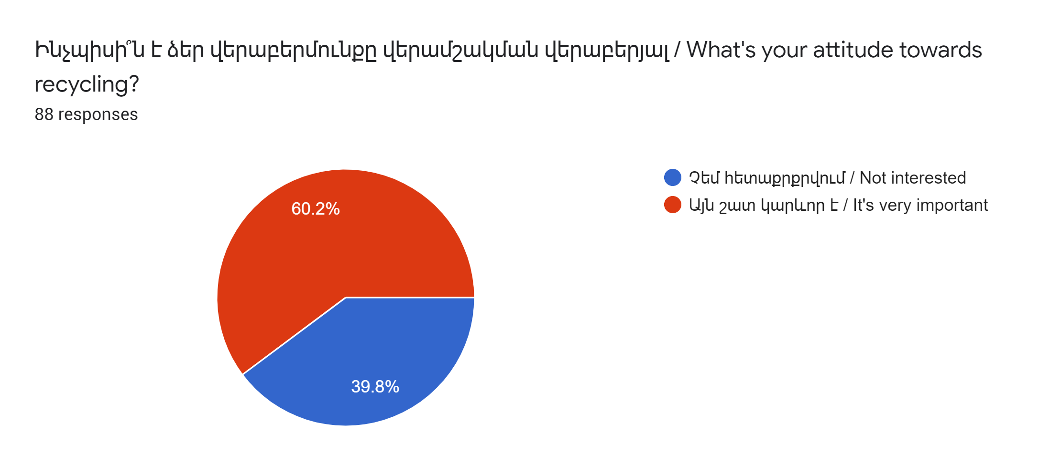
To the question, “What is your attitude towards recycling?” 60.2% of the respondents answered that it is vital. The first thing that may come to your mind is that people do care about the issue, and they find recycling important, so they most likely are engaged in tackling that problem. However, that assumption is detached from reality, and it is merely an assumption. From the next chart, the image of the reality will be more explicit.
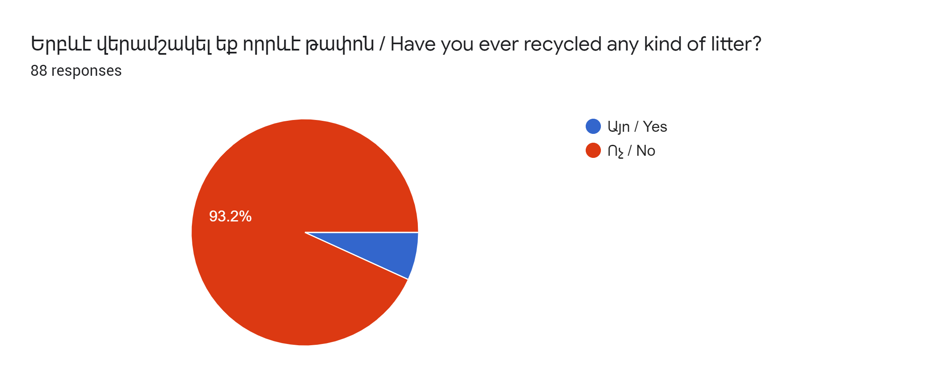
As can be seen from the above chart, almost no one has ever recycled any litter. Although people do think that recycling and sorting are crucial for the environment, they still have never recycled, but this is not the worst side of the issue. Nevertheless, because one of the primary purposes of this paper was also to identify the core of the problem, two more graphs will be provided.
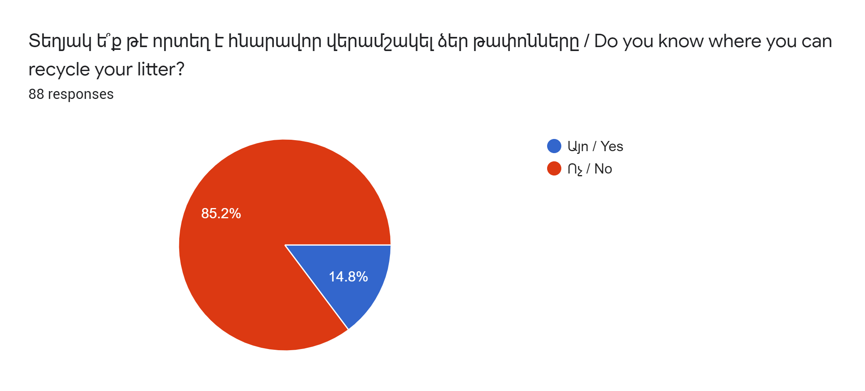
There was an initial assumption that one of the fundamental problems was that people are not educated enough about the importance of this topic, and this assumption was confirmed. As it turns out, the majority of the people do not know the exact locations or specially dedicated organizations that operate in the sphere of waste management. This chart is a clear indicator that people lack educational resources. Maybe if they knew how and where it is possible to sort and recycle litter, we might not have this kind of a picture, but again that is just an assumption.
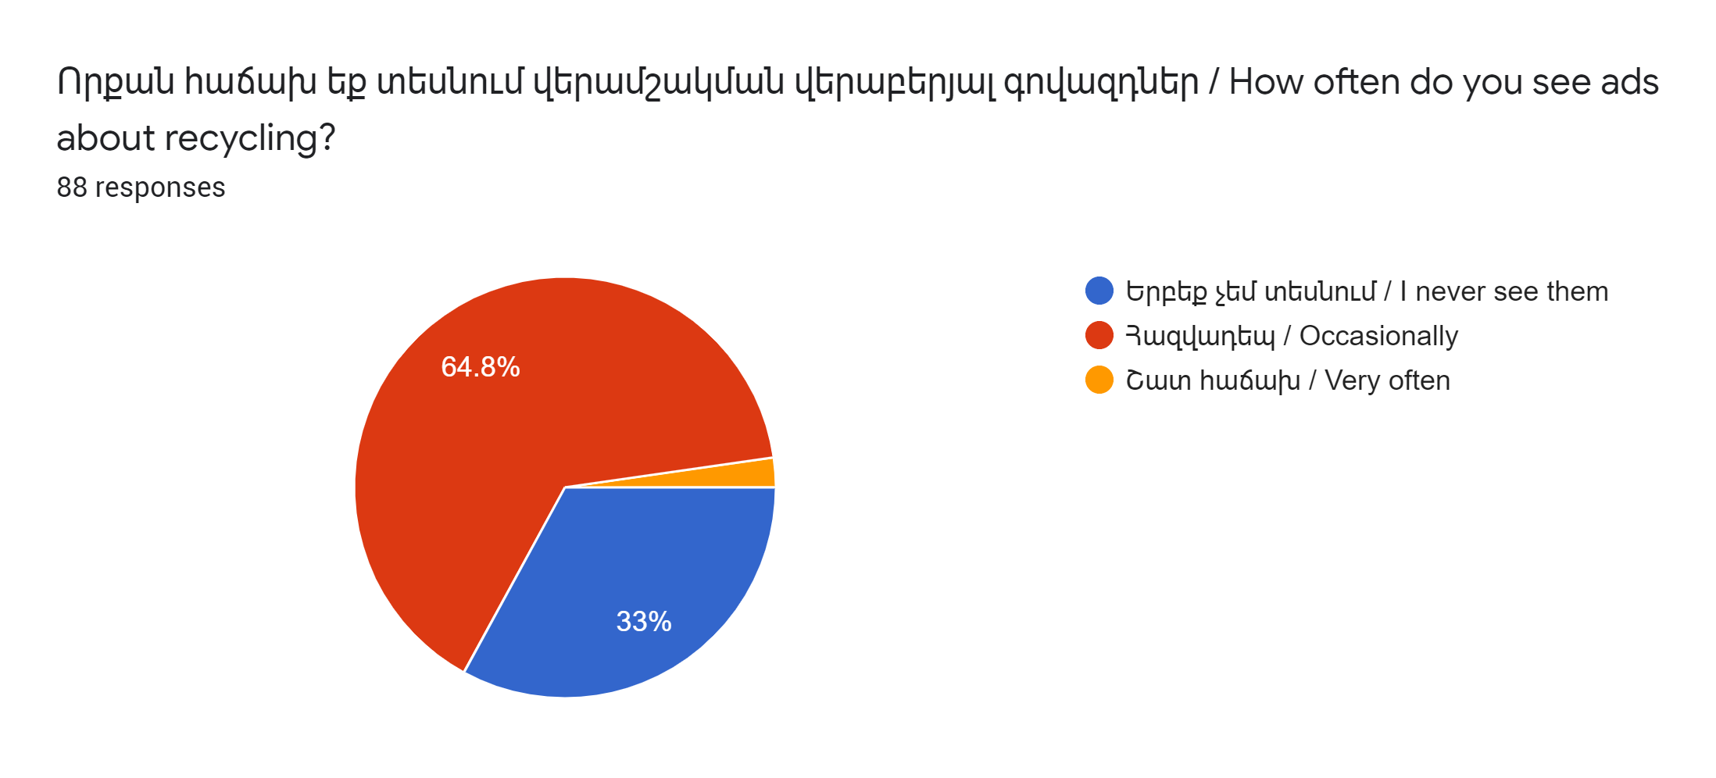
The last chart that is taken from the survey results is another interesting source of insights. As already mentioned, initially, there were certain assumptions about the leading causes of the issue, but still, the results revealed both contradictions and confirmations. So the chart at the above partially confirmed the initial assumption. It was assumed that the majority of the people would claim that they have never been exposed to ads about recycling at all. However, it turned out that most of the people are occasionally being exposed to that kind of ads. The advertising medium (TV, radion, social media) was deliberately not mentioned, so when answering this question, people consider all of them. Nonetheless, what this means is that, while people often see advertisements for waste management, they do not engage in that process at all and seem to be ignorant.

Based on the above shown four graphs, there are certain conclusions that we can make. First of all, we have seen, and therefore we can confirm that people do think that recycling is vital as the majority of the respondents claimed to be so. As that kind of information is not enough for having the whole picture of the situation, other charts were also provided. In the second chart, we saw that most of the people have never recycled anything and because the next obvious question that would arouse in our minds would be why we included the issue in regards to their knowledge about the locations for waste management. As most of the people proved, they do not know where to recycle. On top of that, the last chart, about the frequency of advertisement exposure on various channels helped us to form our final thoughts. We can now conclude that even though people seem to identify recycling as something important, they have never been engaged in the process of waste management because they are not aware of the exact locations while not being enough reminded about the issue via advertisement.
Apart from the survey that showed people’s attitude towards waste management, there was also an interview done with the representatives of the Acopian Center for the Environment (ACE). Alen Amirkhanian (director of ACE), Harutyun Alpetyan (Waste Management Expert) have shared their perspectives on the importance of all of the stages both before and after recycling. As Mr. Apletyan mentioned, “There are stages before the actual recycling process and one of which is sorting that has a crucial role.” His point was that a lot of people think that the issue is merely about recycling and that since people are not recycling the trash by themselves, it leads to huge problems. He was explaining why this is a wrong understanding.
First and foremost, people need to sort their waste, so that people or organizations who operate in that particular sphere deal with the garbage in favor of the environment. What is more, during our discussion, we all agreed on the point that there is a severe lack of educational content for the people who know nothing about the whole chain of waste management, starting from the usage and ending with the reuse. Moreover, Mr. Alpetyan was also talking about the reuse of the everyday things that we use. “Not all of the material goes to recycling because it can be reused, for example, glass bottles.” The apparent problem was and still is that people throw different types of waste altogether, which makes it hard to sort, reuse, or to recycle. We also talked about the existing organizations that are dealing with this issue in Armenia. One of the most famous ones that successfully manages its communication with the public is Eco Aghb.
“Eco aghb does a good job in raising public awareness - they do not appeal to fear.” The research that was conducted showed how effective the fear appeal could be in the context of environmental campaigns. However, the interview with the representatives of ACE has surprisingly revealed precisely the opposite. It showcases that in Armenia, the fear appeal may not be more effective than positive appeals. They believed that fear appeals are only useful if they are “legitimate.” What they meant was, fear appeals should only be used when the situation is out of control, and the whole country or most of the regions are under a severe hazard.
Nevertheless, they still think that fear appeal can be used very effectively but in a more specific context. “Fear appeal can be used for decreasing hazardous waste (batteries, pharmaceuticals, chemicals)” As already mentioned about the legitimacy of the usage of the fear appeal, they believed that there is a great demand for decreasing the hazardous waste not only in Armenia but all over the world because it is the biggest polluter of the environment. Another important thing that Mr. Alpetyan has singled out was about the communication strategy that Eco Aghb is using. “Eco Aghb effectively manages to mobilize people through its communication strategy.” He also added that from the very beginning, this organization did not use any fear appeal and instead used only positive messaging while providing educational content and encouraging people to sort waste for the public good.

Suggestions, Creatives and its Research
According to the analysis of the survey, we can assume that there are two kinds of problems that people have. First is that they are ignorant of the issue, and they think someone else will do that instead of them, and they never refer to that dilemma as a priority. Second, those who show at least some interest in protecting our environment, sorting, and recycling are not being exposed as much as needed because there are either not enough PR or communication campaigns, or they are ineffective.
So there should be strategic solutions for those problems, and they can be divided into three parts. First should be the “awareness campaign,” the purpose of which can be to reach out to as many people as possible and introduce the issue. Second could be “the consideration campaign,” the aim of which would make people think about the issue and start considering whether or not they want to be a part of the campaign. Based on the best practices that can be seen in the literature review section, the fear appeal is a great tool to make people think about the potential consequences if there is too much inaction and ignorance. Last but not least, it can be the action part where, ideally, people will start sorting their litter and give to the appropriate organizations. What more, it is a universal truth that the best-performing advertising channel for Armenians is word of mouth, so all of the parts of the campaigns will have a certain amount of impact.
Nevertheless, as most of the previous research was done outside Armenia and a source of information is the interview with the representatives of the Acopian Center for the Environment, based on their suggestions, positive appeals will work better. To support their perspective, they brought the example of an organization operating in Armenia that conducts all of its communication campaigns with positive appeals rather than fear appeals. It is called “Eco Aghb.”
Below will be the designs that were made based on the survey data, interviews with field professionals, and critical concepts of proper usage of positive and fear appeals taken from the literature review. After each image, there will be an explanatory section where can be found how I came up with that particular design idea, what is its primary purpose, and, most importantly, what are the factors that have been taken into account when making the design.
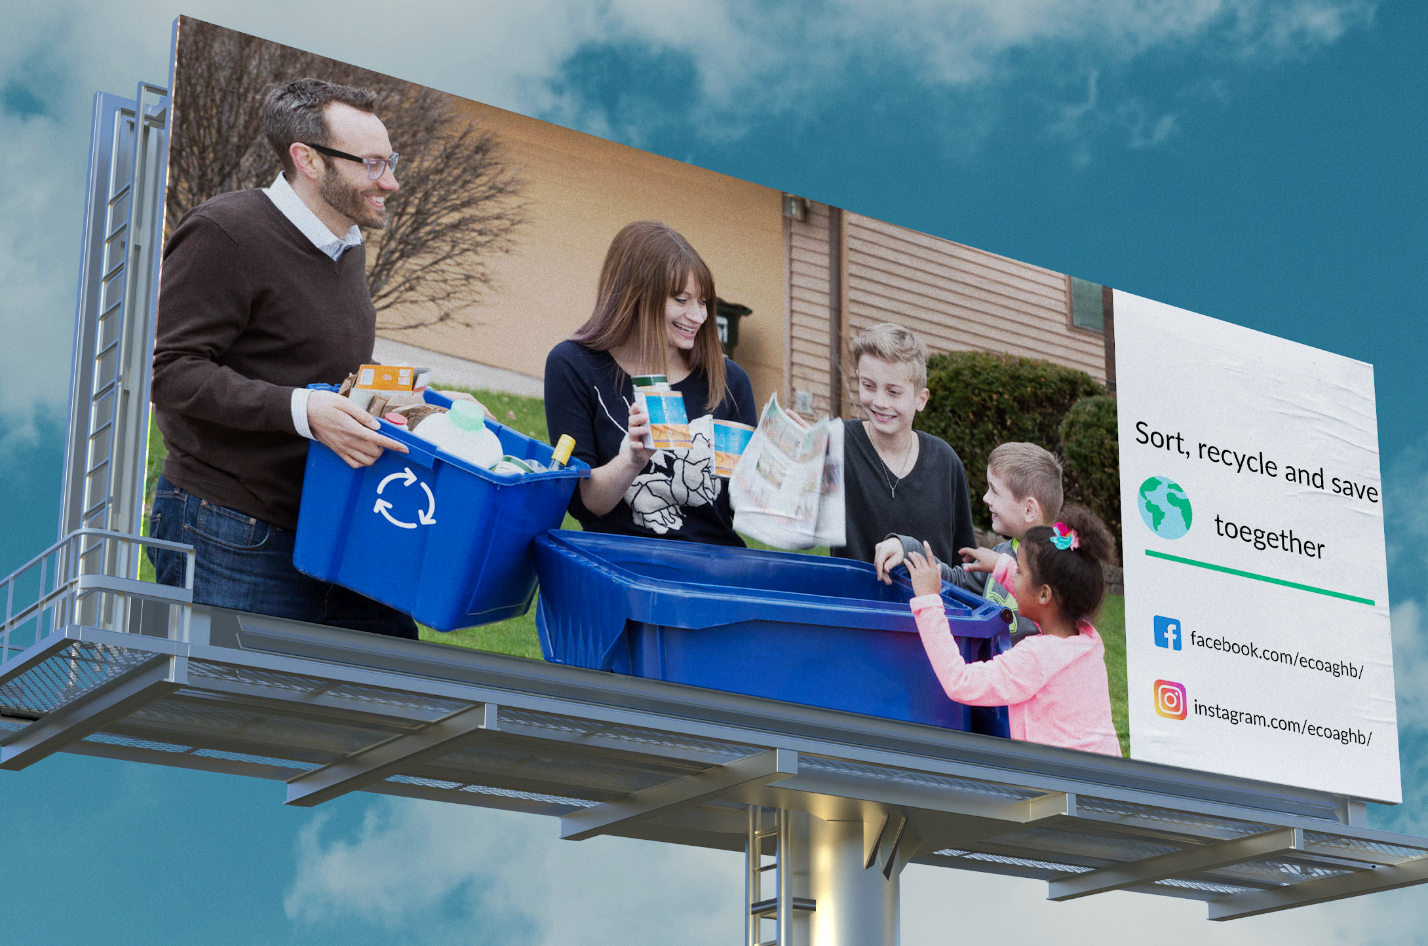
The following image is specifically targeted for the Armenian community for specific reasons. Since Armenians are a very cultural and united nation that has solid family values, this image can provoke lots of positive emotions. In a family setting, everyone is happily engaged with the process of sorting the litter. The idea behind choosing this image is to awaken positive feelings in all of the members of the families. The message is to sort, recycle, and save the planet together. The Facebook and Instagram icons are followed with the names of eco aghb’s pages, respectively. Although a typical viewer is accustomed to green color when seeing ads related to either sorting or recycling, here blue was chosen. As the research showed that people are ignorant of the issue, and they do not trust any organization that is trying to tackle the problem, blue color as a symbolization of trust may have a more substantial effect.

As can be seen from the above images, two bins visually communicate the idea that this particular bin is for one specific usage. The way I came up with the design is based on the survey that I conducted, which included people from different segments. As I found out, most of the people were ignorant towards the issue and did not care about sorting the litter at all. So if we put bins that contain a single line that says plastic/paper will not be enough. Hence, if the container as a whole visually shows that it is designed for individual usage, people, even from far away, will be able to identify and at least not be as ignorant as they currently are. Logos that are seen in the design are made to show if a particular company decides to implement this communication strategy how its logo will look like in terms of the size and its position.
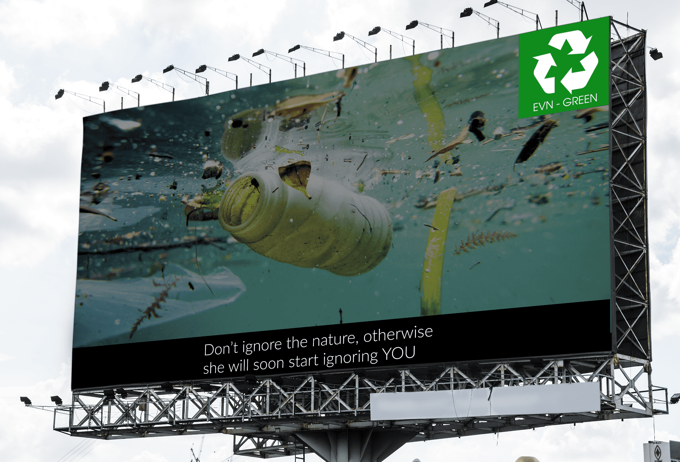

This design was created by taking into account the fear appeal both visually and in the context. The purpose of the visual is to warn the public about the possible consequences that inaction or improper waste management will lead to. There is nothing behind the scenes in this billboard design, no deliberate color usage or typeface. The idea was to create something simple and straightforward, so people see the visual and then read the text.
Finally, people were asked to choose the design that they like the most and below is the winning design. However, to this question only 63 people responded because it was added later because of certain and out of which 35 chose the design below.

Aside from the winning design there is another design with completely different purpose and strategy. Below is an image, taken from the internet, where the idea is to show how an advertisement of social media, in this case Facebook would look like with all the targeting details as well .
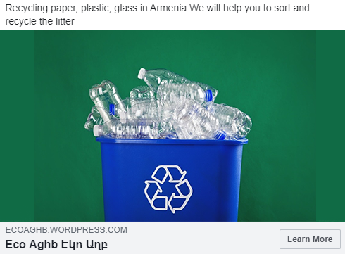

Audience details:
Gender: Both male and female
Age: 18 - 50
Location: Armenia
Audience interests > additional interests
- Air pollution
- Natural environment
- Plastic pollution
- Plastic recycling
- Pollution
- Recycling
- Reuse
- Sustainable development
- Sustainable living
- Waste management
- Water pollution

Interests > hobbies & activities
- Environmentalism
- Sustainability
The “learn more” button theoretically will lead the users to a website where they will learn how the sorting process should be done, the locations, and basically, the goal is to solve all the problems that the survey has revealed. If there is to be a campaign on social media, there should be set very well-thought key performance indicators (KPIs). For example, the growth rate or otherwise put the for the performance measurement one could use:

- Website reach (both new users and returning visitors)
- High CTR (click through rate) on the Facebook and Instagram ads
- Getting the attention of media for the billboards and the campaign in general
- Survey after 1 month

What is more, the following communication strategy will require a certain amount of budget if it is to be launched. In terms of the locations and budget, there are chosen 3 locations for the billboards, and the fourth medium will be paid advertising on Facebook and Instagram because today those are one of the most visited platforms, and it is included as well.

Type | Location | Monthly Price
Billboard | Arabkir, Baghramyan - Proshyan | 270K AMD
Billboard | Kentron, Teryan-Moskovyan | 250K AMD
Billboard | Kentron, Northern Avenue | 150K AMD
Social Media | Facebook & Instagram | 95K AMD
Billboards & Social Media |  | 765K AMD

Within the scope of the second online survey, there were 167 respondents. The study aimed to test whether or not people are open to the initial communication strategy that is going to include mainly three marketing channels (billboards, bins with prints, and social media) and which design do they like the most. The research has revealed that the majority of the participants think that the advertisement will grab their attention. Aside from catching the attention, I was also interested in finding out whether or not people will remember those ads. So on a scale from 1 to 10, I asked how likely it is that you will remember them. The majority of the participants (33 people) chose 5 out of 10. Below is a more detailed representation of the grading scale question.
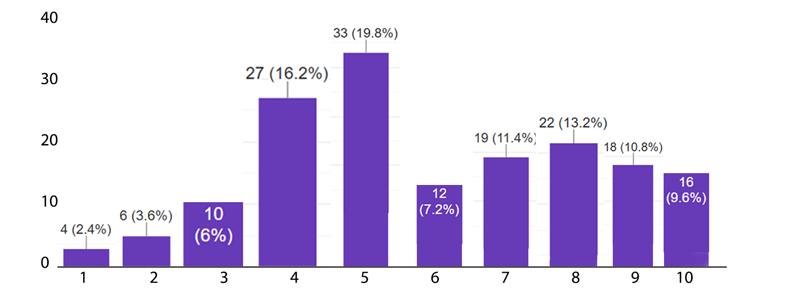

This grading scale is an excellent indicator of a likelihood of remembering the ads that were seen, which means for the sake of the awareness campaign, those types of advertisements with their chosen locations have high potential to work well and change people's attitudes. Another question was, "Will you be interested in seeing ads on this topic on social media platforms?"
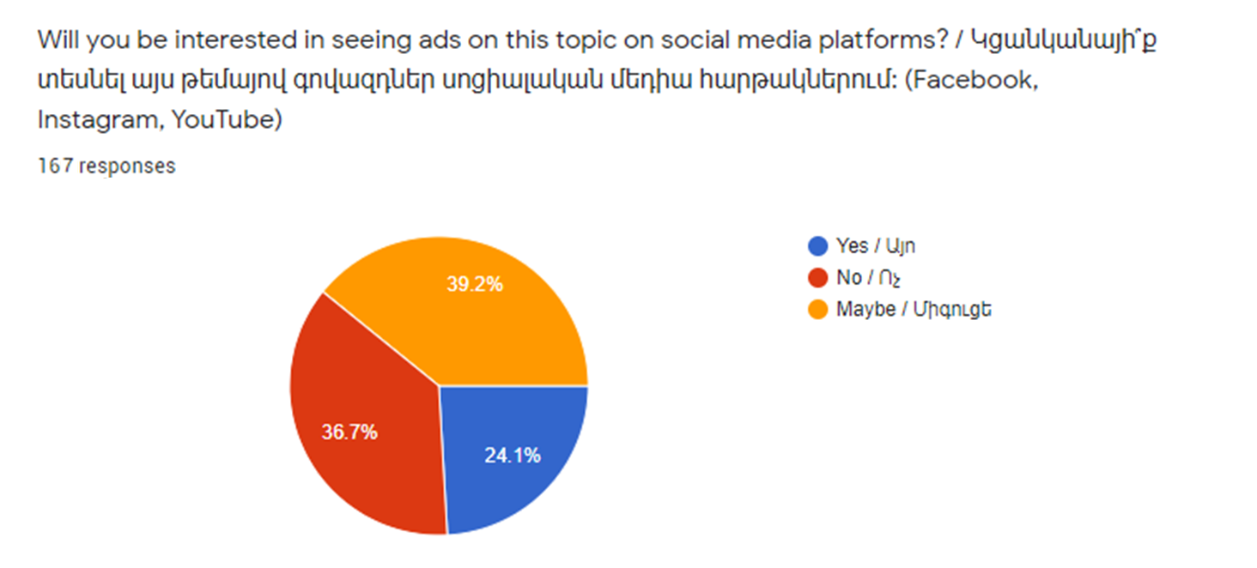
Most of the people surprisingly said maybe, however, as the distribution of answers of yes, no and maybe was 24.1%, 36.7% and 33.2% respectively we can say that there are people who still prefer seeing ads on social media platforms as the majority is in the consideration stage while showing a certain degree of readiness to seeing them. The next question had the purpose of testing what people would think if banks offered certain benefits for those who sort and recycle.

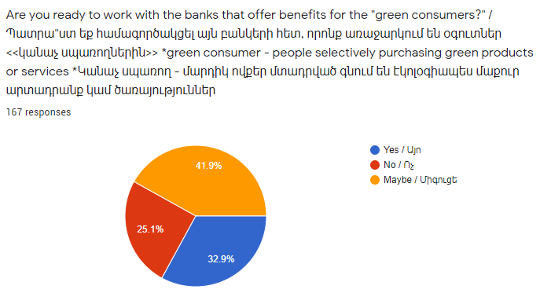
The question above was suggested by my capstone supervisor, Dr. Mica Hilson. He thinks that in Armenia, there is room for different organizations to take part in waste management activities in their own way. Interestingly enough, people were quite positive towards this question, and based on this, there are opening great opportunities for banks to collaborate with organizations that operate in the sphere of waste management. Most probably, the option “maybe” was chosen because people will need more information in regards to the terms and conditions so they can make a final decision. Nevertheless, the graph shows that most people are either ready to cooperate with banks or need more information to decide. The idea behind choosing this question was the fact that a significant number of Armenian people actively use loans, so offering certain benefits may bring some good results. Moreover, this result indicates that there is room for further research.

Limitations and Avenues for Future Research
As a matter of fact, there is always room for further research and improvement, which is why this research cannot be considered as a final work. Within the whole scope of this research, there was both confirmation of the original expectations and a complete contradiction, which was surprising. There is, of course, room for further research because the aim of this paper was focused on presenting the issue in general while also suggesting specific solution models, including the budget and other resources. An accurate assessment for the main limitations of this research project will be the time during which it was written and the small number of survey participants. When writing this thesis project, there was officially announced global pandemics, which affected literally every single individual. Hence, when interviewing people on the topic of appropriate waste management, there were saying that there are more critical issues that need to be addressed, and lots of people even refused to share their thoughts on this particular topic. So surveying more people will definitely be helpful in terms of understanding what other factors make people be so ignorant towards sorting and recycling. For the future scholars who will seek to build on this research, it is highly recommended to conduct more research on the possible partnerships with other organizations that will be open for this type of initiative. The reason behind that suggestion is that lots of organizations such as banks, cafes, and even educational institutions may be interested in promoting the importance of appropriate waste management. In a country where the society is not educated enough for recycling and sorting activities and where there is not so much involvement from various organizations, there are lots of opportunities for collaboration. There is so much exciting stuff that can be done in this field, especially in Armenia, where idea sorting and recycling has just begun to develop. Subsequently, this opens more possibilities in terms of conducting thorough research on how to perform even more effective communication campaigns for the Armenian society.

Conclusion
At the very beginning of this research, just like in the majority of the projects like this, there were certain assumptions regarding the leading causes of the issue. There were various hypotheses according to which, the ineffectiveness of the waste management campaigns mainly comes from lack of fear appeal usage. What is more, because a significant number of sources proved that fear appeal at its best could instantly affect people’s behavior by scaring them through the potential harms that they can experience. Nevertheless, that approach turned out to be not the best strategy that should be implemented in Armenia. The way this thought was formed was based on the interview with the representatives of the Acopian Center for the Environment. Mr. Alpetyan (Waste Management Expert), and Mr. Amirkhanyan (Director of ACE). The idea of using positive appeals was born, and as a support to their thoughts, they brought the example of Eco Aghb that does a great job in its campaign communication. Henceforth, the designs were made for testing one more time if positive appeals will work. What is more, a communication strategy was also developed, which was provided in the “suggestions, the creatives, and its research” part. All in all, the whole research has helped to evaluate the current situation, identify the main problems, come up with several solution strategies while preparing a detailed communication strategy with the selected communication channels, budget, and timeline.

Bibliography
Bolderdijk, J. W., Steg, L., Geller, E. S., Lehman, P. K., & Postmes, T. (2012). Comparing the effectiveness of monetary versus moral motives in environmental campaigning. Nature Climate Change, 3(4), 413–416. doi: 10.1038/nclimate1767
Chen, M.-F. (2015). Impact of fear appeals on pro-environmental behavior and crucial determinants. International Journal of Advertising, 35(1), 74–92. doi: 10.1080/02650487.2015.1101908
“Global Compact in Armenia.” UNDP in Armenia, www.am.undp.org/content/armenia/en/home/operations/projects/poverty_reduction/global-compact-in-armenia-.html.
Hornik, J., Ofir, C., & Rachamim, M. (2017). Advertising Appeals, Moderators, And Impact on Persuasion. Journal of Advertising Research, 57(3), 305–318. doi: 10.2501/jar-2017-017
Johnston, A. C., Warkentin, M., & Siponen, M. (2015). An Enhanced Fear Appeal Rhetorical Framework: Leveraging Threats to the Human Asset Through Sanctioning Rhetoric. MIS Quarterly, 39(1), 113–134. doi: 10.25300/misq/2015/39.1.06
Latour, M. S., & Rotfeld, H. J. (1997). There are Threats and (Maybe) Fear-Caused Arousal: Theory and Confusions of Appeals to Fear and Fear Arousal Itself. Journal of Advertising, 26(3), 45–59. doi: 10.1080/00913367.1997.10673528
Lewis, I., Watson, B., Tay, R., & White, K. M. (2007). The role of fear appeals in improving driver safety: A review of the effectiveness of fear-arousing (threat) appeals in road safety advertising. International Journal of Behavioral Consultation and Therapy, 3(2), 203–222. doi: 10.1037/h0100799
Ron Lennon and Randall Rentfro (2010). Are young adults fear appeal effectiveness ratings explained by fear arousal, perceived threat and perceived efficacy?. Innovative Marketing, 6(1)
Searles, K. (2010). Feeling Good and Doing Good for the Environment: The Use of Emotional Appeals in Pro-Environmental Public Service Announcements. Applied Environmental Education & Communication,9(3), 173–184. doi: 10.1080/1533015x.2010.510025

