UNDERSTANDING CULTURE: CULTURAL IDENTITY AND SYMBOLISM OF CULTURE
Creative project on Armenian, Danish, Polish and Iranian cultures

by

Anush Dilanyan

Presented to the
Department of English and Communications
in Partial Fulfillment of the
Requirements for the Degree of Bachelor of Arts

American University of Armenia
Yerevan, Armenia
14th of May, 2020

Abstract

The field of understanding cultural identity is well developed and growing in popularity. Roots of the field come as far as times of Aristotle, 4th century BC (Thompson, 2015). Recent years have shown rising interest in media to cultural integrity and representation. While essential scientific research based on historical evidence exists, this lacks the quantitative research component, numbers and visualization, which would portray the real picture behind the concept of cultural identity.

The gaps of the research up to now need to be addressed by periodical surveying, as in this rapidly changing world, the notion of identity and culture change faster than ever before. This research aims to contribute to the parallel analysis of existing literature on cultural identity and symbolism as well as present particular patterns for four cultures; Armenian, Danish, Polish and Iranian.

Creative project aims to put this into a visual perspective on how people of those cultural identities see themselves, as well as the outside view they have on each other. The final product of the research is a creative project of photo stand-in posters, to show and not tell, how each cultural identity representing group sees itself, and how do three other cultural identity groups see them from the outside.

Table of Content

Key Terms and Definitions …………………………………………………….…..4
Introduction …………………………………………………………………….…..5
Literature Review ……………………………………………………………..…….7
Project Approach .……………………………………………………………....….11
Data Analysis ………………………………………………………………………13
Discussion and Conclusion ...…………………………………………………….20
Bibliography ....…………………………………………………………………...21
Appendices ...………………………………………………………………………22

Key Terms and Definitions

All terms adapted from Merriam-Webster.com online dictionary

Community - a unified body of individuals
Communication - a process by which information is exchanged through a common system of
symbols, signs, or behavior
Culture - the customary beliefs, social forms, and material traits of racial, religious or social
group; the characteristic features of everyday existence
Identity - the distinguishing character of an individual
Shade - a color produced by a pigment or dye mixture having some black in it; a color slightly different from the one under consideration
Symbolism - the art or practice of using symbols, especially by investing things with symbolic
meaning or by expressing the invisible or intangible by means of visible or sensuous
representation
Tradition - an inherited, established, or customary pattern of thoughts, actions, or behavior
Tone - the color quality or value
Visual Communication - any system of signaling in which the signals are received by the eye

Introduction

Cultural identity is very often taken for granted. While being a huge part of personal development for a human being, associative memory and link of it to the cultural identity is not as widely researched as ethnic and national identity. Culture is defined as a unique collective manifestation of intellectual achievement. But is it unique?
The word ‘symbol’ goes back to the Greek word ‘symbállein’, meaning ‘throw together’ (Fornäs, 2012). Symbols are integrating and serve a purpose for a cultural identity. This paper aims to understand the formation of cultural identity and patterns of symbolism, through parallels drawn between four cultures, Armenian, Danish, Polish, and Iranian.
Armenian culture is very much defined through Christianity and geographic location. Danish culture is often generalized as a Scandinavian culture while missing out on the very Danish aspects of it. Polish is a Slavic culture, sharing cultural traits and history within the Slavic family. Iranian culture is highly associated with Muslim culture and often merged with the Middle East.
The question raised is "How is identity perceived within a culture and from outside the culture, within a geographical region of 3000 mile, from Copenhagen to Tehran?" The main objective of the investigation is to discover and understand cultural identity patterns and parallels, through four cultures, Armenian, Danish, Polish and Iranian.
All of those cultures have their own struggles of standing out and maintaining cultural identity as it is, while also as any cultural group believing that theirs is unique and distinctive.
The final outcomes of the investigation of cultural representation are posters that visually and artistically represent the analyzed data and the results of the analysis. Four posters are to visualize the outcomes of the investigation and represent both the insider view of the cultural identity, as well as portray the outside view from the perspective of three remaining cultural identities.

Literature Review

Karen A. Cerulo's "Symbols and the World System: National Anthems and Flags" (1993), Johan Fornas's "Identifying Symbols" (2012) and Willie Thompson's "Imagined Communities: Signs and Symbols, Identities and Nations" (2015) support the academic research to find specifics of cultural identity creation and understand how cultural identities and communities are theoretically formed. Cerulo's arguments are based on real facts and actual symbols like flag, anthems, traditional food, and much more, where through all those aspects of culture, we can get to discovering cultural identity (Cerulo, 1993).
Fornas takes a more theoretical approach taking very obscure cultural items and breaking down their relation to the creation of cultural identity within communities. For him, all of the arguments are vague if not backed up with symbolic relation and cultural value (2012). Finally, Thompson’s method is theory-based, as well. However, it looks at cultural identity from the lenses of community creation and development, where objects hardly intervene, but on the contrary, within established cultural identity; members of the community artificially create such elements of cultural importance (Thompson, 2015).
The function of anthems and flags has similar functions among cultures and are to serve the purpose of bonding individuals of the same cultural background (Cerulo, 1993). Symbols as might be believed to be decorative and cultural play a role as structuring factors. Symbols convey identity and communicate to the ones identifying with them a certain vision of their self, as well as the “others”' selves.
Every symbol projects a message, and it is not at random. Peaceful coexistence of the cultures and moderation of communication of those cultures is the main product of the cultural symbolism (Cerulo, 1993). Symbols produce enthusiasm and serve to convey the souls of people. While culture is a broad notion, and may include numbers of different elements and be created without a strategic purpose, it is clear that geographically they serve as distinguishing features (Fornäs, 2012).
According to Thompson cultural division comes from the times before civilized society in its form existed. He refers to symbols that tribal communities used to differentiate themselves from their enemies (Thompson, 2015). This also suggests that it is within human nature to create defining symbols and traits for itself, as well as for the other groups to sustain the group. This does not only include visual symbols, but also way of speech, appearance and manners. In the Greek culture it was prominent to believe that their superiority came from their language and claimed others to be ‘barbarians’ only based on their language (Thompson, 2015).
Thompson also points out how religious symbols infiltrated the cultural identity, as in medieval Europe identifying symbols were crucial for the existence of Christian and Muslim cultures. This made it easier to tax the religious minorities and persecute only depending on the visual symbols groups possessed (Thompson, 2015). For centuries dominant, so called elites, defined themselves with the language they spoke and how they visually communicated themselves as a group. They didn’t identify as a cultural group, but most certainly followed a deliberate agenda to identify within a group.
As Fornäs claims, symbols aim at virtually presenting something that is absent. Those symbols forge a chain of associations and strengthen the practice within a culture. Those set in place interpretive communities, and create context or explanation for beliefs and unification of a certain group (Fornäs, 2015). This explains how visions of outside groups about a certain cultural identity may differ from the inside view. Further Fornäs concludes that symbols are cultural phenomena; therefore they circulate through a range of communication media to create a visual and symbolic image of a group.
According to Fornäs, meanings don’t exist by themselves. No symbol can have an a priori connotation without the existence of an interpretive community (Fornäs, 2015). He gives an example of the meaning of Europe. It has its similarities and differences with the objects of a similar meaning. Europe is a continent as are Asia, Africa, but it doesn’t share the same meaning with the latter. The composed units of meaning for Europe are defined within signifying systems and artifacts that imply the meaning of Europe. In the given case such artifacts are the flowers, animals and other units of Europe (Fornäs, 2015).
Cerulo with a more modern approach and trying to globalize the patterns of constructive identity also comes to a conclusion that cultural development correlates to the developments of structural positions of politics, religion and unification of a group. It is also noted that these symbols aim at striking “sameness” and “uniqueness” of a group, not to totally disengage with the outside world, but also to have enough common group to identify as a group (Cerulo, 1993).
The next research article mainly contributes to the creative component of the project, as it discusses scientific and psychological reasoning behind colors and color defects. The research article named "Color Defect and Color Theory," written by C. H. Graham and Yun Hsia (1958), is a door into understanding the ways to communicate the research question and final results of the research to the public. While not related to the research discussed above, the reading gives a direction for the visualization of the collected data into a poster, taking into consideration its theoretical approach to colors and the human perception of those.
Cognitive scientist Donald A. Norman in his book on design and idea communication describes the techniques of making the experience of the audience with the object developed (2013). Main argument that is proposed in the book is the fact that conducted communication ought to be pleasurable and intuitive. In the successful project little to no guidance has to be given (Norman, 2013).
In practice three main aspects have to be taken into account behavioral psychology, ergonomics and design practice (Norman, 2013). For the purpose of our project, paper analyses behavioral psychology and design practice, since the outcome of posters doesn’t include ergonomic value. He believes that design is not just art, but science. This scientific approach to things, let’s the one behind the design understand the audience before jumping into creating ‘art’.
Norman in his book proposes the notion of user-centered design, which makes the “job” of the end user as easy as possible. Design needs to be to the point and avoid detail that is not essential to the overall message (Norman, 2013).

Project Approach

Through a survey, it also involves creative research in the field of visual communication. Survey sent out is completely anonymous and doesn’t require any background other than identifying with a cultural identity off the list provided on the first page. Later all of the respondents are redirected to the section of their cultural identity, where they partake in the survey.
The quantitative research component includes a survey of the representatives of the target cultural identity, which are Armenia, Denmark, Poland, and Iran. The contents of the survey are the same for all of the cultural identity representatives and consist of two essential parts.
Firstly, the respondents are given questions on their cultural identity, mainly their association with color and objects. Same set of questions is repeated for the other three cultural identities that are objectives of the creative project. Respondents are provided an option to indicate the case when having no association with the cultural identity given.
Colors are represented by ten to five grid, without limitations for respondents to choose as many colors as they associate with the given cultural identity. Respondents options of colors are limited to shades, being dark, light, muted, bright and pastel, as well as to primary colors: red blue and yellow, secondary colors, made by mixing the primary colors: orange, purple and green, two tertiary colors: pink and brown, as well as two base tones: black and white.
The set of questions that respondents are required to fill in are short answer fields, where a respondent, first of all, provides any cultural object, location, food, person, event, etc. associations that they have connected to the culture they identify with. No limitation to the answer length or amount of objects is provided. This is to let a respondent have creative freedom and not limit any valuable outcome that might follow. Similarly, a respondent is then given a combined question, regarding all three objective cultural identities, and ask to give as much information as possible on all of the three, but not forced to. One may choose or might have, association with one or two of the nationalities, not all three, which is also an important outtake from the survey.
The survey is distributed through mailing lists of governmental institutions, schools, and universities, in countries that are linked to cultural identity, as well as through social media posts.
The results of the survey are “translated” into the four photo stand-in posters, created in the combination with secondary research findings. Four posters are two-sided, one side representing the insider view on the cultural identity and the other combining outside view from the other three target countries.
Photo stand-in posters are created based on findings, in regards to the visual communication and poster design.
The research heavily relies on the outcomes of the survey, to be able to identify the parallel of symbolism and patterns within and outside the cultural identity.

Data Analysis

Commutatively 209 subjects have participated in the survey. All those surveyed, answered questions anonymously, indicating their cultural background, choosing from: Armenian, Iranian, Danish and Polish. The survey showed participation percentage among all the respondents, Armenian: 64 responses (30.62%); Iranian: 51 responses (24.4%); Danish: 42 responses (20.1%); Polish: 52 responses (24.9%).
Creative component concludes the findings from the investigation, is going to represent two sides for each cultural identity viewed. Posters are to represent an insider view on the cultural identity and on the other side of the poster, the outsider view.

Survey Analysis
As mentioned in Project Approach (p. 8) all the survey participants were surveyed on the same set of questions. Besides color choices made by the respondents, item categories that were divided into Food; Musical instruments; Events, people and locations and Other which are items that didn’t fit into the above mentioned categories. Having open ended response questions and multiple choice answers the data has been analyzed as following.

Armenian cultural identity
Insider view
Armenian cultural background respondents identify with mostly dark colors, with several exceptions. In all color categories dominating color is red, which can also easily be linked to the object associations observed abound Armenian respondents. Majority of color choices are based on rug and carpet patterns, as well as miniature paintings. Several respondents mentioned Vordan Karmir, a red color pigment used in dyes for paint and thread, made of a special breed of worms.
Interestingly, a lot of dominance has the color brown. This is possibly linked to the prominent agricultural culture, as well as the fact that many object associations are churches and architectural monuments.
Armenian’s associative self-reflection is highly based on the history and on real and fictional characters of it. Among writers, political figures and artists of the past we have strong representation of contemporary figures. It is important to mention a presence of many names connected to the Armenian Genocide and First Republic of Armenia.
Many of the objects are religious, connected to Christian belief and customs. Some also are related to the nature and landscapes of Armenia.
All of the musical instruments mentioned by the respondents are ones coming from medieval times, still in use today, but more associated with folk music. This once more confirms the strong ties that Armenian cultural identity has to its history.
Major element of object associations for the respondents is food. While a lot of dishes are included, it is crucial to underline the number of fruits mentioned by the respondents. Also only one type of sweet dish has been mentioned by the respondents, showing the dominance of savory food among the cuisine.

Outside view
A lot of associations that outsider view suggests are connected to the Armenian cuisine and fruits. Largely color choices support this as the most prominent are red, purple and orange. Also Armenian landscapes have a major role in the outsider view formation as suggested by the object associations and colors of choice which are blue and green.
While Danish and Polish cultural background respondents had few associative objects, neighboring and historically connected Iranian background respondents had more associative memory connected to Armenian culture.
Many location associations come less from the history of Armenia but from the current Armenian landscape. Same applies to several people that outsiders associate with Armenian culture.

Danish cultural identity
Insider view
Danish cultural background respondents haven’t chosen colors pink, black and red for themselves. This can be aligned to the fact that a lot of cultural associations that they have are connected to sea and water. It is interesting that no Danish cultural background respondents chose red, despite the fact that the flag of Denmark contains colors red and white. This seems to show that Danish cultural identity is not defined through the national identity symbols.
Only several sites have been selected by the respondents of this cultural identity, and more concentrated on traditions, folk music and food. Despite the fact that nation state doesn’t resonate much with the cultural identity respondents many pointed out the royal family as a key factor to their culture.
Many of the colors selected can be classified as earth colors being blue, green, brown and orange. This can be linked to the object associations with farms and the concept of Hygge. Hygge is a phenomenon that spreads throughout Scandinavian countries and many other cultures. Hygge is the idea of coziness and calmness of a home, an old Danish tradition believes that every house has to follow Hygge to reach harmony (Jenkins, 2012).

Outside view
A lot of associations from outside are quite similar to the respondents of Danish cultural background about their own culture. Many colors are blue, green, brown, orange. Contrary to Danish cultural background respondents, outside view largely associated color red with this culture. It suggests the visual association of Danish culture and their national symbol being Danish flag. Also color white has been largely selected.
A visual association that Danish cultural background respondents don’t share with outsiders is the common feature of Danish people. Most of the outsider views pointed out fair and blonde skin and hair as a distinction of this cultural identity. Also more than in other categories has been popular pastel color category.
A lot of association is also connected to sea, seafood and fish. Also in the food category are notable mentions of cheese, chocolate and pastry.

Polish cultural identity
Insider view
Most of the colors chosen by the Polish cultural identity respondents are bright light and dark. Dominating choices are red, orange and yellow. This can be connected to folk costumes and flower crown tradition of many throughout Polish history. Those have been mentioned by many respondents.
Huge portion of the object associations is food related, mainly foods consisting of grains and widely known as food of commoners (Zubrzycki, 2001). Many responses also are highly connected to Partitions of Poland during the 16-19th centuries and German invasions.
While a lot of associations are connected to the history and traditions, many respondents mentioned modern history’s public figures, musicians, actors and political figures. Also a lot of emphasis is put on the Christian faith. Colors vice a lot of those associations are backed up. Popedom’s colors are red, blue, yellow and brown (Zubrzycki, 2001).
Many associations are connected to folk music and traditional musical instruments.

Outside view
Popular colors of choice from an outsider viewpoint for the Polish cultural identity are bright colors, namely red, green, blue, yellow and orange. No musical instruments have been associated with the cultural identity from outside.
A lot of outside association is connected to the Nazi reign, Germany and concentration camps. Also, all of the other cultural identity respondents pointed out the association of Polish culture is Judaism and Jewish ancestry. Interestingly enough this is not the only time when Polish culture is cross associated with a different culture, as are Russian and Ukrainian and in general Slavic cultures.
A lot of locations are associated with modern day Poland, with mentions of Old Town in Warsaw being dominant. Also a lot of importance is given to Polish embroidery and craftsmanship. Language is also a huge part of the association base, with its Slavic sound and also many pointed out profanity. This is the only cultural identity where alongside religious associations we see mentions of homophobia.

Iranian cultural identity
Insider view
In contrast to other cultural identities Iranian cultural identity respondents gave the most value to locations, events and famous people throughout history. Also a lot of importance is given to architecture and religion.
Colors of the choice for respondents of Iranian cultural identity are largely linked with Islamic manuscripts and books. Green, yellow, white have been dominant in the manuscripts coming as far as from the 5th century (Hanaway, 1993).
Other colors of choice can be associated with traditional costumes as for the longest time purple has been a sign of wealth and was worn by the most noble in Ancient Persia. Dark color category is notably the most voted upon by the Iranian cultural identity as a lot of artwork linked to history, carpets and manuscripts haven’t faded through centuries but used dark and muted colors instead (Hanaway, 1993).

Outside View
Being the only Middle Eastern culture in the list, a lot of association is based on that factor for the Outside view. Highly pointed out is Islam and historical significance of the Iranian culture. Many associated objects are connected to the Holy Book, Quran, as well as prayers, spiritual aura and marriage.
While color vice outside view generally is drawn to the dark color category a lot of importance is given to light colors. Also this is the only category where color black is so high up in the responses. This might be linked to the Islamic traditions of female outwear.
A lot of priority is given to the Iranian cuisine, all other cultural identities pointing out spices and herbs that are very unique for them. Also many indicated the uniqueness of traditional clothing of Iranian culture, decorations, a lot of gold and immense wealth.
Outsider views for the Iranian culture also pointed out historical aspects of destruction, weapons and war. This can explain darker color association bases.

Discussion and Conclusion
As the investigation conducted suggested it is in human nature to seek for symbols and identification methods in order to distinguish one another from each other (Fornäs, 2012). We can see that in the survey responses subconsciously respondents differentiate themselves with the ‘others’. There is a clear difference they see between their own culture and outside culture, and it is natural.
Elements of cultural identity might differ but they fit into patterns. Food, music architecture, language all are crucial for cultural identity development and are ones that strike to the outsiders. As aimed previously posters visualize the experience one has within cultural identity and how he sees others. Those perspectives are agile, and can depend on the background and amount of intercultural communication.
Further research is required for the purposes of understanding more through how the associations are formed. This research aim to find out current associative memory and visualize is through concept posters, and it serves its purpose.

Bibliography
Cerulo, K. (1993). Symbols and the World System: National Anthems and Flags. Retrieved
from http://www.jstor.org/stable/684637
Fornäs, J. (2012). Identifying Symbols. In Signifying Europe. Bristol, UK; Chicago, USA:
Intellect. Retrieved from http://www.jstor.org/stable/j.ctv9hj915.6
Graham, C., & Hsia, Y. (1958). Color Defect and Color Theory. Science, 127(3300).
Retrieved from http://www.jstor.org/stable/1754864
Thompson, W. (2015). Imagined Communities: Signs and Symbols, Identities and Nations.
London: Pluto Press. doi:10.2307/j.ctt183p6q8.15
Norman, D. A. (2013). The design of everyday things. New York, NY: Basic books.

Additional Bibliography
Abrahamyan, L. (2006). Armenian identity in a changing world. Costa Mesa, Calif.: Mazda
Publication. ISBN: 1-568-59185-3
Hanaway, W. (1993). Iranian identity. Iranian Studies, 26(1-2). Doi:
10.1080/00210869308701793
Jenkins, R. 2012. Being Danish: Paradoxes of Identity in Everyday Life. 2nd edition.
Copenhagen: Museum Tusculanum Press. ISBN: 978-87-635-3841-1.
Zubrzycki, G. (2001). "We, the Polish Nation": Ethnic and Civic Visions of Nationhood in
Post-Communist Constitutional Debates. Theory and Society, 30(5), 629-668. Retrieved
from http://www.jstor.org/stable/658104

Appendices

Appendix A: “Understanding Cultural Identity: Project on Iran, Denmark, Poland, and Armenia” survey
Appendix B: Creative component/posters/
Appendix C: Combined data from the survey

Appendix B

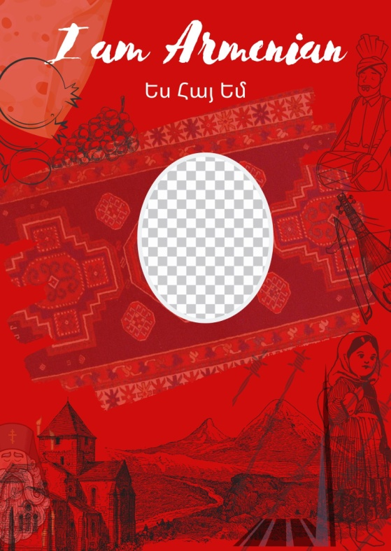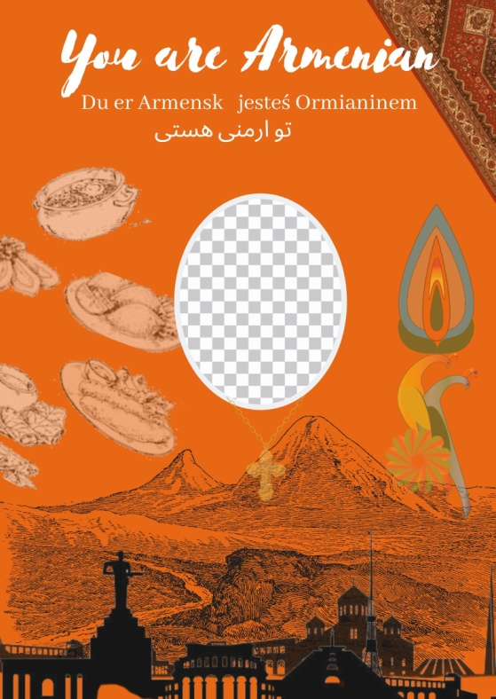

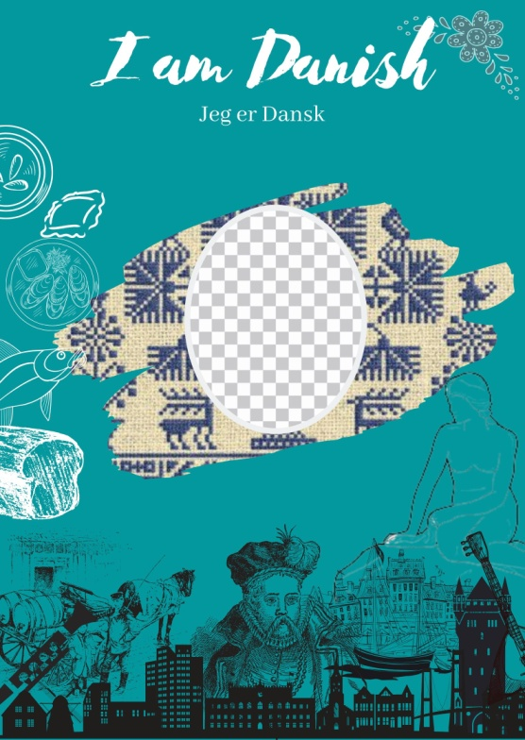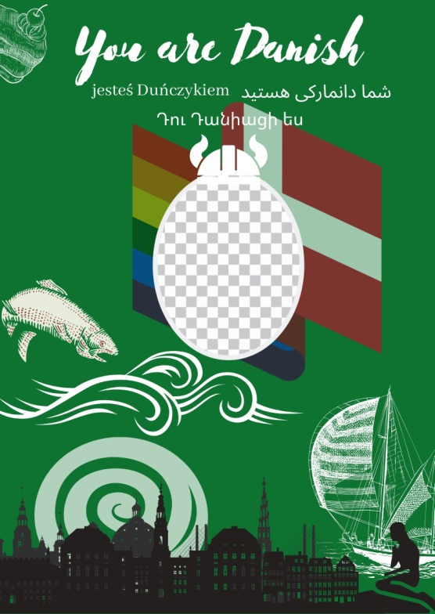

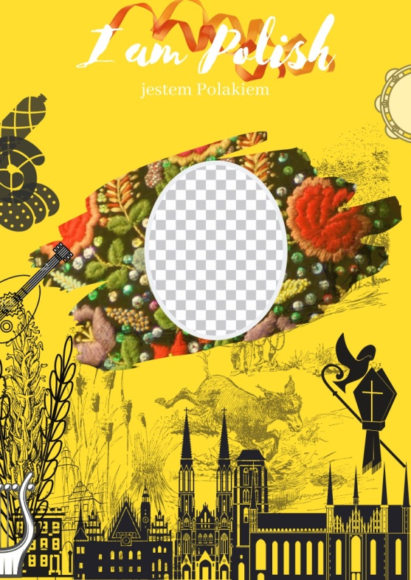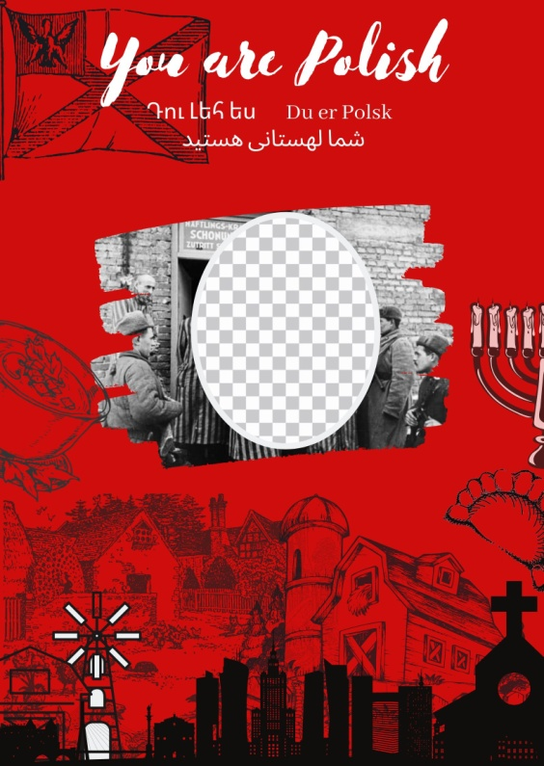

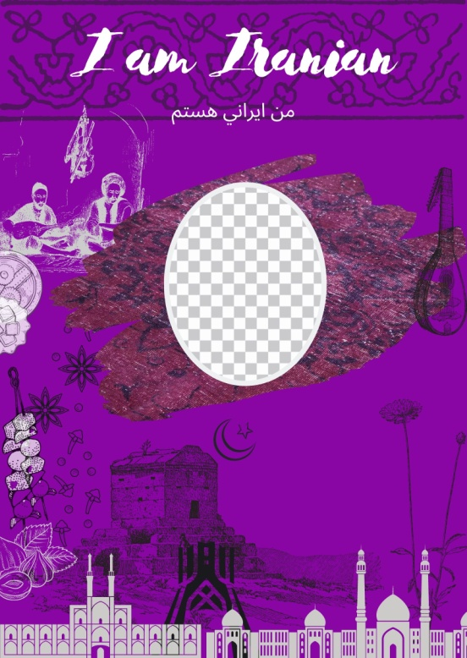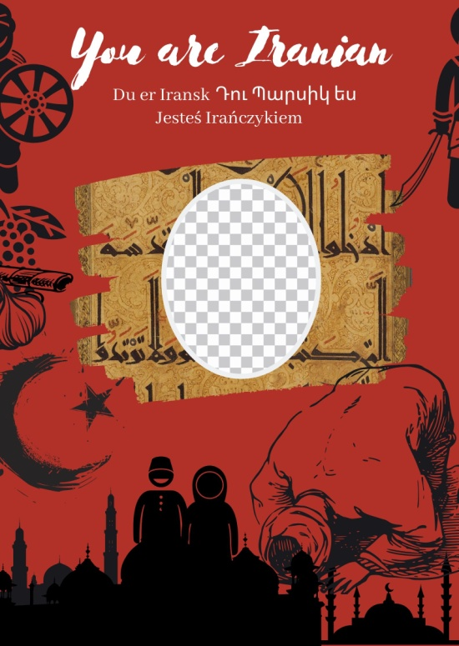

Appendix C

Armenian cultural background /64 responses/
12-14 of respondents chose an option of not having associations with the provided cultural identities. Armenian cultural identity respondents mostly had poor or no associations with Danish cultural identity.

Armenian cultural identity
Predominant colors of choice for Armenian cultural identity chosen by Armenian survey respondents are dark colors, specifically red, black, orange, blue and brown. Light colors of choice of respondents are blue, brown, blue and red. In the bright color category, major colors identified by respondents are red and orange. Less than 5% of respondents in this section made choices in the pastel section, most prominent in the pastel section being brown and white with 5 votes each.

Combined object associations with Armenian cultural identity:
Foods: apricot, pomegranate, apricot, tolma, good food, grapes, wine, lavash(Armenian flatbread), matsun(yogurt), peach, khorovats(Armenian BBQ), brandy, Khash(Armenian dish made with boiled pig feet), meat, Gata(sweet Armenian pastry)
Musical instruments: Duduk, Tar, Qanon, Dhol
Events, people, locations: churches, Ararat mountain, Yerevan, Hayk Nahapet, Krikor Lusavorich, Sasuntsi Davit, Deity Vahagn, Goddess Astghik, Goddess Anahit, monasteries, Lake Sevan, Velvet Revolution, Charle Aznavour, Cher Sarkisian, Kardashians, Komitas, Arno Babajanyan, Aram Khachatryan, Arar Gevorgyan, Nikol Pashinian, Abraham Alikhanyan, Artyom Alikhanyan, Martiros Saryan, Sergei Parajanov
Other: Tuf pink stone, Carpet, family gathering, mud, Vordan Karmir(Worm Red), dry grass, sun, rocks, traditional clothes costumes, flag, cross, Bible, Alphabet, Khach Kar(Cross stone)

Danish cultural identity
Most dominant color category chosen by Armenian respondents is light, bright and pastel. In the light color category Armenian respondents chose blue, yellow, green and white. Bright color category got the most response, with the prominent color being blue, followed by red and white. Pastel color category pointed out the dominant choice of blue and white. For muted colors equal responses once again are received for white and blue.
Combined object associations with Danish cultural identity:
Foods: Strudel, fish, potatoes, smoked cheese, alcohol, seafood, Danish pastry, beer, sweet cheese, weed
Musical instruments: None
Events, people, locations: Hans Christian Andersen, The Little Mermaid tale, pubs, Vikings, Roskilde festival, colorful houses
Other: Clogs (Danish wooden shoes), Scandinavian gloomy weather, strong smell of water in the air, baggy sweaters, blonde hair color, raincoat, sailing, snow, flag, movie Danish girl, high quality of life, ships
Polish cultural identity
Armenian respondents in the dark category majorly chose red and white. Highest number of responses was given in for light and bright color categories. In the light color category the most popular choice is color green, followed by white and red. Bright category underlines high response rate for the color red, and equally distributed responses for blue, yellow and white. Notable is also the dominant choice of blue in the muted color category.
Combined object associations with Polish cultural identity:
Foods: vodka, sausages, Pierogi, sweets, pickled herring, pastry, beer, ginger cookies, potato
Musical Instruments: None
Events, people, locations: Jewish people, Auschwitz, Robert Lewandowski, invasion of Poland by Nazi Germany, abandoned ruins, Warsaw Old town, messy part of Europe, Marie Curie, Frederic Chopin, old villages, Medieval era, Henry Senkevich "Qua Vadis, Dominie"
Other: Catholicism, ribbons, Slavic culture, language that sounds like Ukrainian, homophobia, swear words, currency (zloty and grosz), fairy tales, bright sun, embroidery, medication, quality furniture
Iranian cultural identity
It is important to mention that the pastel color category got only a 2% response rate. The most prominent is the dark color category with 95% of respondents selecting red color, also brown, green and black. Light color category is outstanding with the fact that none of the respondents chose colors pink and purple. Muted colors are fairly equally distributed with the most votes given for brown color.
Combined object associations with Iranian cultural identity:
Foods: Spices, olives, sweet pears, pilaf (rice), sweets, rock candy
Musical instruments: None
Events, people, locations: Qasem Soleimani, landscapes, Tehran, mosque, white spacious areas, arches, Ferdowsi
Other: Old history, chariots, bedazzled hats, Islam, carpet, traditional clothes(majorly green and bright red ethnic patterns), hijab, ornaments, craftsmanship, marriage, left to right alphabet, prayer, spiritual aura, gold, pompous decorations, weapons of mass destruction, national dances, strict rules
Danish cultural background /42 responses/
8-11 respondents chose the option of having no associations with cultural identities.
Armenian cultural identity
Most of the votes from the Danish cultural identity respondents for the Armenian cultural identity are dark, specifically red, purple and blue. Interestingly, 9 colors received equal amounts of responses, light blue, pink, brown, muted green and brown, pastel green and orange. Also a high number of responses were received for black and white colors. In none of the color categories yellow has been selected by the respondents.
Combined object associations with Armenian cultural identity:
Foods: Dolma, honey and jams, dried fruit, white airy bread, apricots, pomegranate, wheat, wine grapes
Musical Instruments: Vocals of street singers, especially tradition song singing men and women
Events, people, locations: Opera house, Cascade Complex, Yerevan, Mount Ararat
Other: specific appearance that many Armenians share; defined noses and darker skin tone
Danish cultural identity
Several colors haven’t been chosen by the Danish cultural background respondents for their own cultural identity. Those are pink, black and red. The highest responses are received for white, bright red and green. In the dark color category green, brown, orange and blue. In the muted color category the most voted for are green and blue colors.
Combined object associations with Danish cultural identity:
Foods: seafood, Smorrebrod (open sandwich), organic food, pancake donuts, meat balls, healthy food, rye bread
Musical Instruments: Classical music, flute, clarinet, fiddle, accordion
Events, people, locations: Hans Christian Andersen, Soren Kierkegaard, Piet Hein, Carl Nielsen, Copenhagen, Royal Family; Danish Monarchy, The Little Mermaid sculpture, Opera House, old farmhouses, sea
Other: Hygge (concept of coziness), patriotism, free education
Polish cultural identity
For this section no responses for the pastel and dark color category have been given. In the light color category the most prominent are brown, red and green. The most response for muted color category has been given for white, green and yellow. Lastly, the bright colors selected were red, blue, yellow, orange and purple.
Combined object associations with Polish cultural identity:
Foods: Pierogi, potatoes, cabbage, baked goods
Musical Instruments: None
Events, people, locations: Warsaw, Gdansk, Vistula, Frederic Chopin, Jews, Partitions, Western Europe
Other: Invasions, Catholicism, Slavic culture, freedom
Iranian cultural identity
The most response in this section has been given in the dark color category. The most voted colors are red, blue and orange. Also majority of the respondents have selected black as an associative color for Iranian cultural identity. In the light color category only one color has a dominant presence, brown. In the muted category the popular ones are green and brown. From the bright colors respondents chose red, green and white.
Combined object associations with Iranian cultural identity:
Foods: Spices, herbs, lamb, garlic, olives, citruses, grapes, peaches, nuts,
Musical Instruments: folk music, Muslim prayer
Events, people, locations: Persia, invasions, Caucasus, Middle East,
Other: Arabic, ancient times, sculptures, kings, pottery, gold

Polish cultural background /52 responses/
7-10 respondents chose the option of having no associations with cultural identities.
Armenian cultural identity
The most voted for color category for Polish cultural background respondents is dark. Dark category colors are red, green and blue. In the bright color category green, orange and brown have the most response. Light color category only has 5 responses, 4 given to blue. In muted colors there is no distinct frontrunner. All the colors have almost similar response rates.
Combined object associations with Armenian cultural identity:
Foods: Spices, meats, lamb, flat bread, black coffee, cheese
Musical Instruments: None
Events, people, locations: Serj Tankian, System of A Dawn(SOAD), Charle Aznavour, forests, nature, Anna Dymna, Teodor Axentowicz, World War 2
Other: Christianity, Genocide, Soviet Union, Communism, Ancient history, Apostolic church, cross stone
Danish cultural identity
In the dark color category dominating colors chosen by Polish cultural background respondents are red, orange, green and blue. Two most popular color categories are light and pastel. In the light color category majority of the respondents chose white, green, yellow, red and brown. No votes given to purple and pink. Pastel color category has three major color choices, being blue, green and orange. In the bright and muted color categories only two colors receive more than half of votes, those colors being red and brown.
Combined object associations with Danish cultural identity:
Foods: Danish pastry, fish, sweet cheese
Musical Instruments: none
Events, people, locations: Little Mermaid statue, Copenhagen, Hans Christian Andersen, sea, beaches, nature
Other: Folklore, fair skin and hair color, Vikings
Polish cultural identity
Most popular color chosen for their own cultural identity by Polish cultural background respondents is white. Fewer than 6% of votes are given to the muted and pastel color categories. In the dark color category dominant colors are red, orange and brown. The light color category is the most voted on one. Here the popular colors are red, green, blue and yellow. In the bright color category dominate yellow, red and blue.
Combined object associations with Polish cultural identity:
Foods: Kulich (traditional Easter pastry), bagel, kielbasa (processed meat), Pierogi, Smoked cheese, noodles, buckwheat, wheat, beer, eggs, tomato soup, broth, Sernik (type of cheesecake), garlic, horseradish
Musical Instruments: Tambourine, Kola (bagpipe), Flute, Accordion, Ligawka (wooden horn), Suka (Polish version of a cello)
Events, people, locations: Partitions of Poland and Lithuania, Easter, All Saints Day, farms, Frederic Chopin, Pope John Paul II, Marie Curie, Adam Malisz, Andrzej Wajda, Andrzej Duda, Kristen Bell, Martha Stewart, Jared Padalecki
Other: Stroje ludowe (traditional clothes), agriculture, resistance, Christianity, Pope, faith, history, opposition, flower crown
Iranian cultural identity
The dark color category is the most popular one. Colors dominantly chosen here are red, brown and green. In the light color category the most voted for color is brown, followed by black and green. Pastel color category received less than 4% of overall votes possible. As for muted color category votes are distributed equal through colors, besides pink, and purple, which have zero votes.
Combined object associations with Iranian cultural identity:
Foods: Herbs, tea, nab at (caramelized sugar), pickles, cinnamon, nuts, wild meat
Musical Instruments: None
Events, people, locations: None
Other: Pottery, carpet, old history, ancient times
Iranian cultural background /51 responses/
Armenian cultural identity
Main color category is the dark color category. Here the dominant colors are blue, purple and orange. In the bright color category dominant are red, blue, green and orange, while purple and brown have zero votes. In the muted color category dominant are brown, orange, red and green. As for the bright color category most votes have red, orange and blue. No votes are given for the light color category.
Combined object associations with Armenian cultural identity:
Foods: Dolma, tabbouleh, baklava, peach, apricot, wine, cigarettes, cheese, Ararat Cognac
Musical Instruments: Duduk
Events, people, locations: Nikol Pashinyan, Esfahan, Tehran Armenian quarter, Urartu, Yeprem Khan, Kim Kardashian, Alexander Abian, Samuel Khachikian, Hambarsoom Grigorian, Mohammad Beg, Sevan lake, Armenian Genocide, Vardavar water holiday, Gyumri Earthquake
Other: Apostolic church, Soviet Union, repatriation, Christianity, neighbors, pulpulak, black outfits of men
Danish cultural identity
In the dark color category dominant colors of choice are blue and green. Two color categories have less than 3% of votes, being muted and pastel. In the bright color category dominant are red, blue and orange. As for the light color category the color with the most votes is yellow, followed with green and blue.
Combined object associations with Danish cultural identity:
Foods: Fish, Danish pastry, potatoes, berries, chocolate
Musical Instruments: Clarinet
Events, people, locations: Sea, island, Copenhagen, Hans Christian Andersen, Little Mermaid statue
Other: Blonde people, Homosexuality, freedom, Vikings
Polish cultural identity
The most popular color category in this section is the bright color category. Here the prominent colors are brown, purple and red. Also the majority of recipients chose the color white for the Polish cultural identity. In the dark color category dominant are red, green and orange. In the light color category we have near equal amounts of votes through colors. No votes have been given to the muted color category. In the pastel color category less than 6% of surveyed voted.
Combined object associations with Polish cultural identity:
Foods: potatoes, cabbage, white bread, beer, sausages, dumplings,
Musical Instruments: None
Events, people, locations: Frederic Chopin, Warsaw, Jews, Nazi Germany, Daniel Davari, Anna Borkowska, Europe
Other: Slavic culture, European Union, refugees
Iranian cultural identity
The most prominent color category for the Iranian cultural identity respondents for their cultural identity is dark. Here the dominant color is purple, followed with red, green and blue. In the light color category prominent are red, green and blue. For the bright color category nearly equal votes are given for red, green, yellow and white. In the muted color category we have red, orange, blue and green. No votes are given for the pastel color category.
Combined object associations with Iranian cultural identity:
Foods: Ice cream, Kebab koobideh, rice
Musical Instruments: Kamancheh
Events, people, locations: Cyrus the great, Reza Shah, Azadi Square, Persepolis, Naqsh-e-Jahan, Jahan Pahlevan Takhti, Naser Hejazi, Iran Army, Nowruz, Haft-sin table, The poet khayyam. Province Yazd architecture, Ferdowsi the poet, Shajarian the singer, Monuments, Islamic architecture
Other: Moral, football, Islam, religion, history, great kings

2011, In Merriam-Webster.com. Retrieved March 4, 2020, from https://www.merriam-webster.com/dictionary

