SOCIO-PSYCHOLOGICAL PROBLEMS OF ADULT AND TEENAGE INSTAGRAM USERS| STOPPING THE ADDICTION IN FAVOR OF MENTAL HEALTH

By

Anna Papyan

Presented to the
Department of English and Communication
In partial Fulfillment of the
Requirements for the Degree of Bachelor of Arts

American University of Armenia
Yerevan, Armenia

April 29, 2020

Table of contents
Abstract-----------------------------------------------------------------------------------------------3
Research question-----------------------------------------------------------------------------------4
Chapter 1
  - Instagram and its functions--------------------------------------------------------------------5

Chapter 2
2.1 Negative aspects of Instagram exposure----------------------------------------------------12
2.2 Instagram and its negative impact on youth’s mental health-----------------------------17
2.3 Instagram and self-esteem---------------------------------------------------------------------18
2.4 Instagram and depression----------------------------------------------------------------------20
2.5 Instagram and loneliness ------------------------------------------------------------------21

Chapter 3 (Research)

3.1 Methodology------------------------------------------------------------------------------------22
3.2 Procedure and samples-------------------------------------------------------------------------22
3.3 Survey results-----------------------------------------------------------------------------------27
3.4 Experiment/reported interviews--------------------------------------------------------------33
3.5. Discussion--------------------------------------------------------------------------------------38
3.6 Limitations--------------------------------------------------------------------------------------40
Conclusion--------------------------------------------------------------------------------------------41
Bibliography------------------------------------------------------------------------------------------42

Abstract

The modern world spills out a large stream of information on a daily basis via Internet and social networks. It makes it quite difficult to understand it and make a choice. This work is a research project to study the features of Internet and social networks used by teenagers and young adults, as well as determine and demonstrate its’ negative effects on ones’ mental state. The topic dealing with social media influence is very relevant today, as the young generation is increasingly exposed to the Internet in their lives. The purpose of this work is to trace the influence of the worldwide global computer network, the Internet, on the worldview of young generation, more specifically, to study the impact of one of the most powerful and influential social media platforms, Instagram, on the psychological health of teenagers. The implementation is highly going to rely on the survey results, as well as the conducted experimentation.
The relevance of this work lies in the fact that in our time, dependence on social networks is becoming an epidemic and this problem undoubtedly needs to be addressed. The relevance of this topic is also due to the rapid development of social networks aimed to shape a social image.
The relationship between teenagers and social networks is one of the most relevant topics of our time. Socialization of a person occurs in the process of education and under the significant influence of the environment. The environment of modern man, in which education takes place, has changed significantly. Now the Internet has the most powerful influence. Currently, the question of influence of both, the Internet and social networks on teenagers has become very acute. Some believe that this is only for the good; others think that it is harmful.

Research question
Instagram is an object of study of sociologists and social psychologists. A number of scientific studies are devoted to ways of solving these problems. I. Goldberg proposed a definition of Internet addiction and a set of diagnostic criteria for its determination (Goldberg, 1995, pp.6-7). K. Young is one of the first scientists to be interested in the topic of the Internet, and she conducted the world's first research on the topic of the Internet and Internet addiction.(Young. K.1996) .J. Morayhan-Martin proposed a terminology, which can help to distinguish between Internet addiction, excessive use of the Internet, and compulsive, pathological, problematic, destructive use of the Internet. However, unfortunately, despite the relevance of the study of social networks as a way of self-presentation, there are not so many sociological studies devoted to this topic. This study is going to determine how does Instagram affect young adult’s psyche and what are the negative effects of Instagram exposure. Based on the analysis of psychological literature, the study is willing to discover what methods of psychological confrontation of the issue exist that can be practiced in order to achieve mentally healthier individual life. The purpose of this research work is to trace the influence of the global social media network, Instagram, on the worldview of teenagers, to reveal the positive and negative psychological aspects of the influence of social networks on young generation and to find ways of solving the problems related to the pastime of teenagers in social networks.

Chapter 1.Instagram and its functions
1.1 The perception of the phenomena
Three billion people worldwide, or about 40% of the population, are heavily exposed to the world of social networks on the Internet. We spend on average of two hours using them every day: we post notes, share photos, and respond to friends ' posts. Every minute, social media users send almost half a million tweets and photos via Snapchat (Francisco, 2019). As social media plays such a big role in our daily lives, it is very important to understand how it affects us. What would change if we do not sacrifice our psychological health and well-being for the sake of online communication? What does scientific research say about this?
Instagram is a social photo network. It is most popular among users due to its simplicity. Instagram is a cross between a social network and a microblog, meaning one can upload photos and give them a brief description. Thanks to this program, people can not only store their photos in the memory of their mobile device, but also show them to the world, creating a vast community around them, which are the subscribers. Instagram is full of accounts of artists, celebrities, athletes, and many other public individuals. With the help of social networks, they keep up to date with the lives of their fans and often become newsmakers, causing extensive resonance with their own pictures or texts. Politicians also understood the important role of the photo service. For them, this is, of course, an opportunity to get closer to the electorate, by showing their best side. Some of the worldwide famous politician-users of Instagram are even the presidents and parliamentary assembly members of certain developed countries, for example Barak Obama, Donald Trump, The Royal Family etc.
Instagram can be considered a large media channel, and it is a little more effective than the rest, because in this network all photos and texts are published, as it were, in the first person, allowing famous people personally express their views on a particular issue.
Therefore, one of the most important features that Instagram has is being considered a tool for forming public opinion: people in this photo network are formed into a human aggregate that has a psychological community. People are formed into groups based on the same interests (Kagan Kircaburun , Mark D Griffiths, 2018). For example, there is a group that is interested in the life of a public person and they "follow it" on Instagram, that is, these people have a common object of experience and attention. Alternatively, for example, there are communities that are interested in fashion or cooking. The next detected feature is that the individual acts like the mass, but he does it consciously at first, and later on- unconsciously. Since consciousness is individual, and the unconsciousness is collective. Even with the very emergence of Instagram, we can see that people's individual consciousness and rational thinking are being turned off. This is expressed in the fact that as soon as a person registers on this photo network, he has a desire to take a lot of photos and generally, record virtually everything that happens in his life or in his space. Some people have a certain "obsession" about the fact that they need to urgently post a photo. Instagram is also a platform for the birth of many trends that people unconsciously follow. Examples of such trends can be selfies (a type of self-portrait that involves capturing oneself on a camera), food photos, photos at the gym, manicure photos, etc.
A very interesting feature is the one that the communities into which people are involved, regardless of their culture, doctrine, or social status, need the support of a leader. He does not persuade them by reason, nor does he force them to submit, but he captivates them using the authority he possesses. On Instagram, the role of the leader is often played by a public person who directs his own page. Everyone wants to see features of a strong, confident character in them or possess some quality of their excellent personality.
The most interesting features of Instagram are: propaganda (or communication), which has an irrational basis, collective beliefs, and enforcing tools at a short distance. Most of our actions are the result of beliefs. Instagram is an example of propaganda. Nowadays different life trends are common in society, and Instagram quickly picks them up and carries them to the masses. For example, feminism and body positive (a movement aimed at accepting one's own body and destroying negative stereotypes of society in relation to people whose appearance differs from the generally accepted standard) are particularly prominent. From the psychological component of this social network, you can identify active use in marketing. If, initially, this app was created for people to share their life events with others, now it is a place where everything is "sold": various products, items, and most importantly – a lifestyle. Thus, Instagram has become an important tool in the hands of marketers. Now there are even more trainings that teach how to get many subscribers and sell a product. The ability to use this network in advertising a product or a service, branding, promotions and competitions is called Instagram marketing, and hundreds of thousands of users and companies are working every day to improve it, coming up with new, interesting materials. Instagram marketing is an opportunity to create a showcase for your product, position your company, store, restaurant, and any product or service that people demand. In the modern world, there is practically no company that does not have its own page on Instagram.
Instagram works with visual images, and this is its strength and weakness. According to statistics, the most" sold " niches on Instagram are: cosmetics, clothing, accessories, boutiques, shopping centers, showrooms, exclusive products, hand-made goods, cafes, restaurants, hotels, Inns, hostels, delivery (pizza, sushi), services (cosmetology, dentistry).
Hashtags are also another popular feature on Instagram. The trend for hashtags has in mind the fact that people often search for images not only by subscriptions, but also by interests. Accordingly, the more hashtags there are under a certain post, the more users will notice it. To increase the number of the audience, users usually add at least ten of them. It is important that they all relate to the same subject of interest.
Thus, from all the above, we can conclude that Instagram is one of the main tools for forming public opinion in the modern world and that it is a platform where speed in the main rule of marketing. The post should turn out clear and immediately understandable, like a billboard on the road: minimum of words, maximum of information. On Instagram, Internet users view posts quickly. It is important that it is beautiful and impressive, so that the potential client remembers it and likes it. Attracting customers via Instagram works well in our modern world.
The following literature review discusses scholarly works by various authors who present the results of their studies targeted at examining the influence of Instagram.
Social networks are one of the ways to present yourself, your inner world, and your desires. J. Barnes [7, p. 103] first fixed this term in 1954. He defined social networks as a type of connection between small groups. This method of communication and information exchange on the Internet is a convenient and fast way to tell about yourself. Looking at a social network like Instagram shows that communication can occur through the exchange of photos, images, and short videos. In this application, you can write an infinite number of quotes and comments. However, we get the main information through images. By posting and providing personal information on social networks, a person constructs his or her virtual identity, it may partially coincide with the real person, or it may be a radically different one. The visual feature of Instagram is promoting a lifestyle. Most often, one can see such styles as a healthy lifestyle, luxuriant lifestyle, a lush, beautiful, rich life etc. Posting photos, short videos, and pinning it with a quote or hashtag (a type of tag that makes it easier to find messages by topic or content) creates a virtual "diary" of real life. This is a continuous process of self-presentation and self-identification.
When creating your own virtual image, there is always time to think about it. When we communicate in real life, our "face" is largely constructed unconsciously than in a virtual network. Our real face has some bumps, imperfections, moles, pimples, black under eye circles etc. After photographing it, we will first take a comfortable facial expression, one that is suitable for ourselves, then in a special editing program we will remove all the shortcomings, add filters, shades, and even change the background. That is how a virtual face is created. All of these layers that are overlaid on top of each other can be considered a mask.
The danger of Instagram (and other social media platforms too) is not in what people consume, but rather in what they create. It can be interpreted in this way: every time one posts a photo, they are contributing to the creation of a persona. It is comparable to the principle of video games. When one posts a photo of them in a beautiful place or being in a condition that they themselves enjoy, their sophistication statistics goes up. When one deletes a photo on which they look bad, their beauty statistics goes up. When they share a funny meme, their humor statistics goes up. People are tend to choose these photos specifically because they want those statistics to go up, they want that persona to be seen in a certain way. Everything that people leave out is also done on purpose, whether it is because it is embarrassing, boring, or not who they want that persona to be. However, the main problem arises when people become attached to that persona. When they look at their profile photos and videos, and the content that they have shared, thinking that it is who they are, at that point the persona, the mask that they have decided to show to people becomes their identity, they start defending it. They develop a high criterion for every selfie to be pretty enough, for every caption to be funny enough. With every single post, people keep in mind: “This is who I am. Judge me”, and that is what can doom oneself, because that constructed identity is not who they are. Authors acknowledge that they are the ones displayed on those photos, but it is not what they look like all the time, and the highly edited and thought through captions do not mean that they are that clever all the time. Those moments are fragments of life, carefully selected and put on a display to make oneself appear in a certain way. Therefore, even though people crave the validation from the likes and the comments, those do not, in fact, make them happy. In principle, the more people care about those likes, the more unhappy they become. One of the reasons for such dissatisfaction is the amount of energy it takes to create and manage an identity. All the photos taken and deleted, time spent on editing, filtering, and the efforts put in getting dressed up, the time spent on crafting witty captions, knowing that they will be later seen on Instagram is very time consuming. People are constantly trying to control how strangers will perceive their reality as they do it. Another reason for why Instagram users feel unhappy is the sacrifices they make to promote their identity. Sometimes people do not do the things they want to do, because they care more about what other people think of them rather than what they think of themselves. The third reason is outsourcing their happiness to the masses. The kind of dependence on the reaction of others, especially strangers, leads to misery. People may spend their entire life trying to please a group of subscribers they barely even know. Fourth, curating an identity may stop people from investing in themselves. Getting physically fit takes months of hard work and discipline, whereas choosing a flattering angle, adding a filter and taking a photo in the gym takes about thirty seconds. Therefore, because of that, many people choose to work more on their persona than on themselves. It is always easier to modify the persona. Thus, when they focus of that they do not get the benefit of actually being fit or of actually being happy. Their persona levels up, while they stagnate. Fifth, and lastly, curating an identity limits people. They have taught themselves that they need to be a certain way on social media. For most people that means to be smiley and happy, for others- whiny and outraged. Either way, they lock themselves into a fixed identity that dictates not only what they should share but also how they should act. People start to forget that they always have a choice on how they want to behave. This is not simply limited to Instagram. It happens on Facebook, on Snapchat, Reddit, Twitter, Pinterest and YouTube. It happens offline as well, in the way people tell stories to build themselves up. They create a persona and then sacrifice their actual happiness in order to promote it. That is basically what Instagram does to one’s life. The effort that people put into appearing a certain way, wastes their time, influences their behavior and makes them unhappy.
Thus, identifying with significant objects and phenomena in the social network that guarantee us happiness, wealth and recognition, we load our person with new standards, laws, and principles, through which our personality will be manifested in the future.
There have been a number of studies conducted dealing with the negative aspects of the Internet; however, a new report by the Royal Society for Public Health (RSPH) in the United Kingdom proposed that Instagram might be the worst social media platform for mental health. The RSPH examined 1500 young adults (14-24 years old) about the mental and emotional effects of the most popular social media platforms. The survey was designed of questions about emotional support, anxiety and depression, loneliness, self-identity, bullying, sleep, body image, real world relationship and FOMO (fear of missing out). The survey found that Instagram, in particular, resulted in the worst body image, anxiety, and depression scores. This certainly brings up the question: why is Instagram the platform that causes the most mental health problems and why is using social media ruining peoples’ life?
Taking into account all the studied material and analyzing the methodological approach of existing research, this work seeks to identify possible manifestations of depressive or self-objectionable behavior by the method of experiment. This work will try to study the psychological behavior of a person who has abstracted from his comfort zone, which he considered the social network Instagram. Such temporary rejection of the usual routine and habitual social behavior of the individual in the social network will help to look at changes in psychological behavior in more detail and see what Instagram fasting would change in the psychology of people.

Chapter 2
2.1 Negative aspects of Instagram exposure.
Human brain is constantly collecting data about the environment without them even noticing it. It does that for a variety of reasons, such as making sure that they are not in danger, or to see if there are any resources nearby. However, one of the most important reasons it does that is to check and see where they currently stand in what is called the “social hierarchy”. Within every social situation and every environment that they find themselves in, whether it be at school, at work, or even at a nightclub, there is a hierarchy, a pyramid. The people at the top of it are the ones who have the most power, the ones who are the strongest, the wealthiest, the ones with the most influence. Human brain determines where exactly they stand on that pyramid by primarily looking at visual cues. They look at someone’s physique, how muscular and fit they are to determine physical strength. They look at the things that someone owns, for example clothing, cars and their lifestyle to determine someone’s wealth. They look at the types of people they surround themselves with to determine their level of influence. People look at all of these things to determine where others around them are on the pyramid. Nevertheless, they also use that information to determine where they are on the exact same pyramid.
Back in a day, before the invention of the internet, before everyone started using social media, there were not that many people to compare themselves to, where their brain would simply look at the people that they spent the most time around and make an estimation out of that. There were, apparently, people who were better than anyone else was, things that were above on the pyramid, but the vast majority of people were essentially equal to others. At least that is how human brain saw it. Whether the problem of modern days is the way social media has made human brain to think that he is competing against extremely successful people, it believes that there are extremely wealthy, fit and popular people who surround them. The brain believes this because of the amount of time people spend on social media and the content they expose themselves to. The average American now spends on average two hours every day on social media; however, that is including adults and the elderly. A recent study found that the average teenager is spending around six to nine hours on social media every single day (El Khouly C, Lockhart Marisa). The crux is when spending that many hours on social media; human brain no longer sees your current environment as it is. It starts to believe that all of the people it sees on Instagram are people who are actually around you in real life and then it starts to look at their lives, comparing it to your own. It notices that these people are so much better looking mainly because of things like lighting, angles, filters and Photoshop. Then human brain starts to believe that there are all these people who are wealthier, much more successful than you, own fancy cars and rest on exotic vacations, wearing expensive clothes. Then human brain starts to believe that there are all of these people living happier lives than one does. Hundreds of pictures smiling as if every single second of their lives is filled with bliss. By spending this much time on social media, you trick your brain into believing that you are no longer average, no longer somewhere in the middle of the pyramid. It starts to believe that you are actually at the bottom. Instead of having just a handful of people who are above you, your brain starts to believe that most people in the world are above you. It seems like everyone is living close to perfect lives. Most Instagram profile owners, especially females, tend to design their profiles in a way to make their followers believe that they are living their best life. They would use the brightest filters, the wealthiest locations, happiness and sexuality imposed postures, the most luxury outfits to demonstrate that they are getting the most out of their lives. Figures 1, 2, 3 and 4 present a glimpse of Instagram profiles of such personalities. If one takes an in depth look at similar profiles, they might notice some commonness and an ongoing trend, which implies a lifestyle of a so-called “Cali girl” (Californian girl). Even though the people represented in the profiles might be from different parts of the world, they still want, whether intentionally or not, to copy a particular trend, a lifestyle that is validated as a successful and trendy one. This trend might be recognized via certain postures, angles and/or photo editing techniques/styles, photo spots, hair and clothes styles, cheerful mood, sunny (Californian) weather, good looking, luxury, expensive and dream like infrastructure etc.
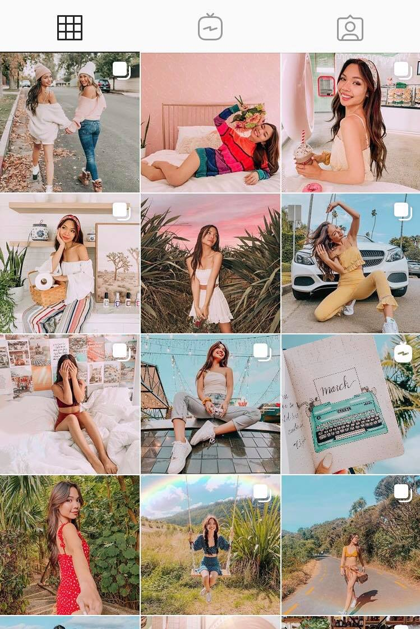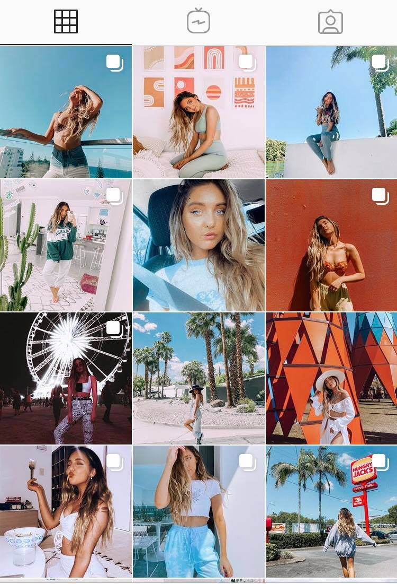
Figure 2. A profile of a girl posing at fashionable locations, living a wealthy life.

Figure 1. A profile filled with bright colors, happiness, luxury and beautiful locations.
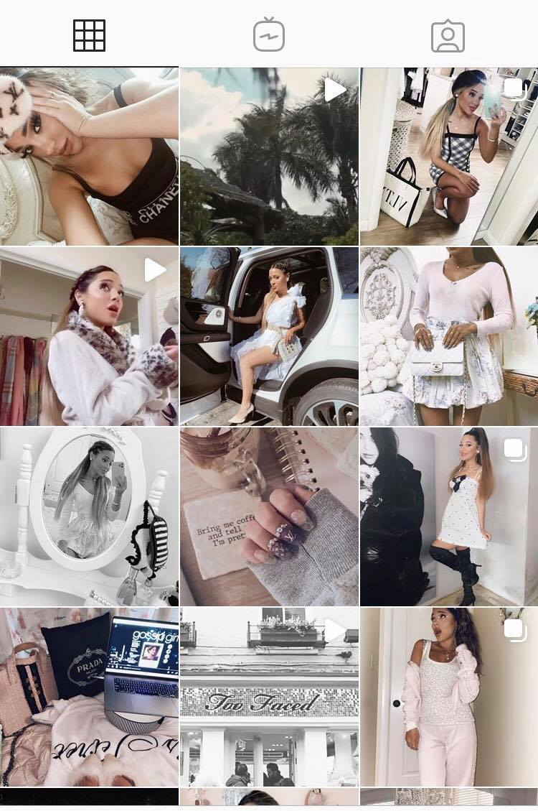
Figure 3. A girl demonstrating a “luxury grunge”, relatively rich lifestyle. This profile is designed in black and white tones implying the trends she likes, that underline her character.
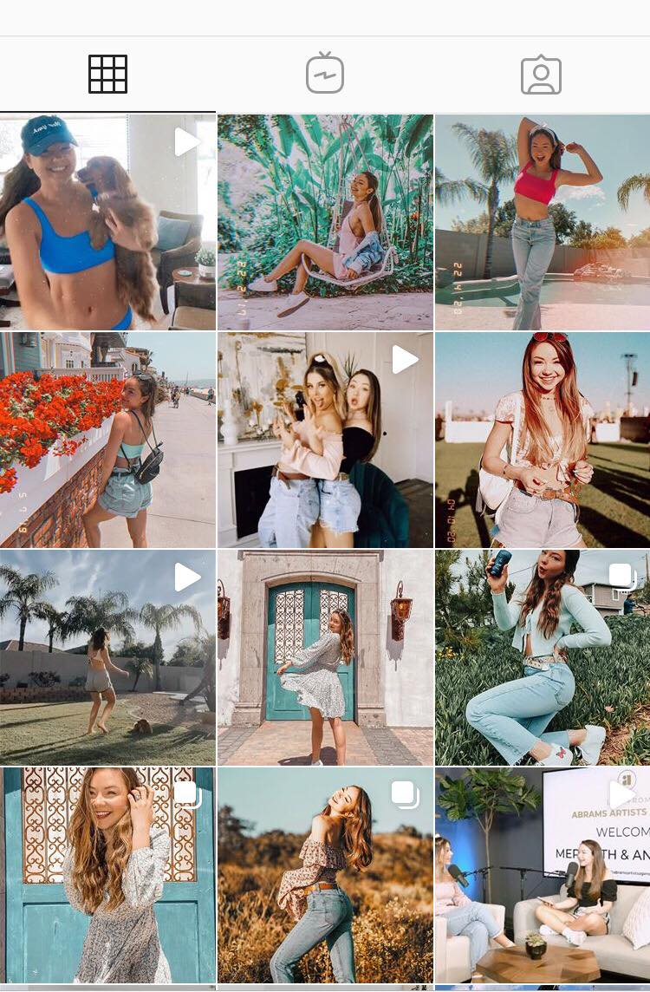
Figure 4. Happiness and smiles induced profile. A lot of light, brightness and colors.

The more time people spend on social media platforms like Instagram and the more they become exposed to such extremely romanticized profiles, the lower on the pyramid they start to believe they are. That is where all the mental health problems stem from. The bottom of any social hierarchy is not a good place to be at. This applies to humans and most other mammals. When they are at the bottom of the pyramid, they assume to be the least valuable people in the group, it means that nobody cares about you, it means that you are a loser. This increases the level of anxiety drastically, causes things like insomnia, panic attacks, depression and addiction, because you cannot relax knowing that you are at the bottom. The brain constantly thinks about how to relax and enjoy life when you believe you are hanging off the cliff with just a couple of fingers. This, of course, is not the truth. The truth is that no one is probably at the bottom of the social hierarchy. Most people around us live very average lives, and one is most likely somewhere around the middle of the social hierarchy in their environment, but the brain does not know that. Because one is spending hours every single day in a fantasy world, a world filled with models, Lamborghinis, vacations and endless smiles, a world that literally no one can compete with even the most successful people in the world. No one is happy every single second of their day, as their pictures will like to have you believe it, and that is why social media platforms like Instagram are ruining ones’ life, because they force you into thinking you have to compete against a huge group of imaginary people that you can never beat.

2.2 Instagram and negative impact on young youth’s mental health
Although social media platforms are useful for one segment of the population in order to keep in touch with people they love, for others it can cause serious mental harm, influencing not only their self-esteem, but also greatly affecting one’s levels of loneliness and depression (Lup et al, 2015). The accessibility of the app may eventually become problematic, especially for females (Holowka, 2018. P-183).
What makes people addicted to Instagram?
There is a variety of reasons for why people become addicted to Instagram. Some of the vividly identified ones are as followed. (Trifiro, 2018).
- People love taking pictures. Because the platform itself was initially created for a photo content, it appeals to people’s need to photograph the beautiful moments of life. With the invent of various gadgets that allow to take photos in a high-quality solution, photographing and sharing it on social media has become easier than ever.
- People get a special form of satisfaction from taking aesthetically pleasing photos. The feeling of knowing that your result was good can barely be compared with anything else. An additional quality that makes Instagram great for many is the ability to master photo editing skills as it has built-in-tools that can semiprofessionally affect the quality of the picture. Users have even came up with a concept “Instagram-worthy”, which implies a photo with various fancy filters and editing techniques applied to it. This idea is directly linked to the next reason…
- Shareability (the intention of being potentially “liked”) massively impacts Instagram addiction. There is a specific level of pleasure users receive from seeing others leaving comments or likes on their posts. Seeing such response from people on Instagram is quite similar to being laughed at when telling a funny joke- it lifts up our ego.

2.3. Instagram and self-esteem
They are the three main authors who aimed to investigate into the study of psychology and Social Networking Services to revel the relationship between them. Instagram and its Relationship between Self-Esteem and Depression amongst Young Adults (March 2018) by El Khouly. C discusses the negative effects of the social network on a particular age group of young adults aged between eighteen to twenty five. The author refers to another scholars work named Rosenberg (1965), who, in turn, claims that self-esteem in young people is strongly related to their peer relationships, “particularly those who link their self-worth with the approval of others.” Social acceptance is the fundamental aspects of people’s everyday life (Dewall, 2011). However, the constant pressure of being “socially accepted” leads to low self-esteem, and on Instagram, photo sharing, liking and commentaries can be a huge determining factor in one’s confidence. She refers to several researches that have reported psychological distresses among the most frequent users of Instagram- teenage females. They are the ones most affected by the “ideal” body images and are more likely to develop narcissistic behavior (Pantic, 2014).
Because media influencers have a direct impact on their followers, their created "ideal self" may intensively affect user’s self-esteem. Seeking for constant validation and craving social acceptance has unfortunately become the fundamental aspect of most young people’s life. Nowadays they have come to base their self-worth on not what they think of themselves, but rather on how other people see them. Due to Instagram being a platform for photo sharing, the type of feedback, the quality and the amount of it can be a huge determining factor in one’s confidence (Lup Et Al, 2015). El Khouly speaks about a conception called “imaginative audience behavior” which is mostly approval seeking from your audience on Instagram. Barker (2009) indicates that there were major differences in the relationship to gender and levels of usage of social networking sites (Barker, 2009). Women were reported to experience a higher level of dissatisfaction with their bodies when they were exposed to model bodies. She argues that the number of female active users of Instagram prevails and that they are more likely to develop a lowered self-esteem, which can later, lead to depression.
Self-esteem is important for maintaining a healthy quality of life. A recent survey shows that “selfies” are very rarely natural and untouched with Photoshop (Lockhart. M, 2019). Even though there are #nomakeup, #natural hashtags trending on Instagram, people still edit their photos to make themselves appear in a better light. Although retouching has already become the norm, the promotion of it may also lead to wrong perception of the self, result in sense of more insecurity as they would feel reliant on using the filters.
The present study's first hypothesis is based on the assumption that the social networking site, Instagram, would directly affect the level of self-esteem of the participant.
It is also assumed that the type of feedback, such as the number of likes and the number of followers, will be associated with one's self-esteem. While there is an abundance of contradictory studies around gender differences, current research has hypothesized that female users would show lower self-esteem than males (El Khouly. C, 2018).
2.4. Instagram and depression
Depression is defined as a chronic disease affecting more than 300 million people worldwide according to a recent survey conducted by the World Health Organization (2017). Women are again being affected more than man, especially those of younger age. The current research does, however, strive to analyze depression in young adults with regard to Instagram usage. As Instagram is a highly accessible app now, the likelihood of it being overused and people becoming addicted to it is very high. Thus, the more time one spends on it, the less time he/she dedicates on being in the real world. This means feelings of being socially isolated and depression may occur in one’s mental stage.
Yang (2016) divides social media usage into three categories: passive, active and interactive. A research in this area has shown that mostly girls who passively use Instagram and boys who actively participate in it are more inclined to the harmful impact of it. Passive usage has been characterized to be more harmful for mental health, as browsing through images of other people’s ideal reality. Our visual memory works much more effectively. By seeing and scrolling through that endless feed of highly edited, glamorized and even romanticized reality, the overall image of that perfect life stamps in our mind. This constant comparison of lives elicits negative feelings similar to jealousy that leads to depression.
Thus, the level of depression caused by Instagram is directly linked to the amount of time spent on it, as well as to the type of usage of it (active, passive, interactive).
2.5. Instagram and loneliness
A recent article claims that the current generation, may be the loneliest ever as a consequence of the prevalence of social media (Pittman & Reich, 2015). Excessive amount of time spent on social media has resulted in people missing out on real life interactions, which, consequently, has led to various negative effects (Yang, 2016). The fact of them being consumed with the cyber world has led to the feelings of loneliness. Social life, in fact, makes people feel isolated, detached and abstracted from the real world as much as it is possible. It even makes the older generation worry that the young ones feel more comfortable interacting online rather than in real life. Although the level of usage is suggested to be a determining factor of one’s level of loneliness (Yang, 2016),conversely, bidirectional research has shown that in fact, social network users, particularly women, are drawn to the internet to reduce their feelings of loneliness (Amichai-Hamburger & Ben –Artzi, 2003). Yang reported that people with certain personality traits are more inclined towards experiencing loneliness.
Despite the fact that the writings above explore some intriguing data regarding this topic, this research aims to study the relationship between Instagram and mental health issues in more detail.

Chapter 3 (Research)
Methodology
The scientific novelty of the study is determined by the development in the socio-psychological literature regarding this problem.
3.1. Procedure and samples
The following steps were implemented during the work:
Stage 1-research and investigative work, including searching for information in reference books and the Internet.
Stage 2-generalization of the acquired material.
Stage 3- conducting an experiment
Stage 4- conducting a survey.
Stage 5- binding the results of the work.
Stage 6- quantitative and qualitative analysis of the results obtained during the diagnosis
The theoretical result of this research project is to construct a hypothesis through in depth analysis of literature and similar informative sources dealing with this topic. The data from those sources was analyzed using compare and contrast methods, as well as generalization of the information.
The practical result of the research was to conduct and analyze surveys, create questionnaires, and to distribute it among the public on social media platforms. This means engaging with people and encourage them to contribute to this study.
Subject of the research: influence of Instagram on young adults
The object of the research: social network
Tasks:
- To study theoretical material about social networks
- To study the negative influence on a targeted age group and conduct an analysis
- Conduct a survey on the study of dependence on social networks

For writing the theoretical section, the literature devoted to this problem was thoroughly studied and analyzed. As part of this work, a study was conducted, the purpose of which was to assess the degree of influence of Instagram on teenagers and young adults in our society. The survey was aimed at collecting data from people by asking them to answer candidly to questions created by the author. Electronic websites and mass media devoted to this problem were used as sources. The survey was conducted via social media networks (Google Forms) and distributed via social media platforms like Facebook and Instagram. The main sources for the publication of the questionnaires have been public groups and forums of interest. These included groups called “Student Survey Exchange”, which is a group that assists students with data collection for their projects, “AUA undergraduate class of 2020”, as well as “AUA English and Communications ” who’s target audience are the students of the American University of Armenia. The questions were designed according to the subject of interest that measured participant’s level of Instagram usage, as well as influentially of the app on individuals. Users were asked to give a maximum of reliable opinions regarding their personal usage of the platform. The questionnaire consisted of 20 thematic questions, including multiple choice, open-ended, yes or no answers. Some of the questions were as followed:
- Have you ever used Instagram?
- Do you consider yourself an active Instagram user?
- How much time daily you spend on Instagram?
- When do you use Instagram most often?
- How often do you post an image on Instagram?
- How often do you post stories?
- Do you feel the need to share it on your Instagram(or stories) when you see something exciting happening (e.g. delicious food, party, cute animals etc)
- Do you feel addicted to Instagram?
- Do you feel depressed, moody or nervous when you're not on Instagram, which goes away once you're back on it?
- Have you ever done Instagram fasting?
- Do you feel pressure from Instagram?
- Do you think Instagram can lower people's self-esteem?
- Do you think Instagram affects people's mental health negatively?
- Are there any solutions on how to make Instagram less harmful for our mental health?
This questionnaire was constructed of questions, which Instagram users would not even think to ask themselves or would rarely consider them. People rarely think of how much time they spend daily on different social media platforms. Some may have not even considered the fact that their exposure to a particular social media platform may lower their self-esteem, or make them feel depressed and lonely. One never sees the level of his/her addiction to something until they conduct a self-analysis. The primary aim of this questionnaire was to draw an estimation between Instagrammers’ stance on themselves and on others. So, it was not only going to measure what Instagrammers think of themselves and other users, but also assess what non users think about the negativity of the exposure. It was also important not to limit respondents to multiple-choice answers, but also give them opportunity and freedom to express any thought related to the question in the section requiring long answer.
Initially the author anticipated getting results from approximately 100 participants within the period of two weeks; however, at the end of that time only 70 answers were collected; with about 66% being females aged 19-24. This survey was especially concerned about the relationship among the degree of usage, gender contrasts, the amount of likes and followers with the regarding factors. The quantitative and qualitative analysis of the results will be represented in the sections below. The Instagram usage and its reduction were measured with self-report which may lack accuracy or prone to bias. The results collected from this survey will help to construct a method, or methods to fight different types of Instagram related psychological vulnerabilities.
Besides the online survey there was also a case study conducted among active Instagram users who met the age range of the group being analyzed, which are young people aged 15 to 25. The participants were aged from 15-26, who have actively used Instagram profiles and demonstrated desire to take part in the experiment. All the candidates were people from authors’ own surrounding (friends, family members, relatives, colleagues) who actively demonstrated interest and willingness in the experiment. Most of the participants taking part in the experiment, have used Instagram previously, and consider it to be an important component of their everyday life. An important factor of the participant selection process was the frequency of Instagram usage, the level of profile “popularity” and the participant’s willingness to share his/her life on social media. All the candidates were people from author’s own surrounding (friends, family members, relatives, colleagues) who would demonstrate interest and willingness in the experiment and would give their agreement to have the results used in a research project. Initially the project intended to have as many participants as possible for the more accuracy of the statistical analysis. However, due to the factor of availability and consent of the people invited to participate, the number of participants eventually resulted in 12, as some rejected to take part in the experiment. They argued for their incapability to delete the app from their phone simply because none of them wanted to fall behind from social life and businesses. Some did not even want to explain the reason for their refusal. Nevertheless, this number was respective enough to get the necessary information. The data-collecting period was challenging again because of the availability of the participants.
The study was based on a so-called Instagram fasting, which implies rejection of the app usage for three weeks. Abstaining from Instagram, or so called Instagram fasting is a relatively new phenomena that implies people becoming disconnected from the app for a certain period of time. The studies conducted before have shown that the motivation for Instagram fasting has been social disturbance such as the negative feelings that upward social comparison caused, exposure to distorted (overly positive) presentation, feeling meaningless or bored, and interpersonal quarrels (Hanley SM, Watt SE, Coventry W (2019)).
The participants were asked to give up Instagram for a certain amount of time and track their mental health alterations. They deleted the app for three weeks and continued living their everyday life with no Instagram exposure. The aim of the study was to determine whether the absence of Instagram exposure affects the improvement of mental health or not. Right after the experiment, the participants were asked questions regarding their experience of Instagram fasting and give a feedback on their mental health. The designed questionnaire included questions on their health. For example:
Have you noticed any improvement in your mental health, or health in general? Tell us about the main differences between your life With Instagram and Without. What do you think has changed within your attitude towards the app?
This work will be a relevant source of reference for psychologists; parents along with the young generation who are interested in the topics covered, and will demonstrate interest to take advantage on it.

3.3. Survey Results
The results of the survey were as followed.
91% of the participants have used Instagram or are currently engaged in it, although there were some people who took the initiative to fill in the survey without ever having an Instagram account.
The 90% of the participants were females aged 19-24 who had an actively used Instagram account. This once again emphasizes the hypothesis that Instagram’s main audience are young females. The opinions on the question whether the participants consider themselves to be active users of Instagram or not evenly split almost into 50/50%. This strongly depend on what they consider to be an active user of Instagram. 47% of the participants spend more than 1 hour (some even more than 2 hours) daily on Instagram (Diagram 1), which is a lot of time and may negatively affects daily activities and busyness.
Diagram 1

2 hours daily spent on scrolling through the feed, liking photos, uploading stories and messaging. However, for people actively posting photos every day this indicator might be higher as it takes more time to take the photos, filter the good ones and edit them. There are 3 out of 70 people posting photos every single day, and 9 of them posting once a week. We can assume that the 80% of the participants are passive users because their main intention is seeing the content rather than uploading their own. This claim is true in regard to the stories as well. The vast majority of the respondents does not demonstrate much activity in posting stories. They do it as rarely as several times per week and several times per month. The greatest portion (37%) prefers to never post Instagram stories.
In case of which social media platform is more prioritizes in creating one’s social image, the majority of replies went for Facebook (40) as compared to Instagram (34). This might give a ground to assume that the creation of a “persona” is most often manifested via these two platforms (unlike YouTube, Twitter and other).
51 people use Instagram when they are bored or have some free time. 41 people use it either in bed once they wake up in the morning, or before going to sleep. This may negatively affect the brain functioning and the vision. However, 24 people have reported that they use Instagram simultaneously with other activities, which might be studying, eating, doing sports etc (Diagram2). 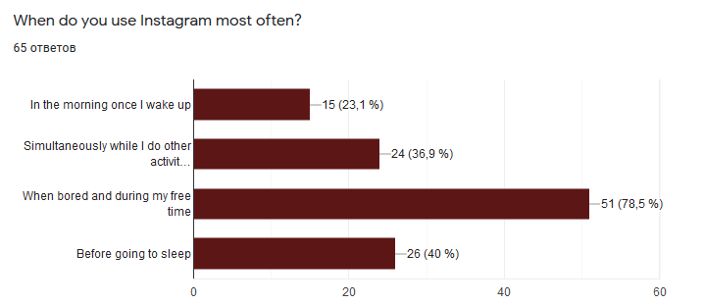
Diagram 2

This is a common practice nowadays. Scrolling through the feed to see the updates might help to digress from stressful studying, but on the other sight it might also distract one from something as important as exam preparation, food consumption (when one’s eyes are following the news feed instead of looking at the plate, this results in blind eating and may cause choking).
One factor that might indicate addiction among the respondents is the answers to ‘Do you feel the need to share it on your Instagram (or stories) when you see something exciting happening (e.g. delicious food, party, cute animals etc)’ question, to find out whether people are pressured or obliged to show that to others. 64% answered no, while the rest considered that there is indeed a need to demonstrate the event to their followers and/or, in case of a party, to show that they are living their best life. The purpose of such demonstrativeness is to prove that one’s position is higher on the social hierarchy pyramid. Sometimes people might also do that unintentionally.
According to 32 replies to the question about content difference of Instagram and other platforms, the majority of answers were tied around several core ideas. Instagram helps its’ younger audience to develop and demonstrate their creative sides. Some said they use it to post about their favorite bands and movies, others to show their professional photographs, travel activities, recipes and books. The commonness was that Instagram is rather for leisure and pastime, interests, whereas Facebook is used for more formal activities like business and work related content. In addition, Facebook allows more flexibility due to the Messenger option, whereas Instagram is less intended for chatting.
The vast majority of the respondents consider Instagram to lower people’s self-esteem (79%) , to make them feel moody, depressed and nervous (83%) and in general, affect people’s mental health negatively (73%), however 70% of the respondents do not feel addicted to Instagram themselves. The assumptions made based on this information can indicate that Instagram users themselves are aware of the negative effects and implications on one’s mental condition. The majority of them acknowledge that people around them, or those in general might develop signs of depression, loneliness, lowered self-esteem, nervousness based on the content they are exposed to on the app. However, the majority of them refuses to admit that in relation to themselves. Only 20 people out of 70 unequivocally confessed their addiction.
Diagram 3

Diagram 4

It has been estimated that Instagram imposes pressure on its’ users more than other social network platforms do (Lockhart. M. 2019). The type of the pressure people might deal with has mostly to do with the appearance. According to the survey results, Instagram impartially enforces one to dress more fashionably, to improve their appearance, be in a better shape, to have a better looking skin (this is mainly the result of the photoshopped and retouched selfies), to look thinner (Diagram 5).

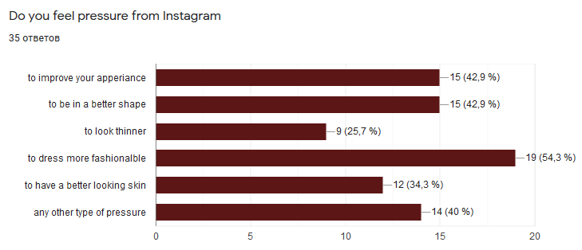
Diagram 5

All of this determines the “idealness” of Instagram content, the perfectness of the images that imply users to start having negative judgments on their appearance. People (who are not in fact that perfectly looking) post their photoshopped images on Instagram, by either making themselves look skinnier, tanned, muscular, tight, glowed up, in order to give the impression of idealness, which, in turn, lifts up their ego. Their subscribers see the photo and start developing a sense of envy, because they realize that they do not look that good. This happens on a day-to-day basis. The more one exposes himself/herself to such photos on Instagram, the more likely they are to become jealous. It is in fact a very negative feeling as it leads to conception of unfairness, which, in turn, triggers anger and hatred. The envious Psyche suffers with impulses to possess, to take it. This process requires a big drain of energy.
The majority of the respondent (80%) have never done an Instagram fasting, whereas 14 out of 70 have at least attempted doing it.
Lastly, the respondents were asked to come up with possible suggestions on how to make the influence of Instagram less harmful for mental health. Around 90% of the long answers were indeed subject oriented, and only the remaining percentage of people refused to give an answer or did not see anything harmful in Instagram. The analysis indicated specific trends that were tied around the same ideas. The most common replies proposed to spend less time on Instagram and/or to control it, or not to use it at all. As all of the responses were recorded anonymously, it is impossible to track the respondents and identify their gender and age in respect to their comment. However, some of them claim: “The solution lies in users, they need to be aware of the app’s effects as to not let negative feelings affect them (low self-esteem or other forms of negative feelings). There is little to be done with the app itself if anything.” In fact, limiting the consumption and a tracked self-control might play in one’s favor. In addition, removing or being able to filter the ads may help to reduce the usage time. Another popular trend was to start normalizing imperfectness and to get rid of overly filtered and retouched body images. “I recognize the work that goes into those beauty and health posts--that they are fabricated far more than what I post. I also know that content creators and influencers need to get paid, and that motive affects what is presented as normal. It's an ad. More harmful to my self worth are the posts from friends who curate a version of themselves that is highly embellished. As a disabled person, I feel bad about myself when I see everyone else leading fantastic, exciting, beautiful lives. Even knowing these are hyperbolic doesn't help me feel better about my lack of interesting experiences, and that's why I am not on there much.”
As the world nowadays is becoming more diverse, humanity needs to starts, in fact, celebrating naturalness, including all body shapes, all skin types and any appearances that fall beyond the adopted standards of beauty. A relevant opinion was to raise the awareness about the negative impact or to come up with actually useful hashtags, trends and challenges to support the positivity. Instagram has already removed the option of the display of the number of likes; however, one possible suggestion was to remove the “like” bottom at all, so that users do not get upset about not receiving many of them. This is due the fact, that not every account is popular, but almost everyone wants to get validation on their posts, thus the removal of the “like” bottom might bring up at least to some equalization and balance within the hierarchy pyramid of account popularity.
Finally, a few comments dealt with the Instagram fasting itself, which is what the second part of the research practice is going to deal with.

3.4. Experiment/Reported interviews
Instagram is a good way to share and connect, as well as to inspire, but with so much being a facade, it makes it lean towards harm than good.
Instagram fasting experiment was conducted among 13 young participants (4 male, 9 female) to exercise a relatively new approach in the field of social media addiction. Participation was not mandatory and every participant expressed his and her own desire to take part in it. The nature of the study and its’ confidentiality was clear to them. All the participants have given their oral consent to use their interview materials in this academic paper.
The purpose of the fast was to track mental health condition of the participants before and after the experiment and to see what general changes are possible to occur within oneself after three weeks of Instagram fasting. All the participants were constantly monitored and asked to record their feelings when they felt they have discovered something new about themselves. After the three week period all of them were asked to report on their overall mental condition. The interviews were recorded, analyzed and translated (some of them). The following section contains sorted out sections from each individual interviewee.
- Marianna, 22 years old. “I actually want to start being more honest and use less filters. With that being said, I acknowledge that pages filled with ideally filtered content usually makes me feel insecure about my appearance, shape. I now got the desire to unfollow such accounts and only follow the ones who remind me that there is a human being behind that page. I always thought that the world want to see the most perfect me, but now I slowly come to a realization that one’s self worth is not defined by their fit shape, flat stomach, long legs etc.”
- Hayk, 18 years old. “I spent past three weeks away from the app. Before the fast, I would spend hours of my daily time scrolling, checking the stories and replying to the comments under my posts. I know have realized that I used to prioritize that time of being on Instagram over to being productive in my studies, or getting enough sleep. Finally, I came across the thought that I never spent enough time with my family. Sometimes my mom would ask me to do something for the household, and would neglect her because I was too busy scrolling through the feed, with no purpose sometimes. I could have done so much more of business if Instagram did not make me this lazy. At first, I used to go back and forth on whether to stop carrying about this experiment and finally share something on my stories, but I did not. The surprising thing for me was the fact that I do not feel “behind” now, or that I have missed Instagram.”
- Vlad, 24 years old. “I indeed think that this fasting made a difference, a mental one. I think that if you truly want to change something, you need to swim against the flow, to stop doing thing everyone else is doing. All the people of your age are on Instagram constantly, showing off, spending “time” which could be spent on something more productive. I truly felt that I was exhausted from all of that social life, so this fast was a great opportunity to take a break and draw comparisons. Not only I felt relatively freed, but I instantly realized that I had developed a bad habit of clicking on the app in a number of random moments during the day that did not benefit me. So, this experiment has taught me to be calm and fill in that time with purposeful activities.”
- Syuzanna, 19 years old. “Kylie Jenner was, and still is one of my role models when it comes to body image. I used to compare and contrast myself with her and I started attending gym a few years ago because I want to have a body like hers. I am mainly subscribed to fitness girl’s profiles to receive inspiration from them. This Instagram fast has actually made me one-step closer to realization that we are all born with unique bodies and there is no need to compare yourself with others, especially with so-called “Influencers”. This was a quality time to step back and see what you really want. Maybe you have been lying to yourself this entire time, and in fact, you do not want to look like someone else on social media.”
- Alina, 19 years old. “Whenever someone asked me something, I always said “one sec!”. After a thorough analysis I realized, that was s sign of addiction. I tried to read more, exercise, but the thought that I cannot share my favorite quote from the book, or the selfie from the gym on my stories made me feel upset. I used to share everything on my stories, from music to memes, from selfies to random pictures. Now that the fast is over I cannot say that I overcame that addiction completely, but now I try to at least control my time and use Instagram whenever I really need to, and not simply out of boredom.”
- Elen, 21 years old. “If you simply think of the fact that we have access to the entire world around us and we decide to get addicted to this “gift”, and I am not speaking of Instagram only, this is about the Internet in general. I think our brains were not ready to obtain so much information in a short period. Humans have become more addicted to the activities happening on social media instead of living the actual life. I am not saying that I am against social media; it simply needs to be dosed. I have practiced social media fasting many times, and I can say the more I do that, the more I become disappointed in it. It just seems more and more pointless to do the things that you do on it, and to see others doing the same. By saying that I mean liking random people and subscribing to random accounts in order to receive likes and subscriptions from them. This proves that one can easily be sold.”
- Harutyun, 20 years old. “Life has been good without Instagram. I have never been and active user. Moreover, I realized that I opened an account simply because all of my friends had one and I did not want to stay behind. It is surprising to understand how addicted we are to something until it is deleted. At first, I was intuitively reaching out to click on Instagram, later on realizing that I have deleted it. I do not think that people really understand what a drug it is until they stop having access to it. The most shocking thing on Instagram for me has been the fact that people create thousands of accounts to buy followers and likes. This tells one thing: the society today is paid for being robots.
I was shocked about what a life changing experience this was for me because at the beginning my attitude was quite skeptical.”
- David, 22 years old. “I always knew that social media is not the reality. It is a mob of people tied around the same ideas, same beliefs, and same lifestyle. I initially crated an Instagram account with that on mind. I never wanted to be popular, to have many subscribers and especially to be an influencer. That Instagram influencing is so wrong and biased. That is so unjustified, how does one decide that they are an influencer, what is the criteria for that? The number of subscribers? The popularity of the profile? Or the quality of the photographs along with the “smart” captions? I do not consider myself addicted to Instagram to the extent, that even after the three-week fast period I forgot to install it back.”
- Armine, 15 years old. “Initially I did not want to participate in the experiment because I did not want to give up something I like and enjoy. During the past year, I have grown so much mentally due to the world of Instagram. I have discovered my passions, friends, communities and I want to be a part of it constantly. That is why deleting the app was so hard for me. I conducted a diary to track my mental journey, but eventually considered it to be a boring idea. After a week and a half of fast, I stopped carrying about the experiment and downloaded Instagram again. That was a relief. I missed out on so much and felt so unusual and weird. I uploaded several photos that I took during the fast period and it received even more likes and comments than before. Most of the comments were based on the idea of my disappearance. It felt like I came back to my world.”
- Yana, 21 years old. “Since being on Instagram I never went as crazy for it as most people do. I never spent hours to work on a post, never implemented too much of a thought into the captions, I simply posted whatever I liked. However, this was a good experience mostly for my friends, because they caught me not being interrupted on Instagram during the time we spent together. Nothing really changed except that I started concentrating better and finishing my work in a much shorter period of time than I used to.”
- Mary, 16 years old. “I love to share my works of art on Instagram. I always pay attention to the comments that I receive. It felt hard for me to stay away from the party, when you know that everyone is having fun. Instagram has certainly triggered my creativity and in some way inspired me to do arts. I tried searching for inspiration in other sources, but nothing turned out to be as effective as Instagram. I know that most people say that the nature, people and reality is the truest way for searching for inspiration, but I consider myself to be an introvert, thus I do not really like to be outside. Maybe one day when I am older I will decide to quit social media completely, but for now, this is what I live by and I do not want to deprive myself from that.”
- Anahit, 25 years old. “I was looking forward to conducting such kind of experience by myself for a long time now. Simply because I felt Instagram diverting me from everything happening in my head and daily life, I thought that it is a good time to take a break. I learned so much about myself throughout this period. To say that it always made me compare my own plans with the ones of others on social media, making me think that mine are not that good enough. So, this fast helped me to reconsider everything and tune to my initial ideas. Instagram also used to take so much of my daily life that I barely managed to do business related work, and always worked late. Now I am ten times more focused on work. I also used to always feel anxious, felt as if my brain was filled up with useless information. Posts that I scrolled through kept sometimes popping in my head when I needed to be focused on work. So, as I said, now I feel a relieve, there is no mental burden anymore, and after these three weeks I am not even willing to pick up my phone and check the feed.”
- Anna, 23 years old. “I have been a passive user of Instagram. I have never done social media fasting, although I have always thought about quitting social media one day. First, this 21-day fast helped me set my priorities, care less about useless things and finally, look around more. At first I was a little bit worried that I will not be able to connect with people, but shortly I have learned that hundreds of other ways of doing it. Also, not having Instagram helped me understand how frequently I check my feed for no reason. There is a ‘My actions’ section on everyone’s profile, which shows how much time daily one spends on Instagram. When I saw my statistics, I was shocked; the average time I spent on Instagram only was more than two hours per day. This was a wake up call for me to start doing something. After the fast, I felt that I have a better control of myself and my time, I quit procrastination and laziness. Moreover, I begun to accept the truth of my body and stopped comparing myself with overly edited bodies of Instagram.”

3.5Discussion
As the current literature has shown, social media usage may potentially have life-changing effects on young adults. Moreover, the type of people’s engagement with social media may determine the scale of these effects. The current study targeted its main argument on the repercussions of Instagram fasting. The results were primarily based on participants’ responses who went on a 21-day experiment. The set of questions was developed to evaluate their relationship with Instagram and reported well-being. The results of the data analysis indicate that the experience of Instagram consumption varies in relation to different age groups. Teenagers seem to be more dependent on their created self-image and persona than college age group. Teenagers care more about what others (mostly people of their age) think of them, because they seem to live in their own world of self-formed beliefs and values. Thus, it was harder for teenagers to abandon their social life, as they believe it will consider a form of treachery in relation to their social life and values. The results also revealed that teenagers are more tend to turn to Instagram compulsively because they felt like they were experiencing FOMO (fear of missing out). With this result in mind, one can draw a conclusion that teenagers are more concerned about their position on the social hierarchy pyramid with regard to their visual representation, than people of older age are. The desire for social competence is detected more vividly in teenagers.
In contrast, people of relatively older age, students and young business owners, did not experience any difficulties in quitting Instagram. Moreover, it turned out to be more beneficial in terms of time management, self-worth and mentality. The evaluation of Instagram use was highly encouraged and easily processed. Besides there was a negative stance detected among relatively older users in regard to Instagram influencers. A few of the participants expressed a criticized and confused position about the standards of credibility of such profiles. In fact, what is the criteria for declaring oneself an influencer?
Finally, college group appears to be relatively more mature to understand, that Instagram is not always the reality, and one should not be dependent on the extremely edited pictures there, as it might lower ones’ confidence in regard to their own body. The mature group easily comprehended their relatively negative position of fakeness and superficiality of posts.
Another tendency recorded among mature participants was their intend to conduct Instagram fasting. This desire was mostly the result of them feeling socially disturbed. The constant feeling of being obliged to social comparison by their peers and the negative feelings that upward social comparison caused, exposure to distorted (overly positive) presentation, feeling meaningless or bored, and interpersonal quarrels were the leading factors for such a desire. The condition of non-dependence on social approval has become more valuable and effective for conducting daily activities as opposed to the condition of constant distraction with Instagram notifications and feed scrolling.
The experiment proposed that social media refusal (for a short period in case of this study, however it can last for longer period of time) focuses on positive mental outcomes.

3.6. Limitations
This study faced several limitations. One of them is the fact that the data processing is self-reported (driven from what is recorded, seen and intended). Such limitations might jeopardize the rationality of the data, counting individual errors and inward/outer legitimacy issues. Certain misunderstanding and validity issues might have happened in the content of the questions. The formulation of the survey questions might have resulted in self-reported replies.
Another limitation has been the process of translation. Most of the interviews with the experiment participants were conducted in their native language because of their lack of ability to express themselves in English. Thus, the translation process was quite challenging again, due to data validity.
Due to the fact, that the experiment was conducted on a free movement basis, meaning that all the participants were allowed to move through space and conduct daily businesses, the commitment of the participants to the seriousness of the experiment was not possible to be traced. With this being said, the data analysis has a possibility of not being completely accurate. In addition, the experimentation results would have been more precise if the number of respondents was higher (at least 20). However, because of the lack of resources the desired outcomes were not met to the fullest extent. Finally, a significant limitation resonated from participants. Out of around 30 people called to take part, some did not demonstrate any interest and others did not respond at all. The efforts of those who expressed interest to participate are highly appreciated.

Conclusion
The present study confirmed that both, an active and passive usage of Instagram might negatively affect ones’ mental condition. The results of the survey revealed the interest of predominantly female audience towards this topic and the awareness of people about the negative effects of Instagram exposure, however the blind consumption does not allow some to realize and notice the mental burden hanging on their psyche. Unlike the survey, the experiment helped to establish a personalized approach to this issue and contact with young people. This allowed us to see different stances in accordance with age and gender and reveal mostly positive changes in the psychology of people. The majority of the participants reported improvements of their quality of life, including increased productivity and satisfaction. Although the information derived from the analyzed literature has significantly contributed to the formation of the theory, a further research in this area is recommended to be conducted. It is clear that it is too early to draw conclusions on many issues. However, we can say that social networks have a very different impact on people, depending on various conditions, and above all - on their personality traits.
As with food, gambling, and many other modern temptations, excessive use of social media may be undesirable for some people. The phenomenon of Internet addiction, including the social network Instagram, is constantly changing along with the rapid development of the Internet and deserves a thorough study. Both qualitative and quantitative research methods should be applied. The current work contributes to the development of the methodology of psychological research and is therefore highly relevant.

Bibliography
- Bennett. E. (August 30, 2019) Instagram Fasting: The Low-Stress Way To Stop Social Media Making You Sad. Retrieved from: https://www.refinery29.com/en-gb/instagram-depression-anxiety-cures
- Efimova. G.Z., Zyuban. E. V. Impact of the social networks on the individual. Online-journal “Mir nauki” 2016, volume 4 No 5.
- El Khouly. C. (March 2018) Instagram and its Relationship between Self-Esteem and Depression amongst Young Adults. Dublin Business School, School of Arts. Retrieved from: https://esource.dbs.ie/bitstream/handle/10788/3460/ba_elkhouly_c_2018.pdf?sequence=1&isAllowed=y
- Fioravanti, Giulia, Alfonso Prostamo & Casale Silvia. (2019). Taking a Short Break from Instagram: The Effects on Subjective Well-Being. Retrieved from: https://www.researchgate.net/publication/337339493_Taking_a_Short_Break_from_Instagram_The_Effects_on_Subjective_Well-Being

- Kyle. F. (July, 2019), How to Beat Instagram Addiction Without Losing your Mind. Retrieved from: https://kenji.ai/blog/instagram-addiction/
- Hanley SM, Watt SE, Coventry W (2019) Taking a break: The effect of taking a vacation from Facebook and Instagram on subjective well-being. PLOS ONE 14(6): e0217743. https://doi.org/10.1371/journal.pone.0217743
- Rakhmawati, Nur Aini,(201X). What are inside the mind of teenagers on Instagram?. Retrieved from: https://www.researchgate.net/publication/338298724_What_is_inside_the_mind_of_teenagers_on_Instagram

- Kircaburun, Kagan & Griffiths, Mark. (2018). Instagram addiction and the Big Five of personality: The mediating role of self-liking. Journal of Behavioral Addictions. 7. 10.1556/2006.7.2018.15. Retrieved from: https://www.ncbi.nlm.nih.gov/pmc/articles/PMC6035031/

- Lockhart, Marisa. (2019). "The relationship between Instagram usage, content exposure, and reported self-esteem". Retrieved from: https://www.researchgate.net/publication/332751267_The_relationship_between_Instagram_usage_content_exposure_and_reported_self-esteem

- Macmillan, Amanda. (May, 2017). Why Instagram Is the Worst Social Media for Mental Health. Retrieved from: https://time.com/4793331/instagram-social-media-mental-health/
- Martinez-Pecino, Roberto & Garcia-Gavilán, Marta. (2019). Likes and Problematic Instagram Use: The Moderating Role of Self-Esteem. Cyberpsychology, Behavior, and Social Networking. 22. 10.1089/cyber.2018.0701. Retrieved from: https://www.researchgate.net/publication/333230835_Likes_and_Problematic_Instagram_Use_The_Moderating_Role_of_Self-Esteem

- Sholeh, Achmad & Rusdi, Ahmad. (2019). A New Measurement of Instagram Addiction: Psychometric Properties of The Instagram Addiction Scale (TIAS). 91-97. Retrieved from: https://www.researchgate.net/publication/335947345_A_New_Measurement_of_Instagram_Addiction_Psychometric_Properties_of_The_Instagram_Addiction_Scale_TIAS

- Trifiro, Briana, (2018). Instagram Use and It's Effect on Well-Being and Self-Esteem. Retrieved from: https://digitalcommons.bryant.edu/macomm/

