The Inclusive Cinephilia of Call Me by Your Name

By
Albert Petrosyan

Presented to the Department of English & Communications in Partial Fulfillment of the Requirements for the Degree of Bachelor of Arts American University of Armenia
Yerevan, Armenia
May 11, 2020
Abstract
Luca Guadagnino's Desire trilogy is a display of different characters captured being "in the moment." Instead of combatting an outside threat, the trilogy's protagonists either act upon or embark on understanding sexual or emotional desires. Whereas these cravings are highly stylized (even farcical) in the first two entries (Io sono l’amore and A Bigger Splash), Call Me by Your Name feels intimate and is successful in making the audience feel empathetic towards the main characters.
Another departure for Guadagnino is the absence of a threat or a personal tragedy that the main characters face after acting upon their desires. Both in A Bigger Splash and Io sono l’amore, the protagonists pay a hefty price once their sexual desires have been met. However, no such thing happens in the 2017 film, mostly an anomaly for LGBTQ-centered narratives. I believe that by using the conventions of Anglo-American LGBTQ movies, Guadagnino subverts the expectations of the audience. That is made possible by hybridizing the familiar boy-meets-boy story with the structurally-loose approach of European cinema (Rohmer, Pialat, and Bertolucci).
Guadagnino's decision not to include the more conventionally tragic epilogue of Aciman's novel into the film shows an incentive of breaking away from the inevitability prophesized by similar high-brow LGBTQ movies. I suggest that when the energy built up by the audience for the foreseeable disappointment does not pay off, Guadagnino guides us to a place where hopeful LGBTQ narratives can exist. By imitating the European art house scene before him, Guadagnino succeeds at giving validity to the feelings of the central characters of Call Me by Your Name.

Introduction
Luca Guadagnino’s Call Me by Your Name is a 2017 coming-of-age film adapted from the eponymous Andre Aciman novel. The film was first screened at the 2017 Sundance Film Festival to rave reviews and went to earn four Academy Award nominations, winning one for James Ivory’s screenplay. The involvement of James Ivory in the production of the movie is the first indicator Guadagnino’s film sharing rich cinematic history with other auteurs. The director’s decision to put the film into the canon of acclaimed romance films is a catalyst for LGBTQ narratives to transcend the clichés and pitfalls of conventional “gay” narratives. Describing the film as a story about the “beauty of the newborn idea of desire, unbiased and uncynical” and opting not to name it a “gay” movie is possible a step in crafting what Bret Easton Ellis calls the first large-scale post-gay movie. Ellis described the movie as free of societal constrains, with no punishment or guilt, art and aesthetics servings as its only ideology. According to Ellis, the movie is both very different from the mournful and condescending portrayals of homosexual portrayals found in previously-produced English-language movies (Brokeback Mountain, Moonlight) and from the sexually explicit European LGBTQ film (L’inconnu du lac, La Vie d’Adele).
This devotion to accepting a new citizen in a larger canon of world cinema is not a wild guess. Conversely, in a 2017 interview, Guadagnino mentioned that the film serves as a “homage to fathers.” The fathers are Guadagnino’s own and his influences: Bertolucci, Renoir, Rohmer, and Rivette. The article concerns itself with how these directors, the first three in particular help the film hybridize an Anglo-American LGBTQ narrative with the conventions of the European art film. Beyond the “cinematic fathers” mentioned, the roles of James Ivory and Maurice Pialat on the films narrative and structure are considered, as the former wrote the screenplay of the film, while the latter’s structurally loose storytelling (Loulou, A nos amours) has been cited by Guadagnino to give the “in the moment” feeling to Call Me by Your Name.
As the intent of the director was to install Call Me by Your Name within the likes of Bertolucci and Rohmer by referencing them, it is important to understand what helped the film to be successful in the directors it lovingly referenced and how that intertextuality interwoven into the structure and the narrative helps to transcend the pitfalls of the Anglo-American LGBTQ narratives. The explication is divided into two distinct parts. One concerns the European art cinema of Rohmer, Renoir, Bertolucci, and Pialat. The second unravels Call Me by Your Name’s screenwriter’s work and how Ivory’s script serves as a spiritual successor to Maurice.
As the movie does not only serve as an homage to the films of the aforementioned directors, the deviations and the subversions of the storytelling of the inspirations behind the film also serve as qualities that Call Me by Your Name possesses that make it stand out both as a European art film and an LGBTQ narrative.

The Fathers
Guadagnino and Rohmer have a lot in common beyond the 2017 Call Me by Your Name. The installments in the Desire trilogy have a lot in common beyond the eponymous sentiment. All three films involve middle to upper-class characters engaging in philosophical conversations (either verbally or aesthetically) that culminate in sexual activity. Both A Bigger Splash and Io sono l’amour (I am Love) serve as a critique of the well-to-do – the privileged stance in the former resulting in personal oblivion of the four main characters in the former, while serving as a symbol for tradition, heteronormative behavior, and unwillingness to change in the latter. While these traits are uncommon to the exposition of Call Me by Your Name, Rohmer and Guadagnino have repeatedly subjected their films to criticize the upper class and intellectualism in general as a backdrop to interpersonal and intrapersonal narratives.
The development Io sono l’amour’s central relationship is a “what if?” scenario of a Rohmer socialite giving in to their sexual desires that threaten to destroy the values of the family. However, as in Rohmer’s movies, the hypocritical nature of the upper-class intellectuals in apparent when the main character is given a chance to re-enter the aristocratic family with them knowing of the adultery involved. In his review of the film, Roger Ebert wrote, “continuity is more important that commitment.” In the same article, he discovers the film to be a mixture of the old and the new, of tradition and feeling. It is possible that the Desire trilogy, as a whole, is in this liminal space between the old and the new, of Guadagnino’s cinematic fathers and his devotion to portray the tantalizing discovery of desire.
Yet still, the most obvious influence on the DNA of Call Me by Your Name is the films of Eric Rohmer. Eric Rohmer was the last figure of post-WWII French New Wave Directors to reach prominence. Even though his fame came later than those of his peers such as Jean Luc-Godard and Francois Truffaut, his filmography is still considered to be of central importance to the second half of 20th-century European Cinema. To understand the relationship between these directors' styles, eight of Rohmer's most famous films were handpicked. These films are some of the Contes moraux (La Collectionneuse (The Collector), Ma nuit chez Maud (My Night at Maud’s), Le Genou de Claire (Claire’s Knee), and L’Amour l’après-midi (Chloe in the Afternoon)) and two from the Comédies et Proverbes collection (Le Rayon vert and Pauline à la plage). Most explore characters who desire flesh or experience love, albeit the exploration usually borders on the critique of the intellectual European. All the features share this commonality within the universe of Rohmer, whereas an inverse of these themes is applied to the narrative of Call Me by Your Name, a notable distinction that contributes to the overall sensual experience of the film.
Narratively, Guadagnino seems concerned with emulating Elio's first contact with infatuation. That is the predominant reason why the plot does not carry a three-act structure. Instead, the narrative is fashioned with short bursts of moments of desire or philosophizing, neither contributing to a linear progression. However, in some Rohmer movies, the plot is fixed, most notably in Pauline à la plage and Ma nuit chez Maud, both told with mathematical precision. Rohmer served as the editor of Cahiers du Cinema, one of the most influential film magazine in France. During these years, he distinguished himself from other film critics of the time by writing in a relatively formal style and tried to breathe an air of formality to the language of film criticism. This is where the significant difference between Rohmer and Guadagnino arises, most probably motivated by the decision to go non-linear in storytelling (Pialat, whom Guadagnino cites as an influence on this particular aspect of the film, will be discussed in detail).
An article that separates Call Me by Your Name and the Rohmer films is John Fawell's "Rohmer's Oppressive Summers." The article touched upon the familiar settings and moods of different Rohmer movies. While other movies set in the summer period would have carried the energy of liberty and self-development, Rohmer's movies veer off into the idea that the seeming infinity of summer leads to stagnation and loneliness. This finding will then be applied to La Collectioneuse, Pauline à la plage, Le Genou de Claire, and some of the earlier Moral Tales. Because these share a space where the unsentimental and the seductive meet, critical differences in the exposition are what drives the careless ease of Call Me by Your Name.
Even though Elio is far from the stereotypical protagonist of a coming-of-age film, he still pertains to the archetype of an awkward and insecure teen. Desire has positive energy in Guadagnino's movies and brings out the best of the characters. This is true for this and the previous two in the trilogy. An article by Joanna Di Mattia identified a new kind of language – people around the amorous subjects observing the love in action. In this film, these characters show kindness without words, thus visually. "Call Me by Your Name is a film in which dialogue is used minimally for maximum effect – its most powerful moments contain few or no words at all." Of all the Guadagnino projects, this one made the most significant critical and scholarly splash; therefore, reflections of this movie will also serve as entry points to understand his other work.
Important is to understand what makes Call Me by Your Name different from films of those filmmakers that inspired its conception. The obvious candidate to which such a diversion is aimed, in particular, is Eric Rohmer. Rohmer's films exist in these liminal spaces, which Call Me by Your Name so deftly possesses; however, they portray the setting and the time spend (mostly in summer) as a source of stagnation. Interestingly, this stagnation is very much in conflict with the intents and the thoughts of the films' protagonists, who usually embark on journeys that reek of unmitigated desire of sex. Even if the main characters of these films do express some concerns with the uncontrolled nature of the sexual desires that await them, they still show a growing tendency of intended participation. Antoine de Baecque and Noel Herpe, in an article about the filming of Le Genou de Claire, mention that the film came to be in a period where the narratives of uncontrolled sex and desire were welcomed, three of Rohmer's films were concerned with "controlling and calibrating desire, not capitulating to it".
Moreover, a preliminary draft of Le Genou de Claire included the following quote: "It is not pleasure that makes people happy, but desire and the obstacles that are put in the way of realizing that desire." Considering that the same filmmaker made Ma nuit chez Maud and L’Amour l’après-midi, it is perhaps unsurprising that a Catholic approach to the portrayal of desire is expected to be employed to a movie that is filled with images of scorching sensuality. The desire comes with the promise of jealousy and infidelity, recourse to the "bad faith" of Jerome, the main character of Le Genou de Claire. The film never criticizes its main character for the inappropriate relationship (by contemporary standards) that may have developed between the adolescent French teens and Jerome. For Rohmer, the conflict within Jerome's faith is more important. Even though some of the scenes may seem problematic for a contemporary audience, Rohmer does not let the characters engage in an activity of sexual nature, which is also apparent in L’Amour l’après-midi and Ma nuit chez Maud. The age difference is a critical aspect in Call Me by Your Name, dictating the form of the relationship. Nevertheless, as opposed to Rohmer, the fulfillment of the desires is seen as a significant step in the self-discovery of Elio Perlman, Guadagnino pushing a narrative of a teen being infatuated of possessing or acquiring the body of the desired object. Even though the age of consent in Italy is fourteen, the central relationship has been a subject of criticism in some of its audience.
The possession or acquisition of the coveted object is also a major theme of La Collectionneuse and, to a lesser degree, of Le Rayon vert. However, this possession is rarely shown in a positive light. In an article about Rohmer's "oppressive summers," John Fawell describes Le Genou de Claire as a "gently cruel" film. It shows the humiliation Jerome feels faced with the indifference of the teenagers that surround him. In addition to a newfound reminder of his age, Jerome is portrayed as an egotist fantasizing about a person that does not reciprocate. This is also a central theme in Pauline à la plage, another significant aesthetic influence on the Guadagnino film. If Call Me by Your Name shows the feeling one experiences when merging with another body, both physically and metaphorically, Rohmer films show his characters out of these types of relationships either to singlehood or to their significant others, who are drastically different and sometimes emotionally distant (L’Amour l’après-midi's couple could also fit into this). Whereas "youth remains sublimely indifferent to middle age," Elio finds a more confident and liberated version of himself in the image of Oliver, a space of comfortable sexual expression. In all of Rohmer's films taken into consideration, the youth is an object of an elaborate mise-en-scene of the older characters, who show their weakness and bad faith in the wake of aging or waning youthful spirit. Rohmer is not concerned with what the eponymous Claire felt at the situation because she is never shown to be interested in the relationship. That probably may be the reason why Rohmer's films come off as scathing or critical. The more the characters talk, the more hypocritical they become. On the other hand, James Ivory's script minimizes the use of dialogues in vital scenes in Call Me by Your Name. When the characters do not speak, they act with their bodies.
They are not providing new interpretations of love but rejecting them to reinforce the traditional ones. Likewise, the main character of Le Rayon vert is pre-occupied with superstitions telling her of a companion that will soon arrive. Delphine, the protagonist of Le Rayon vert, is much different from other ones in the Rohmer canon as she inspires as much sympathy as pity. The audience sees her trying to become one with nature, rejecting the practice of eating meat and taking long strolls in the forest and the mountains. Simultaneously, everyone around her advises that the incoming loneliness of the summer will be alleviated by a quest to find a companion.
Action in the former, and inaction in the latter, bring the loneliness, as Delphine wants to be taken (or possessed) both by nature and a romantic partner, yet she is unable. It is when she takes the initiative and asks permission, the film takes a hopeful turn. What concerns nature – Rohmer's films are famous for the characters tending to "lose rather than find themselves in nature." Nature brings "boredom, directionlessness, overheatedness, and stinging fires." This is a point that the main character of Le Rayon vert has in common with the previously mentioned Rohmer protagonists. It is her fixation on nature and the idea that superior minds were able to capture a harmony with their surroundings that brings her immense pain. Like Jerome in Le Genou de Claire and Frederic of L’Amour l’après-midi, a hypocritical escape from personal relationships highlights the existential dread of commitment these characters fear to face.
All of this is not to suggest that Call Me by Your Name has nothing in common with Rohmer's films. On the contrary, most of the points mentioned are essential to note, because Guadagnino's film may be an inverse of the logic employed in these films. Nature is never dull or distancing in Call Me by Your Name. Conversely, the scenery of nature is a backdrop for several of the most sensual scenes in the film. The scene where Oliver kisses Elio is reminiscent of a similar scene in La Collectionneuse. In Rohmer's scene, the attempt at a kiss by the older character is not returned by the younger one.
Interestingly, the camera does not show what the reaction of the young girl is to the attempt. In Guadagnino's film, Elio awaits the kiss, is given a taste before initiating a kiss himself. The progression of any relations is cut short by Oliver, the older character. Elio could not have done this, as a possible progression aligns with the good faith of the character. Therefore, it can be inferred that Guadagnino chose Rohmer because of the aesthetic language employed, but the themes and the "director as the judge" angle is nowhere to be found. Rohmer shoots his actors in an unsentimental and non-glamorizing fashion. The cinematography is not particularly flashy or sophisticated. Conversely, most of the shots either linger on the spaces the characters inhabit (such as in Le Rayon Vert) or follow a shot, reverse shot pattern. As both Rohmer’s and Guadagnino’s films include long conversations, it is perhaps the reason of why there is no need for “flashy” cinematography.
However, some of the aesthetic deviates from the simplicity found in Rohmer and the reason is the main character serving as the nuclei of the story. Call Me by Your Name ultimately is Elio's story, with the audience taken hostage to empathize with him. The relationship between

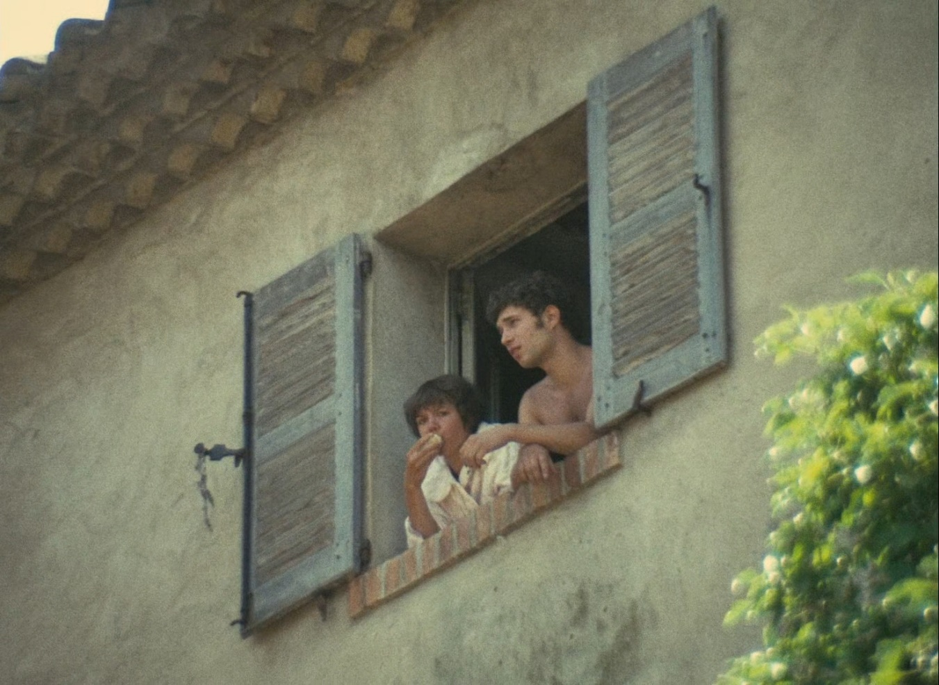
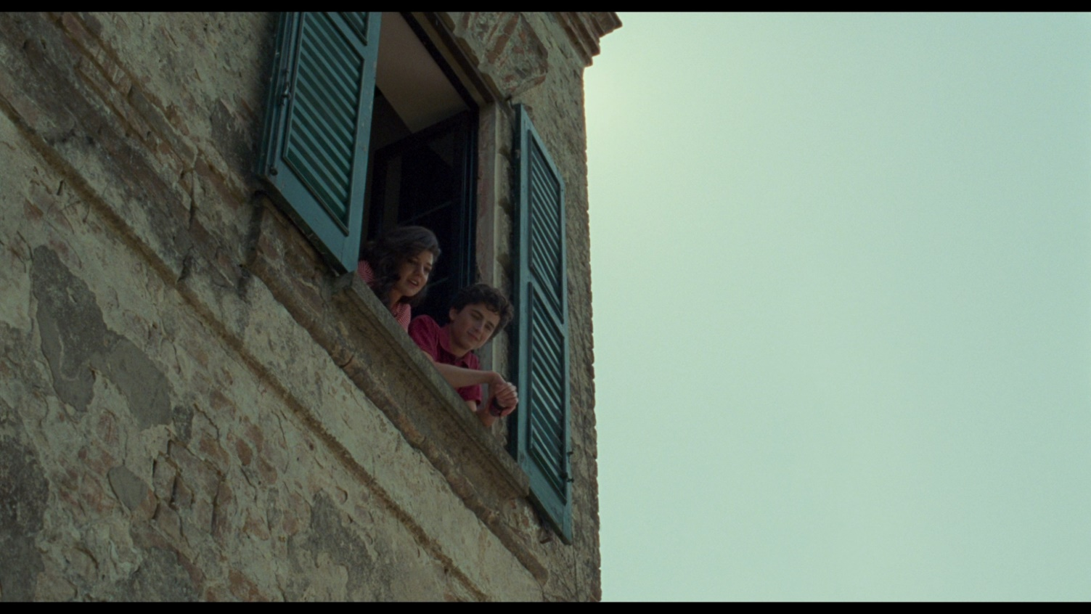
Call Me by Your Name
La Collectionneuse
nature and self-discovery started with Io sono l’amore and A Bigger Splash. However, both feature endings that indicate personal doom for the main character. If Rohmer characters chose to follow their sexual escapades, they would find themselves in similar situations as those in Io sono l’amore and A Bigger Splash. The main difference would be that Guadagnino does not judge – he asks us to laugh at the absurdity witnessed at the screen. Both directors use the same tools. Rohmer sadistically winks at us after witnessing an embarrassing act, while Guadagnino's Rohmer invites us to feel. Joanna Di Mattia's article on the film in Screen Education shows how exactly Guadagnino is able to do this. The article is about the film shaping a compassionate audience with the help of its characters, main and supporting.
The sexual possibilities in Rohmer's films are not to be explored. They are to serve the rectitude of the main character. This is the only place where Rohmer seems to empathize with his characters. When Jerome chooses not to follow up with Claire, he delivers a monologue to his female friend, Aurora. The brief mention of his fidelity to his promise seems to exonerate Jerome of the unhealthy obsession he developed during his stay with the two young teens.
In an interview, Rohmer and Kant are points of comparison in their approach to the aesthetics of natural beauty and artistic beauty. Rohmer's writings may imply "that whereas arts are normally confined to artistic beauty and its aesthetic ideas, leaving (as per Kant) natural beauty to nature alone, cinema has indifferently access to artistic as well as to natural beauty." Rohmer seems to be concerned about capturing beauty as it is because the movie camera allows him to do so. This gives liberation to the shooting nature in its most beautiful moments. Guadaganino used something similar in choosing to shoot with a single lens and at the human eye level.
The realism seen in Rohmer pictures is similar to those found in Jean Renoir's filmography, most notably in his Partie de Campagne (A Day in the Country). By employing a style that values realism over the grandiose, both Rohmer and Renoir are able to show their characters in an unsentimental fashion. Even if the characters in Renoir's and Rohmer's films seem self-pitying or tragic, the directors do not show this development as the talkative, more verbal communication takes over the narrative. Nevertheless, in Call Me by Your Name, intimacy and desire are more readily observable through non-verbal means, primarily in Elio's gaze and body language. Body language is also an integral component in Rohmer's narratives. In Le Genou de Claire, the sentiment of touching the all-powerful knee is clearly foretold by the director's camera. The audience observes and is perplexed by Le Genou de Claire as it is one of the objects in Rohmer's filmography that exists in close-ups.
Interestingly, Rohmer was not a fan of extreme close-ups as the shot did not emulate what the human eye can see. This deviation of Guadagnino to use extreme close-ups of the faces in Call Me by Your Name raises a question whether the film specifically deviates from Rohmer’s aesthetic. The film does not simply restage a Rohmer film for the contemporary audience; it has, in addition, other modes of storytelling inspired by the directors of the second half of the twentieth century.
Some describe the aesthetic of Call Me by Your Name as "dreamy" or "dreamlike." That effect may be attributed to different decisions. The most obvious is the cinematographer's work. Sayumbhu Mukdeeprom, the film's cinematographer, shot Apichatpong Weerasethakul's Uncle Boonmee Who Can Recall Past Lives, and Miguel Gomes' Arabian Nights. The former is the Palme d'Or-winning art film about reincarnation, while the latter is a modern-day retelling of One Thousand and One Nights collection of fairy tales. For both these productions, the implementation of a dreamy aesthetic serves the genre of the stories – magic realism. As Call Me by Your Name is hardly a magic realism film, the decision to shoot the narrative in a hazy or dreamlike aesthetic may have come from the original novel. In the original novel, the narrative is told from a much older Elio, and the rest of the story is a retelling of what he remembers from the encounter. As the film does not have a narrator, the effect is implemented in its visual language. As previously mentioned, Guadagnino chose to shoot the film with a single lens and at the human eye level.
Additionally, there are no scenes in the film that do not feature Elio. This first-person storytelling may have been inherited from the filmography of Bernardo Bertolucci, who is incidentally one of the filmmakers that Guadagnino mentions to have inspired the style of Call Me by Your Name. While Call Me by Your Name's aesthetic and the setting is strikingly similar to Bertolucci's Stealing Beauty, the fixation on the experience of a single character is observable in both Il Conformista and The Dreamers. Both are adaptations of pre-existent material – the former tells its story without narration, while the latter uses narration sparingly to set-up the central conflict. However, the main difference between Guadagnino’s and Bertolucci’s approach to telling memories of the main character is that Call Me by Your Name has no scenes without Elio. Both Il Conformista and The Dreamers make it clear that the narratives are the retellings long removed from the period. However, in Il Conformista, we are subject to a scene without the main character in the last scene, while The Dreamers breaks away from its consistency of the protagonist’s presence only in one scene with Louis Garrel.
By breaking away from its influences, Call Me by Your Name is able to become a standalone narrative that does not feel derivative. In some of Bertolucci’s films, suggestions of homoerotic narratives are never explored – these range from the condemnation of homosexual behavior in Il Conformista to the erasure of the homosexual sex scenes in The Dreamers. Whereas Last Tango in Paris hints at the homoerotic desires of its main character by Brando requesting a simulation of anal sex from Schneider’s character, Call Me by Your Name is not concerned about the act itself. It is always absolutely clear that there is uncontrollable desire for flesh and love between Elio and Oliver, and according to the director, an explicit rendering of the consummation not shown was an indication of the wide appeal that the movie tried to reach.
This cutting-away from the scenes at their most intense is an homage to Maurice Pialat. Pialat’s films are notable for their unusual storytelling through editing. Two of the Pialat films, Loulou and A nos amours, serve as inspirations to the structure and the editing of Call Me by Your Name. In both of these pictures, the story is told through short vignettes – bursts of emotion, intensity and up-close cinematography. Pialat utilizes the jump cut to cut away at the most emblematic of moments to change the setting or the period of the picture. This results in films that feel episodic but tense, non-traditional but comprehensive. The jump cuts rarely, if ever are used as an aesthetic mechanism, they serve the tempo of the story. In Loulou and A nos amours, the setting and the relationships feel very familiar to those that Rohmer sets to tell. Whereas, Rohmer’s summer-holiday movies are relatively laid-back, Pialat’s features feel like an emotional gut punch, they possess lively energy, melancholy and scorching desire. All of the aforementioned directors excluding Bertolucci design unsentimental cinema – Late European Cinema and Realism. The tradition began with stories chronicling the despair of the human condition. The father of movement was Robert Bresson who was one of the first auteurs of the era. An offspring movement of the European realism is the “New Naturalism,” the birth of which is associated with the works of Jacques Doillon and Maurice Pialat. The naturalist approach of Pialat is apparent in the two aforementioned films, focusing on the young people who are exploited or maltreated by the society. Pialat is concerned with representing the quotidian by cinematic realism. It is also associated with the utopian dimension found in the transcendental facets of the literature of André Bazin and Siegfried Kracauer. Pialat thought that cinema is able to create a dream world – it transforms what is quotidian into extraordinary, turning the celluloid into a moment of death. Bazin and Kracauer thought that cinema and photography could save psychological experience and physical reality from rotting in temporality.
Thus, the episodic quality of Pialat’s films helps the individual moments to be reintroduced into what life feels like – episodes “linked at random”. By using what would usually be considered to be mundane or uninteresting, Pialat is able to recreate and cite past in all of its episodes - a more complete understanding of the flow of life is created. Therefore, when familial interactions surge into the narrative, they similarly feel episodic even if they encompass much more conventional exposition than other Pialat scenes. In A nos amours, such a conversation is propelled through a misunderstanding of a central character, not breaking away from the randomness of the storytelling. This is similar to the conversation Elio has with his father in one of the final scenes of Call Me by Your Name. The audience is not in the know if these conversations are usual in the family and judging from the performances of those involved, it seems to be a novelty. Most of the plot progression that takes place in the film is told through an irrational chronology. At no point is it expected that the romantic affliction of these characters would take such a form. Because that allows an arbitrary mode of storytelling, Guadagnino may have opted to expose these scenes through his keen eye for cinephilic detail. Guadagnino may use naturalism as a lens to make the cinematic space Elio and Oliver inhabit more lived-in, but he also is not concerned about rendering the story as an item of realism. As there is little to no social critique in Call Me by Your Name, a dreamier, more impressionistic aesthetic may have been favored, something that some say is present in Bertolucci’s The Dreamers.
The Dreamers is a work of a director-cinephile, much like Guadagnino. Bertolucci and his love of French New Cinema is present in every frame of the 2003 film. The cinephilic aestetic of The Dreamers is one in the trend of cinema “obsessed with the concept of recapturing lost time”. The film aims to capture a period long gone and serves as a mirror image on cinema itself. It is “a drama…’perfect moments’…the result of the cinephilia complex, reflecting on itself in the medium of time.” Bertolucci seems to emulate a time drenched in sex and politics (the subject matter of most of his movies) by bringing the elements born in the cinema of the time period – the 1960s French New Wave. The reconstruction of the long moments is achieved through the carefully planned visual aesthetic of the film, which encompasses the subtle, realistic setting and classical art. Bertolucci’s tendency to include sculptures and statues into the mise-en-scene of The Dreamers to evoke an artistic value in the bodies of the characters. The same principle is present in Call Me by Your Name, where sculptures are seen as indicators of beauty by Elio. Later in the film, Guadagnino frames Armie Hammer as a statue, making Oliver into the ideal of beauty for Elio. Like The Dreamers, Call Me by Your Name is an example of temporal art – the images on screen exist in this little secluded town in Italy. The mise-en-scene and the costume design of the characters are similarly appropriate for the period. Yet, there is not a single mention of the AIDS crisis or the unpopularity of homosexual relationships at the time. In addition, the only time a societal hurdle is mentioned is through Oliver who contrasts his parents with Elio’s, revealing that the place he had inhabited would not be as kind as the one they exist in the moment. It is unreasonable to expect that there would be no fear from the characters towards their relationship. However, as it is a reconstruction of one’s memory, it is not surprising that one would omit the details not directly connected to the relationship. The disjointed structure of Pialat mixed with the mise-en-scene of Bertolucci create a film that is temporal and timeless at the same time.

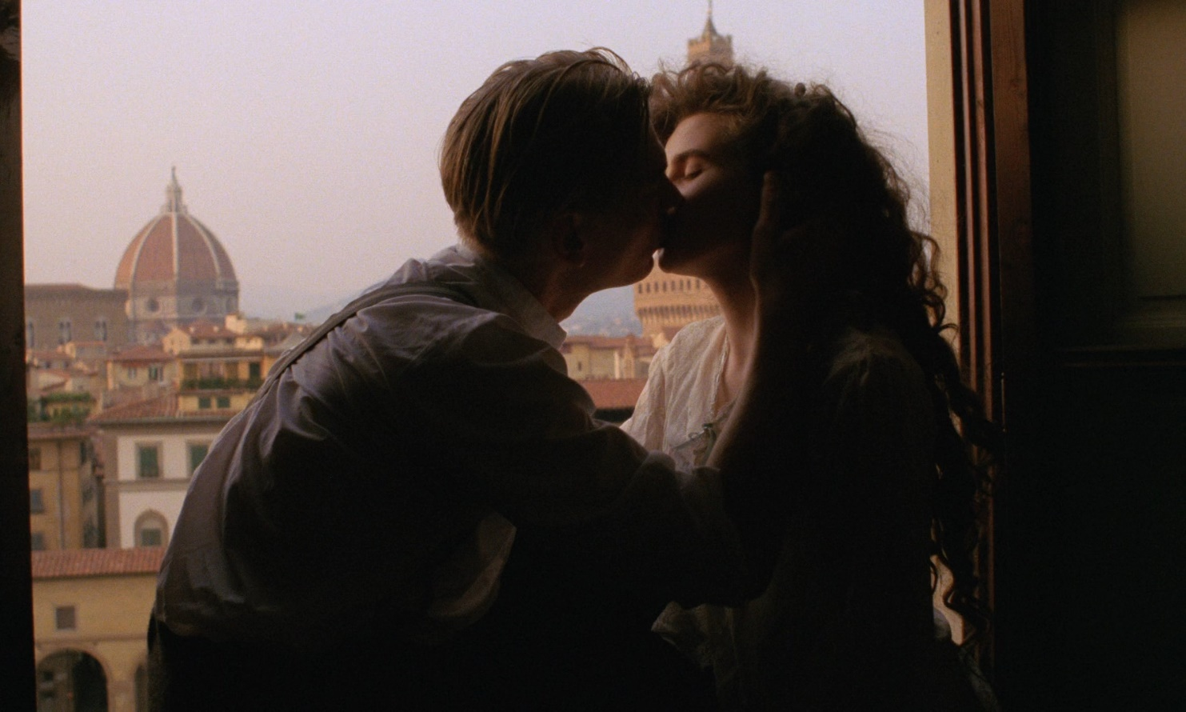
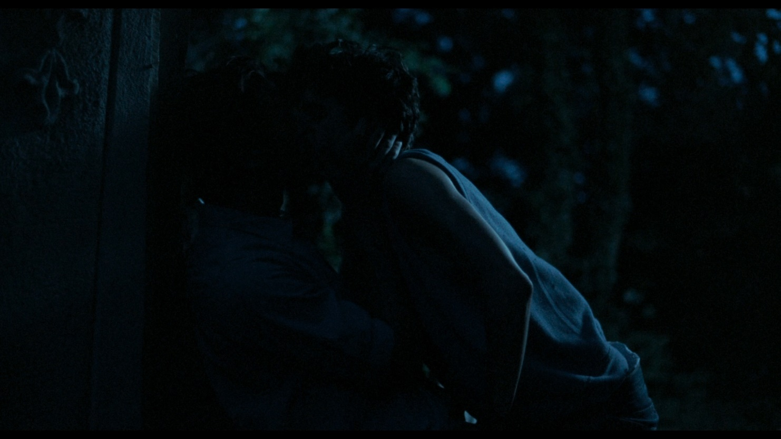
Call Me by Your Name
A Room with a View

The Partner
Guadagnino’s taste of cinema has been shown to contribute to the success of Call Me by Your Name. Through the cinematic “fathers” that penetrated the aesthetic of the film, there is also another person who had a real contribution to make to the film – James Ivory, who wrote the screenplay and even at some point, envisioned to direct the film. Guadagnino does not refer to Ivory as one of the influences behind the picture. However, his screenplay, and references to Ivory’s two E. M. Forster adaptiations, A Room with a View (1981), and Maurice (1987) can be caught in the following decisions.
Most apparent in the intertextuality is some scenes that appear both in Guadagnino’s and Ivory’s filmography. In the first hour of Call Me by Your Name, Elio takes Oliver to a place he has a deep connection to – the lake. The exact same scene is also present in A Room with a View, when Helena Bonham-Carter’s character shows her to-be betrothed a lake she has been persistently visiting as a child – she calls it “a sacred lake.” Later, at the same site, three men fool around in the water, similar in the way as to how Elio, his father and Oliver, play in the lake close to Crema. These happenings, which have been referred to as “unlikely,” add to overall episodes of “an explosion of movement and light and physical joy that is one of the great things in recent movies.” Similar scenes also permeate in Maurice and Call Me by Your Name. When Maurice and Clive
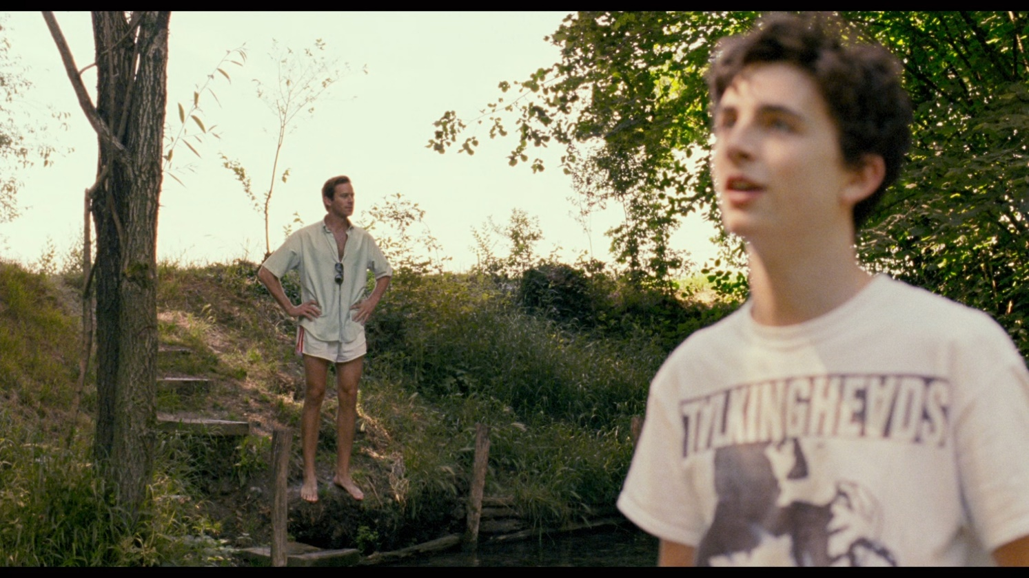
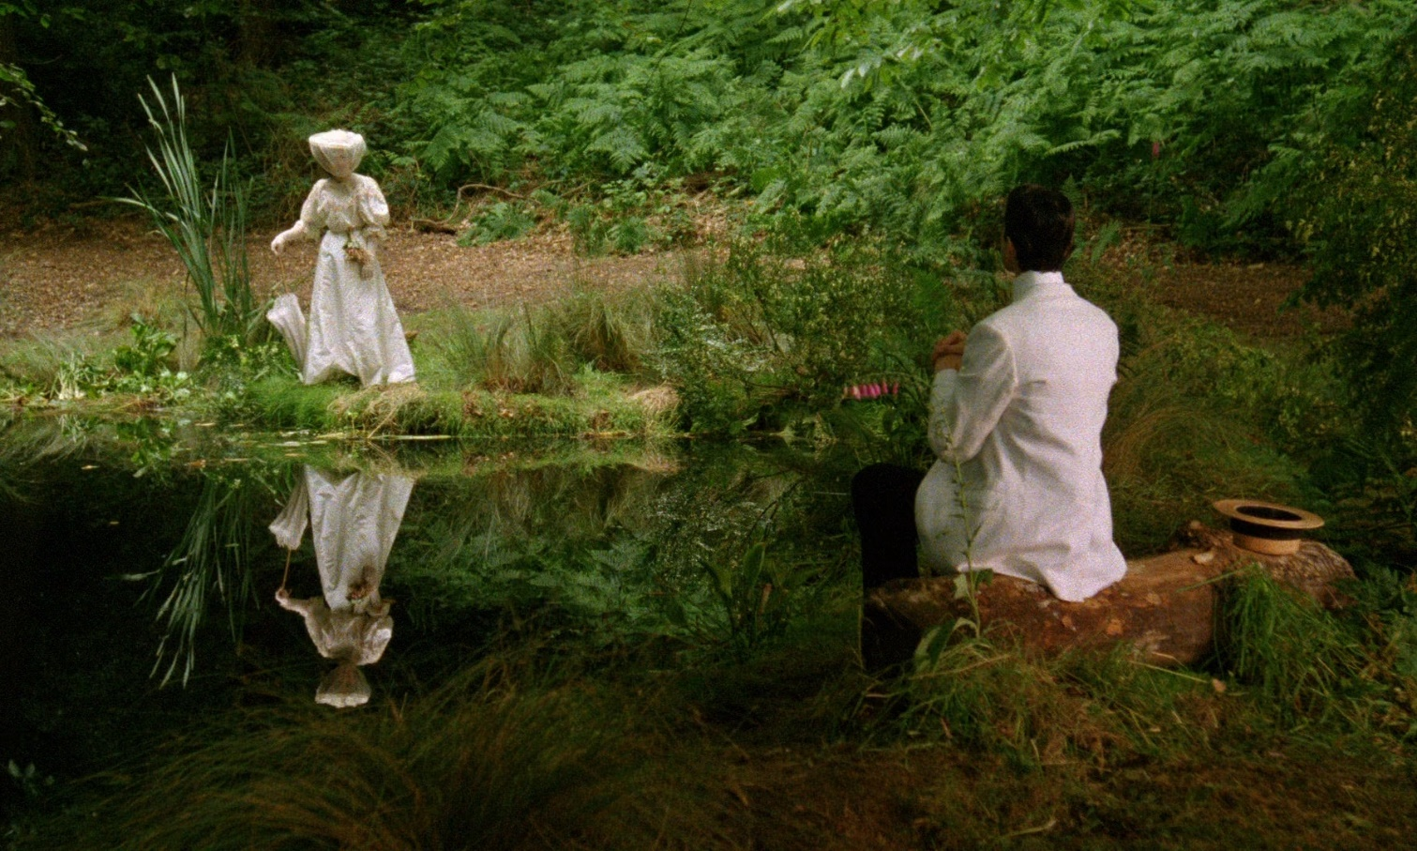
bond with each other for the first time, it is, while the latter is playing the piano. Incidentally, the same musical instrument serves the same purpose in Guadagnino’s film. The shared love over art, classical and contemporary is a commonality of Call Me by Your Name and its screenwriter.
A Room with a View
Call Me by Your Name
When Ivory was asked whether he has been influences by Jean Renoir (one the precursors of the New European Realism), he said “any artist who works in a visual way – any painter, photographer, or film-maker – unconsciously (and sometimes consciously) refers to works of art that have given him, or her, pleasure.” If Ivory followed, albeit unconsciously, the aesthetic tradition of the naturalist/realist directors, it is not unsurprising to see why Guadagnino was able to so aptly stage the screenplay and achieve a movie that favored desire over subject matter. The film, more than anything else is the “witty, clever, and engaging” genre of romance narrative that Ivory intended to make with A Room with a View and Maurice.
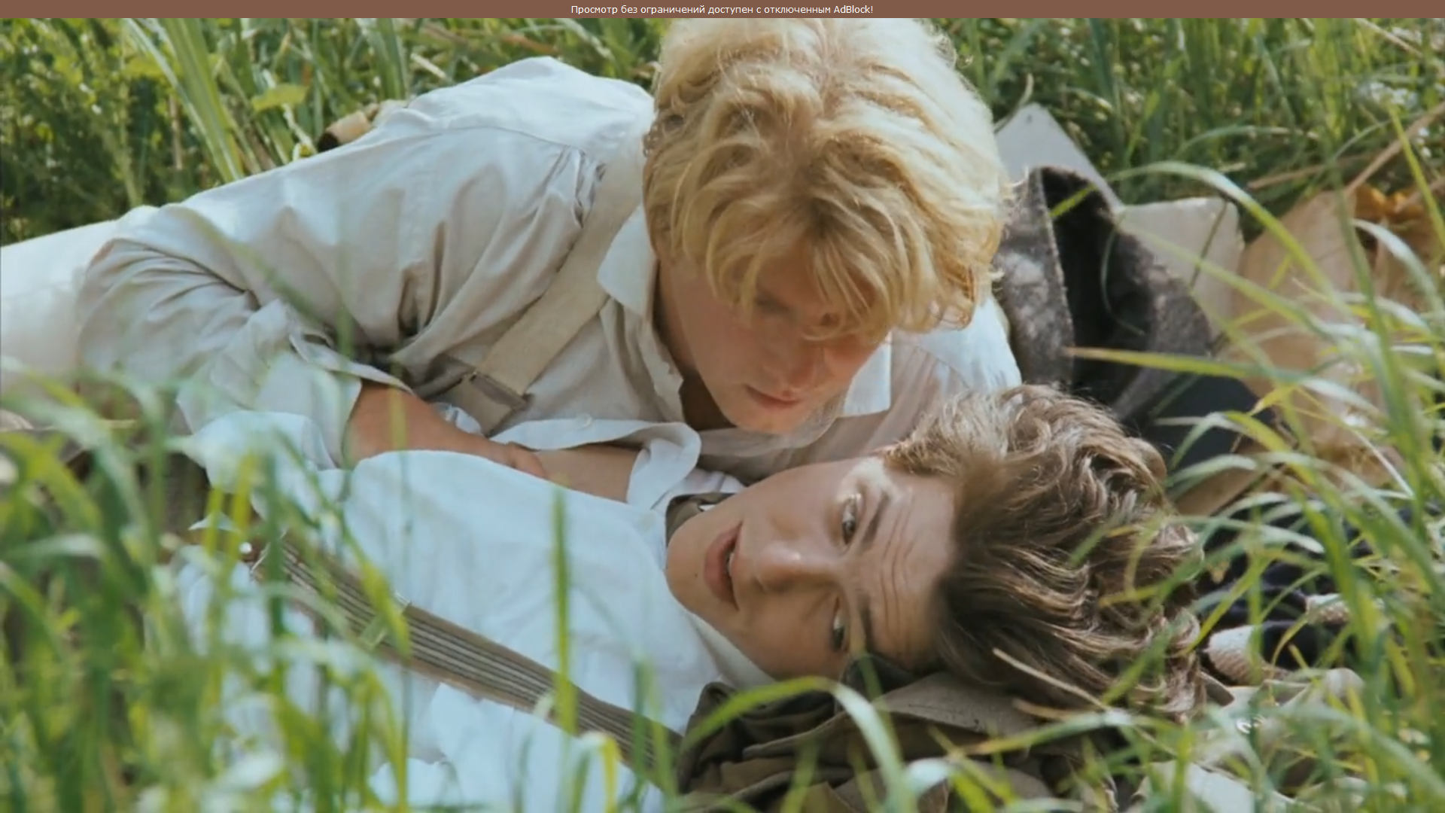
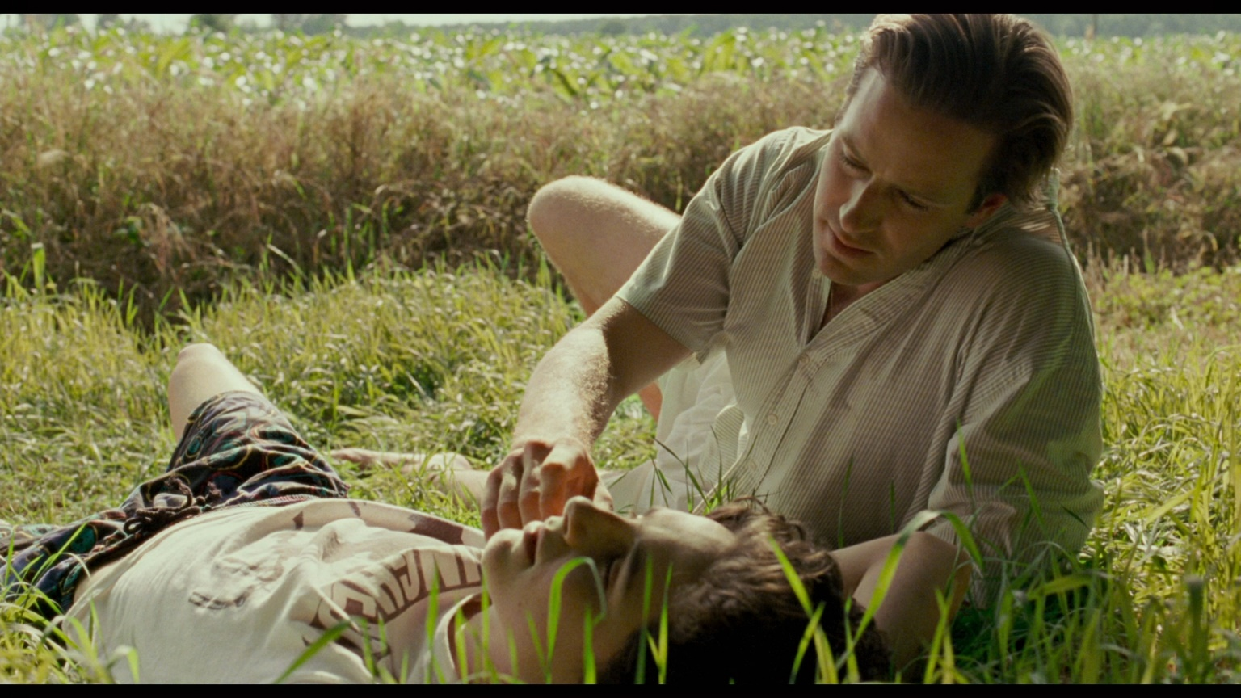
Yet, again, with Maurice and A Room with a View, Ivory seems to criticize the British society. The manners in the former and the persecution of the minorities in the latter are the subject of examination. Ivory even added some scenes into the narrative of Maurice that highlighted the unfavorable conditions for the homosexuals at the time. Moreover, what was only suggested in Maurice came finally came to fruition in Call Me by Your Name. At the very end of the James Ivory production, the narrative hints at a possible happy future for these characters. Forster’s intent was to create a love story between two men that would not be as hopeless as the other novels with the same subject matter at the time. However, in Maurice and other Anglo-American films following its suit, the main characters go through a lot of trouble and personal turmoil before they can get an inkling of happiness. Even the only movie about a homosexual character that took the main prize at the Academy Awards (Moonlight) showed that the societal pressure damages the love life of the main character at the time, culminating in the decades of unhappiness and repression. A few years after the film was released, Ivory talked about the fact that his movie had to end on a happy note, saying that the happy ending might have brought people in to enjoy the experience. However, the joyous, sensual ending of Maurice is what Call Me by Your Name feels like all the time. Yet, whereas, Ivory delays an empathetic reaction to what Maurice feels for the most of the movie, focusing on the other two central characters, Guadagnino chooses Elio as the sole narrator. Therefore, all the scenes and the emotions feel like emotions and memories that have been long lost and lovingly recreated.
Call Me by Your Name
Call Me by Your Name
Works that have received comparable acclaim such as Brokeback Mountain and Carol followed the tradition of telling stories of non-heterosexual love plagued by social injustice and tragedy. Todd Haynes even used Roland Barthes’ Fragments d’un discours amoureux (A Lover’s Discourse) to make the central love story between Cate Blanchett and Rooney Mara an installment in the canon of “timeless” love stories. Todd Haynes gave the book to the cast members to recreate the mise-en-scene in the lesbian context. According to the author, the pre-established aesthetics of falling in love (in Barthes' case, sprinkled with snippets from canon literature and philosophy) may have helped the film feel as if trapped in time while being flourished with delicate taste and nostalgia. However, the film follows the plot of the novel by including a threat to the central relationship that serves as the catalyst for the break-up. It is at the end of Carol that the audience is able to be hinted at a relationship that does not adhere to the prejudices of the time. Carol, Brokeback Mountain and Maurice, successful as they are, do focus on the societal issues surrounding non-heterosexual characters and use the juxtaposition as a major plot point. In contrast, Call Me by Your Name refers to a taboo that exists and rejects its power against the relationship between Elio and Oliver.
Thus, Call Me by Your Name becomes the first mainstream film of all the aforementioned that does not include societies that create unfavorable or judgmental environments for an amorous relationship. Elio’s father and his friends fully support the relationship after seeing the connection between the people in love. While repressed desire and the choice to enter a homosexual relationship when one is bisexual tries to validate the same-sex love in Maurice, Call Me by Your Name does not need that. Even if the audience is in the know of Elio and Oliver being bisexual, they are not conflicted in their entering into a union that would be taboo at the time. Thus, Guadagnino seems to champion the self-discovery and the family of Elio, highlighting the support and the willingness it takes for someone to find his or her love. Therefore, by using the episodic storytelling of Pialat and merging it with all the other directors’ styles, Guadagnino succeeded in making a film that exits outside the society that would condemn it – this ignorance signifying the importance of what unfolds in front of the audience. There are not any societies to critique (all include), there are no choices between partners (all are included). Whoever is pursued a relationship with is the one that is desired the most. At no point in Elio’s discovery does the narrative highlight the importance of the same-sex love. Thus, by using a sophisticated network of cinematic influence and an inclination to craft a film full of joy and wonder of discovery, Call Me by Your Name is possibly the first post-gay film.

Conclusion
Call Me by Your Name is a film that hybridizes the rich legacy it tries to follow and an Anglo-American LGBTQ story. It is able to do so because of the director’s arsenal of film references that also deal with the stories of falling in love in Europe. The work of Eric Rohmer, Jean Renoir, Bernardo Bertolucci, Maurice Pialat all prescribe the visual aesthetic of the film. Renoir gives the film a style that includes believable and realistic characters. Rohmer shares ways how to make long intellectual conversations feel lively and witty. Bertolucci gives the film its close-ups and an air of sensuality in the environment of great art and literature. Maurice Pialat’s films share the same unusual and episodic storytelling. Moreover, beyond following the styles of these directors, Guadagnino (consciously or unconsciously) subverts some of the tendencies of the “fathers,” rendering the film to be exclusively about desire and self-discovery. Therefore, Call Me by Your Name differentiates itself from other LGBTQ stories of the time. By not including the possible depressing outcomes of the story and any sexual contact between its characters, the film excludes any possibility to be about anything but desire.

Literature Review
To get a perspective on the films mentioned by Guadagnino in the interview that shapes the article, it was important to research European Cinema and contemporary LGBTQ cinema. All the articles contributed to the conception of the text, the reference list dominated by analyses of Eric Rohmer, as his filmography is more expansive than the others mentioned are. The literature review is given in the order of the release of the films discussed within.
The first director discussed in the article is Eric Rohmer. Most of his philosophical approach to the storytelling which seems to be displayed in most of his filmography is explicated in Eric Rohmer’s Oppressive Summers, a journal article by J. Fawell. In the article, the alluring summers of Rohmer are shown to be an invitation to stagnate. Most of the Rohmer protagonists seem to be invested in the self-discovery cliché of the summers, hoping that their journeys will reinvigorate either their cerebral or romantic life. “His actors themselves are always to a great extent his characters. This capacity is heightened in his summer pictures, where bodies are more present and where clothing is more expressive and revelatory, where there is, generally, more self-consciousness about the body and how it is adorned.” Similarly, in Call Me by Your Name, the athletic body of Armie Hammer creates the character that seems to be the manifestation of the ideal body in Elio’s mind. The clothes too are given great attention, the characters discussing them at various occasions.
In almost all of Rohmer’s films mentioned (save for Le Rayon Vert), the protagonists are unable to find anything worthwhile – the summers serving as moral stories. Rohmer made most of the movies discussed in an era of sexual liberation in France, telling stories of people who eventually return to self-control and maturity. The exact opposite is observable in The Dreamers, Bertolucci’s love letter to 1960s French New Wave. The Dreamers appears to glorify the period it portrays and depicts the sexual activities of the three main characters as the manifestation of the revolution that was taking place at the time. While Rohmer is pushing for a more conservative model for relationships as a contrast to its time, Bertolucci revisits an era of self-discovery and sex through cinema and nostalgia.
As cinematic realism and late European naturalist cinema is behind the aesthetic choices in Call Me by Your Name, I. Aitken’s Late European Cinema and Realism chapter in the European Film Theory and Cinema which tells of the long tradition of European realist cinema. The chapter touches on three film realists’ theories and their influence on Late European Cinema Realism. The three theorists are Kracauer, Lukacsian, and Bazinian. The author suggests that each of the writers showed their influence in European cinema in different time periods. Maurice Pialat, whose Loulou and A nos amours, is mentioned in the later sections of the chapter. The author describes Pialat as a director who “adopts a predominantly naturalist approach in films such as L’Enfance nue (Naked Childhood, 1969), Passe ton bac d’abord (1979), Loulou (1980) and A nos amours (To Our Loves, 1983)…Pialat often focuses on the subject of youth as a manipulated, exploited or vulnerable section of society.” Call Me by Your Name is similar in structure of storytelling with the following devices: “Pialat’s concern with the representation of the quotidien inherits both a Bazinian emphasis on the need to seek the significant within the mundane, and the concerns of the new history movement assiocated with the Annales school.” This is where Call Me by Your Name seems to use Pialat’s structure. He takes the non-bombastic, liminal spaces of falling in love and renders them into moments of great significance. Yet, Guadagnino’s film is greatly aestheticized, which is where the filmographies seem to deviate – “Pialat’s cinema, with its rejection of aestheticism, focus on the minutiae and texture of everyday interaction and chance events, and use of non-professional actors.” Nevertheless, the structure of Pialat does seem to add to the dreamy narrative at the heart of Guadagnino’s film. “The cinema creates a dream world…it transforms what is sordid into something marvelous, it makes the ordinary exceptional, and turns what is filmed into a moment of death. That’s what I understand by realism.” As the article brings up that Call Me by Your Name is a recreation of someone’s memory (the novel is written in first-person narration), a retelling of someone’s life experience is heightened by the immediacy and the pattern of cutting away when an action of importance seems to take place. This text also serves as an introduction to Renoir’s aesthetic.
As James Ivory wrote the screenplay for Call Me by Your Name and directed an adaptation of a novel with a non-heterosexual relationship at its heart, interviews on the making of two of his E. M. Forster adaptations were also crucial. Both are found in the book, James Ivory in Conversation, by R. Long and J. Maslin. The interviews make clear what the Merchant-Ivory production tried to achieve with its long history and what kind of stories attract James Ivory. Therefore, as visually and thematically, Call Me by Your Name is inspired by Ivory’s work, the text serves as a window into the creative process of its writer. Further information on Maurice is derived from Margaret Goseilo’s article on the absent hero of the film, in which she attempts to explain the strange feeling of watching Maurice and not understanding the motivations of the eponymous character. This is a major deviation between Ivory’s work on Maurice and Call Me by Your Name, as the latter renders its entire story through the mind of Elio, the protagonist. Again, the problem is possibly connected to the source material, which also distances the reader from the emotions of the character.
Most of the material on Guadagninos’ films is not scholarly research, but rather film reviews. As the films are more recent than any mentioned in the article, there is little to no articles published about them. However, some of the reviews taken for consideration are from reputable film critics, such as Roger Ebert, who found Io sono l’amore to be the combination of the old and the new, of tradition and innovation, something the article argues is true for most of his filmography. Similar reputable literature on Call Me by Your Name was used in the form of J. D. Mattia’s piece in Screen Education. Further literature was compiled from multiple interviews with the film’s director, in which he explains the influences behind the film.

References
Aitken, I. (2001). Late European Cinema and Realism. In I. Aitken, European Film Theory and Cinema (pp. 203-227). Edinburgh: Edinburgh University Press.
Baecque, A. d., & Herpe, N. (2016). The Weeping Girl: Éric Rohmer's Filming of "Claire's Knee". Cinéaste, 34-39.
Blessing, J. (2017, October 5). ‘Call Me By Your Name’: Luca Guadagnino Discusses Avoiding Cliches, Costumes & Narration [NYFF]. Retrieved from The Playlist: https://theplaylist.net/call-me-by-your-name-luca-guadagnino-20171005/
Ebert, R. (2010, June 23). The sublime Tilda in lust and love . Retrieved from Rogert Ebert: https://www.rogerebert.com/reviews/i-am-love-2010
Ellis, B. E. (2017, December 18). Movie of the Year: Bret Easton Ellis on the Many Pleasures of Call Me by Your Name. Retrieved from Out: https://www.out.com/out-exclusives/2017/12/18/movie-year-bret-easton-ellis-many-pleasures-call-me-your-name
Fawell, J. (1993). Eric Rohmer's Oppressive Summers. The French Review, 777-787.
Frodon, J.-M. (2004). A nos amours. Film Comment, 46.
Goscilo, M. (1989). Ivory-Merchant's "Maurice:" The Hero in Absentia. Literature/Film Quarterly, 99-107.
Grosoli, M. (2018). From "École Scherer" to "Politique des Auteurs". In M. Grosoli, Eric Rohmer's Film Theory (pp. 149-180). Amsterdam: Amsterdam University Press.
Kellaway, K. (2017, October 15). Call Me By Your Name’s Oscar-tipped double act on their summer of love . Retrieved from The Guardian: https://www.theguardian.com/film/2017/oct/15/armie-hammer-timothee-chalamet-call-me-by-your-name-interview
Long, R. E., & Maslin, J. (2005). England. In R. E. Long, & J. Maslin, James Ivory in Conversation (pp. 197-253). University of California Press.
Mattia, J. D. (2018). Beating Hearts: Compassion and Self-Discovery in Call Me by Your Name. Screen Education, 8-15.
Olivier, M. (2017, August 20). Luca Guadagnino Talks ‘Call Me By Your Name’ And ‘Suspiria’. Retrieved from The Playlist: https://theplaylist.net/luca-guadagnino-suspiria-20170820/
Signkhra, S. (2005). Dreams of Lost Time: A Study of Cinephilia and Rime Realism in Bertolucci's The Dreamers. In M. d. Valck, & M. Hagener, Cinephilia (pp. 45-54). Amsterdam: Amsterdam University Press.
White, P. (2015). Sketchy Lesbians: Carol as History and Fantasy. Film Quarterly, 8-18.

(Olivier, 2017)
(Ellis, 2017)
(Kellaway, 2017)
(Blessing, 2017)
(Ebert, 2010)
(Mattia, 2018, p. 9)
(Baecque & Herpe, 2016, p. 36)
(Fawell, 1993, p. 778)
(Mattia, 2018)
(Fawell, 1993, p. 783)
(Grosoli, 2018)
(Frodon, 2004, p. 46)
(Aitken, 2001, p. 209)
(Aitken, 2001, p. 210)
(Signkhra, 2005, p. 45)
(Long & Maslin, 2005, p. 205)
(Long & Maslin, 2005, p. 253)
(Goscilo, 1989, p. 99)
(Goscilo, 1989, p. 102)
(White, 2015)
(Signkhra, 2005)

